MLOps
The main cause is that there is a fundamental difference between ML development and traditional software development.
Machine Learning is not just code. It is code plus data
Machine learning = Code+Data
A Machine learning model is created by applying an algorithm(via code) to fit the data to result in an ML model.
Code is crafted in the development environment. Data comes from multiple sources for training and testing. The data may change over time in terms of volume, velocity, veracity, and variety. There is some additional dimension that differentiates traditional software and ML applications. Sometimes Big data, brings entirely new challenges to the development process. For this evolving data, code needs to evolve over time.
Volume: It denotes the Size of the data
Velocity: Refers to the speed at which the data enter the system
Veracity: It says how accurate the data is
Variety: Refers to different formats of data.
So data and code with the progression of time, end up going in two directions with one objective of building and maintaining a scalable ML system.
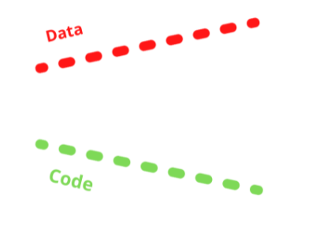
This disconnect causes several challenges that need to be solved to put an ML model in production.
To overcome these challenges, MLOps approaches bridging data and code together over the progression of time.
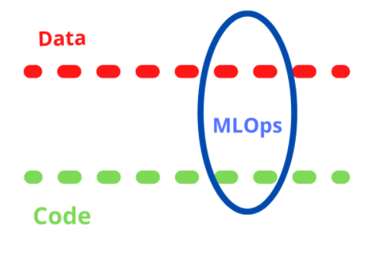

Machine Learning Operations in MLOps
MLOps is a method to fuse ML with software development by integrating multiple domains ML, DevOps and data engineering which aims to build, deploy, and maintain ML systems in production reliably and efficiently. It brings together data engineering, ML, DevOps in a streamlined manner.
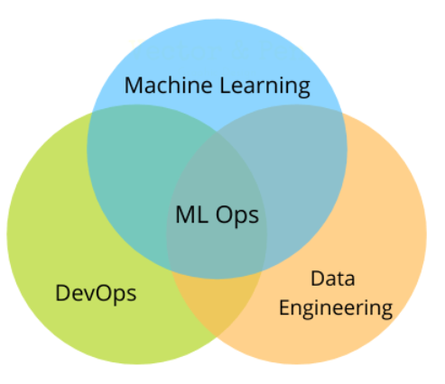

Challenges in ML Models
The main cause is that there is a fundamental difference between ML development and traditional software development.
Machine Learning is not just code. It is code plus data
Machine learning = Code+Data
A Machine learning model is created by applying an algorithm(via code) to fit the data to result in an ML model.
In traditional development, the version of source code produces the version of the software. In machine learning, a version of source code and the version of the data produces the version of the ML model.
Code is crafted in the development environment. Data comes from multiple sources for training and testing. The data may change over time in terms of volume, velocity, veracity, and variety. There is some additional dimension that differentiates traditional software and ML applications. Sometimes Big data, brings entirely new challenges to the development process. For this evolving data, code needs to evolve over time.
Volume: It denotes the Size of the data
Velocity: Refers to the speed at which the data enter the system
Veracity: It says how accurate the data is
Variety: Refers to different formats of data.
So data and code with the progression of time, end up going in two directions with one objective of building and maintaining a scalable ML system.
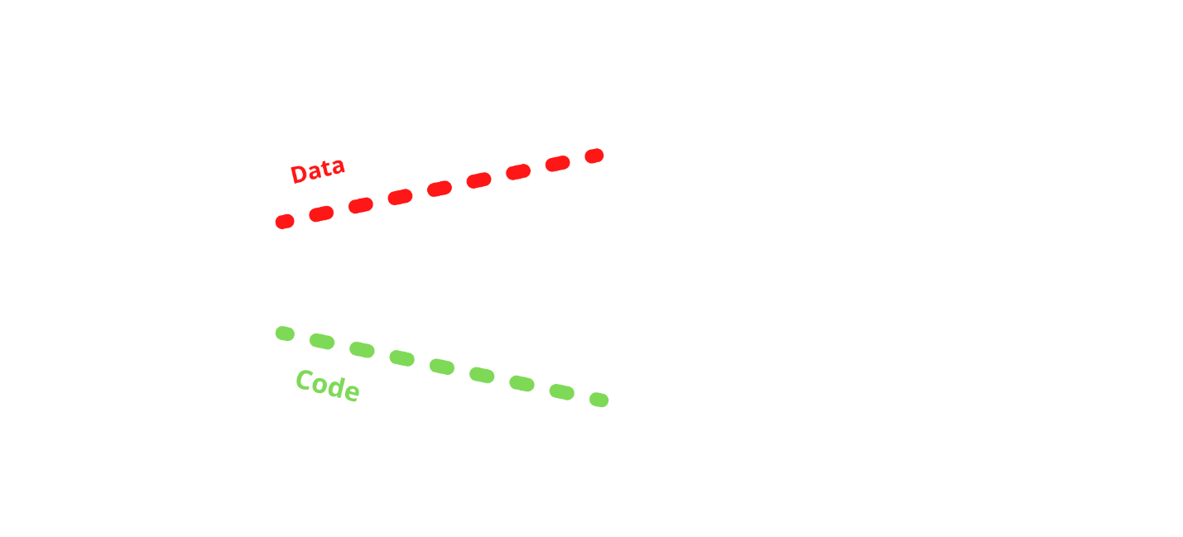
Data and code progress over time
This disconnect causes several challenges that need to be solved to put an ML model in production.
To overcome these challenges, MLOps approaches bridging data and code together over the progression of time.
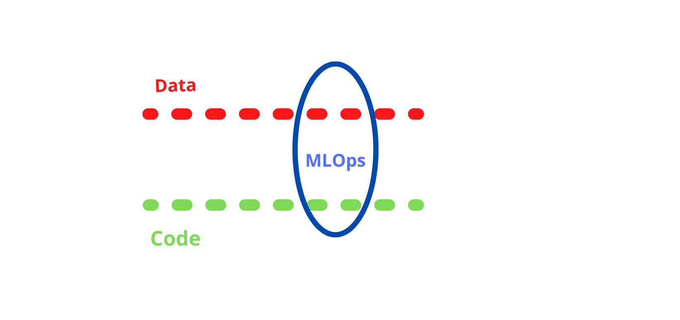

Machine Learning Operations in MLOps
MLOps is a method to fuse ML with software development by integrating multiple domains ML, DevOps and data engineering which aims to build, deploy, and maintain ML systems in production reliably and efficiently. It brings together data engineering, ML, DevOps in a streamlined manner.
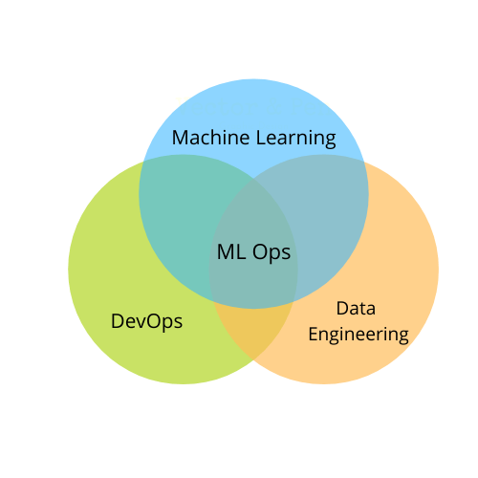
Amazon Sagemaker – Helps in the ML pipeline (i.e) build, train, deploy and monitor machine learning models.
Microsoft Azure MLOps Suite:
Microsoft Machine Learning – Build, train, evaluate models
Azure Pipeline – Automate ML
Azure Monitor – Tracking and monitoring
Azure Kubernetes Service – Managing containers
Google Cloud MLOps:
Dataflow – Used for ETL
BigQuery – Cloud data warehouse, which is used as the source for ML training
TFX – to deploy models
Google Cloud Platform with ML Pipeline: A Step-to-Step Guide

