DATE:25/06/2024

1.FETCH ALL CUSTOMERS AND DISPLAY IF THERE ARE ANY ORDER NAME

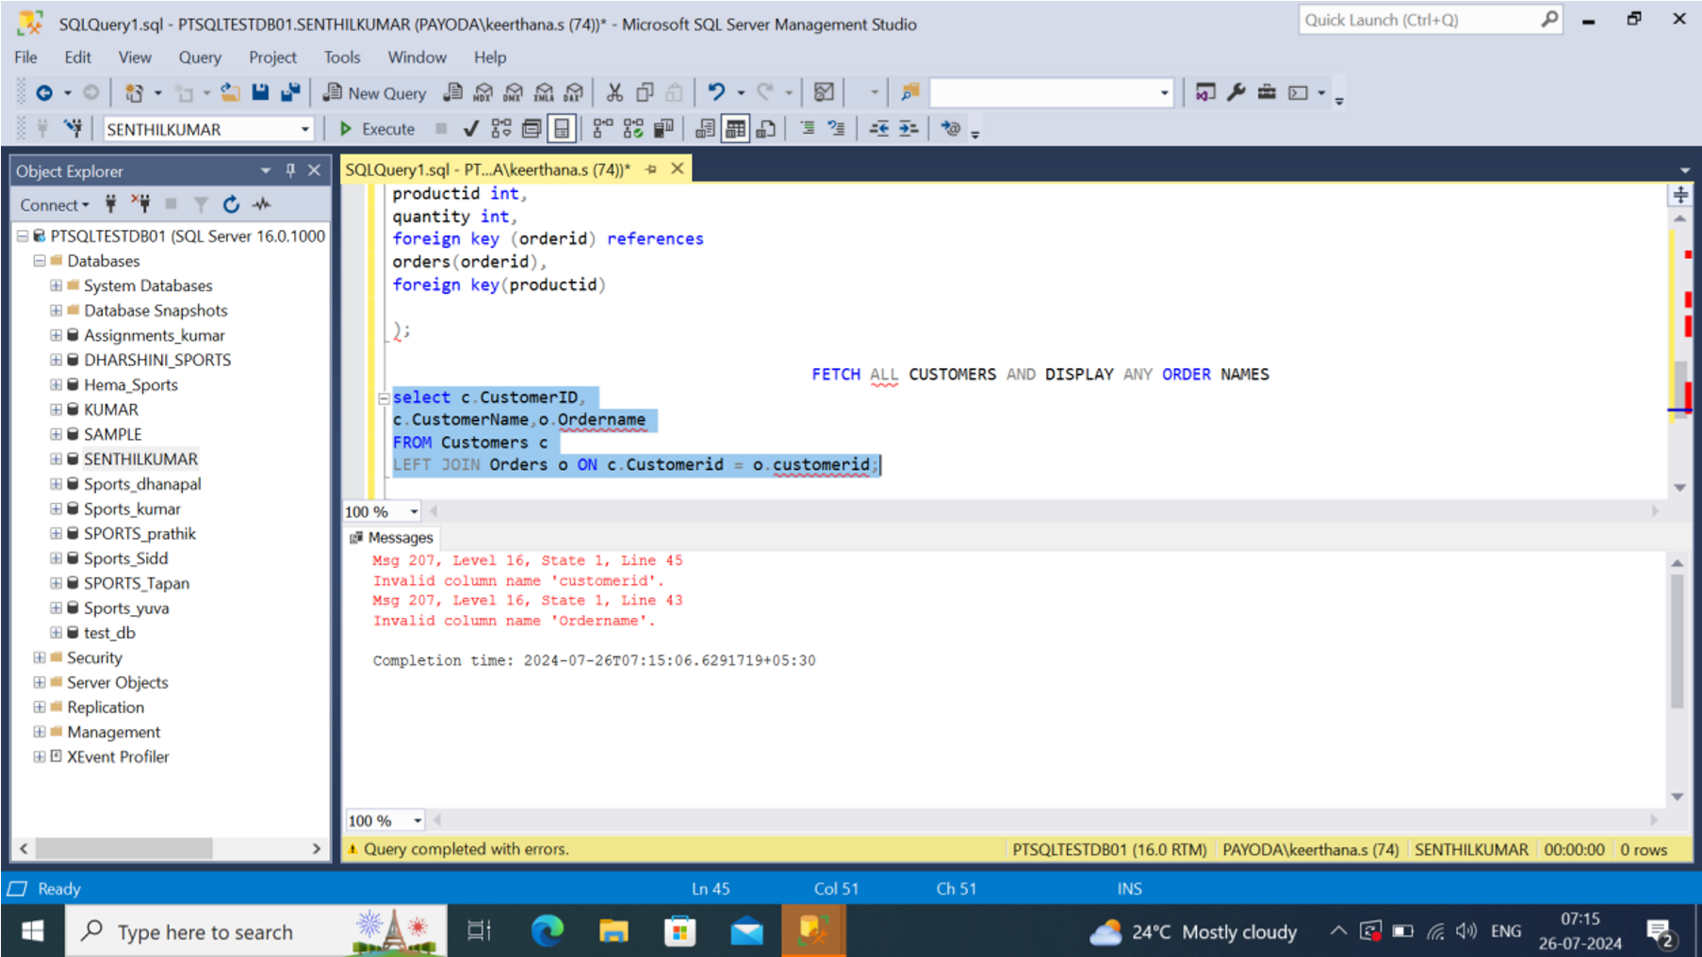

2.FETCH ALL ORDER NAMES PLACED FROM PARTICULAR LOCATION



1. WHAT IS THE MAX PRICE OF PRODUCTS FROM PARTICULAR CATEGORY

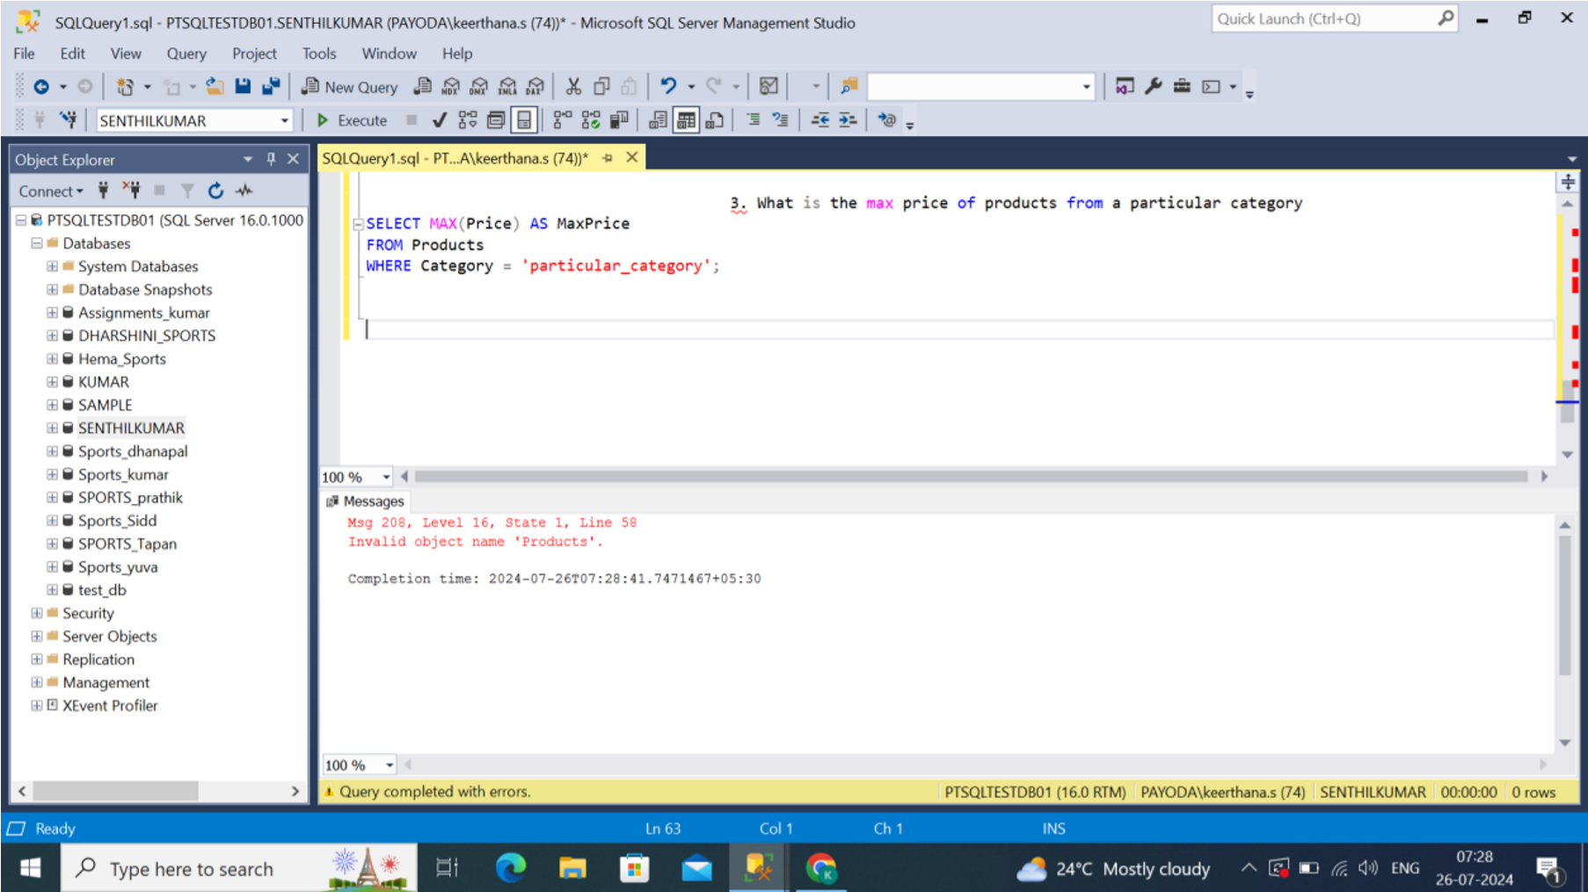

1. DISPLAY ANY PRODUCT WITH THE PRODUCTNAME AS LIKE MOBILE,SPEAKER

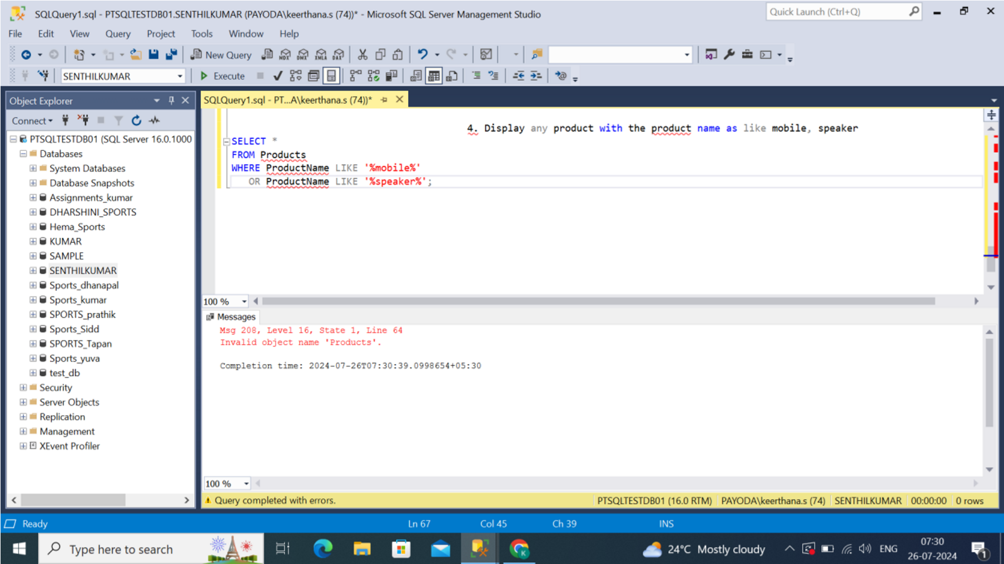

1. CREATE A FUNCTION THAT CALCULATE 10% GET FROM ORIGINAL PRICE

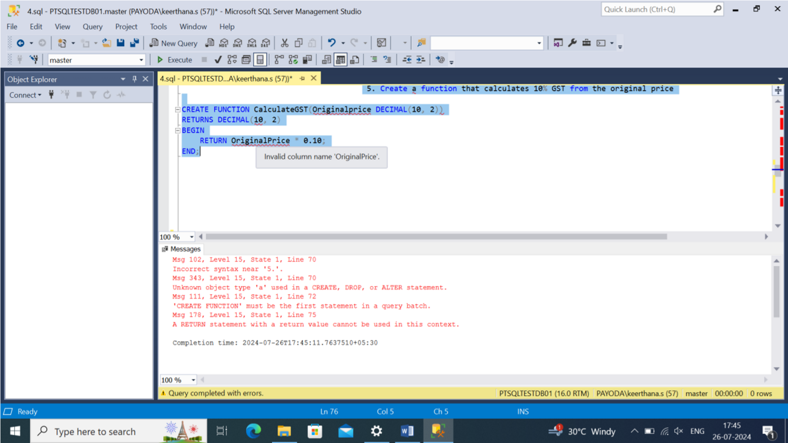

1. CREATE STORED PROCEDURE THAT INCREASES ALL PRODUCT PRICE BY 100 ENSURE ATOMICITY

