* Advance Dashboard for Purchase Team. On clicking Request Po Acceptance the purchase

team will be able to see the list of Po’s.

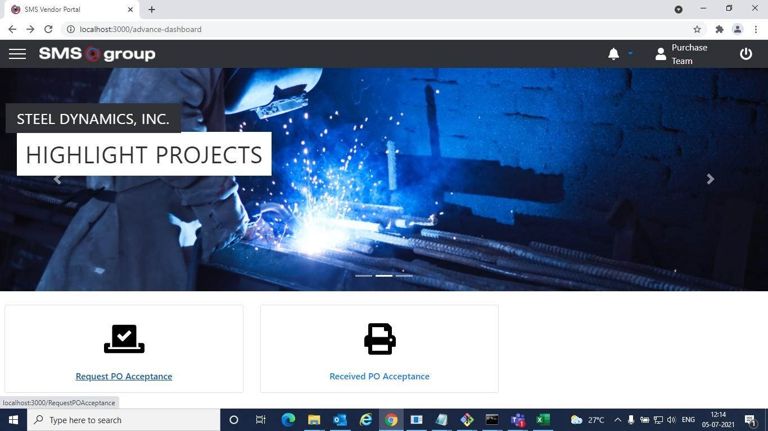

* Purchase Team will upload PO Details document and will select a Po then Request for Po Acceptance.

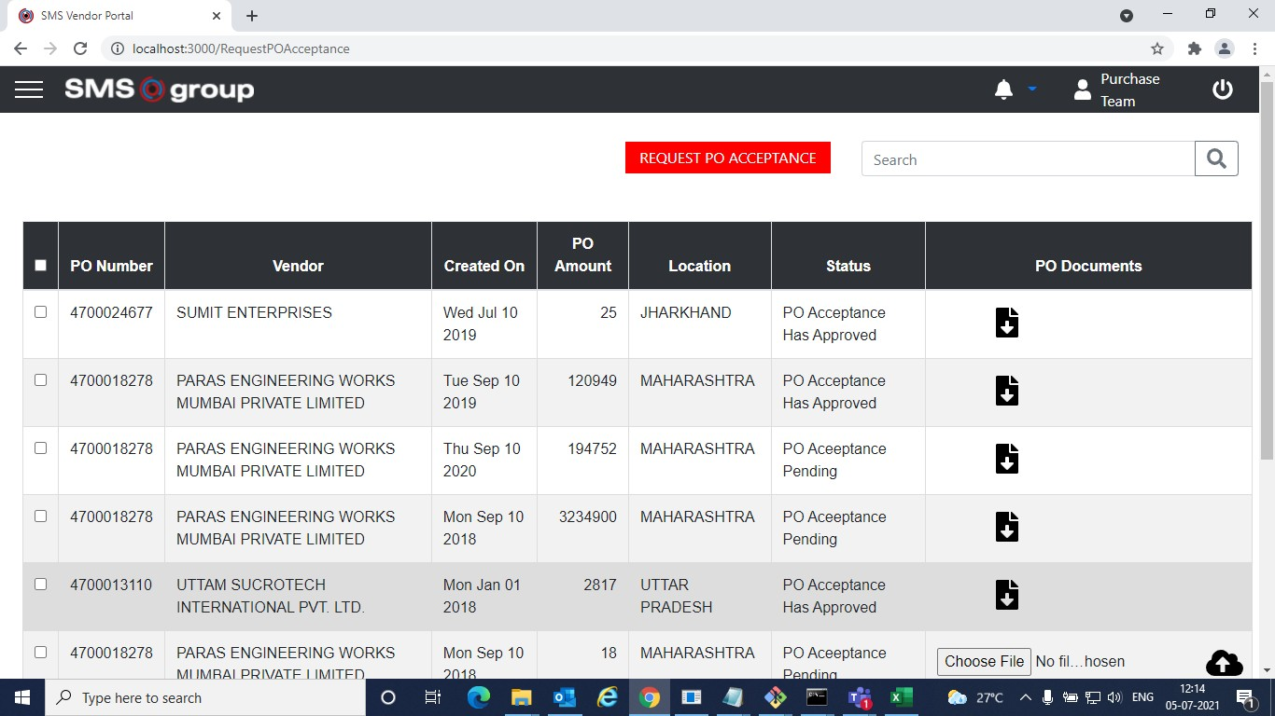

* Advance Dashboard for Paras.

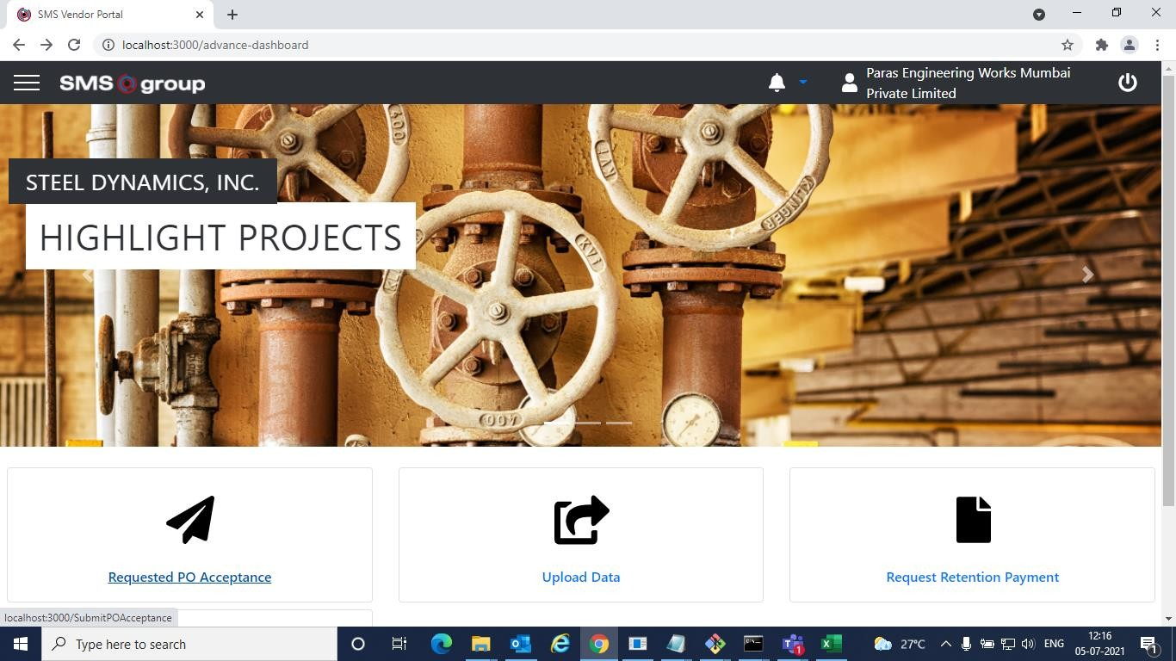

* Now supplier (Paras) will log in and upload the Po Acceptance Document.

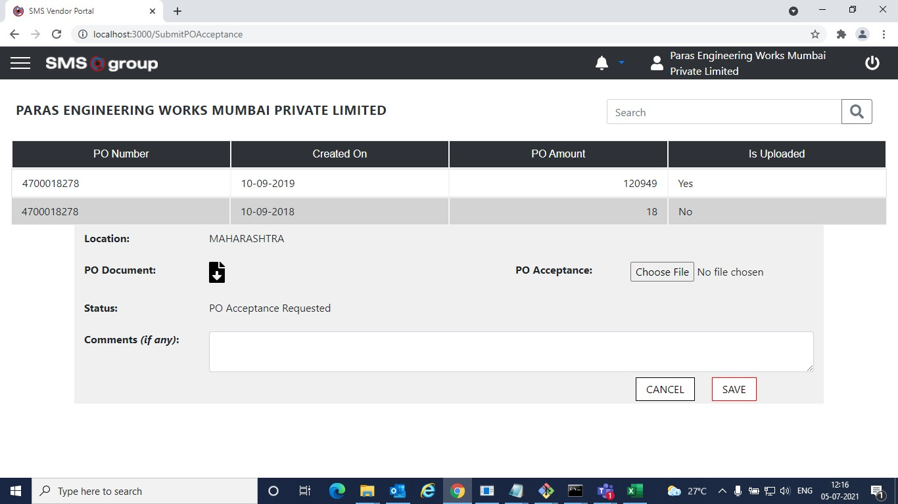

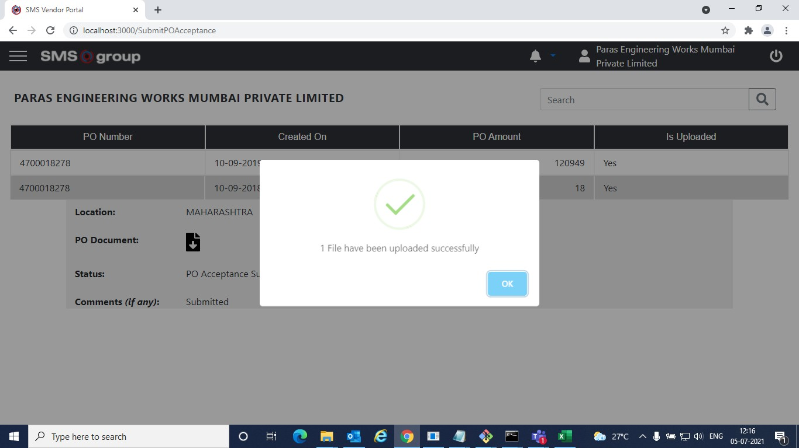

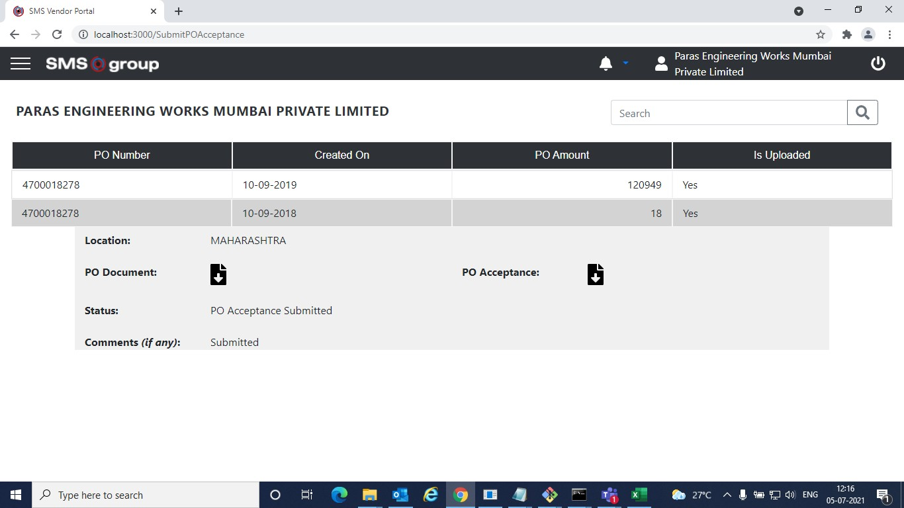

* Now Purchase Team Will Log in. On clicking Received PO Acceptance tab. Purchase team will be able to see all the POs for which PO Acceptance Document has been submitted by the supplier.

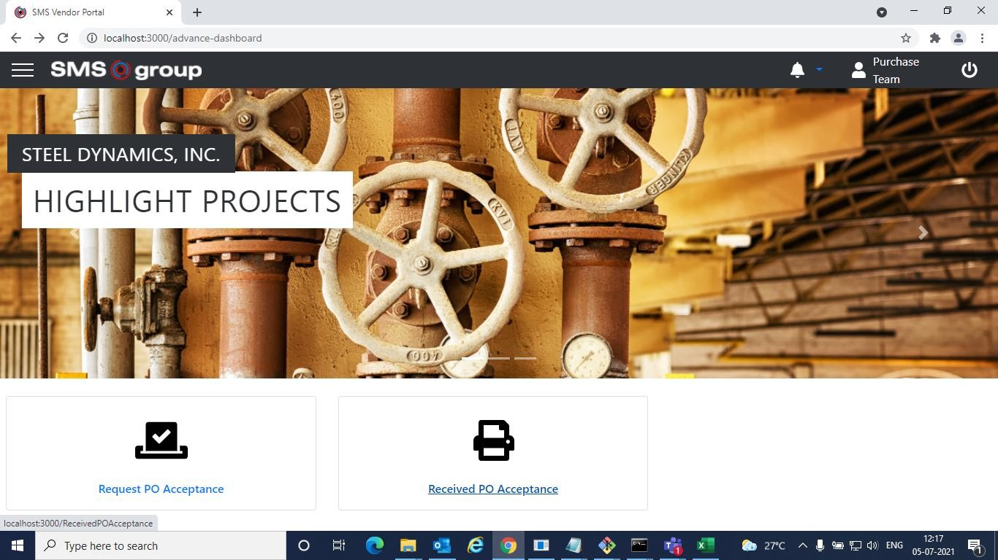

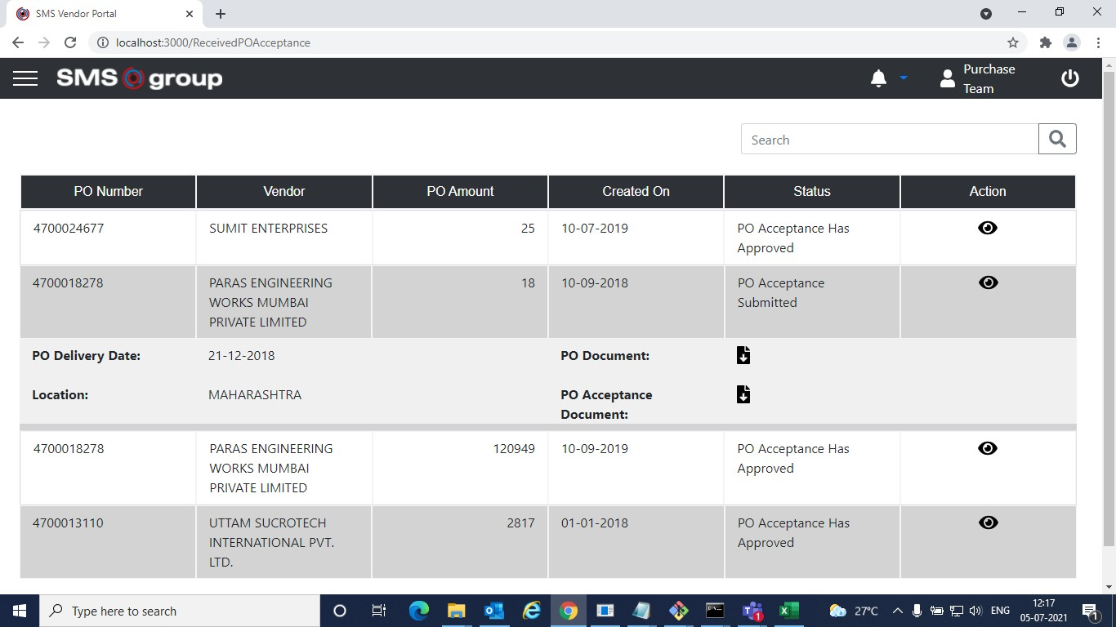

* Now Purchase Team will either Approve the PO Acceptance Document or Request for Revision.

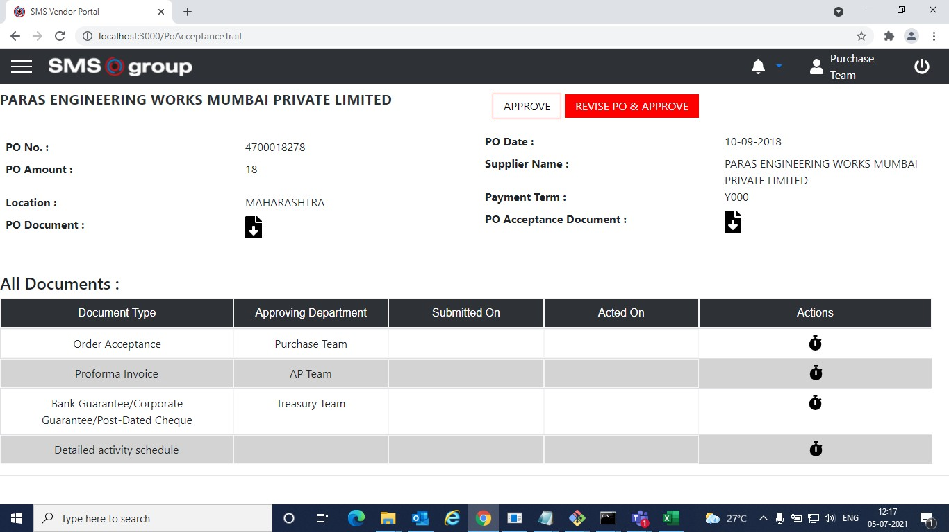

* Once approved by Purchase Team, Paras(supplier) will upload all the supporting documents.
* Click on Upload Data tab to upload the documents.

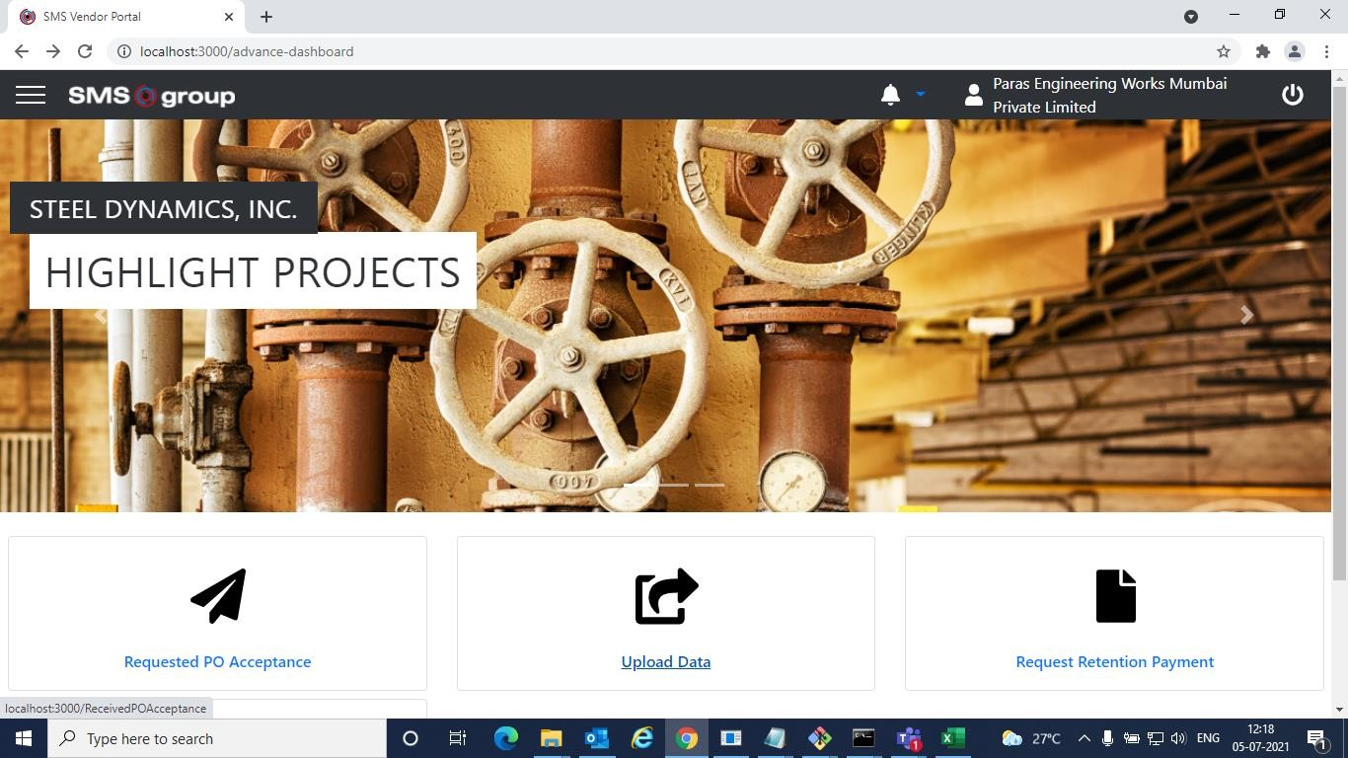

* Paras will upload all the documents and on submitting these documents it will go to respective stakeholders for approval. i.e., Proforma Invoice will approved by AP Team, Bank guarantee will be approved by Treasury Team and so on.





\*- 9 G

lomlhosi:3000/RereivedPOAsre anre

*pq*



Action

4700018278

4T00018Z78



PARAS ENG I NFFRING WORKS MUMBAI PRIVATE LIMITED





2J —12—2018

MAHARASHTRA

120949 10—09—2019

IB 10-09 03B



P'DA‹›oegtance

PO Acceptance Has Approved

PO Acceptance Has











£ 9 fl O lomlhosi:3000/PoA<repnnseTrail

PARAS ENGINEERING WORKS MUMBAI PRIVATE LIMITED



MAHARASHTRA

 YOOD

All Documents :



 Acted On



Accep6nce



BankGuarantee/Corporate Guarantee/Post-Dated Cheque

Detailed acflvityschedue

AP Team



Al No fil...osen





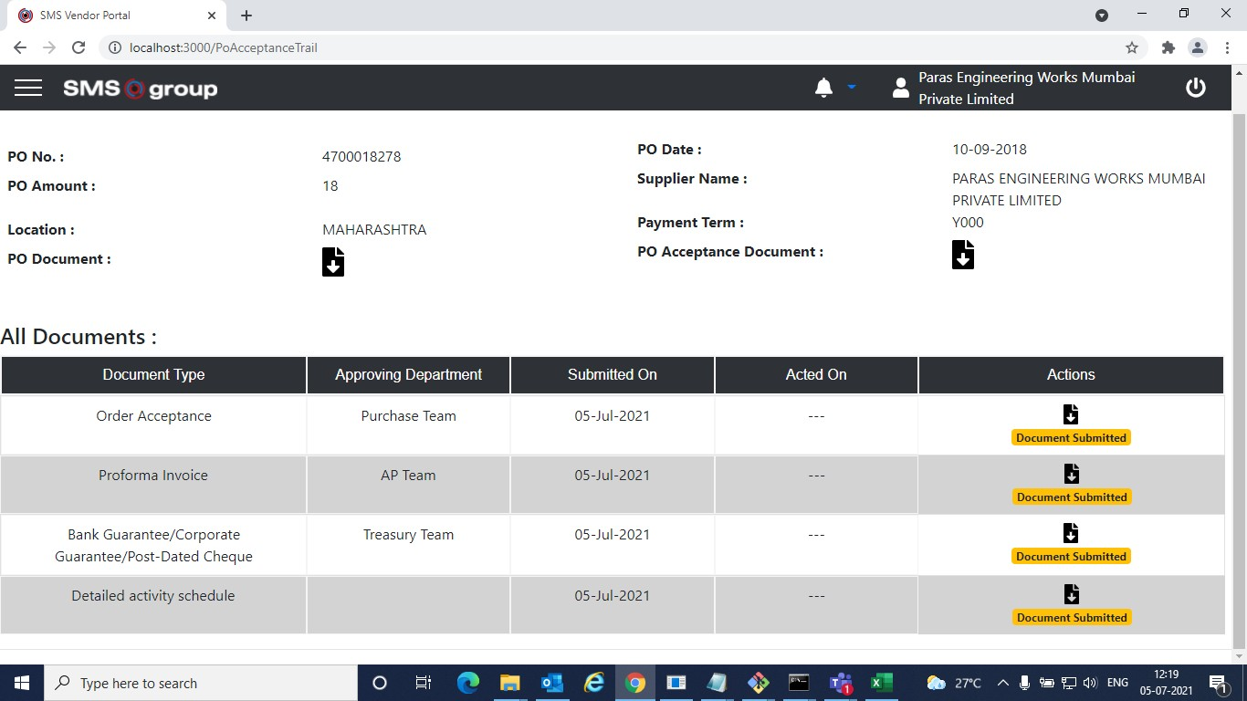

* Now the respective stakeholders will approve these documents parallelly.
* AP Team will approve Proforma invoice, Purchase Team will approve order acceptance, Treasury Team will approve Bank Guarantee.

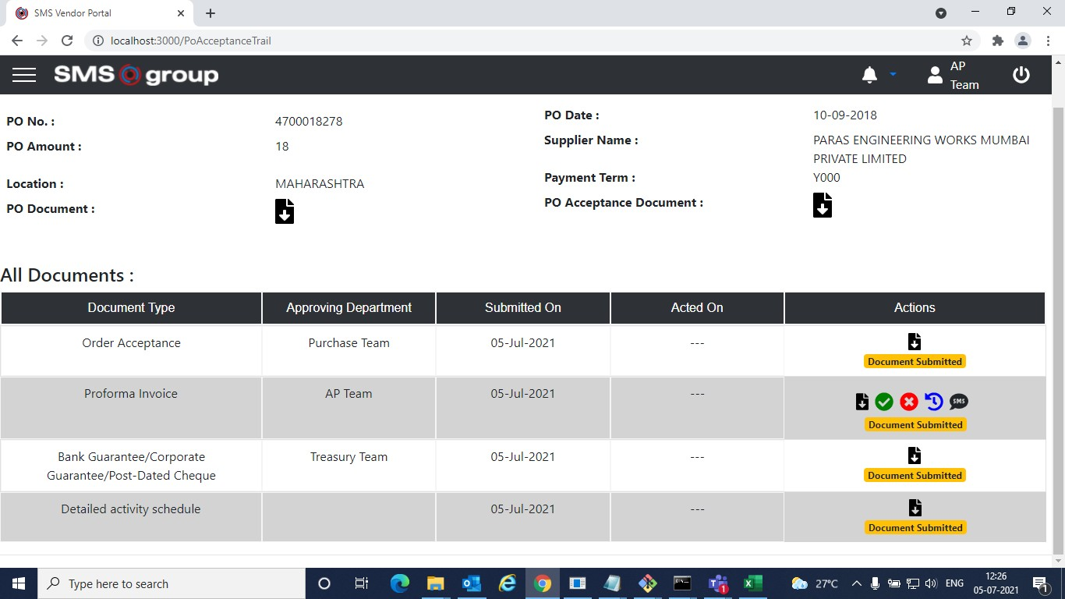

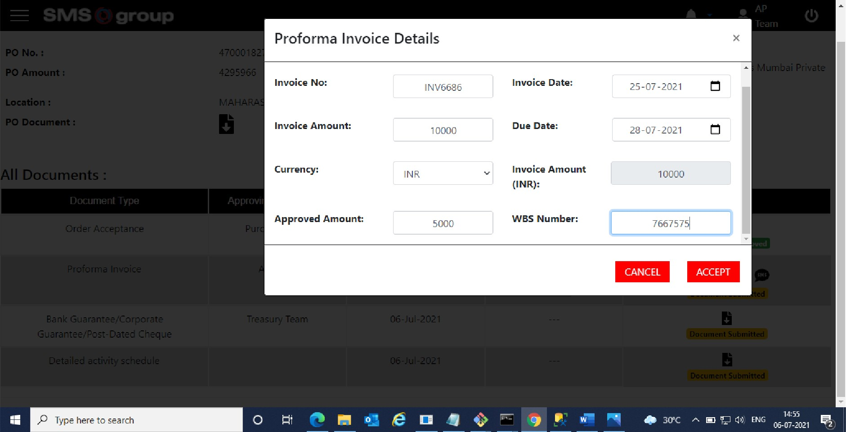\*- 9 fl % lomlhosi:3000/PoA<repnn<eTrail 





£ 9 fl O lomlhosi:3000/PoA<repnn<eTrail

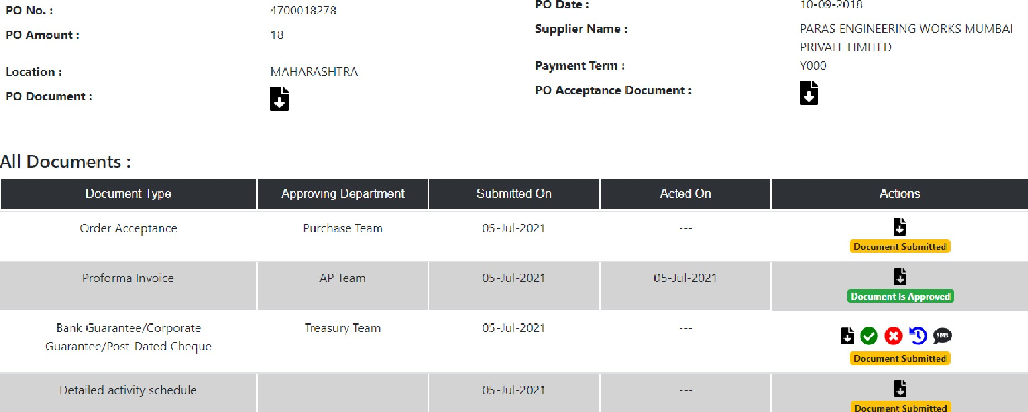



SMS group

@ sus vmao ports

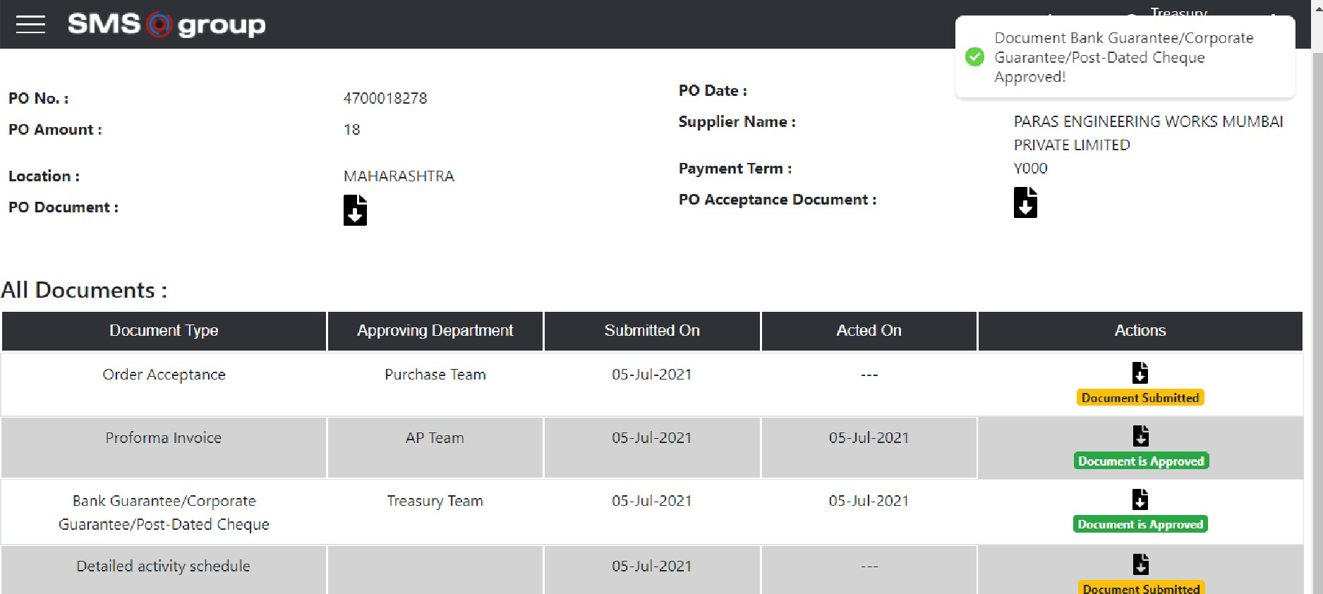6 W W OT IonaIhost•30£Kl/9aAoceptanceTrail @ N

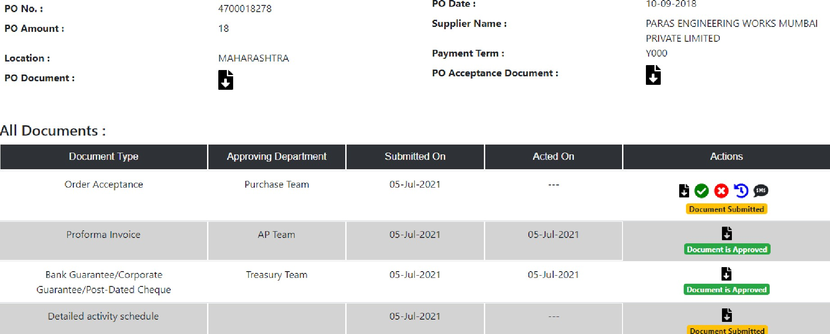



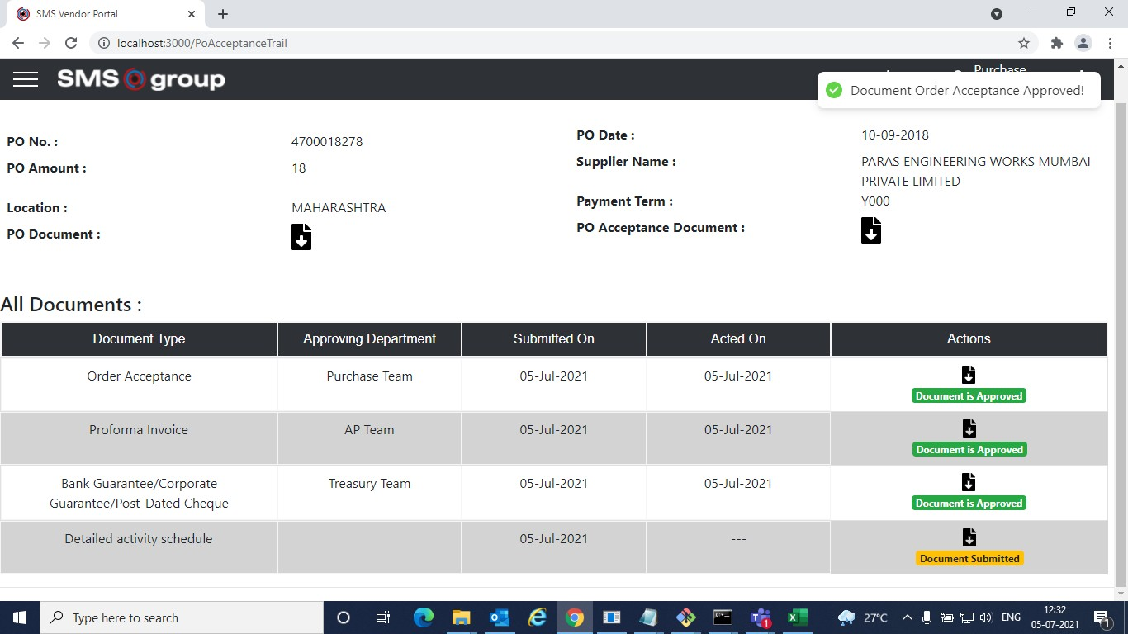

* Once approved by different stakeholders. Paras(supplier) will upload invoice.

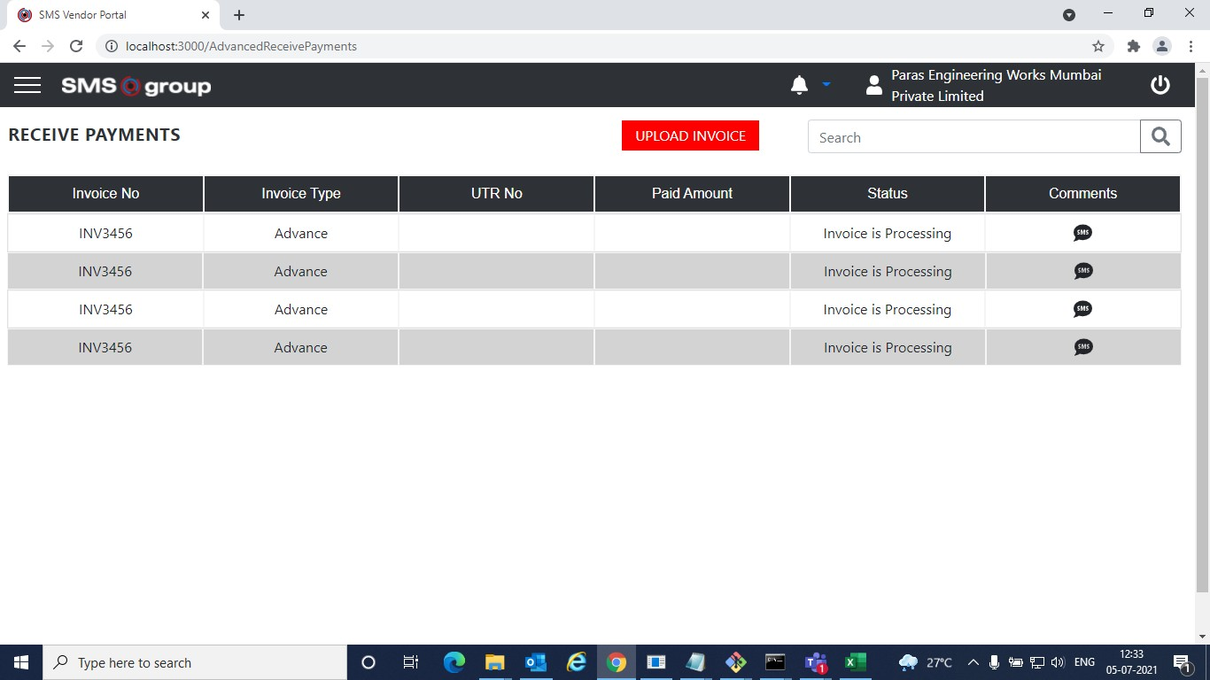

* Upload Invoice modal.

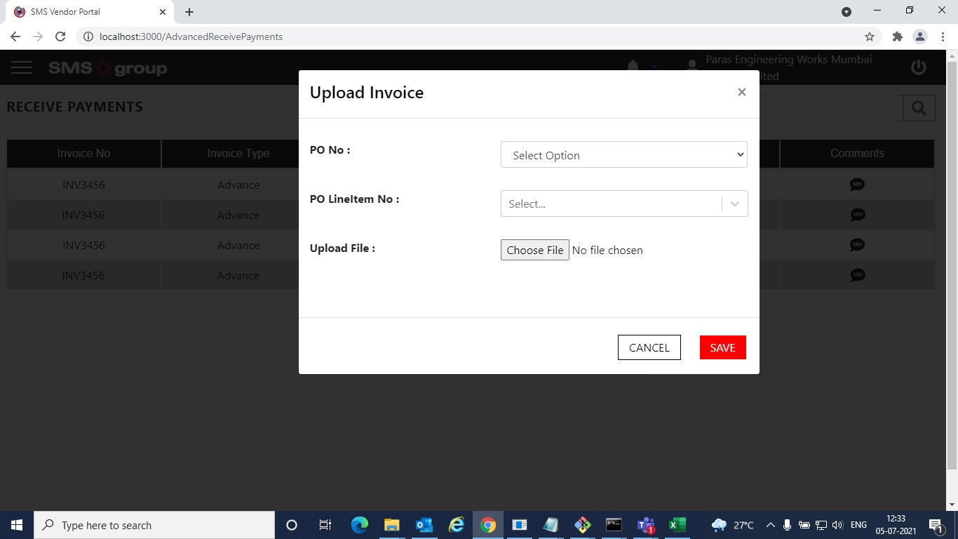

* Once the invoice is uploaded the payment process starts.
* AP Team will add a payment method and he will also set the approved amount and then forward the invoice to Treasury Team.

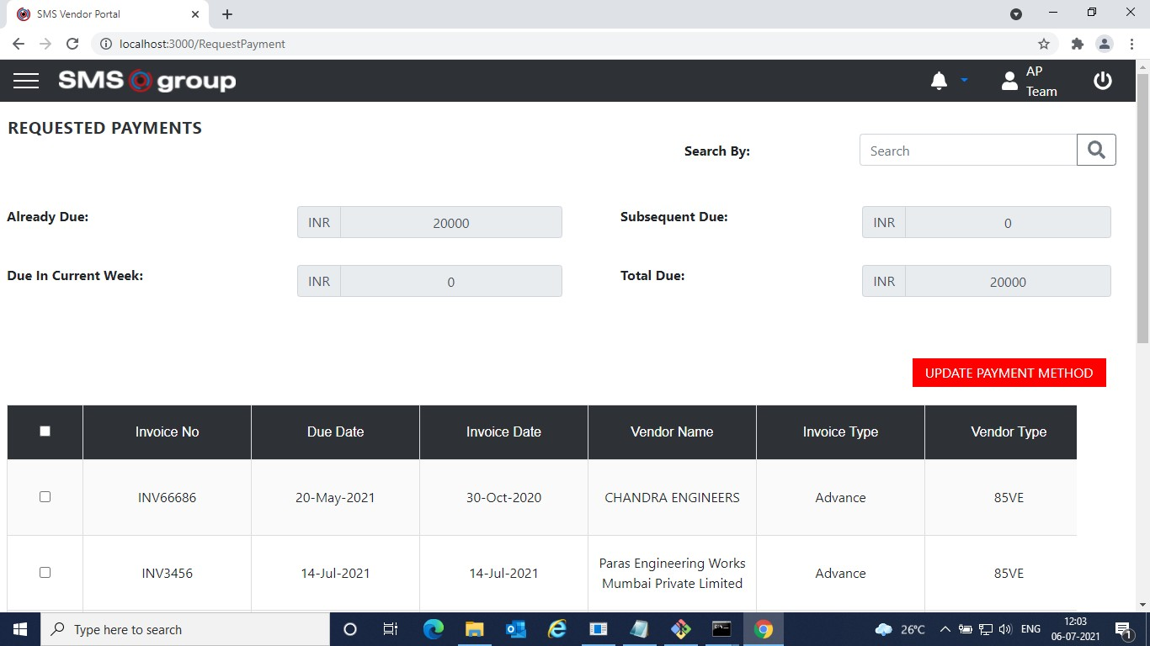

* Update Payment Modal.

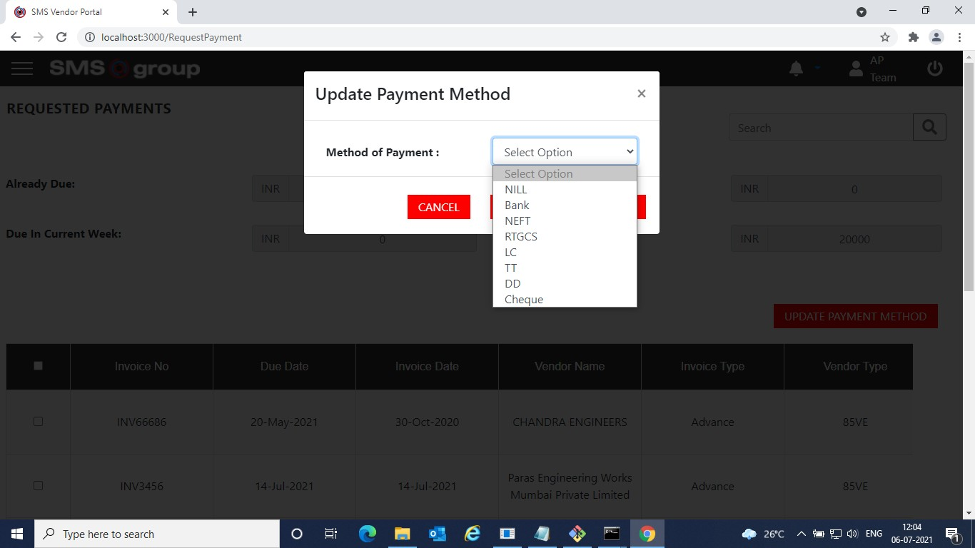

* After setting the payment method and approved amount. The invoices will be sent to Treasury team. Treasury team will forward the invoice to Finance HOD.

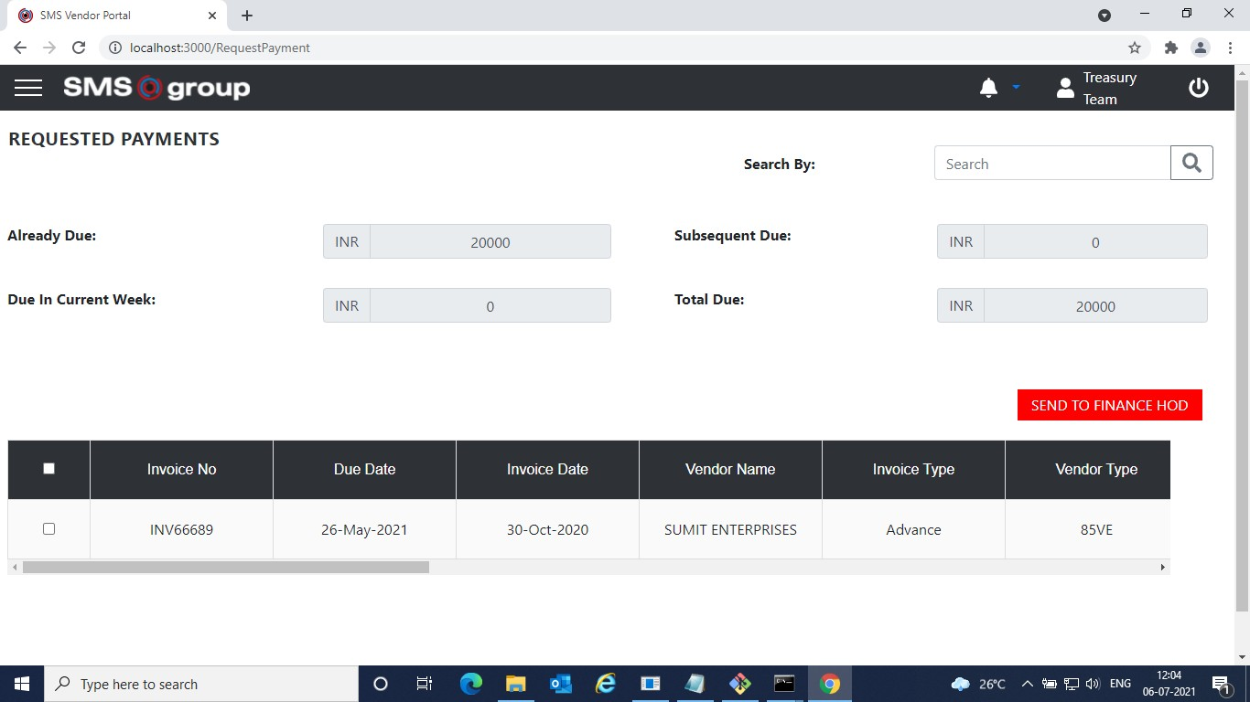

* Finance HOD will set the budget and send the invoice to Teams(Expediting).

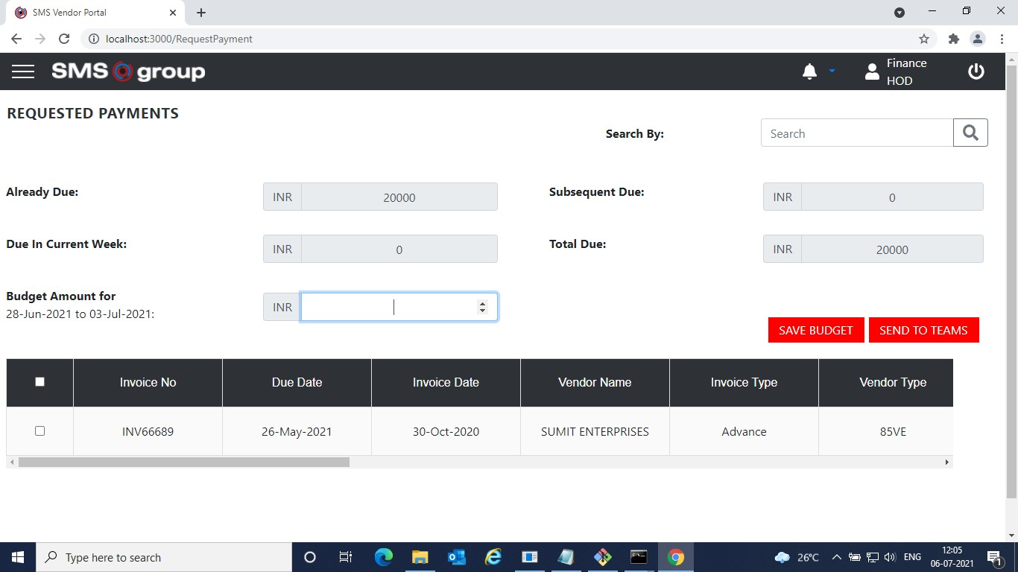

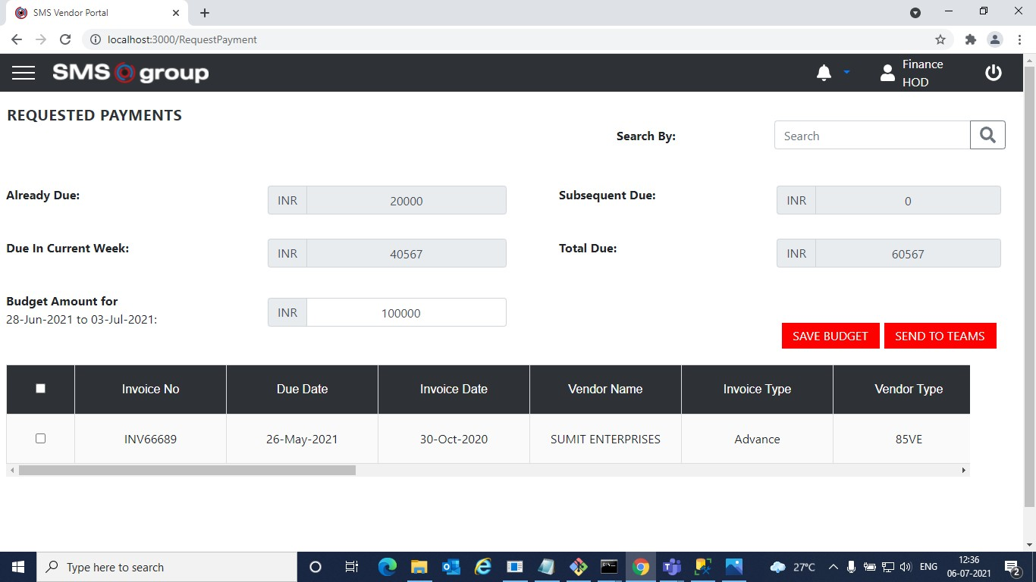

* These teams will login individually and set priority also they have the provision to edit the approved amount and forward the invoice to SCM.

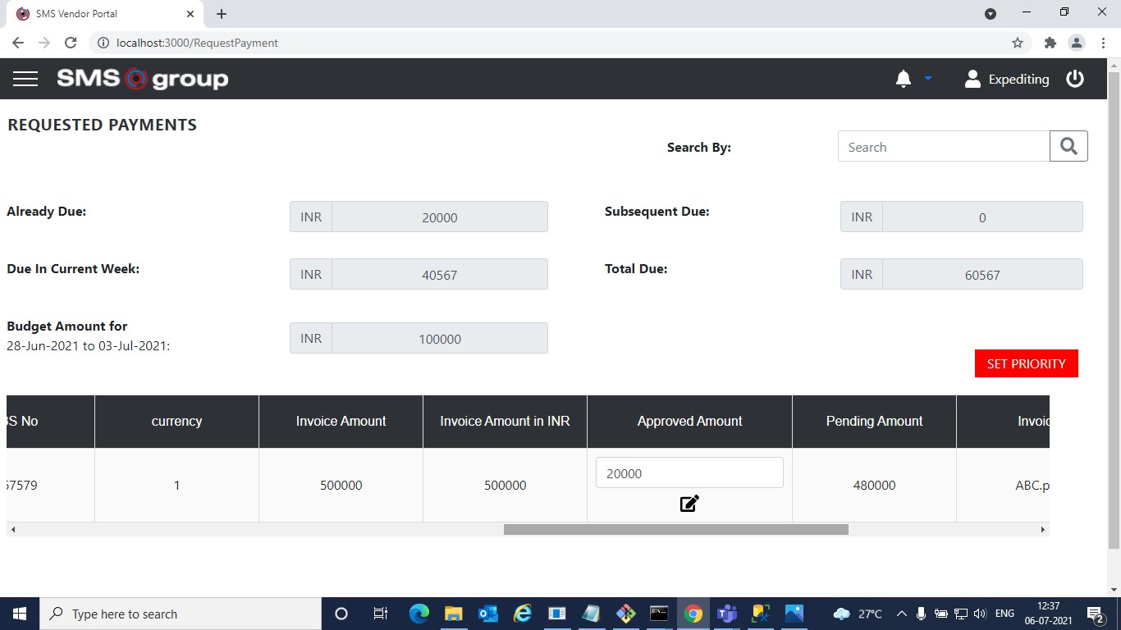

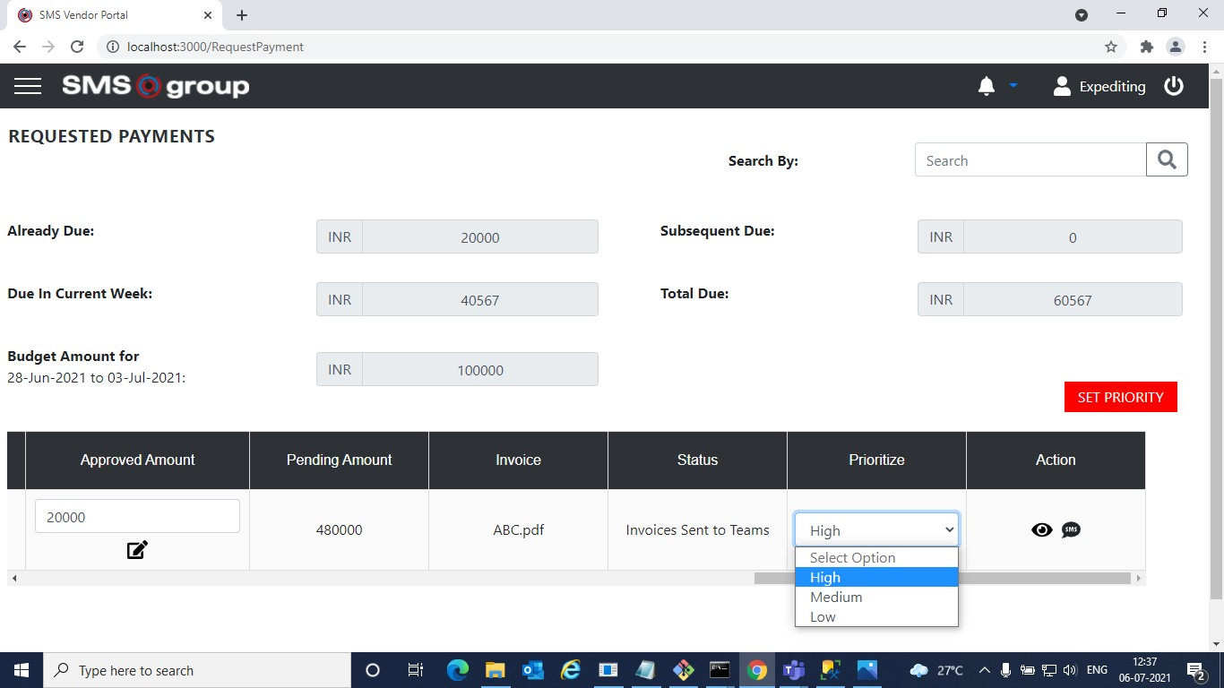

* SCM will login and split the budget approved by Finance HOD into Khurda and Gurgaon.
* SCM will be able to see all the payments requested along with amounts and Priorities set by the Teams. He can also change the approved amount and forward it to Treasury Team for Payment.

\*- fl lomlhosi:3000/SendorPymeni 





2021-06-28to 2024-07-03:



 1 Z



£ fl O lomlhosi:3000/SendorPymeni

I N R ^O567

100000



SUMl\*



Budget Amount for fihurda

83VE

I N R 60567

6000



IZ 47000Z^677

e



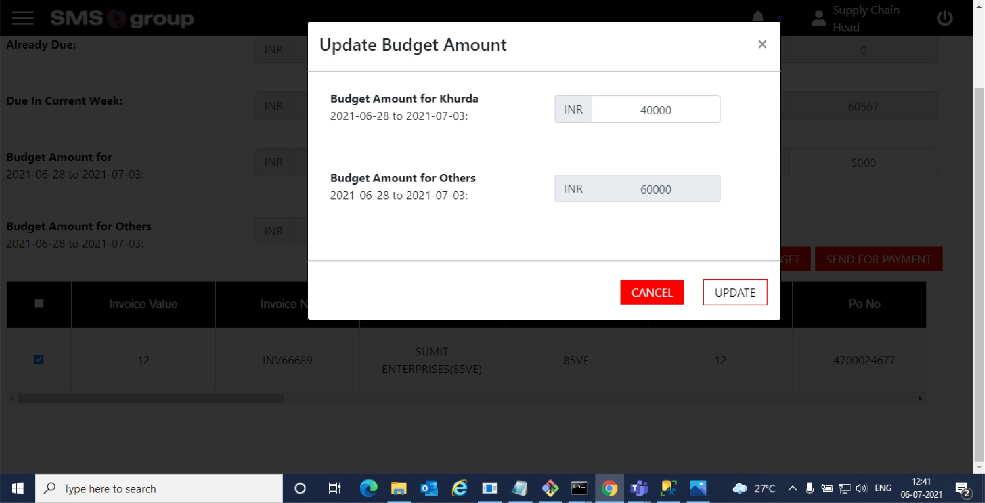

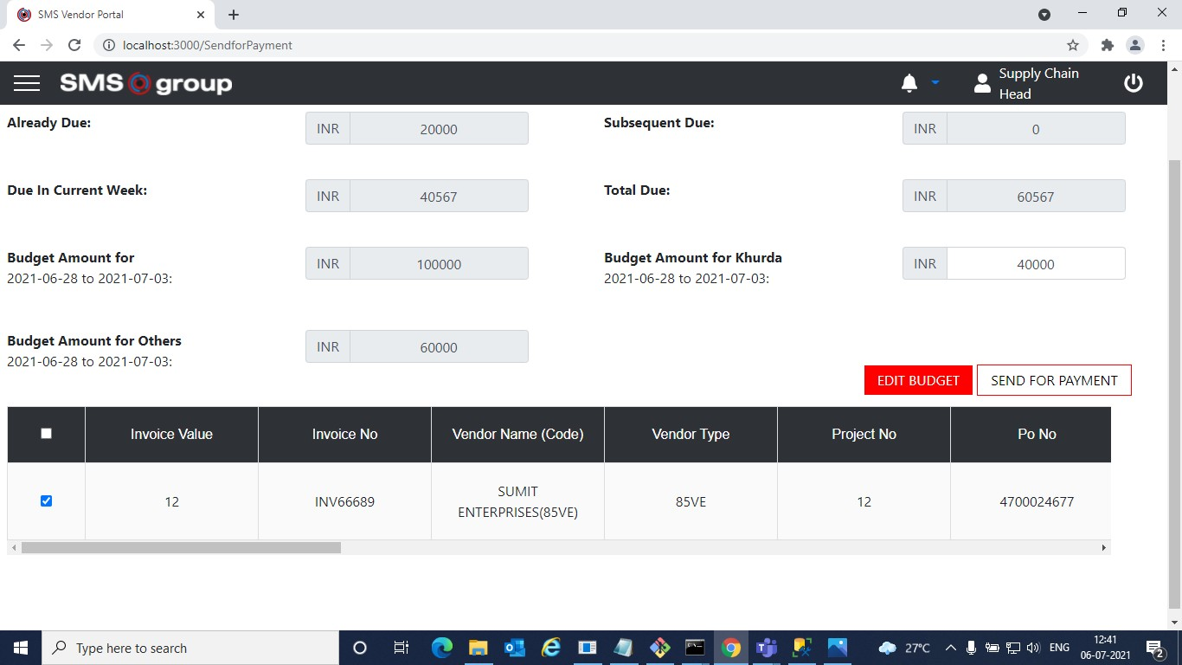

* Treasury Team will make the payment and upload UTR No, Payment Acknowledgement PDF and Payment Date. This will be notified to supplier.

