Lab 11

**Rules:**

* You are asked to implement **Triangle.java** as described below.
* Do not forget to take your work with you when you leave the lab by either copying your work files to your own USB flash disk, or by e-mailing them to yourself.

You are asked to implement the “**Triangle**” class that has the following UML class diagram, representing a right-angled isosceles triangle as shown below:

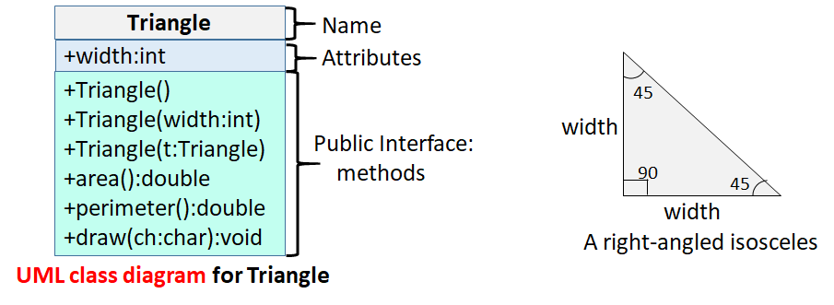

As you can see, the **Triangle** class has one attribute “**width**” with *public access*. It has 3 constructors:

1. A no-arguments constructor that must initialize the width to 1.
2. A parametrized constructor that takes in the user-supplied width and initializes the triangle with it.
3. A copy constructor that takes in a triangle object, and initializes the triangle’s width to that of the passed triangle.

Make sure that you use **constructor chaining** to implement these constructors.

**Triangle** class also has 3 public methods:

1. **area()**, which returns the area of the triangle computed as (width*width/2.0).
2. **perimeter()**, which returns the perimeter of the triangle. You can compute the size of the third side of the triangle, called the hypotenuse, using the following formula: hypotenuse = $\sqrt{(2*width*width)}$. To get the square root of a value, use Math.sqrt function from the Math class.
3. **draw()**, which draws the triangle on the screen using the given character.

To test your class, we are giving you a driver code (**Test.java**) that creates 3 triangles using different constructors and then uses them to test if things work correctly. Here is the expected output of your code when run against **Test.java**:

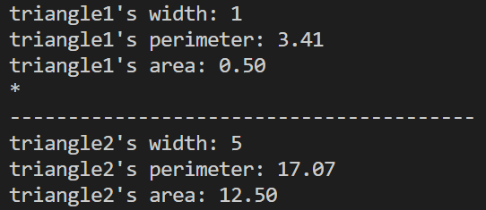

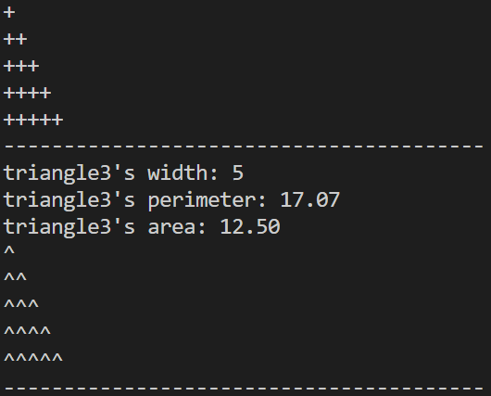

You are advised to implement your own test code. When grading, we may use a different Test. Make sure that your code works under all circumstances.

Lab Work Submission:

* You can continue to work on this lab after our lab class, on your own, at home.
* Submit your lab work via Blackboard on or before: **Wednesday, October 18, 2023, 11:59pm**.
* The only accepted submission method!
* Once you submit your assignment you will not be able to resubmit it!
* Make absolutely sure the Java files you want to submit are the Java files you want graded.
* You will not be able to submit your lab work under any circumstances once **Lab11** disappears at **12:00 a.m.** on **Thursday, October 19, 2023**.
* There will be **NO** exceptions to these rules!
* To submit your lab work, upload **Triangle.java** (**with .java extension**) you did for this lab to the **Lab11** assignment in the **Labs** tab in your Lab section’s presence in Blackboard.
* Then, make sure you click the **Submit** button to submit your lab work.
* This lab is worth **4 points**.