Lab 12 Work

**Rules:**

* You are asked to implement **Triangle.java** as described below.
* Do not forget to take your work with you when you leave the lab by either copying your work files to your own USB flash disk, or by e-mailing them to yourself.

You are asked to modify your “**Triangle**” class from Lab11 with *information (data) hiding* and *with additional methods* as follows:

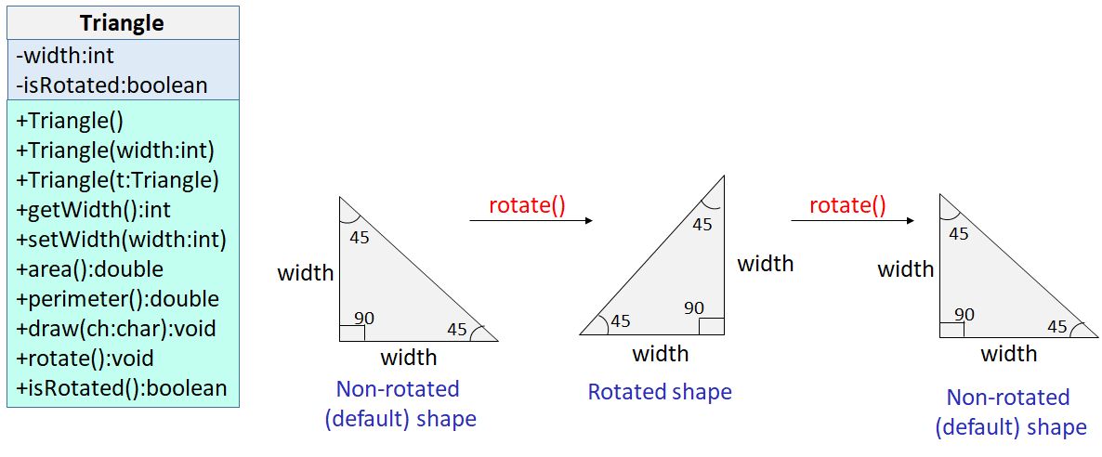

As you can see, the **Triangle** class now has two private attributes “width” and “isRotated”. It still has 3 constructors:

1. A no-arguments constructor that must initialize width to 1 and isRotated to false.
2. A parametrized constructor that takes in the user-supplied width and initializes the triangle with it. The width passed by the user must be greater than or equal to 1. If the user-supplied value is less than 1, then you must throw an IllegalArgumentException(), by the following statement: “throw new IllegalArgumentException()”.
3. A copy constructor that takes in a triangle object, and initializes the triangle’s width to that of the passed triangle.

Make sure that you use **constructor chaining** to implement these constructors. Initially, the triangle is NOT rotated; that is, it should be drawn like the first triangle in figure above (just like the triangle from Lab11). However, it can be rotated as shown above, which changes its orientation as explained below.

**Triangle** class now has 7 public methods:

1. **getWidth()**, which is the getter for width.
2. **setWidth()**, which is the setter for width. Make sure that you validate the width. The width passed by the user must be greater than or equal to 1. If the user-supplied value is less than 1, then you must throw an IllegalArgumentException(), by the following statement: “throw new IllegalArgumentException()”.
3. **isRotated()**, which is the getter for isRotated attribute.
4. **area()**, which returns the area of the triangle computed as (width*width/2.0).
5. **perimeter()**, which returns the perimeter of the triangle. You can compute the size of the third side of the triangle, called the hypotenuse, using the following formula: hypotenuse = $\sqrt{(2*width*width)}$. To get the square root of a value, use Math.sqrt function from the Math class.
6. **draw()**, which draws the triangle on the screen using the given character. This time, you have to pay attention to the current state of the triangle and draw it accordingly. Specifically, if the triangle is in the rotated state, then it should be drawn like the second triangle shown above.
7. **rotate(),** which flips the current state of the triangle. That is, if it is in the non-rotated (default) state, then it changes its state to “rotated”. If it is in the “rotated” state, then it changes the triangle’s state back to “non-rotated”. This is illustrated in the figure above. Basically, the default value of “isRotated” is false. Each time “**rotate()**” is called, it flips the value of “isRotated”.

To test your class, we are giving you a driver code (**Test.java**) that creates 3 triangles using different constructors and then uses them to test if things work correctly. Here is the expected output of your code when run against **Test.java**:

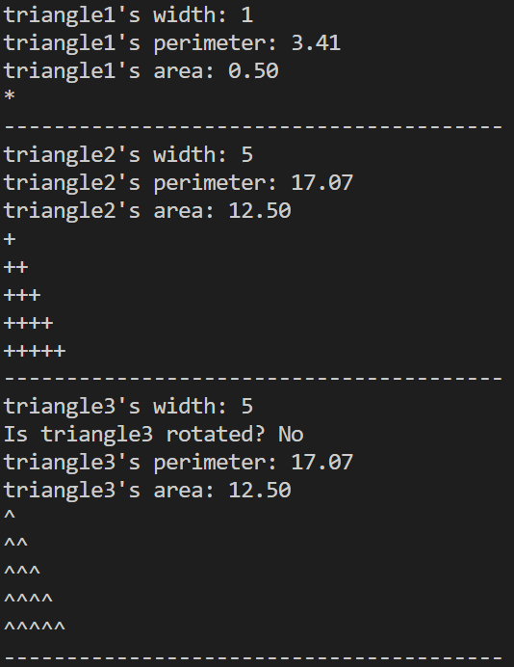

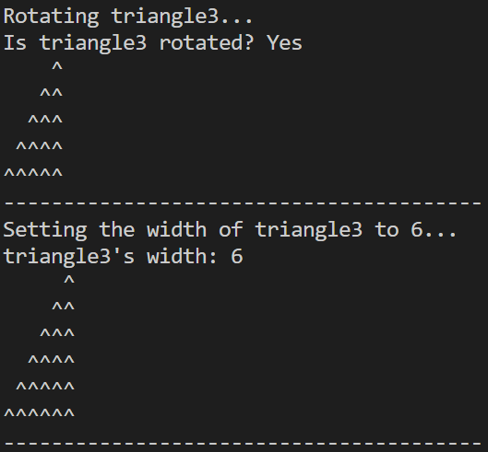

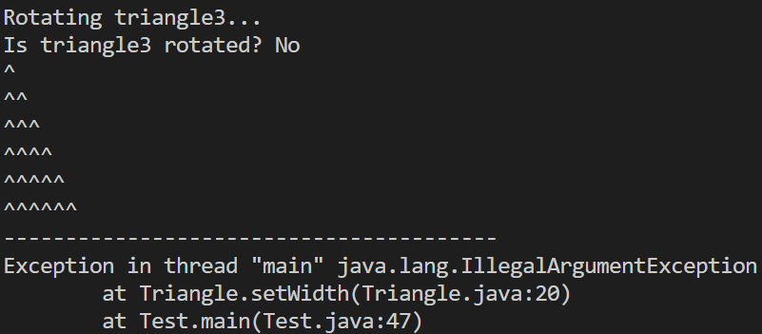

You are advised to implement your own test code. When grading, we may use a different Test. Make sure that your code works under all circumstances.

Lab Work Submission:

* You can continue to work on this lab after our lab class, on your own, at home.
* Submit your lab work via Blackboard on or before: **Wednesday, October 18, 2023, 11:59pm**.
* The only accepted submission method!
* Once you submit your assignment you will not be able to resubmit it!
* Make absolutely sure the Java files you want to submit are the Java files you want graded.
* You will not be able to submit your lab work under any circumstances once **Lab12** disappears at **12:00 a.m.** on **Thursday, October 19, 2023**.
* There will be **NO** exceptions to these rules!
* To submit your lab work, upload **Triangle.java** (**with .java extension**) you did for this lab to the **Lab12** assignment in the **Labs** tab in your Lab section’s presence in Blackboard.
* Then, make sure you click the **Submit** button to submit your lab work.
* This lab is worth **5 points**.