TASKFLOW
Local-First Personal Task Management
Portfolio Project Definition & Presentation Brief
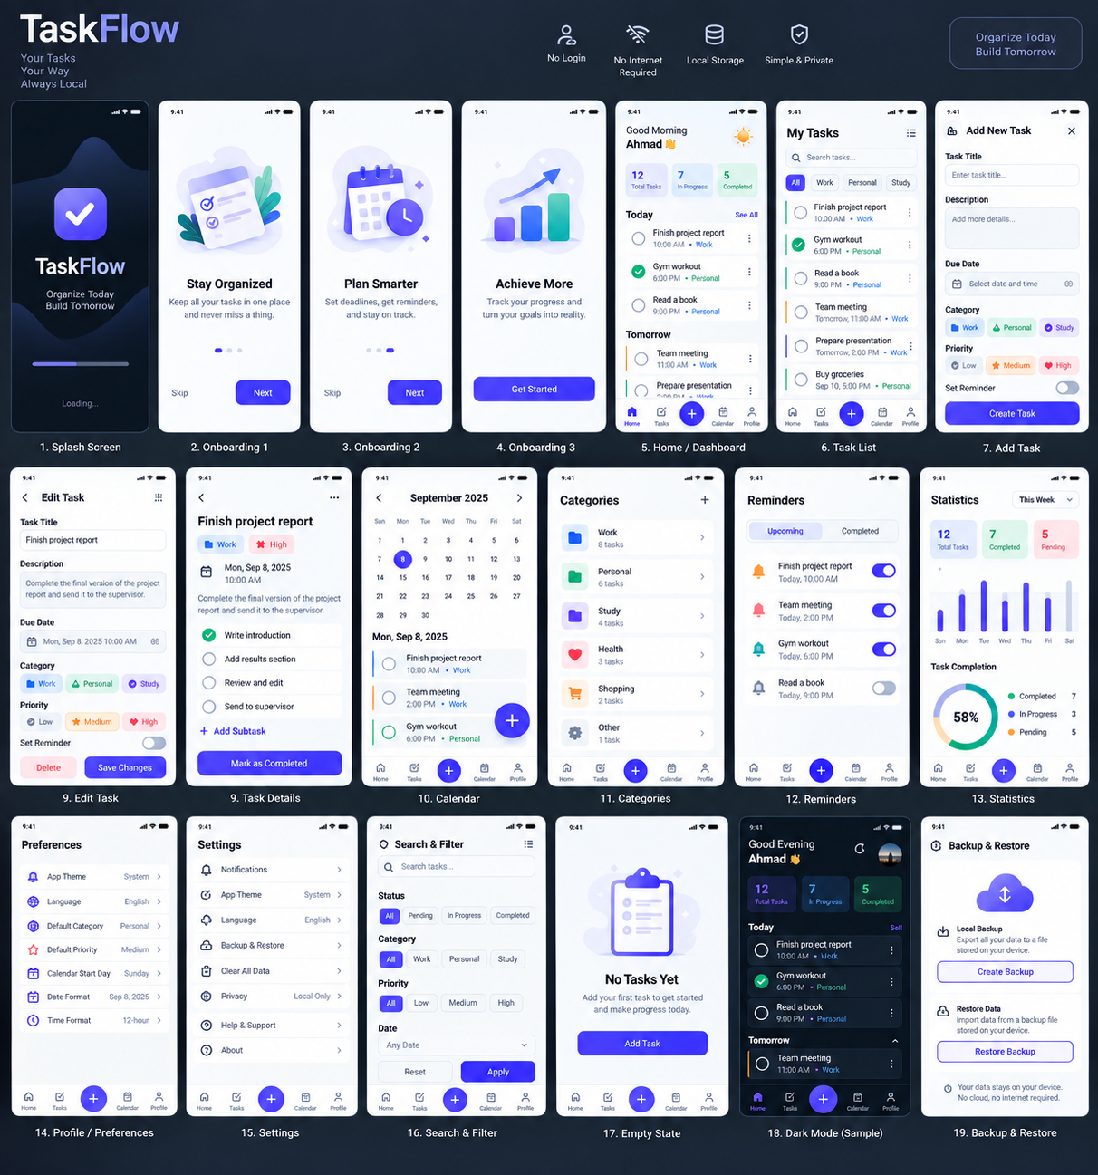
A private, offline-first productivity app for capturing, organizing, scheduling, completing, and reviewing tasks.

1. Purpose of This Document
This document defines TaskFlow as a portfolio project and gives the portfolio agent the project context needed to add it correctly to an existing portfolio website. It should be used together with the final TaskFlow UI reference image and the complete TaskFlow architecture specification.
The architecture specification defines the functional product scope and technical direction. The final UI image defines the visual identity and presentation direction. The portfolio agent should preserve the existing portfolio site's established project schema, layout, typography, metadata structure, and interaction patterns.

2. Project Identity
Property | TaskFlow
Project type | Mobile task-management application
Platform | Flutter mobile application
Language | Dart
Product model | Local-first / offline-first personal productivity app
Authentication | None
Backend | Not required for Version 1
Storage | Local database or local JSON storage
Primary goal | Capture, organize, schedule, complete, and review personal tasks
Design direction | Modern productivity UI with rounded cards, soft shadows, purple-blue accents, and light/dark themes

3. Project Overview
TaskFlow is a polished personal task-management application built around a local-first philosophy. The user installs the app on a phone and can immediately use it without creating an account. Tasks, categories, reminders, preferences, statistics, and backup data are handled locally.
The product focuses on five core activities: capturing a new task, organizing tasks by category/priority/status, scheduling tasks with dates and reminders, completing tasks, and reviewing productivity through statistics.

4. Product Principles
- Local-first: core task data is stored on the device.
- No authentication: there is no login, sign-up, email/password, social account, or logout flow.
- Offline by default: normal task-management features do not require internet access.
- Fast capture: task creation focuses on the minimum information needed.
- Clear hierarchy: today, upcoming, completed, categories, and priorities are easy to distinguish.
- Safe actions: destructive actions use confirmation or undo where appropriate.
- Accessible UI: readable text, adequate contrast, and large touch targets.
- Consistent design: shared colors, typography, spacing, icons, cards, chips, and controls.

5. Startup & User Flow
- Launch the application.
- Show the Splash screen while local services and stored data initialize.
- Load local preferences, categories, and tasks.
- Check whether onboarding has already been completed.
- Show onboarding only on the first launch when enabled.
- Enter the Home Dashboard.
- Review today's and upcoming tasks.
- Create or edit a task.
- Assign category, priority, date, and optional reminder.
- Complete tasks and review updated progress in Statistics.
If onboarding has already been completed, the user goes directly from Splash to Home.

6. Main Navigation
- Home — dashboard and daily overview.
- Tasks — complete task list, search, filters, and sorting.
- Add — emphasized primary action for creating a task.
- Calendar — date-based task planning.
- Profile — local preferences, settings, and local data tools.

7. Complete Screen Inventory
Screen | Purpose
Splash | Brand introduction and local initialization.
Onboarding: Stay Organized | Explains keeping tasks in one place.
Onboarding: Plan Smarter | Explains due dates, reminders, and calendar planning.
Onboarding: Achieve More | Explains progress tracking and statistics.
Home / Dashboard | Greeting, summary cards, today/upcoming tasks, productivity insight, and navigation.
Task List | Searchable, filterable, sortable tasks grouped by date/status.
Add New Task | Task title, description, due date/time, category, priority, reminder, and subtasks.
Edit Task | The Add Task form reused with existing data prefilled.
Task Details | Full task information, subtasks, reminders, and task actions.
Calendar | Month grid plus tasks for the selected date.
Categories | Default and custom task categories with icons/colors and task counts.
Reminders | Upcoming local reminders with enable/disable controls.
Statistics | Time-range summaries, completion chart, completion rate, category distribution, and insight.
Profile / Preferences | Local display name/avatar and preferences; not an online account.
Settings | Appearance, notifications, data tools, general preferences, privacy/about.
Search & Filter | Local search and filters for status, category, priority, date, and completion state.
Empty States | Friendly empty experiences with one clear action.
Dark Mode | Full dark-theme version of the application.
Backup & Restore | Local JSON export/import with validation and safe error handling.

8. Task Management Features
- Create, edit, delete, complete, and reopen tasks.
- Optional description, notes, tags, and subtasks.
- Due date and due time.
- Categories: Work, Personal, Study, Health, Shopping, Other, plus custom categories.
- Priority: Low, Medium, High.
- Status: Pending, In Progress, Completed.
- Local reminders.
- Subtask checklist and ordering.
- Search, filtering, and sorting.
- Calendar-based planning.

9. Task Details & Completion
Task Details exposes the task title, category, priority, description, due date/time, reminder, subtasks, and completion action. The user can edit, delete, reopen, change category/priority/reminder, or manage subtasks.
- When completed, status becomes completed.
- completedAt is recorded.
- Future reminders are cancelled.
- Dashboard counters update.
- Statistics update.
- The task remains in history.

10. Calendar, Search & Filters
- Calendar dates with tasks show indicators.
- Selecting a date filters tasks for that date.
- Task selection opens Task Details.
- Search is entirely local.
- Filters include status, category, priority, due date, and completion state.
- Sorting includes due date, creation date, priority, and alphabetical order.
- Filter state should be preserved when returning from task details where practical.

11. Reminders & Notifications
TaskFlow uses the platform's local notification mechanism. No server is required. A disabled reminder remains stored but is not scheduled. Completing a task cancels future reminders.

12. Statistics
- Time ranges: Today, This Week, This Month.
- Summary: Total, Completed, Pending.
- Completion chart.
- Completion percentage.
- Category distribution.
- Productivity insight.
- Completion rate = completed tasks / total tasks × 100.
- Daily completion count is derived from completed tasks per day.

13. Profile & Settings
Profile is a local preferences area, not an account page. It may contain a local avatar/initials, an optional display name, notifications, theme, language, help/support, about, and local data tools.
Settings includes:
- Appearance: System / Light / Dark, accent color, task density.
- Notifications: enable notifications, default reminder behavior, optional quiet hours.
- Data: export, import, clear completed tasks, reset all data.
- General: start of week, language, about, privacy statement.
No email, account ID, login, sign-up, cloud account, or social authentication controls are part of the documented Version 1 product.

14. Backup & Restore
The application supports a versioned local JSON backup containing exportedAt metadata, tasks, categories, and preferences. Import validates the version and safely rejects malformed data. Backup and restore do not upload user data to a server.

15. Visual Design System
- Modern productivity application.
- Rounded cards and controls.
- Soft shadows.
- White and very light cool-gray surfaces.
- Deep navy text.
- Purple / indigo primary accent.
- Green for completed states.
- Orange for medium priority.
- Red/pink for high priority.
- Generous spacing using a consistent 4/8/12/16/20/24/32 scale.
- Clean sans-serif typography.
- Light and dark themes.

16. Technical Architecture
The documented architecture is layered and feature-oriented. Presentation contains screens, widgets, navigation, theme, and state management. The Application layer contains use cases, controllers/notifiers, validation, and business rules. The Domain layer contains entities and repository contracts. The Data layer contains local persistence, repository implementations, JSON backup/restore, and data mappers.
- Feature areas: splash, onboarding, dashboard, tasks, calendar, categories, reminders, statistics, profile, settings.
- Core services include local storage, notifications, and backup.
- Recommended local storage options in the source architecture include Isar, Drift/SQLite, and Hive.
- The final implementation should use the actual state-management and persistence technologies present in the project rather than inventing technologies for portfolio copy.

17. Data Model
- Task: id, title, description, categoryId, priority, status, dueDate, reminderDate, createdAt, updatedAt, completedAt, subtasks, tags, notes.
- Subtask: id, title, isCompleted, order.
- Category: id, name, color, icon, createdAt.
- Reminder: id, taskId, scheduledAt, isEnabled.
- Preferences: onboarding completion, theme mode, language, start of week, notification setting, default priority.

18. Empty, Loading & Error Experiences
- Loading: skeleton cards or a small progress indicator with stable layout.
- Empty: friendly illustration, short explanation, and one clear action.
- Error: human-readable message and Retry action while preserving loaded data when possible.
- Offline: normal operation should not produce an internet-error experience because the app is local-first.

19. Portfolio Positioning
TaskFlow should be presented as a complete mobile product concept and implementation project rather than as a collection of isolated UI screens. The project demonstrates product thinking, mobile UI/UX, local data architecture, task-domain modeling, state management, calendar workflows, local reminders, analytics, theme systems, backup/restore, validation, and testing.
- End-to-end task lifecycle.
- Reusable Flutter UI system.
- Offline-first architecture.
- Local privacy by design.
- Search, filtering, sorting, and calendar planning.
- Local reminders.
- Productivity analytics.
- Light/dark theme support.
- Local backup and restore.
- Structured architecture and testing strategy.

20. Recommended Portfolio Copy

Short Card Description
TaskFlow — A modern local-first task management app built with Flutter, designed to help users capture, organize, schedule, complete, and review tasks while keeping their data private and on-device.

Detailed Project Description
TaskFlow is a local-first personal productivity application designed around a simple idea: task management should be fast, clear, and private. Built for mobile with Flutter, the app lets users create and organize tasks, assign priorities and categories, schedule due dates and local reminders, manage subtasks, track completion, review productivity statistics, customize the experience, and back up their local data. The product requires no account and no cloud service for its core workflow, giving the user a focused offline-first experience.

21. Accuracy Rules for the Portfolio Agent
- Do not add Login or Sign Up to the final project presentation.
- Do not describe Profile as an online account.
- Do not claim cloud synchronization.
- Do not claim multi-user collaboration.
- Do not invent clients, users, revenue, downloads, performance metrics, or production results.
- Do not claim a feature is implemented unless it is actually present in the project.
- Use the final TaskFlow UI image as the visual reference.
- Use the architecture specification as the functional source of truth.
- Adapt the content to the existing portfolio site's project structure instead of creating an unrelated page format.

22. Final Agent Instruction
Add TaskFlow to the existing portfolio using the portfolio's current project schema, components, styling, and conventions. Use this document to populate project title, category, description, feature highlights, technology information, architecture details, and project-detail content. Use the supplied UI image as the primary project visual. Keep the presentation polished and concise on project cards, while allowing the detail page to communicate the deeper product story. Preserve factual accuracy: TaskFlow is a local, offline-first personal task manager with no authentication or cloud dependency in its documented Version 1 scope.

