Reversi Game Design Document
Project 2 for CSCE 315
This Reversi console game will allow users to login via telnet to a game server and play unlimited reversi games with a friend or against an AI.
Laramie Goode, Chris Voss, Curtis Franks
6/15/2012

Table of Contents
Purpose of Project 2
High Level Entities 3
Simple Game Mechanics 3
Artificial Intelligence 3
Implementing into a Server 3
Low Level Entities 4
Game 4
Server 6
Game Mechanics with AI 8
Reversi Client 8
Works Cited 10

Purpose of Project
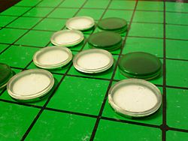
This project is an implementation of the game Reversi. The game is a strategic board game played with two players. Each player takes turns trying to capture the other player's pieces by forming a straight line from a starting piece of their color to an ending piece of their color. If this starting piece and ending piece form a line that contains the opposing player’s pieces, those opposing pieces are converted to the same color as the starting and ending piece of the line. The game ends when all the spots on the board are filled or when there are no more moves to be made. The only valid moves are one where a piece placed is adjacent to another piece and it forms a straight line either vertically, horizontally, or diagonally. The player with the most pieces by the end of the game is declared the winner.
With this project we will create a UNIX console Reversi game mechanism that allows for two people to play against each other or to utilize a player2 AI that will run off of the game server. The user will connect to the game server via an ip address and port and have command line access to begin a game.

High Level Entities
The project is divided into three parts. The first part will be the game mechanics and will consist of two players taking turns making moves on the same machine. The next part will implement an AI so one player plays against the AI. The third part will implement the AI into a server program. A player will connect to the server via telnet and issue commands to the server which the server will handle appropriately.

Simple Game Mechanics
The game will draw the board to the console with ASCII to represent the board and pieces. The game will have a board class which will have a matrix (array of arrays) of a class called Position. Position will have an enum type to represent whether or not the spot is empty, filled with a white piece, or with a black piece. Position will also hold the location of itself. A function will be used to determine whether or not a move is a valid move for the player.

Artificial Intelligence
The game will have three levels of difficulty when playing against the AI. The Easy level of difficulty will have the AI pick random spots to place its piece of the board. The Medium level of difficulty has the AI look ahead one move to determine the best move for the future. The Hard difficulty will have the AI look ahead two moves to determine the best move for the future. To achieve this, a MinMax or Alpha-Beta search will be implemented. These searches will determine the possible move outcomes and find the best one.

Implementing into a Server
The game mechanics along with the AI will be put into a server along with the game loop. The server will have a simple parser to check for commands by the player. To connect to the server, the player will use Telnet with the hostname and port number as the arguments. Once connected, the player will receive messages from the server. To achieve this, the server will create a socket for the client. Once a client has connected to the server the server will loop receiving commands. When the start game command is issued, the game loop will begin and not exit until another command such as exit or quit is issued.

Low Level Entities

Game

Each row will be named 1, 2, 3, ..., 8. Each column will be named a, b, c, ... , h. Initial configuration of the board is:
- d4 white
- e4 black
- d5 black
- e5 white
'O' indicates white and '@' indicates black.
a b c d e f g h
+-+-+-+-+-+-+-+-+
1| | | | | | | | |
+-+-+-+-+-+-+-+-+
2| | | | | | | | |
+-+-+-+-+-+-+-+-+
3| | | | | | | | |
+-+-+-+-+-+-+-+-+
4| | | |O|@| | | |
+-+-+-+-+-+-+-+-+
5| | | |@|O| | | |
+-+-+-+-+-+-+-+-+
6| | | | | | | | |
+-+-+-+-+-+-+-+-+
7| | | | | | | | |
+-+-+-+-+-+-+-+-+
8| | | | | | | | |
+-+-+-+-+-+-+-+-+
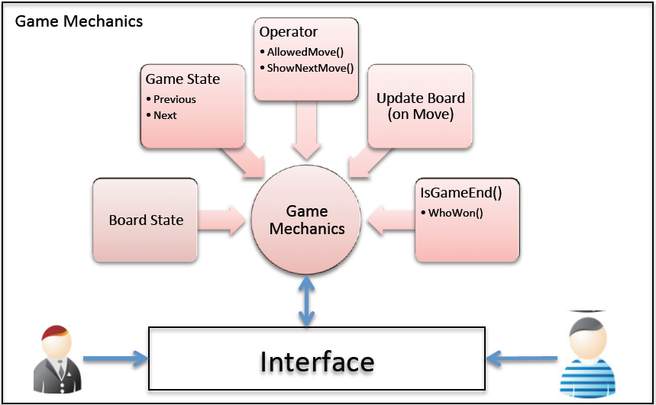
The server will by default play the AI-side and the client will be the human.
This Picture is directly from the project design outline. http://students.cse.tamu.edu/aalap/CSCE315_s12/slides/Project2_Design.pdf
The communication will be through simple ASCII text. The commands are pretty simple.
expr | ::= command | move | comment
command | ::= EXIT | DISPLAY_ON | DISPLAY_OFF | EASY | MEDIUM | HARD  | BLACK | WHITE | UNDO | REDO | SHOW_NEXT_POS
move | ::= column row
comment | ::= ; *
identifier | ::= alpha { ( alpha | digit ) }
alpha | ::= a | ... | z | A | ... | Z | _
digit | ::= 0 | 1 | 2 | 3 | 4 | 5 | 6 | 7 | 8 | 9
row | ::= 1 | 2 | 3 | 4 | 5 | 6 | 7 | 8
column | ::= a | b | c | d | e | f | g | h
The commands are self-explanatory, except that SHOW_NEXT_POS will show the human player what are the available legal positions.

Server
The server will show these messages to the user:
ack | ::= WELCOME | OK | ILLEGAL | BLACK | WHITE | comment
comment | ::= ; *
An unused port should be used for the server. The entire interface should be accessible using telnet, using plain ASCII text. You have to be extra cautious with your code since your server can easily become a security hole. Before you print anything that came from the client or the server, you have to first check if these are printable characters, and make sure the length of the input is within your input buffer size.
An example is shown below. Bold is server, italic is client). Text following ";" are comments and they are simply displayed as they are received and no further action is taken (comments on the far right column are mine, just to explain it a bit). "_" at the end is the cursor waiting for the user input.

WELCOME
WHITE ; choose side
WHITE ; confirms user's choice
EASY ; set up AI difficulty
OK
DISPLAY_ON
OK
; a b c d e f g h ; the board display is sent by the server
; +-+-+-+-+-+-+-+-+
;1| | | | | | | | |
; +-+-+-+-+-+-+-+-+
;2| | | | | | | | |
; +-+-+-+-+-+-+-+-+
;3| | | | | | | | |
; +-+-+-+-+-+-+-+-+
;4| | | |O|@| | | |
; +-+-+-+-+-+-+-+-+
;5| | | |@|O| | | |
; +-+-+-+-+-+-+-+-+
;6| | | | | | | | |
; +-+-+-+-+-+-+-+-+
;7| | | | | | | | |
; +-+-+-+-+-+-+-+-+
;8| | | | | | | | |
; +-+-+-+-+-+-+-+-+
e3
OK
; a b c d e f g h
; +-+-+-+-+-+-+-+-+
;1| | | | | | | | |
; +-+-+-+-+-+-+-+-+
;2| | | | | | | | |
; +-+-+-+-+-+-+-+-+
;3| | | | |O| | | |
; +-+-+-+-+-+-+-+-+
;4| | | |O|O| | | |
; +-+-+-+-+-+-+-+-+
;5| | | |@|O| | | |
; +-+-+-+-+-+-+-+-+
;6| | | | | | | | |
; +-+-+-+-+-+-+-+-+
;7| | | | | | | | |
; +-+-+-+-+-+-+-+-+
;8| | | | | | | | |
; +-+-+-+-+-+-+-+-+
f3 ; server tells you which move it made
; a b c d e f g h
; +-+-+-+-+-+-+-+-+
;1| | | | | | | | |
; +-+-+-+-+-+-+-+-+
;2| | | | | | | | |
; +-+-+-+-+-+-+-+-+
;3| | | | |O|@| | |
; +-+-+-+-+-+-+-+-+
;4| | | |O|@| | | |
; +-+-+-+-+-+-+-+-+
;5| | | |@|O| | | |
; +-+-+-+-+-+-+-+-+
;6| | | | | | | | |
; +-+-+-+-+-+-+-+-+
;7| | | | | | | | |
; +-+-+-+-+-+-+-+-+
;8| | | | | | | | |
; +-+-+-+-+-+-+-+-+
g1
ILLEGAL
; a b c d e f g h
; +-+-+-+-+-+-+-+-+
;1| | | | | | | | |
; +-+-+-+-+-+-+-+-+
;2| | | | | | | | |
; +-+-+-+-+-+-+-+-+
;3| | | | |O|@| | |
; +-+-+-+-+-+-+-+-+
;4| | | |O|O| | | |
; +-+-+-+-+-+-+-+-+
;5| | | |@|O| | | |
; +-+-+-+-+-+-+-+-+
;6| | | | | | | | |
; +-+-+-+-+-+-+-+-+
;7| | | | | | | | |
; +-+-+-+-+-+-+-+-+
;8| | | | | | | | |
; +-+-+-+-+-+-+-+-+
_

Game Mechanics with AI
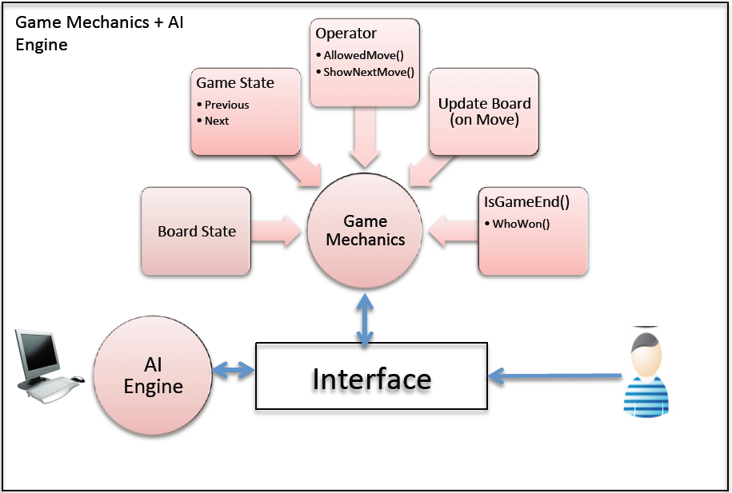
This Picture is directly from the project design outline. http://students.cse.tamu.edu/aalap/CSCE315_s12/slides/Project2_Design.pdf

Reversi Client
The telnet command will be used as the client, so there's no need to write the client.
telnet <hostname> <port>
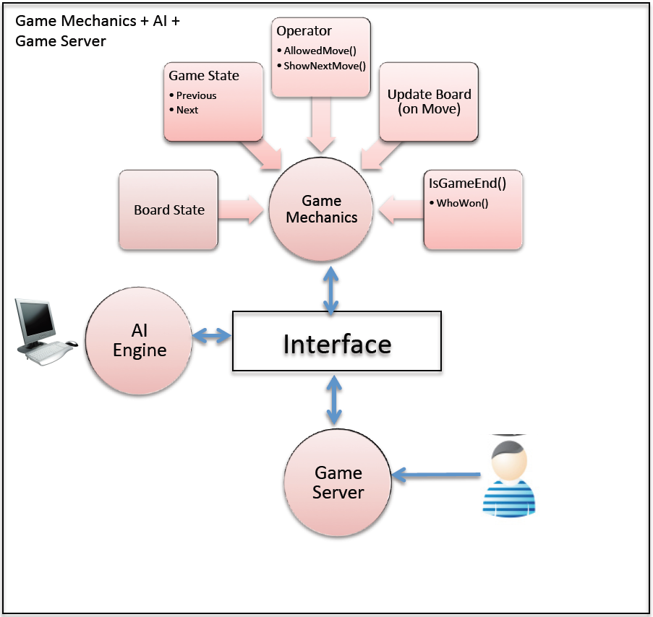
This Picture is directly from the project design outline. http://students.cse.tamu.edu/aalap/CSCE315_s12/slides/Project2_Design.pdf

Works Cited
TAMU CSCE Faculty. (2012, May 31). CSCE 315. Retrieved June 2012, 2012, from TAMU: http://students.cse.tamu.edu/aalap/CSCE315_s12/slides/Project2_Design.pdf

