
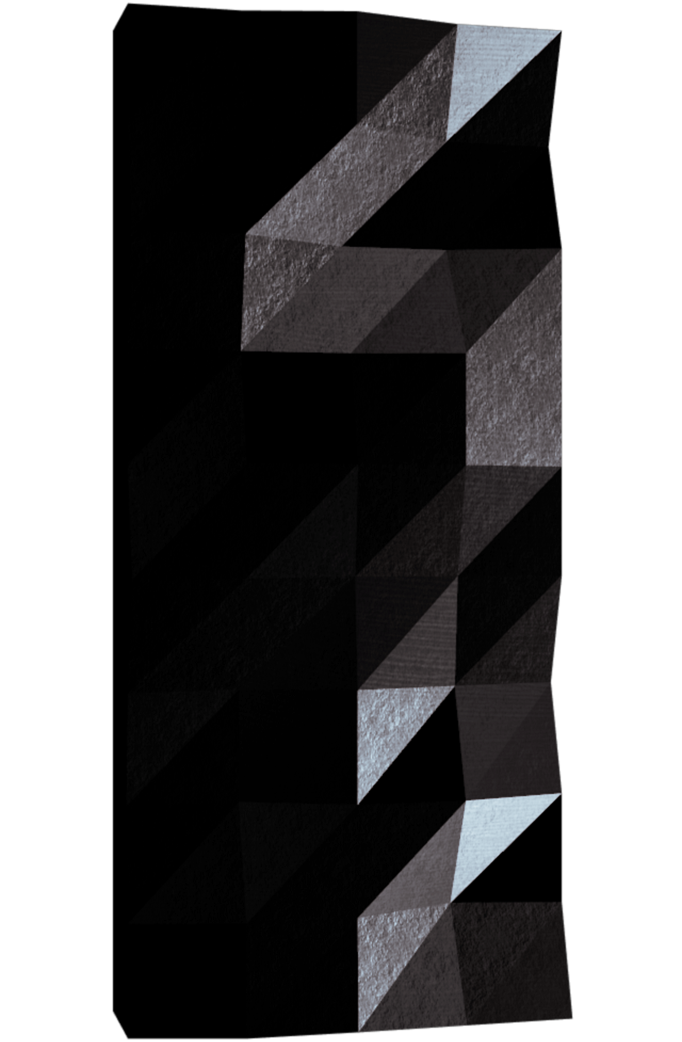

Fly-in
Drones are interesting.

Summary: Design an efficient drone routing system that navigates multiple drones through connected zones while minimizing simulation turns and handling movement constraints.
Version: 1.6

Contents
- Foreword 2
- AI Instructions 3
- Common Instructions 5
  - General Rules . . . . . . . . . . . . . . . . . . . . . . . . . . . . . . . 5
  - Makefile . . . . . . . . . . . . . . . . . . . . . . . . . . . . . . . . . . 5
  - Additional Guidelines . . . . . . . . . . . . . . . . . . . . . . . . . . . 6
- Introduction 7
- Constraints 8
- Let the drone fly 9
- Mandatory Part 11
  - Pathfinding and Algorithm Requirements 11
  - Zone Occupancy Rules 12
  - Movement and Turn Mechanics 12
  - Parser Constraints 13
  - Simulation Output Format 15
  - Scoring System 15
  - Performance Benchmarks 17
- Readme Requirements 20
- Bonus Part 21
- Submission and peer-review 22

1

Chapter I Foreword
Drones have been used to herd sheep in New Zealand, replacing sheepdogs with buzzing aerial shepherds. In Japan, office buildings deploy drones that play loud music and flash lights to literally chase overworked employees home. One drone was trained to paint graffiti on walls mid-flight — a rebellious blend of tech and street art. In Sweden, sci-entists used drones to sniff out whale poop floating on the ocean to study endangered species. Some experimental drones are shaped like birds or insects to spy without being noticed, flapping wings and all. There’s even a drone that flies by flapping soap bubbles, no propellers involved. In volcano research, a drone once flew straight into an eruption cloud, melted mid-air, but managed to send back data just seconds before disintegration. And in South Korea, synchronized drone shows have replaced fireworks — safer, silent, and somehow even more magical.
The phrase comes from the idea that the wheel is a brilliant invention that’s been around forever and works really well. Since there’s nothing wrong with it, trying to invent it again wouldn’t really help and could be a waste of time—especially when that time could be spent solving new problems instead.

In programming, this happens when someone builds something from scratch that already exists — like writing your own sorting algorithm or framework when solid, open-source versions are already out there. But it’s not all bad: doing it yourself can be a great way to learn how things work under the hood. The key is to find a balance — don’t rebuild everything, but take time to explore how the tools you’re using actually work. That way, you’ll grow as a developer without getting stuck reinventing the same old wheels.

Chapter III
Common Instructions

General Rules
    - Your project must be written in Python 3.10 or later.
    - Your project must adhere to the flake8 coding standard.
    - Your functions should handle exceptions gracefully to avoid crashes. Use try-except blocks to manage potential errors. Prefer context managers for resources like files or connections to ensure automatic cleanup. If your program crashes due to unhandled exceptions during the review, it will be considered non-functional.
    - All resources (e.g., file handles, network connections) must be properly managed to prevent leaks. Use context managers where possible for automatic handling.
    - Your code must include type hints for function parameters, return types, and vari-ables where applicable (using the typing module). Use mypy for static type check-ing. All functions must pass mypy without errors.
    - Include docstrings in functions and classes following PEP 257 (e.g., Google or NumPy style) to document purpose, parameters, and returns.

Makefile
Include a Makefile in your project to automate common tasks. It must contain the following rules (mandatory lint implies the specified flags; it is strongly recommended to try –strict for enhanced checking):
    - install: Install project dependencies using pip, uv, pipx, or any other package manager of your choice.
    - run: Execute the main script of your project (e.g., via Python interpreter).
    - debug: Run the main script in debug mode using Python’s built-in debugger (e.g., pdb).
    - clean: Remove temporary files or caches (e.g., pycache , .mypy_cache) to keep the project environment clean.

5
Fly-in Drones are interesting.

    - lint: Execute the commands flake8 . and mypy . --warn-return-any
--warn-unused-ignores --ignore-missing-imports --disallow-untyped-defs
--check-untyped-defs
    - lint-strict (optional): Execute the commands flake8 . and mypy . --strict

Additional Guidelines
    - Create test programs to verify project functionality (not submitted or graded). Use frameworks like pytest or unittest for unit tests, covering edge cases.
    - Include a .gitignore file to exclude Python artifacts.
    - It is recommended to use virtual environments (e.g., venv or conda) for dependency isolation during development.

If any additional project-specific requirements apply, they will be stated immediately below this section.

6

Chapter IV Introduction
Autonomous drones are the future of transportation. They are already used in many industries, such as agriculture, construction, and logistics. They are also used in military operations, such as surveillance and reconnaissance.

Your task is to design a system that efficiently routes a fleet of drones from a central base (start) to a target location (end), while navigating this dynamic network under a set of strict constraints and optimization goals.

You’ll be given a graph representing the network of zones, and a set of constraints
that you must respect.

The graph is represented as a network of connected zones, where connections define pos-sible movement paths between zones.

7

Chapter V Constraints
    - Any library that helps with graph logic is forbidden (such as networkx, graphlib, etc.).
    - The project must be completely typesafe. Using flake8 and mypy is mandatory.
    - The project must be completely object-oriented.
This will have to be demonstrated during the peer review.

8

Chapter VI
Let the drone fly

Attached to this subject, you’ll find multiple files that represent the network of zones in the following format:
Example:
nb_drones: 5

start_hub: hub 0 0 [color=green]
end_hub: goal 10 10 [color=yellow]
hub: roof1 3 4 [zone=restricted color=red]
hub: roof2 6 2 [zone=normal color=blue]
hub: corridorA 4 3 [zone=priority color=green max_drones=2] hub: tunnelB 7 4 [zone=normal color=red]
hub: obstacleX 5 5 [zone=blocked color=gray] connection: hub-roof1
connection: hub-corridorA connection: roof1-roof2 connection: roof2-goal
connection: corridorA-tunnelB [max_link_capacity=2] connection: tunnelB-goal
Interesting, right? To be more precise:
    - The first line defines the number of drones using nb_drones: <number>.
    - Zone definition on each line using type prefixes:
      - start_hub: <name> <x> <y> [metadata] marks the starting zone.
      - end_hub: <name> <x> <y> [metadata] marks the end zone.
      - hub: <name> <x> <y> [metadata] defines a regular zone.
      - The connection syntax forbids dashes in zone names (see below).
    - All metadata is optional and enclosed in brackets [...] with default values:
      - zone=<type> (default: normal)
      - color=<value> (default: none)
      - max_drones=<number> (default: 1) - Maximum drones that can occupy this zone simultaneously
      - Tags inside brackets can appear in any order.
    - Zone types:

9
Fly-in Drones are interesting.

      - normal – Standard zone with 1 turn movement cost (default)
      - blocked – Inaccessible zone. Drones must not enter or pass through this zone. Any path using it is invalid.
      - restricted – A sensitive or dangerous zone. Movement to this zone costs 2 turns.
      - priority – A preferred zone. Movement to this zone costs 1 turn but should be prioritized in pathfinding.
    - Colors:
      - Colors are optional and can be used for visual representation (terminal output or graphical display).
      - Accepted values for color are any valid single-word strings (e.g., red, blue, gray). There is no fixed list of allowed colors.
      - When colors are specified, the implementation should provide visual feedback through colored terminal output or graphical representation.
    - Connections are defined using connection: <name1>-<name2> [metadata]:
      - Define a bidirectional connection (edge) between two zones.
      - The connection syntax forbids dashes in zone names.
      - Optional metadata can be specified in brackets [...]:
∗ max_link_capacity=<number> (default: 1) - Maximum drones that can traverse this connection simultaneously
    - Comments start with ’#’ and are ignored.




The zones coordinates will always be integers, and there will always be a unique start and a unique end zone.

10

Chapter VII Mandatory Part
As you may have guessed, the main objective is to move all drones from the start zone to the end zone in the fewest possible simulation turns.

Pathfinding and Algorithm Requirements
    - Drones may move simultaneously. The algorithm must schedule paths to maximize throughput and avoid unnecessary delays.
    - Your implementation must handle:
      - Distribution of drones across multiple paths.
      - Strategic waiting when movement is not possible.
      - Avoidance of path conflicts and deadlocks.
    - The algorithm must take into account:
      - Path lengths, including movement costs associated with zone types (e.g., re-stricted or priority).
      - Turn scheduling, to prevent drones from colliding or blocking each other.
      - Graph structure, to determine available disjoint or overlapping paths.
      - Zone capacity constraints (max_drones) and connection capacity (max_link_capacity).
    - Your algorithm should be adaptable: different maps may require different routing strategies, depending on the topology and zone types.
    - Visual Representation: Your implementation must provide visual feedback of the simulation, either through:
      - Colored terminal output showing drone movements and zone states
      - A graphical interface displaying the network and drone positions
      - Both options for enhanced user experience

11

Fly-in Drones are interesting.
- How efficient is your algorithm?
- Can it work with a large number of drones?
- What is the complexity (e.g., O(n), O(log n), etc.)?
- Are you recalculating or caching paths?
- How does it impact memory usage?
- How does your visual representation enhance understanding of the simulation?

Zone Occupancy Rules
    - By default, a zone may contain at most one drone at any given simulation turn.
    - Zones with max_drones=N metadata can contain up to N drones simultaneously.
    - The only special exceptions to occupancy rules are:
      - The start zone: all drones begin here and may share the space initially.
      - The end zone: multiple drones can arrive here and are considered delivered.
    - Two drones may not enter the same zone on the same turn unless the zone’s capacity allows it.
    - A drone may not move into a zone that would exceed its maximum capacity.
    - Connection capacity (max_link_capacity) defined on connections limits how many drones can traverse the same connection simultaneously.
    - Drones may move simultaneously, as long as all capacity constraints are respected.

Movement and Turn Mechanics
The simulation proceeds in discrete turns. At each turn, every drone may:
    - Move to an adjacent connected zone (if capacity allows).
    - Move to a connection towards a restricted zone (that requires 2 turns to be reached). In this case, the drone MUST reach its destination during the next turn. It can’t wait extra turns on the connection.
    - Stay in place (e.g., to wait, or if movement is blocked).

The simulation must prevent conflicts and ensure valid movement scheduling based on turn-by-turn state evaluation:
    - Drones moving out of a zone free up capacity for that same turn.
    - A zone must have available capacity for a drone to move into it (after all drones moving out have freed up space).

12
Fly-in Drones are interesting.

    - For multi-turn movements (restricted zones), the drone occupies the connection during transit and MUST arrive at the destination after the specified number of turns. It cannot wait on the connection for an empty space in the destination zone.

Each movement between zones has a cost in turns, based on the zone=type of the destination:
    - normal: 1 turn (default)
    - restricted: 2 turns
    - priority: 1 turn (but should be preferred in pathfinding algorithms)
    - blocked: Inaccessible — cannot be entered

Parser Constraints

The input file must respect the expected structure and syntax:
    - The first line must define the number of drones using nb_drones: <positive_integer>.
    - The program must be able to handle any number of drones.
    - There must be exactly one start_hub: zone and one end_hub: zone.
    - Each zone must have a unique name and valid integer coordinates.
    - Zone names can use any valid characters except dashes and spaces.
    - Connections must link only previously defined zones using connection: <zone1>-<zone2> [metadata].
    - The same connection must not appear more than once (e.g., a-b and b-a are con-sidered duplicates).
    - Any metadata block (e.g., [zone=... color=...] for zones, [max_link_capacity=...]
for connections) must be syntactically valid.
    - Zone types must be one of: normal, blocked, restricted, priority. Any invalid type must raise a parsing error.
    - Capacity values (max_drones for zones, max_link_capacity for connections) must be positive integers.
    - The max_drones capacity is ignored on the start_hub and end_hub zones: these have no capacity limit (all drones may start in the start zone, and any number of drones may be delivered to the end zone). If such metadata is present on those two zones, it is ignored and is not a validation error.
    - Any other parsing error must stop the program and return a clear error message indicating the line and cause.

13


Fly-in Drones are interesting.

It’s highly recommended to make your own map files on top of the ones provided in the subject for handling edge cases and error handling.

14
Fly-in Drones are interesting.

Simulation Output Format
    - The simulation must output the step-by-step movement of drones from the start to the end zone.
    - Each simulation turn is represented by a line.
    - A line must list all the drone movements that occur during that turn, space-separated. Each movement must follow the format: D<ID>-<zone>, or D<ID>-<connection> in case of drones still in flight toward restricted zones.
      - D<ID> refers to the unique drone identifier (e.g., D1, D2).
      - <zone> is the name of the destination zone.
      - <connection> is the name of the connection toward a restricted zone.
    - Drones that do not move in a given turn are omitted from that line.
    - Drones that reach the end zone are considered delivered and are no longer tracked.
    - The simulation ends when all drones have reached the end zone.
    - Example:

D1-roof1 D2-corridorA D1-roof2 D2-tunnelB D1-goal D2-goal

Scoring System
    - The performance of a solution is evaluated based on the total number of simu-lation turns required to route all drones from the start zone to the end zone.
    - The fewer the number of turns, the better the score.
    - A valid simulation must:
      - Comply with all movement and occupancy rules.
      - Correctly handle movement costs associated with zone types.
      - Respect all capacity constraints (zone and connection limits).
      - Avoid all conflicts (e.g., exceeding zone or connection capacity).
Secondary (optional) evaluation metrics may include:
    - The number of drones moved per turn (efficiency of path allocation).
    - The average number of turns per drone.
    - The total path cost (sum of weighted movement costs across all drones).

15
Fly-in Drones are interesting.

    - Quality and usefulness of visual representation.
In case of identical turn counts, solutions may be compared based on secondary metrics or code quality.
These secondary metrics are not mandatory to compute automatically, but learners are encouraged to display them in their simulation output or documentation to help peers evaluate performance.

16
Fly-in Drones are interesting.

Performance Benchmarks
The following performance targets define the expected optimization level your implemen-tation must achieve.

Expected performance:
      - Easy maps should be solved in less than 10 turns
      - Medium maps should be solved in 10–30 turns
      - Hard maps should be solved in less than 60 turns
      - Challenger map (optional) should aim to beat the reference record of 45 turns This level is purely optional and does not affect your grade.
To help you evaluate your algorithm’s efficiency, here are reference performance targets based on the provided test maps:

Easy Maps:
      - Linear path with 2 drones: Target ≤ 6 turns
      - Simple fork with 4 drones: Target ≤ 8 turns
      - Basic capacity with 4 drones: Target ≤ 6 turns

Medium Maps:
      - Dead end trap with 5 drones: Target ≤ 12 turns
      - Circular loop with 6 drones: Target ≤ 15 turns
      - Priority puzzle with 5 drones: Target ≤ 12 turns

Hard Maps:
      - Maze nightmare with 8 drones: Target ≤ 30 turns
      - Capacity hell with 12 drones: Target ≤ 35 turns
      - Ultimate challenge with 15 drones: Target ≤ 45 turns
    - Challenger Map (optional — for exceptional implementations):
      - The Impossible Dream with 25 drones: Reference record: 45 turns
      - This quasi-unsolvable challenge is designed for algorithmic research and opti-mization
      - Solving this map demonstrates exceptional pathfinding and optimization skills
      - Note: This level is purely optional and does not affect your grade



These benchmarks are provided as optimization targets to help you evaluate your algorithm’s performance. Meeting these targets demonstrates a well-optimized implementation and will be assessed during peer evaluation.
17

Fly-in Drones are interesting.
- Can your algorithm meet these performance benchmarks?
- How does your solution compare to the reference targets?
- What optimizations did you implement to achieve better performance?
- Can you solve the Challenger map and beat the 45-turn record?

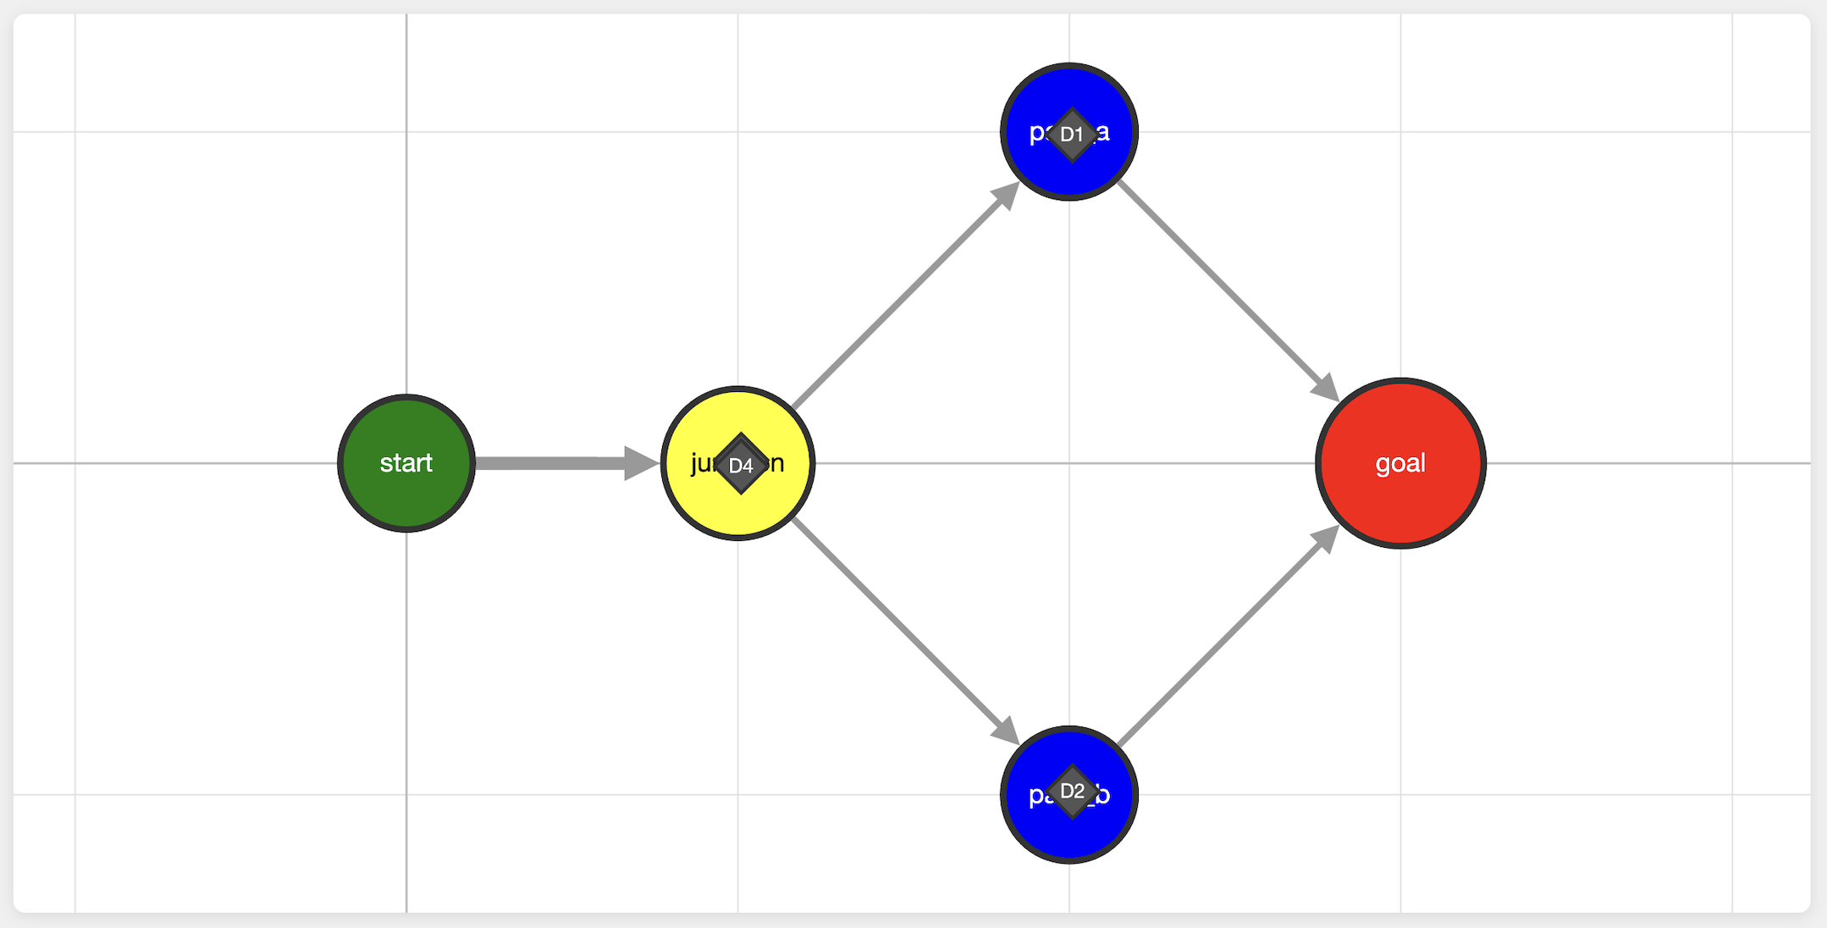
Figure VII.1: Map easy 2

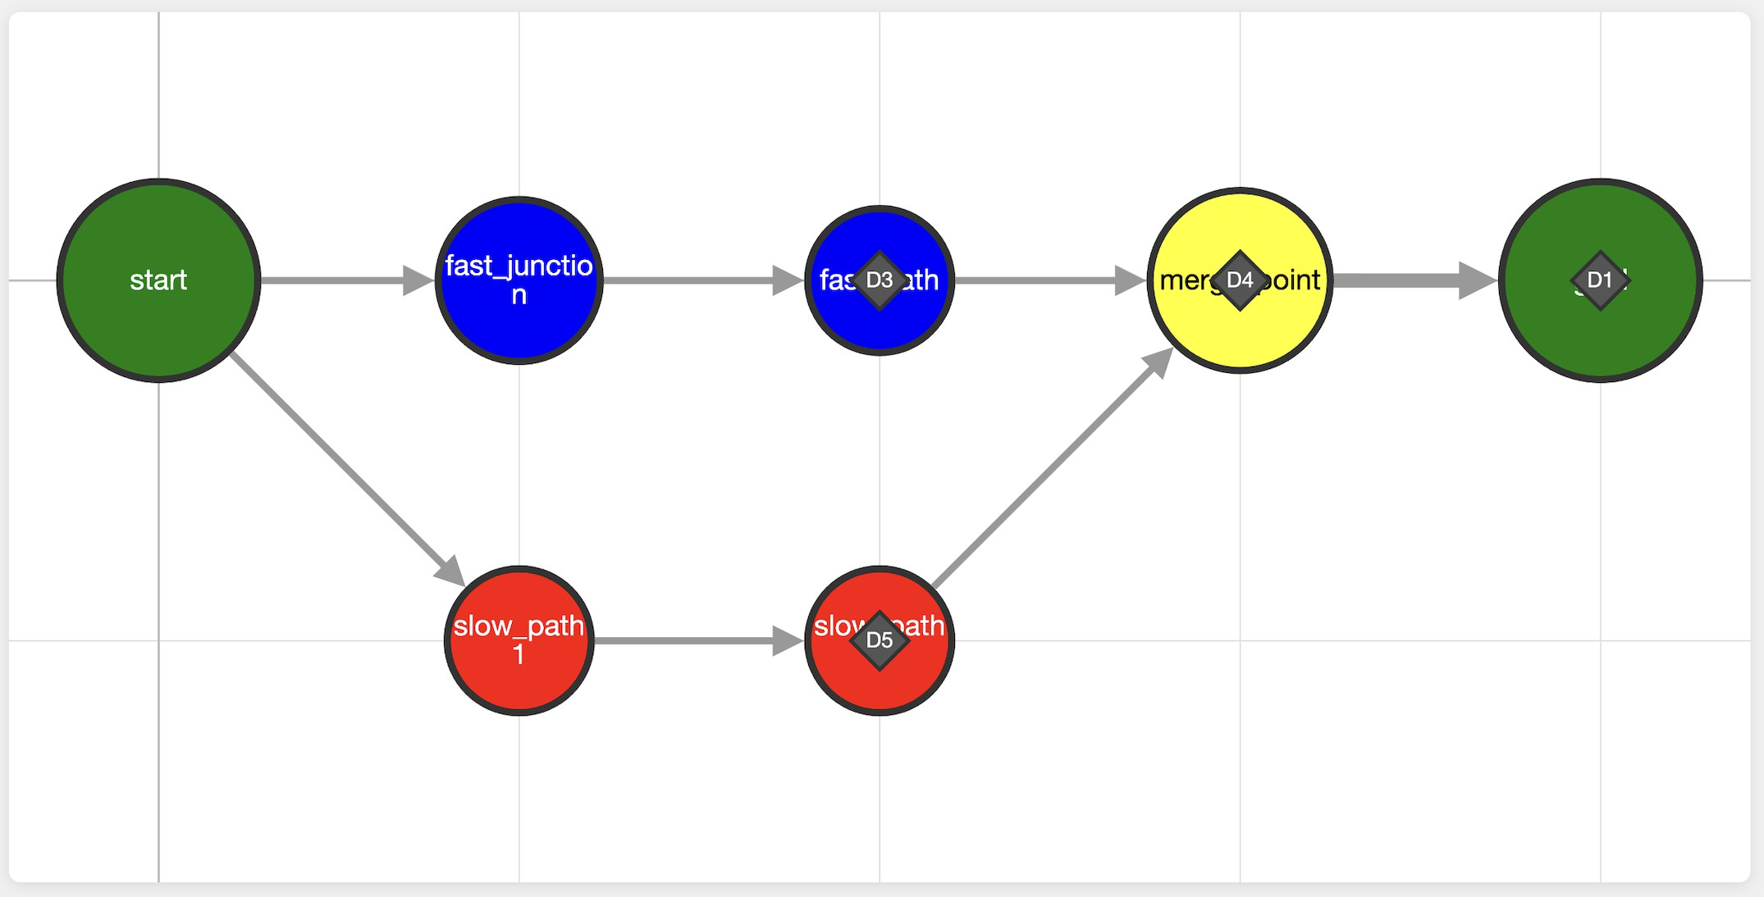
Figure VII.2: Map medium 3

18
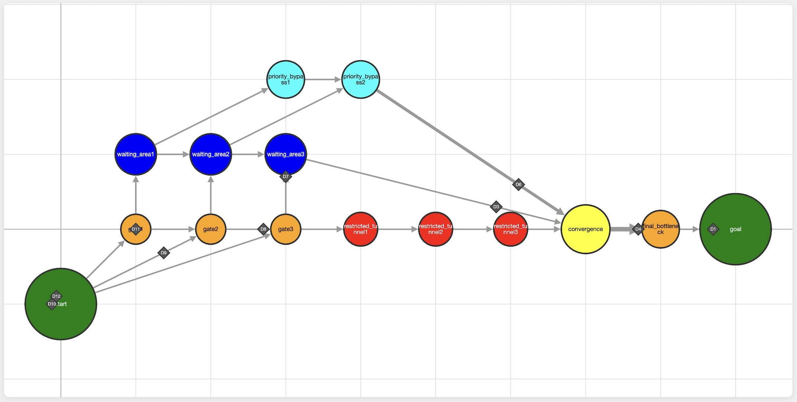
Fly-in Drones are interesting.

Figure VII.3: Map hard 2

19

Chapter VIII
Readme Requirements

A README.md file must be provided at the root of your Git repository. Its purpose is to allow anyone unfamiliar with the project (peers, staff, recruiters, etc.) to quickly understand what the project is about, how to run it, and where to find more information on the topic.
The README.md must include at least:
- The very first line must be italicized and read: This project has been created as part of the 42 curriculum by <login1>[, <login2>[, <login3>[...]]].
- A “Description” section that clearly presents the project, including its goal and a brief overview.
- An “Instructions” section containing any relevant information about compilation, installation, and/or execution.
- A “Resources” section listing classic references related to the topic (documen-tation, articles, tutorials, etc.), as well as a description of how AI was used — specifying for which tasks and which parts of the project.
➠ Additional sections may be required depending on the project (e.g., usage examples, feature list, technical choices, etc.).

Any required additions will be explicitly listed below.

- A detailed description of your algorithm choices and implementation strategy must also be included.
- Documentation of the visual representation features and how they enhance the user experience.
- Example input and expected output demonstrating the program’s functionality.



Your README must be written in English.
20

Chapter IX Bonus Part
This Bonus part will be reviewed only if all the mandatory requirements are met. Here are features you can implement to enhance your project:
- Exceptional performance:
  - You ’perfectly’ meet the performance reference targets for all provided maps.
  - ’perfectly’ means you match or beat the target turn count.
- Challenger map:
  - The Impossible Dream map is solved and beats the reference record of 45 turns.

21

Chapter X
Submission and peer-review

Submit your assignment in your Git repository as usual. Only the work inside your repository will be evaluated during the peer-evaluation. Don’t hesitate to double-check the names of your files to ensure they are correct.

Place all your files at the root of your repository.
A fully working simulation written in Python, including:
- A parser for the input file format.
- A simulation engine respecting movement and zone rules.
- A pathfinding algorithm (or multiple) capable of minimizing total turns.
- A visual representation system (terminal colors and/or graphical interface).
- A terminal or log output that follows the specified format.


Note that we may ask you to explain your code or possibly even to write some code. Make sure to be prepared for this.



Evaluation maps may be different from the ones provided in the subject.

During the evaluation, a brief modification of the project may occasionally be re-quested. This could involve a minor behaviour change, a few lines of code to write or

22
Fly-in Drones are interesting.

rewrite, or an easy-to-add feature.

While this step may not be applicable to every project, you must be prepared for it if it is mentioned in the evaluation guidelines.

This step is meant to verify your actual understanding of a specific part of the project. The modification can be performed in any development environment you choose (e.g., your usual setup), and it should be feasible within a few minutes — unless a specific time frame is defined as part of the evaluation.
You can, for example, be asked to make a small update to a function or script, modify a display, or adjust a data structure to store new information, etc.

The details (scope, target, etc.) will be specified in the evaluation guidelines and may vary from one evaluation to another for the same project.

23

