**Team Members:** Matthew Kirdin, Vladislav Pendishchuk

**Chosen Dataset:** [Diamonds Price Dataset](https://www.kaggle.com/datasets/amirhosseinmirzaie/diamonds-price-dataset)

**Reason of Choice:** We choose Diamond Price Dataset because it has a variety of easily interpretable features as well as an abundance of data.

**Dataset Info:** This dataset contains 50,000 entries and 10 features (listed below).

|  |  |  |
| --- | --- | --- |
| **Feature** | **Type** | **Description, units of measurement** |
| carat | quantitative | Weight, carats |
| cut | categorical | Cutting quality |
| color | categorical | Color from **J** (worst) to **D** (best) |
| clarity | categorical | Clarity from left to right is worst to best: *I1, SI2, SI1, VS2, VS1, VVS2, VVS1, IF* |
| x | quantitative | Length, mm |
| y | quantitative | Width, mm |
| z | quantitative | Depth, mm |
| depth | quantitative | Percentage depth $\frac{z}{mean(x,y)}$, % |
| table | quantitative | Width of the widest point at the top of the diamond, mm |
| price | quantitative | Diamond price |

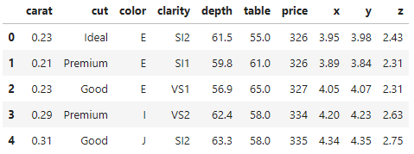**Data examples:**