Practice №4. Apache Kafka workshop.

***Ex.1*** *Create a Kafka topic, producer, and consumer.*

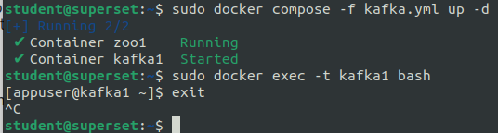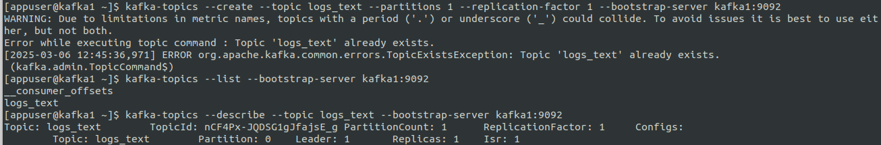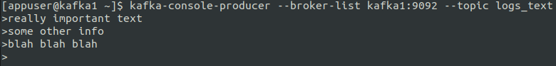

As we can see, everything worked correctly and consumer received the text data from the producer. Now, let us send the consumer data from a file:



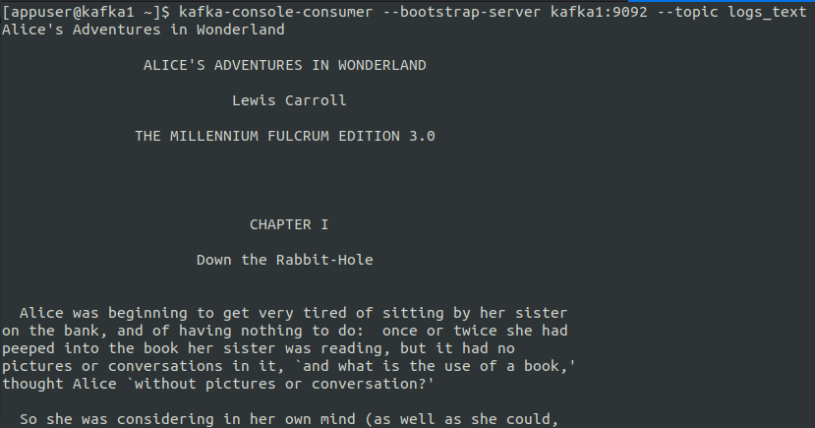

***Ex.2*** *Sending messages from Flume to Kafka.*

For this, first we make a configuration file containing the following code:

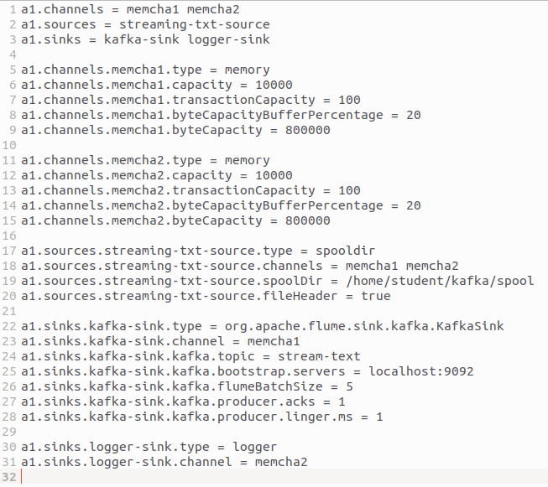

Then, we set up a new topic called stream-text

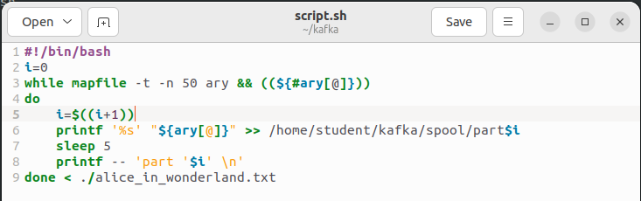

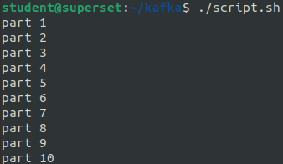

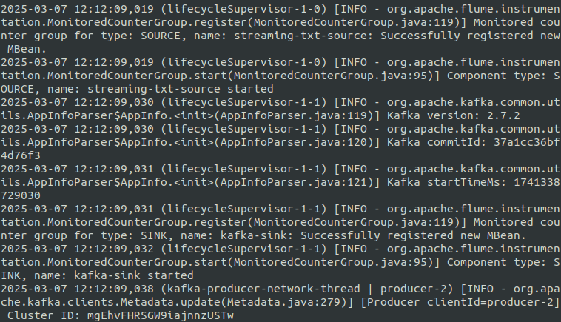

It is clear that the partitioned text was received by the consumer, since there are noticable cutoffs in the text:

