Practice №2. Workshop on Apache Flume.

***Ex.1*** ***Creating a logger.***

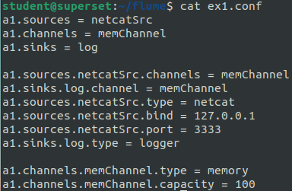 For this I used the following configuration file:

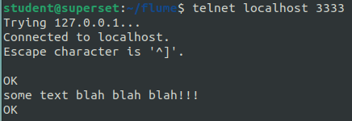and following input

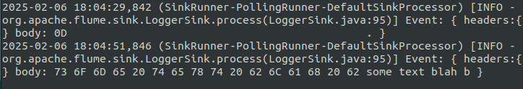This is how logs look like after running the agent:

***Ex.2 Collecting log files in a specified directory.***

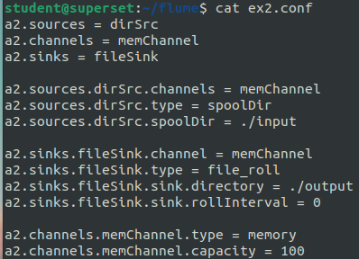 For this, I used the following configuration file:

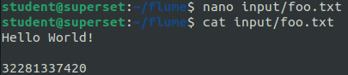Here, the sink directory is ./output and the source directory is ./input, which were manually made beforehand and ./input in particular was populated with text data:

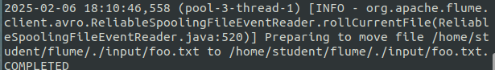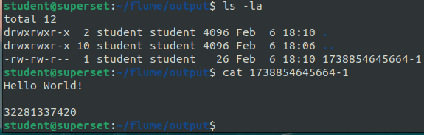After running the agent we see that it registers the files and successfully transfers them:

***Ex.3 Using an interceptor to process incoming events.***

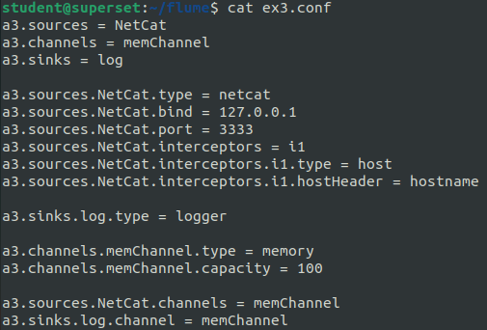 For this I used the following configuration file(it adds hostname at the beginning):

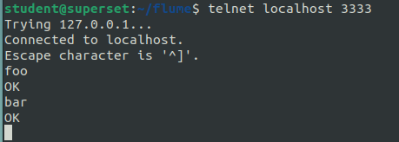With following input:

There results were as follows:

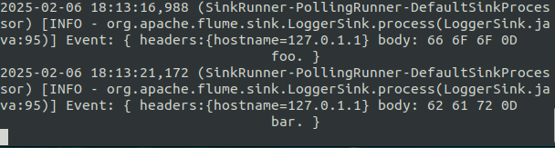One can easily see that the input was indeed inctercepted and hostname was added as its header.

***Ex.4 Using File roll to save events to files.***

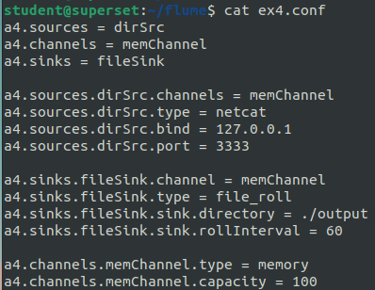For this task I wrote the following configuration file:

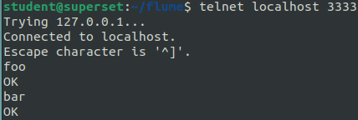It should accumulate events in log files in ./output. With the following input:

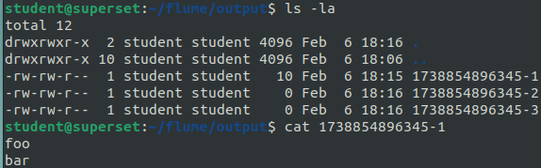We get that

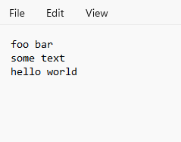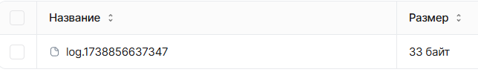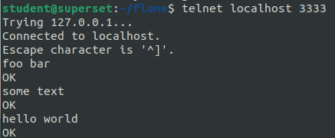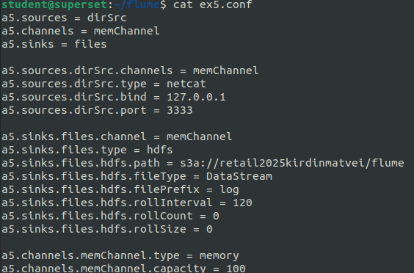***Ex.5 Uploading data to an S3 bucket.***

***Ex. 6 Uploading data to an S3 bucket.***

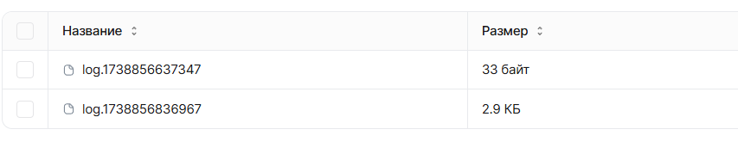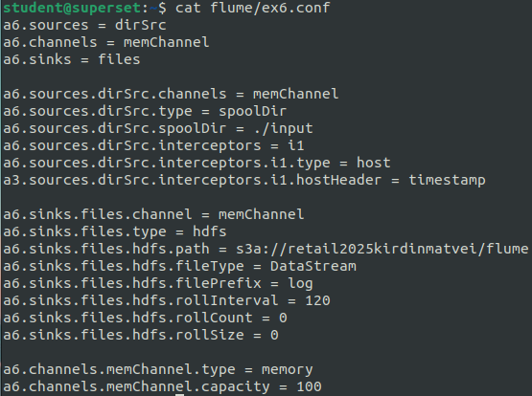 Here is the .conf file. I decided to copy conf files to S3. Let us see how it went:

