# CIST 2373 – Java III

# Lab #1 – 45 Points

# 

# [What is JEE? && Install NetBeans]

1. What does JEE stand for:

Java Enterprise Edition

1. What is the purpose of JEE?

The main purpose of JEE is to build a complete 3 tiered application that will run anywhere.

1. JEE consists of many different technologies. Name any 5 of these technologies:

* + Java API Socket
  + Java API for JSON Binding
  + Java API for JSON Processing
  + Java Servlet.]
  + Java Expression Language

1. All Applications are broken up into 3 parts(Presentation, Business and Data Access). In Java we will be building the following components(Business Objects, HTML files, JSPs, Servlets, JDBC). 🡪Match up the following, use lines to connect(Some on the left may match more than one on the right)[Draw lines]:

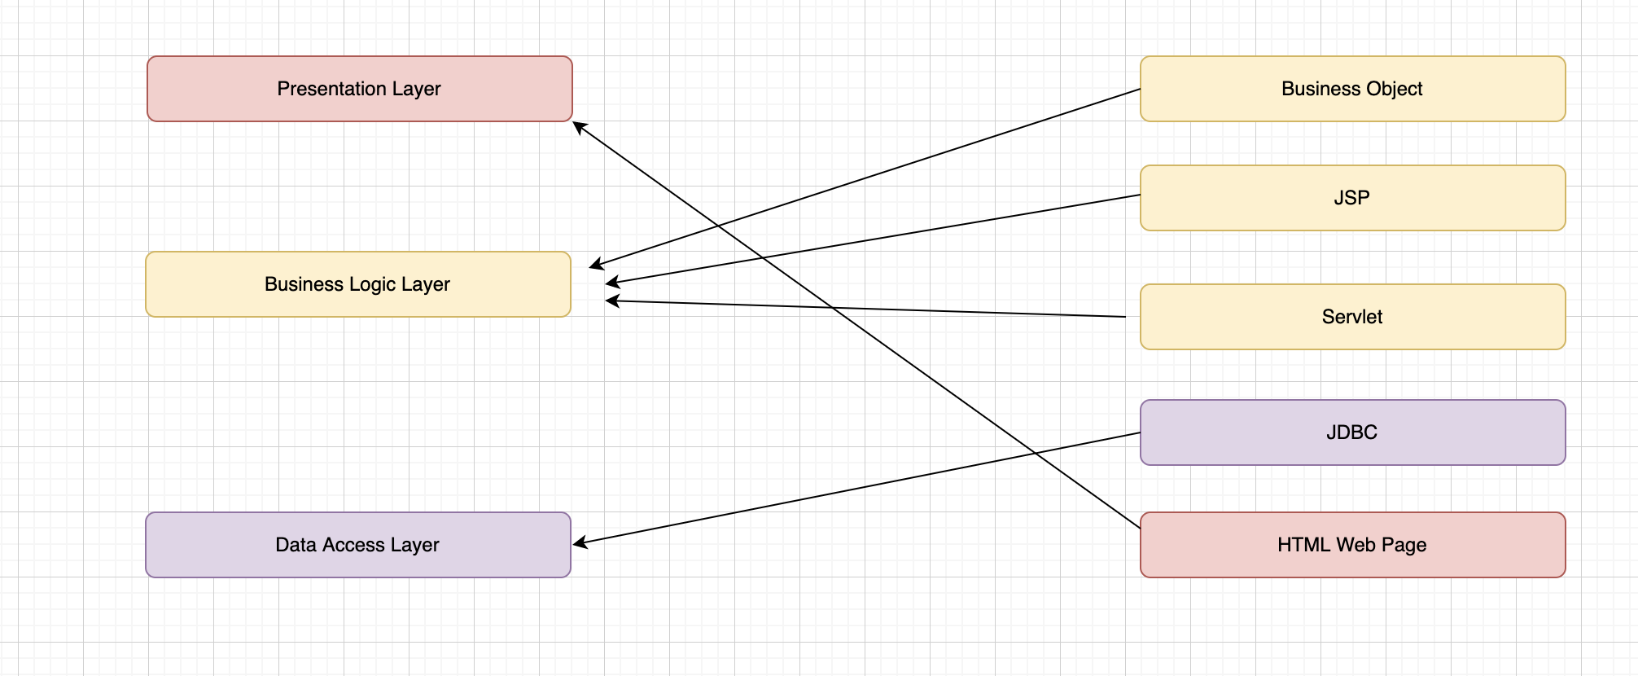

1. A Web Server serves up what?

HTML Web Pages

1. An Application Server serves up what(Don’t put applications)?

Business Object

1. INSTALL: Make sure you have NetBeans for JEE installed on your computer. We will be using NetBeans for this class. There is a video and a document you can follow under “Getting Started”.

NOTE: *If you still have NetBeans on your computer from Java II, then you already have what you need for this Java III class.*