This module will serve as the architectural blueprint for understanding and integrating all subsequent standards (ISO 9001, 14001, 45001, and IATF 16949).
CCH Management Compliance Training Suite
The structure is grouped into three product tiers: Foundational, Core Standards, and Advanced Specialization.
I. Foundational Tier: IMS Architecture & Audit Readiness
This tier is essential for anyone new to ISO or seeking to build an Integrated Management System (IMS).
Module Number | Original Topic | Professional Course Title | Value Proposition (Learning Outcomes)
M1 | HLS & Annex SL | The IMS Blueprint: Mastering the High-Level Structure (HLS) | * Design an Integrated Management System (IMS) using the 10-clause HLS.  * Map common requirements across ISO 9001, 14001, and 45001 for immediate efficiency.  * Understand the PDCA cycle as the driver of continual improvement (Clause 10).
M2 | Initial Gap Analysis | Strategic Gap Analysis: Creating Your Roadmap to Certification | * Systematically assess your organization against all mandatory ISO clauses (e.g., HLS 4-10).  * Execute the 3-Stage Gap Methodology (Documentation, Process, Records).  * Prioritize gaps using risk and complexity scores to justify resources and budgets.
M3 | Context & RBT | Risk-Based Thinking (RBT): Strategy, Context, and Compliance | * Determine Context of the Organization using structured tools (e.g., PESTEL).  * Identify and integrate requirements of all interested parties (e.g., customers, regulators).  * Apply RBT to risks and opportunities to link QES management to strategic business goals.
M4 | Auditor Training | Internal Auditor Excellence: ISO 19011 Compliance & Evidence Collection | * Plan and execute a systematic First-Party Internal Audit covering IMS requirements (HLS 9.2).  * Master the art of evidence collection using the "Procedure, Practice, Proof" audit trail.  * Write defensible Non-Conformity (NC) statements based on objective evidence.
M6 | NC Resolution | CAPA Mastery: Root Cause Analysis (RCA) and Effectiveness Verification | * Differentiate between Minor and Major NCs and their audit consequences.  * Apply 5 Whys and Ishikawa (Fishbone) techniques to determine systemic root causes.  * Design and verify Corrective Action Plans (CAPA) to ensure non-recurrence (HLS 10.2).

II. Core Standards Tier: QES Deep Dives
Targeted courses for implementing the specific requirements of the three main standards.
Module Number | Original Topic | Professional Course Title | Value Proposition (Learning Outcomes)
M7 | ISO 9001:2015 | ISO 9001 QMS: Operational Excellence and Customer Focus | * Implement the Process Approach and the Seven Quality Management Principles.  * Manage Operational Planning & Control processes (Clause 8), including design and purchasing.  * Establish Quality Objectives and metrics that drive customer satisfaction (Clause 6.2).
M8 | ISO 14001:2015 | ISO 14001 EMS: Environmental Risk and Compliance Management | * Identify and evaluate Significant Environmental Aspects (SEAs) using a scoring matrix.  * Establish and maintain the mandatory Compliance Obligations register.  * Plan and test Emergency Preparedness procedures for environmental incidents (e.g., spills).
M9 | ISO 45001:2018 | ISO 45001 OH&S: Hazard Elimination and Worker Participation | * Execute Hazard Identification and Risk Assessment (HIRA) (Clause 6.1).  * Apply the Hierarchy of Controls to prioritize hazard elimination over PPE.  * Fulfill the mandatory requirement for Consultation and Participation of Workers (Clause 5.4).

III. Advanced Specialization Tier: Automotive & Advanced Quality
High-value courses targeting IATF and advanced quality management roles.
Module Number | Original Topic | Professional Course Title | Value Proposition (Learning Outcomes)
M5 | PFMEA & RPFMEA | Advanced PFMEA & RPFMEA: AIAG-VDA 7-Step Risk Optimization | * Apply the 7-Step PFMEA Methodology to systematically identify process failures.  * Use the Action Priority (AP) system to prioritize high-risk failure modes over traditional RPN.  * Conduct Reverse PFMEA (RPFMEA) audits to validate controls on the shop floor.
M10 | IATF 16949 | IATF 16949 Deep Dive: Core Tools, Contingency, and Product Safety | * Understand the mandatory use of Core Tools (APQP, PPAP, MSA, SPC) in the automotive supply chain.  * Develop and test Contingency Plans for critical operations (Clause 6.1.2.3).  * Execute the requirements for Second-Party Audits of your suppliers.
M12 | CSRs | CSR Compliance: Integrating Customer-Specific Requirements (OEM Mandates) | * Integrate mandatory Customer-Specific Requirements (CSRs) into your Control Plan and QMS.  * Implement a system for tracking, reviewing, and responding to CSR changes.  * Mitigate audit risk and avoid costly customer sanctions related to CSR non-conformance.
M11 | Integration & CCH | Sustaining Your IMS: CCH Strategy for Efficiency and Value | * Leverage the HLS overlaps to reduce documentation and auditing burden by up to 40%.  * Define roles for Plant, EHS, and HR Managers within the integrated QES framework.  * Utilize CCH training to achieve and maintain IATF/ISO certification for sustained business advantage.

🏗️ Module 1: The High-Level Structure (HLS) and Annex SL

🎯 Learning Objective
Upon completion, participants will be able to:
- Explain the purpose and components of the High-Level Structure (HLS) and Annex SL.
- Map the 10 common clauses to their respective organizational activities.
- Identify the core requirements common to all management systems to begin building an Integrated Management System (IMS).

📜 I. The Genesis of Standardization: Annex SL
Annex SL is a formal appendix that was added to the ISO/IEC Directives, Part 1. Its primary purpose is to mandate a common structure, core text, and common terms and definitions for all future and revised ISO management system standards (MSS).
Concept | Explanation | Benefit to Managers
High-Level Structure (HLS) | The 10-clause framework that defines the structure of all modern MSS (e.g., ISO 9001:2015, ISO 14001:2015, ISO 45001:2018). | Consistency in documentation and reduced complexity when implementing multiple standards.
Common Core Text | Standardized, non-negotiable text used in specific clauses (e.g., "The organization shall establish, implement, maintain, and continually improve..."). | Clarity on mandatory requirements, reducing ambiguity during audits.
Alignment with Strategic Goals | The structure inherently links the management system to the organization's overall strategic direction and business processes. | Demonstrates to leadership that compliance is a value driver, not just a cost center.
Export to Sheets
Real-Time Example: Before HLS, a company seeking ISO 9001 and ISO 14001 would have two entirely different manuals, with overlapping but differently worded requirements for documentation control or internal auditing. With HLS, these functions can be integrated and performed once, saving massive amounts of time and effort.

🧱 II. The 10 Common HLS Clauses (The Integrated Framework)
The HLS framework follows the Plan-Do-Check-Act (PDCA) cycle, which is the cornerstone of continual improvement.

A. Context, Leadership, and Planning (The PLAN Phase)
Clause # & Title | Detailed Requirement | PDCA Link | Managerial Focus/Example
4. Context of the Organization | Understand internal/external issues, needs of interested parties (customers, regulators, employees), and define the scope of the MS. | P (Plan): Foundation | EHS Manager: Identify regulatory requirements (external issue) and allocate resources (internal issue).
5. Leadership | Top management must demonstrate commitment, establish the Policy (Quality, Environmental, OH&S), and define roles, responsibilities, and authorities. | P (Plan): Direction | Plant Manager: Ensure the quality policy is communicated and understood on the shop floor.
6. Planning | Determine risks and opportunities (Risk-Based Thinking), establish objectives, and plan actions to achieve them. | P (Plan): Actionable goals | HR Manager: Plan training objectives to mitigate the risk of skill gaps impacting process performance.
Export to Sheets

B. Support and Operation (The DO Phase)
Clause # & Title | Detailed Requirement | PDCA Link | Managerial Focus/Example
7. Support | Provide resources: People, infrastructure, environment, competence, communication, and control of documented information. | D (Do): Enablement | HR/Training: Establish a Competence Matrix showing required skills vs. current employee capabilities.
8. Operation | The core business processes: operational planning and control, design and development, control of external provision (purchasing/outsourcing), and handling non-conformities. | D (Do): Execution | Production: Define procedures for running machinery (process control) and managing rejected parts.
Export to Sheets

C. Performance Evaluation and Improvement (The CHECK & ACT Phase)
Clause # & Title | Detailed Requirement | PDCA Link | Managerial Focus/Example
9. Performance Evaluation | Monitoring, measurement, analysis, evaluation, Internal Audits, and Management Review. | C (Check): Assessment | Quality Manager: Analyze customer complaint data and review the effectiveness of past corrective actions.
10. Improvement | Nonconformity and Corrective Action (CAPA), and Continual Improvement of the suitability, adequacy, and effectiveness of the MS. | A (Act): Refinement | All Managers: Use Management Review outputs to set new objectives and initiatives for the next cycle.
Export to Sheets

📊 III. The PDCA Cycle: Driving Continual Improvement
The structure of HLS is designed to map directly onto the Plan-Do-Check-Act (PDCA) cycle, also known as the Deming Cycle. This cycle is the fundamental engine for continual improvement in all management systems.
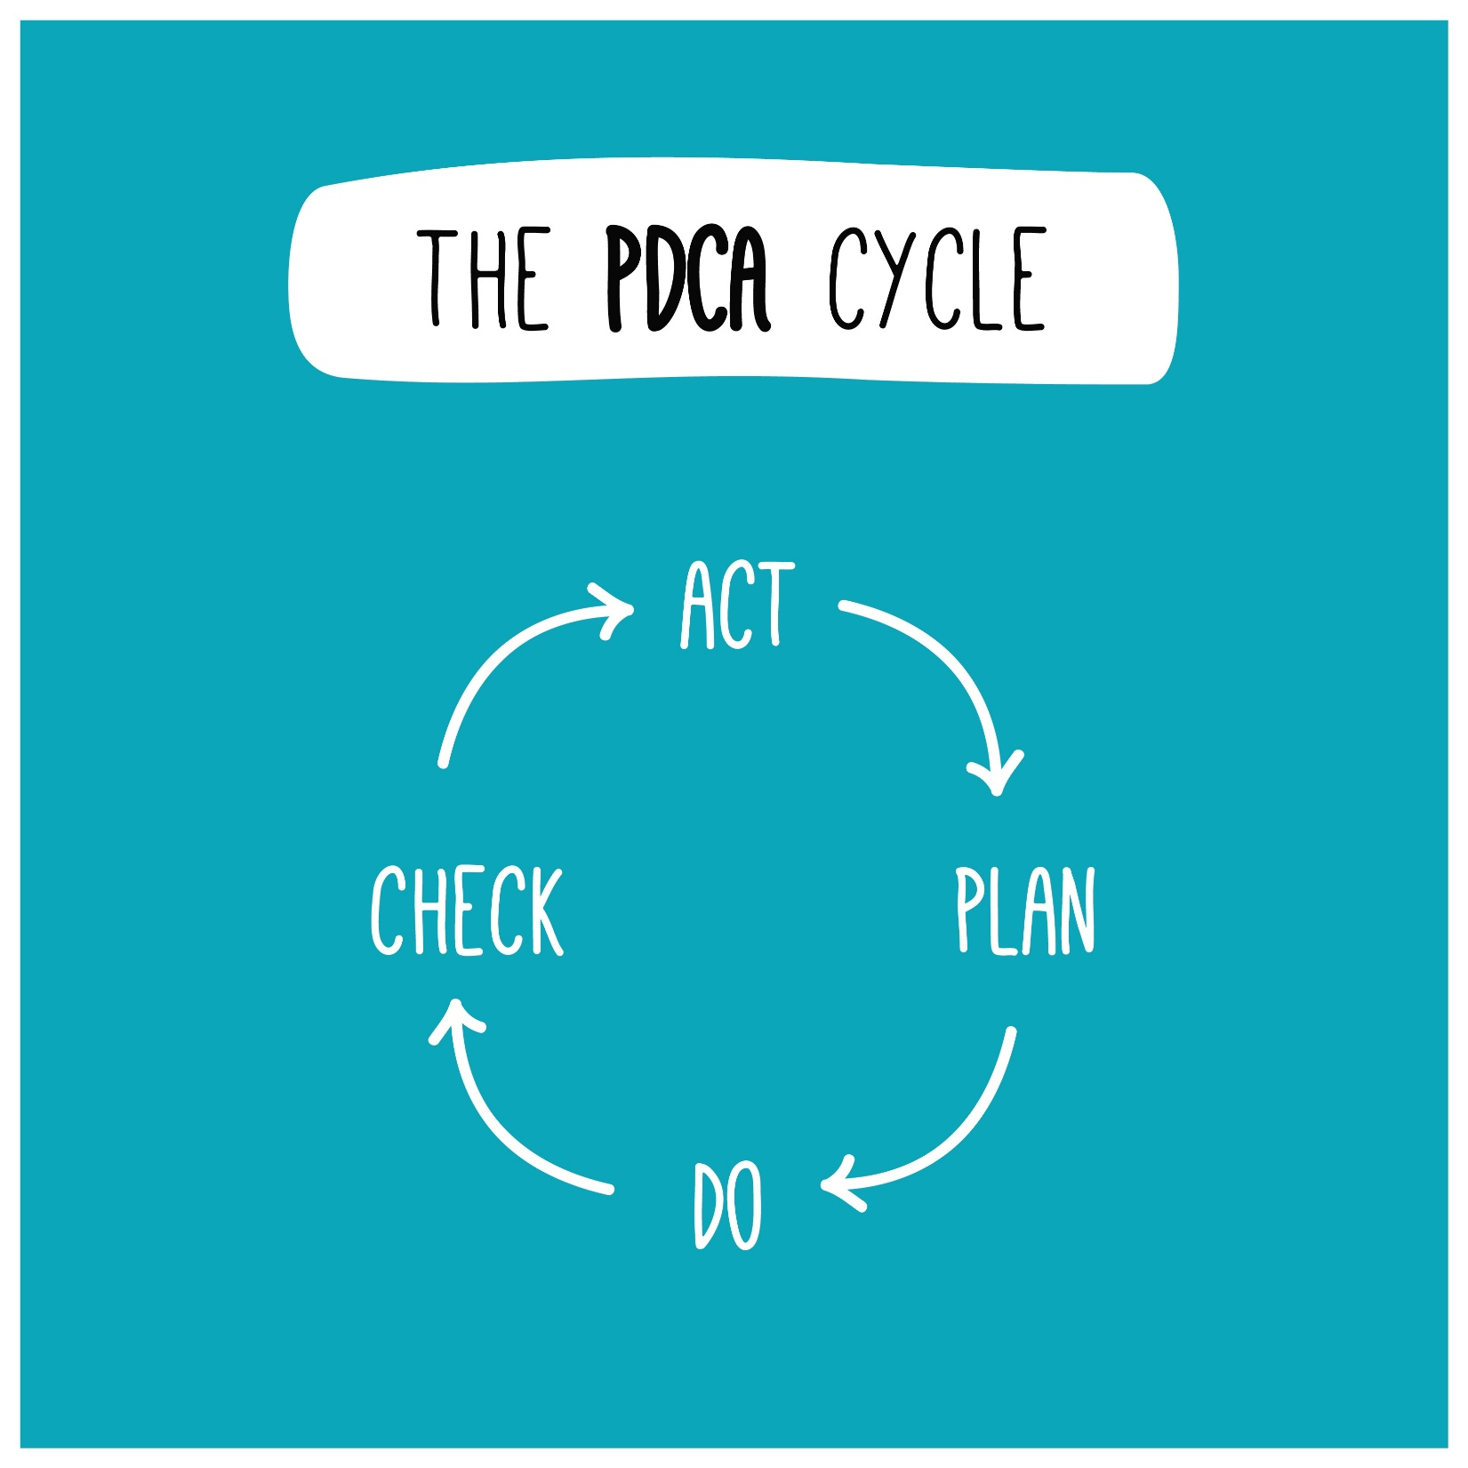
Plan (Clauses 4, 5, 6): Establish objectives and processes necessary to deliver results. (Define the goal and the roadmap)
- Do (Clauses 7, 8): Implement the processes as planned. (Execute the plan and manage resources)
- Check (Clause 9): Monitor and measure processes and the resulting products/services against policies, objectives, and requirements. (Evaluate performance)
- Act (Clause 10): Take actions to continually improve performance. (Adjust and refine the system)
Training Detail: Continual Improvement The core goal of ISO certification is not merely compliance, but achieving continual improvement. This is measured not only by fixing problems (corrective action) but by proactively identifying opportunities for improvement (e.g., reducing waste, improving efficiency, reducing risk). Managers must be able to demonstrate this cycle to auditors.

📝 Summary & Next Steps
By understanding the HLS, CCH course participants now have a universal template for all management standards. They understand that requirements for Leadership (Clause 5) and Internal Audit (Clause 9), for example, exist in every standard, only with specific flavorings (e.g., ISO 45001 requires the involvement of non-managerial workers in audits).

Module 2: The Initial Gap Analysis – Your Implementation Roadmap

🎯 Learning Objective
Upon completion, participants will be able to:
- Define the purpose and scope of a Gap Analysis within the context of an Integrated Management System (IMS).
- Execute the three-stage methodology for comparing current processes and documentation against HLS/Annex SL requirements.
- Prioritize gaps based on risk and complexity to develop a realistic implementation plan.

📝 I. What is a Gap Analysis and Why is it Essential?
A Gap Analysis (or Pre-Assessment) is a systematic process used to determine the difference (the "gap") between an organization's current practices and the required practices dictated by an ISO standard (e.g., ISO 9001, ISO 45001, IATF 16949).
Component | Description | Relevance to Managers
Current State | All existing processes, procedures, work instructions, and records (Documented Information) within the organization. | Provides the baseline of where you are today.
Desired State | The full, uncompromised set of requirements defined by the target ISO standard(s). | Defines the destination and what compliance looks like.
The Gap | The missing, incomplete, or non-conforming elements required to meet the standard. | This gap becomes the Implementation Project List and budget justification.
Managerial Benefit: A well-executed Gap Analysis prevents scope creep and ensures that resources (time, money, personnel) are only spent on closing actual deficiencies, maximizing the Return on Investment (ROI) for the certification project.

🛠️ II. The Three-Stage Methodology for Gap Analysis
The analysis must be performed systematically, typically broken into three stages that mirror the standards' core components: Documentation, Processes, and People.

Stage 1: Documentation Review (The "What is Written")
This is the initial, desk-based review focused on the organization's existing Documented Information (Clause 7.5).
- Action: Collect and review key documents, including existing policies, organizational charts, procedures, forms, and manuals.
- Targeted Requirement Check: Use a checklist structured by the HLS clauses (4 through 10) to determine if a written procedure exists for a mandatory requirement.
  - Example (ISO 9001, Clause 6.1): Does the organization have a documented Risk and Opportunity Management Procedure?
  - Example (ISO 45001, Clause 5.4): Is there documented evidence of a procedure for the Consultation and Participation of Workers?
- Output: A list of missing mandatory documents and an initial assessment of the complexity of existing documentation.

Stage 2: Process Verification (The "What is Done")
This stage moves onto the floor and involves verifying whether the documented procedures are actually implemented and effective in practice. This is where the MS fails most often.
- Action: Process Mapping and Observation. Walk through key processes (e.g., procurement, production, internal auditing, equipment maintenance).
- Technique: Interviews. Speak with process owners and employees to understand their daily work flow. Ask questions like:
  - For a Production Operator: "Where do you find the current Work Instruction (WI) for this machine, and how do you know it's the latest version?" (Checks against Clause 7.5)
  - For a Maintenance Technician: "What process do you follow when you identify an uncalibrated piece of equipment?" (Checks against Clause 7.1.5 - Monitoring and Measuring Resources)
- Output: Identification of Non-Conforming Practices (where actual work contradicts the procedure) and processes that are ineffective or informal.

Stage 3: Records Review (The "Evidence of Results")
The final stage is crucial for compliance. It verifies that the organization is creating and retaining the necessary records (evidence) that prove the processes are working and requirements are met.
- Action: Sampling and inspection of completed forms, logs, and digital records.
- Targeted Requirement Check: Focus on historical evidence:
  - Are Management Review meeting minutes available for the past 12 months (Clause 9.3)?
  - Are there signed records proving that employees have been trained and assessed as competent for their specific tasks (Clause 7.2)?
  - Are internal audit reports available and showing appropriate follow-up on findings (Clause 9.2)?
- Output: Verification of record-keeping compliance and assessment of the traceability and integrity of evidence.

📈 III. Analyzing and Prioritizing the Gaps
Once the data is collected, the Gap Analysis findings must be compiled, quantified, and prioritized to create the Implementation Action Plan.

A. Gap Classification and Quantification
A numerical score or classification system is highly effective for prioritizing.
Gap Classification | Description | Priority Level
Major Gap | Non-existent or severely deficient element of the standard. This would likely lead to a Major Non-Conformity during a certification audit. | P1 (Critical): Address Immediately.
Minor Gap | An element exists but is incomplete, lacks evidence, or is inconsistently implemented (e.g., procedure written but not trained). | P2 (High): Address in Phase 1 of implementation.
Opportunity for Improvement (OFI) | Fully compliant element, but where efficiency or effectiveness could be enhanced. | P3 (Normal): Address during the improvement phase.

B. Risk-Based Prioritization
Prioritization must also consider the risk associated with the gap, especially for ISO 45001 (Safety) and ISO 14001 (Environment).
$$\text{Risk Score} = \text{Severity} \times \text{Likelihood of Occurrence}$$
- Example (ISO 45001): A Major Gap is found in the lockout/tagout (LOTO) procedure for hazardous energy control.
  - Severity: Catastrophic (Potential for serious injury/fatality).
  - Prioritization: Regardless of implementation effort, this becomes the highest priority action due to the catastrophic risk to personnel.

C. The Gap Analysis Report
The final report is the formal justification for the project and should contain:
- Executive Summary: High-level compliance score and overall project complexity.
- Detailed Findings: A matrix listing the specific requirement (e.g., 6.1.1 Actions to address risks and opportunities), the current state, the required change, and the Gap Classification (P1, P2, P3).
- Resource Allocation Estimate: Time and personnel required to close the Major and Minor Gaps.

❓ Next Step
This comprehensive approach to the Gap Analysis provides the necessary detail for managers to launch their ISO project. The next foundational step within the HLS structure is addressing Clause 6: Planning, specifically focusing on Risk-Based Thinking & Context of the Organization (Clauses 4 and 6).

Module 3: Context and Risk-Based Thinking (HLS Clauses 4 & 6)

🎯 Learning Objective
Upon completion, participants will be able to:
- Determine the Context of the Organization (Clause 4) by identifying relevant internal and external issues.
- Identify and analyze the needs and expectations of Interested Parties (Clause 4.2).
- Apply Risk-Based Thinking (RBT) to identify, assess, and plan actions for risks and opportunities (Clause 6.1).
- Understand the unique requirements for risk in ISO 45001 (OH&S Risks) and ISO 14001 (Environmental Aspects).

🏛️ I. Clause 4: Context of the Organization – Knowing Your Environment
The objective of Clause 4 is to ensure that the management system (QMS, EMS, or OH&S MS) is relevant to the organization's purpose and strategic direction. It is the mandatory starting point after defining the scope.

A. Internal and External Issues (Clause 4.1)
The organization must identify and monitor information about its internal and external environment that is relevant to its objectives and its ability to achieve the intended results of the MS. This is often accomplished using a structured PESTEL/SWOT analysis.
Analysis Type | Focus Area | Managerial Example
Political/Legal | Government stability, trade policy, regulatory environment. | EHS Manager: New local air quality regulations (External Issue) that require purchasing a new filtering system (Risk).
Economic | Interest rates, global supply chain stability, competitor pricing. | Plant Manager: Rising raw material costs (External Issue) threatening profit margins (Risk to Quality Objectives).
Social/HR | Company culture, staff morale, skill availability in the local area. | HR Manager: High employee turnover (Internal Issue) leading to competency gaps and safety incidents (Risk).
Technological | Automation potential, IT infrastructure age, cyber threats. | IT/Plant Manager: Aging server infrastructure (Internal Issue) risking downtime and affecting production (Risk to Operations).
Training Detail: Strategy Link
The auditor will look for evidence that these identified issues are not just a list, but that they directly feed into the planning (Clause 6) and management review (Clause 9). If the management review does not discuss the high turnover identified in 4.1, the system is deemed ineffective.
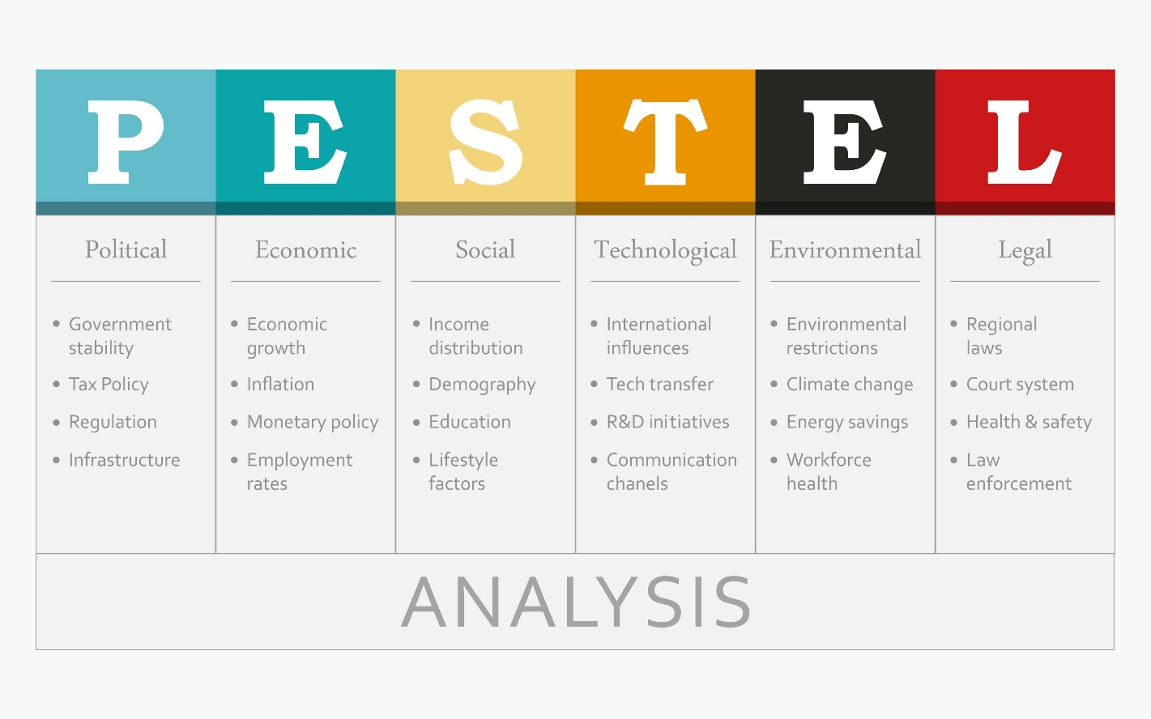
Shutterstock

B. Needs and Expectations of Interested Parties (Clause 4.2)
These are the groups or individuals that can affect, be affected by, or perceive themselves to be affected by the organization’s decisions or activities.
Interested Party | Need/Expectation | MS Requirement Affected
Customers | Defect-free product, timely delivery. | QMS (ISO 9001): Controls on production and shipping (Clause 8).
Regulators/Government | Compliance with environmental permits, safety laws. | EMS (ISO 14001): Compliance Obligations Register (Clause 6.1.3).
Employees | Safe working conditions, fair wages, training. | OH&S MS (ISO 45001): Hazard elimination and participation (Clause 5.4).
Shareholders/Owners | Profitability, return on investment. | All MS: Efficient processes, reduced waste, minimizing non-compliance fines.
Real-Time Situation: An organization's neighbors (external interested party) complain about noise from the evening shift (Environmental Issue). The EMS must have a system (e.g., Clause 6.1 action plan) to address this expectation by, for instance, installing noise dampeners or adjusting operational hours.

⚠️ II. Clause 6.1: Actions to Address Risks and Opportunities – Risk-Based Thinking
Risk-Based Thinking (RBT) replaces preventive action. It mandates that the entire management system must be built around a forward-looking approach to risk.

A. Core Risk Management Process (Common to All Standards)
Step | Action | Focus of Questioning
1. Identify | What can go wrong (Risk) or right (Opportunity)? | What is the worst-case scenario if we don't meet an objective?
2. Assess | Evaluate the risk based on Severity and Likelihood/Occurrence. | How bad is it, and how likely is it to happen?
3. Plan | Determine specific actions to treat the risk (e.g., mitigate, avoid, accept). | What specific controls (procedures, training, equipment) will we put in place?
4. Implement & Monitor | Implement the controls and check their effectiveness (Clause 9). | Did the control actually reduce the risk score?
$$\text{Risk Level (R)} = \text{Probability (P)} \times \text{Impact (I)}$$

B. The Unique "Flavors" of Risk
While the RBT framework is common, the standards have unique, mandatory risk requirements:
Standard | Unique Terminology | Management Tool Focus
ISO 9001 (QMS) | Focus on process risks to product conformity (e.g., supplier failure, equipment breakdown). | Failure Mode and Effects Analysis (FMEA), especially for Design/Process.
ISO 14001 (EMS) | Focus on Significant Environmental Aspects (SEAs) (e.g., resource use, wastewater discharge, emissions). | Aspects and Impacts Register (quantifies impact severity and likelihood).
ISO 45001 (OH&S) | Focus on Hazards and OH&S Risks (e.g., slips, falls, chemical exposure, stress). Requires a hierarchy of controls. | Hazard Identification and Risk Assessment (HIRA), emphasizing worker participation.
IATF 16949 (Automotive) | Focus on Customer-Specific Requirements (CSRs) and robust contingency plans for all manufacturing processes. | Reverse PFMEA (discussed later) and extensive planning for emergency shutdowns.

C. The Hierarchy of Controls (ISO 45001 Mandatory Requirement)
For OH&S Risks, the standard requires that actions be planned and taken according to the Hierarchy of Controls, aiming for elimination first:
- Elimination: Physically remove the hazard (e.g., eliminate the use of a toxic chemical).
- Substitution: Replace the hazard with a less hazardous one (e.g., substitute a solvent-based paint with a water-based one).
- Engineering Controls: Isolate people from the hazard (e.g., machine guards, ventilation systems).
- Administrative Controls: Change the way people work (e.g., work rotation, training, warning signs).
- Personal Protective Equipment (PPE): Protect the worker with last-resort measures (e.g., gloves, hard hats).
EHS Manager Application: If the risk is exposure to excessive noise, the best action is to Engineer the hazard out (soundproof enclosure, new quieter machine). The least effective is relying on PPE (earplugs), which requires training, maintenance, and constant user compliance.

📝 Summary & Next Steps
By completing Modules 1-3, managers now possess the strategic context (Clause 4), the planning framework (Clause 6), and the initial gap assessment to launch their MS project effectively. The foundation is set.

Module 4: Auditor Training – Internal & External Audits (HLS Clause 9.2)

🎯 Learning Objective
Upon completion, participants will be able to:
- Differentiate between First-Party, Second-Party, and Third-Party audits.
- Plan, execute, and report an Internal Audit (First-Party) in compliance with ISO 19011 guidelines and HLS Clause 9.2.
- Write clear, defensible Non-Conformity (NC) statements based on objective evidence.
- Understand the preparation and dynamics required to successfully navigate a Third-Party Certification Audit.

📝 I. Types of Audits: Defining the Scope
Managers must understand the context and purpose of different audits they will encounter.
Audit Type | Party Conducting the Audit | Primary Purpose | Managerial Action
First-Party | The organization's own personnel (Internal Auditors). | To determine if the MS meets the organization's requirements and the standard's requirements. | Own the process. Develop a robust, annual Audit Program.
Second-Party | A customer auditing their supplier (e.g., Ford auditing a parts supplier). | To ensure the supplier meets contractual requirements, including specific standards (e.g., IATF, Customer-Specific Requirements - CSRs). | Host the audit. Prepare documentation and provide process evidence as requested by the customer.
Third-Party | Independent Certification Body (CB) (e.g., SGS, BSI, TÜV). | To issue or maintain the official ISO/IATF Certificate. Results in a formal certification decision. | Navigate the audit. Provide evidence that the system is established, implemented, and effective.
Training Detail: The ISO 9001, 14001, and 45001 standards only mandate the First-Party Internal Audit. However, participation in Second- and Third-Party audits often requires internal audit proficiency.

🔎 II. Conducting the Internal Audit (First-Party)
The internal audit process must be systematic and impartial, following the guidelines of ISO 19011 (Guidelines for Auditing Management Systems).

A. Audit Program and Planning (The PLAN Phase)
- Develop the Audit Program: This is the annual schedule that ensures all clauses, processes, and locations are audited within a defined cycle (typically 12 months). The frequency should be based on Risk and Status (Clause 9.2.2).
  - Example: High-risk processes (e.g., chemical storage in ISO 14001, design in ISO 9001) should be audited more frequently than low-risk processes (e.g., HR filing).
- Audit Checklist Preparation: Internal auditors prepare questions and evidence requests based on the specific HLS clause being audited. This ensures all mandatory "shall" statements in the standard are covered.

B. Execution and Evidence Collection (The DO Phase)
The internal auditor's job is to collect Objective Evidence—facts, data, and information that are verifiable. Auditors should follow the "Three P's" audit trail:
- Procedure (The documented information): What does the organization say it does? (Clause 7.5)
- Practice (Observation/Interview): What are employees actually doing? (Clause 8)
- Proof (Records): What are the records that confirm the practice was followed? (Clause 7.5.3)
Real-Time Scenario (Auditing Competence, Clause 7.2):
- Auditor asks HR: "Do you have a procedure for assessing operator competence?" (P1)
- Auditor goes to Production: "Can you show me the training records for operator John Doe on Machine X?" (P3)
- Auditor observes John Doe: "How do you know when you need refresher training?" (P2)
- Gap/NC: If the procedure requires a signed sign-off form but the auditor finds only emails, that is a lack of objective evidence.

C. Writing the Non-Conformity (NC) Statement
An NC statement is the most crucial output of an audit. It must be clear, concise, and fully supported by evidence.
A good NC statement must contain three parts:
- Requirement: The specific clause and standard that was violated. (E.g., ISO 9001:2015, Clause 8.5.2 (Identification and Traceability)).
- Evidence: The objective facts found by the auditor. (E.g., Production Order #1234 was observed on the assembly line, but the corresponding traceability tag was missing and could not be verified by the supervisor.).
- Statement of Non-Conformity: A clear statement linking the evidence back to the requirement. (E.g., The organization has failed to maintain product traceability as required by the standard.).

🛡️ III. Third-Party Certification Audits (Navigating the External Review)
The external audit typically follows a two-stage process:

Stage 1 Audit (Documentation Review)
- Focus: A preliminary audit to ensure the MS is established.
- Auditor Goal: Review all mandatory documented information (Policies, Scope, Objectives, Procedures) to confirm all HLS requirements have been addressed on paper.
- Outcome: The auditor issues a report highlighting gaps in documentation that must be closed before the Stage 2 audit can proceed.

Stage 2 Audit (Implementation & Effectiveness)
- Focus: A comprehensive, on-site audit to ensure the MS is implemented and effective.
- Auditor Goal: Trace the audit trails (the P's) across all departments, focusing heavily on Clause 8 (Operation) and Clause 9 (Performance Evaluation).
- Outcome: The auditor issues a final report with any Major or Minor NCs.
  - Major NC: A total breakdown of the system for a clause or a non-conformance that would likely lead to the failure of the MS. (Must be addressed before certification can be granted).
  - Minor NC: An isolated lapse in compliance or ineffective implementation. (Requires a Corrective Action Plan, but certification can usually be granted).
Managerial Tip for Stage 2: The auditor will always follow the flow of the product/service, from contract review (sales) to delivery (shipping). Be ready to trace a specific job or batch through your entire process to demonstrate control.

Module 5: Process Failure Mode and Effects Analysis (PFMEA)

🎯 Learning Objective
Upon completion, participants will be able to:
- Define the purpose and scope of a PFMEA as a proactive risk mitigation tool.
- Execute the 7-Step Approach (AIAG-VDA) for developing a robust PFMEA.
- Calculate and use the Action Priority (AP) system to prioritize risks over the traditional RPN.
- Conduct a Reverse PFMEA audit to validate the risk assessment on the shop floor.

📝 I. Understanding the PFMEA Tool
PFMEA is a systematic set of activities used to:
- Recognize and evaluate potential failures of a process.
- Determine the effects of these failures.
- Identify actions that could eliminate or reduce the chance of the potential failures occurring.
PFMEA Component | Question it Answers | Managerial Value
Process | What is the production/service step? | Focuses risk analysis on specific operations.
Failure Mode | How can the process fail to meet the specification? | Defines the risk to Quality, Safety, or Environment.
Effects | What is the consequence if the failure occurs? | Quantifies the Severity of the failure (e.g., Customer Injury, Shutdown).
Analysis | How often does it occur? How can we detect it? | Drives continuous improvement by prioritizing actions.
Context Note (QMS/IATF): While ISO 9001 requires the consideration of process risks (Clause 6.1), the IATF 16949 standard makes the PFMEA a highly detailed and non-negotiable requirement for all manufacturing processes.

🛠️ II. The 7-Step PFMEA Methodology (AIAG-VDA Alignment)
The industry standard methodology has shifted from a focus on the Risk Priority Number (RPN) to a structured 7-Step Approach using Action Priority (AP).

Step 1: Planning and Preparation
- Action: Define the scope (which process?), assembly steps, team members (cross-functional: Engineering, Production, Quality), and project goals.
- Key Tool: Process Flow Diagram (PFD). The PFMEA must follow the sequence of the PFD exactly.

Step 2: Structure Analysis
- Action: Break down the process into three elements: System/Focus Element/Work Element.
- Example: System (Assembly Line) $\rightarrow$ Focus Element (Torque Station 5) $\rightarrow$ Work Element (Operator selects correct bolt).

Step 3: Function Analysis
- Action: Define the function/purpose of the Focus Element and the Requirements associated with it. Failures are derived from missing these requirements.
- Example: Function: "Securely fasten Component A to Component B." Requirement: "Torque setting shall be $10 \pm 1$ Nm."

Step 4: Failure Analysis (The Core)
This step maps the failure chain:
- Failure Mode: The loss of the function/requirement. (e.g., Under-torqued bolt.)
- Failure Effect (SEVERITY): The consequence of the failure. (e.g., Bolt vibrates loose, causing customer component failure.)
- Failure Cause (OCCURRENCE): The root cause of the failure. (e.g., Operator selected the wrong torque setting on the wrench.)

Step 5: Risk Analysis (Quantification)
This step assigns the three key ratings (S, O, D) and introduces Action Priority (AP).
Rating | Definition | Rating Scale Focus (1-10)
Severity (S) | How serious is the Effect? | Highest rating for Safety and Regulatory risks. Cannot be reduced by controls.
Occurrence (O) | How likely is the Cause to happen? | Reduced by Preventive Controls (e.g., training, maintenance).
Detection (D) | How likely are current controls to detect the Failure Mode before it reaches the customer? | Reduced by Detection Controls (e.g., poka-yoke, automatic gauge).
Abandoning RPN: The RPN (Risk Priority Number = $S \times O \times D$) is largely replaced by Action Priority (AP). AP assigns a High (H), Medium (M), or Low (L) priority based on a predefined matrix, forcing mandatory action on high-severity issues, regardless of low occurrence or detection scores.

Step 6: Optimization (Action Planning)
- Action: Develop Recommended Actions to reduce the AP rating (typically by reducing the Occurrence or improving Detection).
- Key Focus: Preventive Actions (reducing Occurrence) are always preferred over Detection Actions.

Step 7: Results Documentation
- Action: Update the PFMEA document with the final actions, the responsible party, the due date, and the resulting S, O, D, and AP scores.

🔄 III. Reverse Process FMEA (RPFMEA)
The Reverse PFMEA (RPFMEA) is a crucial verification tool and a requirement for showing the PFMEA is effective and validated.
Aspect | Description | Managerial Requirement
Purpose | To validate the PFMEA on the shop floor after it has been completed. It reverses the standard PFMEA process. | Demonstrates that the risk mitigation documented in the PFMEA is implemented and effective in reality.
Methodology | Conducted by a cross-functional team at the line/process. The team takes a Failure Mode identified in the PFMEA (e.g., "Wrong part selection") and actively checks the process for the Controls (Detection/Preventive) that are supposed to be in place. | The team literally tries to break the process to see if the controls work. (E.g., Try to run a bad part through the poka-yoke device to see if the machine shuts down.)
Key Questions | 1. Are all severe/high-risk Failure Modes still present in the process? 2. Do the controls listed in the PFMEA actually exist and function as intended? 3. Are there new, unanticipated failure modes that were missed in the original PFMEA team meeting? | RPFMEA often finds that training has lapsed, documentation is missing on the floor, or detection systems have been bypassed.
EHS/Plant Manager Application: The RPFMEA is invaluable for OH&S (ISO 45001). If your PFMEA listed a control for a high-risk machine setup (e.g., "LOTO training is current"), the RPFMEA team must physically verify the training records, observe the LOTO procedure, and ensure the energy isolation point is properly tagged.

📝 Summary & Next Steps
The PFMEA and RPFMEA modules provide managers with a powerful, mandatory tool for proactive risk control (Clause 6.1) and process operation (Clause 8). The successful completion of this activity is essential for achieving IATF certification and demonstrates a robust QMS.

Module 6: Preventing & Resolving Non-Conformities (NCs) – The CAPA System

🎯 Learning Objective
Upon completion, participants will be able to:
- Distinguish between a Minor Non-Conformity and a Major Non-Conformity and their audit implications.
- Execute the Corrective Action and Preventive Action (CAPA) process flow (HLS 10.2).
- Apply and document standard Root Cause Analysis (RCA) methodologies (5 Whys, Ishikawa/Fishbone Diagram).
- Verify and close out corrective actions by demonstrating Effectiveness to prevent recurrence.

🚨 I. Non-Conformity Classification and Impact
A Non-Conformity (NC) is a failure to meet a requirement (HLS 10.2). Understanding the difference between a Minor and a Major NC is essential for managing external audit outcomes.
NC Type | Definition and Severity | Audit Implication | Managerial Priority
Minor NC | A lapse in compliance that is isolated or affects a small part of the system. The intended process exists but was not followed consistently. | Certification can be granted, but the organization must submit a CAPA plan and a completion date within 90 days. | High. Requires a robust RCA and timely implementation to prevent escalation to a Major NC.
Major NC | A total breakdown of a required system element (e.g., no Management Review held) or a failure that would lead to non-conforming product/service or significant risk (e.g., failure of a mandatory safety control). | Certification cannot be granted or maintained until the NC is closed and verified, often requiring a follow-up visit by the external auditor. | Critical. Requires immediate allocation of resources and emergency action.
Crucial Distinction: Corrective Action deals with non-conformities that have already happened. The older standard's concept of Preventive Action (PA) has been subsumed by Risk-Based Thinking (RBT, Clause 6.1). If you successfully address a risk via RBT, you are performing PA. If you take action to fix an NC, you are performing CAPA.

🗺️ II. The Four Steps of the CAPA Process (HLS 10.2)
The organization must systematically address non-conformities. The process is a mini-PDCA cycle for improvement.

Step 1: Containment and Correction
- Correction (The Immediate Fix): This is the firefighting step. It addresses the immediate problem to contain the NC and prevent further damage. It does not solve the root cause.
  - Example (Under-torqued bolt): Correction is pulling the specific batch of under-torqued product from the line and manually reworking or scrapping it.
- Containment: Steps taken to ensure that the non-conforming product/service does not reach the customer. This is mandatory for ISO 9001 and IATF.

Step 2: Root Cause Analysis (RCA)
The core function of CAPA: determining why the failure occurred. This is mandatory for a system to achieve continual improvement. If you only correct the problem, it will happen again.
We will focus on two key RCA tools:

Tool A: The 5 Whys
This is a simple, iterative interrogation technique used to trace the visible problem to its underlying organizational or systemic root cause.
Step | Question & Focus | Example (A batch was scrapped due to incorrect material)
Problem |  | Scrapped batch due to incorrect material usage.
Why 1? | Why did we use the incorrect material? | Because the Operator pulled the wrong stock from the warehouse.
Why 2? | Why did the operator pull the wrong stock? | Because the Warehouse Labeling was confusing and did not match the Work Order.
Why 3? | Why was the labeling confusing? | Because the Material Specification Procedure was not updated after the supplier changed packaging.
Why 4? | Why wasn't the procedure updated? | Because Engineering/Quality Change Control system does not notify the warehouse manager of minor supplier changes.
Why 5 (Root Cause)? | Why does the system fail to notify? | Because the Organizational Structure fails to define clear cross-functional responsibilities for Document Control (HLS Clause 5.3).
Outcome: The systemic Root Cause is a breakdown in the Change Control Procedure (HLS 7.5), not operator error.

Tool B: Ishikawa (Fishbone) Diagram
Also known as the Cause-and-Effect Diagram, this graphically organizes potential causes into major categories to explore the complexity of the problem. It ensures the RCA team looks beyond immediate failure.
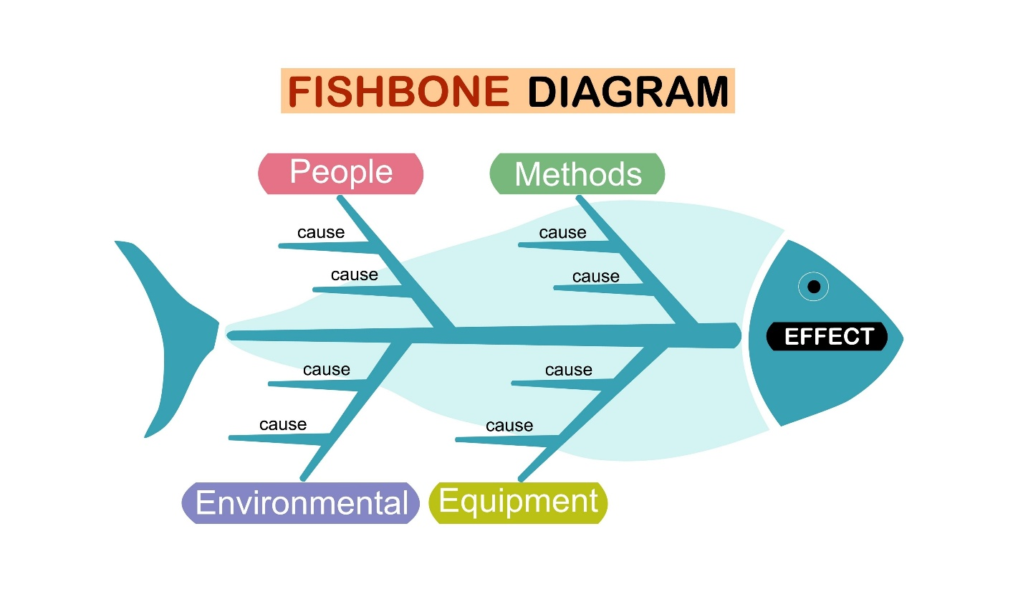
Shutterstock
The standard "bones" (categories) often include:
- Man/People: Lack of training, fatigue, poor supervision.
- Machine: Equipment failure, poor maintenance, outdated tools.
- Method/Process: Procedures unclear, work instructions outdated, poor process design.
- Material: Substandard supplier quality, wrong material used, poor storage.
- Measurement: Calibration issues, incorrect gauge, poor data collection.
- Environment: Lighting, temperature, noise, facility layout.

Step 3: Corrective Action Implementation (The ACT Phase)
Based on the RCA, specific actions are planned to eliminate the root cause.
- Target: The Root Cause identified in Step 2.
- Corrective Action (based on the 5 Whys example): Revise the Change Control Procedure to make Quality and Warehouse Management mandatory signatories for any material/packaging changes.

Step 4: Verification of Effectiveness (VOE)
This is the most frequent failure point in the CAPA process. The external auditor will always ask: "Show me the evidence that your corrective action worked and the problem has not recurred."
- Action: The owner of the CAPA must define clear metrics and a time period for verification.
  - Example: VOE Plan: Monitor the "Incorrect Material Usage" metric for the next six months. If no recurrence is found, and the updated Change Control Procedure has been followed for three supplier changes, the CAPA is considered effective and can be closed.
- Requirement (HLS 10.2): The organization must retain documented information as evidence of the nature of the NCs, the actions taken, and the results of the CAPA.

📈 III. Continual Improvement (HLS Clause 10.3)
The cycle is completed when the outcomes of the CAPA system feed directly into the Management Review (HLS 9.3).
- Data Input: Trend analysis of NCs and CAPAs provides management with data on the effectiveness of the MS.
- Strategic Adjustment: If the majority of NCs are related to training (Man/People), management must dedicate more resources and budget to Competence and Training (HLS 7.2) for the next cycle, demonstrating true continual improvement.

🏁 Conclusion of Foundational Modules
With the completion of this module on NC Resolution, managers now have a robust understanding of the entire Plan-Do-Check-Act (PDCA) framework across the HLS:
- Context and Risk (Plan: Clauses 4 & 6)
- PFMEA (Plan/Do: Risk Mitigation in Operation)
- Auditor Training (Check: Clause 9)
- CAPA/RCA (Act: Clause 10)

Module 7: ISO 9001:2015 Quality Management System (QMS) Deep Dive

🎯 Learning Objective
Upon completion, participants will be able to:
- Explain the seven Quality Management Principles (QMPs) and how they underpin the QMS.
- Detail the specific requirements for Leadership (Clause 5), emphasizing accountability and the Quality Policy.
- Implement and manage the Operational Planning and Control (Clause 8) process, including requirements for design, purchasing, and control of non-conforming outputs.
- Demonstrate system effectiveness through Performance Evaluation (Clause 9) metrics.

I. ⚖️ The Seven Quality Management Principles (QMPs)
ISO 9001 is not just a standard; it's a philosophy built on seven core principles that guide effective quality management. These principles are the yardstick by which the culture of your QMS is assessed.
- Customer Focus: The primary focus is to meet customer requirements and strive to exceed customer expectations. (This drives all of Clause 8).
- Leadership: Leaders at all levels establish unity of purpose and direction and create conditions in which people are engaged in achieving the organization's quality objectives. (This drives Clause 5).
- Engagement of People: Competent, empowered, and engaged people are essential to enhance the organization's capability to create and deliver value. (This drives Clause 7.2 Competence).
- Process Approach: Consistent and predictable results are achieved more effectively and efficiently when activities are understood and managed as interrelated processes. (The core of the entire QMS structure).
- Improvement: Successful organizations have an ongoing focus on improvement. (Driven by the PDCA cycle and Clause 10).
- Evidence-based Decision Making: Decisions based on the analysis and evaluation of data and information are more likely to produce desired results. (Driven by Clause 9.1 Performance Evaluation).
- Relationship Management: For sustained success, an organization manages its relationships with relevant interested parties, such as suppliers. (Driven by Clause 8.4 Control of Externally Provided Processes).

II. 🧑‍💼 Clause 5: Leadership – Accountability for Quality
ISO 9001 places a strong emphasis on Top Management accountability (not just delegating).

A. Leadership and Commitment (Clause 5.1)
Top management must demonstrate leadership with respect to the QMS by:
- Taking Accountability: Ensuring the QMS is effective, not just established.
- Integrating QMS: Ensuring the QMS requirements are integrated into the organization's business processes (avoiding a "separate quality system").
- Resource Provision: Ensuring the necessary resources (people, infrastructure, environment - Clause 7) are available.

B. Policy (Clause 5.2)
The Quality Policy must be:
- Appropriate to the context of the organization.
- Provide a framework for setting quality objectives (linking Clause 5.2 to Clause 6.2).
- Include a commitment to satisfy applicable requirements and continual improvement.
- It must be maintained as documented information and communicated throughout the organization.

III. 📈 Clause 6: Planning – Quality Objectives and Risk
While Clause 6.1 (Actions to Address Risks and Opportunities) is HLS common text, Clause 6.2 (Quality Objectives) is specific to 9001.

Quality Objectives and Planning to Achieve Them (Clause 6.2)
The organization shall establish quality objectives at relevant functions, levels, and processes. These objectives must be:
- Consistent with the Quality Policy.
- Measurable (Quantitative).
- Applicable to conformity of products/services and enhancement of customer satisfaction.
- Monitored, Communicated, and Updated.
Managerial Example: If a company's Quality Policy commits to "Timely Delivery," a measurable objective must be set, such as: "Reduce on-time delivery failures (orders shipped late) from 5% to 2% within the next fiscal year." The plan (Clause 6.2.2) details the actions, resources, responsibilities, and timeframe for achieving the 3% reduction.
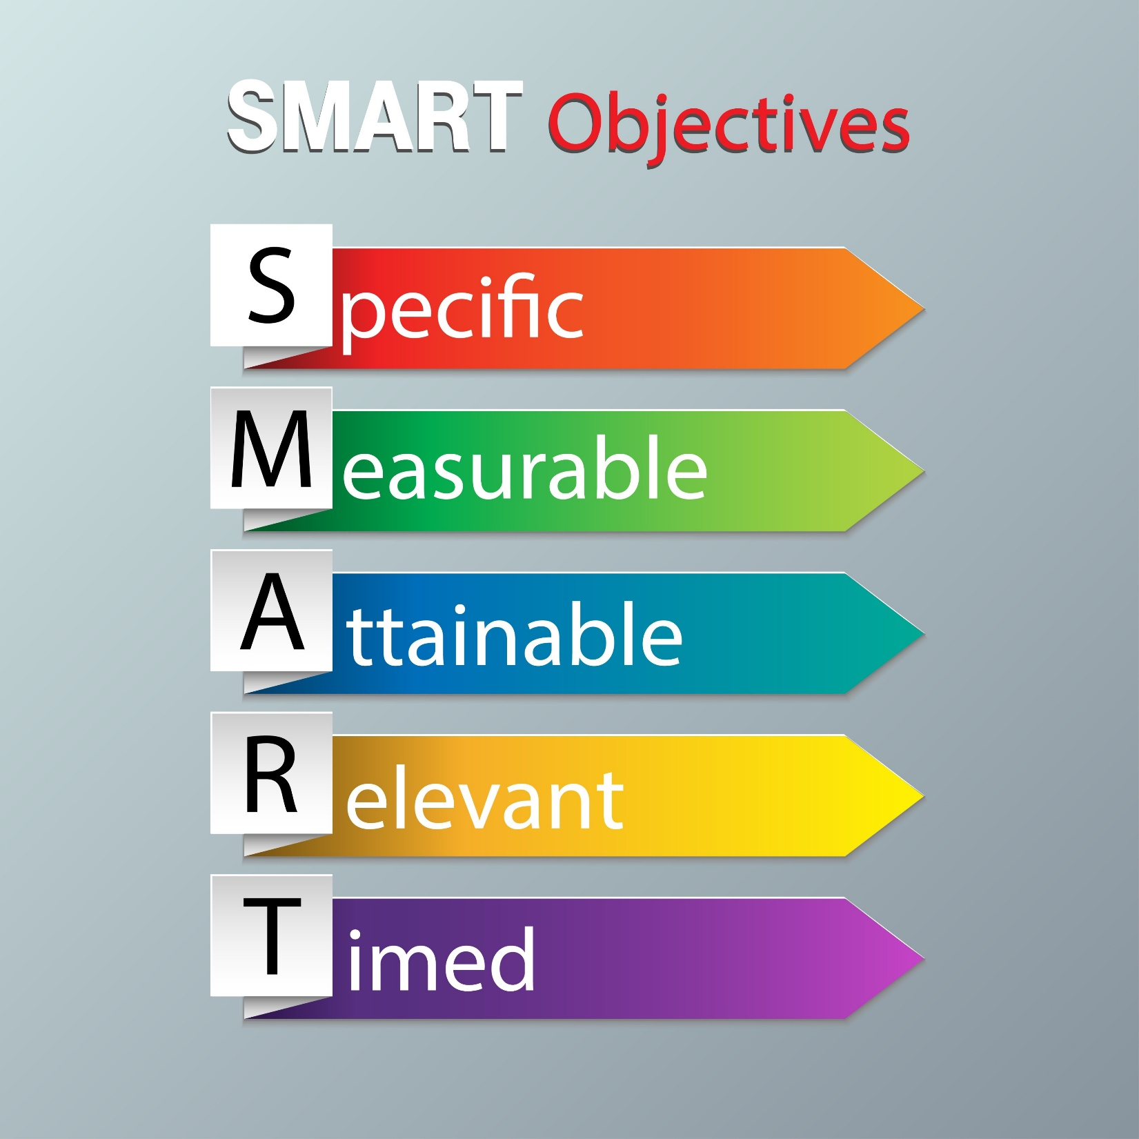

IV. ⚙️ Clause 8: Operation – The Core of QMS
Clause 8 details the requirements for the processes that directly create the product or service. This is where most external audit time is spent.

A. Operational Planning and Control (Clause 8.1)
All planned operational processes must be controlled. This involves:
- Determining the requirements for the products/services.
- Establishing criteria for the processes and the acceptance of the products/services.
- Determining the resources needed.
- Implementing control of the processes in accordance with the criteria.

B. Requirements for Products and Services (Clause 8.2)
This ensures you know exactly what the customer wants and that you can deliver it. It includes:
- Customer Communication: Establishing defined ways to communicate with customers regarding product information, contracts, handling non-conforming product, and feedback.
- Review of Requirements: Before committing to supply a product/service, the organization must review the requirements to ensure it has the ability to meet them.

C. Design and Development (Clause 8.3)
This is only mandatory if your organization performs design functions. If excluded, it must be justified in the scope (Clause 4.3).
If you design, the process must include controlled stages:
- Planning: Define the stages, reviews, and necessary resources.
- Inputs: Define requirements (functional, legal, prior designs, etc.).
- Controls: Including Reviews (at suitable stages), Verification (design meets input requirements), and Validation (resulting product meets intended use).
- Outputs: Documents that allow the product/service to be manufactured/provided (e.g., specifications, drawings, acceptance criteria).

D. Control of Externally Provided Processes, Products and Services (Clause 8.4)
This covers Purchasing and Suppliers. The organization must ensure that externally provided processes, products, and services conform to requirements.
- Supplier Evaluation: The organization must determine and apply criteria for the evaluation, selection, monitoring of performance, and re-evaluation of external providers.
- Extent of Control: The level of control applied must be proportional to the risk the supplier poses to the organization's ability to consistently meet customer and statutory/regulatory requirements.

E. Production and Service Provision (Clause 8.5)
This is the shop floor control:
- Controlled Conditions: Work must be carried out under controlled conditions (availability of documented information, infrastructure, competent people).
- Validation: Processes where the resulting output cannot be verified by subsequent monitoring or measurement must be validated (e.g., specialized welding processes).
- Identification and Traceability: Where necessary, products/services must be identifiable (e.g., batch numbers) and traceable (e.g., back to the raw material or service provider).

F. Control of Non-Conforming Outputs (Clause 8.7)
When a product or service fails to meet requirements (an NC):
- It must be identified and controlled to prevent unintended use or delivery.
- The non-conformity must be corrected (fixed) and subject to subsequent verification.
- If delivered, appropriate action must be taken (e.g., recall, customer notice). All actions taken must be retained as documented information.

V. 📊 Clause 9: Performance Evaluation – Measuring Quality
This clause addresses the CHECK phase of PDCA, ensuring the QMS is working.

Monitoring, Measurement, Analysis, and Evaluation (Clause 9.1)
The organization must determine:
- What needs to be monitored and measured (e.g., process metrics, product conformity, delivery performance).
- Methods for monitoring, measurement, and analysis.
- When the results shall be analyzed and evaluated.

Customer Satisfaction (Clause 9.1.2)
ISO 9001 mandates that organizations monitor customers’ perceptions of the degree to which their needs and expectations have been fulfilled.
- Evidence: This requires mechanisms like customer satisfaction surveys, direct customer feedback, complaint analysis (HLS 10.2), and warranty data.

Management Review (Clause 9.3)
This is the top management's formal check of the entire system (HLS 9.3). The review shall be conducted at planned intervals and cover mandatory inputs, including:
- The status of actions from previous management reviews.
- Changes in external/internal issues (Clause 4).
- Information on the performance and effectiveness of the QMS, including:
  - Customer satisfaction and feedback.
  - The extent to which quality objectives have been met.
  - Non-conformities and corrective actions (CAPA).
  - Audit results (Internal and External).
  - The need for change to the QMS.

Module 8: ISO 14001:2015 Environmental Management System (EMS) Deep Dive

🎯 Learning Objective
Upon completion, participants will be able to:
- Define the specific requirements for the Environmental Policy and top management commitment (Clause 5).
- Execute the process for identifying and evaluating Significant Environmental Aspects (SEAs) (Clause 6.1.2).
- Establish and maintain the register of Compliance Obligations (Clause 6.1.3).
- Detail the requirements for Operational Control related to environmental performance (Clause 8.1 and 8.2).

I. 🌍 Clause 5: Leadership – Environmental Commitment
ISO 14001 requires the integration of the EMS into the organization’s strategic direction, ensuring that environmental performance is prioritized at the highest level.

A. Environmental Policy (Clause 5.2)
The Environmental Policy is the cornerstone of the EMS. It must explicitly include three core commitments, often referred to as P.I.C. (Pledge, Improvement, Compliance):
- Protection of the environment, including preventing pollution (Pledge).
- Commitment to fulfill its compliance obligations (Compliance).
- Improvement of the EMS for the enhancement of environmental performance (Improvement).
Managerial Accountability: Auditors will check that the policy is appropriate to the nature, scale, and environmental impacts of the organization’s activities, products, and services (e.g., a chemical plant's policy must address chemical waste, while an office must address paper/energy use).

II. 📝 Clause 6: Planning – The Core EMS Requirements
The planning clause for ISO 14001 is where the standard diverges significantly from ISO 9001 and defines the unique aspects of environmental management.

A. Environmental Aspects and Impacts (Clause 6.1.2)
The organization shall establish, implement, and maintain a process to identify its environmental aspects and the associated environmental impacts from its activities, products, and services.
- Environmental Aspect: An element of an organization's activities or products or services that interacts or can interact with the environment. (This is the Cause.)
  - Examples: Air emissions, waste generation, raw material consumption, water discharge.
- Environmental Impact: A change to the environment, whether adverse or beneficial, wholly or partially resulting from an organization's environmental aspects. (This is the Effect.)
  - Examples: Air pollution, land contamination, resource depletion, climate change.

Determining Significant Environmental Aspects (SEAs)
The organization must determine which aspects have or can have a Significant Environmental Impact (SEA). This process is crucial and often uses a matrix approach, similar to risk assessment, but focused on environmental consequence.
$$\text{Significance Score} = \text{Severity/Scale of Impact} \times \text{Frequency/Likelihood} \times \text{Regulatory Concern}$$
- EHS Manager Action: A typical manufacturing plant generates general office waste (Aspect) and hazardous chemical waste (Aspect). While both are waste, the hazardous chemical waste will have a much higher Severity score due to contamination risk, making it an SEA requiring mandatory operational controls and objectives.

B. Compliance Obligations (Clause 6.1.3)
The organization shall determine and have access to the compliance obligations related to its SEAs. These include:
- Legal Requirements: Mandatory laws, regulations, and permits (e.g., wastewater discharge permits, hazardous waste manifest laws).
- Voluntary Requirements: Non-mandatory commitments the organization chooses to adopt (e.g., industry codes of practice, supplier environmental requirements, voluntary agreements with communities).
Crucial Requirement: The organization must maintain documented information of its compliance obligations (often called the Compliance Register) and evaluate its performance against these obligations (Clause 9.1.2). Auditors will verify that the organization has a mechanism to monitor changes in law and update the register.

III. 🏭 Clause 8: Operation – Environmental Control
Operational control ensures that the activities linked to the SEAs are managed effectively to prevent pollution and ensure compliance.

A. Operational Planning and Control (Clause 8.1)
The organization must plan, implement, and control processes to meet its compliance obligations and environmental objectives. This includes:
- Establishing documented operational criteria for controlling SEAs (e.g., procedure for hazardous waste labeling, monitoring, and storage).
- Implementing controls for changes to the EMS (e.g., introduction of a new chemical).
- Ensuring controls are applied to outsourced processes (e.g., the disposal procedure used by a waste hauling contractor).

B. Emergency Preparedness and Response (Clause 8.2)
The EMS must include a plan for preventing and mitigating the environmental impacts of potential emergency situations.
- Examples: Major chemical spill, catastrophic containment system failure, fire impacting stored hazardous materials.
- Action: The organization must periodically test these emergency response procedures (e.g., annual spill drill) and review and revise them, particularly after actual incidents or tests. This often links directly with the OH&S emergency planning (ISO 45001).

IV. 📊 Clause 9: Performance Evaluation – Measuring Environmental Success
Environmental performance must be monitored and measured to demonstrate the EMS's effectiveness.

A. Monitoring, Measurement, Analysis, and Evaluation (Clause 9.1)
Organizations must track metrics that demonstrate improvement against their Environmental Objectives and Compliance Obligations.
- Key Environmental Performance Indicators (EPIs):
  - Resource Usage: $\text{kWh}$ per unit of production, water consumption per unit, or waste generated per employee.
  - Compliance Score: Number of compliance deviations, fines issued, or percentage of compliance register reviewed.
  - Objective Status: Tracking reduction goals (e.g., $\text{CO}_2$ emissions reduction percentage).

B. Evaluation of Compliance (Clause 9.1.2)
The organization shall evaluate its compliance with its legal and voluntary obligations at planned intervals.
EHS Audit Focus: The auditor will check for records demonstrating that the EHS Manager regularly reviews the facility against all legal requirements (e.g., monthly walkthrough checking permit conditions, labeling, storage areas) and reports the status of this compliance evaluation to the Management Review (Clause 9.3).

Module 9: ISO 45001:2018 Occupational Health & Safety (OH&S) MS Deep Dive

🎯 Learning Objective
Upon completion, participants will be able to:
- Explain the OH&S Policy requirements and the non-negotiable commitment to eliminating hazards.
- Detail the mandatory requirements for Consultation and Participation of Workers (Clause 5.4).
- Execute the process for Hazard Identification and Risk Assessment (HIRA), applying the mandatory Hierarchy of Controls (Clause 6.1.4).
- Understand the requirements for managing OH&S Opportunities and the continual improvement cycle specific to safety.

I. 🤝 Clause 5: Leadership – Worker Consultation
ISO 45001 requires leaders to not only commit to safety but to ensure that the workers who face the risks are actively involved in the system's design and operation.

A. OH&S Policy (Clause 5.2)
The OH&S Policy is the cornerstone of the safety system and must include two specific commitments:
- A commitment to provide safe and healthy working conditions for the prevention of work-related injury and ill health.
- A commitment to eliminate hazards and reduce OH&S risks (This is stronger than 9001/14001—it requires proactive elimination).
- A commitment to the consultation and participation of workers.

B. Consultation and Participation of Workers (Clause 5.4)
This clause is unique to ISO 45001 and is a frequent area of non-conformity. The system must ensure that workers are consulted on safety decisions and participate in safety functions.
- Consultation: Seeking the views of non-managerial workers before a decision is made (e.g., consulting workers on new PPE selection).
- Participation: Active involvement in decision-making (e.g., non-managerial workers are mandatory members of the Safety Committee, or part of the HIRA team).
HR/Plant Manager Application: The auditor will check for documented evidence (e.g., meeting minutes, signed training records) that non-managerial workers (and their representatives, if applicable) are involved in:
- The development of the OH&S Policy.
- Identifying hazards and evaluating risks.
- Determining control measures and investigating incidents.

II. ⚠️ Clause 6: Planning – Hazard Management
This clause is the heart of the safety management system, focusing entirely on proactive risk management for health and safety.

A. Hazard Identification and Assessment of OH&S Risks (HIRA) (Clause 6.1.2)
The organization shall establish a process to identify OH&S hazards and assess OH&S risks. This goes beyond physical risks to include:
- Routine and Non-Routine Activities: Including maintenance, cleaning, and emergency activities.
- Human Factors: Including fatigue, stress, competency gaps.
- Situations in the vicinity: Risks from contractors, visitors, or neighbors.
- Design of Work Areas: Including machinery, equipment, and facility design.

B. The Hierarchy of Controls (Clause 8.1.2)
After identifying risks, the organization shall prioritize and implement controls using the Hierarchy of Controls. This is a mandatory sequence—lower-level controls cannot be used unless higher-level controls are not feasible.
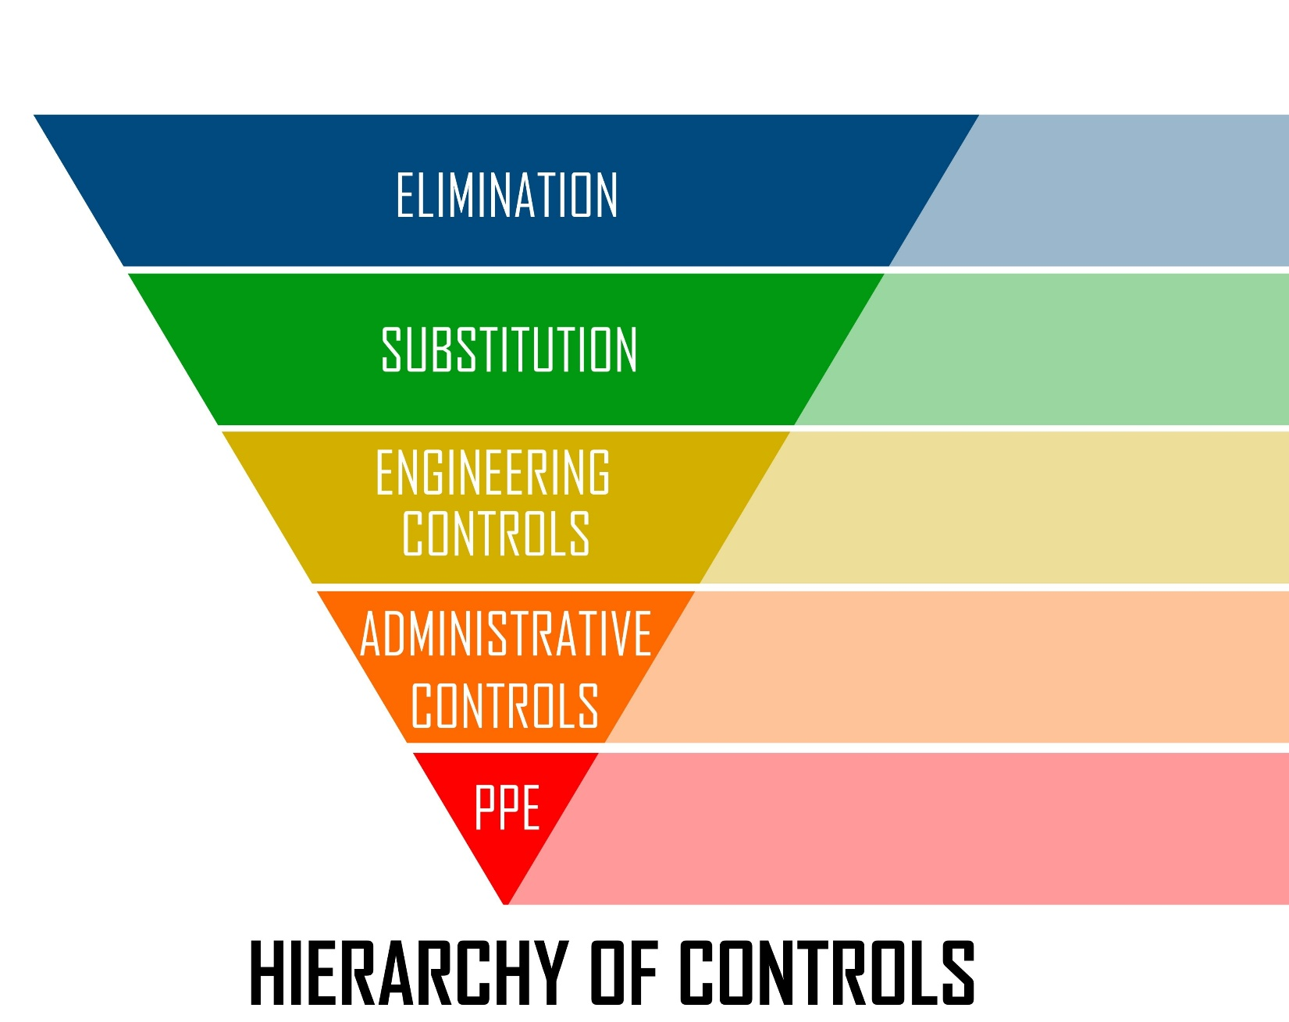

- Elimination: Physically remove the hazard (e.g., eliminate the need to work at height by lowering the equipment).
- Substitution: Replace the hazard with a less hazardous one (e.g., using a safer chemical alternative).
- Engineering Controls: Design out the hazard or isolate people from it (e.g., installing machine guards, local exhaust ventilation (LEV) systems).
- Administrative Controls: Change the way people work (e.g., written procedures, job rotation, warning signs, LOTO procedures).
- Personal Protective Equipment (PPE): Last resort, protects the individual (e.g., safety glasses, gloves, hard hats).
EHS Manager Compliance Focus: Auditors will look for evidence that the organization systematically tried the first three levels before settling on Administrative Controls or PPE. Example: Did you try to substitute a quieter machine (Engineering) before issuing earplugs (PPE)?

C. Management of Change (MOC) (Clause 8.1.3)
This is a critical preventive requirement, ensuring that risks are evaluated before changes are implemented.
- The organization shall establish a process for MOC covering:
  - New products, processes, equipment, or facilities.
  - Changes to compliance obligations.
  - Changes in knowledge and information about hazards.

III. 🏭 Clause 8: Operation – Safety Controls and Emergencies

A. Operational Planning and Control (Clause 8.1)
The organization must establish controls to manage risks identified in the HIRA.
- Procurement: Safety must be a mandatory criterion when purchasing goods and services. (e.g., requiring safety data sheets (SDS) before chemical delivery, verifying new equipment is certified safe).
- Contractors: The organization must ensure that contractors and their workers comply with the OH&S requirements and that the contractor's activities do not negatively impact the organization's safety performance (a major liability area).

B. Emergency Preparedness and Response (Clause 8.2)
The OH&S system must include a plan for emergencies that could arise from the organization’s processes.
- Examples: Medical emergencies, fire, evacuation, severe weather, release of hazardous materials.
- Testing: Emergency procedures must be tested periodically (e.g., annual fire drills, LOTO simulations) and reviewed and revised after testing or actual incidents.

IV. 📊 Clause 9: Performance Evaluation – Monitoring Safety

Incident Investigation (Clause 10.2)
When an OH&S incident (injury, near-miss, or hazard detection) occurs, the organization shall establish a mandatory process to:
- React: Provide immediate medical aid and investigate the incident.
- Identify Root Causes: Use RCA tools (5 Whys, Fishbone) to determine the systemic failures.
- Implement Corrective Action: Take action to eliminate the root cause and prevent recurrence.
- Review Risks: Update the HIRA for the process where the incident occurred.
Key Difference: For ISO 45001, incident investigation is treated as a Corrective Action (Clause 10.2). The organization must always review its performance to determine if the safety system is effective.

Module 10: IATF 16949:2016 – QMS for Automotive Production Deep Dive

🎯 Learning Objective
Upon completion, participants will be able to:
- Explain the relationship between ISO 9001, IATF 16949, and Customer-Specific Requirements (CSRs).
- Detail the mandatory requirements for Contingency Plans and Product Safety (Clause 6.1.2.3 and 4).
- Implement and document core automotive tools like APQP, PPAP, MSA, and SPC (Clauses 8.3 and 8.5).
- Understand the requirements for Second-Party Audits and the severe consequences of Major Non-Conformities in the automotive sector.

I. 🗺️ The Automotive Quality Pyramid
IATF 16949 is not a standalone standard; it is an overlay that must be used in conjunction with ISO 9001:2015.
Level | Requirement | Detail & Scope
Foundation (Level 1) | ISO 9001:2015 | The basic QMS requirements (HLS Clauses 4-10). The foundation for all systems.
The Overlay (Level 2) | IATF 16949:2016 | Specific, enhanced requirements for the design, development, production, installation, and servicing of automotive-related products. This section adds, replaces, or reinterprets specific 9001 clauses.
The Details (Level 3) | Customer-Specific Requirements (CSRs) | Mandatory additional requirements defined by OEMs (e.g., Ford, GM, Stellantis, BMW, VW). These are mandatory and failure to meet them is an IATF non-conformity.
The Tools (Level 4) | Core Tools (AIAG/VDA) | Mandatory methodologies like APQP, PPAP, PFMEA, MSA, and SPC.
Crucial Concept: If a specific clause is covered in IATF 16949 (e.g., Clause 8.3.2.1), the organization must comply with the IATF requirement in addition to the ISO 9001 requirement. If a CSR exists for that clause, the organization must comply with all three.

II. ⚠️ Enhanced Planning and Risk (Clause 6)
IATF significantly beefs up planning and risk assessment to prevent catastrophic production failures.

A. Product Safety (Clause 6.1.2.3)
The organization shall have documented processes for the management of product safety related products and manufacturing processes. This includes:
- Identifying and controlling safety-related processes (e.g., torquing, welding, critical component placement).
- Defining responsibilities for product safety at all organizational levels.
- Retaining records of risk analyses (often achieved via Design FMEA and Process FMEA) and mandatory special characteristics.

B. Contingency Plans (Clause 6.1.2.3)
This is a mandatory enhancement to ISO 9001's general planning. The organization shall prepare contingency plans for all identified risks associated with interruptions to production.
- Mandatory Coverage: Utility interruption (power/water), key equipment failure, labor shortages, field returns, and failure of external infrastructure (e.g., supply chain delivery).
- Requirement: Contingency plans must be periodically tested for effectiveness (e.g., conducting a blackout drill) and reviewed at least annually. Auditors specifically check the records of these tests.

III. ⚙️ Core Automotive Operating Requirements (Clause 8)
Clause 8 (Operation) contains the bulk of IATF's unique demands.

A. Core Tools Mandate
IATF makes several quality methodologies (Core Tools) mandatory for implementation and reporting to the customer.
Core Tool | IATF Clause Link | Purpose/Requirement
APQP (Advanced Product Quality Planning) | 8.3 Design & Dev. | Structured process for ensuring customer satisfaction by planning and developing products and services that meet requirements.
PPAP (Production Part Approval Process) | 8.3.4.4 PPAP | Mandatory submission of evidence (e.g., testing, measurement results, control plan) to the customer for approval before full-scale production begins.
PFMEA (Process Failure Mode & Effects Analysis) | 6.1.2.1 Risk | Mandatory tool for assessing risks related to manufacturing processes. Must follow the AIAG-VDA 7-Step Method (as covered in Module 5).
MSA (Measurement System Analysis) | 7.1.5.1.1 MSA | Mandatory statistical study to determine if the measurement system itself (gauge, tester, operator) is accurate and precise enough for the job (e.g., Gauge R&R studies).
SPC (Statistical Process Control) | 9.1.1.1 SPC | Mandatory use of statistical tools (e.g., Control Charts) to monitor process stability and capability, proving the process can consistently meet specifications.

B. Traceability (Clause 8.5.2.1)
Traceability requirements are significantly tightened, particularly for safety-related products.
- The organization shall identify product status with respect to monitoring and measurement requirements throughout the production process.
- For product safety and regulatory purposes, the organization shall implement a defined traceability plan (e.g., serialization) that enables rapid, documented response to customer/regulatory recalls.

C. Control Plan (Clause 8.5.1.1)
The Control Plan is a dynamic document that describes the methods used to control the system and product at three levels (prototype, pre-launch, and production).
- Mandatory Requirement: A Control Plan must be created for all products and processes and must explicitly list the Special Characteristics (safety-critical features, fit/function).
- Key Link: The Control Plan is derived directly from the PFMEA and Process Flow Diagram, ensuring every identified risk is controlled on the shop floor.

IV. 📝 Second-Party Audits and Certification Management (Clause 9)
IATF auditors are highly focused on the compliance lifecycle.

A. Internal Audits (Clause 9.2)
Internal audits must cover three distinct areas:
- QMS Audits: Auditing the conformance of the IATF 16949 clauses.
- Manufacturing Process Audits: Auditing the effectiveness of all manufacturing processes using a process approach (checking inputs, activities, and outputs).
- Product Audits: Auditing the finished product against customer specifications.

B. Supplier Quality Management (Second-Party Audits) (Clause 8.4)
The organization is responsible for ensuring its suppliers comply with quality requirements.
- Supplier Selection: IATF requires the use of a documented supplier selection process that includes an assessment of the supplier's QMS and their ability to meet technical requirements.
- Mandatory Requirement: The organization shall perform Second-Party Audits of its suppliers when required by its risk analysis or by customer requirements.

C. Major Non-Conformities and Sanctions (Third-Party Audits)
The consequences of failing an IATF audit are severe, often leading to sanctions that disrupt business.
- Major NC Sanction: A Major NC (system failure or risk of non-conforming product reaching the customer) requires the organization to provide containment and corrective actions within 60 days. Failure to do so leads to certificate withdrawal.
- Special Status: Repeated failure or severe customer dissatisfaction can lead to the OEM placing the supplier on "Special Status" (e.g., Tier 1, Managed Shipping), which requires mandatory daily reporting and continuous monitoring by the customer.
Training Detail: The IATF auditor uses a process approach and will audit your system by tracing a single Customer Order through your entire facility (from order entry to design, supplier management, production, inspection, and shipping) to verify controls at every step.

Module 11: Integrating the IMS: The CCH Compliance Advantage

🎯 Learning Objective
Upon completion, participants will be able to:
- Define the structure and benefits of an Integrated Management System (IMS).
- Identify where the requirements of ISO 9001, 14001, 45001, and IATF 16949 overlap based on the High-Level Structure (HLS).
- Explain how EHS, Plant, and HR Managers can collaborate within an IMS framework to reduce redundancy and maximize efficiency.
- Articulate how CCH resources are designed to support and sustain a compliant IMS.

I. 🌐 The Power of the Integrated Management System (IMS)
An IMS combines all the organization's management system requirements (Quality, Environment, Safety, etc.) into one cohesive system. This is only possible because all modern ISO standards share the High-Level Structure (HLS) / Annex SL.
Advantage | Benefit to the Organization | Stakeholder Impact
Reduced Duplication | Eliminating redundant documentation, procedures, and training (e.g., one Document Control procedure instead of three). | HR Manager: Simplifies training programs and competence records.
Holistic Risk Management | Assessing risks (Q, E, S) concurrently, ensuring controls address multiple hazards (e.g., LOTO procedure addresses both equipment damage and worker injury). | Plant Manager: Ensures operational planning meets all QES requirements simultaneously.
Unified Audit Program | Conducting one internal audit covering all standards, saving time and personnel resources. | EHS Manager: Streamlines audit preparation and reporting efforts.
Consistent Strategy | Aligning all QES objectives with the company's single strategic direction (HLS Clause 4 & 5). | Top Management: Provides a clearer, consolidated view of organizational performance.

II. 🔗 Overlap: Where Integration Occurs
The following table demonstrates the key areas of mandatory overlap where a single integrated procedure or document is sufficient to meet multiple standards:
HLS Clause | Common Requirement | ISO 9001 Focus (Q) | ISO 14001 Focus (E) | ISO 45001 Focus (S)
4. Context | External/Internal Issues | Market competition, technology | Regulatory changes, resource scarcity | Worker availability, legal changes
5. Leadership | Policy & Commitment | Quality Policy & Customer Focus | Environmental Policy & Pollution Prevention | OH&S Policy & Hazard Elimination
6.1 Planning | Risk Assessment | PFMEA, Process Risk | Significant Environmental Aspects (SEAs) | Hazard Identification (HIRA)
7.2 Competence | Training & Evaluation | Skills needed for product quality | Training on SEAs/Spill Response | Training on HIRA/LOTO
7.5 Documented Info | Document Control | Control of Specifications, Control Plans | Control of Compliance Register | Control of OH&S Procedures
8.2 Emergency | Preparedness | Customer communication for recalls | Spill response, containment | Fire, medical, evacuation drill
9.2 Internal Audit | Audit Plan & NCs | Audit quality processes | Audit environmental aspects/compliance | Audit safety controls/consultation
9.3 Mgmt Review | Review Inputs | Review Customer Satisfaction, Quality data | Review Compliance Status, SEA data | Review Incident Data, HIRA status
Process Example (Integrated Internal Audit): An auditor reviews the Preventive Maintenance (PM) procedure (HLS 8.1). They check:
- QMS: Is the PM procedure followed to prevent product defects? (9001)
- EMS: Is the oil disposal listed in the PM procedure handled according to the hazardous waste plan? (14001)
- OH&S: Does the PM require Lockout/Tagout (LOTO) to be performed, and are the workers trained? (45001)
One audit step, three compliance checks.

III. 🧩 Departmental Collaboration within the IMS
The IMS breaks down traditional organizational silos, mandating cross-functional cooperation for key HLS clauses.

A. The Plant Manager & Operations (HLS Clause 8)
- Role: The owner of the production process and the executor of controls.
- IMS Focus: Ensures that operational criteria (e.g., machine settings, work instructions) simultaneously manage Product Quality (9001), Energy/Waste Consumption (14001), and Worker Safety (45001).
- CCH Advantage: Using CCH training, the Plant Manager can conduct RPFMEA (Module 5) to proactively confirm controls are effective for Q, E, and S risks.

B. The EHS Manager (HLS Clause 6 & 8)
- Role: The expert on legal compliance and risk mitigation (Environmental Aspects and OH&S Hazards).
- IMS Focus: The EHS Manager creates the integrated Risk Register, ensuring that the Compliance Obligations (14001, 45001) are linked as risks to the business (HLS 6.1) and communicated to Operations.
- CCH Advantage: CCH provides clear guidance on the Hierarchy of Controls (Module 9), ensuring safety improvements are systematic, not just PPE-reliant, and documented for ISO 45001 compliance.

C. The HR Manager (HLS Clause 7)
- Role: The owner of competence, training, and internal communication.
- IMS Focus: Maintains a single, integrated Competence Matrix (HLS 7.2) that tracks employee training across all standards (e.g., LOTO training for 45001, Statistical Process Control (SPC) training for 9001/IATF, and Hazardous Waste training for 14001). HR also manages the mandatory Consultation and Participation process (45001).
- CCH Advantage: CCH training modules ensure the Quality of Training is consistent and documented, satisfying the auditor's requirement to prove competence on all QES elements.

IV. 🚀 CCH: Your Source for Sustained Compliance
CCH is positioned to be the key resource for managers at every stage of the compliance journey:
- Gap Analysis to Implementation: CCH courses provide the detailed methodology to transition from the "Desired State" identified in the Gap Analysis (Module 2) to a fully implemented system.
- Audit Readiness: By providing deep training on Internal Auditing (Module 4) and Non-Conformity Resolution (Module 6), CCH ensures the organization is ready for Second and Third-Party Audits (especially critical for IATF).
- Advanced Automotive Compliance: Specialized training on PFMEA/RPFMEA and Core Tools (Module 5 & 10) ensures your team meets the mandatory technical requirements of the automotive sector.
- Continual Improvement: CCH modules reinforce the PDCA cycle and the use of RCA/CAPA (Module 6), proving to auditors that compliance is an ongoing, value-driven process, not just a one-time certification effort.

Module 12: Customer-Specific Requirements (CSRs) – The Mandatory Overlays

🎯 Learning Objective
Upon completion, participants will be able to:
- Define Customer-Specific Requirements (CSRs) and distinguish them from ISO/IATF requirements.
- Explain the mandatory nature of CSRs and their impact on QMS compliance and certification.
- Implement a robust system for identifying, integrating, and maintaining compliance with CSRs (HLS Clause 4 & 6).
- Understand the severe business and audit consequences of CSR non-conformance.

I. 📝 What Are Customer-Specific Requirements (CSRs)?
Customer-Specific Requirements (CSRs) are mandatory supplemental requirements defined by an organization's specific customer(s), particularly Original Equipment Manufacturers (OEMs) like Ford, GM, BMW, or Stellantis.

A. The Requirement Hierarchy
CSRs sit at the top of the automotive quality pyramid, overriding general IATF or ISO requirements where they are more stringent.
- Foundation: ISO 9001 (Basic QMS)
- Layer 1: IATF 16949 (Automotive enhancement of 9001)
- Layer 2 (The Overlays): CSRs (Specific, mandatory rules set by the customer)
Key Distinction: IATF 16949 is a technical specification that tells the organization what to do (e.g., "The organization shall conduct a measurement system analysis"). The CSRs tell the organization how to do it for that specific customer (e.g., "The MSA Gauge R&R study must use the software and format specified in our internal manual, and the acceptable R&R limit is 10%, not the standard 20%").

B. Common Areas Covered by CSRs
CSRs usually focus on areas where the OEM has unique standards, proprietary systems, or requires tighter control than the general IATF specification:
- Core Tools: Specific formats, submission portals, and acceptable limit criteria for PFMEA, PPAP, Control Plans, and SPC.
- Supplier Requirements: Detailed requirements for the supplier's supply chain (e.g., mandating the use of a specific supplier portal for transactions).
- Warranty Management: Specific protocols and reporting metrics for handling customer warranty claims and return parts analysis.
- Product Identification: Unique labeling standards (e.g., barcoding, serialization) and packaging requirements.
- Special Characteristics: Unique symbols or control methods for critical or safety-related characteristics.

II. 🏭 Impact and Implementation for Companies
CSRs impact nearly every clause in the QMS and directly affect the cost and feasibility of production. Failure to meet a CSR is treated by a third-party IATF auditor as a Non-Conformity (NC) to the IATF 16949 standard itself.

A. Implementation Stage 1: Identification and Integration (HLS Clause 4 & 6)
CSR compliance begins in the planning phase.
- Identification (HLS Clause 4.2 - Interested Parties): The organization must identify the relevant CSRs for every customer and every specific part/program they supply. This must be listed in the Compliance Register (like an ISO 14001 legal register).
  - Challenge: CSRs are frequently updated. The organization must have a formal, documented process (HLS Clause 7.5) to track, receive notification of, and review CSR changes.
- Integration into the QMS (HLS Clause 6.1 - Planning): Once identified, every CSR must be broken down and integrated into the relevant internal procedures and documented information.
  - Example: If a CSR mandates a specific Customer Scorecard reporting frequency, the internal Performance Evaluation Procedure (HLS 9.1) and Management Review Input (HLS 9.3) must be updated to match that frequency.

B. Implementation Stage 2: Verification and Control (HLS Clause 8 & 9)
Compliance must be demonstrated through documented evidence and audits.
- Operational Control (HLS Clause 8): CSRs often dictate how work is done. The Control Plan (a mandatory IATF document) must explicitly reference the CSR for every step it affects.
  - Example: The Control Plan for a safety feature must reference the OEM's CSR regarding the frequency of testing for that specific characteristic.
- Internal Audits (HLS Clause 9.2): Internal auditors must be trained to audit CSRs. The Internal Audit Checklist must contain specific questions derived directly from the CSR document.
  - Audit Focus: The auditor will look for evidence that employees on the shop floor know which CSRs apply to their job and how they implement them (e.g., "Show me the procedure that verifies this part is labeled according to Ford's CSR").

III. 🚨 Consequences of Non-Compliance
The impact of CSR non-conformance extends far beyond a typical ISO minor finding.

A. Certification Impact (IATF)
- Audit NCs: An IATF third-party auditor will cite a non-conformance to IATF 16949 if a CSR is not met, classifying it based on severity. Since CSRs are often tied to product delivery or safety, they frequently result in Major Non-Conformities.
- Loss of Business: Failure to address a Major NC can lead to the withdrawal of IATF certification, which immediately makes the supplier ineligible to quote new business with most OEMs.

B. Customer Sanctions
CSR violations trigger the customer's proprietary quality management system, leading to severe sanctions that affect the supplier's standing:
- Supplier Scorecards: Poor CSR compliance often results in a low Supplier Scorecard rating, which can prevent the supplier from being awarded future contracts.
- Cost Recovery: If the CSR non-compliance leads to a Customer Complaint, Warranty Claim, or Field Return, the OEM has the contractual right (often defined in the CSR) to seek cost recovery from the supplier for inspection, sorting, or scrap costs.
- Special Status: Repeated or severe CSR issues can lead to the supplier being moved to "Forced Status" or "Special Status" by the customer, requiring daily reporting, mandatory site visits, and potentially the cost of the customer's resident engineer on site.

C. The CCH Advantage: Turning CSRs into a Competitive Edge
CSRs are a burden, but companies that manage them efficiently gain a competitive advantage.
- Centralized Knowledge: CCH training provides a structured methodology for breaking down complex, often lengthy CSR documents into actionable, auditable internal requirements.
- Risk Mitigation: By linking CSRs directly to the PFMEA/Control Plan (HLS 6.1 and 8.5), CCH helps managers proactively assess the risk of non-compliance, avoiding costly sanctions and charge-backs.
- Cross-Functional Alignment: CCH emphasizes that CSR compliance is a team effort (Quality, Production, Engineering, HR), using the IMS framework to assign clear responsibility for monitoring different sections of the CSR.

This assessment will test your knowledge of the AIAG-VDA 7-Step Process Failure Mode and Effects Analysis (PFMEA) and the critical application of Reverse PFMEA (RPFMEA), which are essential for proactive risk management in quality and operations.
PFMEA & RPFMEA Mastery Assessment
Nov 11, 1:14 PM
This assessment covers the foundational principles and application steps of the PFMEA and RPFMEA, ensuring your participants grasp the critical aspects of automotive risk analysis and control va
1.
Which of the following best describes the primary objective of a Reverse Process FMEA (RPFMEA) audit?
A.
To physically validate on the shop floor that the controls listed in the PFMEA are implemented, functional, and effective.
That's right!
The core purpose of RPFMEA is to verify the efficacy of the documented controls by testing them in the live operational environment.
B.
To calculate the Risk Priority Number (RPN) for high-severity failure modes before final approval.
C.
To review the PFMEA team's severity, occurrence, and detection ratings in a classroom setting.
D.
To document the failure modes and effects for a completely new manufacturing process.

2.
In the AIAG-VDA 7-Step PFMEA methodology, which rating factor is primarily reduced by implementing preventive controls (e.g., enhanced training, scheduled maintenance, Poka-Yoke)?
A.
Detection (D)
B.
Action Priority (AP)
C.
Occurrence (O)
That's right!
Preventive controls are intended to stop the cause of the failure mode from happening, thereby reducing the Occurrence rating.
D.
Severity (S)

3.
Which PFMEA step is characterized by breaking down the process into System/Focus Element/Work Element to clearly define the boundaries of the analysis?
A.
Step 3: Function Analysis
Not quite
Function Analysis focuses on defining the purpose and requirements of each element, not its structural relationship.
B.
Step 4: Failure Analysis
C.
Step 1: Planning and Preparation
D.
Step 2: Structure Analysis
Right answer
Structure Analysis maps the elements of the process to ensure a clear, systematic flow and define what is being analyzed at each stage.

4.
According to the AIAG-VDA FMEA Handbook, what is the key difference between the traditional RPN (Risk Priority Number) system and the modern Action Priority (AP) system?
A.
RPN requires a cross-functional team, whereas AP allows a single process engineer to perform the risk assessment.
B.
AP is only used for high-volume production, while RPN is for prototyping.
C.
AP provides a High, Medium, or Low priority level, forcing mandatory action on high-severity issues regardless of RPN score.
Right answer
AP moves beyond the simple RPN multiplication, using a matrix that prioritizes the most severe failures even if Occurrence or Detection scores are low.
D.
AP is primarily used for Design FMEA, while RPN is used for Process FMEA.
Not quite
RPN and AP are used for both Design and Process FMEA, depending on the organizational standard.
5.
In the PFMEA Failure Analysis (Step 4), a high rating for Severity (S) is always determined by which element of the failure chain?
A.
The potential consequences/impact (Effect) on the customer or system if the failure reaches them.
Right answer
Severity is a measure of the seriousness of the Failure Effect, with the highest scores reserved for safety or regulatory non-compliance.
B.
The resources required to implement the corrective action plan.
C.
The ability of the current controls to detect the failure.
Not quite
Control capability determines the Detection (D) rating, not the Severity (S).
D.
The likelihood of the Failure Cause occurring.

6.
Which of the following is the highest priority action for risk optimization in a PFMEA?
A.
Implement a Detection Control (e.g., end-of-line gauge) to catch the failure.
Not quite
Detection is a necessary control, but is less effective than prevention because the failure has already occurred.
B.
Accept the risk and document the rationale in the Management Review minutes.
C.
Increase the Severity rating based on the potential financial loss.
D.
Implement a Preventive Control (e.g., Poka-Yoke, process interlock) to eliminate the cause.
Right answer
Preventive actions are always preferred because they eliminate the root cause and prevent the failure from occurring in the first place, thus reducing Occurrence.
7.
A PFMEA team identifies the Failure Mode as 'Wrong part selected by operator'. What is the most likely Failure Cause associated with this mode?
A.
The entire assembly line shuts down for 30 minutes.
B.
Product is scrapped or requires costly rework.
C.
A check station at the end of the line is bypassed by the operator.
D.
Operator lacks training and parts bins are visually identical and not color-coded.
That's right!
The Cause is the specific deficiency in the system (lack of training, poor visual management) that allows the Mode to occur.
8.
In the AIAG-VDA system, the Function Analysis (Step 3) requires the team to define two things for each Focus Element. What are they?
A.
The potential Failure Modes and the Preventive Controls.
Not quite
Failure Modes are defined in Step 4; Controls are defined in Step 5/6.
B.
The Severity rating and the RPN value.
C.
The external infrastructure and all interested parties.
D.
The specific Function/Purpose and the associated Requirements (e.g., torque spec, cycle time).
Right answer
Function Analysis establishes what the process is supposed to do and the criteria for success, which then allows for the identification of failure (loss of function).

9.
When assessing the Detection (D) rating in a PFMEA, what principle leads to a lower (better) score?
A.
The control is a non-automated gauge or test that checks the product several steps after the failure occurred.
B.
The control is an automated Poka-Yoke that physically stops the process and prevents the cause from occurring.
Not quite
Poka-Yoke is an error-proofing preventive control, not strictly a detection control, though its D score would be excellent.
C.
The failure mode is detected by a human visual inspection at the end of the assembly line.
D.
The control is automated and implemented at the source of the failure to detect non-conforming characteristics 100% of the time.
Right answer
Automated 100% checks at the source provide the highest confidence of detection, resulting in the lowest (best) Detection score.
10.
Which organizational role is primarily responsible for ensuring that the PFMEA results are integrated into the Control Plan (HLS Clause 8) and used to establish process monitoring criteria?
A.
External Certification Auditor
B.
Financial Controller
C.
Process Engineer / Quality Manager
That's right!
The Process Engineer and Quality Manager are the primary owners of process documentation, including the PFMEA, Control Plan, and ensuring process monitoring criteria are set.
D.
Human Resources Manager

PFMEA & RPFMEA Mastery (AIAG-VDA 7-Step)
https://gemini.google.com/share/233ac6ea8399

