Project: File Management

Background

We manufacture and market ‘Music Servers’. The music servers are Fedora Linux computers that are run headless as a digital music source in stereo systems. The music servers use ‘setup’ software that users access by browsing to the music server on their local network. The existing setup software is supplied to us by a partner and is not well documented. It is written using SMARTY PHP Template Engine.

Users of our music servers turn them on and then browse to our website where we display the music servers on their local network. This happens because every startup and shutdown communicates with a database on our web server.

When the user clicks on the music server they wish to configure, they are taken to the user interface referred to above.

The software partner is good at the backend software – Fedora OS, real-time kernel, etc, but the user interface is poor. It has been agreed that we will re-write the user interface in stages. In the first stage, we have improved the UI but the functionality is still based on the existing SMARTY PHP functionality. We have html and css skills but we do not have SMARTY, PHP or Javascript skills and seek a coder with excellent skills to assist us with the next stages of development.

The File Management Project is to develop functionality that is missing in the existing software solution, so it can be written in any suitable language. It does not need to be in SMARTY. Our preference is for it to be written in PHP but we are happy to consider other alternatives, provided it does not limit our future development or maintenance of the software. We have already had two applications developed in PHP for us.

We have looked at existing application options available to meet our needs, and there are some available that meet some or most of our needs, but they need work in order to meet all of our needs. We have included one of these applications as a placeholder in our prototype software, which we will provide to you. This application is a single php file and may provide a good starting point for development.

Objective

When the user opens the file management link, a new web page should open, at the file management ‘/storage’ directory. Here is a screenshot of how it should look (not necessarily this colour scheme, but this image illustrates a suitable structure).

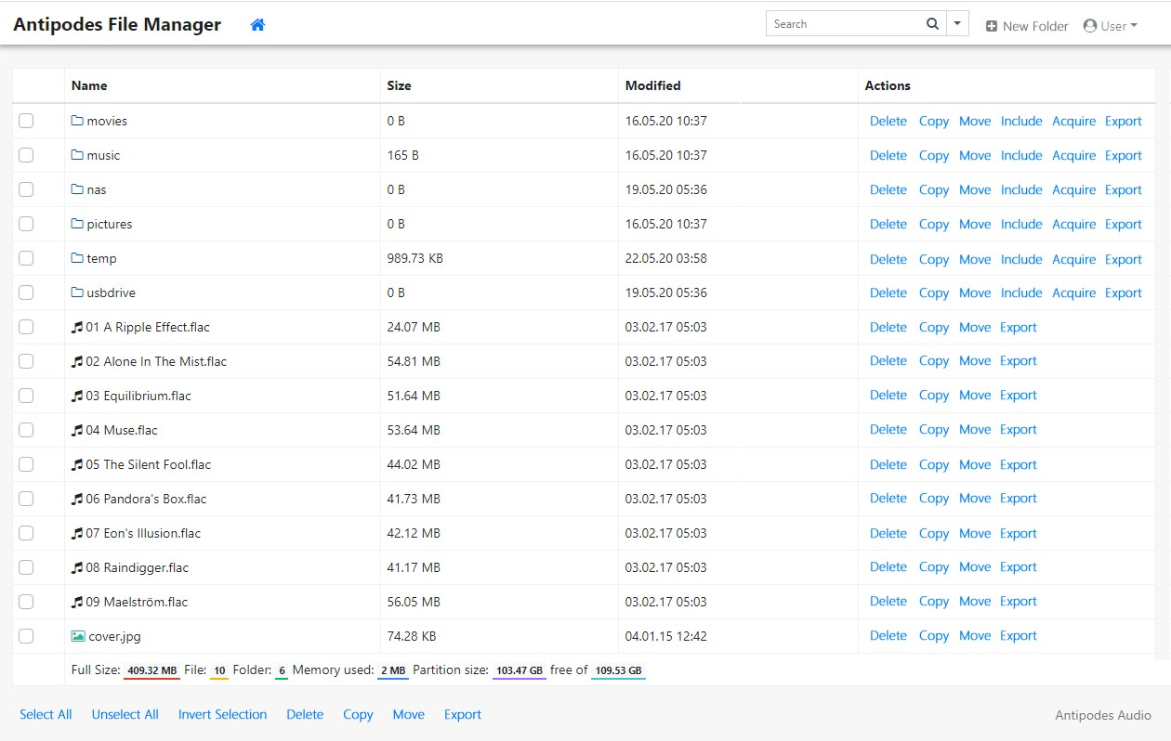

Some directories need to be able to be set by us as not able to be deleted or renamed. Otherwise the use, ‘apache’, has ownership and can do any deleting, copying, moving, renaming etc.

* At the top of the screen:
  + Top-left: Branding and breadcrumbs. The breadcrumbs are to be navigable.
  + Top-right: Search. The search function should ideally search all locations within the current location. By that I mean, the existing directory and all sub-directories.
  + Top-right: New Folder. When a user clicks on ‘New Folder’ a dialog box opens for the user to type in the name of the folder – or some other method.
  + Top-right: User. This dropdown might be replaced with just a ‘Close’ button to close the screen, but it is also a place where you could add any useful user settings.
* To the left of all Folders and Files:
  + Checkboxes to select Folders and Files to select which will be affected by clicking on the buttons at the bottom left of the screen.
  + Select All: As the name suggests, clicking on this button will select all Files and Folders.
  + Unselect All: Clicking on this button will unselect all Files and Folders.
  + Invert Selection: Clicking on this button will invert the selection. Selected become unselected, and unselected become selected.
  + Delete: This button is used to delete all selected Files and Folders. Clicking on this button will open a modal or dialog to explain what will happen if the user proceeds and give the user the option to Cancel. Delete will not delete system-protected folders.
  + Copy: This button could open a window or a dialog box for the user to navigate to the destination or type in the path of the destination. Other methods are possible here.
  + Move: This button is like copy but it removes the selected Files and Folders from the origin.
  + Export: This button copies the selected Files and Folders to an external location. Therefore a web page needs to open to display:
    - SMB share locations found on the local network. The user can then drill down to find the folder to put the copied files and folders under, preserving the folder structure.
    - And, as an alternative, a dialog box where the network location can be entered.
    - If the SMB share location requires a user and password be entered then a dialog box should be presented so that the user can enter these credentials.
    - Copying should be incremental, ie. only copying files and folders not present in the destination, and requesting permission about whether files should over-write files of the same name.
* Buttons to the right of every File, buttons to apply only to that File:
  + Delete: To delete the File – the user will be asked to confirm before deletion.
  + Copy: To Copy the File to another location on the music server. This button could open a window or a dialog box for the user to navigate to the destination or type in the path of the destination.
  + Move: This button is like Copy but it removes the File from the origin.
  + Export: This button copies the File to an external location. Therefore a web page needs to open to display:
    - SMB share locations found on the local network. The user can then drill down to find the folder to put the copied File under.
    - And, as an alternative, a dialog box where the network location can be entered.
    - If the SMB share location requires a user and password be entered then a dialog box should be presented so that the user can enter these credentials.
    - Copying should be incremental, ie. only copying a file not present in the destination, and requesting permission about whether the file should over-write a file of the same name.
* Buttons to the right of every Folder, buttons to only apply to that Folder:
  + Delete: To delete the Folder and its contents – the user will be asked to confirm before deletion.
  + Copy: To Copy the Folder and its contents to another location on the music server. This button could open a window or a dialog box for the user to navigate to the destination or type in the path of the destination.
  + Move: This button is like Copy but it removes the Folder and its contents from the origin.
  + Include: This button only works when the Folder is empty. If the Folder is not empty then the user sees an error message telling them to create a new Folder. The Include button is so that the user can mount any network location. Therefore a web page needs to open to display:
    - SMB share locations found on the local network. The user can then drill down to find the folder to put the copied File under.
    - And, as an alternative, a dialog box where the network location can be entered.
    - If the SMB share location requires a user and password be entered then a dialog box should be presented so that the user can enter these credentials.
  + Acquire: This button copies Files, Folders and their contents from an external location into the Folder. Therefore a web page needs to open to display:
    - SMB share locations found on the local network. The user can then drill down to find the Folder to copy to the music server.
    - And, as an alternative, a dialog box where the network location can be entered.
    - If the SMB share location requires a user and password be entered then a dialog box should be presented so that the user can enter these credentials.
    - Copying should be incremental, ie. only copying files not present in the destination, and requesting permission about whether files should over-write files of the same name.
  + Export: This button copies the selected Folder and its contents to an external location. Therefore a web page needs to open to display:
    - SMB share locations found on the local network. The user can then drill down to find the folder to put the copied File under.
    - And, as an alternative, a dialog box where the network location can be entered.
    - If the SMB share location requires a user and password be entered then a dialog box should be presented so that the user can enter these credentials.
    - Copying should be incremental, ie. only copying files not present in the destination, and requesting permission about whether files should over-write files of the same name.

OTHER CONSIDERATIONS

Note that the music servers will have existing code that prevents large files being up-loaded – such as in php.ini, or elsewhere. Resolving this issue and any other issues that might otherwise limit the functionality of the File Management Application, are part of the scope of this project.