
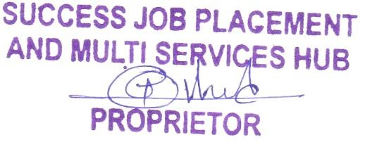
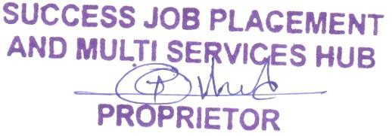




________________________________________________________________________________________
.
Rs:
{amount}/-
Received With thanks: {candName} __
Towards: Placement Registration Charges
___
____ _ _ _________
By Cheque / Cash/ Online: Cash
_ ____
___ __ _
_
_
_
Note:
- Registration Validity till Life Time.
- Registration Fees no Refundable.
- Candidates Selection on their own efforts /Knowledge
- This Fee is only for notification of job description
- If you will not get suitable interview calls then all fees will be refundable.
FOR, SUCCESS JOB PLACEMENT
& MULTI SERVICES HUB
Candidate Sign
Thank You
Sinner Office:- Near Sai Xerox, below Yashraj Hotel, Near Waje Petrol Pump, Sinner- 422103 Nashik
Nashik Office: - 307, Atlanta Shoppers, W40asan Nagar, Pathardi Phata, below Signus hospital, Nashik Email: - Successcareerplacement@gmail.com Mob:-8600463218 GSTIN :-
SUCCESS JOB PLACEMENT& MULTI SERVICES HUB
“Your Success Our Goal”
RECEIPT
Date: {date}
SJPS {sjpsNumber}

