CSS Tutorials

CSS & CSS 3

CSS 3 Introduction

CSS 3 Modules

CSS3 has been split into "modules". It contains the "old CSS specification" (which has been split into smaller pieces). In addition, new modules are added.

Some of the most important CSS3 modules are:

* Selectors
* Box Model
* Backgrounds and Borders
* Image Values and Replaced Content
* Text Effects
* 2D/3D Transformations
* Animations
* Multiple Column Layout
* User Interface

Most of the new CSS3 properties are implemented in modern browsers.

CSS 3 – Rounded Corners

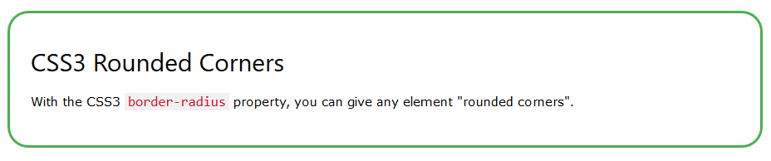

**Browser Support**

The numbers in the table specify the first browser version that fully supports the property.

Numbers followed by -webkit- or -moz- specify the first version that worked with a prefix.

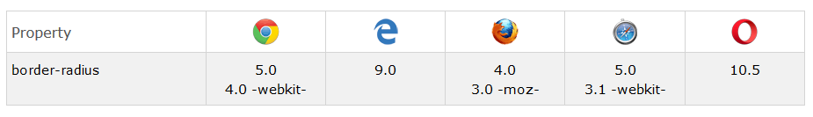

CSS border-radius Property

With CSS3, you can give any element "rounded corners", by using the border-radius property.

Here are three examples:

1. Rounded corners for an element with a specified background color:  
   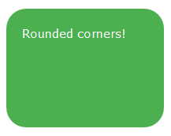
2. Rounded corners for an element with a border:  
   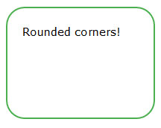
3. Rounded corners for an element with a background image  
   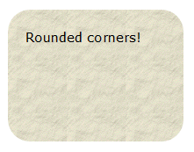

Here is the code:

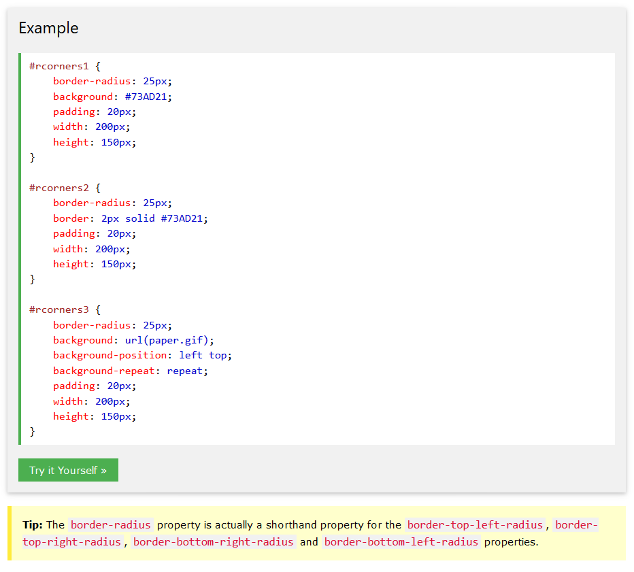

**CSS3 border-radius - Specify Each Corner**

If you specify only one value for the border-radius property, this radius will be applied to all 4 corners.

However, you can specify each corner separately if you wish. Here are the rules:

* **Four values:** first value applies to top-left, second value applies to top-right, third value applies to bottom-right, and fourth value applies to bottom-left corner
* **Three values:** first value applies to top-left, second value applies to top-right and bottom-left, and third value applies to bottom-right
* **Two values:** first value applies to top-left and bottom-right corner, and the second value applies to top-right and bottom-left corner
* **One value:** all four corners are rounded equally

Here are three examples:

1. Four values - border-radius: 15px 50px 30px 5px:  
   
2. Three values - border-radius: 15px 50px 30px:  
   
3. Two values - border-radius: 15px 50px:  
   

Here is the code:

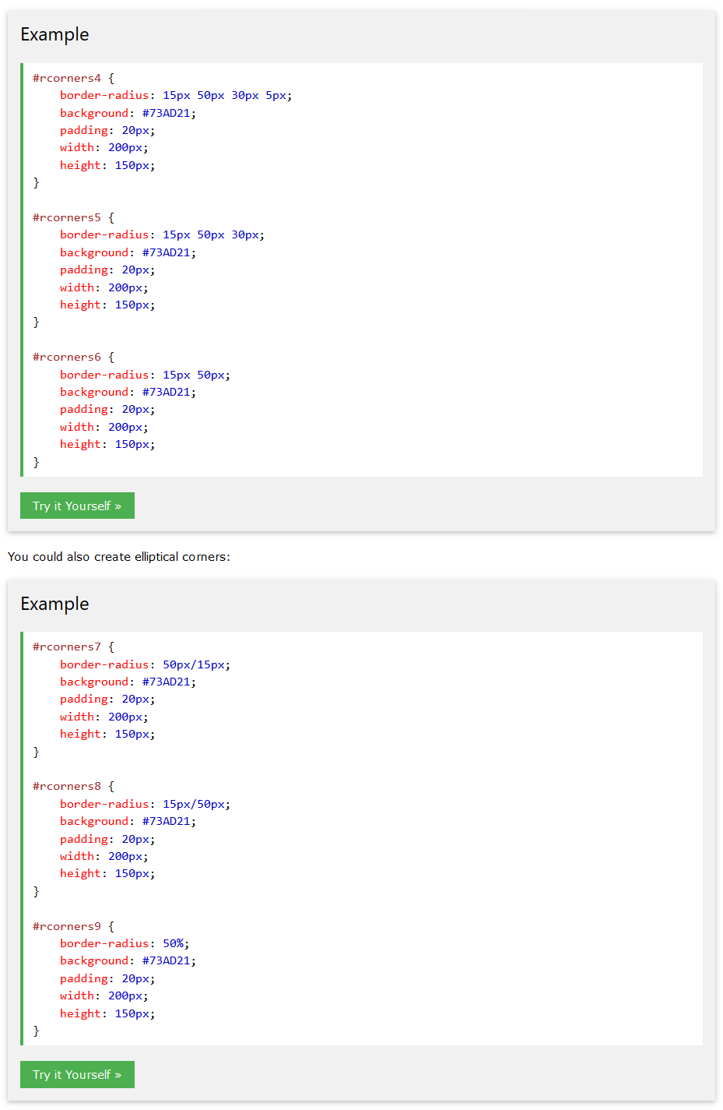

**CSS3 Rounded Corners Properties**

