SignalWard Project Proposal
TEAM RADHE | AI/ML · IoT SIMULATION · SOFTWARE PRODUCT DEVELOPMENT
THE IDEA An evidence-aware home-care digital twin that separates patient-pattern signals from sensor trust, so noisy or stale readings trigger a measurement check instead of a misleading patient-risk score.

The problem
Home monitoring combines vital readings, caregiver observations, and medical-equipment status, but these signals may be incomplete or misleading. One abnormal value can reflect a patient change, a poor measurement, stale data, or a device/power issue. If a dashboard treats every value as equally trustworthy, it may create confusing alerts. Connectivity interruptions can delay review.

Our solution
SignalWard simulates a home-care episode and routes each packet through three separate views: patient trajectory, evidence confidence, and equipment context. It explains the resulting event and supports caregiver acknowledgement, notes, and visit logging. A browser queue demonstrates store-and-forward behavior during simulated outages.

Why this approach stands out
- Evidence before risk: low-quality or stale packets suppress the patient-state score and create an Evidence Check.
- A visible counterexample: the Noisy Sensor scenario looks alarming but has poor evidence confidence; judges can compare it with clean multi-signal drift.
- Separate fault domains: device connection and backup battery remain equipment context, not patient physiology.
- Human review stays central: explanations and acknowledgement are visible; the system does not prescribe treatment.

End-to-end architecture
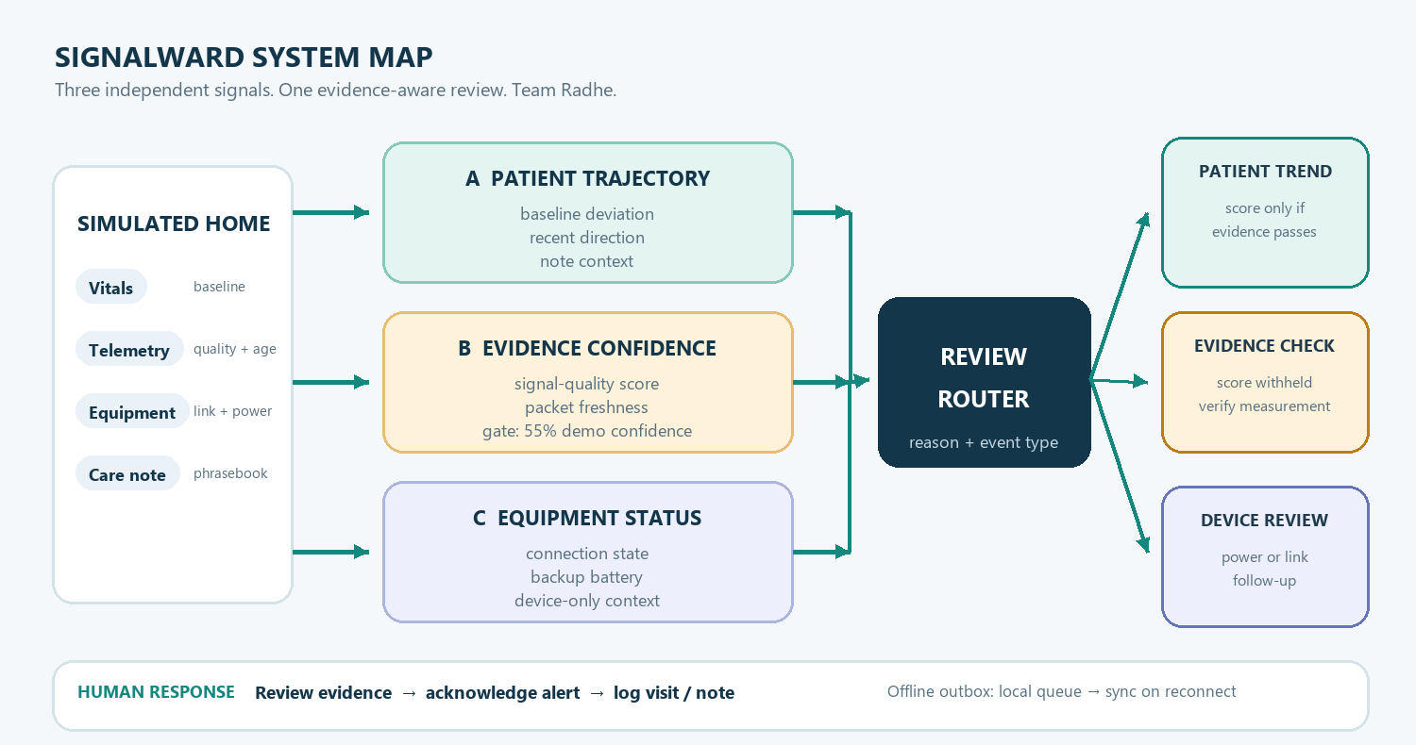
Figure 1. SignalWard separates patient trajectory, evidence confidence, and equipment state before routing an event.

How the decision works
SignalWard first assesses whether a synthetic packet is sufficiently fresh and has sufficient simulated signal quality. Only then can the toy patient-trajectory model display an illustrative tier. The 55% cutoff is a prototype gate, not a medical threshold.
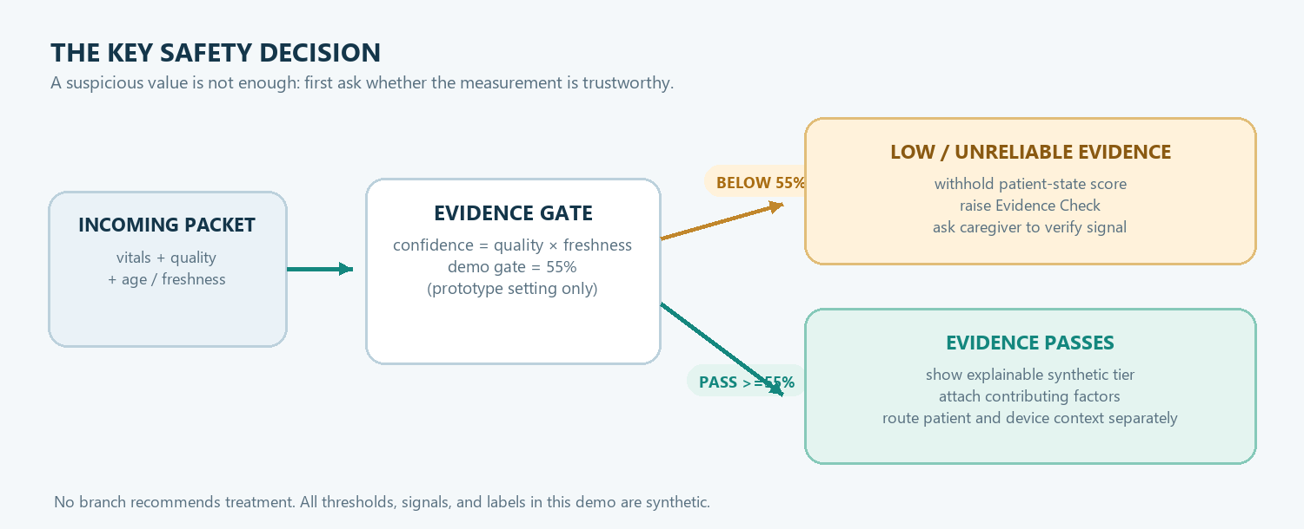
Figure 2. Low evidence confidence withholds the patient score; passing the gate only permits an illustrative synthetic result.

Demo scenarios
SCENARIO | WHAT IT SHOWS | EXPECTED ROUTE
Stable | Near-baseline readings, reliable mock signal | No elevated synthetic trend
Watch | Clean, moderate multi-signal drift | Illustrative trend + reason labels
Noisy Sensor | Concerning-looking value, poor signal quality | Evidence Check; patient score withheld
Escalation | Larger synthetic drift + device interruption | Combined review with separate device context
Power Backup | Near-baseline readings + backup power state | Device context visible

Caregiver response and resilience
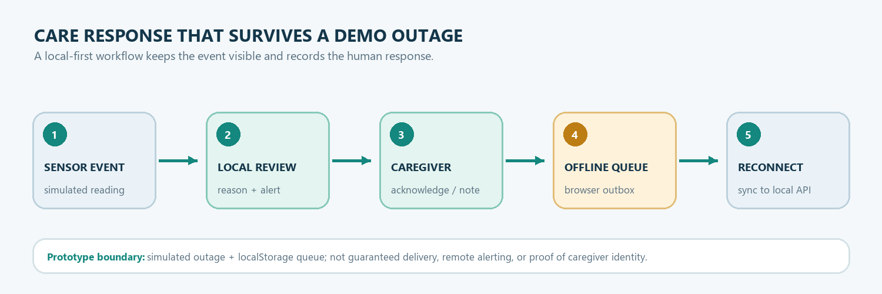
Figure 3. The demo keeps events reviewable and queues browser actions during simulated disconnection.

Implementation plan and stack
COMPONENT | IMPLEMENTATION
Frontend | Responsive HTML, CSS, vanilla JavaScript; SVG trend chart
API + simulator | Python standard-library HTTP server; built-in synthetic scenarios
Persistence | SQLite for readings, notes, alerts, acknowledgements, attendance events
Model demo | Logistic regression trained at startup on generated examples; separate evidence gate
Offline behavior | Browser localStorage outbox; simulated equipment backup-power telemetry
Deployment | Localhost only; no hardware, cloud service, or external API

Expected outcome
A working software-only demonstration of the complete path from simulated sensor packet to reasoned event to caregiver response. Success is shown through observable scenario behavior:
- Noisy sensor routes to Evidence Check and withholds the patient-state score.
- Stable readings remain without an elevated synthetic pattern.
- Clean drift displays a synthetic tier and contributing factors.
- Device interruption appears as equipment context, separate from physiology.
- Caregiver acknowledgement is recorded; offline actions sync after reconnect.

Technical boundaries and safety
All profiles, readings, notes, signal-quality values, equipment states, and model labels are generated. The model is trained only on generated examples and is not clinically validated. Its “24–48 hour” label is a demo target, not a real forecast. A synthetic quality score cannot prove sensor accuracy. The demo caregiver code does not prove identity or physical presence. Do not enter real patient data. The local prototype is not designed for internet exposure and does not send real notifications or make care decisions.

Team and submission details
Team name | Radhe
Project title | SignalWard — Confidence-Aware Home-Care Digital Twin
Submission | IoT simulation · full-stack platform · synthetic AI/ML risk demonstration
PRESENTATION LINE “A bad reading should first trigger a check on the evidence. SignalWard makes that distinction visible, explainable, and testable.”

