Sumit Chadha

,

Manager – Data Engineering (UHG-Optum)

E-Mail: [sumitchadha89@gmail.com](mailto:pawanik2003@gmail.com)

Phone: +91-9552711500

12.5 years of track record of success in designing and development of enterprise level IT applications with passion for **resolving business problems using technical innovation** while envisioning the bigger picture.

Responsible for successful end to end implementation of complex enterprise level IT platform implementations via Frameworks.

Good experience on fronts of Data Engineering and Software Engineering in **modernizing Legacy systems** using new generation technologies **like Kafka, Java Microservices, Spark, Databricks on Cloud Platforms**.

Responsible for **Agile Project Management** and having E2E Engineering responsibilities for multiple Scrum and Kanban teams. **Led and implemented** complex projects with **globally distributed teams**

Technical Skills

|  |
| --- |
| Technology Leadership – Data Engineering |
| Big Data Analytics and BI (Spark, Scala, Sqoop, Tableau) |
| Technology Transformation (Java, Microservices, Cloud, Spring, Kafka, APIs) |
| ETL/ELT (DataStage, Informatica, Databricks, Azure Data Factory, Synapse) |
| Cloud Transformation (Azure, GCP) |
| SQL, PL/SQL, Shell Scripting |
| Monitoring Tools - Prometheus, Grafana |
| CDC Tools -Qlik Replicate (Attunity) |
| Solution Architecture & System Design |
| Enterprise Datawarehouse & Data Lake |
| Risk/Stakeholder Management |
| DevOps and CI CD – GitHub, Jenkins, Docker |
| System Design |
| Real Time Streaming ETL Pipeline Designs |

Self-driven, hands on& accomplished goal-oriented IT professional with 12.5 years’ experience in Application Design & Development/ Data Engineering/ Solution Architecture/ Data Modelling and Technology Transformation projects with expertise in **Cloud Transformation Projects**.

Key Result Areas:

* Accountability for Enterprise Data Lake and Warehouse serving various data products and BI/Analytics/Reporting Solutions on **Azure Cloud using Kafka , ADF , Databricks , Spark , Scala , Delta Lake , Synapse with E2E ownership** of delivery and support
* Working with various business partners for **requirement gathering, scoping, estimation and execution plan for various capabilities** and features and working with business and approval committee on approval of same.
* Getting **new engagement for team, requirements onboarding and design patterns** for the scrum team.
* **Technology roadmap** for Data Management and Analytics Landscape including modernization and operational cost reduction.
* **Solution and Design Architecture engagement for complex project** which are starting from scratch and need robust designing and customer centricity.
* Focus on **continuous improvement, Engineering Maturity and automation.**
* Working on technical solutions for given business problem with Architects, working with Engineers on Low Level Design and while contributing to **code reviews when needed.**
* Building **cost efficient design** for cloud solutions ranging from real-time stream models to batch models
* Holding **technical review board meetings** and coordinating with other team members for defining best practices for project support

Experience Timeline

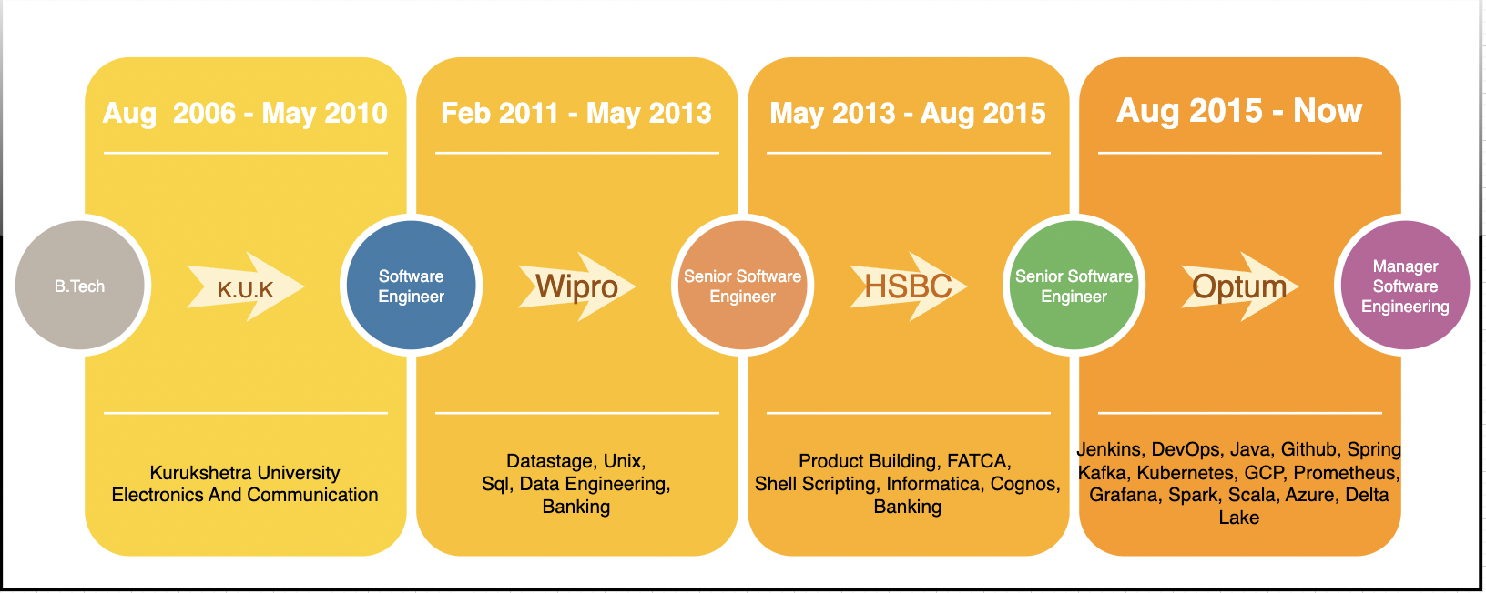

Education

BE (Electronics and Comm) Kurukshetra University, Kurukshetra

Certifications

* L-100 Healthcare Exam, conducted by American Healthcare Insurance Plan (AHIP) Organization
* AHM-250 Healthcare Exam, conducted by Academy of Health Management, US
* IBM Infosphere DataStage
* Professional Scrum Master (PSM)
* Java FSE-I Internal

Roles Played

* Engineering Manager
* Solution Architect
* Data Engineer
* Technical Lead
* ETL Lead
* DevOps Coordinator
* Senior Engineer
* Project Engineer

Extracurricular Activities

* Played Volleyball at Zonal level while in school.

Notable Accomplishments Across the Career

* Got **MAKE IT HAPPEN** **award** for creating out of box IT solution in just 3 weeks using Kafka, ETL workloads **during COVID in April 2020 which enabled our company to disburse a part of $100 Billion relief fund** to various healthcare providers in partnership with US Health department. [Link](https://www.hhs.gov/about/news/2020/04/10/hhs-to-begin-immediate-delivery-of-initial-30-billion-of-cares-act-provider-relief-funding.html)
* Delivered FATCA compliant reports to IRS for HSBC bank and was the **first Bank** to perform testing with US authority for same. Link to news
* Helping the **modernization agenda for moving legacy applications into cloud** fora very big enterprise application having a headcount of 100+ folks across the globe.
* Successfully led the **Resource Transformation** agenda for my team to transform them into using new technology.
* Established the concept of **Release Entry Framework** process that enabled IT Ops team to get engaged much early in life cycle of delivery of various capabilities and features.
* Maintained **very high manager effectiveness score** as part of annual Employee Experience survey.
* Fastest individual to grow and transform on personal learnings in project (headcount - 100)
* Adopting Open-source tools and methodologies thereby reducing the overall cost without impacting business.
* Generated approximately, **2 million in savings** through various initiatives like ***modernization, automation, Infrastructure cost reduction, application hardening and productivity improvement.***
* Leading the Engineering Maturity Team which consist of multiple Engineering Manager with focus on **Agile Metrics Improvement, CI-CD transformation, technology transformation, application hardening.**

Personal Details

Date of Birth: 22 July 1989

Gender: Male

Father’s Name: Mr. Manmohan Krishan Chadha

Nationality: Indian

Languages Known: English, Hindi, Punjabi

Current Address: 3086, 1st floor, Sector-23, Gurgaon, Haryana - 122017

Permanent Address: 98, Vikas Vihar, Ambala City, Haryana -134003

Education

BE (Electronics and Comm) Kurukshetra University, Kurukshetra

Certifications

* L-100 Healthcare Exam, conducted by American Healthcare Insurance Plan (AHIP) Organization
* AHM-250 Healthcare Exam, conducted by Academy of Health Management, US
* IBM Infosphere DataStage
* Professional Scrum Master (PSM)
* Java FSE-I Internal

Roles Played

* Engineering Manager
* Solution Architect
* Data Engineer
* Technical Lead
* ETL Lead
* DevOps Coordinator
* Senior Engineer
* Project Engineer

Extracurricular Activities

* Played Volleyball at Zonal level while in school.

Annexure

* #1 - Data Management and Analytics is a central data warehouse unit and analytical platform to various consumers of medicines recommendation and home deliveries.
* It is a Framework driven product which enables data onboarding for various clients via use of modern tech. It is also responsible for facilitating data products for various business.
* #2 - Payment product is a central health product to perform Payments for Members and Providers and create documents which includes Provider Remittance Advice and Electronic Remittance advice.
* It is a configurable product which provides Partner Level, Payment Level, Claim Level, Policy Level configurations and delivers multi-million payments every day.
* It takes in Claim/Payment/Non-Claim data, does the preprocessing, converts the input to one standard format and applies multi fold business rules.
* FATCA compliance is where we need adhere to US published guidelines
* This project initially focused on identifying the FFIs and Individuals using mainframe which were then passed to DataStage processes for computation and reporting to business.
* It was further scaled up to send out details to IRS which included encryption of data using the provided standards from IRS.
* Fifth Third bank was focused on Retail banking and Incentive Compensation where Individuals bonus for the quarter/year was to be calculated and was required to be displayed using Hyperion.

Optum Global Solution

HSBC

Wipro Technologies