|  |  |
| --- | --- |
| Name | Muhammad Suchal Riaz |
| Class | BSCS5B |
| Reg# | 121033 |

lab 5

Advanced Programming

# Introduction

This lab is about using non-mutable approach to use an algorithm that relies on eliminating the composite numbers to leave the prime numbers. The purpose of this lab is to use non-mutable data structure to implement an algorithm which relies on changes.

# Approach

I have used a list to store all numbers from 2 to n, using range. Then i call the recursive function from parameter 2 to sqrt(n), on each recursive call the list passed to the next call has been filtered out from all multiples of the prime number, x. In the end, the list the is passed to function only has prime number, so that list is returned.

# How to use

Compile and run main.scala file.  
Enter a number till which you want to compute prime numbers.  
The program will display list of all prime numbers till that number  
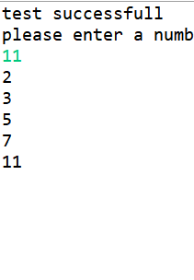

# Github

https://github.com/suchal/Sieve-of-Eratosthenes.git

# Analysis

