Photo Object

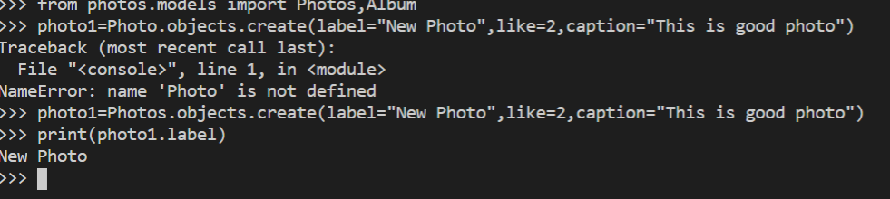

Album Object

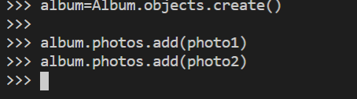

Test Case

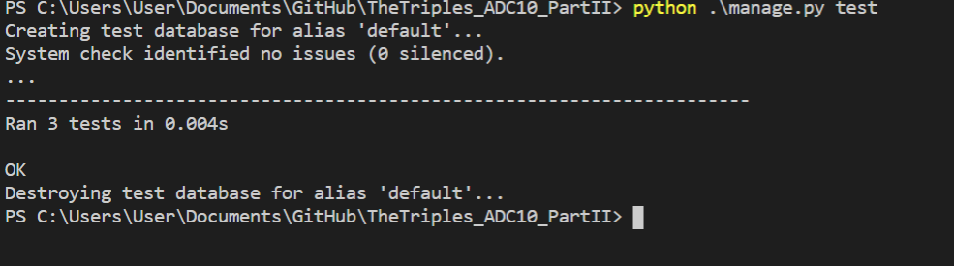

Permission Table

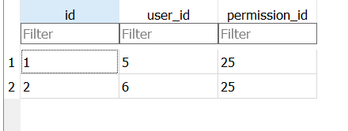

User Auth Table

