SWING EXERCISE

- Create below screens in Swing with dummy data.

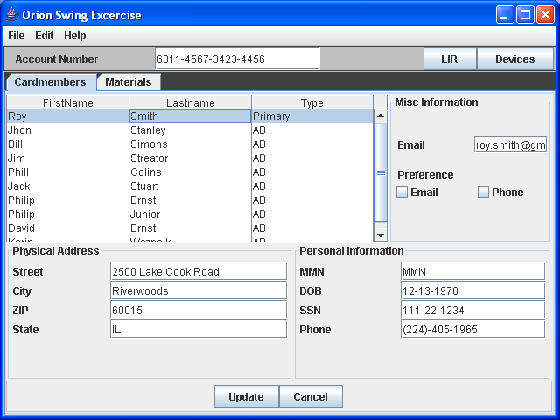

Additional Requirements
- On selection of each card-member relevant information should be populated in the fields.
- On right click on any card-member pop up menu should be displayed with option for “Add Card-member” of card-member.
- Click on “Add Card-member” should open a new screen and should have options to collect below information with Save and Cancel option.
Card member name
SSN
MMN
Type of card-member
Address

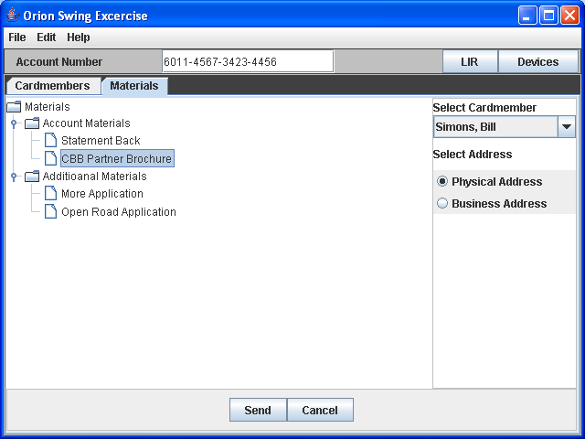

Additional Requirements
- Combobox should display all the card-members being displayed in the Card-member screen for selection.

