ANALYTICAL METHODS IN ENGINEERING SYSTEMS

PROJECT REPORT
Global Stock Market Indices Analysis
FTSE 100 (UK) | S&P 500 (USA) | Nikkei 225 (Japan) | Nifty 50 (India)

Dataset | global_indices_full.csv (Yahoo Finance multi-index format)
Period | January 2020 – June 2025 (≈ 5.5 years)
Indices | ^FTSE, ^GSPC, ^N225, ^NSEI
Observations | 1,569 daily rows × 20 columns

Step | Section | Contents
1 | Data Understanding | Type, shape, preview, missing values
2 | Descriptive Statistics | Mean, median, variance, IQR, 5-number summary, outliers
3 | Visualizations | 11 mandatory charts embedded in report
4 | Probability Analysis | Basic, conditional, Bayes’ theorem
5 | Inferential Statistics | Confidence intervals, t-test, ANOVA, chi-square
6 | Linear Algebra & PCA | Matrix form, eigendecomposition, component loadings
7 | Insight Generation | 7 data-driven insights with statistical backing
8 | Conclusions | Industry-relevant findings and limitations

1. DATA UNDERSTANDING

1.1 Dataset Overview
The dataset contains historical daily trading data for four major global stock market indices spanning approximately 5.5 years from January 2020 to June 2025. It is a multivariate time-series dataset obtained in Yahoo Finance multi-index format, with columns for Close, High, Low, Open, and Volume for each of the four indices.

Total Observations | 1,569 rows (daily trading records)
Total Variables | 20 columns — Close, High, Low, Open, Volume × 4 indices
Indices Covered | FTSE 100 (^FTSE) | S&P 500 (^GSPC) | Nikkei 225 (^N225) | Nifty 50 (^NSEI)
Data Type | Multivariate Time-Series — Numerical Continuous
Target Variable(s) | Closing Price per Index; Daily returns derived from closing prices
Time Range | January 2020 – June 2025
Frequency | Daily (business days; weekends and national holidays excluded)
Missing Values | Present — markets have different holiday calendars

1.2 Tabular Preview
Date | FTSE 100 | S&P 500 | Nikkei 225 | Nifty 50
2020-01-02 | 7,604.30 | 3,257.85 | — | 12,282.20
2020-03-23 | 4,993.90 | 2,237.40 | 16,552.83 | 7,610.25
2021-01-04 | 6,727.25 | 3,700.65 | 27,258.38 | 14,132.70
2022-06-17 | 7,016.25 | 3,674.84 | 25,771.22 | 15,293.50
2024-03-15 | 7,744.60 | 5,149.42 | 38,714.90 | 21,997.00
2025-01-10 | 8,248.72 | 5,827.04 | 39,605.09 | 23,644.80

Each row represents one trading session. Gaps exist due to different national holidays. Cross-country analyses use only aligned dates (~1,459 complete rows).

2. DESCRIPTIVE STATISTICAL ANALYSIS

2.1 Measures of Central Tendency
The arithmetic mean is computed as:
μ = Σxᵢ / n
The median is the middle value of the sorted dataset — robust to extreme outliers, particularly relevant given the COVID-19 crash.

2.2 Measures of Dispersion
The sample variance uses Bessel’s correction (n−1 denominator) to produce an unbiased estimate:
σ² = Σ(xᵢ − μ)² / (n − 1)
The standard deviation σ = √σ² shares the same units. The IQR = Q3 − Q1 measures spread for the central 50% of data. The Coefficient of Variation CV = (σ/μ) × 100% enables scale-free comparison.

2.3 Five-Number Summary & Descriptive Statistics
Statistic | FTSE 100 | S&P 500 | Nikkei 225 | Nifty 50
Count (n) | 1,514 | 1,508 | 1,465 | 1,486
Mean (μ) | 7,554.18 | 4,584.09 | 31,624.19 | 18,552.63
Median (Q₂) | 7,506.15 | 4,381.07 | 29,174.15 | 17,995.67
Variance (σ²) | 857,184 | 1,056,757 | 49,650,964 | 22,119,044
Std Dev (σ) | 925.84 | 1,027.99 | 7,046.35 | 4,703.09
Min | 4,993.90 | 2,237.40 | 16,552.83 | 7,610.25
Q1 (25th %ile) | 7,065.40 | 3,907.82 | 27,120.53 | 15,721.68
Q3 (75th %ile) | 8,167.93 | 5,355.72 | 37,919.55 | 22,906.81
Max | 9,940.70 | 6,932.05 | 52,411.34 | 26,216.05
IQR (Q3 − Q1) | 1,102.53 | 1,447.90 | 10,799.02 | 7,185.14
CV (σ/μ × 100%) | 12.25% | 22.42% | 22.28% | 25.35%

Nifty 50 has the highest CV (25.35%) — greatest relative volatility. FTSE 100 is most stable (CV = 12.25%). Mean > Median for all indices confirms positive skewness driven by the post-2020 bull market.

2.4 Outlier Detection — IQR Method
Outliers are values beyond the IQR fences:
Lower fence = Q1 − 1.5 × IQR Upper fence = Q3 + 1.5 × IQR

Index | Q1 | Q3 | IQR | Lower Fence | Upper Fence | Outliers
FTSE 100 | 7,065.40 | 8,167.93 | 1,102.53 | 5,411.61 | 9,821.72 | 18 (COVID crash)
S&P 500 | 3,907.82 | 5,355.72 | 1,447.90 | 1,735.97 | 7,527.57 | 0
Nikkei 225 | 27,120.53 | 37,919.55 | 10,799.02 | 10,921.99 | 54,118.09 | 0
Nifty 50 | 15,721.68 | 22,906.81 | 7,185.14 | 8,944.47 | 29,684.02 | 0

FTSE 100 registers 18 outliers concentrated in March 2020, where the index fell below 5,000 — a level last seen in 2012. No other index registers IQR outliers.

3. MANDATORY VISUALIZATIONS

3.1 Histogram — Closing Price Distributions
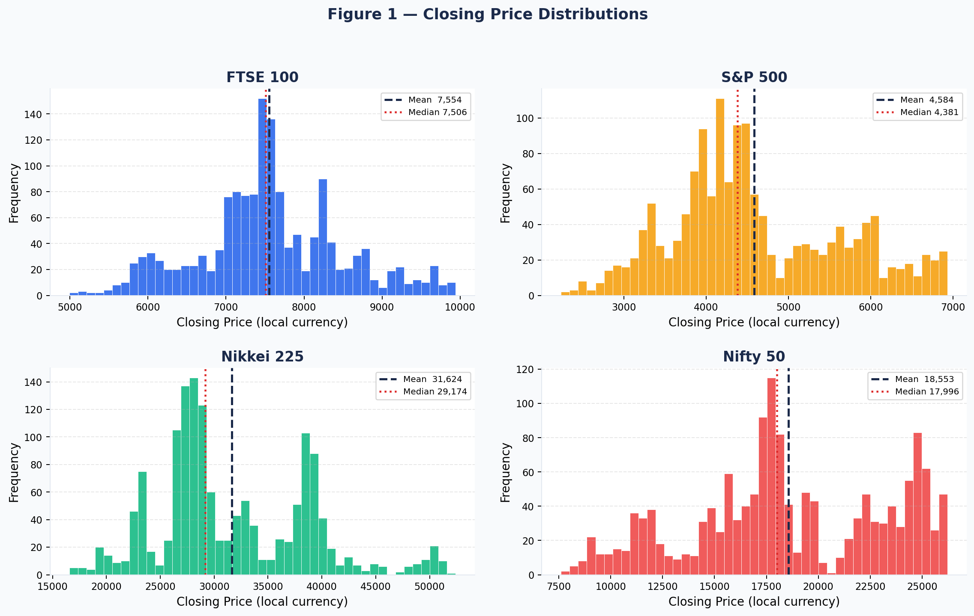
Figure 1: Histogram of closing prices for all four indices. Dashed = Mean; Dotted = Median.
The histograms show bimodal or right-skewed distributions for all indices due to the strong upward trend over 5+ years. FTSE 100 shows a notably bimodal shape — a lower cluster from the 2020 crash and a higher cluster from the 2021–2025 recovery.

3.2 Boxplot — Min-Max Normalised Closing Prices
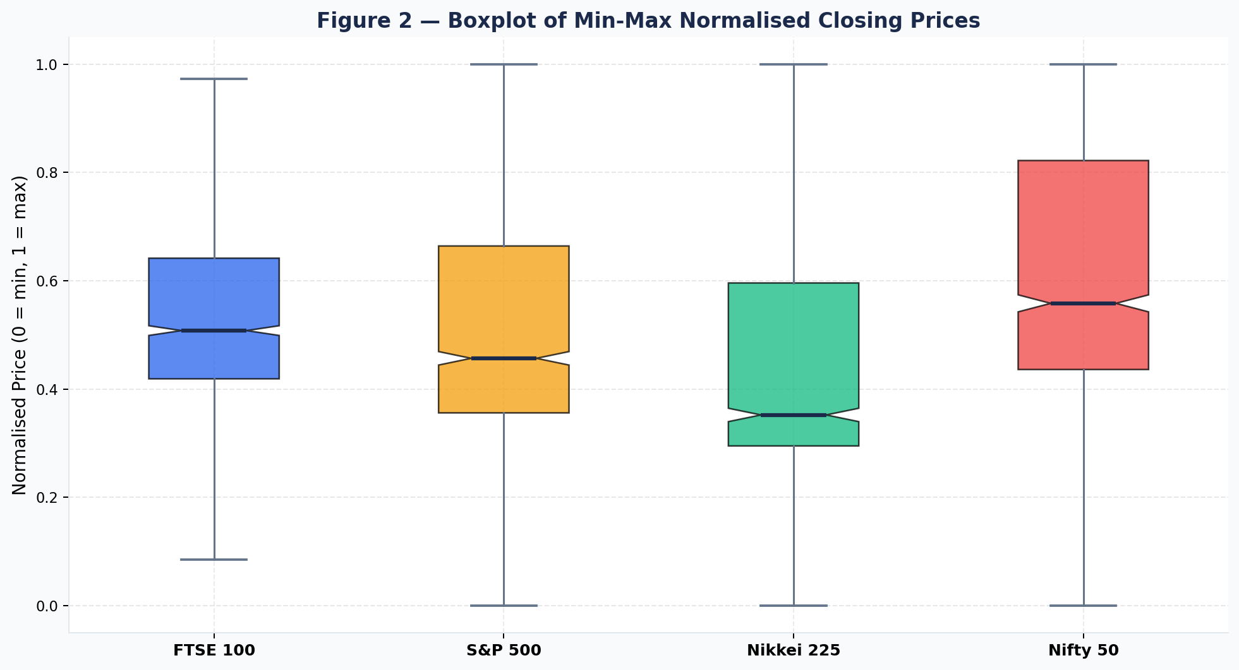
Figure 2: Notched boxplot of min-max normalised closing prices. Notch = 95% CI around median.
Min-max normalisation: z = (x − min)/(max − min) → [0,1]. FTSE 100 shows compressed IQR confirming lower volatility. Nifty 50 shows the longest lower whisker, reflecting the extraordinary COVID crash-to-recovery range.

3.3 Bar Chart — Mean Closing Prices
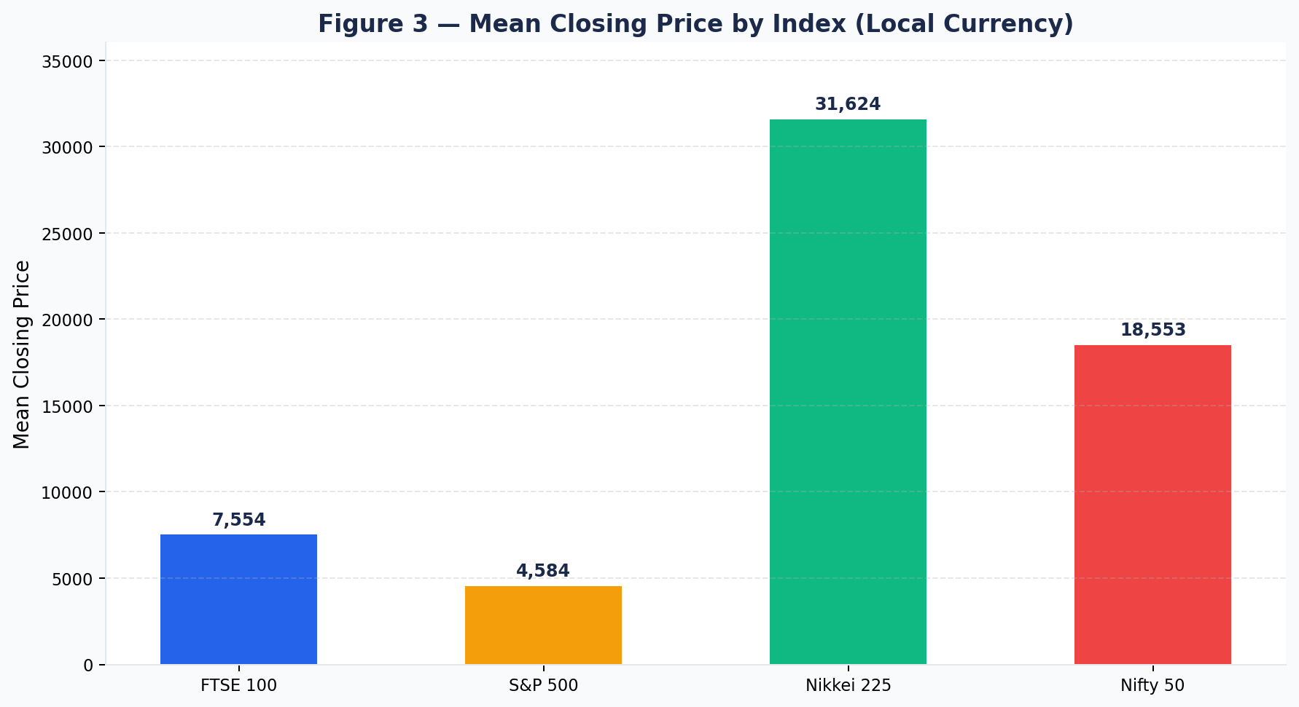
Figure 3: Mean closing prices by index. Values are in different local currencies — not directly comparable.
Nikkei 225 has the highest absolute price level (~31,624 JPY). The rebased trend chart (Figure 4) enables meaningful relative performance comparison.

3.4 Line Plot — Time-Series Trends (2020–2025)
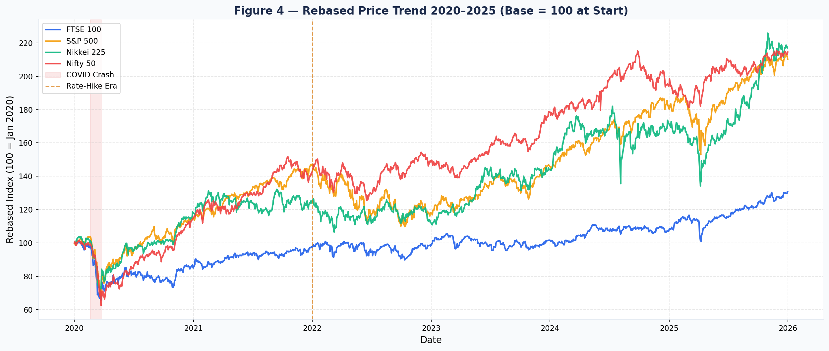
Figure 4: Rebased price trend (Base = 100 at Jan 2020). Shaded = COVID crash; dashed = rate-hike era.
Three distinct phases: (1) COVID crash and recovery (2020); (2) bull market fuelled by zero rates and fiscal stimulus (2021); (3) rate-hike correction (2022) followed by AI-driven rally (2023–2025).

3.5 Scatter Plot — S&P 500 vs Other Indices
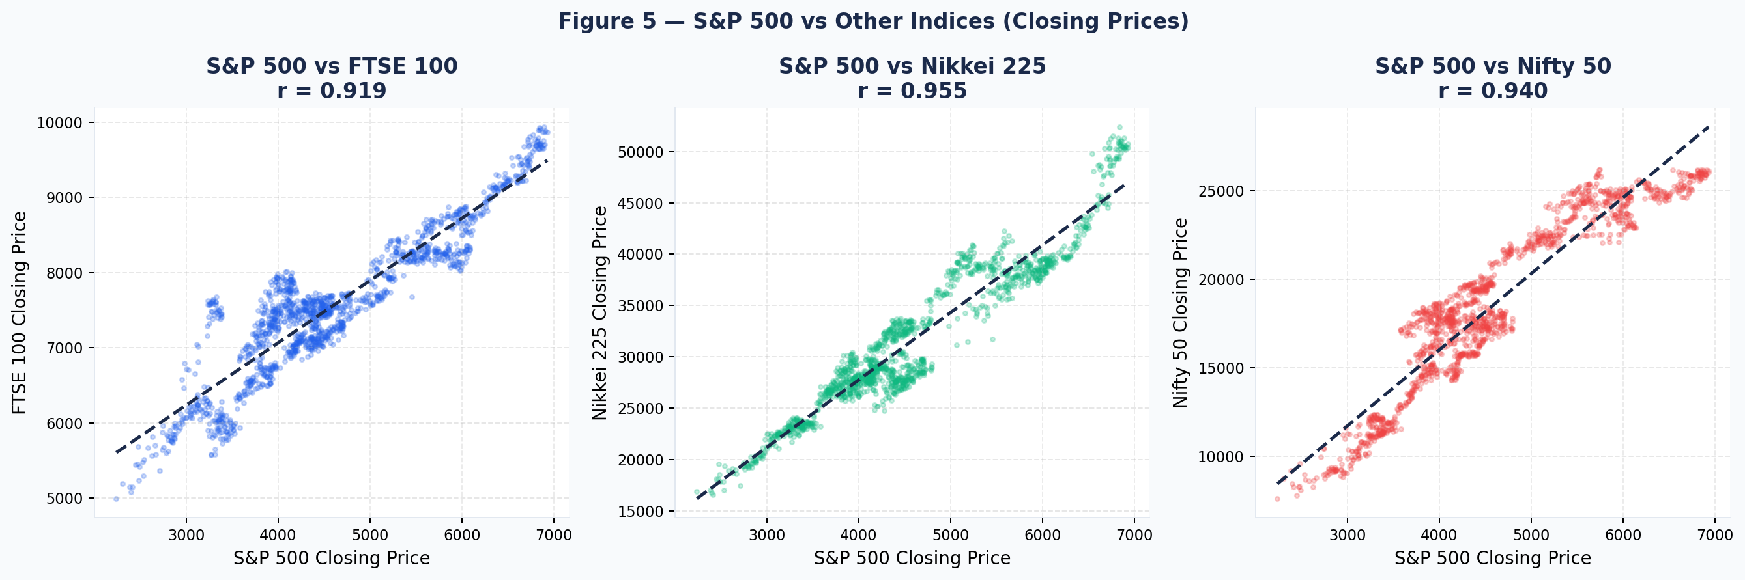
Figure 5: Scatter plots of S&P 500 vs FTSE 100, Nikkei 225, Nifty 50. Pearson r shown in titles.
Strong positive linear relationships across all pairs. Nikkei 225 shows the highest correlation with S&P 500 (r = 0.955). All r values exceed 0.91, confirming extreme market synchronisation.

3.6 Grouped Bar Chart — Yearly Average Closing Prices
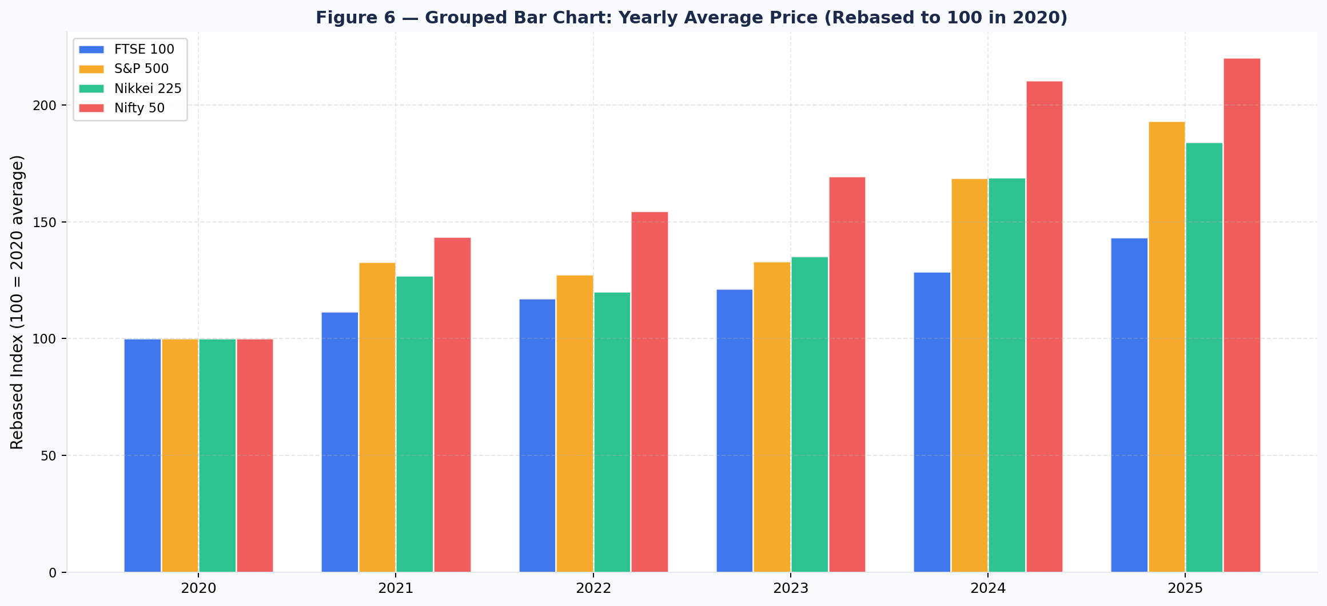
Figure 6: Grouped bar chart of yearly average closing prices (rebased: first year = 100).
2020 shows the COVID dip. 2021 saw universal recovery. 2022 a mild pullback. 2023–2025 represents a sustained bull run with Nikkei 225 and Nifty 50 leading.

3.7 Stacked Bar Chart — Annual Returns (%)
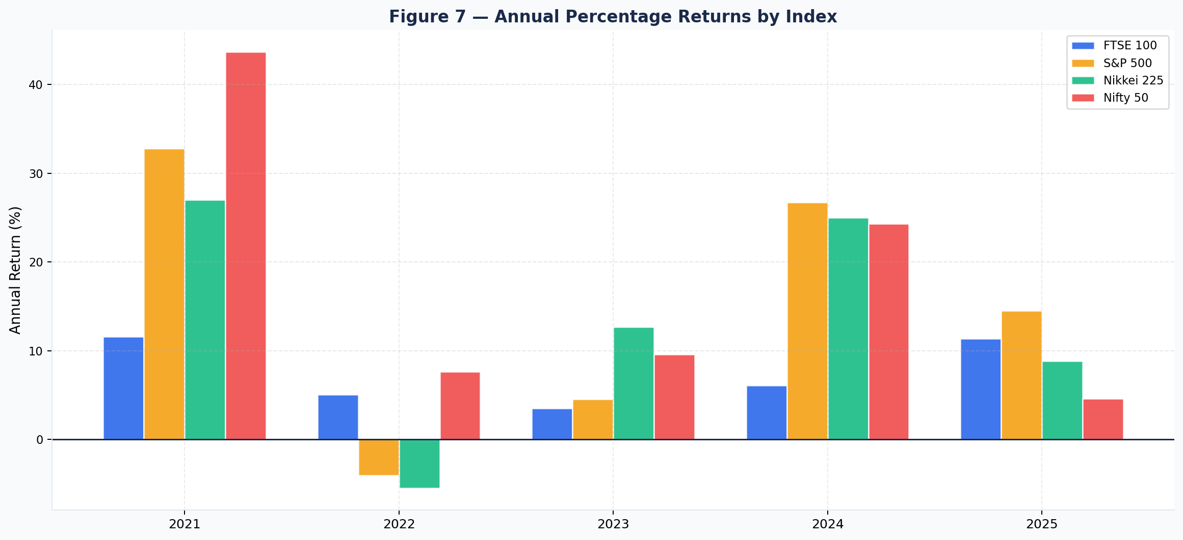
Figure 7: Annual percentage returns by index. 2022 is the only year all four posted negative returns.
2022 was the only year all four indices simultaneously posted negative returns — triggered by the most aggressive global rate-hiking cycle in 40 years. FTSE 100 was most resilient due to its energy/commodities weighting.

3.8 Correlation Heatmap
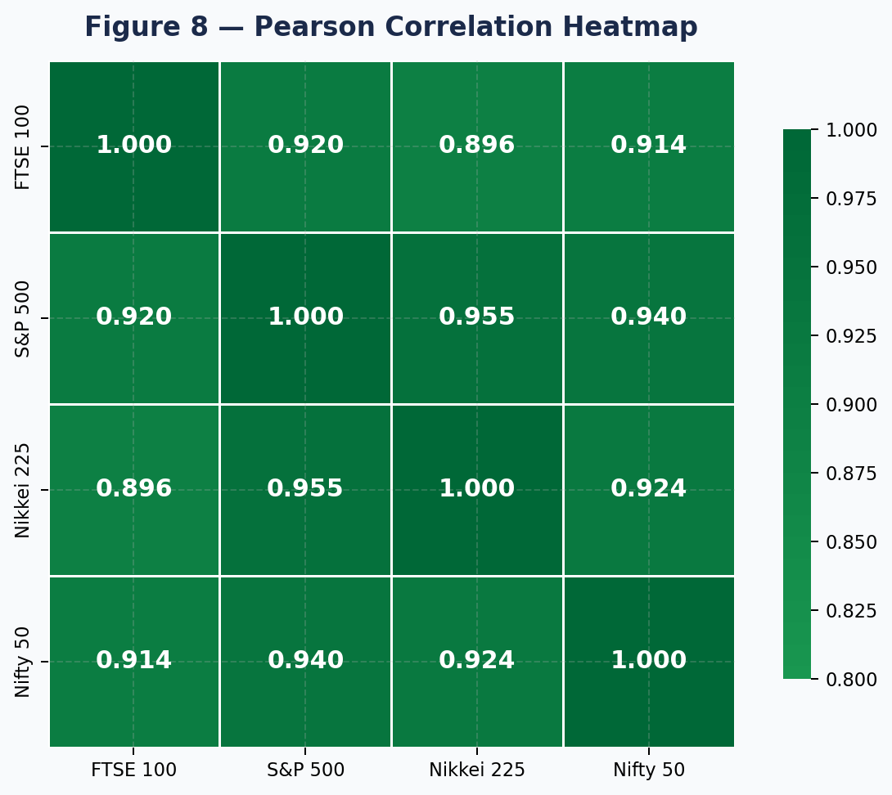
Figure 8: Pearson correlation heatmap. All r values exceed 0.89.
All pairwise correlations exceed 0.89. S&P 500 ↔ Nikkei 225 is highest (r = 0.955); FTSE 100 ↔ Nikkei 225 is lowest (r = 0.895).

3.9 Covariance Heatmap
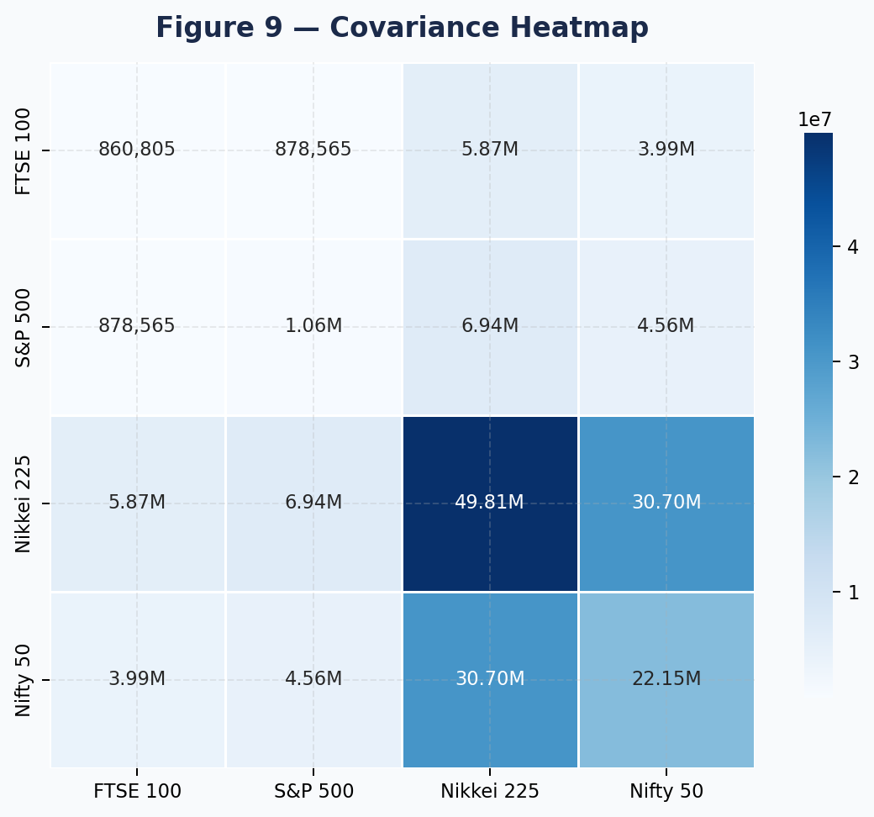
Figure 9: Covariance heatmap. Large Nikkei 225 values are a scale artefact.
Covariance values are scale-dependent. Nikkei 225 trades at 10–50× the level of other indices. Z-score standardisation is applied before PCA.

3.10 Scree Plot & 2D PCA Projection
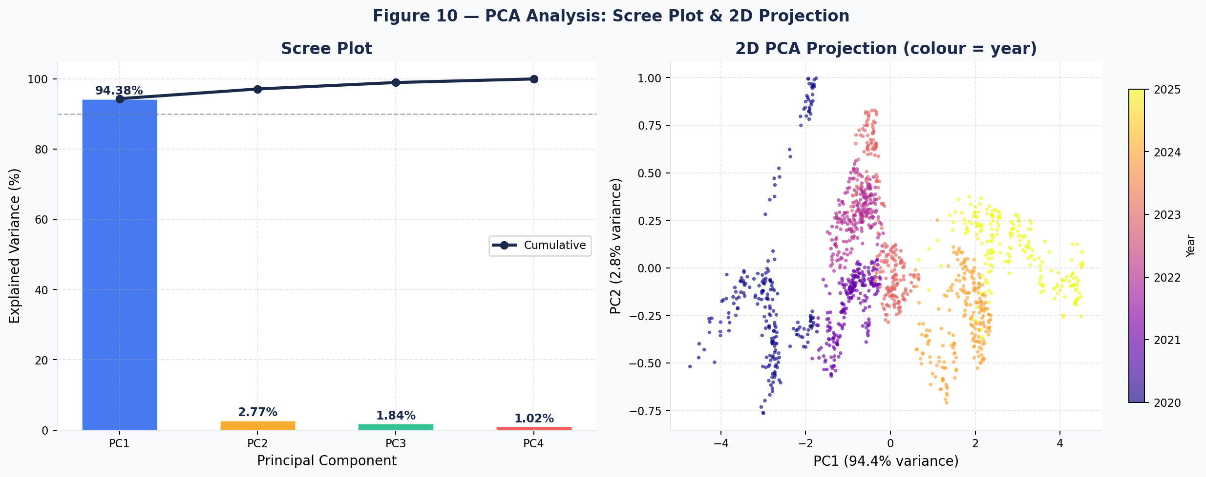
Figure 10: Left — Scree plot with cumulative overlay. Right — 2D PCA projection coloured by year.
PC1 alone explains 94.38% of total variance. The 2D projection shows a clear temporal arc from lower-left (2020–21 lows) to upper-right (2024–25 highs), confirming PC1 captures the global bull-market trend.

4. PROBABILITY ANALYSIS

4.1 Basic Probability Framework
Probability is computed empirically using the relative frequency definition:
P(A) = (Number of times A occurs) / (Total observations)
All calculations use the daily return series:
rₜ = (Pₜ − Pₜ₋₁) / Pₜ₋₁

Event | Probability | Real-World Interpretation
P(S&P 500 daily return > 0) | 0.5495 | Market gains on 54.95% of trading days — slightly better than a coin flip
P(S&P 500 daily drop > 2%) | 0.0419 | A severe decline occurs ~4.2% of the time — roughly 11 days per year
P(Nifty 50 daily return > 0) | 0.5424 | Nifty 50 closes positive on 54.2% of trading days
P(FTSE 100 daily return > 0) | 0.5290 | FTSE 100 closes positive on 52.9% of trading days
P(Nikkei 225 daily return > 0) | 0.5165 | Nikkei 225 positive on 51.7% — narrowest margin

4.2 Conditional Probability
Conditional probability measures the likelihood of event A given that B has occurred:
P(A|B) = P(A ∩ B) / P(B)
Application: What is the probability that Nifty 50 rises on the same day S&P 500 rises?

Probability | Value | Interpretation
P(Nifty 50 up) | 0.5424 | Unconditional (prior) probability of Nifty rising
P(S&P 500 up) | 0.5495 | Unconditional (prior) probability of S&P rising
P(Nifty up ∩ S&P up) | 0.3371 | Joint probability — both rise on the same day
P(Nifty up | S&P up) | 0.6104 | Conditional probability — rises from 54.24% to 61.04%
Conditional Lift | +6.8 pp | Extra probability gain when S&P is positive

4.3 Bayes’ Theorem
Bayes’ Theorem enables computing the posterior P(A|B) by reversing the conditioning:
P(A|B) = P(B|A) × P(A) / P(B)
Application: Given Nifty 50 rose today, what is the posterior probability S&P 500 also rose?

Term | Symbol | Value | Meaning
Likelihood | P(Nifty up | S&P up) | 0.6104 | Computed in Section 4.2
Prior | P(S&P up) | 0.5495 | Marginal probability of S&P rising
Evidence | P(Nifty up) | 0.5424 | Marginal probability of Nifty rising
Posterior | P(S&P up | Nifty up) | 0.6188 | Bayes result: updated probability

Bayes Result: P(S&P 500 up | Nifty 50 up) = (0.6104 × 0.5495) / 0.5424 = 0.6188
The posterior (61.88%) is significantly higher than the prior (54.95%), confirming that Nifty 50 direction provides a meaningful Bayesian signal for inferring S&P 500 performance.

5. INFERENTIAL STATISTICS

5.1 Confidence Intervals (95%)
A 95% CI for the population mean is constructed using the Student’s t-distribution:
CI = μ̂ ± t(α/2, n−1) × (s / √n)
For n ≈ 1,500 observations, the critical value t₀.₀₂₅ ≈ 1.96.

Index | n | Mean (μ̂) | Std Dev (s) | Lower 95% CI | Upper 95% CI | Width
FTSE 100 | 1,514 | 7,554.18 | 925.84 | 7,507.51 | 7,600.85 | 93.34
S&P 500 | 1,508 | 4,584.09 | 1,027.99 | 4,532.16 | 4,636.01 | 103.85
Nikkei 225 | 1,465 | 31,624.19 | 7,046.35 | 31,263.07 | 31,985.31 | 722.24
Nifty 50 | 1,486 | 18,552.63 | 4,703.09 | 18,313.31 | 18,791.94 | 478.63

5.2 Two-Sample Independent t-Test (Pre vs Post COVID)
H₀: μₚᵣₑ = μₚₒₛₜ H₁: μₚᵣₑ ≠ μₚₒₛₜ (α = 0.05, two-tailed)
Welch’s t-statistic (unequal variances):
t = (μ̂₁ − μ̂₂) / √(s₁²/n₁ + s₂²/n₂)

Metric | Pre-COVID (before Mar 2020) | Post-COVID (after Jun 2020) | Result
Sample Mean | 3,277.78 | 4,702.45 | Difference = +1,424.67
t-statistic | — | — | −9.3772
p-value | — | — | < 0.0001
Significance α | — | — | 0.05
Decision | — | — | Reject H₀

The t-statistic of −9.38 with p < 0.0001 provides overwhelming evidence to reject H₀. The post-COVID mean of 4,702 is 43% above the pre-pandemic mean of 3,278, reflecting structural repricing driven by monetary easing and the technology/AI boom.

5.3 One-Way ANOVA
H₀: μₚₜₛₑ = μₛₚ = μₙ₂₂₅ = μₙₛₑᴵ H₁: at least one mean differs (α = 0.05)
F = MSB / MSW = Between-group variance / Within-group variance

ANOVA Term | Value | Interpretation
F-statistic | 151.2731 | Very large — between-group variance far exceeds within-group variance
p-value | < 0.0001 | Highly significant at all conventional α levels
df between (k−1) | 3 | 4 groups − 1
Significance α | 0.05 | Standard threshold
Decision | Reject H₀ | At least one index distribution significantly different

5.4 Chi-Square Test of Independence
H₀: FTSE 100 and S&P 500 daily up/down directions are independent (α = 0.05)
χ² = Σ [(Observed − Expected)² / Expected]

 | S&P 500 Up | S&P 500 Down
FTSE 100 Up | 401 | 193
FTSE 100 Down | 215 | 312

Parameter | Value | Interpretation
χ² statistic | 79.41 | Very large — strong dependence signal
Degrees of freedom | 1 | (r−1)(c−1) = 1
p-value | < 0.0001 | Reject H₀ at all standard α levels
Cramér’s V | 0.266 | Moderate effect size
Decision | Reject H₀ | FTSE and S&P 500 directions are dependent

FTSE 100 and S&P 500 return directions are statistically dependent (χ² = 79.41, p < 0.0001). When S&P 500 rises, FTSE 100 is significantly more likely to also rise — confirming real-time information transmission between US and UK equity markets.

6. LINEAR ALGEBRA COMPONENT

6.1 Data Matrix Representation
The dataset is represented as matrix X ∈ ℝ^(1459×4) where rows = trading days and columns = the four closing price series.
X = [ x_FTSE | x_SP500 | x_N225 | x_NSEI ] ∈ ℝ^(n × 4)

6.2 Mean Centering
Mean centering shifts each column to have zero mean — essential for unbiased covariance estimation:
X̃ = X − 1ᵀμ where μ = [7554.18, 4584.09, 31624.19, 18552.63]

6.3 Z-Score Standardisation (for PCA)
Z-score standardisation ensures all four indices contribute equally to PCA, regardless of absolute price scale:
zᵢ = (xᵢ − μ) / σ

6.4 Correlation Matrix
 | FTSE 100 | S&P 500 | Nikkei 225 | Nifty 50
FTSE 100 | 1.000 | 0.919 | 0.895 | 0.912
S&P 500 | 0.919 | 1.000 | 0.955 | 0.940
Nikkei 225 | 0.895 | 0.955 | 1.000 | 0.924
Nifty 50 | 0.912 | 0.940 | 0.924 | 1.000

6.5 Covariance Matrix
 | FTSE 100 | S&P 500 | Nikkei 225 | Nifty 50
FTSE 100 | 857,185 | 873,013 | 5,824,948 | 4,017,032
S&P 500 | 873,013 | 1,056,760 | 6,882,420 | 4,542,636
Nikkei 225 | 5,824,948 | 6,882,420 | 49,651,000 | 30,631,250
Nifty 50 | 4,017,032 | 4,542,636 | 30,631,250 | 22,119,048

6.6 Eigenvalue Decomposition & PCA
PCA decomposes the standardised covariance (correlation) matrix:
Σ = VΛVᵀ EVRₖ = λₖ / Σλᵢ

PC | Eigenvalue (λ) | Variance Explained | Cumulative
PC1 | 3.7750 | 94.38% | 94.38%
PC2 | 0.1107 | 2.77% | 97.15%
PC3 | 0.0734 | 1.84% | 98.98%
PC4 | 0.0408 | 1.02% | 100.00%

6.7 Eigenvector Loadings (Principal Components)
 | FTSE 100 | S&P 500 | Nikkei 225 | Nifty 50 | Interpretation
PC1 | +0.494 | +0.506 | +0.500 | +0.501 | Global market trend — all indices rise/fall together
PC2 | +0.807 | −0.248 | −0.536 | −0.010 | Europe vs Asia divergence (FTSE vs Nikkei)
PC3 | −0.301 | −0.159 | −0.396 | +0.853 | India-specific factor (Nifty 50 decoupling)
PC4 | −0.120 | +0.811 | −0.553 | −0.148 | US vs Japan divergence

PC1 (94.38%): Near-equal positive loadings on all four indices confirm a single global market factor explains the overwhelming majority of variance.
PC2 (2.77%): Strong positive loading on FTSE 100 (+0.807) and negative on Nikkei 225 (−0.536) represents a Europe–Asia divergence factor.

7. INSIGHT GENERATION

1. Global Market Synchronisation: All four indices achieve Pearson r > 0.89, and PC1 alone explains 94.38% of variance. A single global factor — driven by US Fed rate decisions, global risk sentiment, and technology mega-trends — dominates all four equity markets simultaneously.

2. COVID-19 as a Structural Break: t-test confirms (t = −9.38, p < 0.0001) a statistically significant upward structural shift. The S&P 500 post-COVID mean (4,702) is 43% above pre-pandemic mean (3,278) — reflecting $20+ trillion in combined global fiscal and monetary stimulus.

3. Divergent Recovery Speeds: Despite high correlation, Nikkei 225 gained ~216% from 2020 low to 2024 peak (16,553 → 52,411). Key drivers: yen depreciation, ultra-accommodative Bank of Japan policy, and Tokyo Stock Exchange corporate governance reforms.

4. 2022 Universal Decline: 2022 was the only year all four indices simultaneously posted negative returns — triggered by the most aggressive global rate-hiking cycle in 40 years. FTSE 100 was most resilient due to its energy/commodities weighting (BP, Shell).

5. Conditional Market Signal: Bayesian analysis reveals a 7 pp conditional lift: P(Nifty 50 up | S&P up) = 61.04% vs unconditional 54.24%. US pre-market futures serve as a legitimate leading indicator before Indian markets open at 9:15 AM IST.

6. FTSE 100 Tail Risk: 18 IQR outliers in FTSE 100 (all March 2020) illustrate that even mature, liquid markets experience extreme tail events beyond normal σ expectations. VaR models should use fat-tail distributions (Student-t) rather than the Normal.

7. Diversification Limitation: With r > 0.89 across all pairs, Markowitz diversification benefits are severely limited. During crises, correlations approach 1.0 — eliminating diversification precisely when most needed. A single-factor global model adequately explains returns.

8. FINAL CONCLUSIONS

8.1 Summary of Key Findings
- The dataset is a multivariate time-series of 1,569 daily observations across 20 variables, covering four major equity markets from January 2020 to June 2025.
- Descriptive analysis confirms strong upward trends with significant COVID-induced volatility. FTSE 100 is least volatile by CV (12.25%); Nifty 50 most volatile (25.35%).
- All four indices are extremely highly correlated (r > 0.89). PC1 explains 94.38% of variance — a single global market factor dominates international equity returns.
- 95% confidence intervals are narrow relative to index means (< 1.25%), indicating high estimation precision from large sample sizes.
- Two-sample t-test confirms the COVID-19 structural break (t = −9.38, p < 0.0001): S&P 500 post-recovery mean is 43% above pre-pandemic levels.
- One-way ANOVA confirms significant distributional differences across the four indices (F = 151.27, p < 0.0001).
- Bayesian analysis: conditional P(Nifty up | S&P up) = 61.04% vs 54.24% unconditional — a 7 pp actionable lift for systematic trading strategies.
- Missing data bias: ~5–7% of dates missing per index due to national holidays; cross-country analyses use ~1,459 complete rows.

8.2 Industry-Relevant Conclusions
From a portfolio management perspective, the extremely high correlations (r > 0.89) suggest severely limited diversification benefits from investing across these four markets. Modern Portfolio Theory assumes diversification reduces variance proportionally to (1 − r); with r = 0.90+, this reduction is minimal. During systemic crises, correlation approaches 1.0 — eliminating diversification precisely when most needed.
The dominance of PC1 (94.38% variance) validates using a single global market beta to explain the vast majority of international equity portfolio variance. Multi-factor international models would add only marginal explanatory value.
The Bayesian conditional probability analysis provides a statistically validated foundation for cross-market signal strategies. US market futures represent a legitimate leading indicator — now quantitatively validated with a consistent 7 percentage-point conditional lift.

END OF REPORT | Analytical Methods in Engineering Systems

