PES UNIVERSITY
Unsupervised Learning: Mini Project Report
E-Commerce Product Clustering
Grouping 6,000 real Amazon products with unsupervised machine learning
Submitted by
Name | SRN
Sucheendra Ramesh | PES1PGE25DS067
Dayanand Kenchappanavr
Batch: RRBatch-1
Submitted to: ______________________
November 2026

Abstract
Online stores list millions of products, and their category labels are often missing, inconsistent or too broad. This project applies unsupervised machine learning to automatically group products by similarity, without using any labels. We use 6,000 real Amazon product listings (Amazon Reviews 2023 metadata, McAuley Lab, UC San Diego), 1,000 from each of six categories.
Each product's title and description are converted to numbers with TF-IDF and compressed into 50 latent topics with Truncated SVD (Latent Semantic Analysis). Price and review count are log-transformed and standardised together with rating. K-Means clusters the combined 53-dimensional representation; the number of clusters (K = 6) is chosen with the Elbow method and the Silhouette score. K-Means is compared with Agglomerative (Ward) clustering and DBSCAN.
K-Means found six interpretable clusters: pet supplies, phone accessories, clothing, lighting, hard goods & outdoor, and home & storage. Although the model never saw Amazon's categories, the pet and phone clusters are 97% and 98% pure, and the overall agreement with Amazon's categories is ARI = 0.412 (0 = random). K-Means outperformed Agglomerative clustering on every metric, while DBSCAN discarded 41% of products as noise. The same six themes appeared with 1,800 and 6,000 products, showing the clusters are stable. The trained pipeline also assigns new products to a cluster and retrieves similar products, which supports catalogue organisation and recommendation.
Keywords: unsupervised learning, clustering, K-Means, TF-IDF, LSA, DBSCAN, hierarchical clustering, e-commerce, product categorisation

Table of Contents
Abstract
Table of Contents
1. Introduction
1.1 Background
1.2 Problem statement
1.3 Objectives
1.4 Applications
2. Background and Techniques
2.1 Unsupervised learning
2.2 Text representation: TF-IDF
2.3 Dimensionality reduction: Truncated SVD (LSA) and PCA
2.4 Clustering algorithms
2.5 Evaluation metrics
3. Dataset
3.1 Source
3.2 Attributes used
3.3 Selection and cleaning
3.4 Exploratory analysis
4. Methodology
4.1 Pipeline overview
4.2 Design decisions
4.3 Choosing the number of clusters
4.4 Comparison protocol
5. Implementation
5.1 Tools
5.2 Project files
5.3 Core code
5.4 Interactive demo
6. Results
6.1 Choosing K
6.2 Cluster profiles
6.3 Visualisation
6.4 Validation against Amazon's categories
6.5 Algorithm comparison
6.6 Stability and prediction
7. Discussion
7.1 Why are Silhouette scores low?
7.2 Business value
7.3 Learnings
8. Limitations and Future Work
9. Conclusion
References
Appendix A: How to Run

(If the table above is empty, right-click it in Word and choose Update Field.)

1. Introduction

1.1 Background
E-commerce platforms such as Amazon, Flipkart and Myntra list millions of products uploaded by thousands of independent sellers. Sellers choose categories themselves, so the same kind of product often appears under different categories, and broad categories hide useful sub-groups. Manually labelling a catalogue of this size is slow and expensive.
Clustering, a core unsupervised learning technique, groups items so that items in the same group are more similar to each other than to items in other groups. Because it needs no labelled training data, it is well suited to organising large, messy product catalogues.

1.2 Problem statement
Given only the information a seller provides (title, description, price) and customer signals (rating, number of reviews), automatically group products into meaningful clusters without using any category labels.

1.3 Objectives
- Collect and clean a real, publicly available e-commerce product dataset.
- Convert unstructured text and numeric product attributes into a single numeric feature representation.
- Choose a suitable number of clusters using the Elbow method and Silhouette score.
- Cluster products with K-Means and interpret each cluster using keywords and statistics.
- Compare K-Means with Agglomerative (hierarchical) clustering and DBSCAN using internal and external metrics.
- Build an interactive demo that assigns new products to clusters and recommends similar products.

1.4 Applications
- Catalogue organisation: detect mis-categorised products and suggest categories for new listings.
- Recommendations: “customers also viewed” suggestions from products in the same cluster.
- Segment discovery: find product groups that existing categories do not capture (this project found a separate lighting segment).
- Search and merchandising: group similar items for filters, banners and pricing analysis.

2. Background and Techniques

2.1 Unsupervised learning
In supervised learning a model learns from examples with known answers (labels). In unsupervised learning there are no labels; the algorithm discovers structure, such as groups, on its own. Clustering is the most common unsupervised task.

2.2 Text representation: TF-IDF
Term Frequency–Inverse Document Frequency gives each word in a product a weight: how often it appears in this product × how rare it is across all products. Words such as “dog” or “iphone” receive high weight; words common to every listing receive low weight.

2.3 Dimensionality reduction: Truncated SVD (LSA) and PCA
TF-IDF produces a very wide, sparse matrix (45,899 word and phrase columns in our data). Truncated Singular Value Decomposition compresses it into a small number of latent “topics”, grouping words that occur together; applied to text this is known as Latent Semantic Analysis (LSA). Principal Component Analysis (PCA) is used only to project the final features into two dimensions for visualisation.

2.4 Clustering algorithms
Algorithm | How it works | Strengths | Weaknesses
K-Means | Places K centres; assigns each point to the nearest centre; moves centres to the mean of their points; repeats until stable. Minimises within-cluster sum of squares (inertia). | Fast, simple, scales to large data, can predict new points | K must be chosen; assumes roughly round clusters of similar size
Agglomerative (Ward) | Starts with every point as its own cluster and repeatedly merges the two clusters whose merge increases variance the least. | Produces a hierarchy (dendrogram); no random start | O(n²) memory and time; cannot assign new points directly
DBSCAN | Clusters are dense regions: a point with at least min_samples neighbours within radius eps is a core point; sparse points are labelled noise (−1). | Finds arbitrary shapes; detects outliers; K not needed | Sensitive to eps; struggles in high dimensions where density is uniform

2.5 Evaluation metrics
- Inertia (WCSS): total squared distance from points to their cluster centre. Always falls as K grows; used for the Elbow method.
- Silhouette score (−1 to 1, higher is better): how much closer a point is to its own cluster than to the nearest other cluster.
- Davies–Bouldin index (≥ 0, lower is better): average similarity between each cluster and its most similar neighbour.
- Adjusted Rand Index, ARI (−1 to 1, higher is better): chance-corrected agreement between two groupings. We use it only after clustering, to compare clusters with Amazon's categories; the labels are never used for training.

3. Dataset

3.1 Source
We use the Amazon Reviews 2023 product metadata collected by the McAuley Lab at UC San Diego (Hou et al., 2024), accessed through the public Hugging Face mirror milistu/AMAZON-Products-2023. The full dataset contains 117,243 products and is about 1.6 GB because it includes images and embeddings; our download script streams only the six columns required, so no account or API key is needed.

3.2 Attributes used
Column | Type | Description
title | Text | Product title written by the seller
description | Text | Product description (HTML removed, capped at 500 characters)
price | Numeric | Price in US dollars
rating | Numeric | Average customer rating, 1 to 5
num_reviews | Numeric | Number of customer ratings
true_category | Label | Amazon's main category. Hidden from the model; used only for evaluation

3.3 Selection and cleaning
- Kept six distinct categories: Amazon Fashion, Amazon Home, Tools & Home Improvement, Cell Phones & Accessories, Pet Supplies, Sports & Outdoors.
- Removed products with a missing title, price or rating.
- Removed prices of $0 or $2,000 and above (data errors and extreme outliers).
- Stripped HTML tags and extra whitespace from text; removed duplicate titles and titles shorter than 10 characters.
- Sampled 1,000 products per category so that no category dominates (the smallest category, Pet Supplies, has 1,338 clean products).

3.4 Exploratory analysis
Price is strongly right-skewed: most products are cheap and a few are expensive (mean is more than twice the median). Without correction, a handful of expensive items would dominate distance calculations, so we apply a logarithm before scaling (Figure 1). The number of reviews is skewed in the same way.
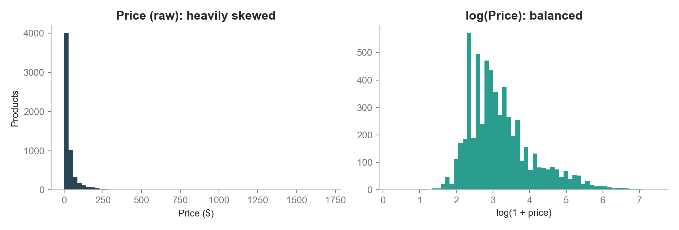
Figure 1: Price distribution before and after the log transform
Statistic | Value
Products | 6,000
Categories (hidden) | 6 × 1,000
Median price | $19.88
Mean price | $43.57
Mean rating | 4.14
Median number of reviews | 14

4. Methodology

4.1 Pipeline overview
All steps are combined into one scikit-learn Pipeline, so exactly the same transformations are applied when the model is trained and when a new product is predicted.
Step | Input | Operation | Output / reason
1 | title + description | TF-IDF (unigrams + bigrams, English stop words removed, min_df = 2, max_df = 0.5, sublinear tf) | 45,899 weighted word/phrase features
2 | TF-IDF matrix | Truncated SVD to 50 components, then L2 normalisation | 50 dense topic features; removes noise and groups related words
3 | price, num_reviews | log(1 + x), then StandardScaler | 2 features; corrects skew and puts them on a common scale
4 | rating | StandardScaler | 1 feature
5 | all features | Weight text × 1.0 and numbers × 0.1; concatenate | 53-dimensional product vector
6 | product vectors | K-Means (K = 6, n_init = 10, random_state = 42) | Cluster label for every product
7 | product vectors | PCA to 2 components | 2-D picture for visualisation only

4.2 Design decisions
- Why combine text and numbers? Text tells us what a product is; price and popularity distinguish, for example, budget accessories from premium equipment.
- Why weight numbers at 0.1? With a weight of 0.25 the algorithm created a cluster of “badly rated products” (average rating 2.1) instead of a product type. Lowering the weight lets text decide the product type while numbers still refine it.
- Why sublinear tf and max_df = 0.5? Long descriptions repeat words; sublinear term frequency dampens repetition, and max_df removes words found in more than half the products. Together they improved agreement with Amazon's categories from ARI 0.25 to about 0.36 in our tuning on the first 1,800-product sample.
- Why SVD rather than PCA on text? TF-IDF is sparse; Truncated SVD works on sparse data directly, while PCA would require centring (densifying) it.

4.3 Choosing the number of clusters
K-Means was run for K = 2 to 10. For each K we recorded the inertia (Elbow method) and the Silhouette score. K was chosen where the elbow curve flattens and the clusters remain interpretable for a business user.

4.4 Comparison protocol
The same 53-dimensional features were clustered with K-Means, Agglomerative (Ward) clustering with the same K, and DBSCAN (eps = 0.6, min_samples = 10). Silhouette and Davies–Bouldin were computed on non-noise points; ARI was computed against Amazon's categories on all points.

5. Implementation

5.1 Tools
Python 3.10, pandas and NumPy for data handling, scikit-learn 1.7 for all machine learning, Matplotlib and Plotly for charts, Streamlit for the interactive demo, and pyarrow with huggingface_hub to stream the dataset.

5.2 Project files
File | Purpose
download_data.py | Streams the dataset from Hugging Face, cleans it and saves products.csv
clustering.py | Complete pipeline: features, choosing K, K-Means, comparison, profiles, plots, self-check
Product_Clustering.ipynb | The same pipeline step by step with explanations and saved outputs
app.py | Streamlit web app with five tabs: Data, Choose K, Clusters, Compare algorithms, Try a product
outputs/ | choose_k.png, clusters_pca.png and products_clustered.csv

5.3 Core code
The whole model is defined in a few lines, which makes it easy to retrain and to apply to new products:
text = Pipeline([
("tfidf", TfidfVectorizer(stop_words="english", ngram_range=(1, 2), min_df=2,
sublinear_tf=True, max_df=0.5)),
("svd", TruncatedSVD(n_components=50, random_state=42)),
("norm", Normalizer()),
])
features = ColumnTransformer(
[("text", text, "text"),
("skewed", make_pipeline(FunctionTransformer(np.log1p), StandardScaler()),
["price", "num_reviews"]),
("normal", StandardScaler(), ["rating"])],
transformer_weights={"text": 1.0, "skewed": 0.1, "normal": 0.1})

model = Pipeline([("features", features),
("kmeans", KMeans(n_clusters=6, n_init=10, random_state=42))])
model.fit(products) # train
model.predict(new_products) # assign new products to clusters

5.4 Interactive demo
The Streamlit app lets the user change K with a slider and re-cluster live, hover over each product in the 2-D plot, compare algorithms while adjusting DBSCAN's eps, and type a new product to see its predicted cluster and the five most similar products (cosine similarity in feature space).

6. Results

6.1 Choosing K
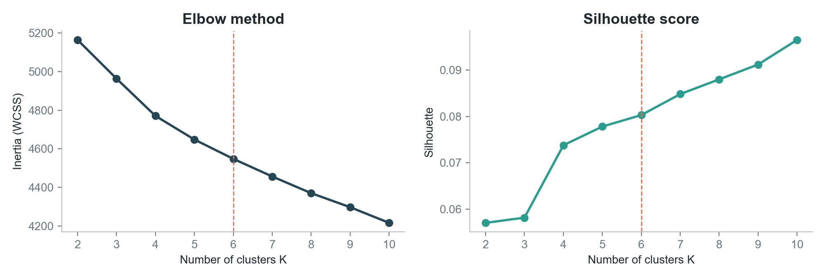
Figure 2: Elbow method (left) and Silhouette score (right); dashed line marks K = 6
K | 2 | 3 | 4 | 5 | 6 | 7 | 8 | 9 | 10
Inertia | 5,165 | 4,964 | 4,771 | 4,648 | 4,548 | 4,456 | 4,370 | 4,297 | 4,216
Silhouette | 0.057 | 0.058 | 0.074 | 0.078 | 0.080 | 0.085 | 0.088 | 0.091 | 0.097

Inertia falls steadily with no sharp elbow, and the Silhouette score rises slowly from 0.057 to 0.097. This gradual pattern is typical of text data: products sit in a high-dimensional space and genuinely overlap. We selected K = 6, where the decrease in inertia begins to flatten and every cluster can be described in business terms; higher K mainly splits large clusters into small, harder-to-interpret pieces.

6.2 Cluster profiles
# | Cluster name | Products | Avg price | Top keywords | Largest Amazon category
0 | Pet supplies | 832 | $27.2 | dog, dogs, cat, pet, cats, toy | 97% Pet Supplies
1 | Clothing | 932 | $43.9 | women, men, sleeve, shirt, casual, comfort | 76% Fashion
2 | Lighting | 257 | $40.1 | light, led, lights, lamp, solar, lighting | 85% Tools & Home Improvement
3 | Hard goods & outdoor | 1,898 | $59.9 | steel, water, bag, stainless, size, easy | 41% Sports & Outdoors
4 | Phone accessories | 876 | $27.1 | case, phone, galaxy, samsung, compatible, cover | 98% Cell Phones & Accessories
5 | Home & storage | 1,205 | $41.7 | storage, home, set, room, gift, size | 59% Amazon Home
Table: K-Means clusters with K = 6. Names were assigned by us from the keywords.
- Pet supplies and phone accessories are almost pure (97% and 98%), recovered without ever seeing a label.
- Lighting is a segment that Amazon does not have: 85% of it comes from the broad Tools & Home Improvement category.
- Clothing absorbs sportswear from Sports & Outdoors (175 products), which is reasonable: cycling shorts are clothing.
- Hard goods & outdoor is the broadest cluster (bottles, bags, steel tools, gear) and is the most expensive on average ($59.9).

6.3 Visualisation
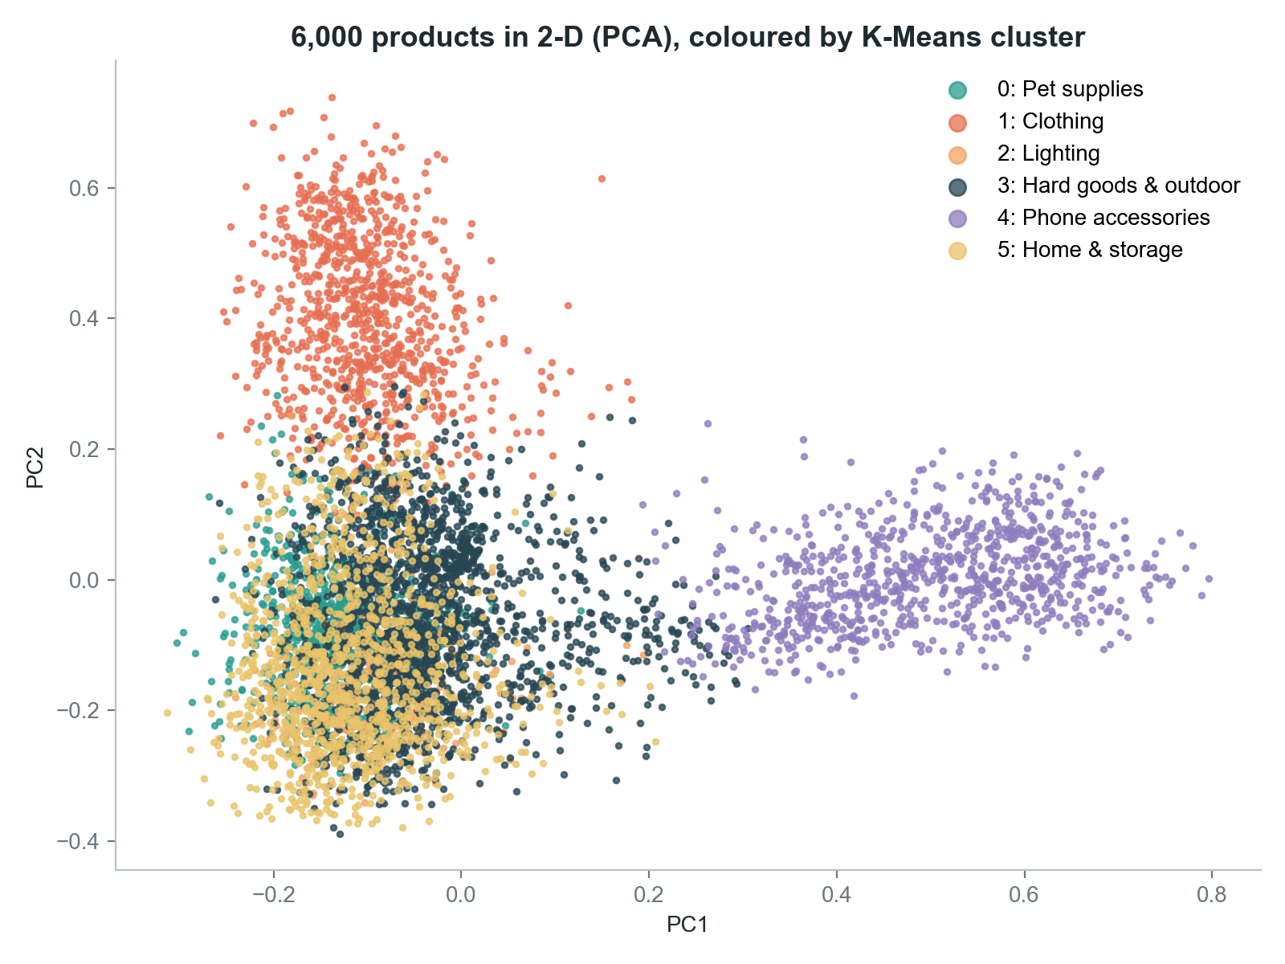
Figure 3: All 6,000 products projected to two dimensions with PCA, coloured by cluster
Phone accessories (purple) and clothing (orange) form clearly separate regions. The home, hard-goods and pet clusters overlap in this 2-D view; PCA keeps only two of the 53 dimensions, and these clusters are better separated in the full space, as the high purity of the pet cluster shows.

6.4 Validation against Amazon's categories
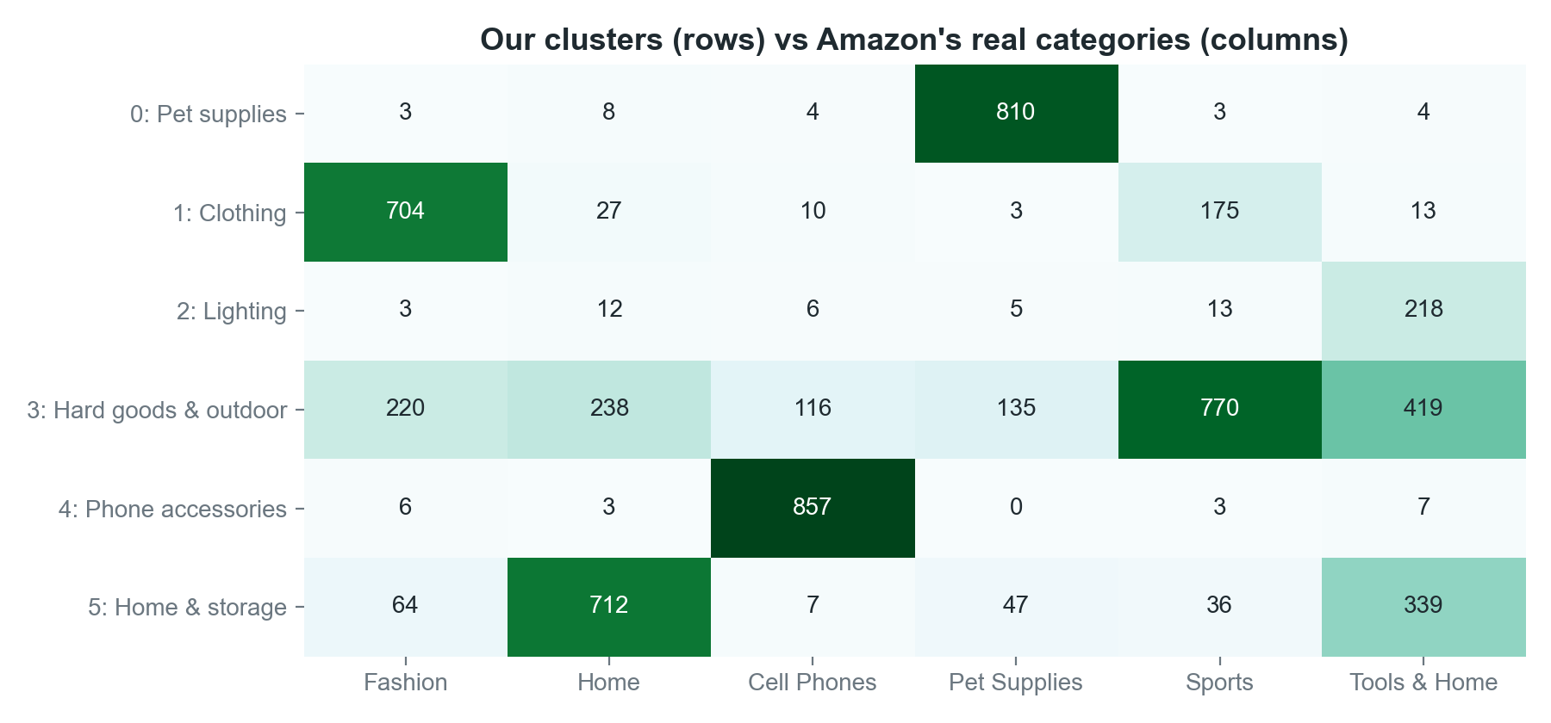
Figure 4: Number of products from each Amazon category in each cluster
Agreement between our clusters and Amazon's six categories is ARI = 0.412, far above the value of 0 expected from random grouping. It is not close to 1 because Amazon's categories themselves overlap (a water bottle can be listed under Sports, Home or Tools) and because the clusters found meaningful groups, such as lighting, that differ from Amazon's taxonomy.

6.5 Algorithm comparison
Algorithm | Clusters | Noise points | Silhouette ↑ | Davies–Bouldin ↓ | ARI ↑
K-Means | 6 | 0 | 0.080 | 3.508 | 0.412
Agglomerative (Ward) | 6 | 0 | 0.067 | 3.559 | 0.331
DBSCAN | 35 | 2,464 | 0.114 | 1.562 | 0.186

- K-Means vs Agglomerative: K-Means is better on all three metrics (Silhouette 0.080 vs 0.067, Davies–Bouldin 3.508 vs 3.559, ARI 0.412 vs 0.331), and it is faster and can predict new products.
- DBSCAN: its Silhouette and Davies–Bouldin look better only because they are computed on the products it kept. It labelled 2,464 products (41%) as noise and split the rest into 35 small clusters, giving the lowest ARI (0.186). In high-dimensional text space densities are nearly uniform, which is a known weakness of density-based methods.
K-Means is therefore selected as the final model.

6.6 Stability and prediction
The pipeline was first developed on 1,800 products (300 per category) and then re-run on 6,000 products. The same six themes appeared in both runs (ARI 0.43 and 0.41), indicating that the clusters reflect real structure rather than a lucky sample.
For a new, unseen product “Stainless steel dog food bowl, non-slip – Durable bowl for small and medium dogs and cats” ($14.99), the model predicts the pet-supplies cluster, and the five most similar products returned are all stainless-steel or slow-feeder pet bowls.

7. Discussion

7.1 Why are Silhouette scores low?
Silhouette values around 0.08 would be poor for low-dimensional numeric data, but they are common for text. In 53 dimensions distances between points become similar, and real products sit on a continuum (a “dog water bottle” is both a pet product and a bottle). Interpretability, purity and agreement with an external taxonomy are therefore more informative here, and all three support the result.

7.2 Business value
- Catalogue clean-up: products whose cluster disagrees with their listed category are candidates for review.
- Cold-start recommendations: a new product with no sales history can immediately be matched to similar items.
- Assortment insight: cluster price profiles show, for instance, that hard goods average about twice the price of phone accessories.

7.3 Learnings
- Feature engineering (log transform, weighting, TF-IDF settings) had a larger effect on quality than the choice of clustering algorithm.
- Internal metrics alone can mislead: DBSCAN scored best on Silhouette while producing the least useful grouping.
- Hidden labels, used only for evaluation, are a valuable sanity check for unsupervised models.

8. Limitations and Future Work
The project meets its objectives, but several limitations remain. Each suggests a natural next step:
Limitation | Possible improvement
TF-IDF matches exact words only (“sofa” ≠ “couch”) | Sentence embeddings (e.g. BERT, sentence-transformers) to capture meaning
One broad hard-goods cluster | Re-cluster that group (hierarchical drill-down) or use a larger K
Each product belongs to exactly one cluster | Gaussian Mixture Models for soft, probabilistic membership
Product images are not used | Add image features from a pre-trained CNN
Six categories, 6,000 products | Scale to all categories with MiniBatchKMeans

9. Conclusion
This project grouped 6,000 real Amazon products into six meaningful clusters using only their text, price, rating and review count, with no labels. A pipeline of TF-IDF, Truncated SVD, log scaling and K-Means produced clusters that are easy to interpret, agree with Amazon's own categories far better than chance (ARI 0.412, with two clusters above 97% purity), and remained stable when the dataset was tripled. K-Means outperformed Agglomerative clustering and DBSCAN on this data. The trained model assigns new products to clusters and recommends similar items, showing how unsupervised learning can support catalogue management and recommendations in e-commerce.

References
- Hou, Y., Li, J., He, Z., Yan, A., Chen, X., & McAuley, J. (2024). Bridging Language and Items for Retrieval and Recommendation. arXiv:2403.03952. (Amazon Reviews 2023 dataset.)
- milistu. AMAZON-Products-2023 dataset. Hugging Face. https://huggingface.co/datasets/milistu/AMAZON-Products-2023
- Pedregosa, F. et al. (2011). Scikit-learn: Machine Learning in Python. Journal of Machine Learning Research, 12, 2825–2830.
- MacQueen, J. (1967). Some methods for classification and analysis of multivariate observations. Proc. 5th Berkeley Symposium on Mathematical Statistics and Probability.
- Ester, M., Kriegel, H.-P., Sander, J., & Xu, X. (1996). A density-based algorithm for discovering clusters in large spatial databases with noise. KDD-96.
- Ward, J. H. (1963). Hierarchical grouping to optimize an objective function. Journal of the American Statistical Association, 58(301).
- Deerwester, S. et al. (1990). Indexing by latent semantic analysis. Journal of the American Society for Information Science, 41(6).
- Rousseeuw, P. J. (1987). Silhouettes: a graphical aid to the interpretation and validation of cluster analysis. Journal of Computational and Applied Mathematics, 20.
- Hubert, L., & Arabie, P. (1985). Comparing partitions. Journal of Classification, 2(1).

Appendix A: How to Run
Full instructions, settings and troubleshooting are in HOW_TO_RUN.md in the project folder. Summary:
# one-time setup
python3 -m venv .venv && source .venv/bin/activate # Windows: .venv\Scripts\Activate.ps1
pip install -r requirements.txt

python3 download_data.py # once, needs internet, 2-5 min -> products.csv
python3 clustering.py # full pipeline, ~10 s -> outputs/
streamlit run app.py # demo at http://localhost:8501

The notebook Product_Clustering.ipynb can be opened in VS Code or Jupyter and run with Run All; its outputs are already saved inside the file.

