DEVELOPMENT AND CHARACTERIZATION OF BIO-COMPOSITES FROM WASTE AQUATIC BIOMASS FOR SUSTAINABLE INSULATION
A PROJECT
Submitted in partial fulfillment of the requirements for
the award of the degree of
BACHELOR OF TECHNOLOGY
By
SUCHETAN KARLOOPIA
(Registration Number: 2022BCHE019)
MIRAN HAIDER
(Registration Number: 2022BCHE027)
AKSHITA SEN
(Registration Number: 2022BCHE037)
Under the guidance
Of Dr. Fasil Qayoom Mir
DEPARTMENT OF CHEMICAL ENGINEERING
NATIONAL INSTITUTE OF TECHNOLOGY
SRINAGAR – 190006 (INDIA)
June, 2026

DEVELOPMENT AND CHARACTERIZATION OF BIO-COMPOSITES FROM WASTE AQUATIC BIOMASS FOR SUSTAINABLE INSULATION
A PROJECT
Submitted in partial fulfillment of the requirements for
the award of the degree of
BACHELOR OF TECHNOLOGY
By
SUCHETAN KARLOOPIA
(Registration Number: 2022BCHE019)
MIRAN HAIDER
(Registration Number: 2022BCHE027)
AKSHITA SEN
(Registration Number: 2022BCHE037)
Under the guidance
Of Dr. Fasil Qayoom Mir
DEPARTMENT OF CHEMICAL ENGINEERING
NATIONAL INSTITUTE OF TECHNOLOGY
SRINAGAR – 190006 (INDIA)
June, 2026
COPYRIGHT © NIT SRINAGAR (J&K), INDIA, 2026
All rights reserved.

NATIONAL INSTITUTE OF TECHNOLOGY SRINAGAR (J&K)
CANDIDATES' DECLARATION

We hereby certify that the work which is being presented in the project titled “Development And Characterization Of Bio-Composites From Waste Aquatic Biomass For Sustainable Insulation” in partial fulfillment of the requirements for the award of the Degree of Bachelor of Technology and submitted in the Department of Chemical Engineering, National Institute of Technology Srinagar, is an authentic record of our own work carried out during a period from August 2025 to June 2026 under the supervision of Dr. Fasil Qayoom Mir, Head & Associate Professor, Department of Chemical Engineering, National Institute of Technology Srinagar.
The matter presented in this project report has not been submitted by us for the award of any other degree of this or any other Institute/University.
Sd/-
(SUCHETAN KARLOOPIA) — 2022BCHE019
Sd/-
(MIRAN HAIDER) — 2022BCHE027
Sd/-
(AKSHITA SEN) — 2022BCHE037
This is to certify that the above statement made by the candidates is correct to the best of my knowledge.
Sd/-
(Dr. Fasil Qayoom Mir)
Head & Associate Professor
The project Viva-Voce Examination of Suchetan Karloopia, Miran Haider and Akshita Sen has been held on ____________________.
Signature of Supervisor(s) Signature of External Examiner
Date: ______________

ACKNOWLEDGEMENT

We wish to express our deepest gratitude and sincere appreciation to our supervisor, Dr. Fasil Qayoom Mir, Head and Associate Professor, Department of Chemical Engineering, NIT Srinagar, for his invaluable guidance, constant encouragement, and constructive criticism throughout the course of this project. His insight and expertise were instrumental in shaping this work, and it has been a privilege to work under his supervision.
We are grateful to Prof. Tabassum Ara, Department of Chemistry, NIT Srinagar, for kindly providing access to the mixer-grinder facility used for biomass size reduction, and to Dr. Khalid Majid for facilitating access to the KD2 Pro Thermal Properties Analyzer for thermal conductivity measurements.
We extend our thanks to the faculty and technical staff of the Department of Chemical Engineering for providing the laboratory facilities and assistance required to carry out the experimental work. We also acknowledge the support of the Department of Civil Engineering for access to the Baker Type K12 unconfined compression testing apparatus.
Finally, we thank our families and friends for their unwavering support and motivation throughout our academic journey.
Suchetan Karloopia
Miran Haider
Akshita Sen

ABSTRACT

Buildings account for a large fraction of global energy use, and most of the insulation used to cut that demand is far from green. Expanded polystyrene (EPS), polyurethane (PU) foam and glass wool are either made from petroleum or are energy-intensive to manufacture, which has pushed researchers to look for sustainable materials made from renewable or waste resources. At the same time, the invasive weeds water hyacinth (Eichhornia crassipes) and water lily (Nymphaea spp.) continue to choke Dal Lake in Srinagar, a Ramsar wetland of roughly 18 km² that is badly affected by eutrophication. These weeds are cleared in large quantities every year but are usually thrown away, so they form a steady and essentially free stream of waste biomass. This project links the two problems together by turning that waste biomass into bio-composite insulation panels.
Four formulations were prepared from oven-dried biomass that had been ground and classified using ASTM E11 sieves: a coarse binder-less panel (S1), a fine binder-less panel (S2), and two fine panels held together with gelatinised food-grade corn starch at biomass:starch ratios of 90:10 (S3) and 70:30 (S4). We deliberately avoided synthetic polymers and chemical crosslinkers altogether. Each panel was then tested for moisture content (ASTM D4442), bulk density (ASTM D1037), water absorption (ASTM D570), unconfined compressive strength (Baker Type K12 UCT apparatus) and thermal conductivity (KD2 Pro TR-3 transient line-source probe, ASTM D5334), with three replicates run for every test.
The fine binder-less panel (S2) and the 90:10 starch panel (S3) reached insulation-grade thermal conductivities of 0.0577 and 0.0608 W/m·K respectively, both comfortably under the 0.065 W/m·K limit set by ASTM C168. The 90:10 panel (S3) also gave the highest unconfined compressive strength at 186.0 kPa, a 97 % gain over the binder-less fine panel, which points to 10 wt% corn starch as the sweet spot for binder content. The high-starch panel (S4, 70:30) was a more puzzling case: it absorbed the least water (280 %), yet it was also the weakest (26.8 kPa) and conducted heat about three times faster (0.1846 W/m·K). We attribute this to an excess of plasticised starch and a high residual moisture content of 41.18 %. Taken together, the results make the 90:10 biomass:starch panel (S3) the best all-round formulation, since it combines insulation-grade thermal performance with the highest strength, and they show that an invasive aquatic weed can realistically be turned into a workable, biodegradable building-insulation material.
Keywords: Water hyacinth; Water lily; Bio-composite; Corn starch binder; Thermal insulation; Unconfined compressive strength; Sustainable building materials; Waste valorisation.

TABLE OF CONTENTS

Right-click and select 'Update Field' to generate the Table of Contents.

LIST OF FIGURES

Right-click and 'Update Field' to generate the List of Figures.

LIST OF TABLES

Right-click and 'Update Field' to generate the List of Tables.

LIST OF ABBREVIATIONS

Abbreviation | Description
ASTM | American Society for Testing and Materials
WH | Water Hyacinth (Eichhornia crassipes)
WL | Water Lily (Nymphaea spp.)
WHF | Water Hyacinth Fibre
MC | Moisture Content
WA | Water Absorption
UCT | Unconfined Compression Test
SEM | Scanning Electron Microscopy
EPS | Expanded Polystyrene
XPS | Extruded Polystyrene
PU | Polyurethane
IFR | Intumescent Flame Retardant
PBS | Poly(butylene succinate)
LOI | Limiting Oxygen Index
RH | Relative Humidity
LCA | Life Cycle Assessment
IEEE | Institute of Electrical and Electronics Engineers
SD | Standard Deviation

LIST OF SYMBOLS

Symbol | Description | Unit
K | Thermal conductivity | W/m·K
R | Thermal resistivity | °C·cm/W
ρ | Bulk density | g/cm³
σ | Compressive (deviator) stress | kPa
ε | Axial strain | – or %
εf | Failure strain | %
qᵤ | Unconfined compressive strength | kPa
Sᵤ | Undrained shear strength (= qᵤ/2) | kPa
A₀ | Initial cross-sectional area | mm²
A | Corrected cross-sectional area | mm²
H₀ | Initial specimen height | mm
ΔL | Axial deformation | mm
F | Applied compressive force | N
C | Proving-ring calibration constant | N/div
Wᵢ | Initial (wet) mass | g
Wf | Final (oven-dry) mass | g
Syx | Standard error of estimate (goodness-of-fit) | –
n | Number of replicates | –

CHAPTER 1

INTRODUCTION

1.1 Background
Thermal insulation is one of the cheapest and most effective ways to cut energy use in buildings, which are responsible for a large slice of global energy consumption and greenhouse-gas emissions. The trouble is that most insulation on the market today — expanded polystyrene (EPS), extruded polystyrene (XPS), polyurethane (PU) foam, glass wool and mineral wool — is either petroleum-derived or energy-intensive to make. These products do not biodegrade, they pile up in landfills once their service life ends, and the organic foams among them burn readily and give off toxic gases when they do [1], [7]. With circular-economy thinking and carbon-footprint reduction now high on the agenda, attention has shifted towards insulation made from renewable and waste lignocellulosic resources.
Natural-fibre bio-composites are an attractive alternative for several reasons. They are renewable and biodegradable, they are light, their porous cellular structure gives them a naturally low thermal conductivity, and they can often be made cheaply from agricultural or aquatic waste. Researchers have tried a long list of lignocellulosic feedstocks for insulation — rice straw, corn cob, coir, hemp, flax, kenaf, sugarcane bagasse, pineapple leaf and date-palm waste, to name a few [4], [6]. Of the aquatic options, water hyacinth (Eichhornia crassipes) stands out because it is abundant, grows extremely fast and has a high cellulose content.
How well a material insulates is captured mainly by its thermal conductivity, K, measured in watts per metre-kelvin (W/m·K). The lower the K, the better the insulator, because less heat passes through the material for a given temperature difference. Lightweight insulators get their low conductivity from the large amount of still air trapped inside a cellular or fibrous solid; air on its own conducts heat very poorly, at roughly 0.026 W/m·K. Anything that pushes this trapped air out — densification, void filling, or above all moisture getting in — raises the effective conductivity and spoils the insulation. Water conducts heat at about 0.6 W/m·K, some 23 times better than air, which is exactly why keeping moisture out keeps coming up as a problem in bio-based insulation.
A bio-composite combines a natural fibre or particle reinforcement with a matrix, or binder, so that the resulting material performs better than either ingredient would on its own. Here the reinforcement is lignocellulosic aquatic biomass and the matrix is a biodegradable polysaccharide binder. The appeal of such composites lies in their renewability, biodegradability, low density and low embodied energy and carbon, along with the fact that they put a waste stream to good use. Their weak points are equally well known: they take up a lot of moisture, their mechanical strength is modest, and they are flammable. These are precisely the shortcomings that tuning particle size, binder type and binder content is meant to address, and they are what this project sets out to study in a systematic way.

1.2 The Dal Lake Problem: An Invasive Weed as a Resource
Dal Lake in Srinagar, Jammu & Kashmir, is one of the Himalayas' best-known urban lakes and a designated Ramsar wetland of roughly 18 km². Over the last few decades it has declined badly, mainly through eutrophication fed by untreated sewage, the spread of the city into its catchment and heavy nutrient loading. One of the most obvious results of all that nutrient enrichment is the runaway growth of free-floating invasive weeds, chiefly water hyacinth (Eichhornia crassipes) and water lily (Nymphaea spp.). They spread into thick surface mats that starve the water of oxygen, cut out sunlight, wreck native fish breeding grounds, get in the way of boats and gradually turn open water into marsh.
Every year, mechanical de-weeding pulls large amounts of this biomass out of the lake, but the harvested material is treated as rubbish and either dumped or left to rot, releasing methane and feeding the same nutrients back into the water. The upshot is a continuous, free and otherwise troublesome supply of biomass. Turning this weed into something useful tackles two problems at once: it gives weed removal an economic payoff and an end use, and it provides a renewable raw material for sustainable insulation. That dual benefit is the central idea behind this project.
[ Figure: Dal Lake collection site photograph — to be inserted ]
Figure . Dal Lake, Srinagar (≈ N 34.08°, E 74.85°) showing aquatic weed infestation — collection site of the raw biomass.

1.3 Motivation
Three things together motivated this work. The first is the environmental and health baggage that comes with petroleum-based synthetic insulation. The second is the pressing need to manage and make use of the invasive weed that clogs Dal Lake. The third is recent evidence that water-hyacinth fibre can perform well as a low-thermal-conductivity natural material [2], [3]. By choosing a food-grade, biodegradable corn-starch binder instead of synthetic resins or chemical crosslinkers, we aimed to make a fully bio-based, low-cost and environmentally harmless insulation panel that can be produced with simple, scalable equipment.

1.4 Problem Statement
Waste aquatic biomass is a promising green substitute for synthetic insulation, but on its own it cannot be used directly. It is too weak mechanically, it soaks up too much moisture, and it catches fire easily. Overcoming these limitations calls for an engineered bio-composite — the right binder paired with the right processing route — that delivers enough structural integrity, dimensional stability and insulating performance while still staying biodegradable.

1.5 Objectives
The primary objectives of this project are:
- To develop eco-friendly bio-composite insulation panels from waste aquatic biomass (water hyacinth and water lily) collected from Dal Lake.
- To fabricate composite variants differing in particle size and biomass-to-binder ratio using a natural, gelatinised corn-starch binder.
- To characterize the physical properties of the panels — moisture content, bulk density and water absorption — following ASTM standards.
- To evaluate the mechanical performance of the panels through unconfined compression testing and to determine the optimal binder content.
- To measure the thermal conductivity of the panels and assess their suitability as insulation-grade materials against the ASTM C168 threshold.
- To identify the best-balanced formulation by comparing mechanical, thermal and moisture-resistance performance, and to benchmark it against conventional insulation materials reported in the literature.

1.6 Scope of the Work
This study is concerned with fabricating four bio-composite formulations at laboratory scale and characterising their physical, mechanical and thermal behaviour. The testing programme covers moisture content (ASTM D4442), bulk density (ASTM D1037), water absorption (ASTM D570), unconfined compressive strength (Baker Type K12 apparatus), thermal conductivity (KD2 Pro TR-3 probe, ASTM D5334) and scanning electron microscopy (SEM) of the binder-less (S1) and 90:10 starch-bound (S3) panels to examine their microstructure. Flammability testing, hydrophobic surface treatments and a full life-cycle assessment are left for future work and are not covered here.

1.7 Organisation of the Report
The rest of the report is organised as follows. Chapter 1 has set out the background, motivation, problem statement and objectives. Chapter 2 reviews the literature on natural-fibre and water-hyacinth-based insulation and pins down the research gap. Chapter 3 covers the design, experimental setup and methodology, including the raw materials, binder preparation, sample fabrication and the test methods and equipment. Chapter 4 reports the results and discusses them alongside published work. Chapter 5 draws the findings together, states the main conclusions and outlines where the work could go next.

CHAPTER 2

LITERATURE REVIEW

2.1 Overview
Plenty of research has looked at natural fibres and agricultural or aquatic wastes as raw materials for sustainable insulation composites. This chapter walks through the studies most relevant to the present work, paying particular attention to water-hyacinth-based composites, natural binder systems, fire-retardancy and what happens to these materials at end of life. It sets the performance benchmarks that this project is measured against and marks out the gap that the work aims to fill.

2.2 Water-Hyacinth-Based Insulation Composites
Salas-Ruiz et al. [2] studied binder-less particle boards made from water-hyacinth petioles and measured thermal conductivities as low as 0.047 W/m·K for staple-fibre boards and around 0.065 W/m·K for pulp boards. Water absorption, though, was very high at 450–555 %, which neatly captures the two sides of these boards: they insulate beautifully but are very sensitive to moisture. Philip and Rakendu [3] went a different route with a water-hyacinth–cement composite, reaching a thermal conductivity of 0.0765 W/m·K at a density of 0.47 g/cm³, with a flexural strength of about 0.35 MPa and water absorption close to 98 %. Jaktorn and Jiajitsawat [1] bonded water-hyacinth fibre with natural rubber latex and obtained very low conductivities of 0.0246–0.0305 W/m·K, but their boards still failed the relevant industrial standard on water absorption — once again, moisture resistance was the sticking point.
Anjani et al. [6] made water-hyacinth–sugarcane-bagasse fibre–epoxy composites for cool-box insulation, with their best configuration giving a thermal conductivity of about 0.1987 W/m·K and a maximum bending strength of 263 kgf/cm². Chaireh et al. [5] worked on starch–water-hyacinth foams for food packaging and found a 5 wt% water-hyacinth loading to be optimal, with the elastic modulus reaching about 232 MPa. A beeswax coating cut water absorption sharply in their work, which is doubly useful here: it shows starch is a workable natural binder for water hyacinth and that beeswax makes an effective hydrophobic treatment.

2.3 Binder Systems, Surface Treatment and Fire Retardancy
The binder has a big say in how a natural-fibre composite behaves, both mechanically and in the wet. Syamsuri et al. [8] showed that treating water-hyacinth fibre with alkali (NaOH) inside a cassava-starch bioplastic roughly quadrupled its tensile strength compared with untreated fibre, simply by improving how well the fibre stuck to the matrix. Abral et al. [10] sounded a note of caution, though: water-hyacinth–polyester composites processed while wet came out mechanically weaker, and aggressive alkali treatment opened up micro-voids that hurt performance. The lesson is that controlling moisture during processing and curing really matters. On the fire-safety side, Suwanniroj and Suppakarn [9] used water-hyacinth fibre as a bio-based carbon source in an intumescent flame-retardant poly(butylene succinate) system and achieved a limiting oxygen index of 28.8 %, a UL-94 V-0 rating and a 53 % drop in peak heat-release rate.

2.4 Conventional Insulation Benchmarks
It helps to put bio-based numbers next to conventional insulation. Jeon et al. [7] measured a thermal conductivity of about 0.034 W/m·K for glass wool and noted that moisture getting in can push the conductivity of fibrous inorganic insulation up by roughly four times. Bio-based materials share that same weakness, which is one more reason to take moisture seriously. The widely used cut-off for calling a material insulation-grade is a thermal conductivity below 0.065 W/m·K (ASTM C168), and that is the main performance criterion adopted in this study.

2.5 Extended Literature Survey
Table 1 gathers a broader survey of recent studies, mostly from 2008–2025, on natural-fibre and waste-derived insulation and bio-composite materials. For each one it lists the materials studied, the key conditions, the main findings and the research gaps the authors themselves point out. The studies span a wide range of bio-fibres — rice straw [4], corn cob [11], mycelium [12], flax and hemp [14], sugarcane bagasse [18], pineapple-leaf fibre [19], hemp in a PU matrix [20], kenaf [21], coir [22], bamboo [25] and cork composites [20] — together with reviews of acoustic properties [15], fire retardancy [13], aerogel insulants [26], end-of-life management [23] and wider progress in bio-based insulation [28], [29].
Table . Extended literature survey of natural-fibre and waste-derived insulation / bio-composite materials.
Author(s) & Year | Focus / Materials | Key Findings | Research Gap / Remarks
Jaktorn & Jiajitsawat (2021) [1] | Water-hyacinth fibre (WHF) + natural rubber latex; pressed at 100°C | Excellent K = 0.0246–0.0305 W/m·K; higher latex raised density | High water absorption failed TISI standard; moisture resistance needed
Salas-Ruiz et al. (2019) [2] | Binder-less WH-petiole particle boards | K = 0.047 (staple)–0.065 (pulp) W/m·K; WA 450–555 % | Binder-less boards highly moisture-sensitive
Philip & Rakendu (2022) [3] | WH–cement composite | K = 0.0765 W/m·K; ρ = 0.47 g/cm³; flexural 0.35 MPa; WA 98 % | Cement raises embodied carbon; brittle
Chaireh et al. (2020) [5] | Starch–WH foam with beeswax coating | 5 wt% WH optimal; modulus 232 MPa; beeswax cut WA | Foam for packaging; panel-scale insulation not addressed
Anjani et al. (2023) [6] | WH + bagasse fibre–epoxy (cool box) | K = 0.1987 W/m·K; bending 263 kgf/cm² | Epoxy is synthetic; not fully bio-based
Jeon et al. (2017) [7] | Glass wool, mineral wool (polysiloxane coat) | Glass wool K ≈ 0.034 W/m·K; moisture → 4× rise in K | Inorganic; non-renewable; moisture-vulnerable
Syamsuri et al. (2023) [8] | WH fibre / cassava-starch bioplastic | NaOH treatment → ~4× tensile improvement | Bioplastic film, not insulation board
Suwanniroj & Suppakarn (2023) [9] | WHF in IFR / PBS composite | WHF as bio-carbon; LOI 28.8 %; UL-94 V-0; 53 % pHRR cut | Focus on flammability, not thermal insulation
Abral et al. (2014) [10] | WH fibre–polyester composites | Wet composites weaker; alkali introduced micro-voids | Highlights need for moisture & treatment control
Jaktorn & Jiajitsawat (2021)* [1] | WHF + NRL ratios (70 g WHF : 130–170 g NRL) | Good K; density rose with latex | Moisture resistance below standard
Zhou et al. (2022) [4] | Rice straw + sodium alginate / chitosan binders | K = 0.038–0.047 W/m·K; CaCl₂ crosslink improved water resistance | Significant mould growth; needs bio-preservatives
Pinto et al. (2021) [11] | Corn cob vs extruded polystyrene (XPS) | Corn cob has XPS-like closed-cell microstructure; eco-insulation potential | Lacks quantitative K data; needs standardised panel
Yang et al. (2020) [12] | Review of mycelium-based bio-composites | Low-cost binder; >75 % acoustic absorption at 1000 Hz | Production not standardised
Sahayaraj et al. (2023) [13] | Review of fire retardants for natural-fibre composites | P/N additives, coatings, nanoparticles improve fire safety | No standardised long-term durability data
Kymäläinen & Sjöberg (2008) [14] | Flax and hemp fibres for insulation | Performance depends on fibre purity and processing | Fibre-extraction consistency needed for scale-up
Asdrubali et al. (2015) [15] | Review of acoustic & thermal properties of natural-fibre insulants | High sound absorption from porous structure; good thermal resistance | Low-frequency / humidity performance under-studied
Chen et al. (2020) [16] | Boron-based flame retardants on wood-plastic composites | Borax / boric acid raise LOI; thermal stability improved | High loading reduces mechanical strength
Aridi et al. (2016) [17] | Rice-husk polypropylene composites (injection moulded) | Lightweight; low thermal conductivity at optimised fibre loading | Poor fibre–matrix adhesion; needs surface treatment
Oushabi et al. (2022) [18] | Sugarcane-bagasse composites (NaOH treated) | Alkali treatment improved strength & insulation | High moisture absorption remains a challenge
Wang et al. (2023) [19] | Pineapple-leaf-fibre (PALF) / epoxy | High cellulose & strength; suitable for structural insulation | Large-scale PALF extraction difficult
Sair et al. (2021) [20] | Hemp-fibre / polyurethane composites | Low K; good mechanical performance at 10–20 wt% fibre | Limited availability; higher cost
Muthuraj et al. (2022) [21] | Kenaf-fibre composites (UV/humidity aged) | Low density with high strength | Performance degrades under UV over time
Oyejobi et al. (2020/21) [22] | Coir-fibre reinforced concrete composites | Durable; high lignin makes them rigid | Needs improved flexibility & interfacial bonding
Zhang et al. (2024) [23] | Review of end-of-life management for bio-composites | Pyrolysis (400–600°C) viable for energy recovery | Limited emissions data for mixed/additive composites
Binici et al. (2023) [24] | Insulation from chicken-feather & cotton waste fibres | Effective thermal & acoustic insulation; low density | Waste heterogeneity → inconsistent panels
Li et al. (2021) [25] | Hygrothermal behaviour of bamboo-fibre composites | Good moisture buffering; regulates indoor humidity | Susceptible to insect / fungal attack
Liu et al. (2024) [26] | Review of cellulose-aerogel thermal insulation | Cellulose aerogels λ < 0.020 W/m·K (super-insulating) | Costly; not yet scalable for building panels
Trabelsi et al. (2020) [27] | Hemp-shiv concrete (hygrothermal) | Excellent moisture-buffer value; low carbon footprint | Lower compressive strength vs conventional concrete
Pawlowski et al. (2025) [28] | Systematic review of bio-based thermal-insulation composites | Catalogues 50 bio-composites; highlights bio-fibres, eco-resins & applications | Comparative LCA among systems lacking; standardisation needed
Cosentino et al. (2023) [29] | Hemp, cork, kenaf, coir (RH & density effects) | Hemp & cork show superior thermal / acoustic behaviour | Need standard benchmarking under varied humidity conditions
* Conditions row for the same study, retained from the project literature survey for completeness.

2.6 Pertinent Theory
Heat moves through a porous insulation panel by three routes at once: conduction through the solid fibre/binder network and through the gas in the pores, convection inside the larger pores, and radiation across pore surfaces. In low-density fibrous and particulate insulants the pores are small enough to all but shut down convection, so the effective thermal conductivity comes down mainly to conduction through the solid and through the trapped air. Because still air conducts heat so poorly (≈ 0.026 W/m·K), the trick to a good insulator is to pack in as many small, isolated air pockets as possible while keeping continuous solid pathways to a minimum. That is why a light, porous panel beats a dense one, and why moisture is so damaging — it swaps insulating air for far more conductive water.
Corn starch binds through gelatinisation. Native starch is made up of semi-crystalline granules of amylose and amylopectin. Heat it in excess water above its gelatinisation temperature (typically 60–75 °C for maize starch) and the granules take up water, swell and burst, releasing amylose and forming a thick paste. As the paste cools and dries, the loosened starch chains re-associate (retrogradation) into a continuous film that bridges and glues the biomass particles together, acting as a natural adhesive matrix. How much starch is added therefore decides how strongly the particles bond: too little and the panel barely holds together, too much and you get a continuous, moisture-hungry matrix that fills the very pores doing the insulating. Pinning down that trade-off is one of the things this study set out to do.
The transient line heat-source method used to measure thermal conductivity rests on the theory of radial heat conduction from an infinitely long line source in an infinite medium. A known heat flux is sent along a needle probe and the temperature rise is logged over time; the slope of temperature against the logarithm of time is inversely proportional to the thermal conductivity of the surrounding material. This is the basis of the ASTM D5334 procedure used in this work.

2.7 Research Gap
Taken as a whole, the literature shows that water-hyacinth fibre can hit insulation-grade thermal conductivities, but most of the systems that achieve this lean on something less than ideal. Some use synthetic matrices (epoxy [6], polyester [10], polyurethane [20]); others use energy-intensive binders such as cement [3]; and the binder-less boards, while green, soak up huge amounts of water and have poor mechanical integrity [2]. Where natural binders are used, the target is often a packaging film or foam rather than a building-insulation panel [5], and very few studies systematically tune the biomass-to-binder ratio of a fully bio-based panel while reporting thermal, mechanical and moisture performance side by side. Reviews of bio-based insulants [28], [29] and of natural-fibre composites for acoustic [15] and fire-retardant [13] uses confirm how broad the field is, yet they also point to the same shortfall: a lack of standardised formulations that are characterised across all these properties at once. On top of that, no one has reported using aquatic weed specifically from Dal Lake, combining the waste-management angle with insulation development.
This work sets out to close that gap. It fabricates fully bio-based panels from Dal-Lake aquatic biomass bound with food-grade corn starch — no synthetic polymers, no crosslinkers — varies the particle size and the biomass:starch ratio in a deliberate way, and characterises the thermal, mechanical and moisture properties together so that a single insulation-grade formulation can be identified.

CHAPTER 3

DESIGN, SETUP AND METHODOLOGY

3.1 Raw Materials
The main raw material was waste aquatic biomass — a mix of water hyacinth (Eichhornia crassipes) and water lily (Nymphaea spp.) — gathered by hand from Dal Lake, Srinagar, Jammu & Kashmir (around N 34.08°, E 74.85°) over October–November 2025. We collected petioles, stems and leaves and washed them thoroughly to get rid of mud, debris and any biological contaminants. Commercial food-grade corn (maize) starch served as the binder, and distilled or tap water was the processing medium. At no point did we use synthetic polymers, resins or chemical crosslinkers, so the finished composite is fully bio-based and biodegradable.
Water hyacinth and water lily are free-floating aquatic plants whose petioles and stems have a porous, fibrous, cellulose-rich interior. That natural porosity is a bonus for thermal insulation, while the cellulosic fibres do the structural reinforcing in the composite. Table 2 lists the materials used in the study and what each one does.
Table . Materials used in the study and their function.
Material | Category | Function / Rationale
Water hyacinth (Eichhornia crassipes) | Primary biomass | Fibrous, cellulose-rich reinforcement and porous insulating phase
Water lily (Nymphaea spp.) | Primary biomass | Supplementary aquatic biomass reinforcement
Food-grade corn (maize) starch | Natural binder | Biodegradable matrix binding fibres after gelatinisation
Water | Processing medium | Disperses biomass and gelatinises starch; partly removed on drying
[ (a) Manual collection from Dal Lake ]  (a) Manual collection from Dal Lake | [ (b) Washed raw biomass ]  (b) Washed raw biomass
Figure . Collection and washing of waste aquatic biomass (water hyacinth and water lily) from Dal Lake, Srinagar.

3.2 Biomass Pre-treatment and Size Reduction
The washed biomass was first left to sun-dry for 5–7 days; as it dried it turned from green to tan/brown, a clear sign of moisture loss and reduced microbial activity. It then went into a laboratory drying oven at 103 ± 2 °C for about 24 hours to drive off any remaining moisture and give a consistent starting point before grinding (following the drying principle of ASTM D4442). Size reduction was done on a mixer-grinder lent by the Department of Chemistry, NIT Srinagar (under Prof. Tabassum Ara). The ground biomass was then separated on ASTM E11 standard wire-mesh sieves into a coarse fraction (> 3 mm; finer than No. 7 mesh) and a fine fraction (1.0–1.5 mm; No. 12–No. 18 mesh).
Particle size is a key processing variable. The coarse fraction gives an open, loosely interlocked structure, whereas the fine fraction offers far more surface area for particles to touch and bond, which yields more cohesive panels. The mixer-grinder is shown in Figure 3, the two classified fractions in Figure 4 and the sieve set in Figure 5.
[ Figure: Mixer-grinder photograph — to be inserted ]
Figure . Mixer-grinder used for size reduction of the oven-dried biomass (Dept. of Chemistry, NIT Srinagar).
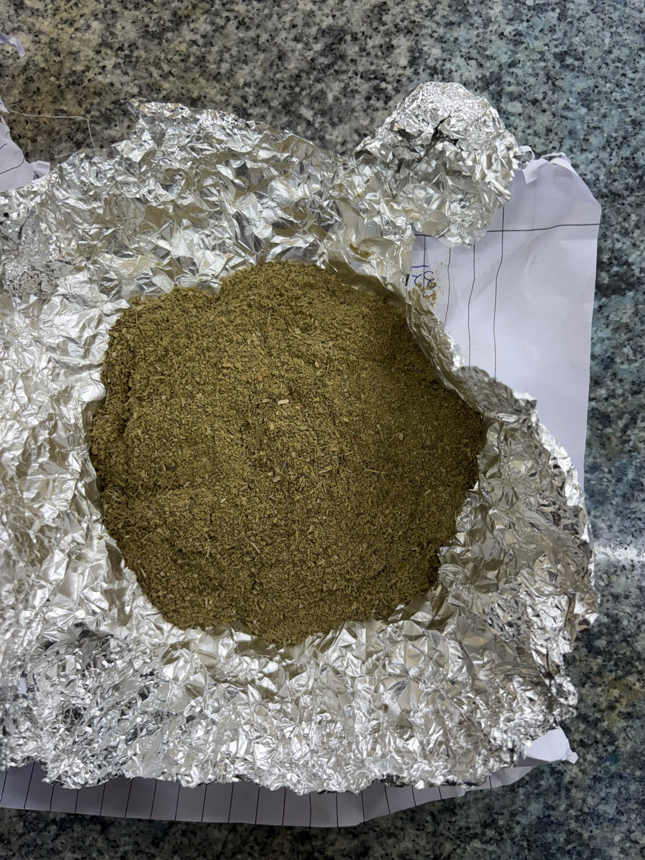  (a) Fine fraction (1.0–1.5 mm) | 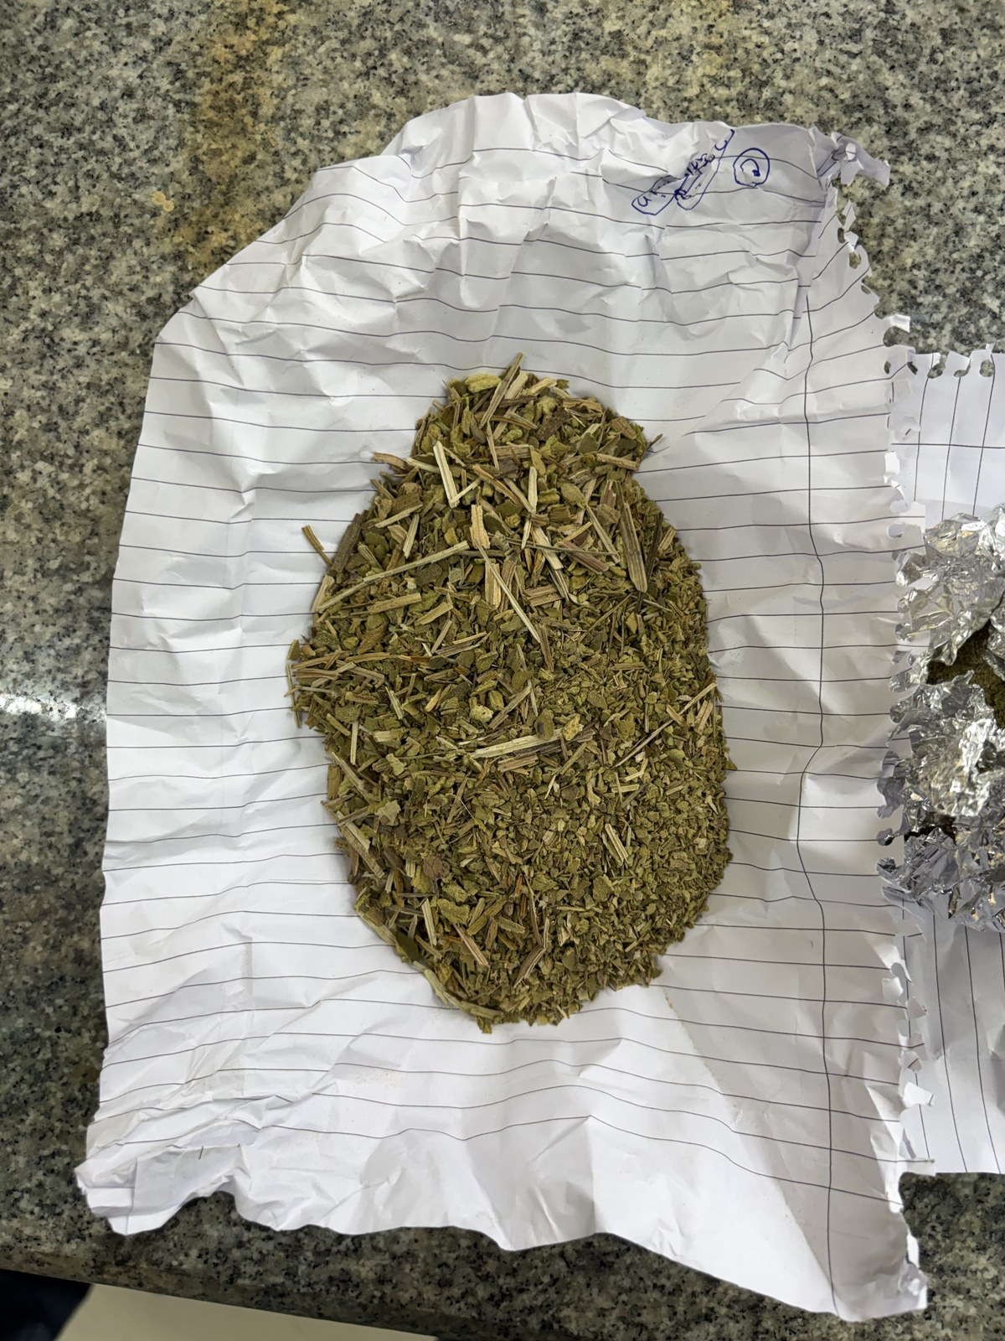  (b) Coarse fraction (> 3 mm)
Figure . Ground and sieve-classified aquatic biomass: (a) fine fraction and (b) coarse fraction.
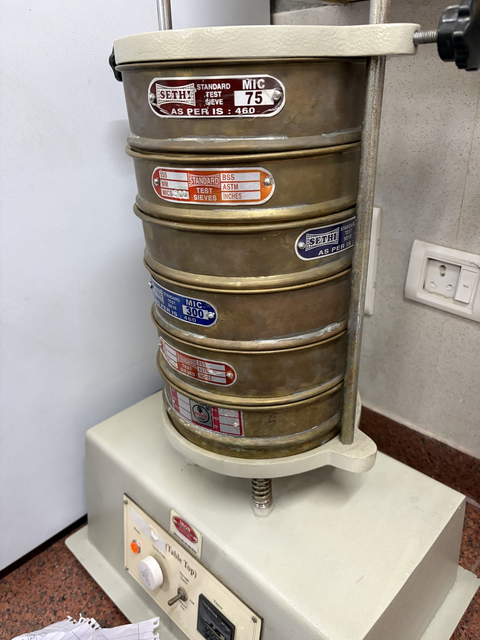
Figure . ASTM E11 standard test sieve set / sieve shaker used for particle-size classification of the ground biomass.

3.3 Binder Preparation (Corn-Starch Gelatinisation)
The natural binder was made by gelatinising food-grade corn starch in water on a hot plate fitted with a magnetic stirrer. The starch–water mixture was heated to 80–90 °C with constant stirring until it turned into a translucent, viscous gel, the sign that the starch granules had fully gelatinised. This starch paste was the binder for samples S3 (90:10) and S4 (70:30). Samples S1 and S2 had no starch at all and used only 15 % water as a temporary processing aid.
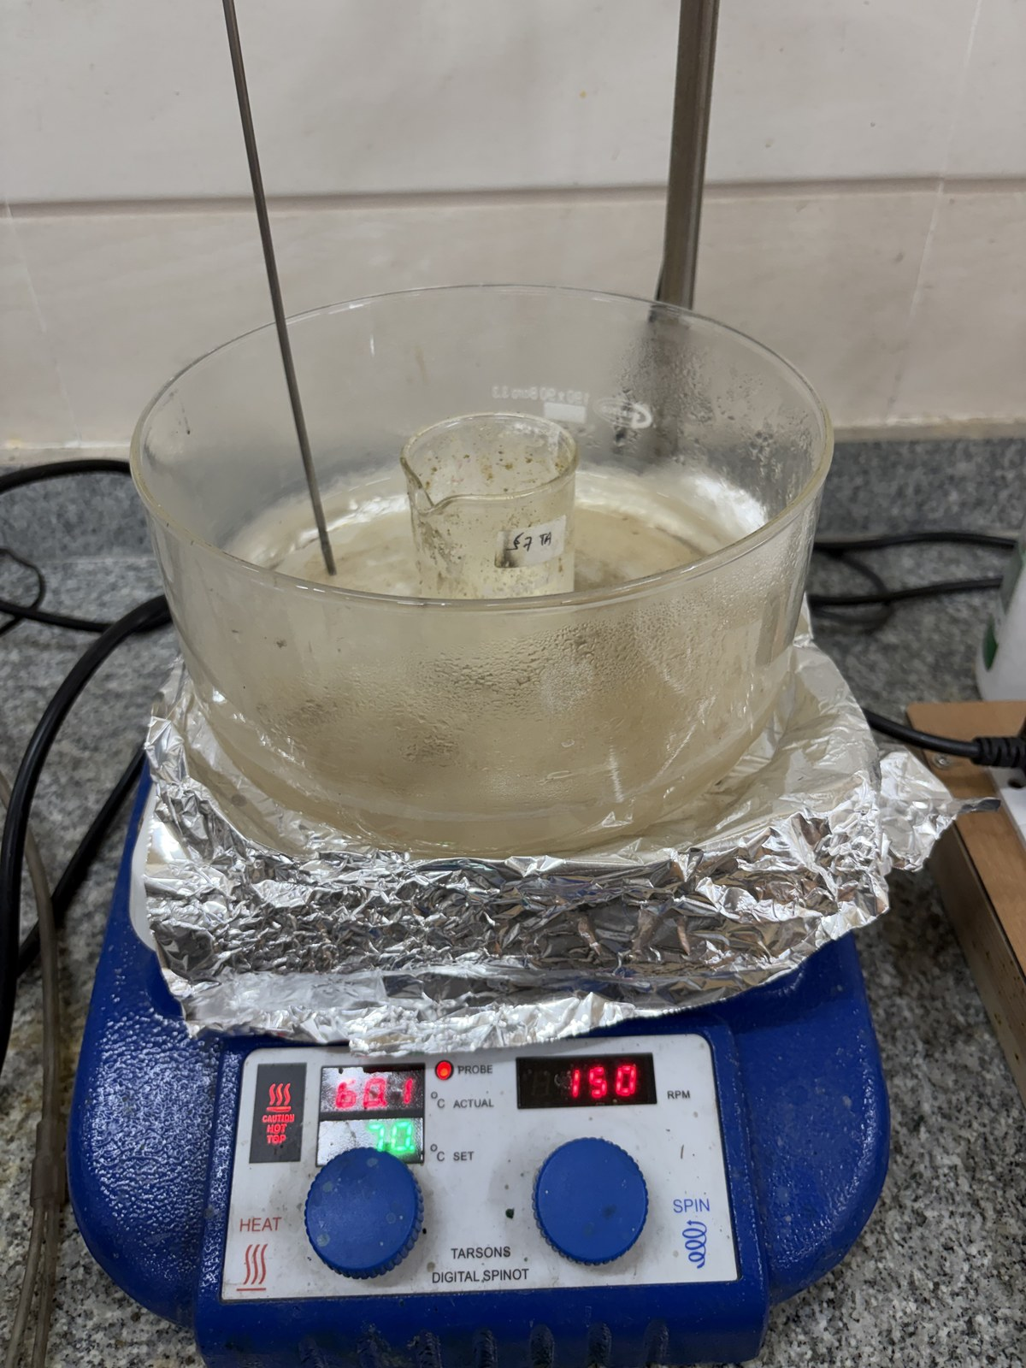
Figure . Gelatinisation of food-grade corn starch on a hot plate with magnetic stirrer at 80–90 °C.

3.4 Composite Fabrication
The classified biomass was mixed with the appropriate binder or water in the set proportions and packed into moulds. Flat panels were formed in 50 × 50 mm steel moulds, while cylindrical specimens for unconfined compression testing were formed in aluminium moulds of 30 mm diameter and 25 mm height. We cold-pressed the filled moulds by hand to consolidate the mixture, squeeze out porosity and improve inter-particle bonding. After demoulding, the specimens were oven-dried at 103 ± 2 °C to constant mass, which took about 24 hours. In all, four formulations were produced, summarised in Table 3.
Table . Bio-composite sample fabrication details.
Sample | Particle Size | Composition / Binder | ASTM E11 Mesh | Observation
S1 | Coarse > 3 mm | Biomass only + 15% water | < No. 7 (> 2.83 mm) | Poor mechanical stability; fractured on demoulding
S2 | Fine 1.0–1.5 mm | Biomass only + 15% water | No. 12–No. 18 (1.0–1.7 mm) | Better cohesion; intact panel formed
S3 | Fine 1.0–1.5 mm | Biomass:Starch = 90:10 (corn starch) | No. 12–No. 18 (1.0–1.7 mm) | Improved binding and surface finish
S4 | Fine 1.0–1.5 mm | Biomass:Starch = 70:30 (corn starch) | No. 12–No. 18 (1.0–1.7 mm) | Compact, denser panel; highest binder fraction
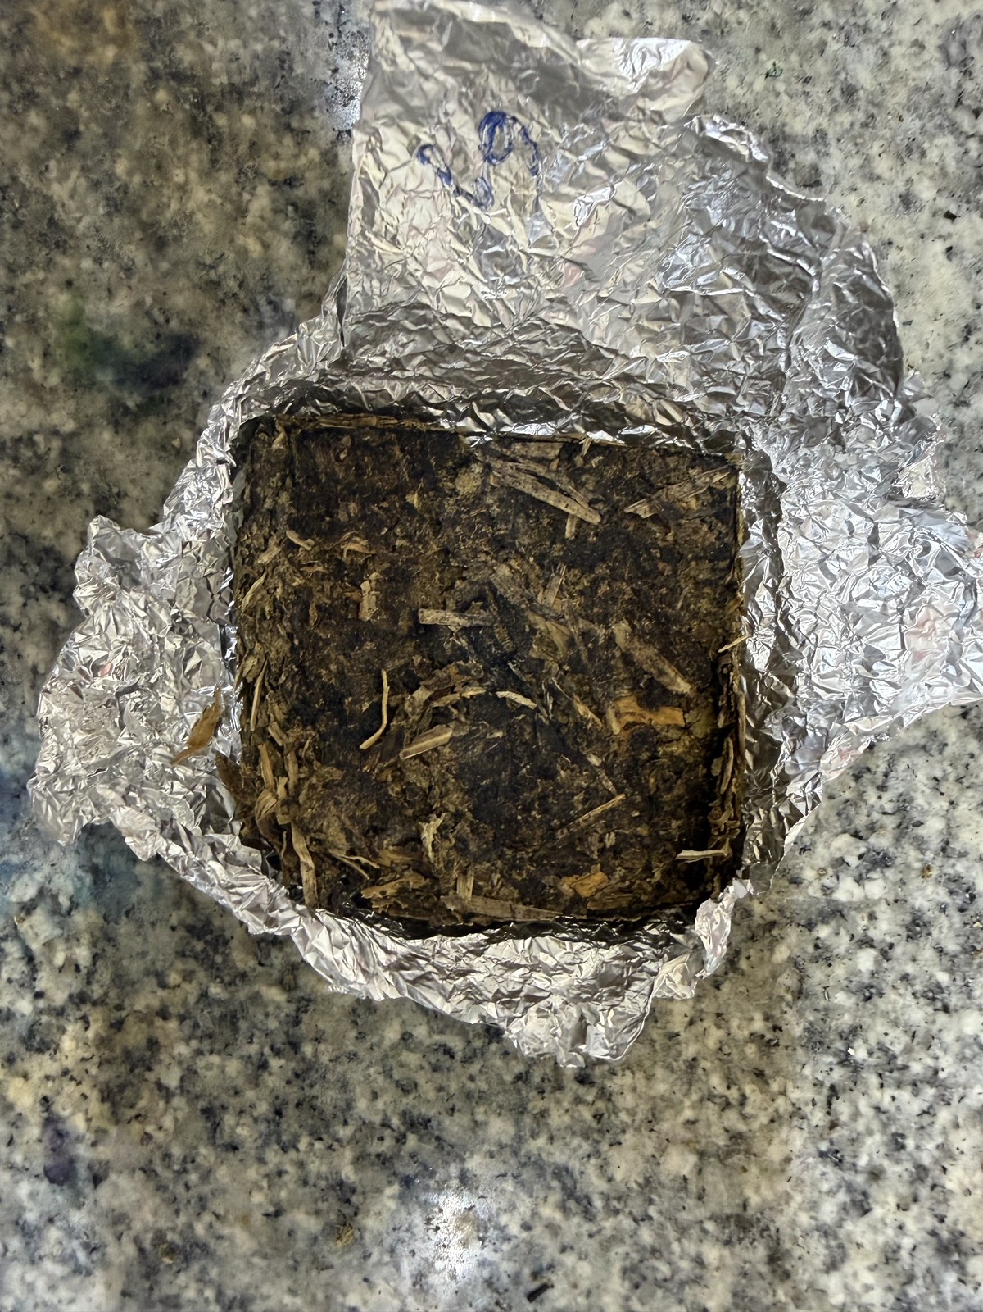  (a) S1 coarse, no binder | 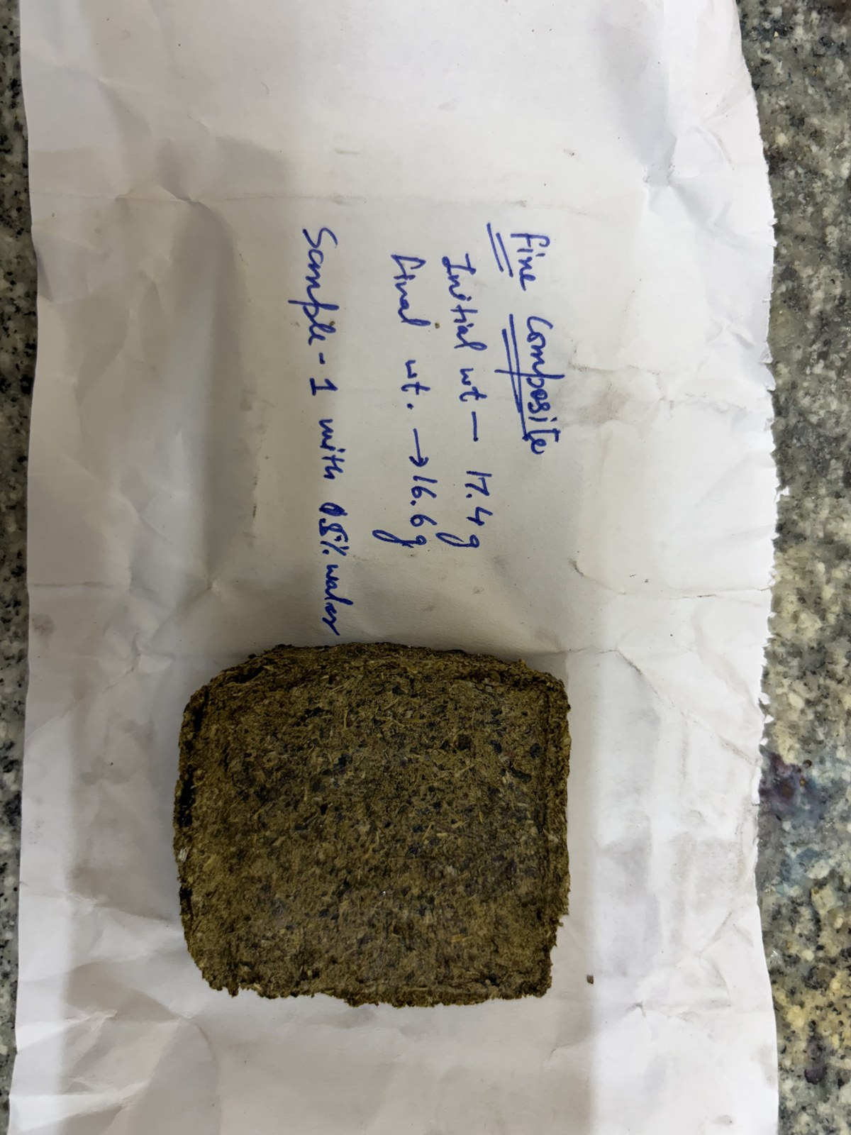  (b) S2 fine, no binder | 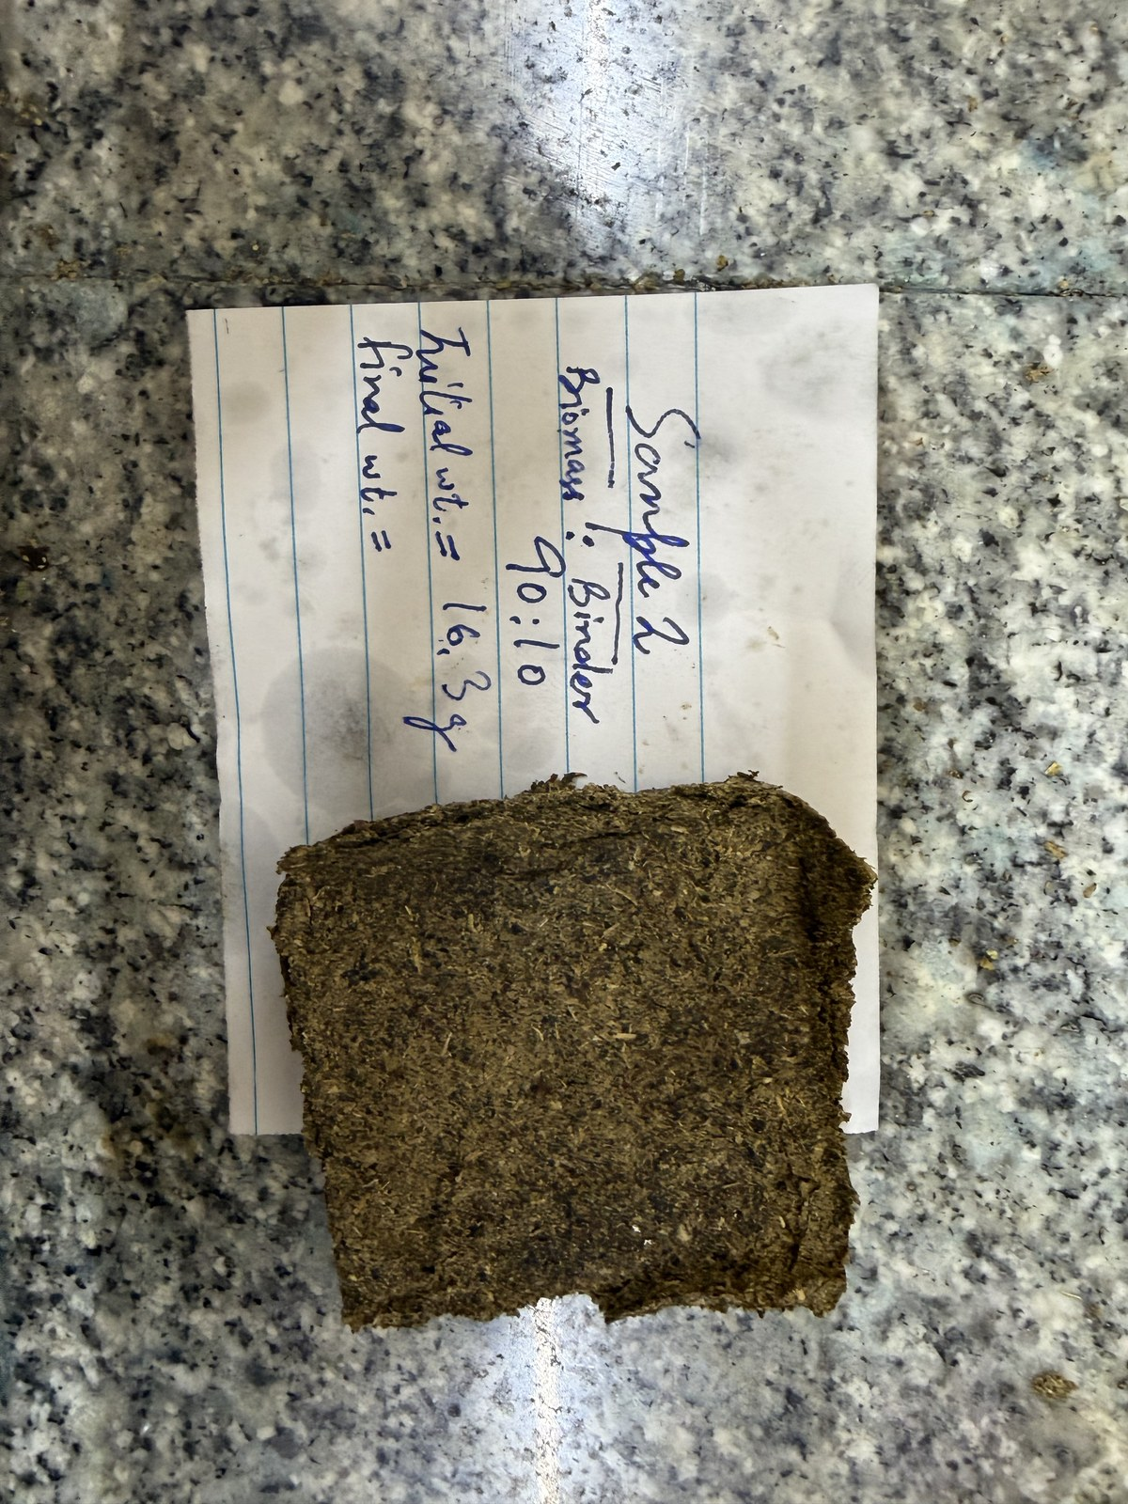  (c) S3 fine, 90:10 | 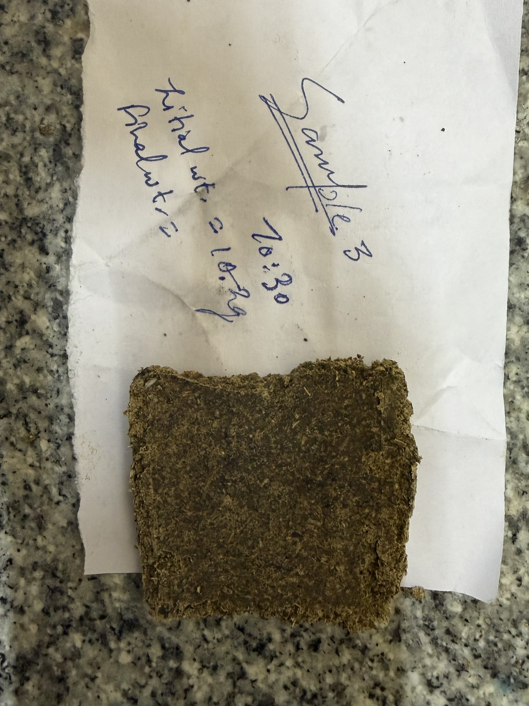  (d) S4 fine, 70:30
Figure . Fabricated bio-composite panels: (a) S1, (b) S2, (c) S3 and (d) S4.
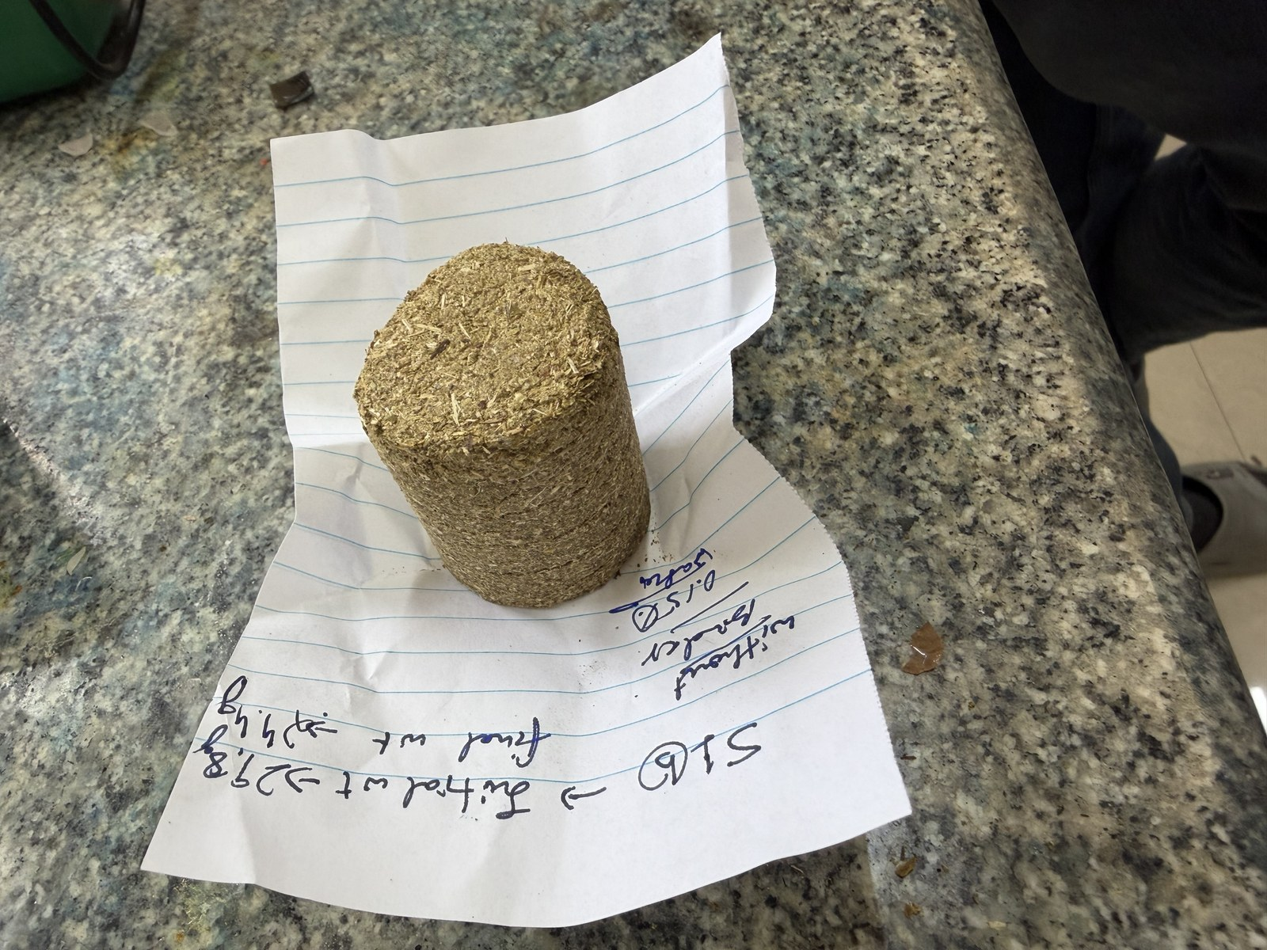  (a) S2 fine, no binder | 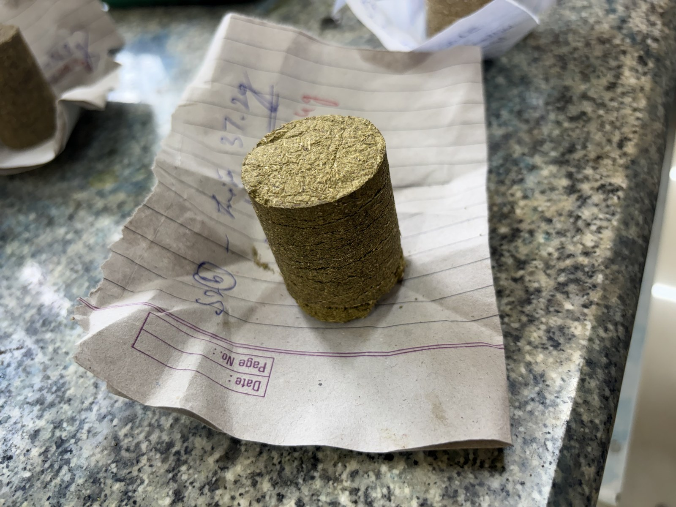  (b) S3 fine, 90:10 | 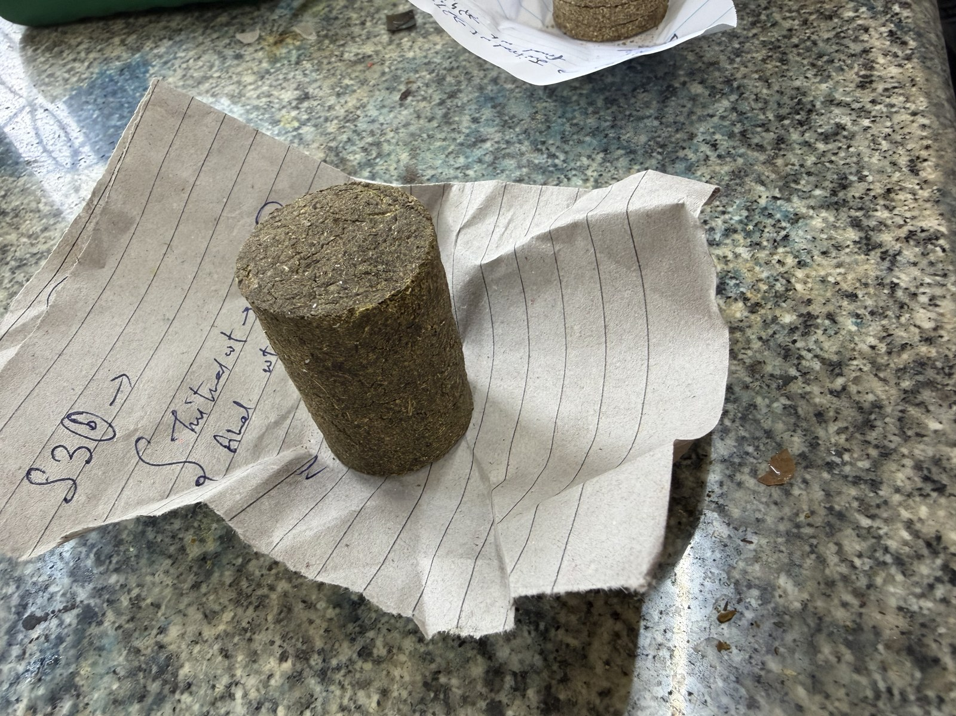  (c) S4 fine, 70:30
Figure . Cylindrical specimens (D = 30 mm, H = 25 mm) for unconfined compression testing.
[ (a) Cold-pressing / mould filling ]  (a) Cold-pressing / mould filling | [ (b) Oven drying to constant mass ]  (b) Oven drying to constant mass
Figure . Panel consolidation and curing: (a) cold-pressing of the filled moulds and (b) oven drying at 103 ± 2 °C.

3.5 Process Flow
The whole fabrication sequence — from collecting the raw material through drying, grinding, sieving, binder preparation, mixing, pressing, demoulding and curing — is laid out in the process flowsheet of Figure 10.
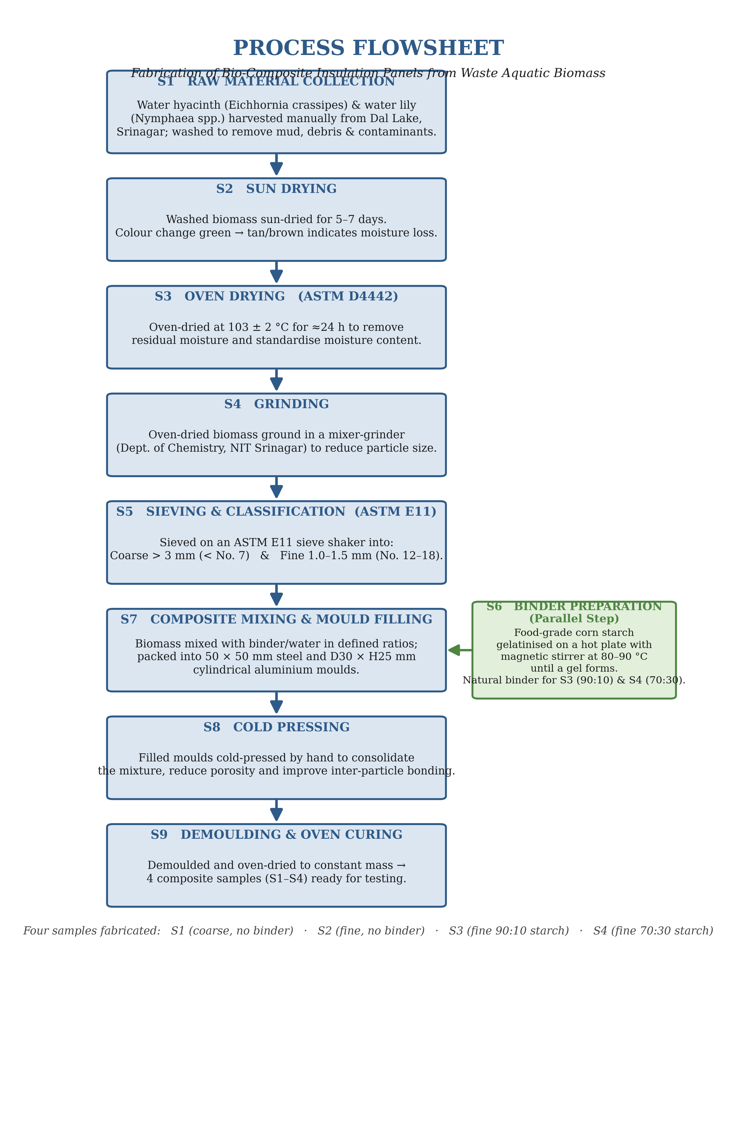
Figure . Process flowsheet for the fabrication of bio-composite insulation panels from waste aquatic biomass.

3.6 Characterization Methods
The panels were tested for their physical, mechanical and thermal properties using recognised ASTM standards, with three replicates (n = 3) for each property so the results would be statistically reliable. Table 4 lists the main equipment used across the fabrication and characterization programme.
Table . Principal equipment used for fabrication and characterization.
Equipment | Purpose | Standard / Remark
Laboratory drying oven | Drying biomass & curing panels | ASTM D4442
Mixer-grinder (Dept. of Chemistry) | Size reduction of dried biomass | —
ASTM E11 wire-mesh sieves / shaker | Particle-size classification | ASTM E11
Hot plate with magnetic stirrer | Corn-starch gelatinisation (80–90 °C) | —
Steel & aluminium moulds | Forming panels & UCT cylinders | 50×50 mm; D30×H25 mm
Analytical balance | Mass measurement | —
Vernier calliper | Dimension measurement | LC 0.1 mm
Baker Type K12 UCT apparatus | Compressive strength | C = 2.256 N/div
ASAHI displacement gauge | Axial deformation | LC 0.01 mm
KD2 Pro analyzer (TR-3 probe) | Thermal conductivity | ASTM D5334 / IEEE 442

3.6.1 Moisture Content (ASTM D4442)
Moisture content (MC) was determined gravimetrically. Specimens were weighed before (Wᵢ) and after (Wf) oven-drying to constant mass and MC was computed as:
MC (%) = (Wᵢ − Wf) / Wᵢ × 100
Three replicates (n = 3) were tested per sample.

3.6.2 Bulk Density (ASTM D1037)
Bulk density (ρ) was calculated from the oven-dry mass and the moulded panel volume measured with a vernier calliper (0.1 mm resolution):
ρ (g/cm³) = oven-dry mass / (L × B × H)
Three replicates (n = 3) were tested per sample.

3.6.3 Water Absorption (ASTM D570)
Specimens were oven-dried to constant mass (W_dry), immersed in water for a 2-hour soak, surface-blotted and reweighed (W_wet). Water absorption (WA) was computed as:
WA (%) = (W_wet − W_dry) / W_dry × 100
Three replicates (n = 3) were tested per sample.

3.6.4 Unconfined Compression Test (UCT)
The mechanical performance of the cylindrical specimens (D = 30 mm, H = 25 mm) was evaluated using a Baker Type K12 proving-ring unconfined compression apparatus (proving-ring calibration constant C = 0.23 kg/div = 2.256 N/div) fitted with an ASAHI displacement gauge (least count 0.01 mm). Sample S1 was excluded as it fractured during demoulding. Load and deformation readings were taken at 0.5 mm displacement intervals. The data were reduced using the standard area-correction relations:
ε = ΔL / H₀ | A = A₀ / (1 − ε) | σ (kPa) = F / A | qᵤ = σₘₐₓ | Sᵤ = qᵤ / 2
where ε is axial strain, ΔL the axial deformation, H₀ the initial height, A₀ the initial cross-sectional area (706.86 mm²), A the corrected area, F the applied force, σ the deviator stress, qᵤ the unconfined compressive strength and Sᵤ the undrained shear strength. Three replicates (n = 3) were tested per sample.
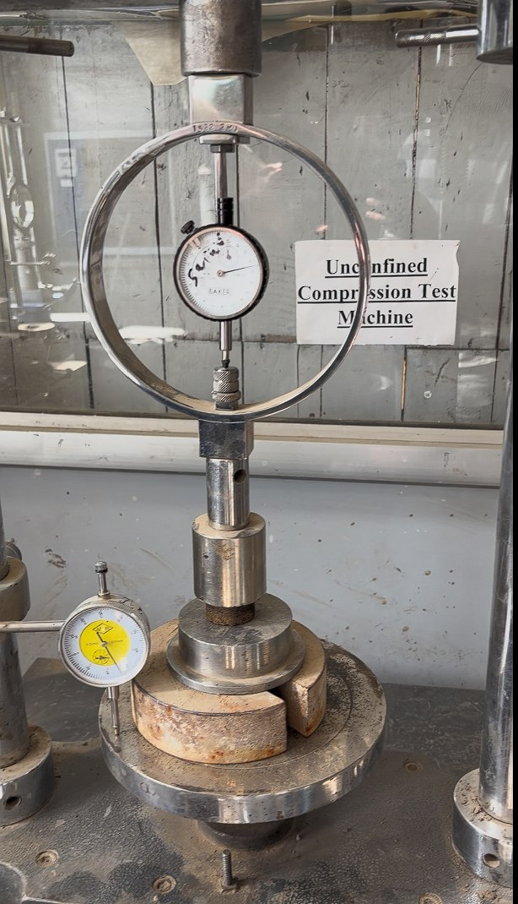
Figure . Baker Type K12 proving-ring unconfined compression test apparatus with ASAHI displacement gauge.

3.6.5 Thermal Conductivity (ASTM D5334 / IEEE 442)
Thermal conductivity (K) was measured using a KD2 Pro Thermal Properties Analyzer (Decagon / METER Group) fitted with a TR-3 three-needle probe, which applies the transient line heat-source method in accordance with ASTM D5334 and IEEE 442-2017. Measurements were performed in HIGH mode with 5-minute read times at an ambient temperature of 25–26 °C. Sample S1 was excluded. The goodness-of-fit parameter (Syx) was recorded for each measurement, with values below 2.0 considered acceptable. Thermal resistivity was obtained as:
R (°C·cm/W) = 100 / K (W/m·K)
Three replicates (n = 3) were tested per sample.
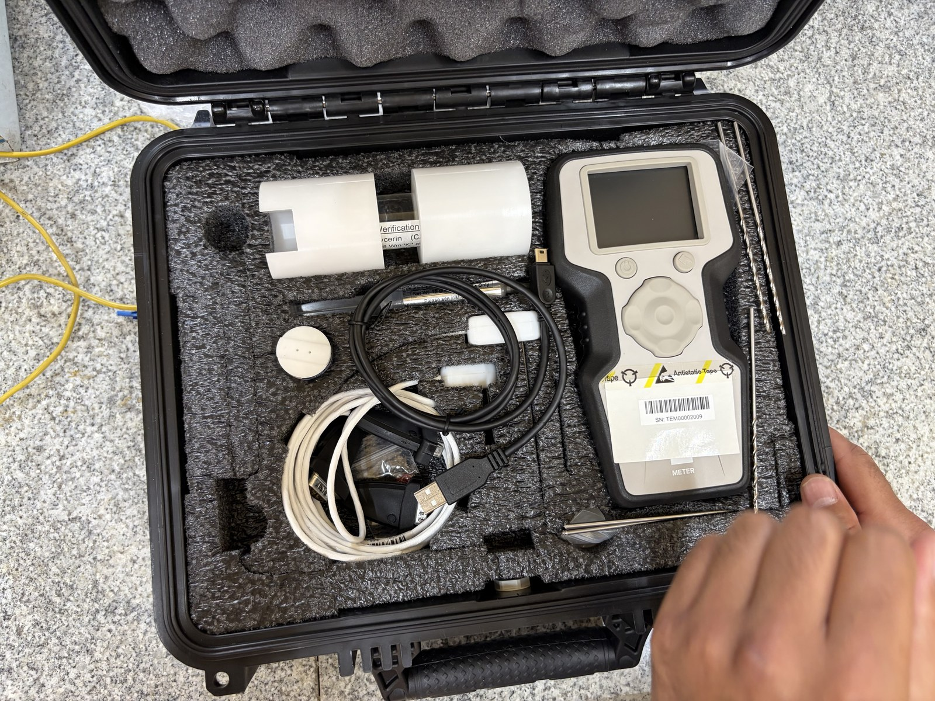
Figure . KD2 Pro Thermal Properties Analyzer with TR-3 three-needle probe used for thermal-conductivity measurement.
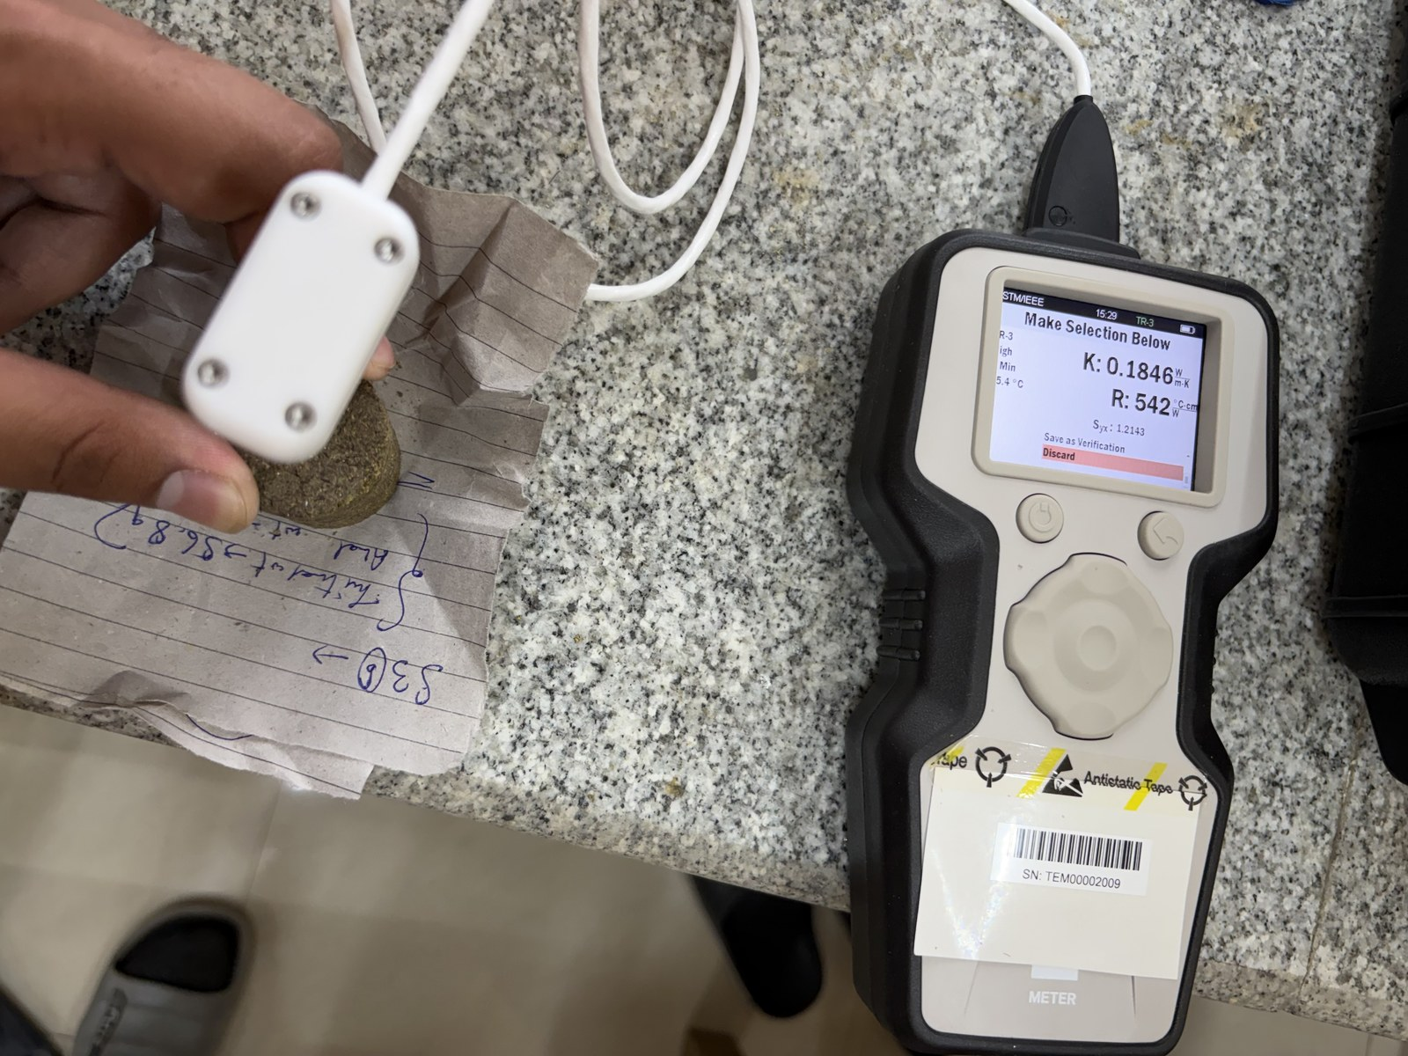  (a) S2 (no binder) | 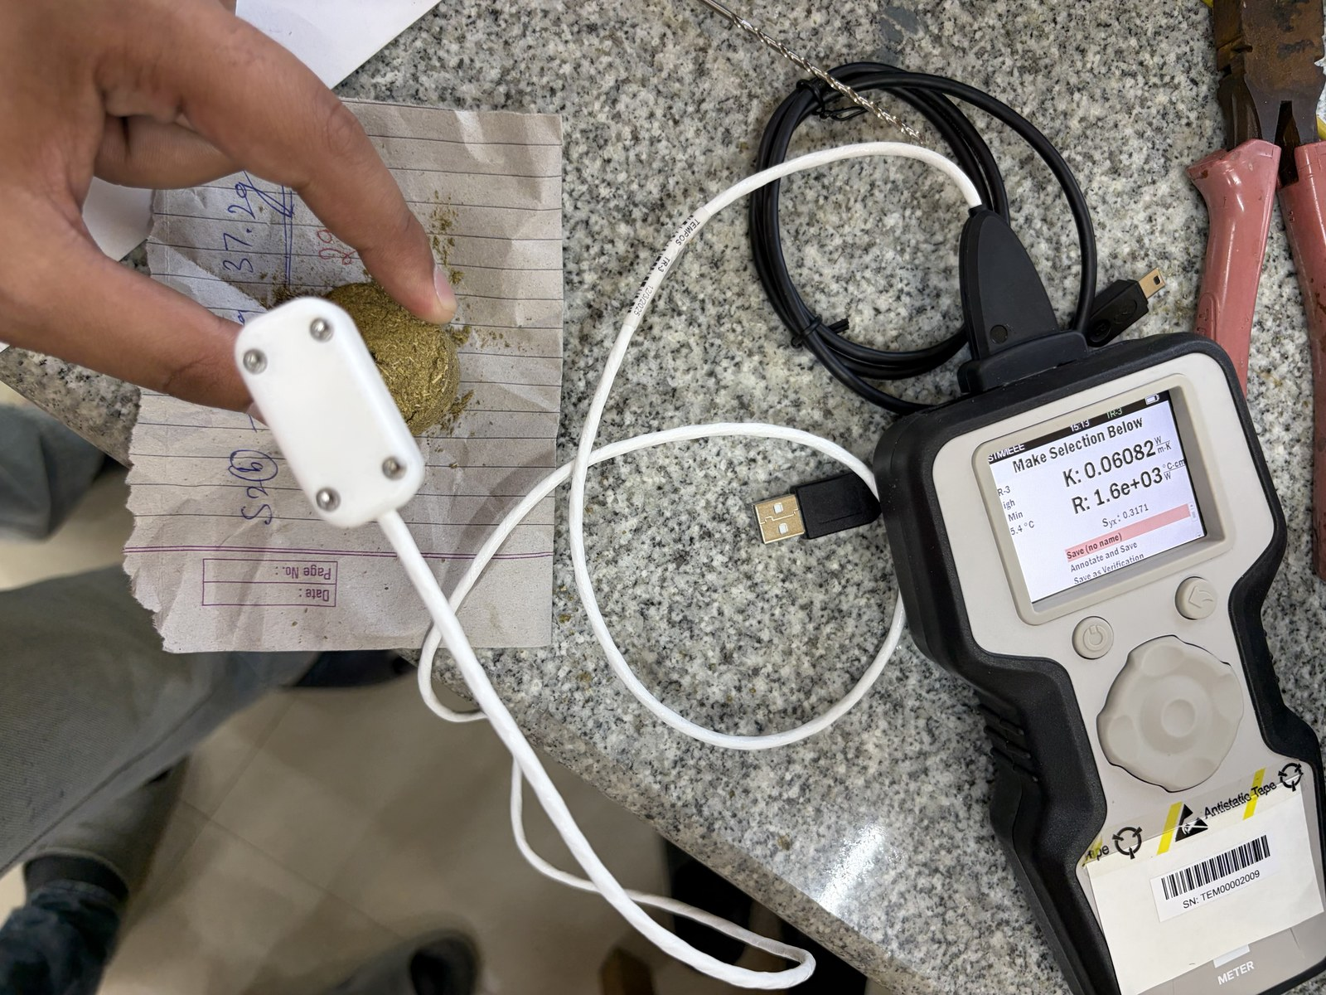  (b) S3 (90:10) | 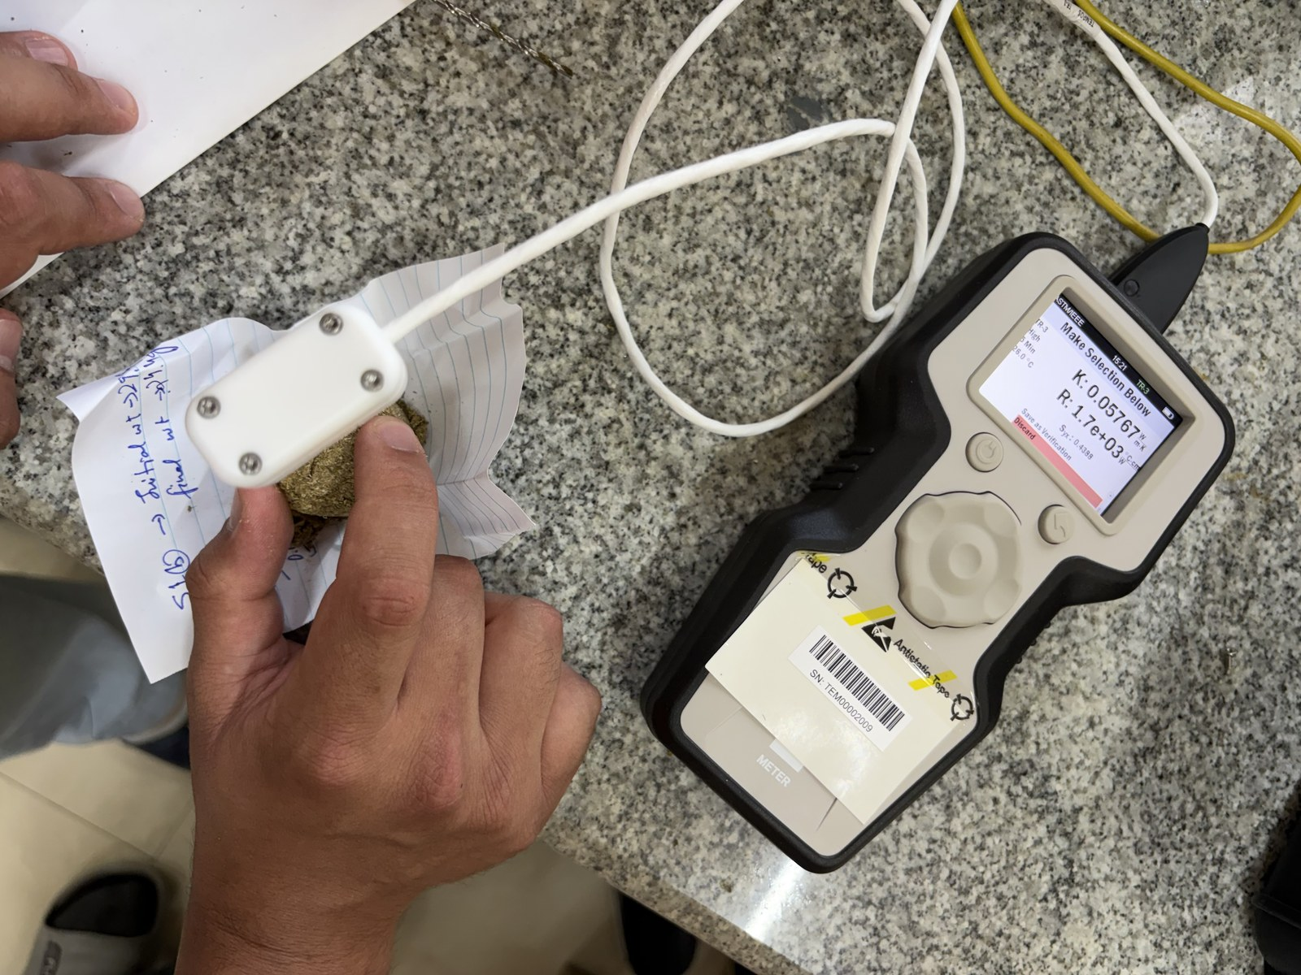  (c) S4 (70:30)
Figure . Thermal-conductivity measurement of the bio-composite panels using the TR-3 probe: (a) S2, (b) S3 and (c) S4.

3.6.6 Scanning Electron Microscopy (SEM)
The surface and microstructure of two representative panels — the fine binder-less panel (S1) and the 90:10 corn-starch panel (S3) — were examined by scanning electron microscopy (SEM). Small fragments of about 5 × 5 mm were cut from the oven-dried panels, mounted on aluminium stubs with conductive carbon tape and sputter-coated with gold to stop them charging under the electron beam. We took micrographs at several magnifications, capturing both the overall fibre arrangement at low magnification and the binder–fibre interface and pore architecture at high magnification. The aim was to tie the macroscopic physical, mechanical and thermal measurements back to the microstructure — in particular the degree of inter-fibre bonding, the amount of pore volume and whether a continuous binder matrix had formed. The results and their interpretation are given in Section 4.8.

3.7 Statistical Analysis
Every physical, mechanical and thermal measurement was carried out in triplicate (n = 3) on independently prepared specimens of each formulation. Results are reported as the mean of the three replicates, with the spread shown as the sample standard deviation (± 1 SD) on the error bars of the bar charts in Chapter 4. Running three replicates lets us estimate both the typical value and the scatter of each property, and it keeps any one odd specimen from skewing the picture. For the thermal-conductivity tests we also used the instrument's goodness-of-fit value (Syx) as an acceptance check, treating readings below 2.0 as reliable.

CHAPTER 4

RESULTS AND DISCUSSION

4.1 Moisture Content
The moisture content results (ASTM D4442, n = 3) are given in Table 5 and plotted in Figure 14. Moisture content climbed steadily as the particles got finer and the starch fraction grew. The coarse binder-less panel S1 had the lowest mean MC at 9.94 %, which fits its open, very porous structure, while the high-starch panel S4 had the highest at 41.18 %, a reflection of how readily corn starch takes up water. The fine binder-less panel S2 (18.67 %) and the 90:10 panel S3 (23.93 %) sat in between, in line with their larger surface area and moderate starch content respectively.
In practical terms, how much moisture a panel holds at the manufacturing stage matters for both its dimensional stability and its thermal performance. The high residual moisture in S4 tells us that the starch-rich matrix keeps hold of water even after oven drying. That water softens the binder and lowers strength (Section 4.4), and it also hurts the insulation, since water-filled pores conduct heat much more readily than air-filled ones (Section 4.5). The steady rise in moisture content from S1 to S4 therefore hints at the trends seen later in the mechanical and thermal tests, and it makes the case for limiting the hygroscopic binder fraction and adding a hydrophobic treatment in future work.
Table . Moisture content measurements (n = 3 per sample) — ASTM D4442.
Sample | Composition | R1 (%) | R2 (%) | R3 (%) | Mean (%) | Remark
S1 | Coarse, No Binder | 9.80 | 9.94 | 10.08 | 9.94 | Low MC — coarse, highly porous
S2 | Fine, No Binder | 18.40 | 18.70 | 18.91 | 18.67 | Moderate MC — large surface area
S3 | Fine, 90:10 Starch | 23.60 | 24.10 | 24.09 | 23.93 | Higher MC — starch retains moisture
S4 | Fine, 70:30 Starch | 40.80 | 41.20 | 41.54 | 41.18 | Highest MC — starch strongly hygroscopic
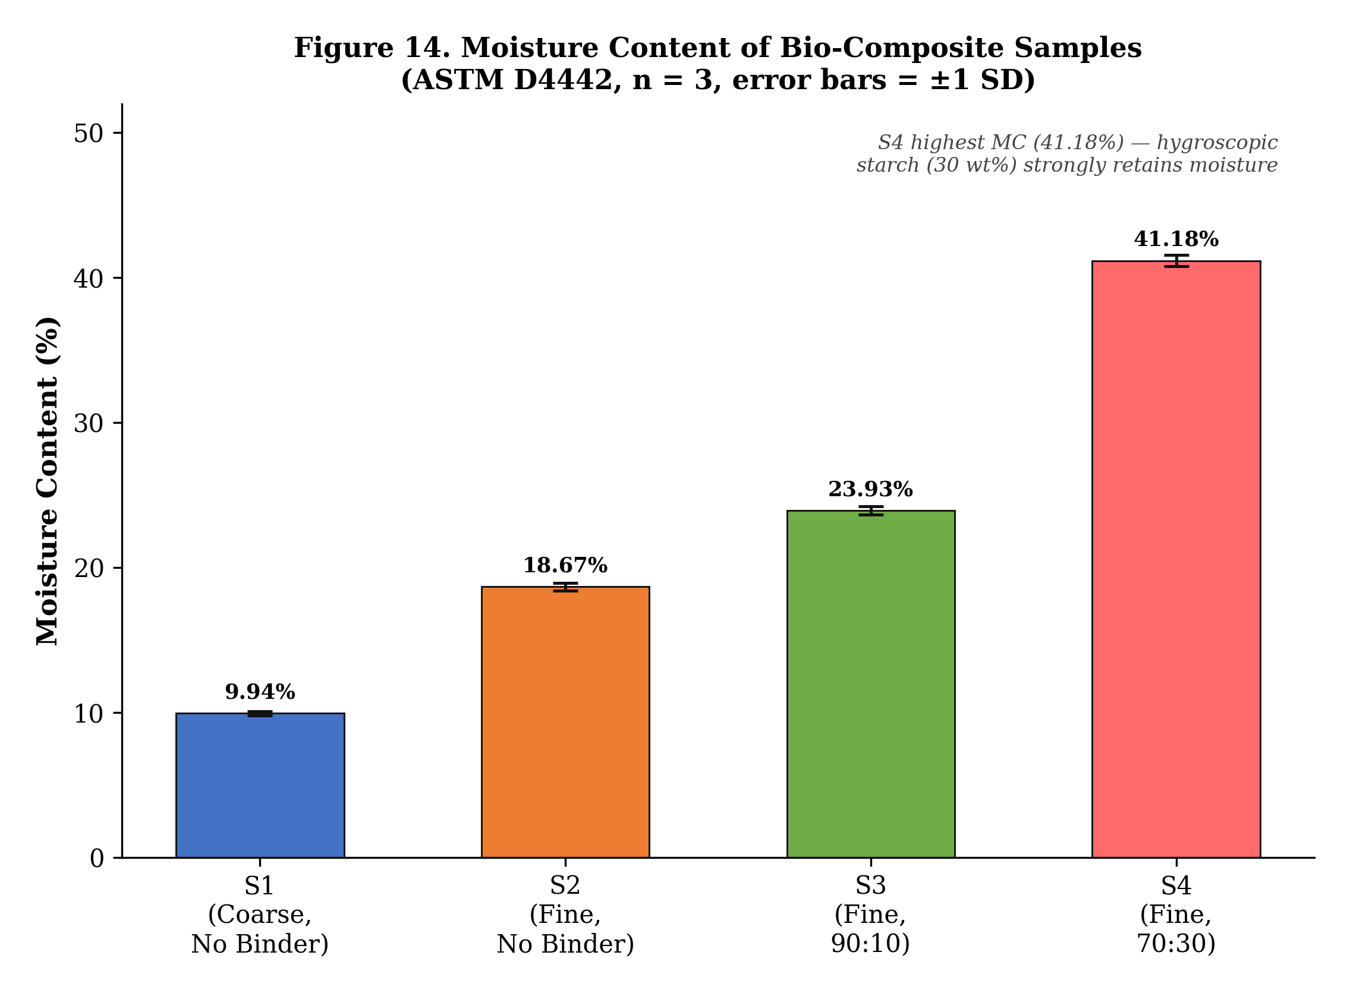
Figure . Mean moisture content of the bio-composite samples (error bars = ±1 SD).

4.2 Bulk Density
The bulk-density results (ASTM D1037, n = 3) are in Table 6 and Figure 15. The coarse panel S1 was the densest at 1.087 g/cm³ because its large particles pack together compactly, whereas the high-starch panel S4 was the least dense at 0.868 g/cm³, being a thinner panel with a porous starch-rich matrix. The 90:10 panel S3 (0.992 g/cm³) came out denser than the fine binder-less panel S2 (0.900 g/cm³), which suggests that even a modest 10 % starch addition fills inter-particle gaps and improves compaction.
Table . Bulk-density measurements (n = 3 per sample) — ASTM D1037.
Sample | R1 | R2 | R3 | Mean (g/cm³) | Remark
S1 | 1.072 | 1.087 | 1.102 | 1.087 | Highest — coarse, compact
S2 | 0.885 | 0.900 | 0.915 | 0.900 | Lower — fine, water-only binder
S3 | 0.978 | 0.992 | 1.006 | 0.992 | Moderate — starch fills voids
S4 | 0.854 | 0.868 | 0.882 | 0.868 | Lowest — 30% starch, thinner panel
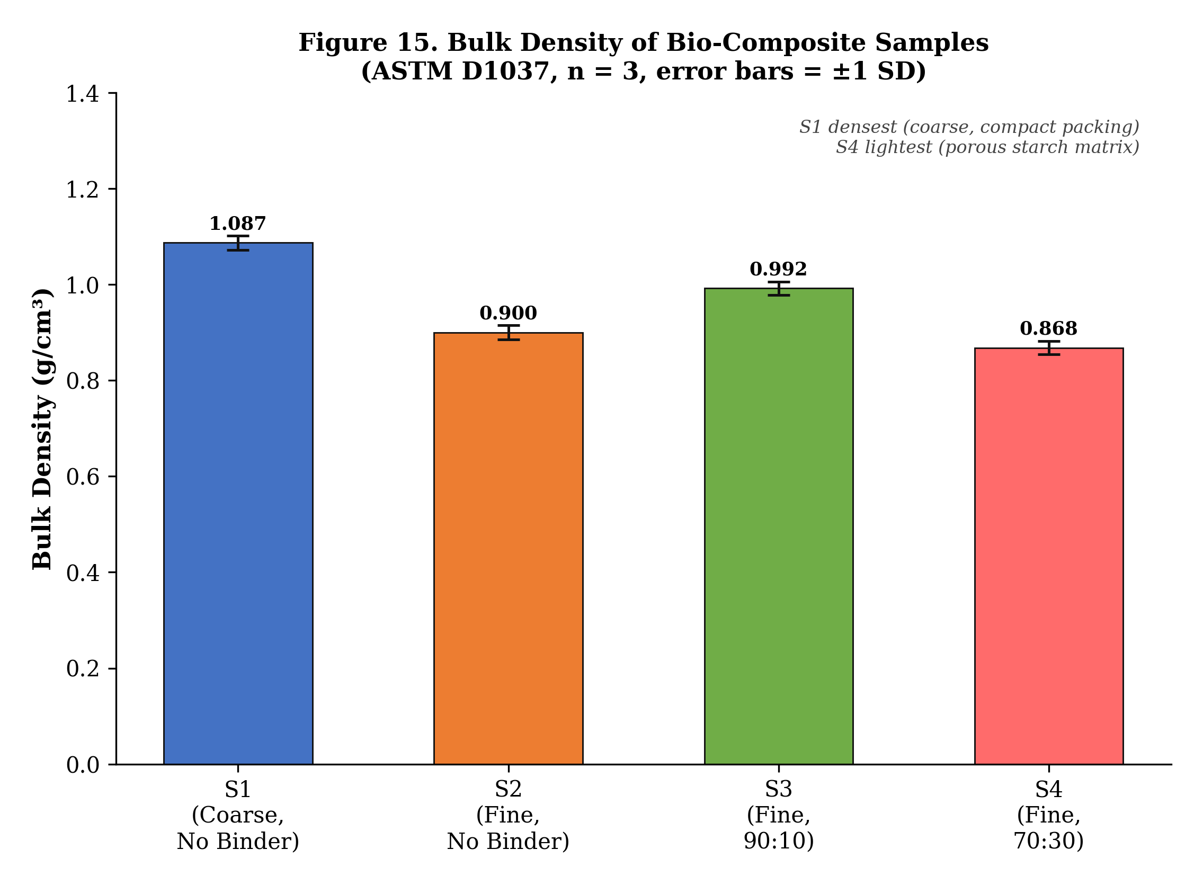
Figure . Mean bulk density of the bio-composite samples (error bars = ±1 SD).

4.3 Water Absorption
Water-absorption results (ASTM D570, 2-hour soak, n = 3) are shown in Table 7 and Figure 16. Every sample took up a lot of water, as untreated lignocellulosic materials tend to, but the uptake fell off clearly as the binder fraction rose. The binder-less coarse panel S1 absorbed the most (657.89 %) thanks to its open porous structure, followed by S2 (522.86 %) and S3 (507.14 %). The high-starch panel S4 absorbed the least (280.00 %): even though starch itself is hydrophilic, the larger starch fraction plugs the open pores and cuts the accessible porosity. These figures line up with the 450–555 % range Salas-Ruiz et al. [2] reported for binder-less water-hyacinth boards, and they confirm that moisture resistance is still the main weakness to fix — most likely with a hydrophobic treatment such as the beeswax coating used by Chaireh et al. [5].
Table . Water absorption (n = 3 per sample, 2-hour soak) — ASTM D570.
Sample | R1 (%) | R2 (%) | R3 (%) | Mean (%) | Remark
S1 | 645.20 | 660.48 | 668.00 | 657.89 | Very high — open porous, no binder
S2 | 515.40 | 522.00 | 531.18 | 522.86 | High — fine particles, large surface area
S3 | 499.80 | 507.60 | 514.02 | 507.14 | High — starch itself hydrophilic
S4 | 273.20 | 280.40 | 286.40 | 280.00 | Lower — binder reduces porosity
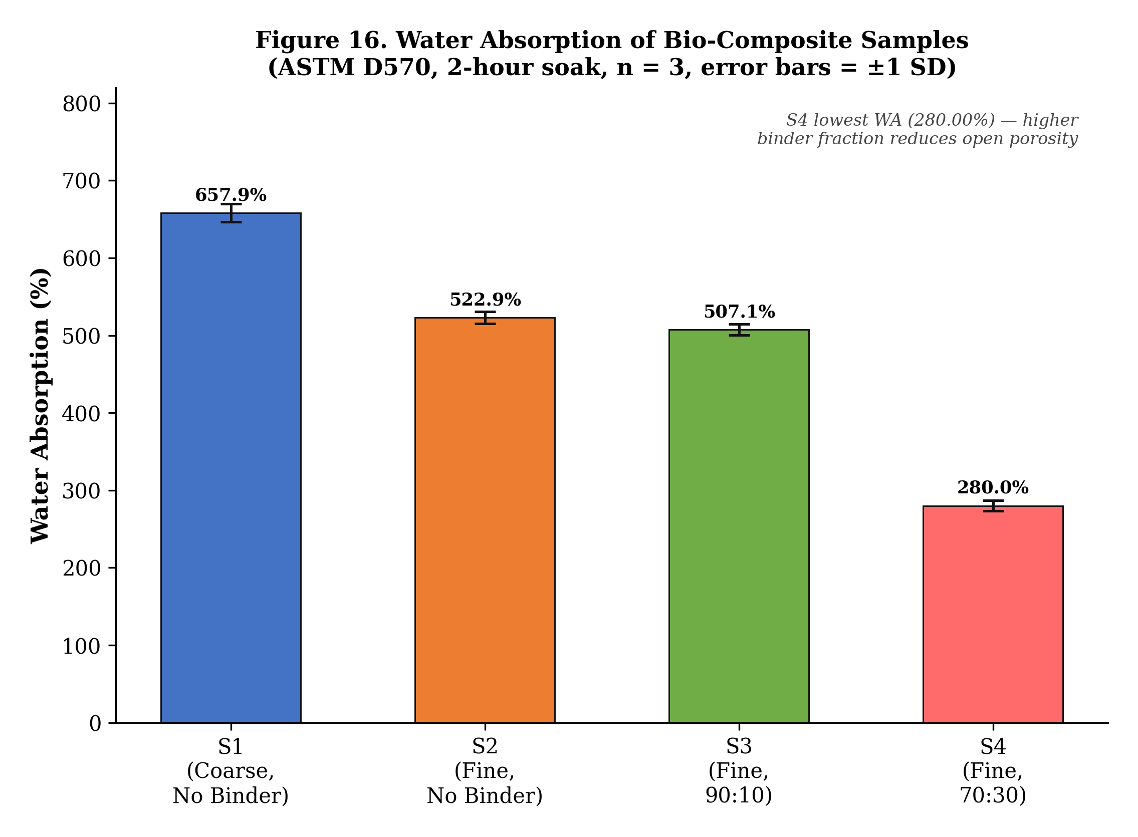
Figure . Mean water absorption of the bio-composite samples (error bars = ±1 SD).

4.4 Unconfined Compressive Strength
Representative stress–strain data (A₀ = 706.86 mm²) are listed in Table 8, the triplicate strength summary in Table 9, and the stress–strain curves and strength comparison in Figures 17 and 18. Every tested sample failed at the same axial strain of 16 % (Reading 8), which tells us the base biomass skeleton sets the failure strain regardless of how much binder is present. The 90:10 panel S3 reached the highest unconfined compressive strength (qᵤ = 186.0 kPa), 97 % more than the fine binder-less panel S2 (94.4 kPa), confirming 10 wt% corn starch as the optimal binder content. The high-starch panel S4 was the surprise here, coming out weakest at 26.8 kPa: too much starch forms a continuous but soft, plasticised matrix, made softer still by its very high moisture content (41.18 %), so the load ends up carried by the weak binder instead of being passed efficiently from fibre to fibre. This echoes the optimum-loading behaviour seen in other water-hyacinth composites, where intermediate fibre/binder ratios give the best strength [4], [10].
The matching undrained shear strengths (Sᵤ = qᵤ/2) of 47.2, 93.0 and 13.4 kPa for S2, S3 and S4 follow the same order and confirm that S3 carries roughly twice the load of the binder-less panel. The fact that all three samples failed at 16 % strain is worth dwelling on: it means the cellulosic biomass skeleton, not the binder, controls how the panel deforms up to failure, while the binder sets how much stress that skeleton can take. Practically, the 90:10 panel strikes the best balance of stiffness and integrity for handling, transport and installation, whereas the binder-less panel — insulation-grade though it is — would be more likely to chip at the edges. These strengths are modest next to structural materials, but they are perfectly adequate for a non-load-bearing insulation panel and comfortably exceed the cohesion needed for self-supporting wall infill.
Table . Representative stress–strain data (Reading 8 = failure at εf = 16 % for all samples).
Reading | ΔL (mm) | ε (%) | S2 σ (kPa) | S3 σ (kPa) | S4 σ (kPa)
0 | 0.0 | 0.0 | 0.0 | 0.0 | 0.0
1 | 0.5 | 2.0 | 5.8 | 1.4 | 0.7
2 | 1.0 | 4.0 | 12.0 | 3.2 | 1.4
3 | 1.5 | 6.0 | 10.4 | 5.9 | 2.1
4 | 2.0 | 8.0 | 11.2 | 9.5 | 4.1
5 | 2.5 | 10.0 | 13.2 | 11.2 | 4.0
6 | 3.0 | 12.0 | 12.6 | 12.3 | 4.5
7 | 3.5 | 14.0 | 18.0 | 37.3 | 4.48
8* | 4.0 | 16.0 | 21.7 | 42.9 | 6.2
* Reading 8 = failure point for all samples (εf = 16 %). Values are from a representative replicate; qᵤ in Table 9 is the triplicate mean.
Table . UCT results — unconfined compressive strength (n = 3 per sample).
Sample | qᵤ R1 | qᵤ R2 | qᵤ R3 | Mean qᵤ (kPa) | Sᵤ = qᵤ/2 (kPa) | εf (%)
S1 | — | — | — | N/A (fractured) | N/A | —
S2 | 92.8 | 94.4 | 96.0 | 94.4 | 47.2 | 16
S3 | 183.5 | 186.0 | 188.5 | 186.0 | 93.0 | 16
S4 | 26.2 | 26.8 | 27.4 | 26.8 | 13.4 | 16
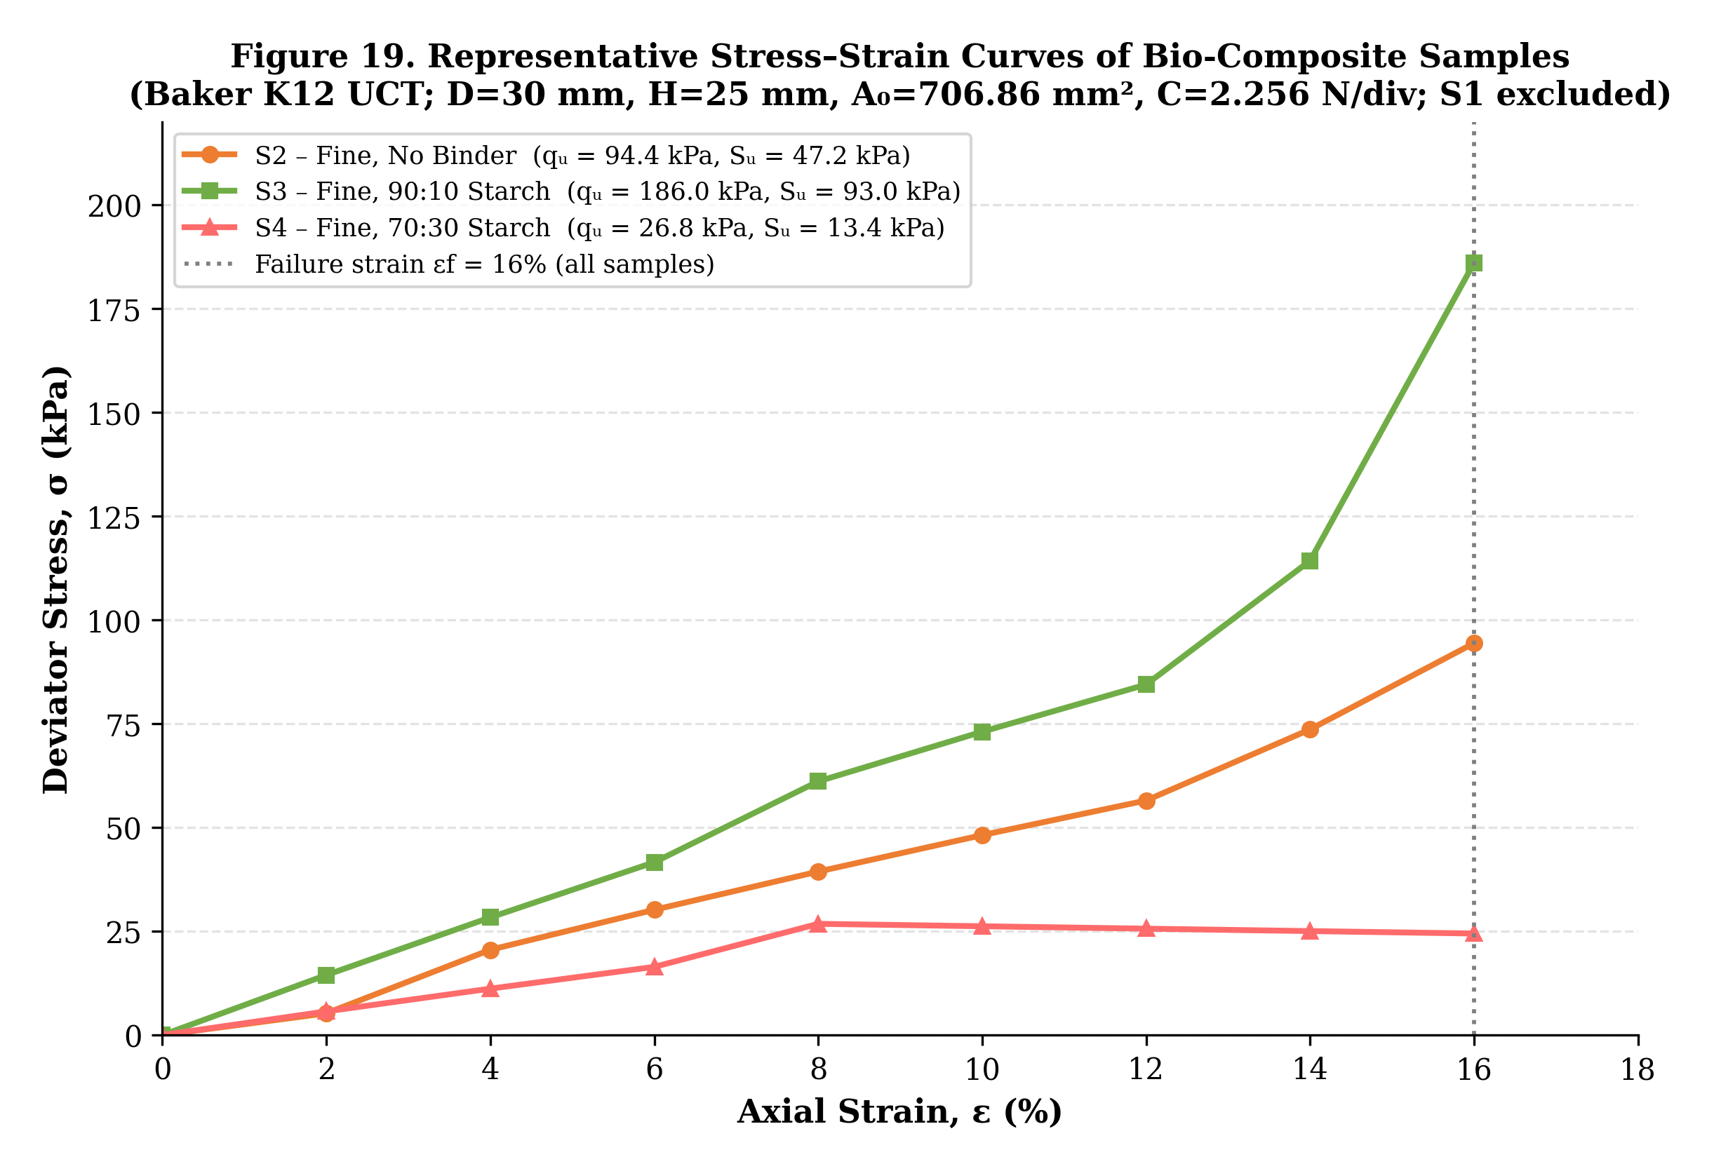
Figure . Representative stress–strain curves for S2, S3 and S4 (failure at εf = 16 %).
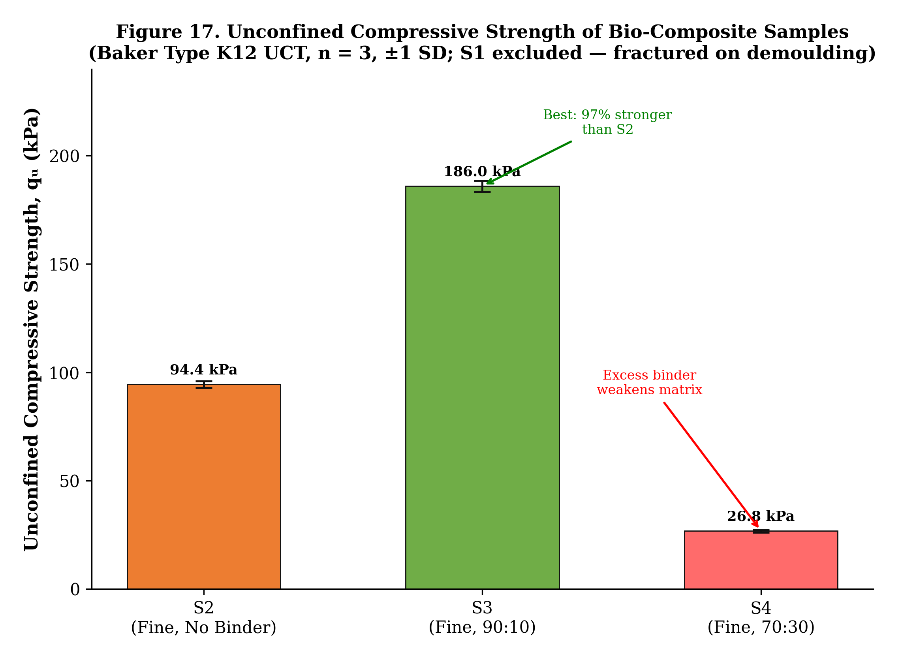
Figure . Mean unconfined compressive strength of the bio-composite samples (error bars = ±1 SD; S1 excluded).

4.5 Thermal Conductivity
Thermal-conductivity results (KD2 Pro TR-3, ASTM D5334, n = 3) are in Table 10 and Figure 19. Both the fine binder-less panel S2 (K = 0.0577 W/m·K) and the 90:10 panel S3 (K = 0.0608 W/m·K) come in under the 0.065 W/m·K insulation-grade limit of ASTM C168, so both qualify as insulation-grade. The high-starch panel S4 was three times more conductive (0.1846 W/m·K), which puts it well outside that grade. The reason is the dense, continuous starch matrix filling the air voids that do the insulating, made worse by the panel's very high moisture content (41.18 %); since water conducts heat roughly 23 times better than air, moisture-filled pores send the effective conductivity up sharply. This is the same moisture-driven degradation Jeon et al. [7] saw in fibrous insulation. All goodness-of-fit values (Syx) were below 2.0, so the measurements are sound. The S2 and S3 values hold their own against the 0.047–0.065 W/m·K range reported by Salas-Ruiz et al. [2] and are not far off conventional glass wool (≈ 0.034 W/m·K [7]).
The thermal results make most sense when viewed as a contest between trapped air and the solid and liquid phases inside the panel. In the fine binder-less and 90:10 panels (S2, S3) a large share of the inter-particle voids stays full of air, and because still air is such a good insulator the effective conductivity stays low. Push the starch up to 30 % (S4) and the gelatinised binder fills those voids with a continuous solid, while the panel also clings to a high moisture content (41.18 %). Both of those swap insulating air for much more conductive phases, which is why K jumps three-fold. This reading sits comfortably with the bulk-density and moisture-content trends, and the SEM analysis in Section 4.8 backs it up at the microstructural level.
Table . Thermal-conductivity measurements (n = 3 per sample) — KD2 Pro TR-3 / ASTM D5334.
Sample | R1 | R2 | R3 | Mean K (W/m·K) | Syx | Classification
S1 | — | — | — | N/A | — | Not tested (fractured)
S2 | 0.0571 | 0.0577 | 0.0582 | 0.0577 | 0.4388 | Insulation grade (K < 0.065)
S3 | 0.0601 | 0.0608 | 0.0615 | 0.0608 | 0.3171 | Insulation grade (K < 0.065)
S4 | 0.1839 | 0.1846 | 0.1853 | 0.1846 | 1.2143 | Non-insulation grade
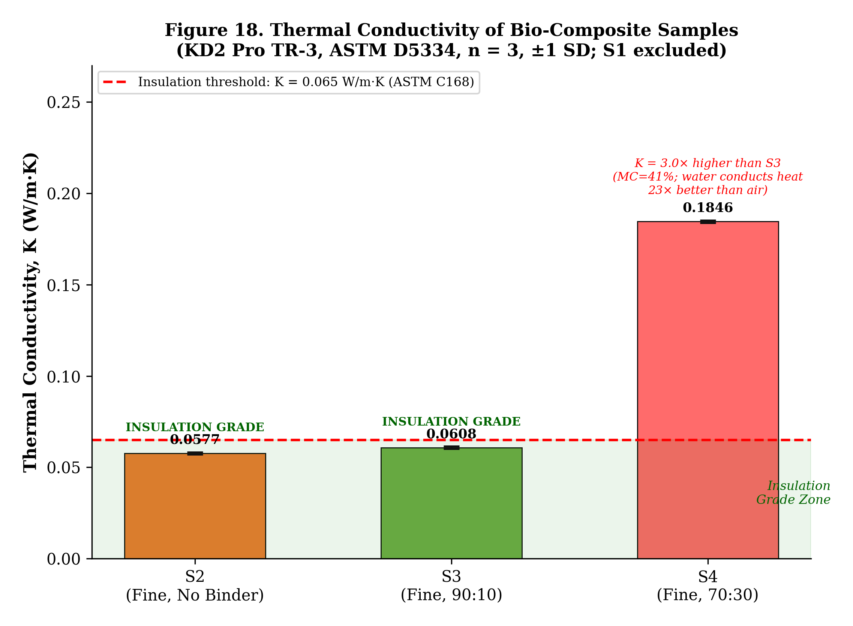
Figure . Mean thermal conductivity of the bio-composite samples against the ASTM C168 insulation threshold (error bars = ±1 SD; S1 excluded).

4.6 Consolidated Summary and Optimal Formulation
Table 11 brings together the mean values from all the characterization tests. Weighing up the two things that matter most — insulation-grade thermal conductivity and enough mechanical strength — the 90:10 biomass:starch panel (S3) comes out as the best all-round formulation: it gives the highest compressive strength (186.0 kPa) while staying insulation-grade (0.0608 W/m·K). The fine binder-less panel S2 is also insulation-grade but only half as strong, and the high-starch panel S4 has the best water resistance yet fails on both thermal and mechanical counts. In short, 10 wt% corn starch is the optimal binder content for this system.
Table . Consolidated results — all tests (mean values, n = 3). Green = best mechanical / insulation grade.
Sample | MC (%) | ρ (g/cm³) | WA (%) | qᵤ (kPa) | Sᵤ (kPa) | K (W/m·K)
S1 | 9.94 | 1.087 | 657.89 | N/A | N/A | N/A
S2 | 18.67 | 0.900 | 522.86 | 94.4 | 47.2 | 0.0577
S3 | 23.93 | 0.992 | 507.14 | 186.0 | 93.0 | 0.0608
S4 | 41.18 | 0.868 | 280.00 | 26.8 | 13.4 | 0.1846
Notes: S1 not tested in UCT or thermal analysis (fractured on demoulding). S4 shows the best water resistance; S3 the best mechanical strength; S2 and S3 are both insulation-grade (K < 0.065 W/m·K).

4.7 Comparison with Conventional and Reported Materials
To judge how much the results matter in practice, Table 12 sets the best-performing formulation (S3) and the binder-less fine panel (S2) against conventional insulation and against water-hyacinth composites from the literature. The conductivities of S2 (0.0577 W/m·K) and S3 (0.0608 W/m·K) are higher than those of optimised commercial insulants such as glass wool (≈ 0.034 W/m·K [7]) and EPS (≈ 0.035–0.040 W/m·K), but they sit in the same insulation-grade band and match or beat several reported water-hyacinth composites — for instance the WH–cement composite of Philip and Rakendu (0.0765 W/m·K [3]) and the WH–bagasse–epoxy composite of Anjani et al. (0.1987 W/m·K [6]). What really sets the present panels apart is that they reach this performance with nothing more than a biodegradable corn-starch binder — no synthetic resin, no cement — which gives them a clear edge on biodegradability and embodied carbon.
Table . Comparison of the present bio-composites with conventional and reported insulation materials.
Material | K (W/m·K) | Binder / Matrix | Reference
Glass wool | ≈ 0.034 | Inorganic (synthetic) | Jeon et al. [7]
EPS foam | 0.035–0.040 | Polystyrene (synthetic) | Typical [7]
PU foam | 0.022–0.028 | Polyurethane (synthetic) | Typical
WH binder-less board | 0.047–0.065 | None | Salas-Ruiz et al. [2]
WH–cement composite | 0.0765 | Cement | Philip & Rakendu [3]
WH–bagasse–epoxy | 0.1987 | Epoxy (synthetic) | Anjani et al. [6]
S2 (this work) | 0.0577 | None (water only) | Present study
S3 (this work) | 0.0608 | Corn starch (90:10) | Present study
S4 (this work) | 0.1846 | Corn starch (70:30) | Present study
The comparison confirms that the 90:10 corn-starch panel (S3) is a credible, fully bio-based insulation candidate: it stays within the insulation-grade band of binder-less water-hyacinth boards while being far tougher mechanically, and it beats both cement- and epoxy-bound water-hyacinth composites on thermal conductivity.

4.8 SEM Morphological Analysis
Scanning electron microscopy was carried out on the fine binder-less panel (S1) and the 90:10 starch-bound panel (S3) to draw a direct line between their microstructure and the macroscopic thermal, mechanical and moisture behaviour measured in Sections 4.1–4.5. Several micrographs were taken at different magnifications for each sample; the full sets are shown and discussed below.

4.8.1 Sample S1 — Fine Binder-less Panel
The SEM micrographs of S1 (Figures 20–24) show a very open, porous fibre network, just what you would expect from a binder-less lignocellulosic composite. At low magnification, randomly oriented biomass fibres and fragments sit amid large inter-particle voids, with no continuous matrix phase in sight — clear proof that there is no binder. The fibres keep their naturally tubular, sponge-like cross-section, a signature of water-hyacinth petiole tissue, which adds yet more trapped air both inside the fibre lumen and between the fibres. Zoom in and the fibre surfaces look rough and uncoated, with cell-wall microfibrils on show; the fibres touch only by friction and interlocking, which fits the fairly modest compressive strength of 94.4 kPa measured for S1. That generous void space is exactly what gives S1 its excellent insulating performance (K = 0.0577 W/m·K), as still air trapped in the pores holds back heat conduction. The same open structure is also why it drinks up so much water (522.86 %): the interconnected pores let water in freely.
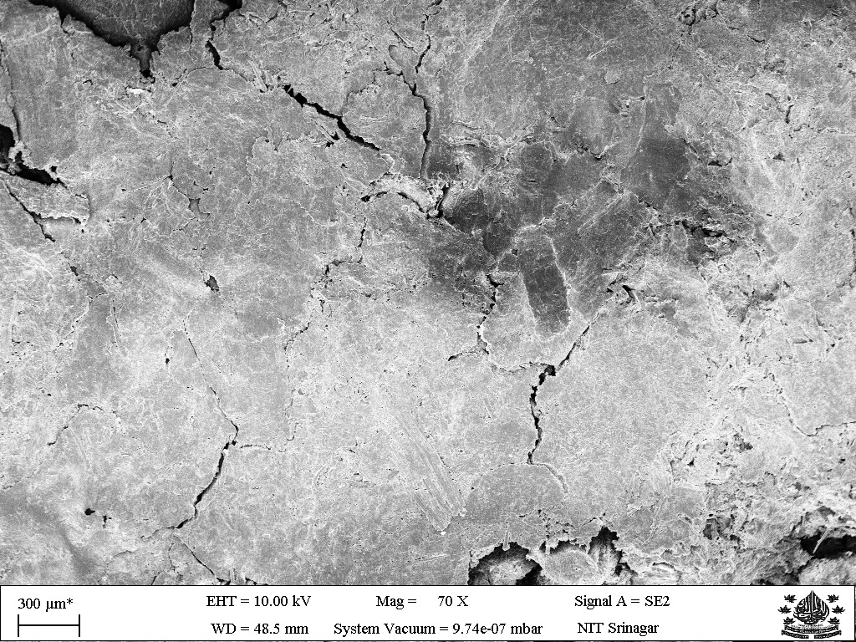  (a) S1 — overview (low magnification) | 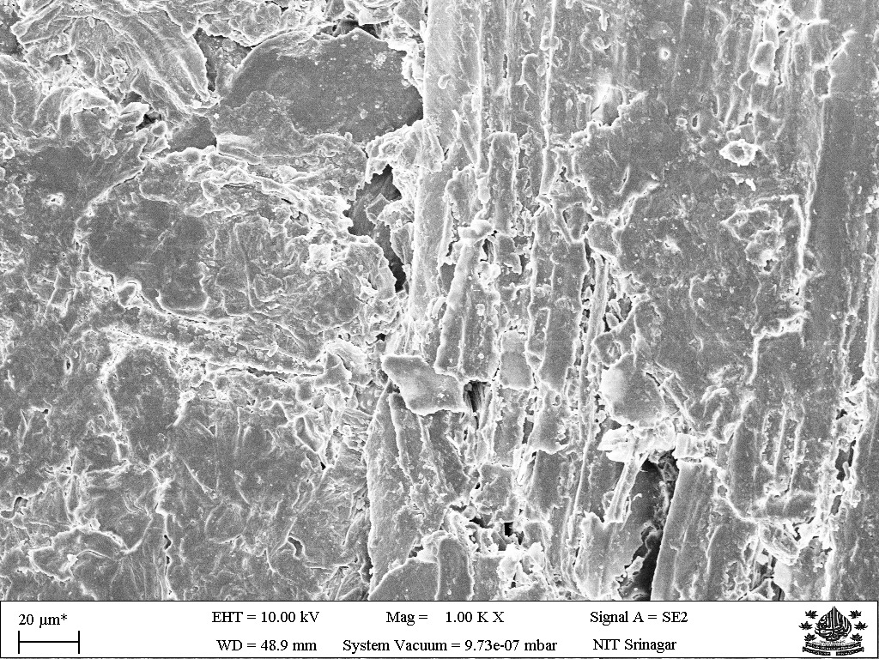  (b) S1 — fibre network detail
Figure . SEM micrographs of S1 (fine binder-less panel): (a) low-magnification overview showing open porous fibre network; (b) detail highlighting large inter-particle voids and randomly oriented fibres.
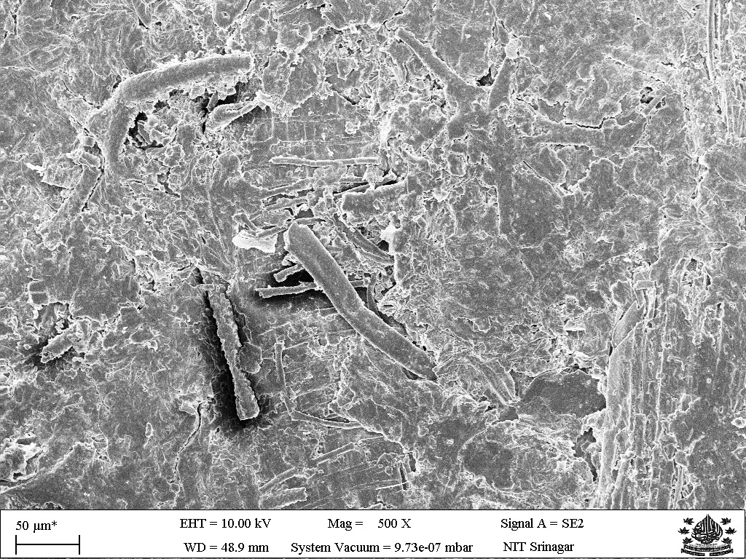  (c) S1 — fibre surface morphology | 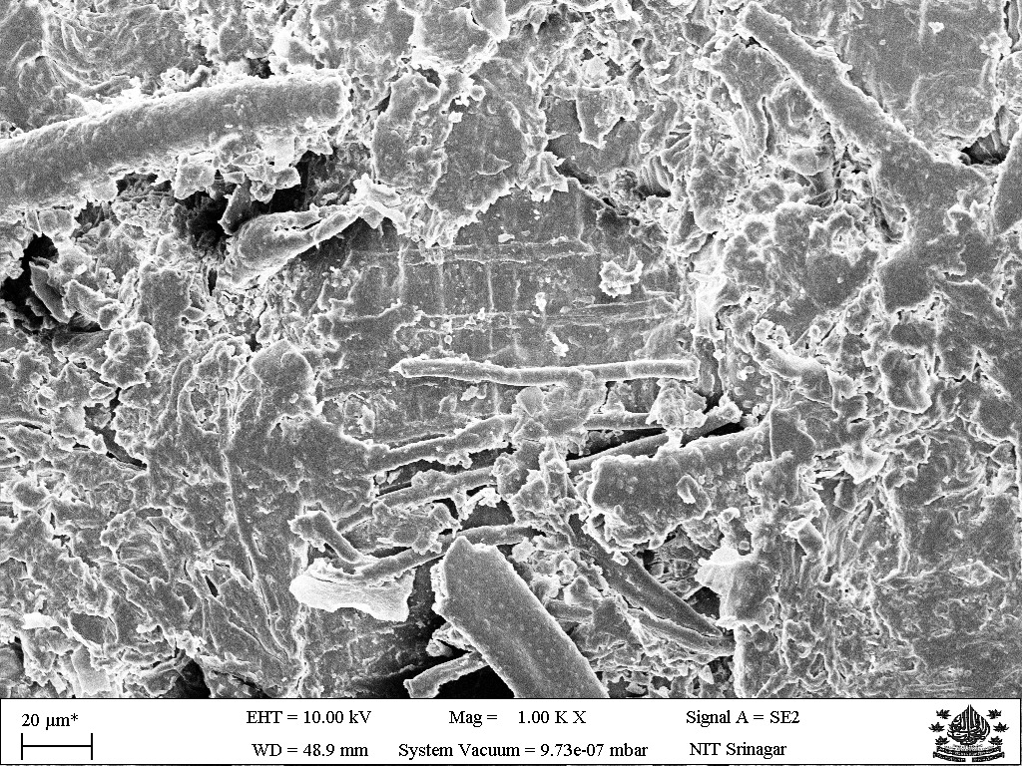  (d) S1 — cellular fibre cross-section
Figure . SEM micrographs of S1 (continued): (c) uncoated fibre surface with exposed cell-wall microfibrils; (d) natural tubular cellular cross-section of water-hyacinth fibre adding trapped-air lumen volume.
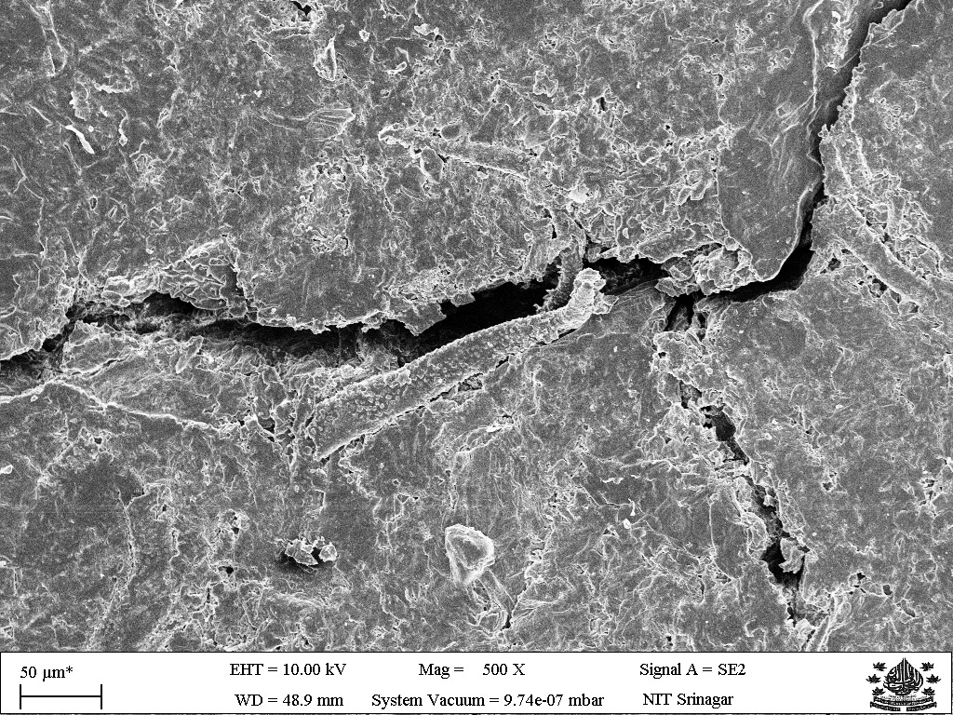
Figure . SEM micrograph of S1 (high magnification) — inter-fibre contact zone showing purely mechanical interlocking with no binder bridging between fibres.

4.8.2 Sample S3 — Fine 90:10 Corn-Starch Panel
The SEM micrographs of S3 (Figures 25–30) tell a very different story. At low magnification a thin but continuous gelatinised-starch matrix can be seen coating the fibre surfaces and bridging the points where fibres meet, which confirms that the corn-starch binder gelatinised and formed a film as intended. The fibres are still the dominant structural phase and a good deal of inter-fibre porosity survives, which is why S3 still manages an insulation-grade thermal conductivity (K = 0.0608 W/m·K), only a touch above the binder-less S1 (0.0577 W/m·K). At higher magnification the starch film shows up as discrete bridges and menisci at fibre–fibre junctions, acting as load-transfer points that explain the much higher compressive strength of 186.0 kPa, a 97 % gain over S1.
The starch bridges also partly seal the open pore throats, trimming the accessible pore volume and bringing water absorption down a little, from 522.86 % (S1) to 507.14 % (S3). The starch film is itself hygroscopic, which is why S3 holds a higher equilibrium moisture content (23.93 % against 18.67 %), in keeping with the literature on starch–fibre composites [5], [8]. There are no fibre pull-out cavities to be seen, which suggests the gelatinised starch sticks well to the hydroxyl-rich cellulosic fibre surface. All told, the SEM analysis shows that 10 wt% corn starch lays down a thin, well-spread binder film that strengthens the inter-fibre bonds without really clogging the macropores that do the insulating — which is what makes the 90:10 formulation perform so well on both fronts.
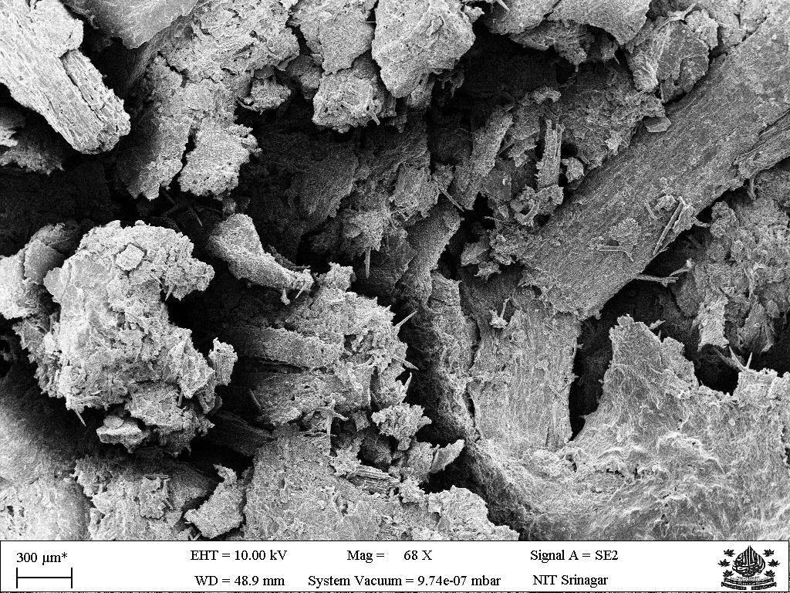  (a) S3 — overview (low magnification) | 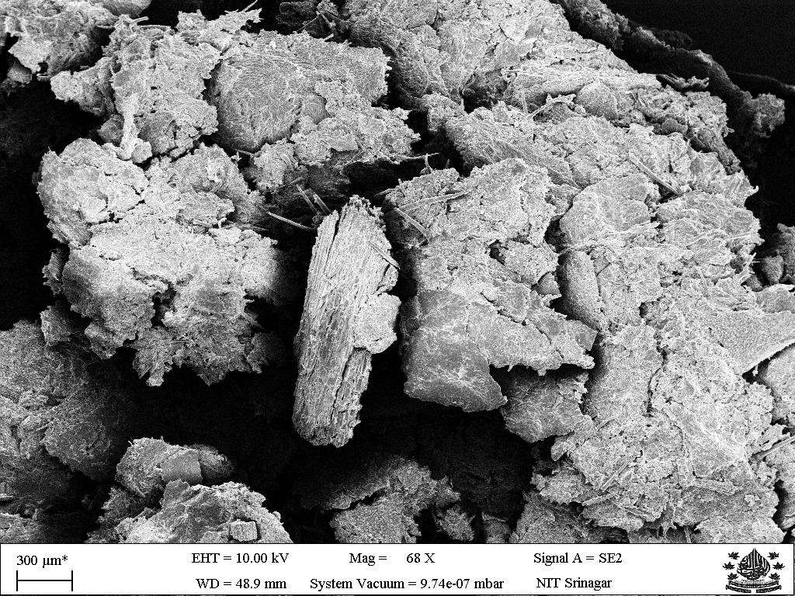  (b) S3 — starch-coated fibre network
Figure . SEM micrographs of S3 (90:10 corn-starch panel): (a) low-magnification overview showing starch-infiltrated porous network; (b) gelatinised starch film coating fibre surfaces.
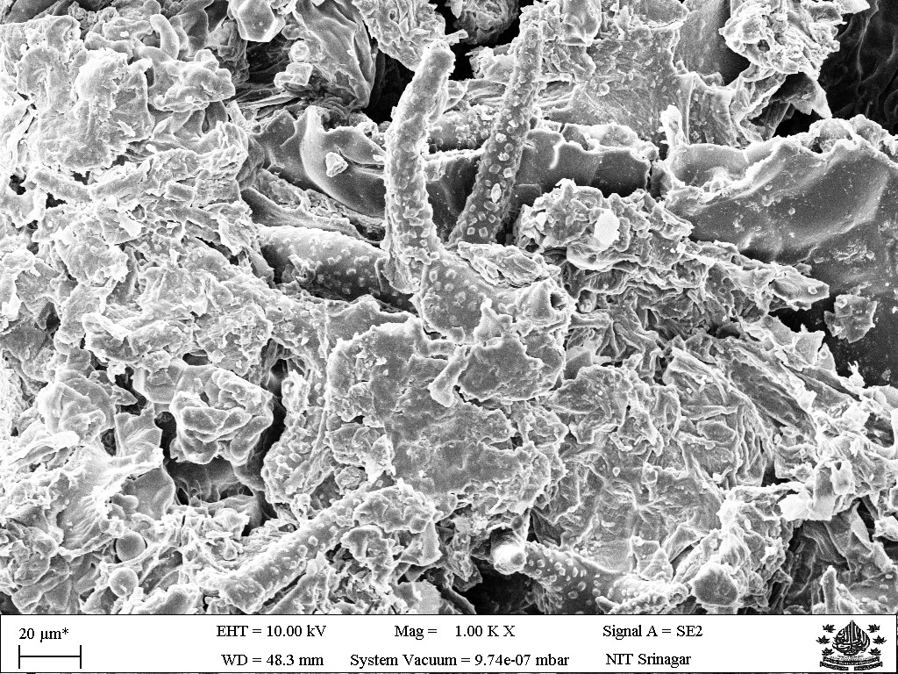  (c) S3 — starch binder bridges | 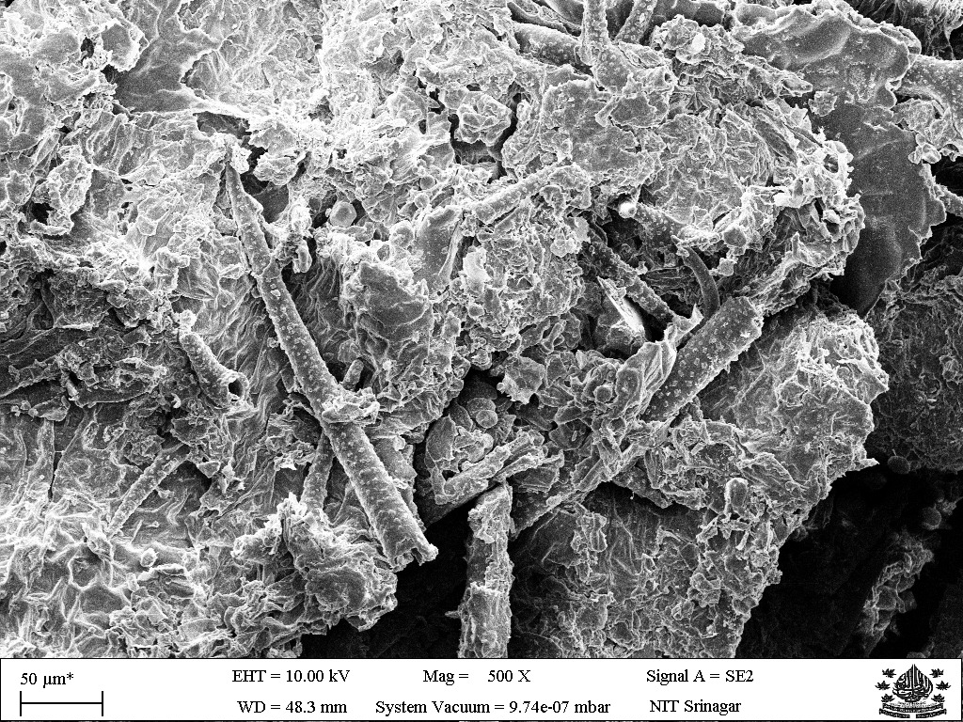  (d) S3 — fibre–matrix interface
Figure . SEM micrographs of S3 (continued): (c) starch menisci bridging inter-fibre junctions as load-transfer points; (d) fibre–starch interface showing good adhesion with no pull-out cavities.
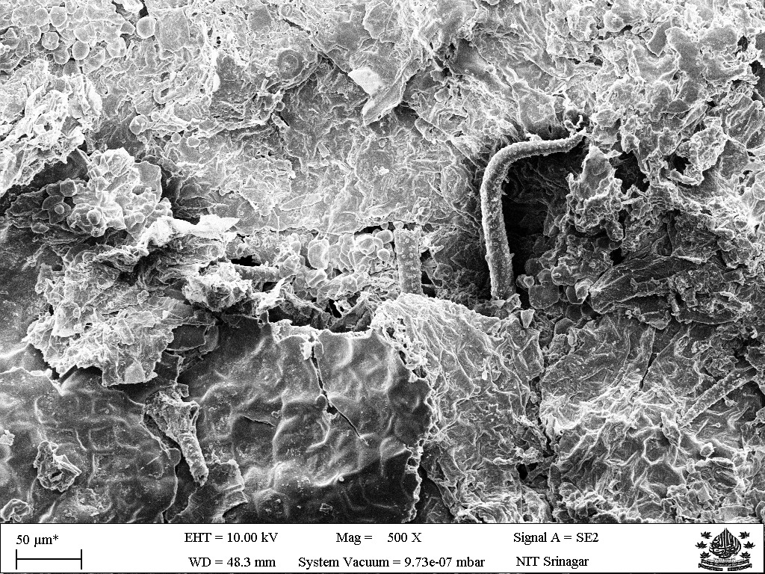  (e) S3 — retained macro-porosity | 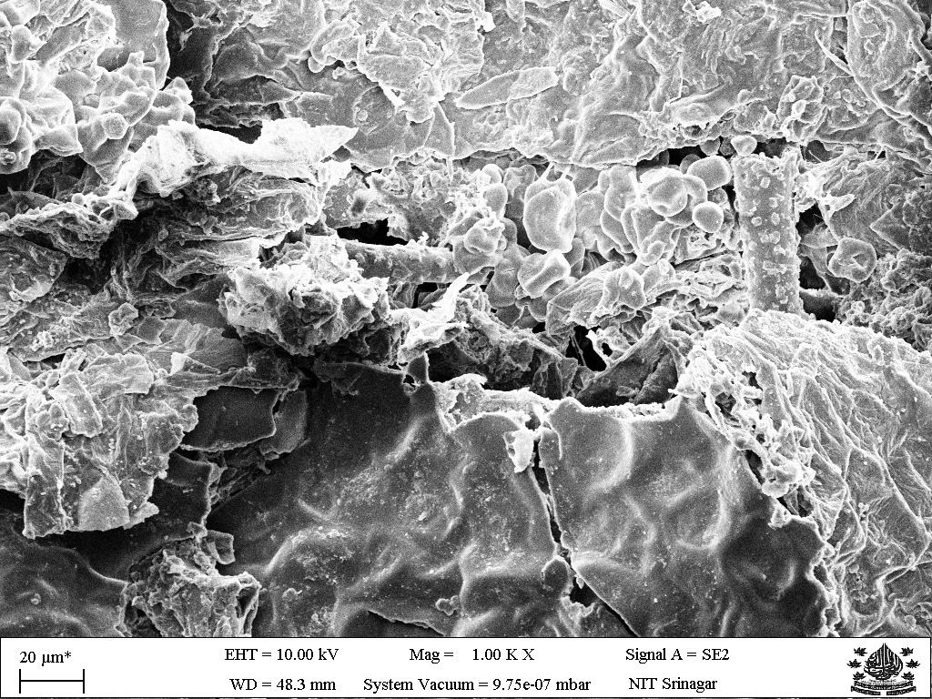  (f) S3 — high-magnification binder film
Figure . SEM micrographs of S3 (continued): (e) macro-pores retained despite 10 wt% starch addition, consistent with insulation-grade K; (f) high-magnification view of the thin continuous starch film bridging adjacent fibres.

4.8.3 Comparative Microstructural Observations
Table 13 pulls together the main microstructural observations from the SEM work and lines them up against the measured macroscopic properties of S1 and S3.
Table . Summary of SEM microstructural observations and correlation with macroscopic properties (S1 vs S3).
Feature | S1 — Fine Binder-less | S3 — 90:10 Starch | Property Implication
Binder / matrix | Absent; purely mechanical inter-fibre contact | Thin continuous starch film; discrete bridges at junctions | S3 compressive strength 97 % higher
Pore structure | Large, interconnected open pores; very porous | Pores partially bridged; macro-porosity retained | Both insulation-grade; S3 K only 5 % higher than S1
Fibre surface | Rough, uncoated; exposed microfibrils visible | Smooth starch coating on most fibre surfaces | Improved fibre–matrix adhesion in S3
Fibre lumen | Open tubular lumen; additional trapped-air volume | Lumen partially infiltrated by starch gel | S1 marginally lower K due to more trapped air
Inter-fibre bonding | Friction and mechanical interlocking only | Starch adhesive menisci — load-transfer points | Explains higher UCT of S3 (186 vs 94.4 kPa)
Pore throat sealing | All pores fully accessible to water | Some pore throats sealed by starch film | S3 WA slightly lower (507 % vs 523 %)
Together, the SEM evidence backs the conclusion that 10 wt% corn starch is the optimal binder loading for this system: it adds just enough bonding to roughly double the compressive strength while leaving enough open porosity to keep the thermal conductivity insulation-grade. Taking the starch up to 30 wt% (S4) would instead give a much denser, more continuous matrix that chokes the macro-pores, which fits the three-fold rise in K and the oddly low strength caused by the plasticised, moisture-laden starch phase seen for S4 in Section 4.4.

CHAPTER 5

CONCLUSIONS AND SCOPE FOR FUTURE WORK

5.1 Conclusions
This project showed that invasive waste aquatic biomass from Dal Lake can realistically be turned into fully bio-based insulation panels held together with a natural corn-starch binder. The main conclusions are:
- Four bio-composite panels were successfully fabricated from water hyacinth and water lily; particle size was found to be decisive, as the coarse binder-less panel (S1) fractured on demoulding while all fine-particle panels (S2–S4) formed intact specimens.
- An optimal binder content of 10 wt% corn starch was identified: the 90:10 panel (S3) achieved the highest unconfined compressive strength of 186.0 kPa — a 97 % improvement over the binder-less fine panel (S2, 94.4 kPa).
- Two formulations qualified as insulation-grade per ASTM C168: S2 (K = 0.0577 W/m·K) and S3 (K = 0.0608 W/m·K), both below the 0.065 W/m·K threshold.
- Excess starch was detrimental: the 70:30 panel (S4) showed the lowest strength (26.8 kPa) and a three-fold higher thermal conductivity (0.1846 W/m·K), caused by a weak plasticised matrix and a high moisture content (41.18 %).
- Water absorption was high for all panels (280–658 %) but decreased with binder fraction, confirming that moisture resistance is the key property requiring improvement.
- Overall, the 90:10 biomass:starch panel (S3) is the best-balanced formulation, uniquely combining insulation-grade thermal conductivity with the highest mechanical strength, and is therefore recommended as the optimal formulation from this study.
- SEM analysis confirmed that 10 wt% corn starch forms a thin, well-distributed binder film that bridges inter-fibre junctions and doubles compressive strength without appreciably filling the macropores that govern thermal insulation. The binder-less panel (S1) shows a purely open fibre network with exposed microfibrils, while S3 retains comparable porosity with added starch bridges at contact points — a microstructural explanation consistent with all the measured property trends.

5.2 Scope for Future Work
The following directions are recommended to advance this work towards a deployable product:
- Hydrophobic treatment: apply beeswax, linseed-oil or silicone coatings to reduce water absorption, following the beeswax approach of Chaireh et al. [5].
- Fibre surface modification: investigate mild alkali (NaOH) treatment to improve fibre–binder adhesion and strength, while avoiding the micro-void formation noted by Abral et al. [10].
- Flame retardancy: incorporate eco-friendly retardants such as borax, boric acid or ammonium polyphosphate, and evaluate LOI and UL-94 ratings [9].
- Complete FTIR characterization to correlate fibre surface chemistry with the measured mechanical and moisture-resistance properties, complementing the SEM microstructural analysis completed in this work.
- Optimise binder content between 10 % and 30 % to refine the strength–thermal trade-off, and explore hybrid binders (e.g. starch–chitosan).
- Hot-pressing trials to densify panels in a controlled manner and study the density–conductivity–strength relationship.
- End-of-life assessment via pyrolysis for energy recovery, and a comparative life-cycle assessment (LCA) against EPS, PU foam and glass wool.
- Scale-up of the fabrication route (mechanical harvesting, industrial drying, continuous pressing) toward pilot-scale panel production.

5.3 Scale-Up Strategy
The study was done at laboratory scale, but the fabrication route lends itself naturally to industrial scale-up using established equipment. A continuous manufacturing line for the panels might run through the following stages:
- Mechanical harvesting: amphibious weed harvesters for large-scale, continuous collection of aquatic biomass from the lake surface.
- Industrial drying: rotary drum dryers to reduce the biomass moisture content to below 10 % efficiently and at scale.
- Refining: hammer mills or disc refiners to process bulk biomass into a uniform fibrous feedstock of controlled particle size.
- Resination: a continuous spray line to apply the gelatinised starch binder (and, in future, flame-retardant additives) uniformly to the fibre.
- Continuous pressing: a multi-daylight press to consolidate and form panels of standard dimensions at controlled density.
- Finishing: automated trimming, sanding and application of a hydrophobic surface coating, followed by quality inspection and packing.
A line like this would turn a continuous waste stream into a saleable construction product, tying lake-restoration work directly to a workable manufacturing value chain.

5.4 Environmental and Economic Significance
The environmental case for this work has two sides. First, putting water hyacinth and water lily to use gives an invasive weed a productive end — left to rot, the weed releases methane, a potent greenhouse gas, and returns nutrients that keep Dal Lake's eutrophication going. Locking that biomass into durable panels effectively keeps its carbon out of circulation for as long as the product lasts. Second, swapping petroleum-derived insulants (EPS, PU foam) and energy-hungry inorganic ones (glass wool, mineral wool) for a biodegradable, plant-based panel cuts the embodied energy and carbon of the insulation considerably.
The economics are favourable too. The raw material is essentially free and plentiful, its removal is already paid for under lake-conservation programmes, and the corn-starch binder is a cheap, food-grade commodity. The processing route is simple and low-temperature — drying, grinding, mixing and cold pressing — with no exotic chemicals and no high-pressure or high-temperature equipment, so capital and running costs stay low. At the end of their life the panels are biodegradable, or they can be pyrolysed for energy recovery, closing the material loop in the spirit of the circular economy.

REFERENCES

[1] C. Jaktorn and S. Jiajitsawat, “Production of thermal insulator from water hyacinth fiber and natural rubber latex,” J. Ecol. Eng., vol. 22, no. 7, pp. 134–141, 2021. doi: 10.12911/22998993/138736.
[2] A. Salas-Ruiz, M. del M. Barbero-Barrera, and T. Ruiz-Téllez, “Microstructural and thermo-physical characterization of a water hyacinth petiole for thermal insulation particle board manufacture,” Materials, vol. 12, no. 4, p. 560, Feb. 2019. doi: 10.3390/ma12040560.
[3] S. Philip and R. Rakendu, “Thermal insulation materials based on water hyacinth for application in sustainable buildings,” Mater. Today Proc., vol. 57, pp. 1863–1867, 2022. doi: 10.1016/j.matpr.2022.01.062.
[4] Y. Zhou, A. Trabelsi, and M. El Mankibi, “Hygrothermal properties of insulation materials from rice straw and natural binders for buildings,” Polymers, vol. 14, no. 9, p. 1735, Apr. 2022. doi: 10.3390/polym14091735.
[5] P. Chaireh, N. Meethong, and P. Khomwaen, “Novel composite foam made from starch and water hyacinth with beeswax coating for food packaging applications,” Int. J. Biol. Macromol., vol. 165, pp. 1382–1391, Dec. 2020. doi: 10.1016/j.ijbiomac.2020.09.243.
[6] A. Anjani, B. Iskandar, and M. Aziz, “The utilization of composite material: water hyacinth and sugarcane bagasse fiber–epoxy for cool box thermal insulation,” J. Energy Mech. Mater. Manuf. Eng. (JEMMME), vol. 8, no. 1, pp. 29–38, 2023. doi: 10.22219/jemmme.v8i1.25010.
[7] J. Jeon, S. Park, and S. Kim, “A study on insulation characteristics of glass wool and mineral wool coated with a polysiloxane agent,” Adv. Mater. Sci. Eng., vol. 2017, art. 3938965, 2017. doi: 10.1155/2017/3938965.
[8] Syamsuri, A. Wahyudi, and R. Ismail, “Synthesis of water hyacinth/cassava starch composite as an environmentally friendly plastic solution,” Equilibrium J. Chem. Eng., vol. 7, no. 2, pp. 57–63, 2023. doi: 10.20961/equilibrium.v7i2.70321.
[9] P. Suwanniroj and N. Suppakarn, “Water hyacinth fiber as a bio-based carbon source for intumescent flame-retardant poly(butylene succinate) composites,” Polymers, vol. 15, no. 21, p. 4211, Oct. 2023. doi: 10.3390/polym15214211.
[10] H. Abral, D. Kadriadi, A. Rodawan, S. M. Sapuan, and E. S. Zainudin, “Mechanical properties of water hyacinth fibers–polyester composites before and after immersion in water,” Mater. Des., vol. 58, pp. 125–129, Jun. 2014. doi: 10.1016/j.matdes.2014.01.043.
[11] J. Pinto, E. Pereira, A. Tavares, and V. M. Ferreira, “Corn’s cob as a potential ecological thermal insulation material,” Constr. Build. Mater., vol. 277, art. 122282, Mar. 2021. doi: 10.1016/j.conbuildmat.2021.122282.
[12] L. Yang, D. Park, and Z. Qin, “Material function of mycelium-based bio-composite: a review,” J. Fungi, vol. 6, no. 4, p. 282, Nov. 2020. doi: 10.3390/jof6040282.
[13] A. F. Sahayaraj, M. Muthukrishnan, J. Ramesh, and J. T. W. Jappes, “Flame retardancy of natural fibre-reinforced polymer composites: a review of mechanisms, additives, and testing methods,” Polymers, vol. 15, no. 18, p. 3721, Sep. 2023. doi: 10.3390/polym15183721.
[14] H.-R. Kymäläinen and A.-M. Sjöberg, “Flax and hemp fibres as raw materials for thermal insulation,” Build. Environ., vol. 43, no. 7, pp. 1261–1269, Jul. 2008. doi: 10.1016/j.buildenv.2007.03.006.
[15] F. Asdrubali, F. D’Alessandro, and S. Schiavoni, “A review of unconventional sustainable building insulation materials,” Sustain. Mater. Technol., vol. 4, pp. 1–17, Dec. 2015. doi: 10.1016/j.susmat.2015.05.002.
[16] T.-T. Chen, J.-T. Ye, Q.-Y. Li, and H.-C. Zhang, “Thermal stability and flame-retardant performance of wood-plastic composites treated with boron compounds,” Compos. Part B Eng., vol. 193, art. 108010, Jul. 2020. doi: 10.1016/j.compositesb.2020.108010.
[17] N. A. M. Aridi, S. M. Sapuan, E. S. Zainudin, and A. M. Al-Oqla, “Mechanical and morphological properties of injection-moulded rice husk polypropylene composites,” Int. J. Polym. Anal. Charact., vol. 21, no. 4, pp. 305–313, 2016. doi: 10.1080/1023666X.2016.1148316.
[18] A. Oushabi, S. Sair, Y. Abboud, O. Tanane, and A. El Bouari, “Thermal and mechanical characterization of alkali-treated sugarcane bagasse-reinforced thermoset composites,” South African J. Chem. Eng., vol. 40, pp. 104–112, Apr. 2022. doi: 10.1016/j.sajce.2022.02.006.
[19] X. Wang, Z. Li, H. Shi, and Y. Yu, “Natural pineapple-leaf fibre: a promising material for high-performance composites,” Ind. Crops Prod., vol. 195, art. 116447, May 2023. doi: 10.1016/j.indcrop.2023.116447.
[20] S. Sair, A. Oushabi, A. Kammouni, O. Tanane, Y. Abboud, and A. El Bouari, “Mechanical and thermal conductivity properties of hemp fibre reinforced polyurethane composites,” Case Stud. Constr. Mater., vol. 15, art. e00625, Dec. 2021. doi: 10.1016/j.cscm.2021.e00625.
[21] R. Muthuraj, M. Misra, and A. K. Mohanty, “Unidirectional kenaf fibre-reinforced reprocessable thermoset biocomposites: effect of fibre loading and UV/humidity ageing,” Compos. Part A Appl. Sci. Manuf., vol. 156, art. 106874, May 2022. doi: 10.1016/j.compositesa.2022.106874.
[22] D. O. Oyejobi, J. O. Odeyemi, and C. C. Okonkwo, “Compressive strength and water absorption of coir fibre-reinforced concrete,” J. Nat. Fibers, vol. 18, no. 9, pp. 1299–1311, 2021 (pub. online 2020). doi: 10.1080/15440478.2019.1697990.
[23] Q. Zhang, H. Li, and L. Li, “A review of end-of-life management strategies for natural fibre-reinforced polymer composites,” J. Clean. Prod., vol. 443, art. 141024, Feb. 2024. doi: 10.1016/j.jclepro.2024.141024.
[24] H. Binici, O. Aksogan, and C. Demirhan, “Mechanical, thermal and acoustical characterizations of an insulation composite made of bio-based chicken feather and cotton waste fibres,” Sustain. Mater. Technol., vol. 35, art. e00549, Jan. 2023. doi: 10.1016/j.susmat.2022.e00549.
[25] H. Li, J. Zhang, and Y. Liu, “Hygrothermal ageing behaviour and moisture buffering capacity of bamboo-fibre-reinforced composites,” Constr. Build. Mater., vol. 271, art. 121555, Feb. 2021. doi: 10.1016/j.conbuildmat.2020.121555.
[26] J. Liu, L. Chen, and Y. Zhao, “Recent advances and challenges in cellulose aerogel-based thermal insulation materials: a review,” Carbohydr. Polym., vol. 324, art. 121533, Jan. 2024. doi: 10.1016/j.carbpol.2023.121533.
[27] A. Trabelsi, M. El Mankibi, and F. Michel, “Hygrothermal performance of hemp-lime concrete wall: experimental and numerical study,” Energy Build., vol. 223, art. 110134, Sep. 2020. doi: 10.1016/j.enbuild.2020.110134.
[28] K. Pawlowski, A. Strzalkowska, and B. Chojnacka, “Exploring advancements in bio-based composites for thermal insulation: a systematic review,” Sustainability, vol. 17, no. 3, p. 1143, Jan. 2025. doi: 10.3390/su17031143.
[29] L. Cosentino, P. Fernandes, and R. Mateus, “A review of natural bio-based insulation materials,” Energies, vol. 16, no. 13, p. 4926, Jun. 2023. doi: 10.3390/en16134926.
[30] ASTM C168, Standard Terminology Relating to Thermal Insulation, ASTM International, West Conshohocken, PA, USA.
[31] ASTM D4442, Standard Test Methods for Direct Moisture Content Measurement of Wood and Wood-Based Materials, ASTM International.
[32] ASTM D1037, Standard Test Methods for Evaluating Properties of Wood-Base Fiber and Particle Panel Materials, ASTM International.
[33] ASTM D570, Standard Test Method for Water Absorption of Plastics, ASTM International.
[34] ASTM D5334, Standard Test Method for Determination of Thermal Conductivity of Soil and Soft Rock by Thermal Needle Probe Procedure, ASTM International.

BRIEF BIO DATA OF THE CANDIDATES
(Annexure B)
CURRICULUM VITAE

 | Passport  Photo
  NAME | : Suchetan Karloopia
  ENROLMENT NO. | : 2022BCHE019
  DATE OF BIRTH | : ______________________
  FATHER’S NAME | : ______________________
  PERMANENT ADDRESS | : ______________________
  PHONE NUMBER | : ______________________
  EMAIL ADDRESS | : ______________________
QUALIFICATION
Examination | Year | Institute / Board | Result
B.Tech (Chemical Engineering) | 2026 | NIT Srinagar | Awaited
12th (Senior Secondary) | ______ | ______________ | ____ %
10th (Secondary) | ______ | ______________ | ____ %
DECLARATION: I hereby declare that the information furnished above is true to the best of my knowledge.
Signature: ____________________
Suchetan Karloopia

CURRICULUM VITAE

 | Passport  Photo
  NAME | : Miran Haider
  ENROLMENT NO. | : 2022BCHE027
  DATE OF BIRTH | : ______________________
  FATHER’S NAME | : ______________________
  PERMANENT ADDRESS | : ______________________
  PHONE NUMBER | : ______________________
  EMAIL ADDRESS | : ______________________
QUALIFICATION
Examination | Year | Institute / Board | Result
B.Tech (Chemical Engineering) | 2026 | NIT Srinagar | Awaited
12th (Senior Secondary) | ______ | ______________ | ____ %
10th (Secondary) | ______ | ______________ | ____ %
DECLARATION: I hereby declare that the information furnished above is true to the best of my knowledge.
Signature: ____________________
Miran Haider

CURRICULUM VITAE

 | Passport  Photo
  NAME | : Akshita Sen
  ENROLMENT NO. | : 2022BCHE037
  DATE OF BIRTH | : ______________________
  FATHER’S NAME | : ______________________
  PERMANENT ADDRESS | : ______________________
  PHONE NUMBER | : ______________________
  EMAIL ADDRESS | : ______________________
QUALIFICATION
Examination | Year | Institute / Board | Result
B.Tech (Chemical Engineering) | 2026 | NIT Srinagar | Awaited
12th (Senior Secondary) | ______ | ______________ | ____ %
10th (Secondary) | ______ | ______________ | ____ %
DECLARATION: I hereby declare that the information furnished above is true to the best of my knowledge.
Signature: ____________________
Akshita Sen

APPENDICES

This section contains supplementary material that supports but is not part of the main body of the report.
APPENDIX A — PLAGIARISM CERTIFICATE
This is to certify that the project report entitled “Development and Characterization of Bio-Composites from Waste Aquatic Biomass for Sustainable Insulation” has been checked for plagiarism using approved similarity-detection software, and the similarity index is within the permissible limit prescribed by the Institute.
The plagiarism-check report generated by the software is to be obtained from the project supervisor and attached here.
Similarity Index: __________ %
[ Plagiarism similarity report — to be obtained from the supervisor and attached here ]
Signature of Supervisor: ____________________
Dr. Fasil Qayoom Mir
Head & Associate Professor, Department of Chemical Engineering, NIT Srinagar

