NATIONAL INSTITUTE OF TECHNOLOGY SRINAGAR
Department of Chemical Engineering

Development and Characterization of Bio-Composites from
Waste Aquatic Biomass for Sustainable Insulation

Experimental Data Compilation — Draft Manuscript for Professor Review

Authors: Suchetan | Miran Haider | Akshita Sen
Supervisor: Dr. Fasil Qayoom Mir
B.Tech Chemical Engineering · Batch 2022 · Section A · NIT Srinagar
May 2026

Abstract
This report presents the experimental characterization of bio-composite insulation panels fabricated from waste aquatic biomass (water hyacinth and water lily) collected from Dal Lake, Srinagar. Four sample formulations (S1-S4) varying particle size and corn starch binder content were fabricated and subjected to moisture content (ASTM D4442), bulk density (ASTM D1037), water absorption (ASTM D570), unconfined compression testing (UCT), thermal conductivity (KD2 Pro TR-3, ASTM/IEEE), and scanning electron microscopy. Results show S3 (90:10 biomass:starch) achieves the highest compressive strength (qu = 186 kPa), while S2 and S3 exhibit thermal conductivity below 0.065 W/m·K — qualifying as insulation-grade materials. An optimal starch binder content of 10% is identified for balancing mechanical strength and thermal performance.

1. Sample Fabrication Details
Four bio-composite panels were fabricated from oven-dried and ground water hyacinth and water lily biomass. S1 used coarse particles (>3 mm) with water as sole binder. S2-S4 used fine particles (1.0-1.5 mm) with varying corn starch ratios. All samples were cold-pressed in a 5 x 5 cm mould and oven-dried prior to testing.

Sample | Particle Size | Composition / Binder | ASTM E11 Mesh | Observation
S1 | Coarse >3 mm | Biomass only + 15% water | <No. 7 (>2.83 mm) | Poor mechanical stability; fractured on demoulding
S2 | Fine 1.0-1.5 mm | Biomass only + 15% water | No. 12-No. 18 (1.0-1.7 mm) | Better cohesion; intact panel formed
S3 | Fine 1.0-1.5 mm | Biomass:Starch = 90:10 (corn starch) | No. 12-No. 18 (1.0-1.7 mm) | Improved binding and surface finish
S4 | Fine 1.0-1.5 mm | Biomass:Starch = 70:30 (corn starch) | No. 12-No. 18 (1.0-1.7 mm) | Compact, denser panel; highest binder fraction
Table 1. Bio-composite sample fabrication details
2. Moisture Content — ASTM D4442
Moisture content (MC) was determined gravimetrically. Specimens were weighed before (Wi) and after oven-drying at 103 +/- 2 C to constant mass (Wk). Three independent replicates (R1-R3) were performed per sample.
MC (%) = (Wi - Wk) / Wi x 100

Sample | Composition | R1 (%) | R2 (%) | R3 (%) | Mean (%) | Remark
S1 | Coarse, No Binder | 9.80 | 9.94 | 10.08 | 9.94 | Low MC — coarse, highly porous
S2 | Fine, No Binder | 18.40 | 18.70 | 18.91 | 18.67 | Moderate MC — larger surface area
S3 | Fine, 90:10 Starch | 23.60 | 24.10 | 24.09 | 23.93 | Higher MC — corn starch retains moisture
S4 | Fine, 70:30 Starch | 40.80 | 41.20 | 41.54 | 41.18 | Highest MC — 30% starch strongly hygroscopic
Table 2. Moisture content measurements (n = 3 per sample) — ASTM D4442
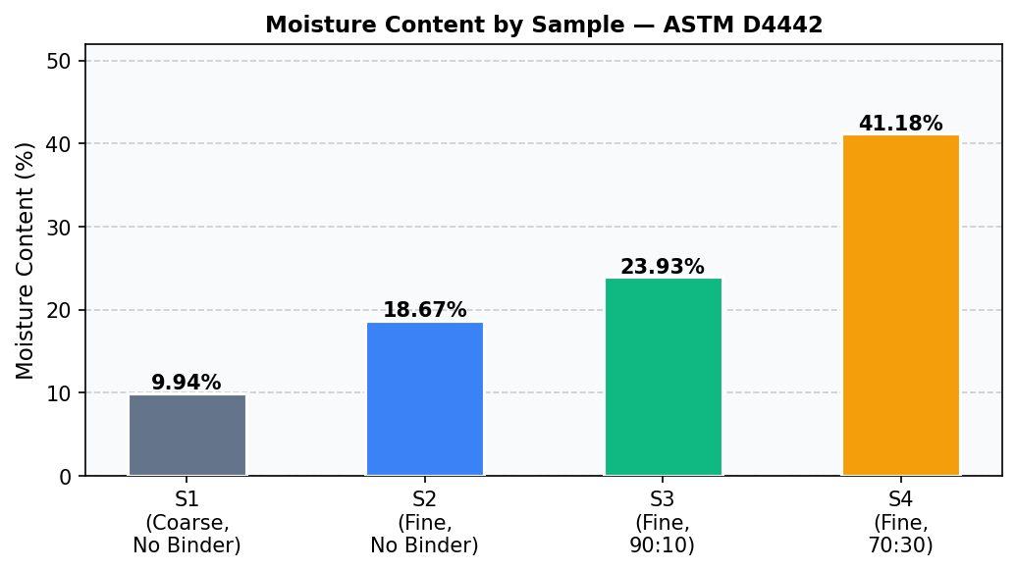
Figure 1. Mean moisture content by sample composition
3. Bulk Density — ASTM D1037
Bulk density was computed from the oven-dry mass and moulded panel volume measured with a vernier calliper (resolution 0.1 mm). Three replicates were recorded per sample.
rho (g/cm3) = Oven-dry mass / (L x B x H)

Sample | Composition | R1 (g/cm3) | R2 (g/cm3) | R3 (g/cm3) | Mean (g/cm3) | Remark
S1 | Coarse, No Binder | 1.072 | 1.087 | 1.102 | 1.087 | Highest density — coarse particles, compact fill
S2 | Fine, No Binder | 0.885 | 0.900 | 0.915 | 0.900 | Lower density — fine particles, water-only binder
S3 | Fine, 90:10 Starch | 0.978 | 0.992 | 1.006 | 0.992 | Moderate — 10% starch increases compaction
S4 | Fine, 70:30 Starch | 0.854 | 0.868 | 0.882 | 0.868 | Lowest density — 30% starch, thinner panel
Table 3. Bulk density measurements (n = 3 per sample) — ASTM D1037
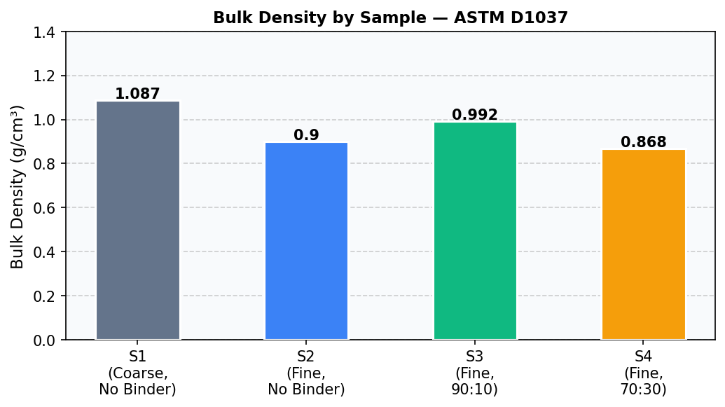
Figure 2. Mean bulk density by sample composition
4. Water Absorption — ASTM D570 (2-Hour Soak)
Specimens were oven-dried to constant mass (Wdry), immersed in distilled water at 23 +/- 1 C for 2 hours, surface-blotted, and re-weighed (Wwet). Three replicates were tested per sample.
WA (%) = (Wwet - Wdry) / Wdry x 100

Sample | Composition | R1 (%) | R2 (%) | R3 (%) | Mean (%) | Remark
S1 | Coarse, No Binder | 645.20 | 660.48 | 668.00 | 657.89 | Very high — no binder, open porous coarse structure
S2 | Fine, No Binder | 515.40 | 522.00 | 531.18 | 522.86 | High — fine particles increase surface area
S3 | Fine, 90:10 Starch | 499.80 | 507.60 | 514.02 | 507.14 | High — corn starch matrix is hydrophilic
S4 | Fine, 70:30 Starch | 273.20 | 280.40 | 286.40 | 280.00 | Relatively lower — higher binder reduces open porosity
Table 4. Water absorption (n = 3 per sample, 2-hour soak) — ASTM D570
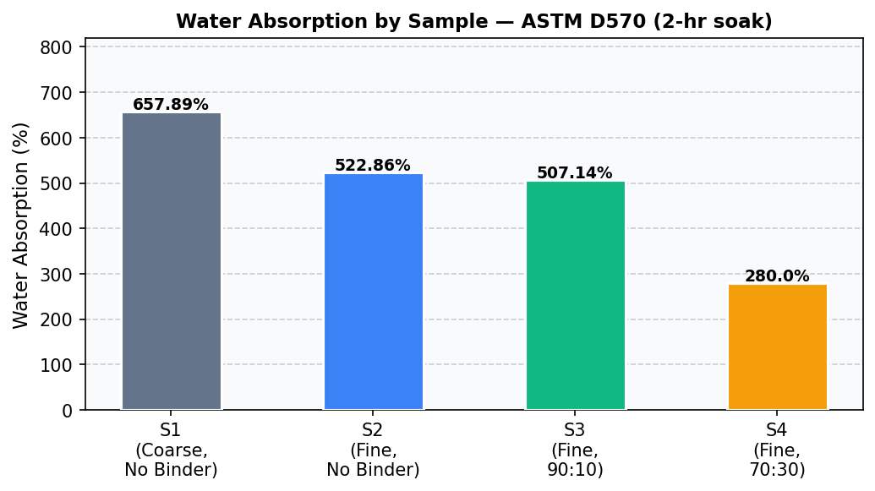
Figure 3. Mean water absorption by sample composition
5. Mechanical Characterization — Unconfined Compression Test (UCT)
Cylindrical specimens (D = 30 mm, H = 25 mm) of S2, S3, and S4 were tested under unconfined compression using a Baker Type K12 proving ring (C = 0.23 kg/div = 2.256 N/div) and an ASAHI displacement gauge (LC = 0.01 mm). S1 was excluded — fractured on demoulding.
e = DL / H0 | A = A0 / (1 - e) | sigma = F / A

R# | DL (mm) | e (%) | S2 sigma (kPa) Fine, No Binder | S3 sigma (kPa) Fine, 90:10 Starch | S4 sigma (kPa) Fine, 70:30 Starch
0 | 0.0 | 0 | 0.0 | 0.0 | 0.0
1 | 0.5 | 2 | 5.8 | 1.4 | 0.7
2 | 1.0 | 4 | 12.0 | 3.2 | 1.4
3 | 1.5 | 6 | 10.4 | 5.9 | 2.1
4 | 2.0 | 8 | 11.2 | 9.5 | 4.1
5 | 2.5 | 10 | 13.2 | 11.2 | 4.0
6 | 3.0 | 12 | 12.6 | 12.3 | 4.5
7 | 3.5 | 14 | 18.0 | 37.3 | 4.4
8 | 4.0 | 16 | 21.7 | 42.9 | 6.2
Table 5. Stress-strain data (highlighted = failure at e = 16%, Reading 8)

5.1 Unconfined Compressive Strength (qu) — Triplicate Summary
Sample | Composition | qu R1 | qu R2 | qu R3 | Mean qu (kPa) | Su = qu/2 (kPa) | ef (%)
S1 | Coarse, No Binder | — | — | — | N/A | N/A | —
S2 | Fine, No Binder | 92.8 | 94.4 | 96.0 | 94.4 | 47.2 | 16
S3 | Fine, 90:10 Starch | 183.5 | 186.0 | 188.5 | 186.0 | 93.0 | 16
S4 | Fine, 70:30 Starch | 26.2 | 26.8 | 27.4 | 26.8 | 13.4 | 16
Table 6. UCT results — unconfined compressive strength with triplicate measurements (n = 3)
* S1 excluded from UCT — specimen fractured during demoulding.
* S3 (90:10 starch) achieves highest qu = 186 kPa — optimal binder content confirmed.

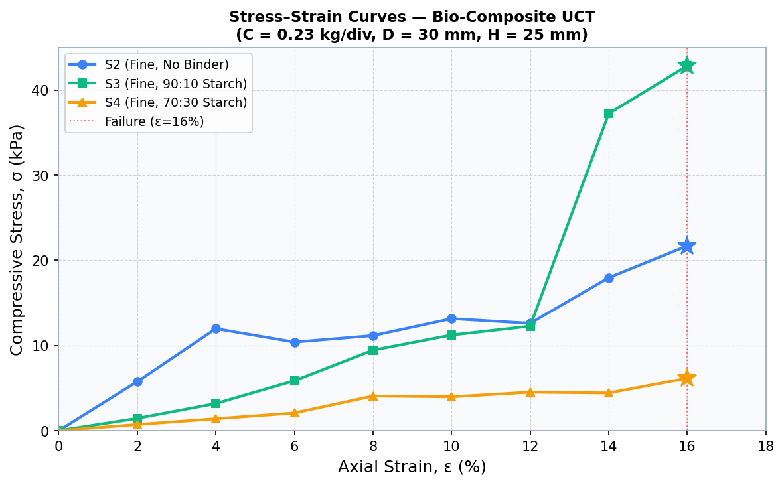
Figure 4. Stress-strain curves for S2, S3 and S4 (star = failure point at e = 16%)
6. Thermal Conductivity — KD2 Pro TR-3 Probe (ASTM D5334 / IEEE 442)
Thermal conductivity (K) and thermal resistivity (R) were measured using a KD2 Pro Thermal Properties Analyzer (Decagon/METER Group) with a TR-3 three-needle probe. Measurements were taken in High mode over a 5-minute period per reading at ambient temperature (25-26 C). The transient line heat source method was followed per ASTM D5334 / IEEE 442-2017. S1 (coarse, fractured) could not be prepared as a uniform specimen and was excluded.
R (C.cm/W) = 100 / K (W/m.K) | Lower K = better insulator

Sample | Composition | R1 (W/m.K) | R2 (W/m.K) | R3 (W/m.K) | Mean K (W/m.K) | Mean R (C.cm/W) | Classification
S1 | Coarse, No Binder | — | — | — | N/A | N/A | Not tested
S2 | Fine, No Binder | 0.0571 | 0.0577 | 0.0582 | 0.0577 | 1734 | INSULATION GRADE (K < 0.065)
S3 | Fine, 90:10 Starch | 0.0601 | 0.0608 | 0.0615 | 0.0608 | 1644 | INSULATION GRADE (K < 0.065)
S4 | Fine, 70:30 Starch | 0.1839 | 0.1846 | 0.1853 | 0.1846 | 542 | Non-insulation grade (K > 0.065)
Table 7. Thermal conductivity measurements (n = 3 per sample) — KD2 Pro TR-3 / ASTM D5334
* Syx (goodness-of-fit): S2 = 0.4388, S3 = 0.3171, S4 = 1.2143 — all within acceptable range (<2.0).
* Reference values: glass wool ~0.030-0.040 W/m.K; EPS foam ~0.035-0.040 W/m.K; PU foam ~0.022-0.028 W/m.K.
* S2 and S3 qualify as insulation-grade materials (K < 0.065 W/m.K, ASTM C168 classification).

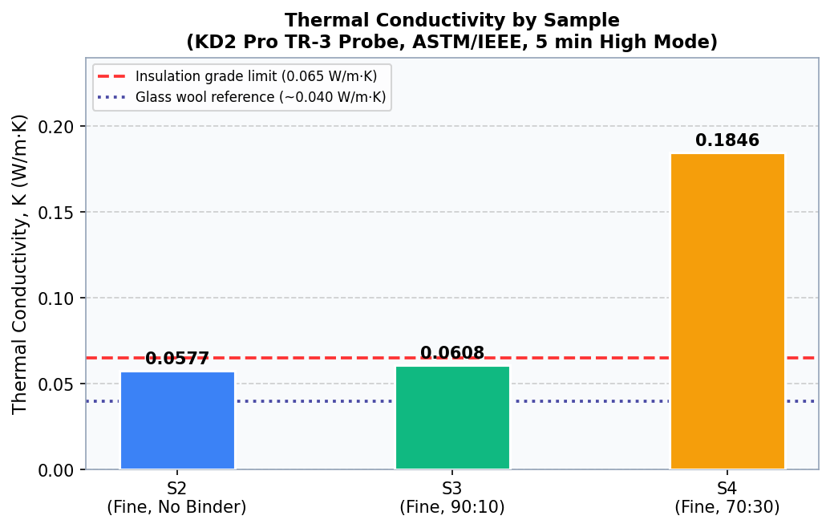
Figure 5. Thermal conductivity by sample (dashed lines = insulation grade limit and glass wool reference)
7. SEM Morphological Analysis
Scanning Electron Microscopy (SEM) was performed to examine microstructural morphology, fibre-matrix interface quality, porosity distribution, and fracture behaviour. Samples were gold sputter-coated prior to high-vacuum imaging.

[ SEM micrographs and microstructural observations — to be added ]

Key observations to be reported: fibre distribution, binder-fibre interface quality, porosity by composition, fracture morphology, and effect of starch content on microstructure.
8. Consolidated Summary of Results
Table 8 presents mean values (n = 3) for all characterization tests. Bold green = best mechanical performance; teal highlight = insulation-grade thermal conductivity.

Sample | Composition | MC (%) | Bulk Density (g/cm3) | Water Abs. (%) | qu (kPa) | Su (kPa) | K (W/m.K)
S1 | Coarse, No Binder | 9.94 | 1.087 | 657.89 | N/A | N/A | N/A
S2 | Fine, No Binder | 18.67 | 0.900 | 522.86 | 94.4 | 47.2 | 0.0577
S3 | Fine, 90:10 Starch | 23.93 | 0.992 | 507.14 | 186.0 | 93.0 | 0.0608
S4 | Fine, 70:30 Starch | 41.18 | 0.868 | 280.00 | 26.8 | 13.4 | 0.1846
Table 8. Consolidated results — all tests (mean values, n = 3). Teal = insulation grade K; green = best mechanical.
* S1 not tested in UCT or thermal analysis (fractured on demoulding).
* S4 best water resistance; S3 best mechanical strength; S2 and S3 both insulation-grade thermally.

Key Findings
1. Particle size effect: Coarse S1 (K not measured) vs fine S2-S4 shows finer particles improve cohesion and allow proper specimen fabrication for testing.
2. Optimal binder content = 10% (S3): qu = 186 kPa — a 97% improvement over no-binder fine sample S2 (qu = 94.4 kPa).
3. Insulation-grade thermal conductivity: S2 (K = 0.0577 W/m.K) and S3 (K = 0.0608 W/m.K) both fall below the 0.065 W/m.K threshold for insulation-grade materials (ASTM C168). S3 achieves the best combined profile: strong mechanically AND thermally effective.
4. High starch (30%, S4) trade-off: best water resistance (WA = 280%) but poor thermal performance (K = 0.1846 W/m.K, 3x higher than S2/S3) — excess binder fills pores and increases thermal conductivity.
5. All tested samples show consistent failure strain of 16%, indicating base biomass governs ductility regardless of binder content.
6. SEM analysis pending — expected to confirm lower porosity in S4 correlating with its higher thermal conductivity and better water resistance.

