Valorisation of Invasive Aquatic Weed from Dal Lake into Corn-Starch Bonded Bio-Composite Panels for Sustainable Building Insulation: Fabrication, Mechanical, Thermal and Microstructural Characterisation
Suchetan Karloopia, Miran Haider, Akshita Sen, Fasil Qayoom Mir*
Department of Chemical Engineering, National Institute of Technology, Srinagar, Jammu & Kashmir, 190006, India
* Corresponding author: mirfasil@nitsri.ac.in
Abstract
The building sector accounts for approximately 40% of global final energy use, and most commercial insulants are petroleum-derived, non-biodegradable and energy-intensive to manufacture. In parallel, the invasive aquatic weeds water hyacinth (Eichhornia crassipes) and water lily (Nymphaea spp.) infest Dal Lake, Srinagar — an approximately 18 km² Ramsar wetland suffering severe eutrophication — generating large quantities of waste biomass that must be periodically removed to maintain the lake's ecological balance. This study valorises this waste biomass into fully bio-based composite insulation panels using food-grade corn starch as the sole binder. Four formulations were fabricated: a coarse binder-less panel (S1), a fine binder-less panel (S2), and two fine panels bound with gelatinised corn starch at 90:10 (S3) and 70:30 (S4) biomass:starch ratios by weight; no synthetic polymers or chemical crosslinkers were used at any stage. All panels were characterised for moisture content (ASTM D4442), bulk density (ASTM D1037), water absorption (ASTM D570), unconfined compressive strength (Baker Type K12 apparatus), and thermal conductivity (KD2 Pro TR-3 transient line-source probe, ASTM D5334). Scanning electron microscopy (SEM) was used to relate macroscopic performance differences to fibre-matrix microstructure. Both S2 (k = 0.0577 W m⁻¹ K⁻¹) and S3 (k = 0.0608 W m⁻¹ K⁻¹) qualified as insulation-grade per ASTM C168 (threshold: 0.065 W m⁻¹ K⁻¹). The 90:10 panel S3 achieved the highest compressive strength (186.0 kPa), a 97% improvement over the binder-less S2 (94.4 kPa), identifying 10 wt% corn starch as the optimal binder content. SEM confirmed a continuous gelatinised starch matrix bridging fibres at inter-particle contact points in S3, whereas binder-less S2 showed open inter-fibre voids. The 90:10 panel S3 is the best-balanced formulation, demonstrating the technical feasibility of converting an invasive aquatic weed into a viable, biodegradable building-insulation material.
Keywords: Water hyacinth; Dal Lake; Bio-composite insulation; Corn-starch binder; Thermal conductivity; Compressive strength; Scanning electron microscopy; Waste valorisation
1. Introduction
Thermal insulation is among the most cost-effective strategies for reducing operational energy demand in buildings. The building sector globally consumes about 40% of total final energy and contributes approximately one-third of greenhouse-gas emissions; improving the thermal performance of the building envelope is widely recognised as the single highest-impact mitigation measure (Cosentino et al., 2023; Tazmeen and Mir, 2024). The dominant commercial insulants — expanded polystyrene (EPS), extruded polystyrene (XPS), polyurethane (PU) foam, glass wool and mineral wool — are either petroleum-derived and non-biodegradable, or energy-intensive to produce. During combustion, organic polymer foams release toxic gases, a serious life-safety concern in building fires (Jeon et al., 2017; Jaktorn and Jiajitsawat, 2021). The transition to circular-economy principles and low-carbon construction has therefore intensified research into bio-based thermal insulants derived from agricultural and aquatic lignocellulosic waste (Pawlowski et al., 2025; Asdrubali et al., 2015).
Thermal conductivity k (W m⁻¹ K⁻¹) is the primary measure of an insulant's performance; low-k materials owe their properties to large volumes of immobilised air (k ≈ 0.026 W m⁻¹ K⁻¹) trapped within a cellular or fibrous matrix. ASTM C168 classifies materials with k < 0.065 W m⁻¹ K⁻¹ as insulation-grade. Numerous lignocellulosic feedstocks have been shown to reach this range: rice straw with natural binders (Zhou et al., 2022), corn cob (Pinto et al., 2021), hemp and flax fibres (Kymäläinen and Sjöberg, 2008), sugarcane bagasse (Oushabi et al., 2022), and pineapple-leaf fibre (Wang et al., 2023). Among aquatic plants, water hyacinth (Eichhornia crassipes) has attracted particular attention because of its abundance, rapid growth rate, and high cellulose content of 16–20% (Salas-Ruiz et al., 2019; Tanobe et al., 2005).
1.1. Bio-based insulation and the role of the binder
The binder system is a critical variable in bio-composite panel manufacture. Most published composite systems employ synthetic resins such as epoxy or polyester, which improve cohesion but negate the biodegradability advantage (Abral et al., 2014; Anjani et al., 2023; Madhu et al., 2019). Corn starch is an attractive natural binder alternative: it is cheap, renewable, fully biodegradable and widely available. When heated above its gelatinisation temperature (≈60–75 °C), the semi-crystalline starch granules swell, disperse and re-associate on cooling to form a continuous adhesive film that coats and bridges fibres (López et al., 2013; Ruiz-Gómez et al., 2021). Systematic optimisation of the biomass-to-starch ratio in a fully bio-based building panel has not previously been reported for water-hyacinth composites.
1.2. Dal Lake: from ecological burden to engineering resource
Dal Lake in Srinagar, Jammu & Kashmir (approximately 34.08° N, 74.85° E), is a designated Ramsar wetland of approximately 18 km². It has suffered severe eutrophication driven by untreated sewage, catchment urbanisation and intense houseboat tourism. The most visible consequence is the explosive proliferation of invasive free-floating weeds — principally water hyacinth and water lily (Nymphaea spp.) — which form dense surface mats that reduce light penetration, deplete dissolved oxygen and accelerate conversion of open water to marshland (Mitra et al., 2020). Large quantities of biomass are mechanically removed each year but generally composted or dumped. Valorising this waste biomass into insulation panels simultaneously provides an economic incentive for weed removal and supplies a renewable raw material for the construction sector.
1.3. Research objectives
The present study addresses the above gap by: (i) fabricating four fully bio-based formulations from oven-dried, sieve-classified Dal Lake biomass bound with food-grade corn starch, systematically varying particle size and biomass:starch ratio; (ii) characterising moisture content, bulk density, water absorption, unconfined compressive strength and thermal conductivity of all formulations; (iii) examining the microstructure of representative panels by SEM to link macroscopic performance to fibre-matrix architecture; and (iv) benchmarking results against conventional insulants and reported bio-composites to assess the practical potential of the optimal formulation.
2. Materials and Methods
2.1. Raw Materials
The primary raw material was waste aquatic biomass comprising water hyacinth (Eichhornia crassipes) and water lily (Nymphaea spp.) collected manually from Dal Lake, Srinagar, during October–November 2025. Petioles, stems and leaves were thoroughly washed to remove mud, debris and biological contaminants. The binder was commercial food-grade corn (maize) starch; distilled water was used as the processing medium throughout. No synthetic polymers, resins or chemical crosslinkers were employed at any stage, ensuring a fully bio-based and biodegradable composite. The water-hyacinth petiole has a spongy aerenchyma-rich interior with large air channels surrounded by thin fibre walls (Salas-Ruiz et al., 2019), a structure inherently advantageous for thermal insulation.
2.2. Biomass Pre-Treatment and Size Classification
The washed biomass was sun-dried for 5–7 days and then oven-dried at 103 ± 2 °C for approximately 24 h to standardise moisture content prior to grinding (ASTM D4442). Size reduction was carried out with a laboratory mixer-grinder, and the ground material was sieve-classified using ASTM E11 wire-mesh sieves into two fractions: a coarse fraction (> 3 mm, finer than No. 7 mesh) and a fine fraction (1.0–1.5 mm, No. 12–No. 18 mesh). Figure 1 shows the two classified fractions. Particle size is critical: the coarse fraction produces an open, weakly interlocked structure, whereas the fine fraction provides a larger specific surface area for inter-particle contact and binding.
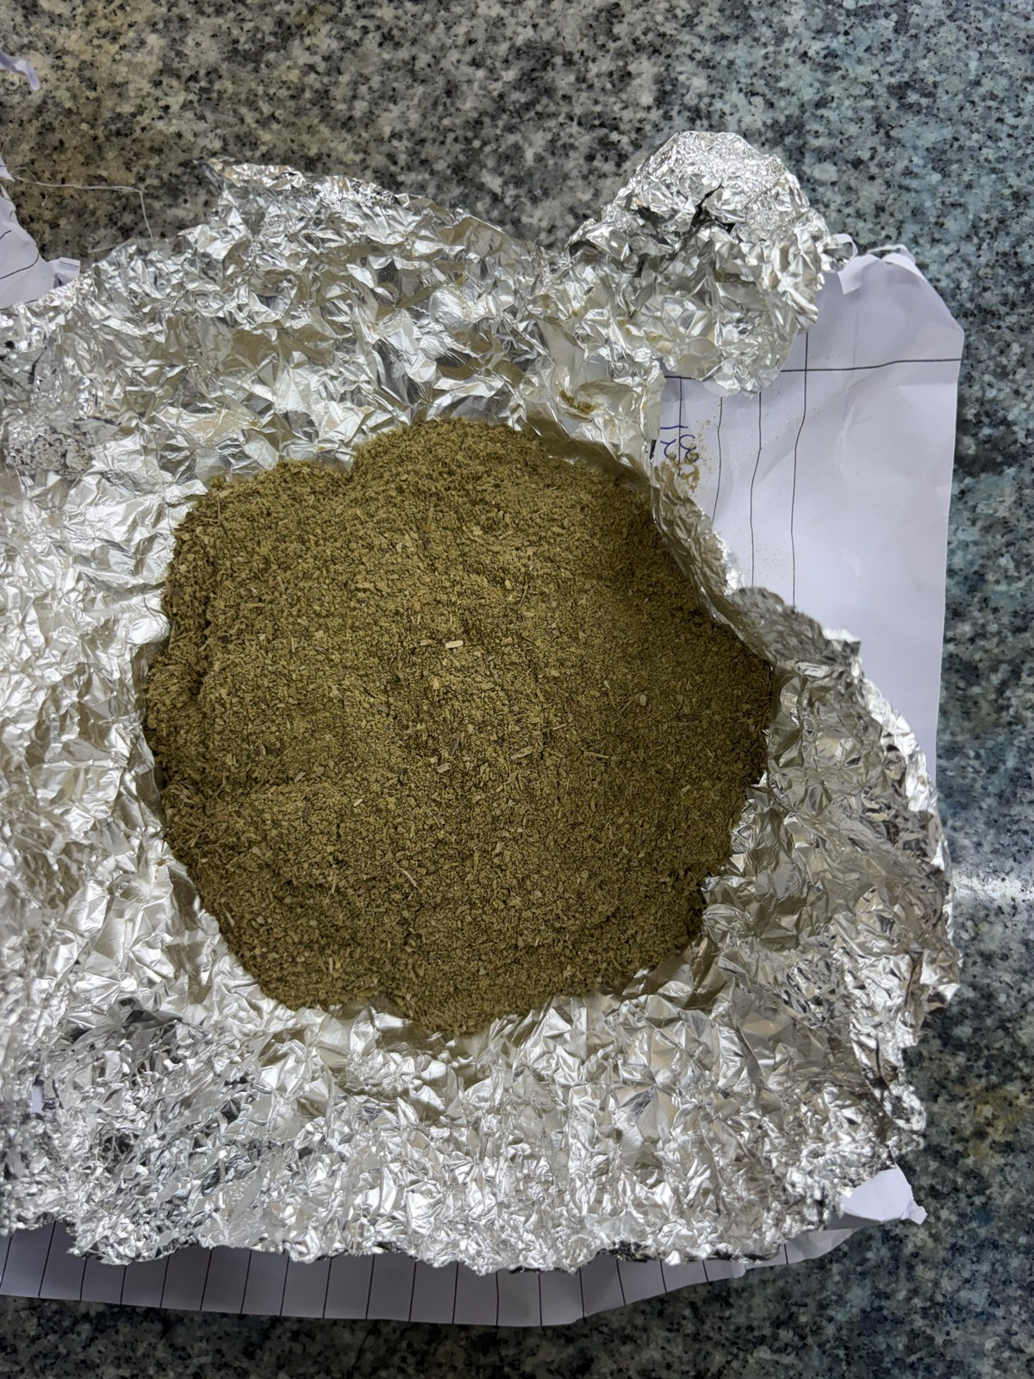  (a) Fine fraction (1.0–1.5 mm) | 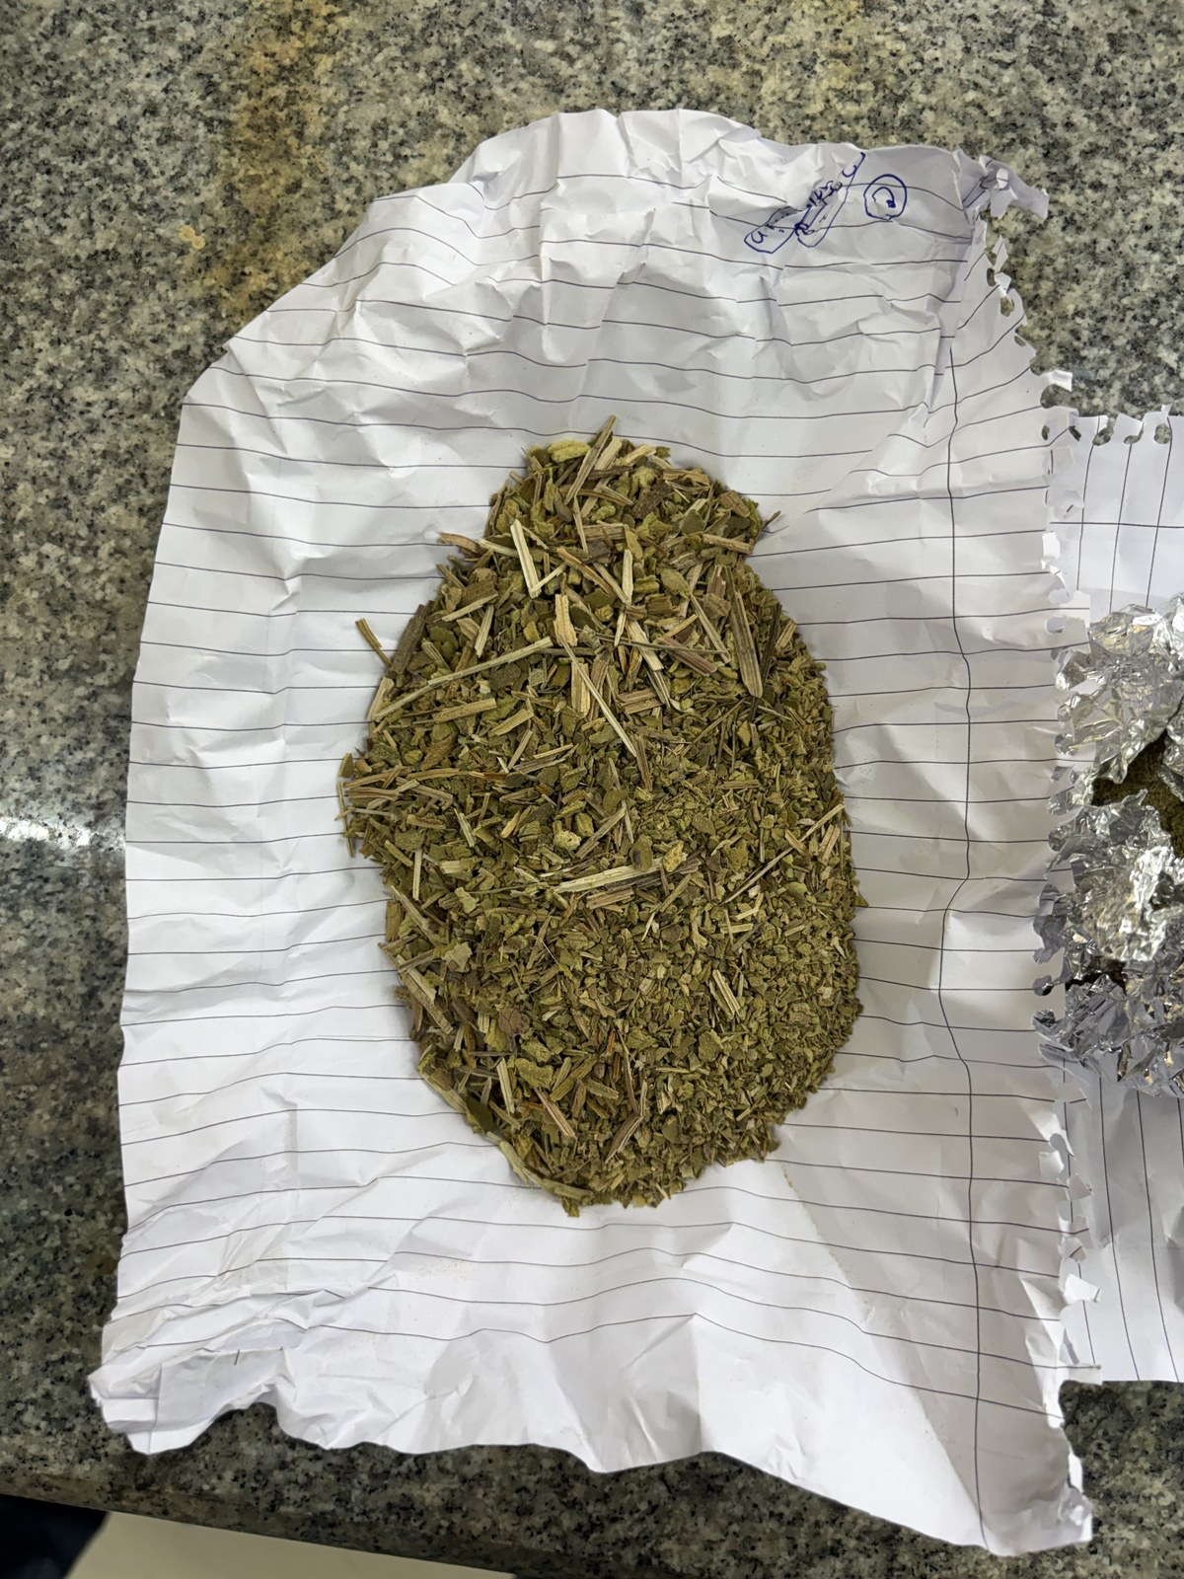  (b) Coarse fraction (> 3 mm)
Figure 1. Ground and sieve-classified Dal Lake aquatic biomass: (a) fine fraction and (b) coarse fraction.
2.3. Binder Preparation
The corn-starch binder was prepared by dispersing starch in distilled water (≈15 wt% solids) and heating on a hot plate with continuous magnetic stirring to 80–90 °C until a translucent, viscous gel formed, indicating complete gelatinisation. On cooling, the dispersed amylose and amylopectin chains partially re-associate to form a continuous adhesive film that coats and mechanically bonds biomass particles (López et al., 2013). The gel was used immediately after preparation to prevent retrogradation-induced stiffening.
2.4. Panel Fabrication
Four formulations were produced (Table 1). The classified biomass was blended with the appropriate mass fraction of gelatinised starch and packed into two mould types: flat panels in 50 × 50 mm steel moulds and cylindrical specimens (30 mm diameter, 25 mm height) in aluminium moulds. The moulds were cold-pressed by hand to consolidate the mixture, demoulded, and oven-dried at 103 ± 2 °C to constant mass. The complete process flowsheet is given in Figure 4. The coarse binder-less specimen (S1) fractured on demoulding due to insufficient inter-particle cohesion and was excluded from mechanical and thermal-conductivity tests, but retained for moisture, density and water-absorption measurements.
Table 1. Bio-composite panel formulations and key observations on demoulding.
Sample | Particle size | Biomass : Starch (wt%) | Binder type | Observation
S1 | Coarse > 3 mm | 100 : 0 | None (water only) | Fractured on demoulding; excluded from UCT and thermal tests
S2 | Fine 1.0–1.5 mm | 100 : 0 | None (water only) | Good cohesion; intact flat panel and cylinder
S3 | Fine 1.0–1.5 mm | 90 : 10 | Corn starch (gelatinised) | Improved binding and surface finish; intact specimens
S4 | Fine 1.0–1.5 mm | 70 : 30 | Corn starch (gelatinised) | Compact, denser panel; slightly thinner due to densification

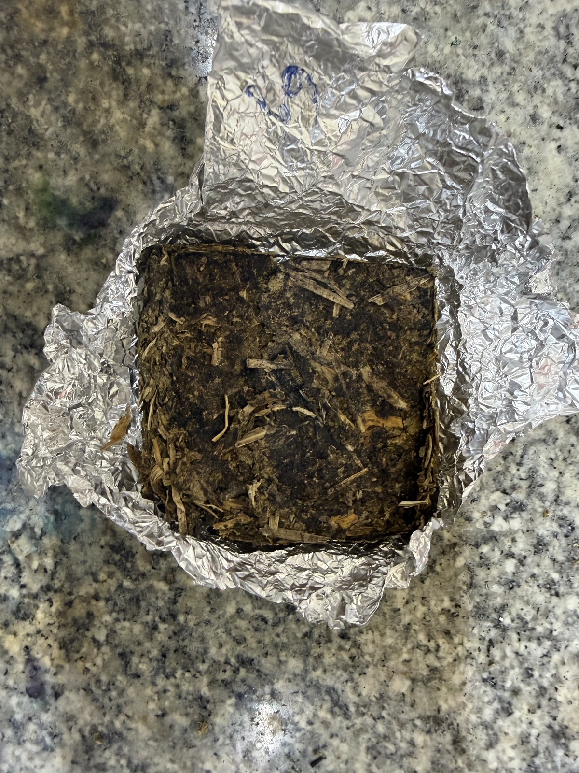  (a) S1 – coarse, no binder | 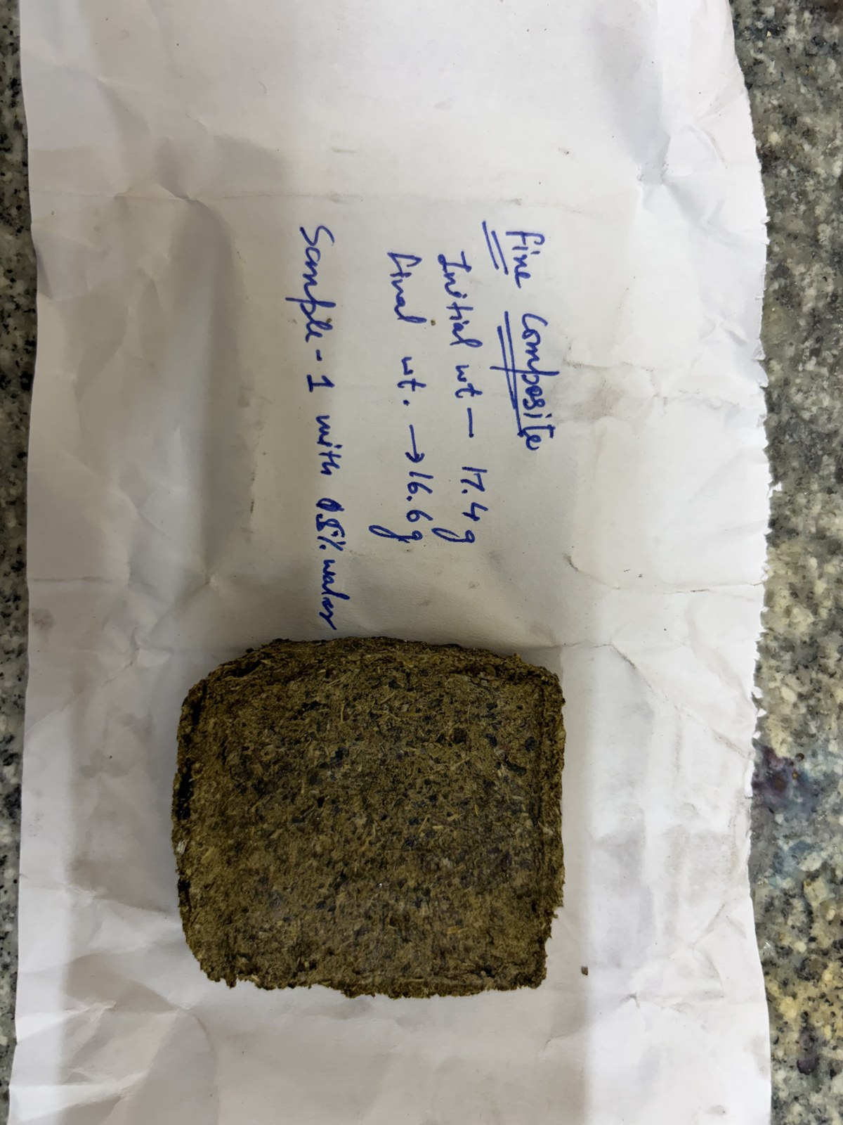  (b) S2 – fine, no binder | 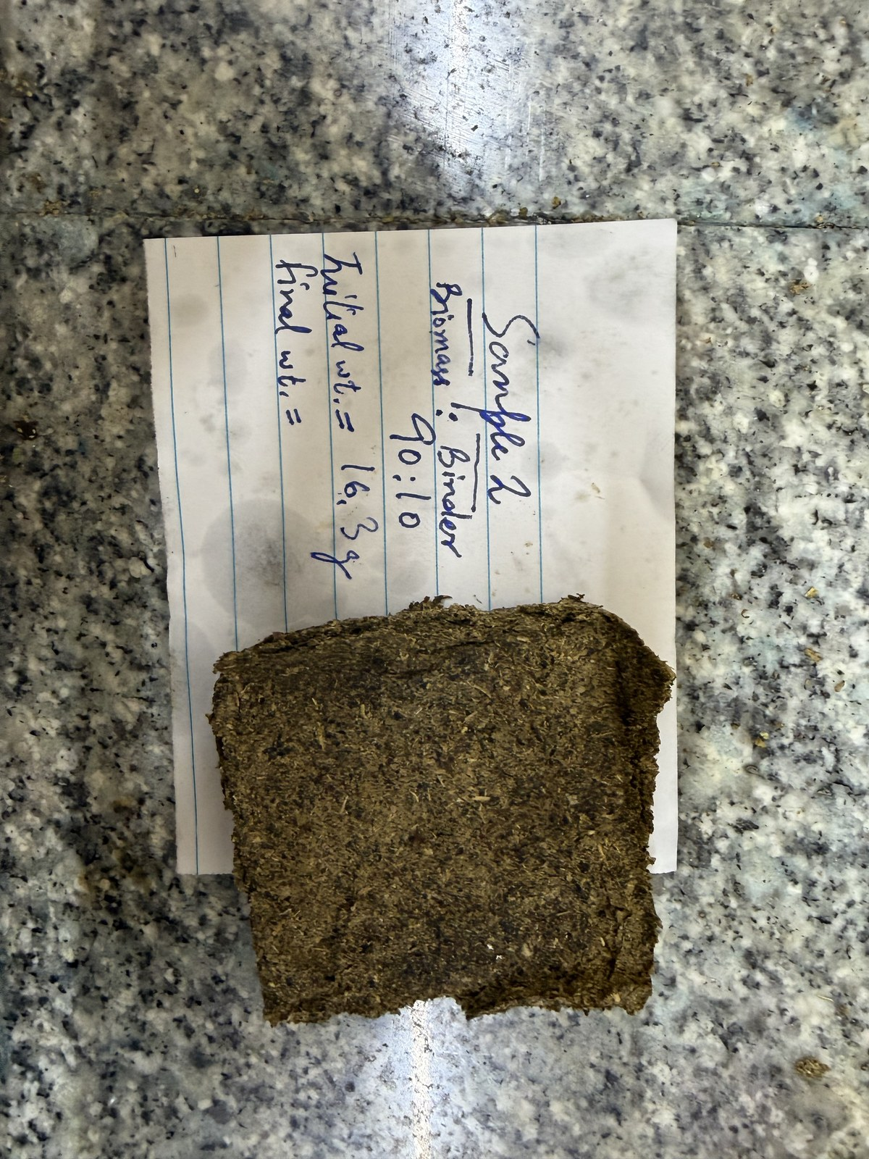  (c) S3 – fine, 90:10 | 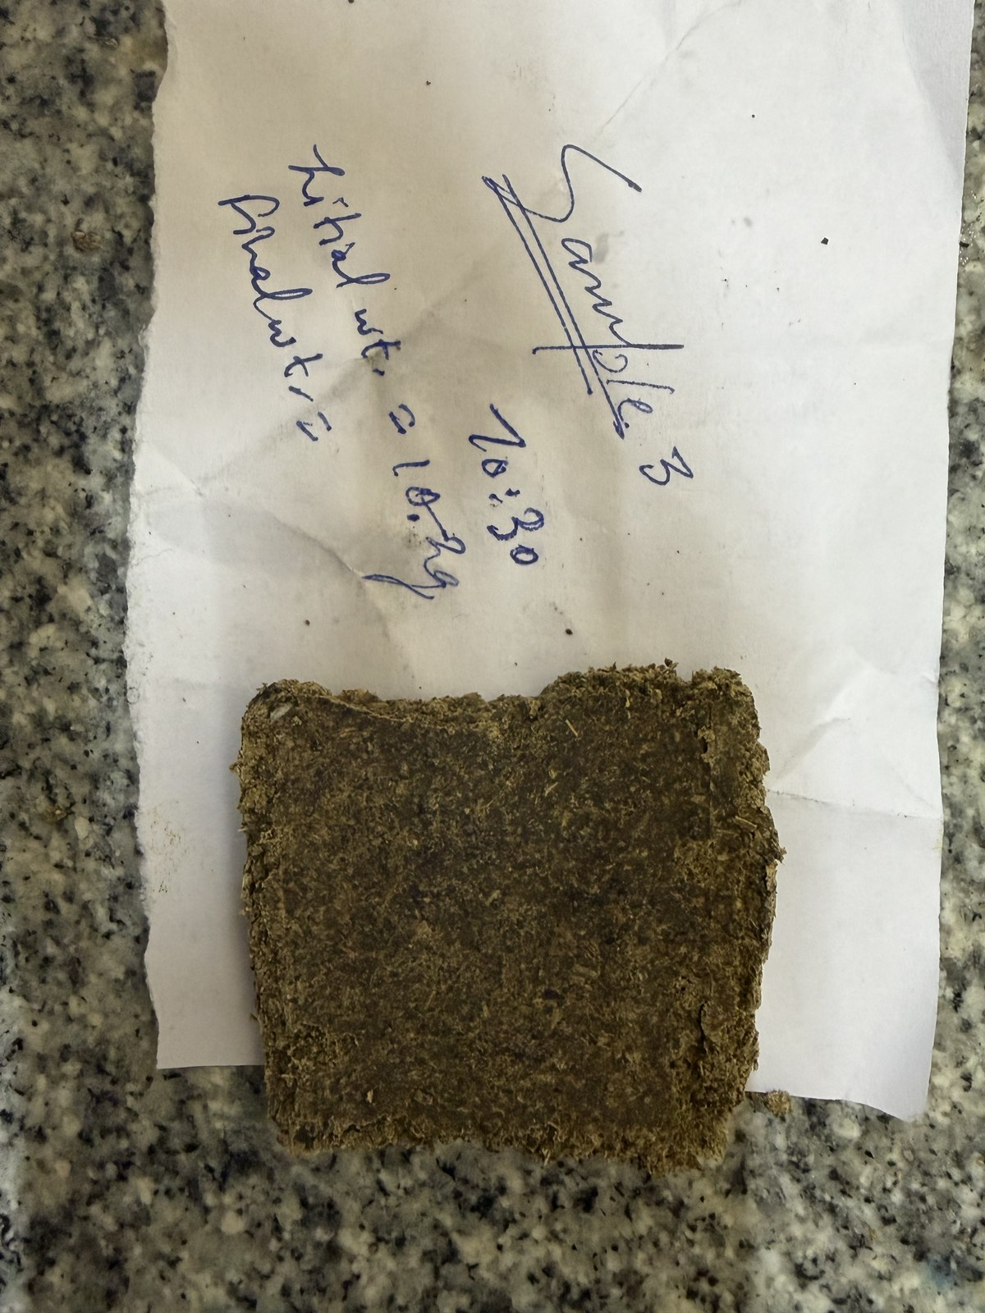  (d) S4 – fine, 70:30
Figure 2. Fabricated bio-composite flat panels: (a) S1 (coarse, no binder), (b) S2 (fine, no binder), (c) S3 (fine, 90:10 corn starch), and (d) S4 (fine, 70:30 corn starch).
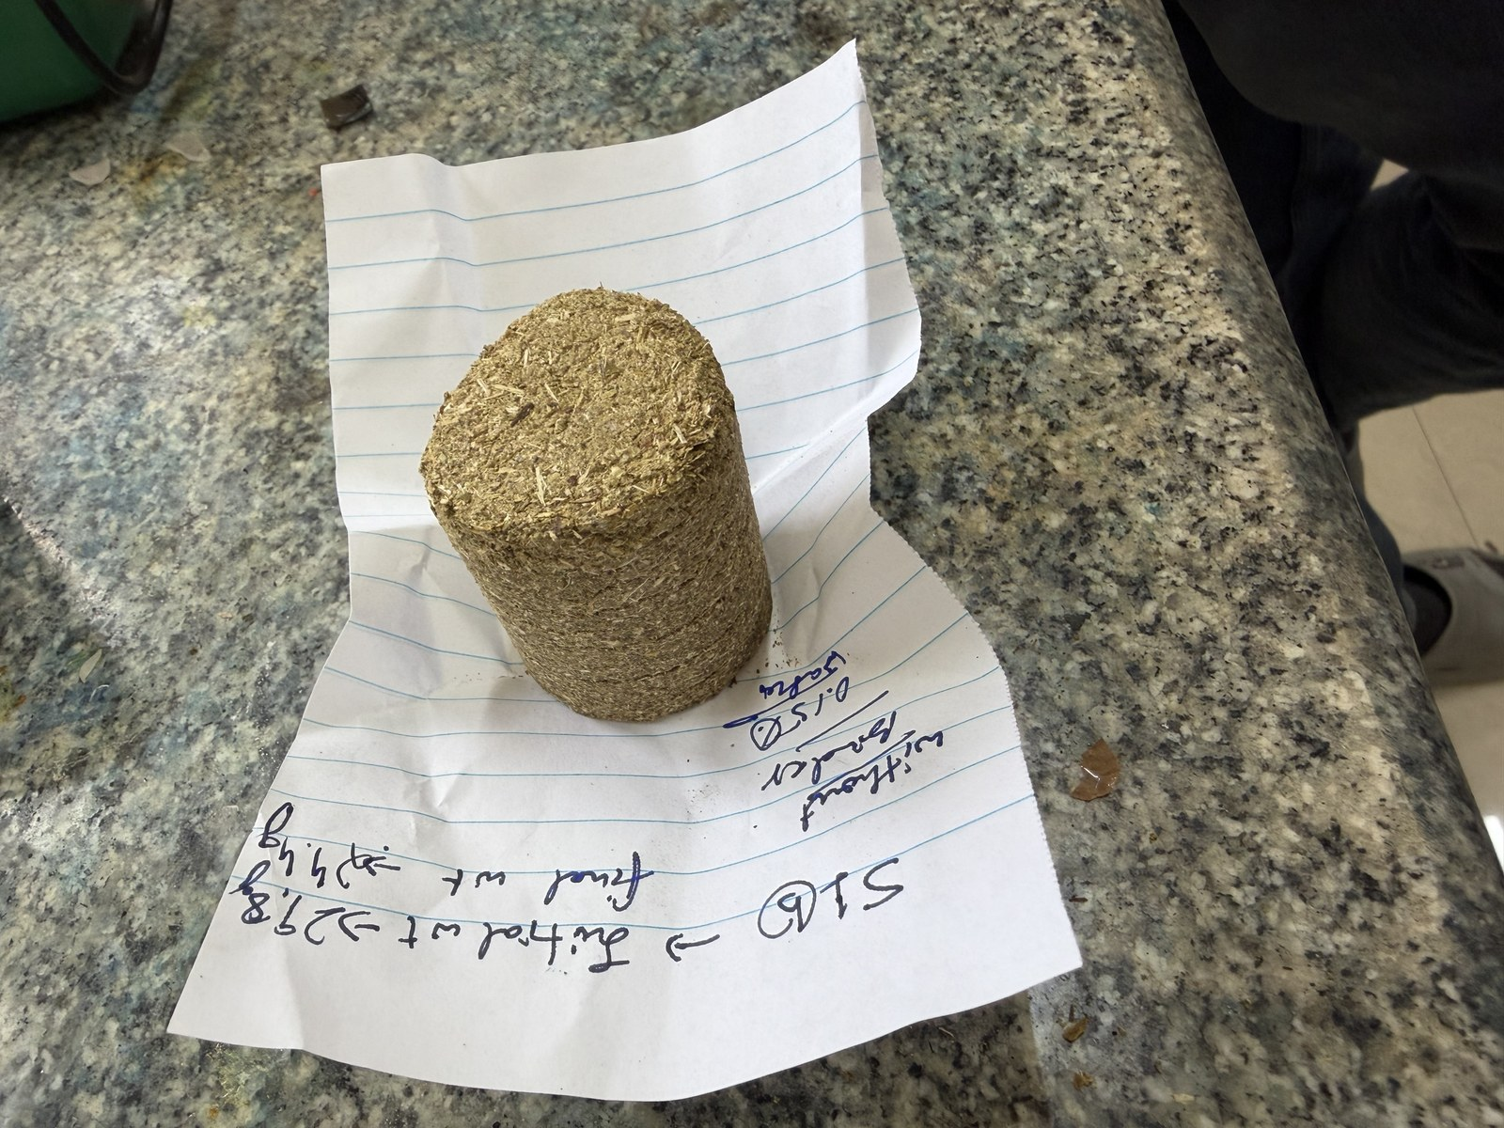  (a) S1 (coarse — fractured) | 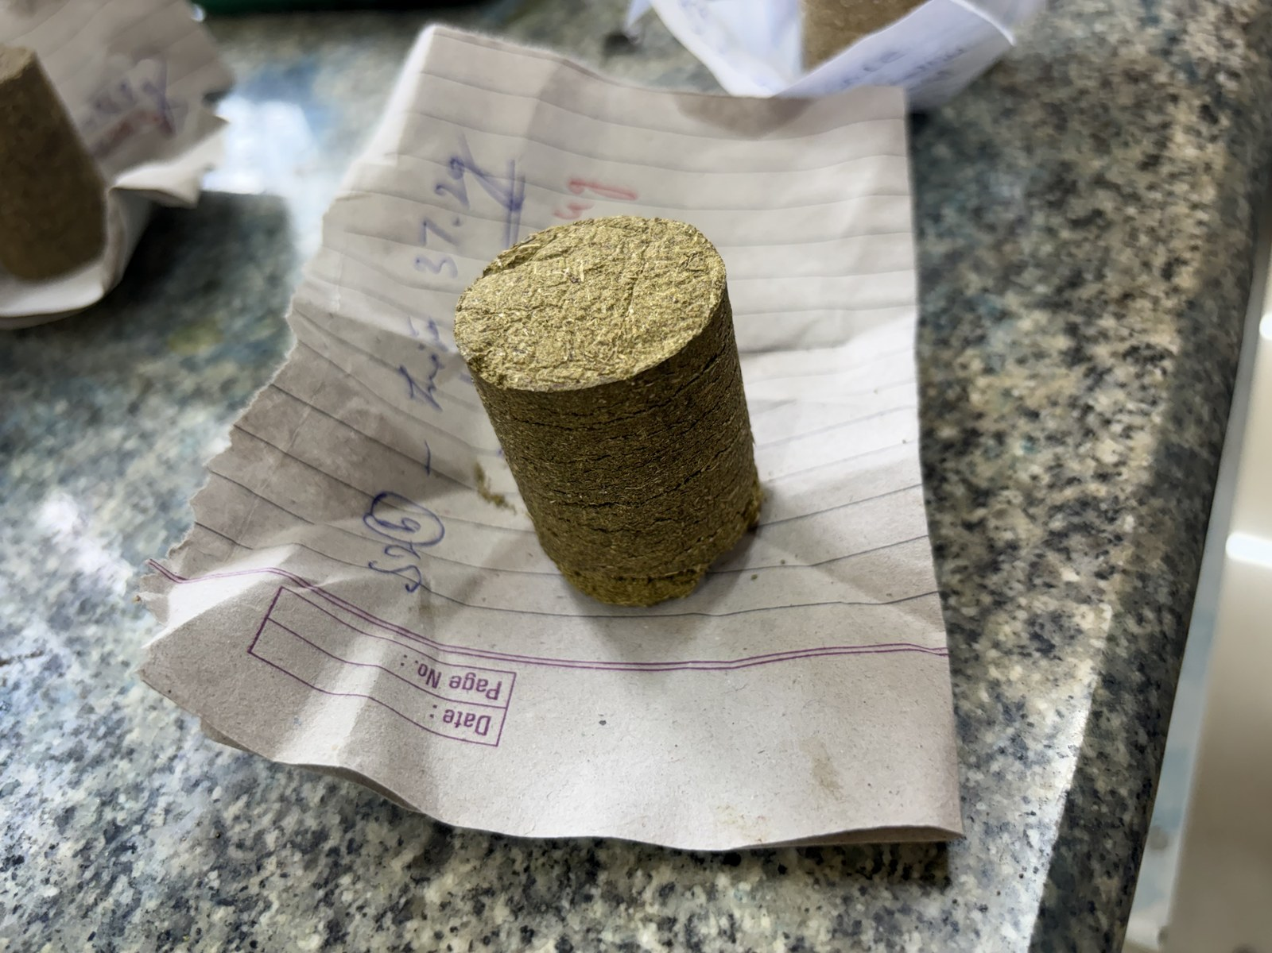  (b) S3 (90:10 starch) | 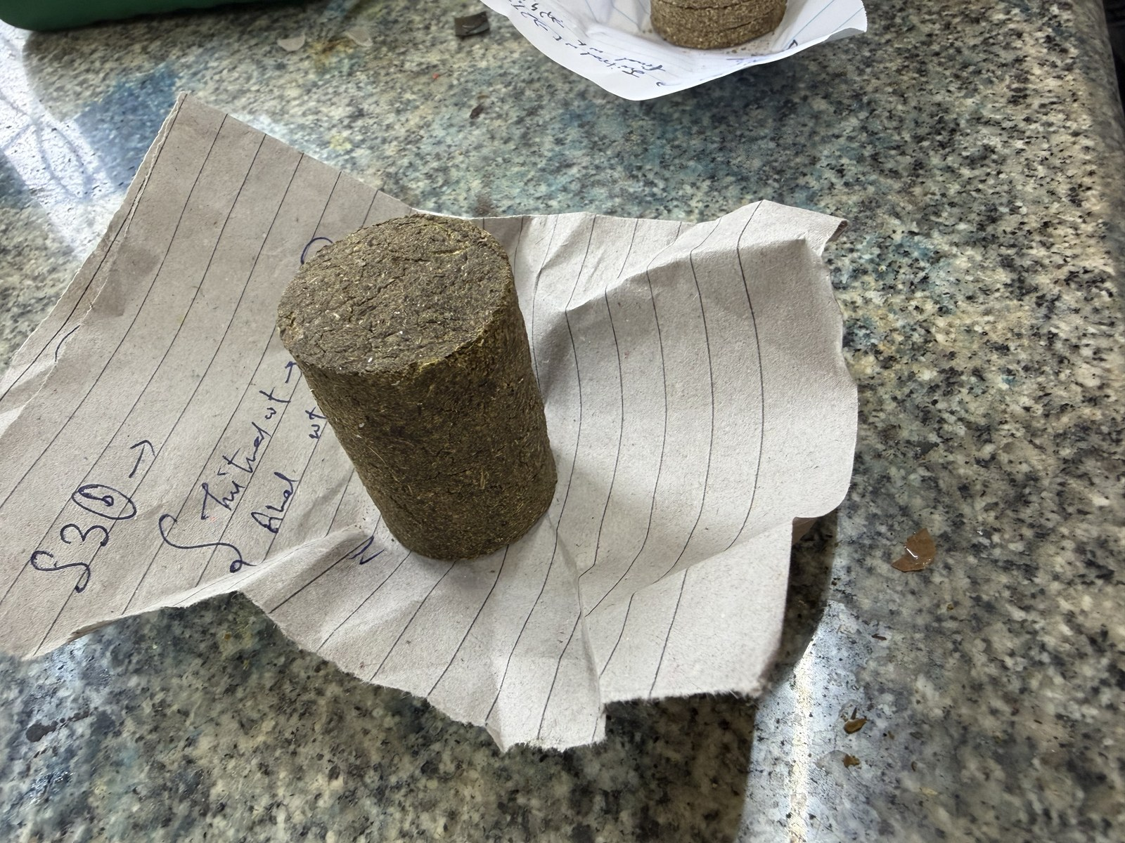  (c) S4 (70:30 starch)
Figure 3. Cylindrical specimens (30 mm diameter × 25 mm height) used for unconfined compression testing: (a) S1 (coarse, no binder — fractured on demoulding), (b) S3 (90:10 starch), and (c) S4 (70:30 starch).
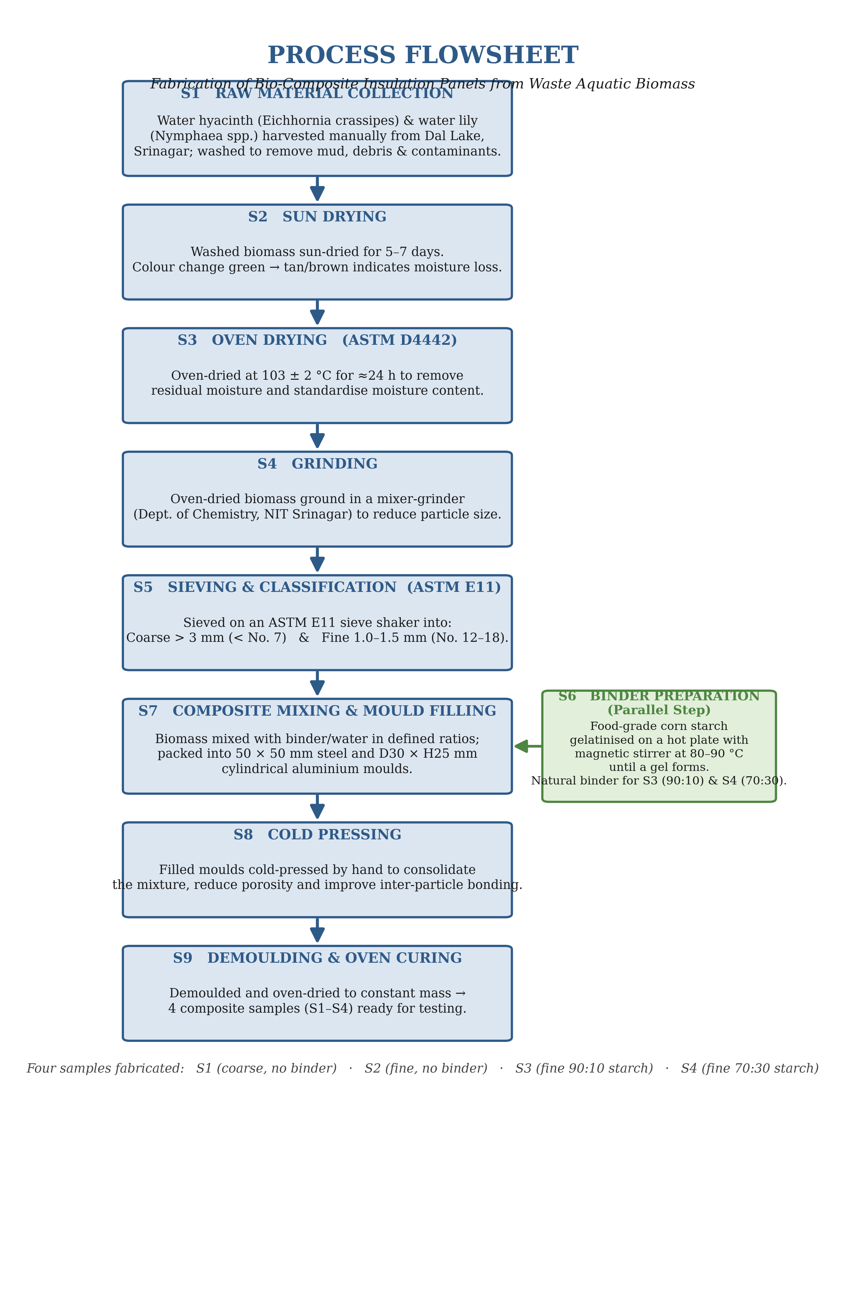
Figure 4. Complete process flowsheet for fabrication of bio-composite insulation panels from waste Dal Lake aquatic biomass.
2.5. Characterisation Methods
All properties were measured in triplicate (n = 3) on independently prepared specimens. Results are reported as the arithmetic mean ± one sample standard deviation (SD), shown as error bars on all bar charts.
Moisture content (MC) was determined gravimetrically as MC = [(Wᵢ − Wᶠ) / Wᵢ] × 100, where Wᵢ is the initial mass and Wᶠ the oven-dry mass after drying at 103 ± 2 °C to constant mass (ASTM D4442). Bulk density (ρ) was computed from the oven-dry mass divided by the moulded volume measured with a vernier calliper (ASTM D1037). Water absorption (WA) was measured after 2 h full immersion as WA = [(Wᵤᵉᵗ − Wᵒᴺʸ) / Wᵒᴺʸ] × 100 (ASTM D570).
Unconfined compressive strength was measured with a Baker Type K12 proving-ring apparatus (calibration constant C = 2.256 N/div, Asahi displacement gauge, 0.01 mm resolution). Load and deformation were recorded at 0.5 mm intervals and reduced using the corrected-area formulation: ε = ΔL/H₀, A = A₀/(1 − ε), σ = F/A, with initial area A₀ = 706.86 mm² and height H₀ = 25 mm. The peak stress was taken as the unconfined compressive strength qᵤ, and the undrained shear strength as Sᵤ = qᵤ/2.
Thermal conductivity was measured with a KD2 Pro Thermal Properties Analyzer (METER Group) fitted with a TR-3 three-needle probe applying the transient line-source method (ASTM D5334 / IEEE 442), in HIGH power mode with 5-minute read times at 25–26 °C. The instrument goodness-of-fit parameter Sᵧᵺ was recorded; values below 2.0 indicate an acceptable measurement. Results were compared against the ASTM C168 insulation-grade threshold k < 0.065 W m⁻¹ K⁻¹. Figure 8 shows the probe placement during measurement.
Scanning electron microscopy (SEM) was performed on the fine binder-less panel (S2) and the 90:10 starch-bound panel (S3). Fragments (≈10 × 10 mm) cut from oven-dried panels were mounted on aluminium stubs with conductive carbon tape, sputter-coated with gold to prevent charging, and examined at multiple magnifications to capture both overall fibre arrangement and inter-fibre binder morphology.
3. Results and Discussion
3.1. Moisture Content and Bulk Density
Moisture content increased markedly with both decreasing particle size and increasing starch fraction (Table 2, Figure 5a). The coarse binder-less panel S1 recorded the lowest MC (9.94%) owing to its open, highly porous structure and rapid oven-drying. The high-starch panel S4 recorded the highest MC (41.18%), reflecting the strongly hygroscopic nature of gelatinised corn starch. S2 (18.67%) and S3 (23.93%) lay in between. This progressive rise in MC foreshadows both the mechanical and thermal trends discussed below: residual moisture simultaneously plasticises the starch matrix, reducing compressive strength, and elevates effective thermal conductivity by replacing insulating air (k ≈ 0.026 W m⁻¹ K⁻¹) with conductive water (k ≈ 0.60 W m⁻¹ K⁻¹) in the pore space (Jeon et al., 2017).
Bulk density (Figure 5b) was highest for the compact coarse panel S1 (1.087 g cm⁻³) and lowest for the starch-rich S4 (0.868 g cm⁻³). The 90:10 panel S3 (0.992 g cm⁻³) was denser than the binder-less S2 (0.900 g cm⁻³), indicating that 10 wt% starch fills inter-particle voids and improves compaction. All density values fall within the 0.9–1.1 g cm⁻³ range reported for binder-less water-hyacinth boards (Salas-Ruiz et al., 2019), confirming that the present panels are representative of this material class.
Table 2. Physical properties of the bio-composite panels (mean ± SD, n = 3 per sample).
Sample | Composition | Moisture content (%) | Bulk density (g cm⁻³) | Water absorption (%)
S1 | Coarse, no binder | 9.94 ± 0.14 | 1.087 ± 0.015 | 657.89 ± 11.4
S2 | Fine, no binder | 18.67 ± 0.26 | 0.900 ± 0.015 | 522.86 ± 7.9
S3 | Fine, 90:10 starch | 23.93 ± 0.25 | 0.992 ± 0.014 | 507.14 ± 7.2
S4 | Fine, 70:30 starch | 41.18 ± 0.37 | 0.868 ± 0.014 | 280.00 ± 6.6

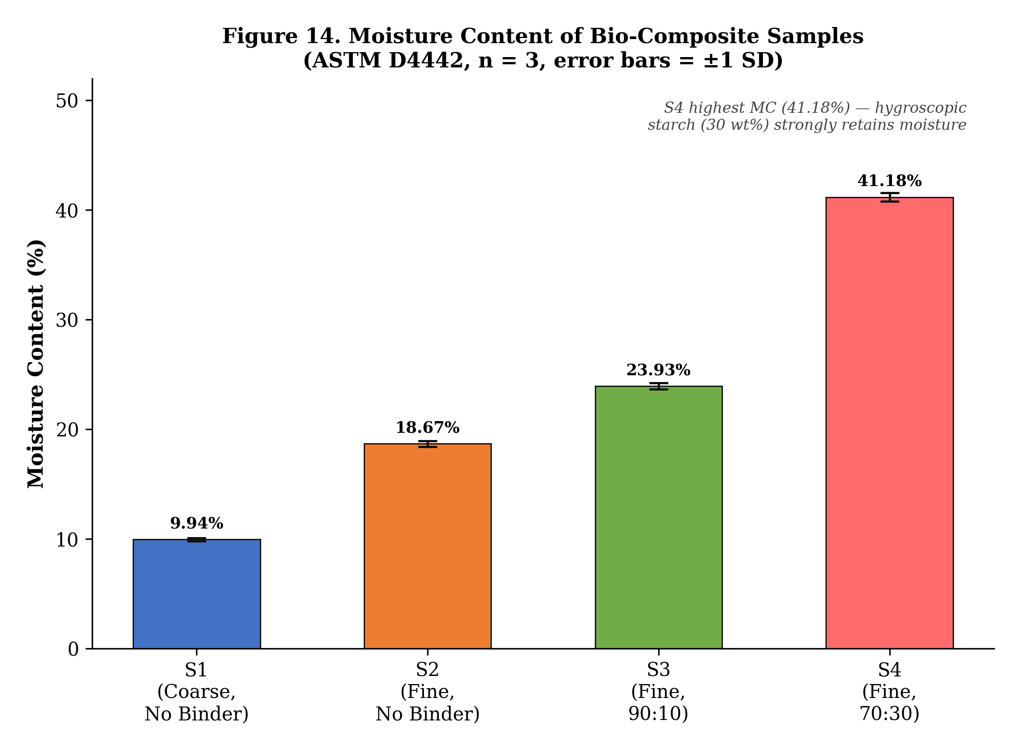  (a) Moisture content (%) | 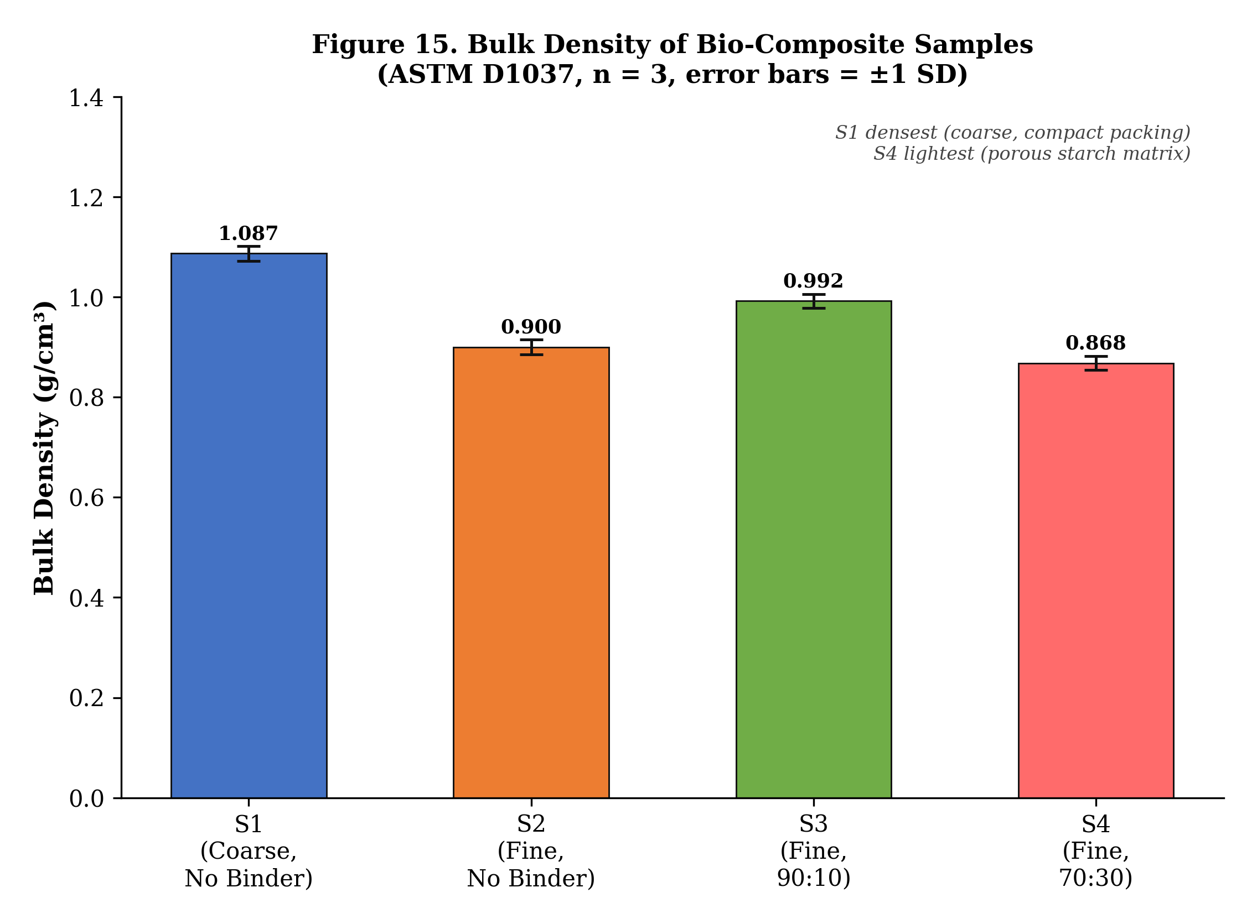  (b) Bulk density (g cm⁻³)
Figure 5. (a) Mean moisture content and (b) mean bulk density of the bio-composite panels (error bars = ± 1 SD).
3.2. Water Absorption
All panels exhibited high water uptake characteristic of untreated lignocellulosic materials (Table 2, Figure 6), but with a clear decreasing trend as binder fraction increased. The coarse binder-less S1 absorbed the most (657.89%), followed by S2 (522.86%) and S3 (507.14%); the high-starch panel S4 absorbed the least (280.00%) because the large starch fraction densifies the panel and reduces accessible porosity, despite starch being intrinsically hydrophilic. The values for S2 and S3 are consistent with the 450–555% range reported by Salas-Ruiz et al. (2019) for binder-less water-hyacinth boards. High water absorption is the principal practical limitation of these panels, and a hydrophobic surface treatment will be required before field deployment. A beeswax coating, as demonstrated by Chaireh et al. (2020) for starch-WH composite foams, is the most promising near-term option.
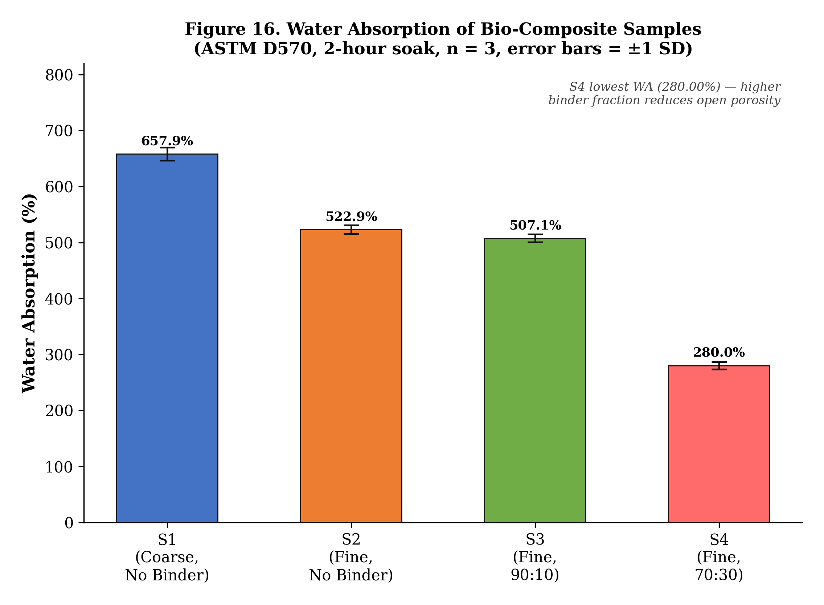
Figure 6. Mean water absorption of the bio-composite panels after a 2-hour full immersion soak (ASTM D570; error bars = ± 1 SD).
3.3. Unconfined Compressive Strength
The stress–strain responses (Figure 7a) and mean compressive strengths (Table 3, Figure 7b) show that all tested panels (S2–S4) failed at a consistent axial strain of approximately 16%. This uniform failure strain indicates that the cellulosic biomass skeleton governs deformation capacity irrespective of binder content, while the binder controls the magnitude of stress the skeleton can sustain. The 90:10 panel S3 achieved the highest unconfined compressive strength (qᵤ = 186.0 kPa), a 97% improvement over the fine binder-less S2 (94.4 kPa), confirming 10 wt% corn starch as the optimal binder content. The corresponding undrained shear strengths (Sᵤ = qᵤ/2) are 47.2, 93.0 and 13.4 kPa for S2, S3 and S4 respectively.
Counter-intuitively, the high-starch panel S4 was the weakest (26.8 kPa). An excess of gelatinised starch produces a continuous but weak, plasticised matrix; this is further compounded by S4's very high moisture content (41.18%), which softens the starch film so that load transfer between fibres becomes inefficient. This optimum-loading behaviour — strength rising with binder content to a peak then declining — mirrors results reported for other lignocellulosic composites (Abral et al., 2014; Zhou et al., 2022). A compressive strength of 186.0 kPa, while modest relative to structural materials, is adequate for a non-load-bearing insulation panel and provides sufficient integrity for handling, transport and installation.
Table 3. Unconfined compressive strength results (Baker Type K12 apparatus; n = 3; initial area A₀ = 706.86 mm²; failure strain εᶠ ≈ 16% for all tested samples). S1 excluded (fractured on demoulding).
Sample | Composition | qᵤ R1 (kPa) | qᵤ R2 (kPa) | qᵤ R3 (kPa) | Mean qᵤ (kPa) | Sᵤ (kPa) | εᶠ (%)
S1 | Coarse, no binder | — | — | — | Fractured | Fractured | —
S2 | Fine, no binder | 92.8 | 94.4 | 96.0 | 94.4 ± 1.6 | 47.2 | 16
S3 | Fine, 90:10 | 183.5 | 186.0 | 188.5 | 186.0 ± 2.5 | 93.0 | 16
S4 | Fine, 70:30 | 26.2 | 26.8 | 27.4 | 26.8 ± 0.6 | 13.4 | 16

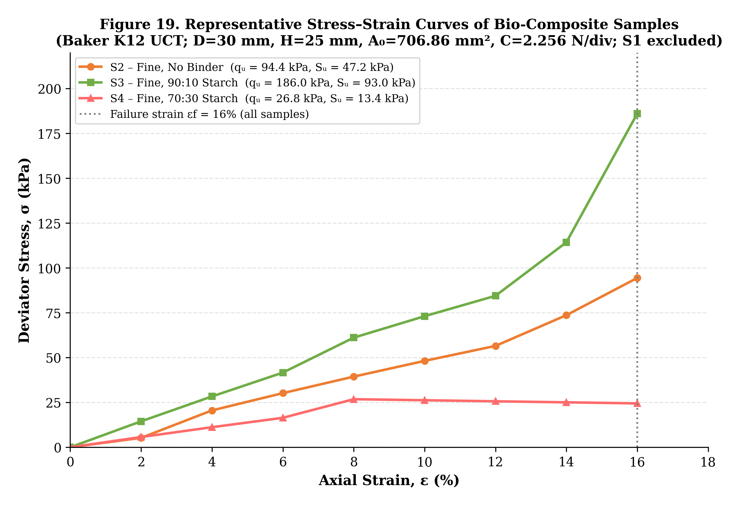  (a) Stress–strain curves | 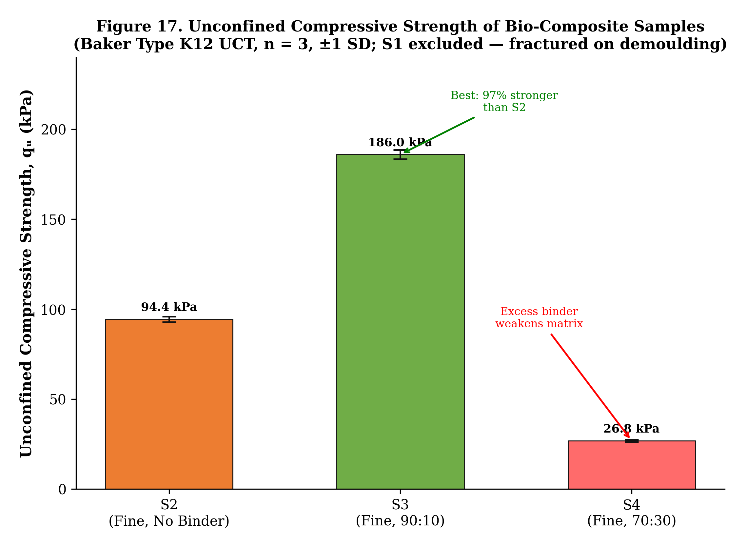  (b) Mean compressive strength
Figure 7. Mechanical behaviour of panels S2–S4: (a) stress–strain curves (representative replicate; failure at εᶠ ≈ 16%) and (b) mean unconfined compressive strength (error bars = ± 1 SD; S1 excluded).
3.4. Thermal Conductivity
Thermal conductivity results are presented in Table 4 and Figures 9–10. Both the fine binder-less panel S2 (k = 0.0577 W m⁻¹ K⁻¹) and the 90:10 panel S3 (k = 0.0608 W m⁻¹ K⁻¹) fall below the ASTM C168 insulation-grade threshold of 0.065 W m⁻¹ K⁻¹. All Sᵧᵺ values were below 2.0, confirming acceptable measurement quality. The S2 and S3 conductivities are competitive with the 0.047–0.065 W m⁻¹ K⁻¹ range of binder-less WH petiole boards (Salas-Ruiz et al., 2019), and are within the same insulation-grade band as cellulose-fibre insulation (≈40–50 mW m⁻¹ K⁻¹) and hemp boards (Kymäläinen and Sjöberg, 2008).
The high-starch panel S4 exhibited a three-fold higher conductivity (0.1846 W m⁻¹ K⁻¹), placing it outside the insulation grade. Two mechanisms explain this: (i) the dense continuous starch matrix fills air voids that are primarily responsible for insulation; and (ii) S4's very high moisture content (41.18%) means a large fraction of pore space is occupied by water rather than air. Since water conducts heat roughly 23 times more effectively than air, even a modest increase in moisture dramatically raises the effective conductivity — the same moisture-driven degradation reported by Jeon et al. (2017) for glass wool and by Zhou et al. (2022) for straw boards.
Table 4. Thermal conductivity of the bio-composite panels (KD2 Pro TR-3, ASTM D5334; mean ± SD, n = 3). S1 was not tested (fractured on demoulding).
Sample | Composition | k (W m⁻¹ K⁻¹) | Sᵧᵺ | Classification (ASTM C168)
S2 | Fine, no binder | 0.0577 ± 0.0012 | 0.44 | Insulation grade (k < 0.065)
S3 | Fine, 90:10 starch | 0.0608 ± 0.0015 | 0.32 | Insulation grade (k < 0.065)
S4 | Fine, 70:30 starch | 0.1846 ± 0.0041 | 1.21 | Non-insulation grade

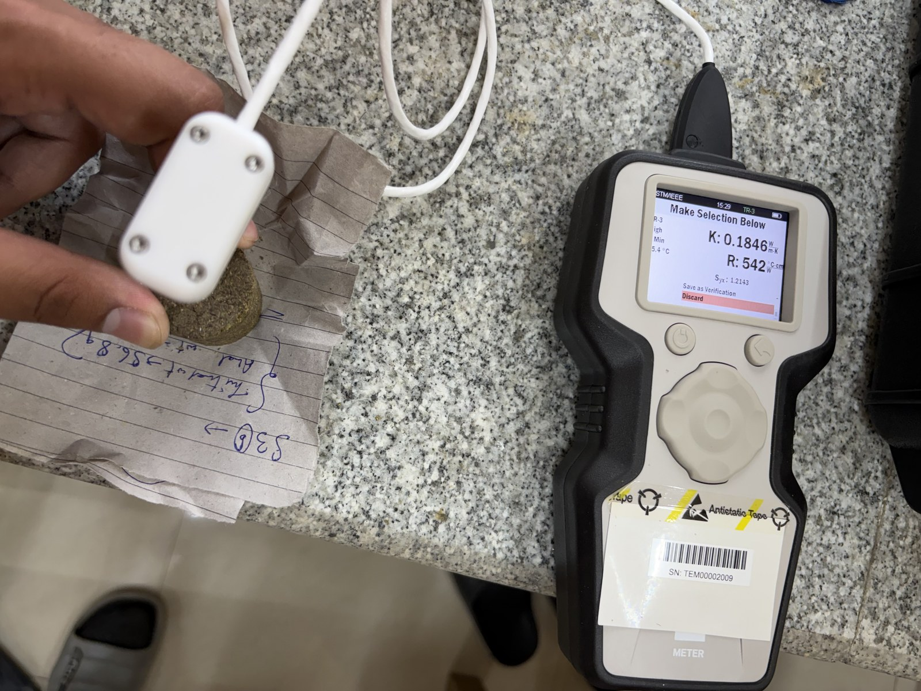  (a) S2 – binder-less | 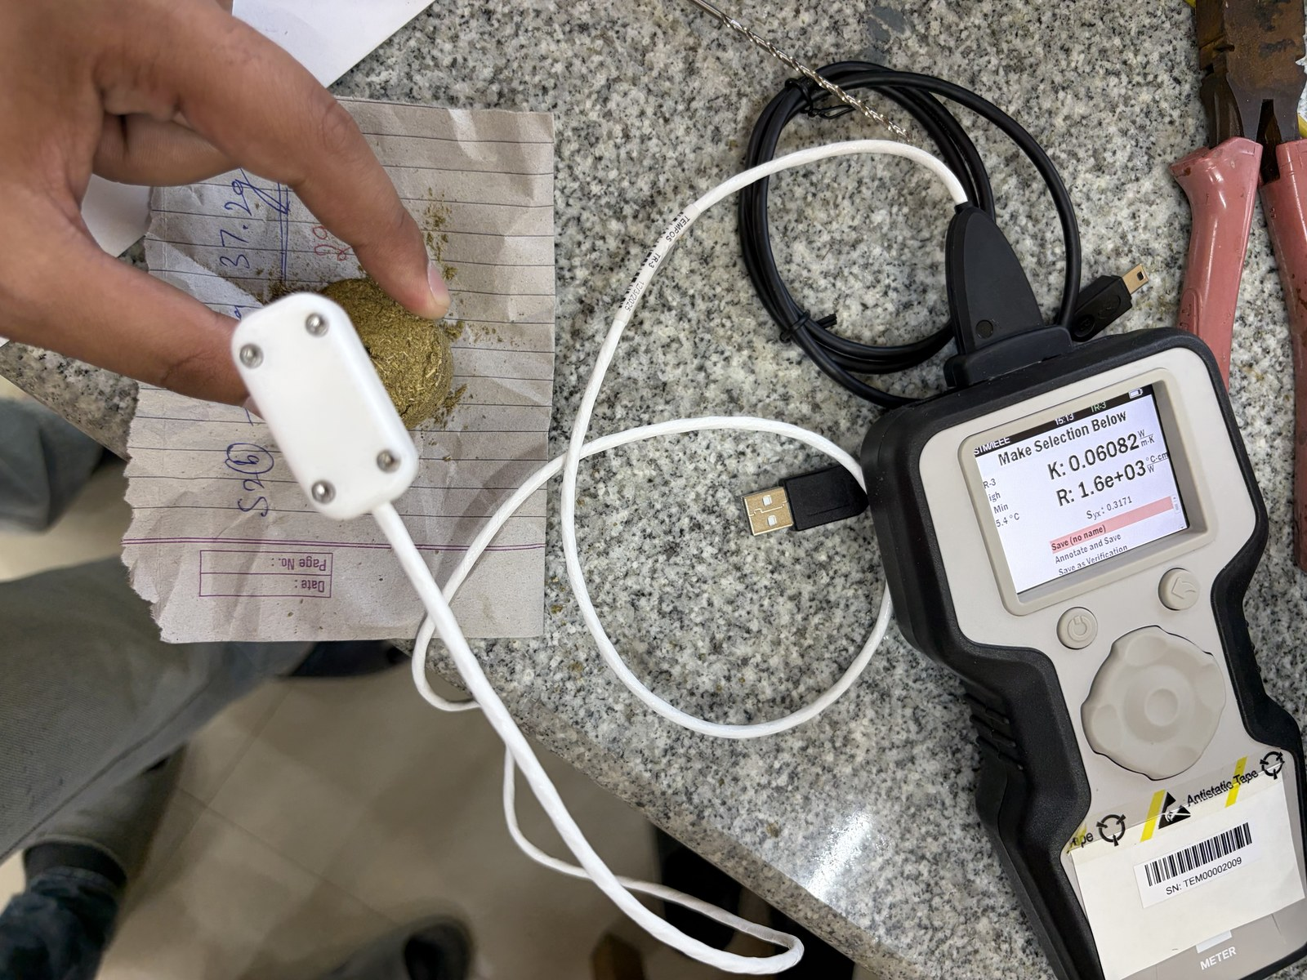  (b) S3 – 90:10 starch | 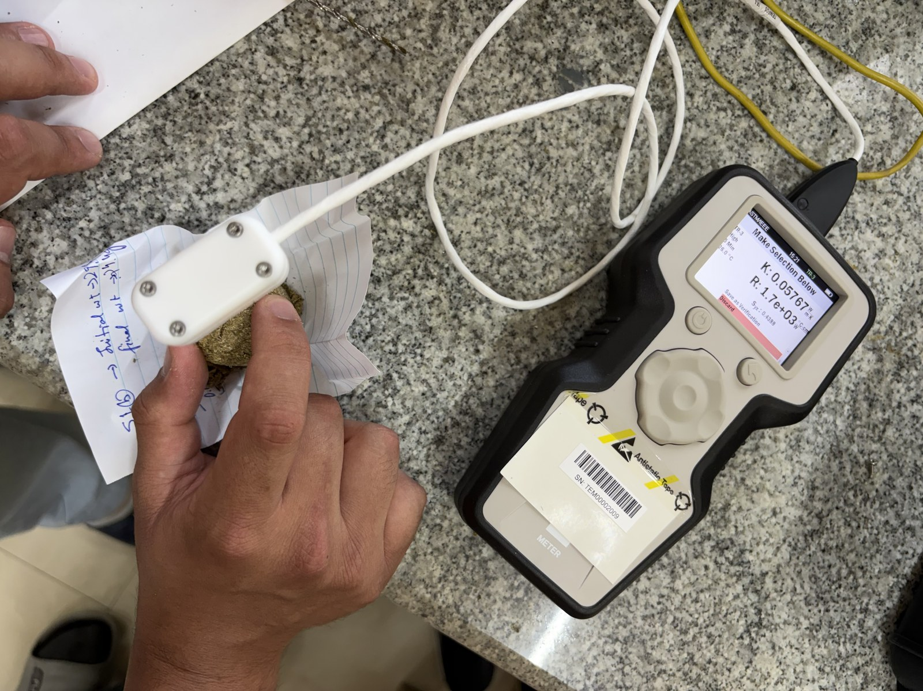  (c) S4 – 70:30 starch
Figure 8. KD2 Pro TR-3 probe embedded in the bio-composite panels during thermal conductivity measurement: (a) S2 (binder-less), (b) S3 (90:10 starch) and (c) S4 (70:30 starch).
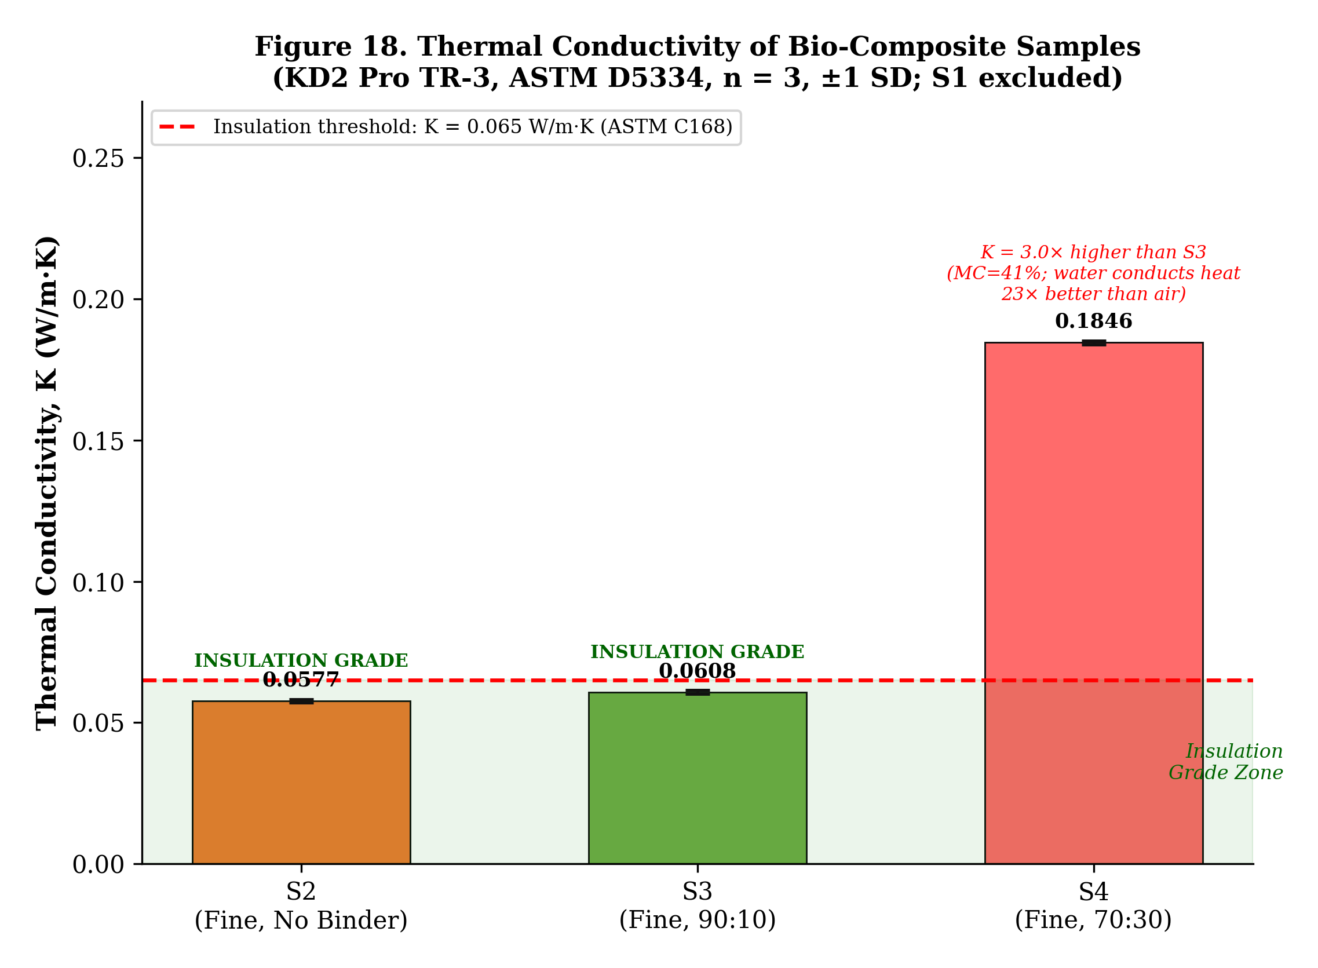
Figure 9. Mean thermal conductivity of the bio-composite panels. The dashed line marks the ASTM C168 insulation-grade threshold (k = 0.065 W m⁻¹ K⁻¹); error bars = ± 1 SD; S1 excluded.
3.5. Microstructural Characterisation (SEM)
SEM micrographs of the fine binder-less panel S2 (Figure 10) and the 90:10 corn-starch panel S3 (Figure 11) provide direct microstructural evidence correlating the macroscopic performance differences to the underlying fibre-matrix architecture.
In the binder-less panel S2, the micrographs reveal a loosely packed network of irregular cellulosic fibre bundles with rough, corrugated surfaces and no bridging adhesive matrix. Inter-fibre contacts are maintained solely by physical interlocking and surface friction. Large open macro-pores are distributed throughout the cross-section. At higher magnification, the characteristic vascular bundle architecture of the water-hyacinth petiole — large aerenchyma air channels surrounded by thin fibre walls — is clearly visible. This highly porous, air-rich microstructure is the direct physical origin of S2's low thermal conductivity (0.0577 W m⁻¹ K⁻¹). The absence of a cohesive adhesive matrix explains the moderate compressive strength (94.4 kPa): under axial load, fibres slip at contact points rather than fracturing through a continuous matrix.
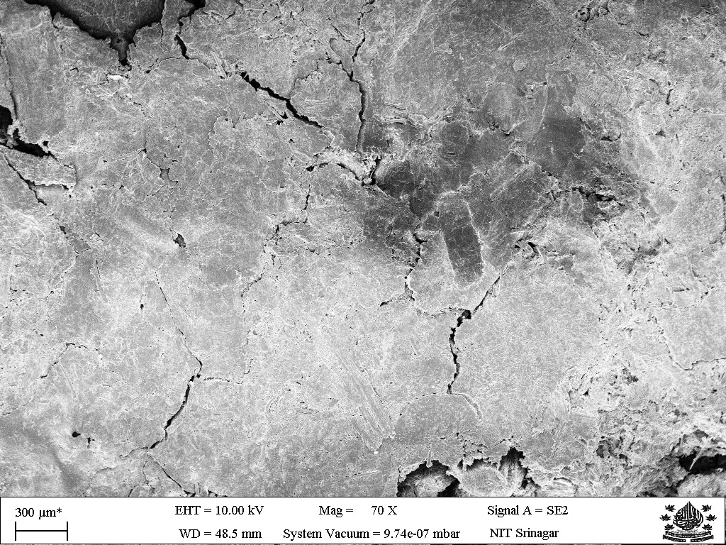  (a) | 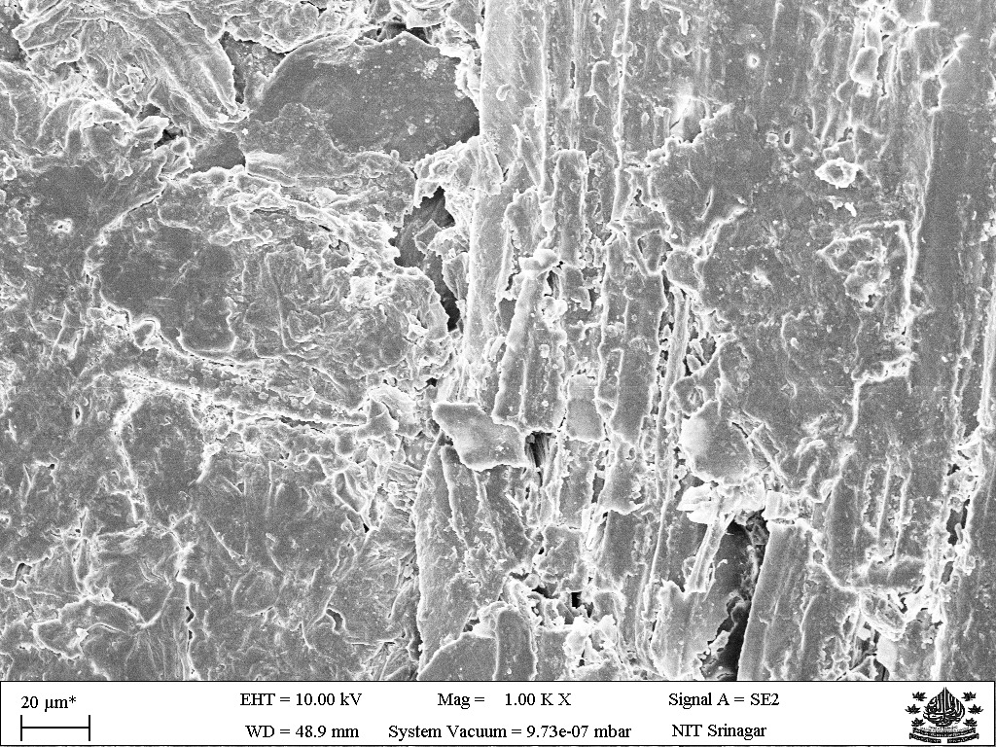  (b)
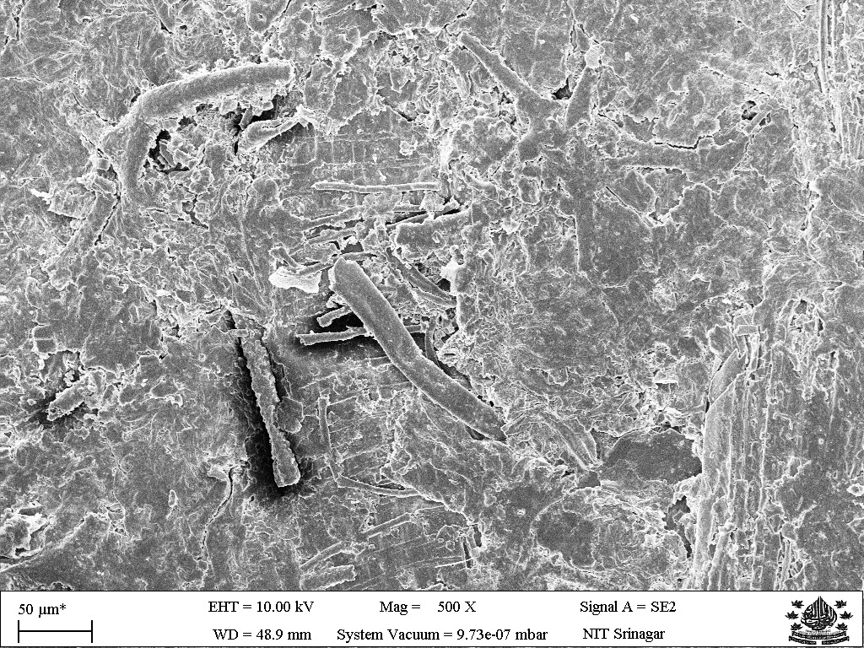  (c) | 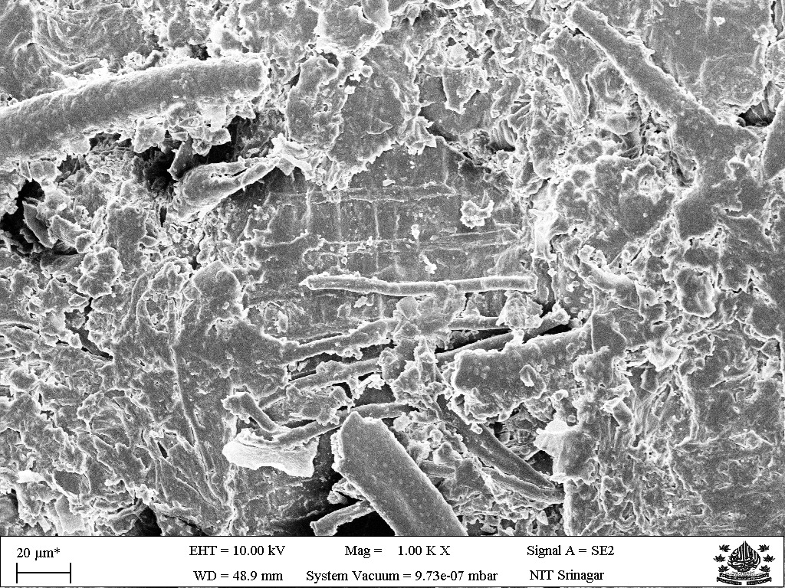  (d)
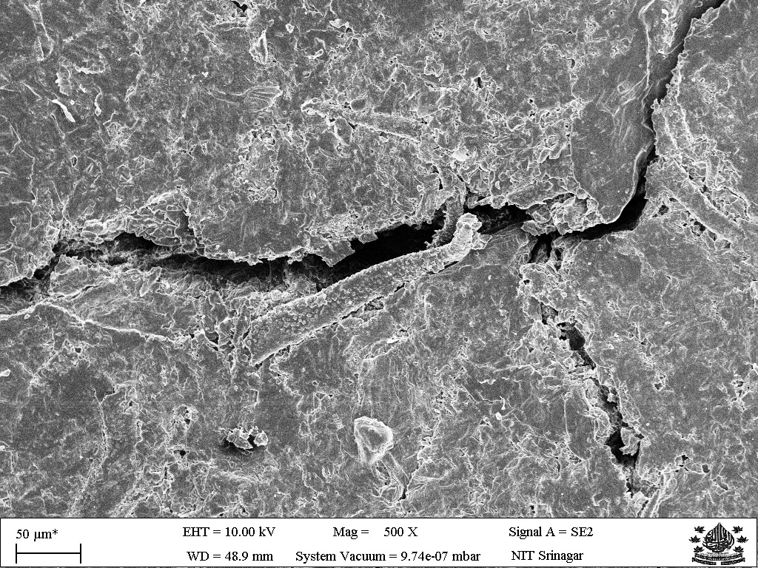
Figure 10. SEM micrographs of the fine binder-less panel S2 at increasing magnification: (a)–(b) low magnification showing overall fibre arrangement and large open macro-pores; (c)–(d) intermediate magnification showing individual fibre bundle morphology and open inter-fibre void space; (e) high magnification revealing the vascular bundle architecture and corrugated fibre surface with no binder film.
The 90:10 starch-bound panel S3 shows a markedly different microstructure. A continuous gelatinised corn-starch matrix is clearly visible coating the fibre surfaces and forming bridges at inter-fibre contact points. The large open macro-pores seen in S2 are substantially reduced in size and number, consistent with S3's higher bulk density (0.992 vs 0.900 g cm⁻³). At high magnification the starch–fibre interface appears well-bonded with no visible delamination, indicating good adhesion between the gelatinised starch film and the cellulosic fibre surface. This coherent load-bearing matrix explains the 97% increase in compressive strength of S3 relative to S2. The partial retention of open pore space is also consistent with S3 remaining insulation-grade: 10 wt% starch displaces some insulating air, but not enough to raise k above the 0.065 W m⁻¹ K⁻¹ threshold. The SEM evidence therefore corroborates the optimality of the 90:10 formulation: starch builds a continuous load-bearing matrix without compromising thermal performance.
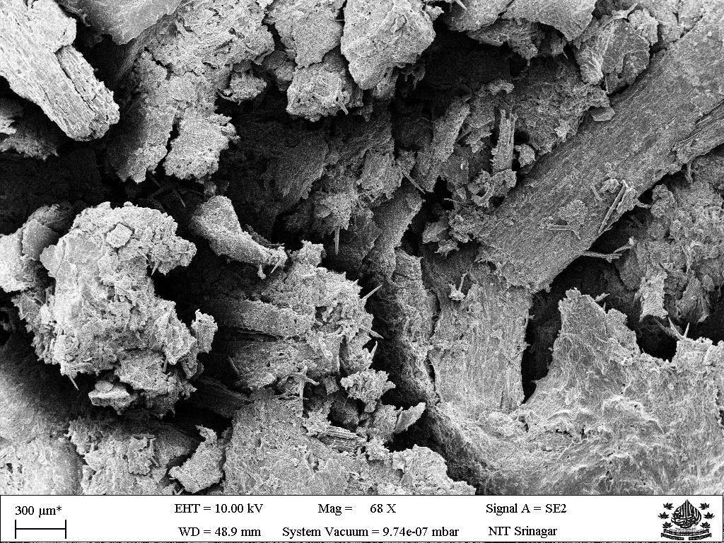  (a) | 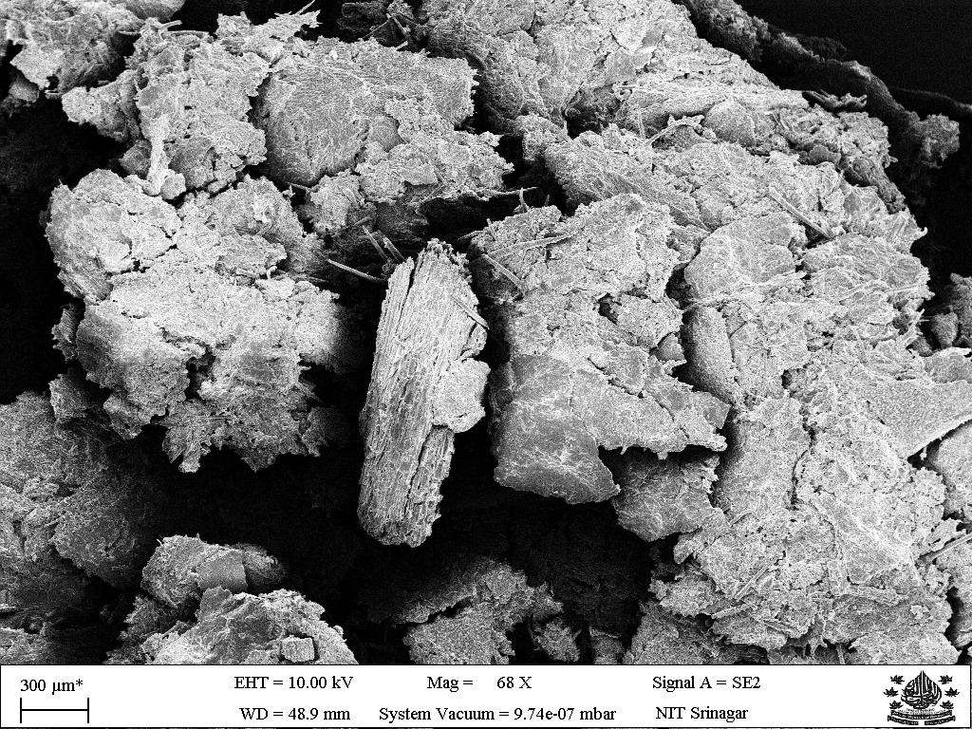  (b)
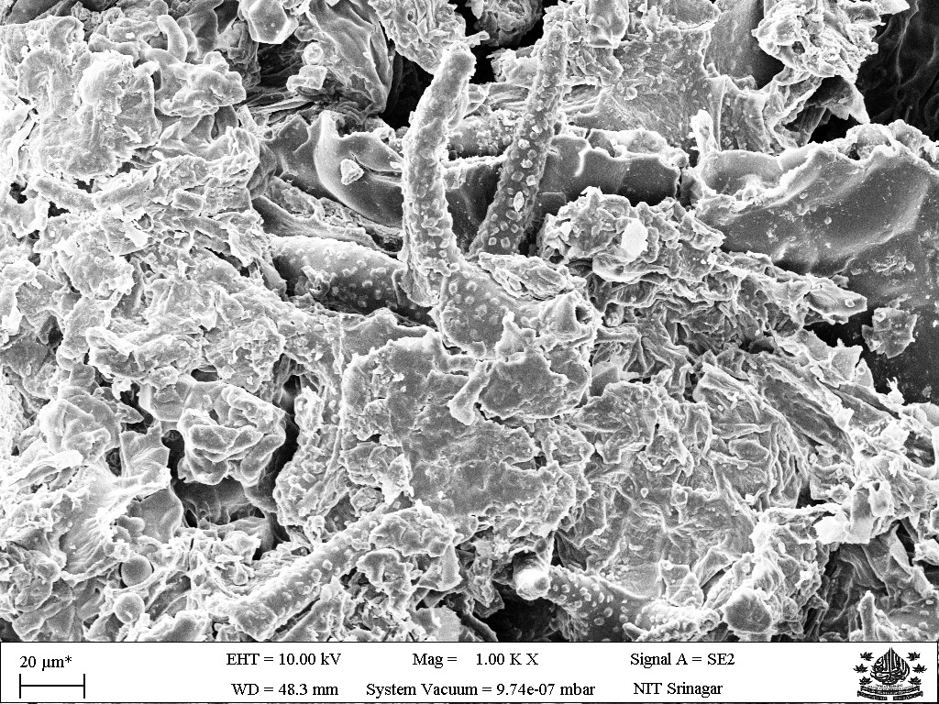  (c) | 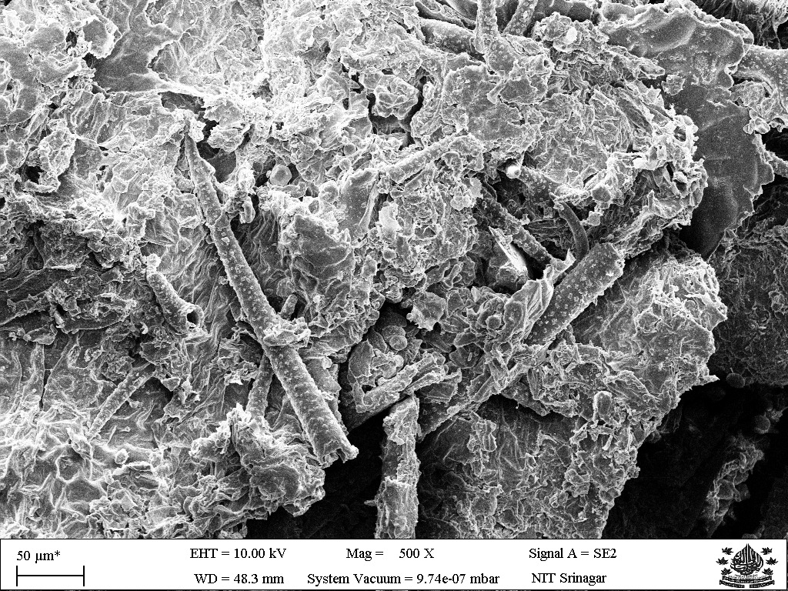  (d)
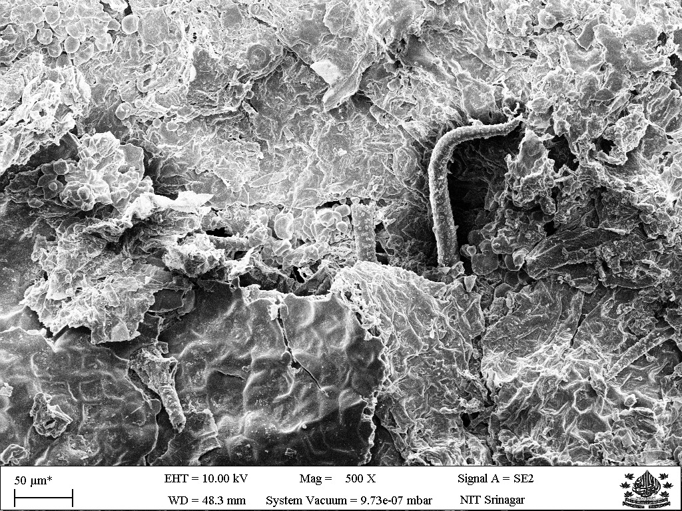  (e) | 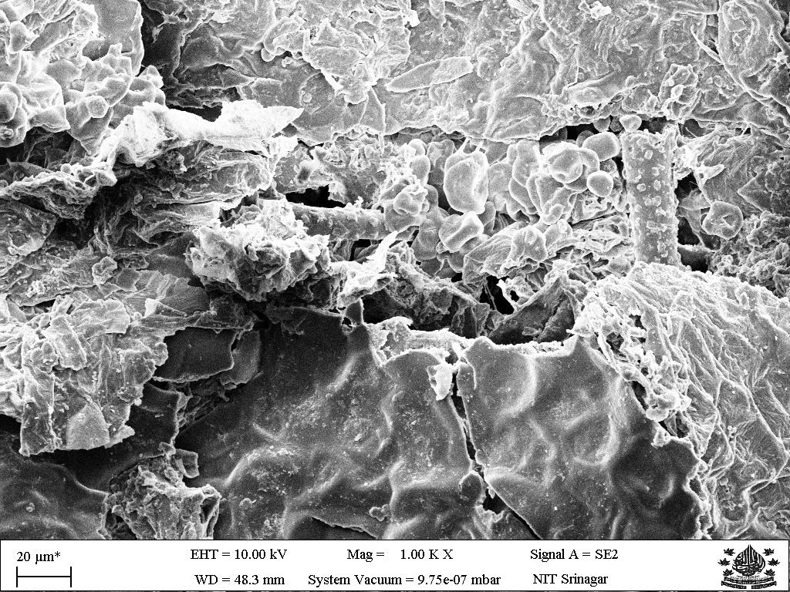  (f)
Figure 11. SEM micrographs of the 90:10 corn-starch panel S3 at increasing magnification: (a)–(b) low magnification showing reduced macro-porosity and starch-coated fibre bundles; (c)–(d) intermediate magnification showing the continuous starch matrix bridging fibres at contact points; (e)–(f) high magnification revealing the starch–fibre interface morphology with good adhesion and no delamination.
3.6. Optimal Formulation and Comparison with Reported Materials
Considering the combined requirements of insulation-grade thermal conductivity, adequate compressive strength and a well-bonded microstructure, the 90:10 biomass:starch panel S3 emerges as the best-balanced formulation. It delivers the highest compressive strength (186.0 kPa) while remaining insulation-grade (k = 0.0608 W m⁻¹ K⁻¹), and SEM confirms a well-bonded continuous starch matrix. The binder-less panel S2 is also insulation-grade but offers only half the compressive strength. The high-starch panel S4 offers the lowest water absorption (280%) but fails on both thermal and mechanical criteria. The coarse panel S1 fractured on demoulding, demonstrating that fine particle size is non-negotiable for panel integrity.
Table 5 benchmarks the present panels against conventional insulants and reported bio-composites. The conductivities of S2 and S3 are higher than glass wool (≈34 mW m⁻¹ K⁻¹) and EPS (35–40 mW m⁻¹ K⁻¹), but fall within the same insulation-grade band and are competitive with binder-less WH boards (Salas-Ruiz et al., 2019), hemp boards (Kymäläinen and Sjöberg, 2008), corn-cob boards (Pinto et al., 2021) and rice-straw panels (Zhou et al., 2022). Crucially, S3 achieves this performance using only a biodegradable corn-starch binder derived from an invasive weed waste stream, with no synthetic resin, cement or petrochemical additive — a clear embodied-carbon and end-of-life advantage over epoxy-based (Anjani et al., 2023) and cement-based (Philip and Rakendu, 2022) alternatives.
Table 5. Comparison of the present bio-composite panels with conventional insulants and reported water-hyacinth and other bio-based composites.
Material | k (W m⁻¹ K⁻¹) | Binder / matrix | Reference
Glass wool | ≈ 0.034 | Inorganic (mineral) | Jeon et al. (2017)
EPS foam | 0.035–0.040 | Polystyrene (synthetic) | Typical value
Hemp / flax board | 0.040–0.060 | None / mineral binder | Kymäläinen & Sjöberg (2008)
Corn-cob board | 0.046–0.052 | None | Pinto et al. (2021)
Rice-straw board | 0.050–0.070 | Natural binder | Zhou et al. (2022)
WH binder-less board | 0.047–0.065 | None | Salas-Ruiz et al. (2019)
WH–rubber latex board | ≈ 0.055 | Natural rubber latex | Jaktorn & Jiajitsawat (2021)
WH–cement board | 0.0765 | Portland cement | Philip & Rakendu (2022)
WH–bagasse–epoxy | 0.1987 | Epoxy resin (synthetic) | Anjani et al. (2023)
S2 (this study) | 0.0577 | None (water only) | —
S3 (this study) | 0.0608 | Corn starch 10 wt% | —
S4 (this study) | 0.1846 | Corn starch 30 wt% | —

4. Conclusions
This study demonstrated the technical feasibility of valorising invasive aquatic weeds from Dal Lake, Srinagar, into fully bio-based insulation panels using food-grade corn starch as the sole binder. The following principal conclusions are drawn:
- Particle size is decisive. The coarse binder-less panel (S1) fractured on demoulding due to insufficient inter-particle cohesion, whereas all fine-particle panels (1.0–1.5 mm) formed intact specimens, confirming that fine particle size is a necessary condition for structural integrity.
- An optimal binder content of 10 wt% corn starch was identified. The 90:10 panel S3 achieved the highest unconfined compressive strength (186.0 kPa), a 97% improvement over the binder-less fine panel S2 (94.4 kPa). SEM confirmed a continuous, well-adhered gelatinised starch matrix bridging fibres at inter-particle contact points in S3.
- Two formulations qualified as insulation-grade per ASTM C168: S2 (k = 0.0577 W m⁻¹ K⁻¹) and S3 (k = 0.0608 W m⁻¹ K⁻¹). Their low conductivities originate from the high volume fraction of air in the porous fibre network, as directly confirmed by SEM.
- Excess starch is detrimental. The 70:30 panel S4 showed the lowest compressive strength (26.8 kPa) and a three-fold higher conductivity (0.1846 W m⁻¹ K⁻¹), attributable to void filling by the dense starch matrix and a high residual moisture content (41.18%) that displaces insulating air with conductive water.
- Water absorption was high for all panels (280–658%) but decreased with increasing binder fraction. Moisture resistance is the principal practical limitation and must be addressed by hydrophobic surface treatment before field deployment.
- The 90:10 biomass:starch panel S3 is the best-balanced formulation, uniquely combining insulation-grade thermal conductivity with the highest mechanical strength and a well-bonded microstructure. It represents a viable, biodegradable and fully bio-based alternative to EPS and PU foam, derived from a freely available invasive-weed waste stream that must already be removed to protect Dal Lake.
Future work should address: (i) hydrophobic surface treatment using beeswax, silicone or linseed-oil coatings; (ii) mild alkali fibre pre-treatment to improve surface adhesion and moisture resistance; (iii) eco-friendly flame-retardant additives; (iv) hot-pressing trials to increase density; (v) FTIR characterisation of the starch–fibre chemical interface; and (vi) a comparative life-cycle assessment against EPS, PU foam and glass wool to quantify the embodied-carbon advantage of this fully bio-based system.
CRediT Authorship Contribution Statement
Suchetan Karloopia: Conceptualization, Methodology, Investigation, Writing – original draft, Visualization. Miran Haider: Investigation, Validation, Data curation. Akshita Sen: Investigation, Formal analysis, Visualization. Fasil Qayoom Mir: Supervision, Conceptualization, Writing – review & editing, Resources, Project administration.
Declaration of Competing Interest
The authors declare that they have no known competing financial interests or personal relationships that could have appeared to influence the work reported in this paper.
Data Availability
The raw experimental data supporting the conclusions of this article will be made available by the corresponding author on reasonable request.
Acknowledgements
The authors gratefully acknowledge the Department of Chemical Engineering, NIT Srinagar, for laboratory facilities; the Department of Chemistry, NIT Srinagar, for access to the mixer-grinder; the Department of Civil Engineering, NIT Srinagar, for the Baker Type K12 unconfined compression apparatus; and the technical staff who facilitated the KD2 Pro thermal-conductivity measurements. The authors also thank the Jammu & Kashmir Lakes and Waterways Development Authority for permission to collect aquatic biomass samples from Dal Lake.
References
Abral, H., Kadriadi, D., Rodianus, A., Mistar, P., Sapuan, S.M., Zainudin, E.S., 2014. Mechanical properties of water hyacinth fibers–polyester composites before and after immersion in water. Mater. Des. 58, 125–129. https://doi.org/10.1016/j.matdes.2014.01.043
Anjani, A., Iskandar, B., Aziz, M., 2023. The utilization of composite material: water hyacinth and sugarcane bagasse fiber–epoxy for cool box thermal insulation. J. Energy Mech. Mater. Manuf. Eng. 8 (1), 29–38. https://doi.org/10.22219/jemmme.v8i1.25010
Asdrubali, F., D’Alessandro, F., Schiavoni, S., 2015. A review of unconventional sustainable building insulation materials. Sustain. Mater. Technol. 4, 1–17. https://doi.org/10.1016/j.susmat.2015.05.002
Chaireh, P., Meethong, N., Khomwaen, P., 2020. Novel composite foam made from starch and water hyacinth with beeswax coating for food packaging applications. Int. J. Biol. Macromol. 165, 1382–1391. https://doi.org/10.1016/j.ijbiomac.2020.09.243
Cosentino, L., Fernandes, P., Mateus, R., 2023. A review of natural bio-based insulation materials. Energies 16 (13), 4926. https://doi.org/10.3390/en16134926
Jaktorn, C., Jiajitsawat, S., 2021. Production of thermal insulator from water hyacinth fiber and natural rubber latex. J. Ecol. Eng. 22 (7), 134–141. https://doi.org/10.12911/22998993/138736
Jeon, J., Park, S., Kim, S., 2017. A study on insulation characteristics of glass wool and mineral wool coated with a polysiloxane agent. Adv. Mater. Sci. Eng. 2017, 3938965. https://doi.org/10.1155/2017/3938965
Kymäläinen, H.-R., Sjöberg, A.-M., 2008. Flax and hemp fibres as raw materials for thermal insulation. Build. Environ. 43 (7), 1261–1269. https://doi.org/10.1016/j.buildenv.2007.03.006
López, O.V., Zaritzky, N.E., Grossmann, M.V.E., García, M.A., 2013. Acetylated and native corn starch blend films produced by casting. J. Food Eng. 116 (2), 286–297. https://doi.org/10.1016/j.jfoodeng.2012.12.002
Madhu, P., Praveenkumara, J., Mavinkere Rangappa, S., Siengchin, S., 2019. A comprehensive review on synthesis and characterization of agro-industrial waste-based bio-composites for construction and structural applications. J. Clean. Prod. 246, 119003. https://doi.org/10.1016/j.jclepro.2019.119003
Mitra, S., Bhatt, D., Bhatt, S., 2020. Assessment of Dal Lake, Kashmir: a review on water quality, biodiversity, threats and restoration measures. Environ. Monit. Assess. 192, 774. https://doi.org/10.1007/s10661-020-08723-8
Oushabi, A., Sair, S., Abboud, Y., Tanane, O., El Bouari, A., 2022. Thermal and mechanical characterization of alkali-treated sugarcane bagasse-reinforced thermoset composites. South Afr. J. Chem. Eng. 40, 104–112. https://doi.org/10.1016/j.sajce.2022.02.006
Pawlowski, K., Strzalkowska, A., Chojnacka, B., 2025. Exploring advancements in bio-based composites for thermal insulation: a systematic review. Sustainability 17 (3), 1143. https://doi.org/10.3390/su17031143
Philip, S., Rakendu, R., 2022. Thermal insulation materials based on water hyacinth for application in sustainable buildings. Mater. Today Proc. 57, 1863–1867. https://doi.org/10.1016/j.matpr.2022.01.062
Pinto, J., Pereira, E., Tavares, A., Ferreira, V.M., 2021. Corn’s cob as a potential ecological thermal insulation material. Constr. Build. Mater. 277, 122282. https://doi.org/10.1016/j.conbuildmat.2021.122282
Ruiz-Gómez, N.A., Fonseca-Florido, H.A., Rios-Soberanis, C.R., Aragón-Piña, A., Castillo-Atoche, A.C., 2021. Cassava starch-based films reinforced with sisal fibres: moisture and UV radiation effects on degradation. Polymers 13 (4), 600. https://doi.org/10.3390/polym13040600
Salas-Ruiz, A., Barbero-Barrera, M. del M., Ruiz-Téllez, T., 2019. Microstructural and thermo-physical characterization of a water hyacinth petiole for thermal insulation particle board manufacture. Materials 12 (4), 560. https://doi.org/10.3390/ma12040560
Tanobe, V.O.A., Sydenstricker, T.H.D., Munaro, M., Amico, S.C., 2005. A comprehensive characterization of chemically treated Brazilian sponge-gourds (Luffa cylindrica). Polym. Test. 24 (4), 474–482. https://doi.org/10.1016/j.polymertesting.2004.12.004
Tazmeen, T., Mir, F.Q., 2024. Sustainability through materials: a review of green options in construction. Results Surf. Interfaces 14, 100206. https://doi.org/10.1016/j.rsurfi.2024.100206
Wang, X., Li, Z., Shi, H., Yu, Y., 2023. Natural pineapple-leaf fibre: a promising material for high-performance composites. Ind. Crops Prod. 195, 116447. https://doi.org/10.1016/j.indcrop.2023.116447
Zhou, Y., Trabelsi, A., El Mankibi, M., 2022. Hygrothermal properties of insulation materials from rice straw and natural binders for buildings. Polymers 14 (9), 1735. https://doi.org/10.3390/polym14091735

