**Assignment**

**Analysis:**

***For Single Page Application***

1) For making UI of a single page application we can go with AngularJS/Angular.

2) For Responsive pages: Bootstrap/Media Query can be used that will adjust the design as per the screen size.

3)Business requirement

First screen can be achieved either

a) by populating all employees in a dropdown or

b) by populating employees in a grid/table

Second screen can so be achieved by

a) for dropdown: as user selects the user feedback form gets load below the dropdown

b) for grid: provide a link change the view and display the feedback form based for submit/update

4) Once feedback is provided for a user, need to fetch the already entered details of feedback form and update it, if required, feedback details should now be updated as per the new ratings.

***For Quick Feedback***

According to Business Requirement

1) Making the categories as checkbox for multiple selection

2) Making rating as radio button

3) Getting user info by default

**Task Flow:**

***Single Page Application***

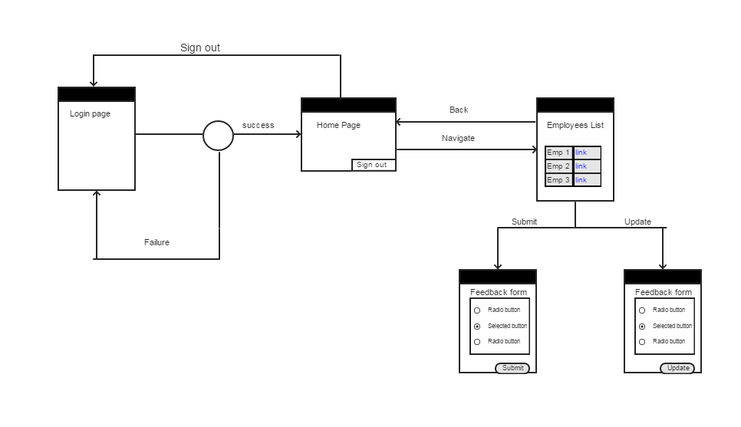

***Quick Feedback***

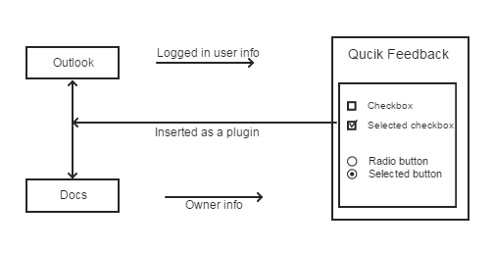

**Wireframe:**

***Single Page Application***

This is the first page as per the business requirement, where the list of employee is populated in Grid, user can provide feedback by clicking on the hyperlink (based on the status it can be either submission of feedback or modification of feedback)

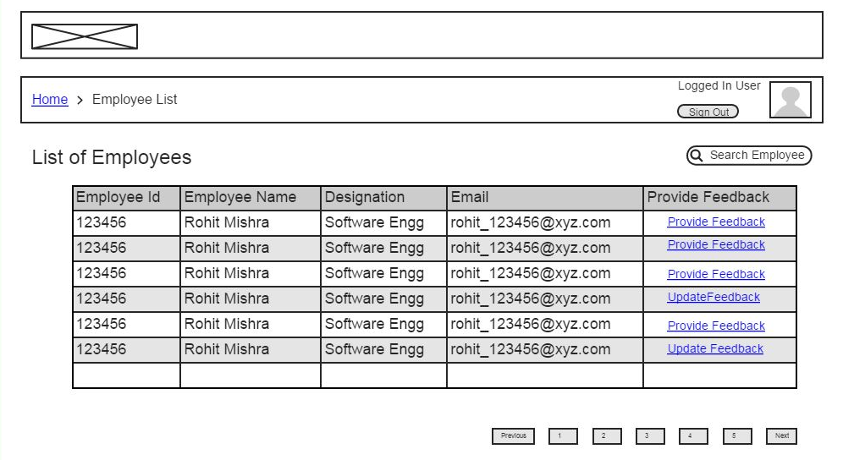

Fig: List of Employees

This is the second page based on the business requirement, where user can provide rating corresponding to respective feedback category separately.

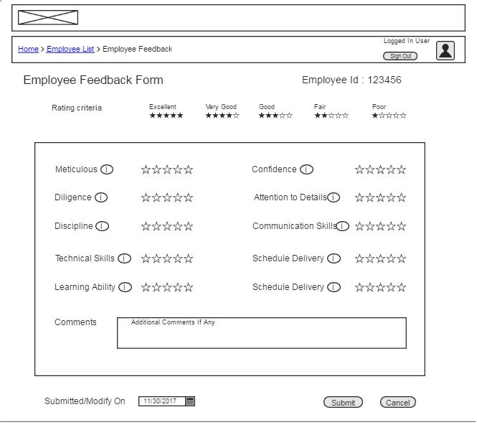

Fig: Feedback form based on the requirement (without ratings)

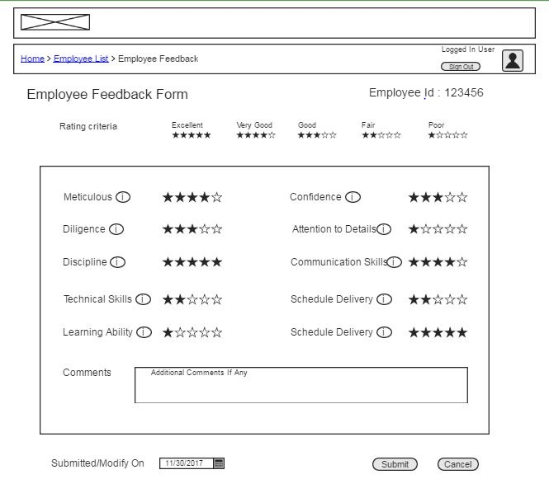

Fig: With Ratings

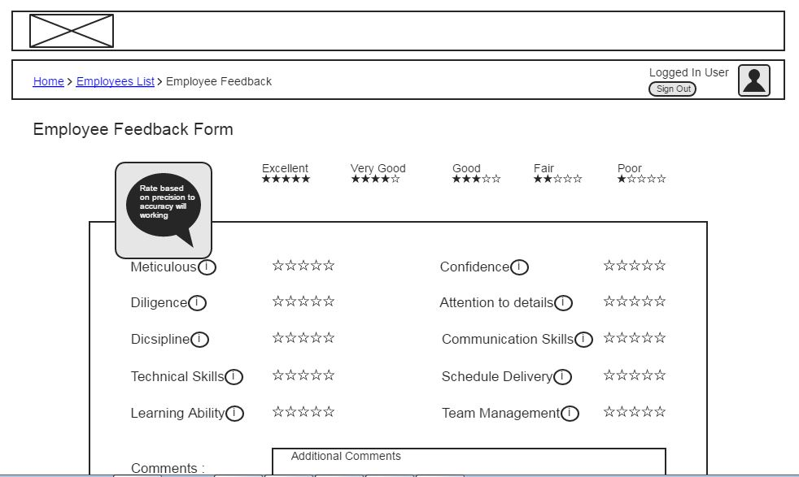

Fig: User can hover over the info icon and get the details regarding the category

(This can also be achieved via tooltips property also)

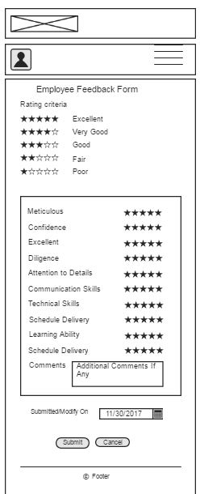

Fig: Mobile View (Responsive Design through Bootstrap)

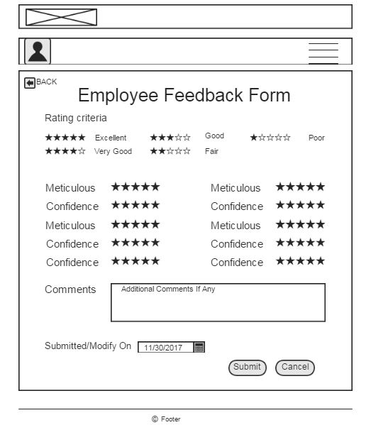

Fig: Tablet View (Responsive Design through Bootstrap)

This is based on business requirement, after click of submit button on successful submission of feedback success alert pop up will appear.

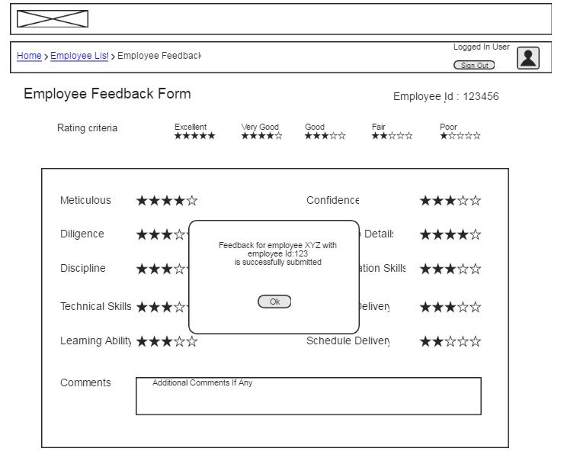

Fig: Popup after successful submission

***Quick Feedback:***

This is based on the business requirement, where multiple category will have same rating and employee details will be auto-populated.

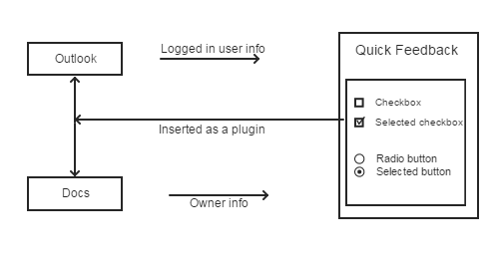

Fig: Quick Employee Feedback