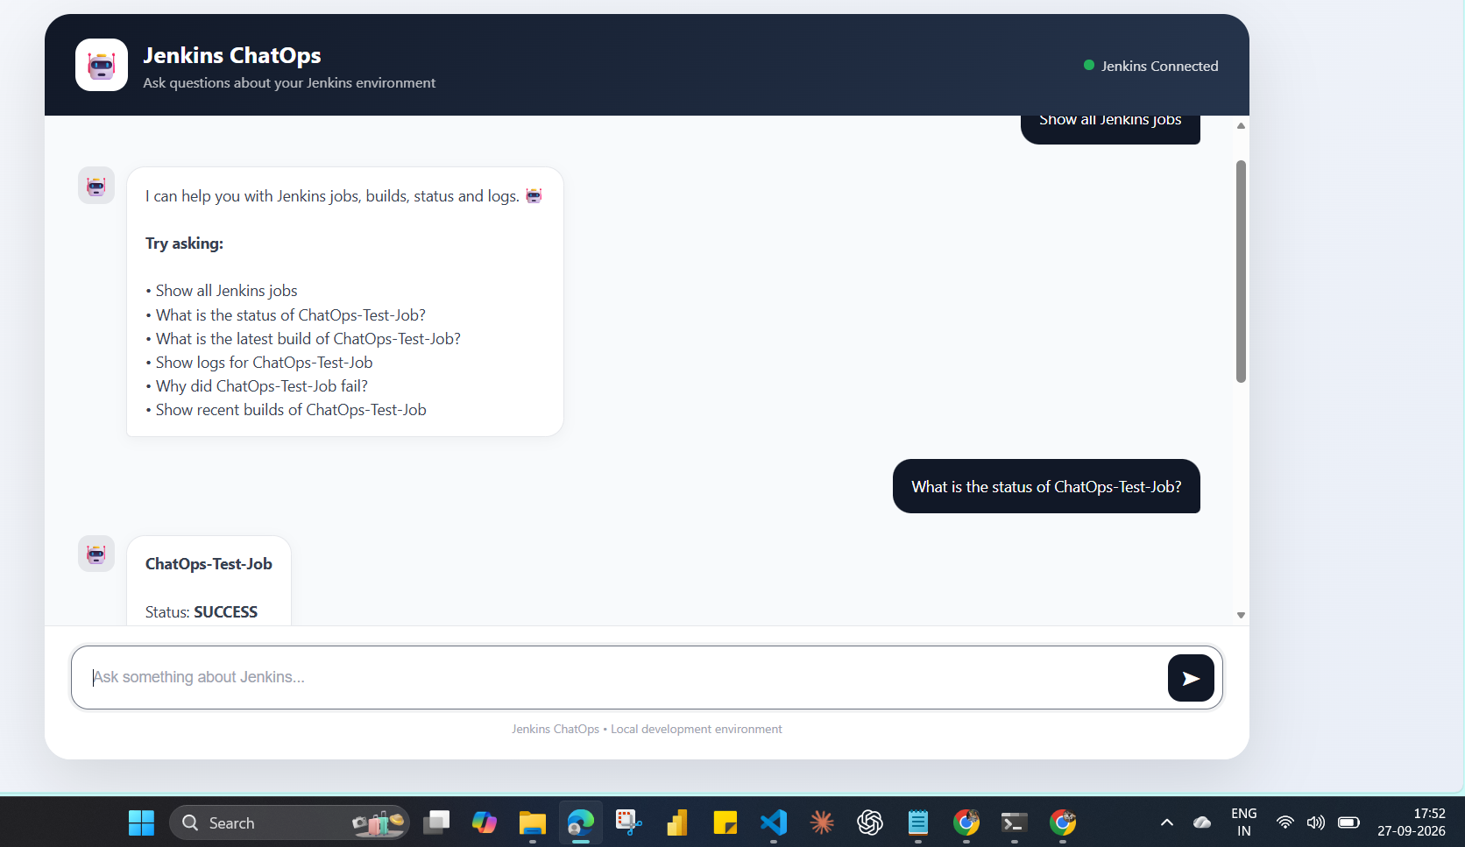

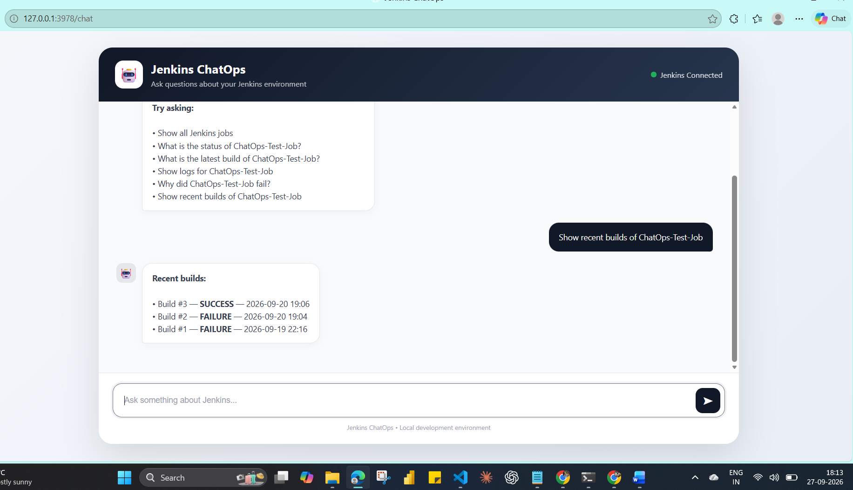
To connect this
Dowload code form github repository
git clone https://github.com/suchi-kuchi/ChatOps.git
cd ChatOps
python -m venv .venv (create virtual envrmnt)
.\.venv\Scripts\activate (activate virtual envrmnt)
pip install -r requirements.txt
Then they create their own .env:
uvicorn app.main:app --reload --port 3978 (To run )

