**Analysis of the Distribution of Financial Institutes in Brooklyn boroughs in NY .**

Nadeesha J Silva

April 2019

**1. Background**

Banks are financial institutions play very important roles in the society by rendering various services to people and businesses. They not only keep the money safe by borrowing customer money but also provide lending services in terms of loans which are very important for expanding businesses, higher education, health and so on. Therefore they contribute immensely for the economy of the society. It would be interesting to look at the distribution of banking systems in different neighborhoods in the New York city to gain various insights that can in tern benefit the public. There are five main Boroughs in New York city namely Bronx, Brooklyn, Manhattan, Queens and Staten Island. Manhattan has the highest Gross Domestic Product (GDP) and the highest per capita (PC) out of the five. Brooklyn which is the most populated borough has a significantly less GDP (third highest) and a low PC. Since 2010 Brooklyn has evolved a lot with many amusements parks, marine parks and technological advances. So in this research project the main idea is to look into Brooklyn boroughs in new York city and identify the areas which are strong in economic sense and the areas that need more attention in terms of finances. For city authorities It helps them determine which areas are more richer in an economical perspective just by looking at the information on how financial institutes are distributed and accessible to people. For the neighborhoods that Lack sufficient number of banking systems may require the attention of the city/state authorities not only because that makes the lives of the citizens less comfortable but also it is a key factor that predicts which areas need their attention to allocate more fundings for the development of the society. On another note it would be beneficial for the bank owners to look in to these information as it would yield them to gain insight as to where would be a better place to open a new branch. In today’s competitive economy it would be very interesting for different banks to look at this information to see which areas they need to have more coverage specially when their competitors already have branches and when they don’t It would be a setback for them as more customers get used to going to the ones that were there established for a longer period of times than the new ones. It is important in this perspective to be the first and especially in areas there are no banks would be ideal.

**2. Research Goal**

The objective of this research project is to analyze the distribution of banking systems in the Brooklyn borough of NY city and to evaluate which areas would be more economic to open new branches for a client owner of a US banking system. (Chase Bank)

**3. Data Requirement and Manipulation**

In order to address the above mentioned research problem there are two types of data that we need to collect. Firstly and fore mostly we need the geographical data of the new York city. It is vital that we have all the information needed regarding the different borrows and neighborhoods in the New York city. This information can be found at <https://geo.nyu.edu/catalog/nyu_2451_34572> for free. The .jason file can be found at <https://cocl.us/new_york_dataset>.

It is also necessary to use the Foursquare API to request information on neighboring venues which are banks in this project to see how many and the density of the fanatical institutes in the neighborhoods of Brooklyn.

Upon preliminary investigations of the results it was apparent that there are 70 neighborhoods in the Brooklyn borough, 81 in Queens, 52 in Bronx, 63 in Staten Island and only 40 in Manhattan which is the smallest out of all the five. Our study is restricted to Brooklyn borough. Since it is wise to look at where and how the competitors are located a **total of 87 banks** are analyzed on how and where they are distributed. Latitude and Longitude values are needed for each neighborhood and the radius is defined for each neighborhood as 500 m2. For each neighborhood within this range of distance it is expected to request the information regarding the banking systems present in turn we can determine how many banks are present for each neighborhood and we can sum it up to find the total for the overall borough.

Data wrangling

Upon doing the preliminary data wrangling it was evident that there are 294 banks distributed in the 70 different boroughs in the Brooklyn borough. Some boroughs have a very few banks while some have over 15 different accessible banks. It was also found out that only 57 neighborhoods out of the 70 actually have any bank available at all. In the data wrangling process I analyzed the distribution of 87 different banks to make a comparison to major banks and decide where to open a CHASE branch.

Methodology.

Kmeans clustering method was used to segment the 57 neighborhoods identified to have different banks distributed in various numbers. The reason for choosing only these 57 neighborhoods that since the rest of the 13 neighborhoods are not shown to be financially developed. Therefore for a big bank like Chase should target a location more promising to be successful.

Results

Figure 1 shows how the banks are distributed in numbers within the 57 neighborhoods in the Brooklyn borough.

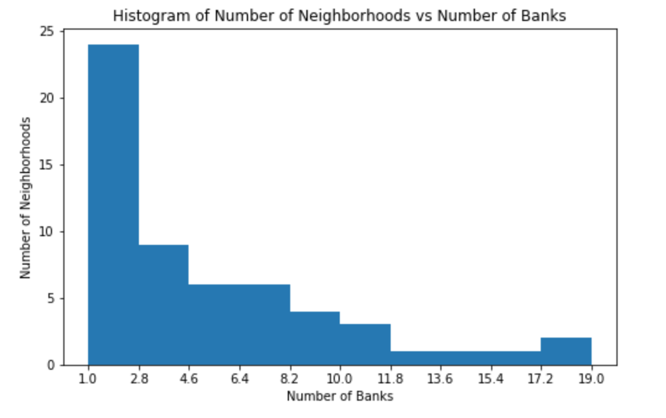

Figure 1. The histogram of number of neighborhoods vs. number of banks

It is evident that from this data that there are a few boroughs that are fanatically and economically more stable and advance than the rest of the neighborhoods. These three neighborhoods are **Bay Ridge, Brooklyn Heights and Borough Park** in order of the number of banks. Surprisingly when I analyzed the number of CHASE banks in the these three neighborhoods it was evident that Bay Ridge doesn’t have a branch. (This information is disregarding any ATM) It is the one with the most number of major US banks.

This information can also be seen from the bar graph as shown in figure 2.

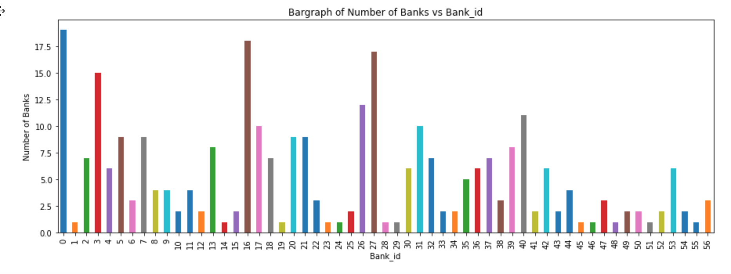Figure 2. The bar graph of Number of banks vs. The bank_id. (ID=0; Bay Ridge, ID=16; Brooklyn Heights and ID=27; Borough Park.

In order to visualize the neighborhoods that have atleast seven banks accessible I did a box plot and the results are shown in the figure 3.

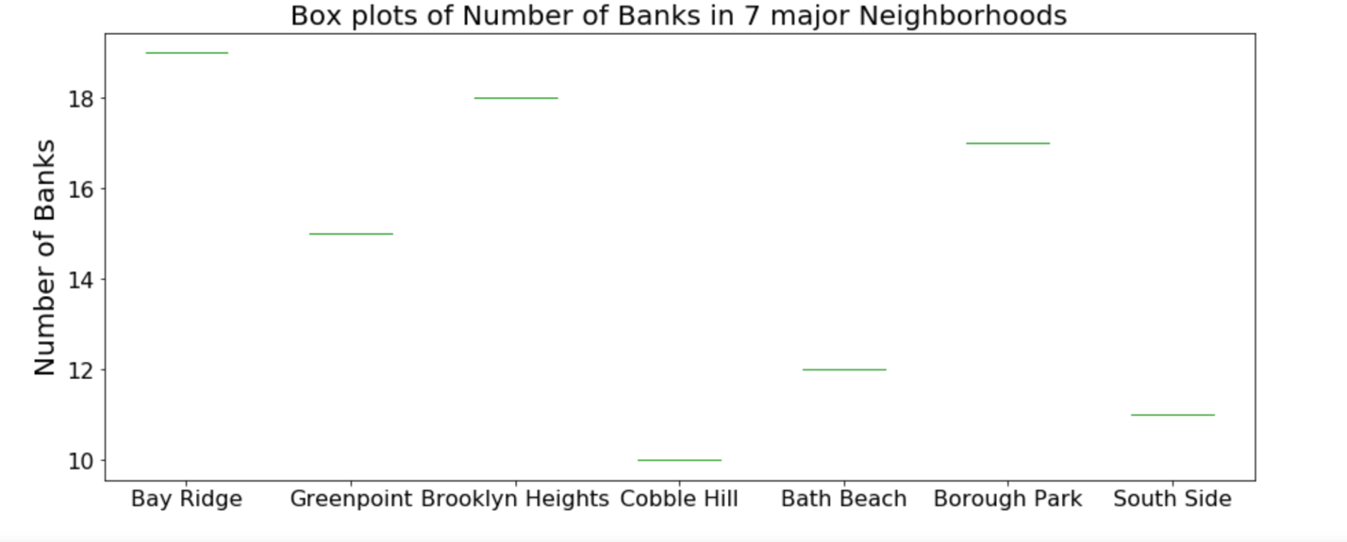

Figure 3. The seven neighborhoods with the most number of banks

KMeans clustering also segmented the different neighborhoods into segments based on the distribution of number of banks.

Discussion

The analyzed result by means of KMeans clustering and using various other visualization techniques, it was evident that the distribution of the finantial institutes are not even among different neighborhoods in Brooklyn Borough. There were a total of 294 banks distributed in the Brooklyn borough. Even though there were 70 neighborhoods there were only 57 that had access to bank at all. According to further investigations on these 57 boroughs it was evident that there exist 7 neighborhoods that had at least 7 different bank out of the 87 analyzed in this study. Looking at these neighborhoods I was able to list them according to the order and three major ones were identified as **Bay Ridge, Brooklyn Heights and Borough Park.** However the only drawback of this study is that some ATM were not listed in the json file requested. But ignoring this minor setback I looked at how many actual CHASE bank branches were present in these major neighborhoods. Surprisingly there were none for Bay Ridge eventhough it is the one with the highest number of banks with a total of 19. Therefore I suggest that it would be beneficial for the client (CHASE bank) to consider opening a new branch in Bay Ridge, Brooklyn.

Conclusions.

The study analyzed the distribution of 87 different banks in 70 neighborhoods in Brooklyn borough. The three main neighborhoods with the highest number of accessible banks were identified as Bay Ridge, Brooklyn Heights and Borough Park in the Brooklyn borough. The study showed that out of these three that Bay Ridge neighborhood didn’t have a real bank branch (Not ATM) . Therefore it can be concluded that the best neighborhood to open new CHASE branch would be Bay Ridge out of the 70 neighborhoods in Brooklyn Borough analyzed in the present study.