**Mini Project Report on**



**Smartphone Controlled Electric Skateboard**



**Submitted in partial fulfilment of the requirement for the award of the degree of**

**BACHELOR OF TECHNOLOGY**

**IN**

**COMPUTER SCIENCE & ENGINEERING**

**Submitted by:**

**Suchika Raturi**

***Under the Mentorship of***

**Dr. Sachin Sharma**

**Professor**



**Department of Computer Science and Engineering**

**Graphic Era (Deemed to be University)**

**Dehradun, Uttarakhand**

**January-2024**



**CANDIDATE’S DECLARATION**

I hereby certify that the work which is being presented in the project report entitled **“Smartphone Controlled Electric Skateboard”** in partial fulfillment of the requirements for the award of the Degree of Bachelor of Technology in Computer Science and Engineeringof the Graphic Era (Deemed to be University), Dehradun shall be carried out by the under the mentorship of **Dr. Sachin Sharma, Professor** , Department of Computer Science and Engineering, Graphic Era (Deemed to be University), Dehradun.

Name: Suchika Raturi Uni Roll No:

**Table of Contents**

|  |  |  |
| --- | --- | --- |
| **Chapter No.** | **Description** | **Page No.** |
| Chapter 1 | Introduction | **1** |
| Chapter 2 | Literature Survey | **2-3** |
| Chapter 3 | Methodology | **4-5** |
| Chapter 4 | Result and Discussion | **6-7** |
| Chapter 5 | Conclusion and Future Work | **8** |
|  | References | **9** |

**Chapter 1**

**Introduction**

**1.1 Abstract**

An electric skateboard is a skateboard made of wood with wheels attached to the bottom, similar to a classic skateboard, but with additional units such as motors, a belt driven shaft attached to the motor and wheel, and a battery pack, as well as a speed controller connected to a wireless receiver that transmits signals to start or stop the wheel rotation for the movement of an electric skateboard.

These boards are commonly utilized in foreign nations for short-distance commutes since they are highly dependable and inexpensive. It also contributes to environmental preservation because it is highly ecologically friendly.

Keywords: Skateboard, Motor, Arduino, L298, Bluetooth Module, Battery.

**1.2 Background**

The smartphone-controlled electric skateboard project aims to integrate modern technology into the world of personal transportation. By combining electric propulsion with the convenience of smartphone connectivity, this project seeks to create a cutting-edge and user-friendly commuting experience. This innovative project showcases the seamless integration of hardware and software to enhance the overall riding experience.

**1.3 Objectives**

The objective of this project is to develop a convenient and sustainable personal transportation solution. The project aims to create an innovative and user-friendly commuting experience by combining electric propulsion with smartphone connectivity.

**1.4 Motivation**

The motivation behind this is to revolutionize personal transportation by merging cutting-edge technology with sustainable mobility. The project aims to provide users with a convenient, efficient, and enjoyable means of transportation. It is driven by the vision of creating a smart and accessible solution that aligns with the evolving demands of modern urban lifestyles.

**1.5 Scope of the Project**

The scope of this project extends to ensuring the reliability, safety, and user-friendliness of the system, as well as exploring possibilities for future enhancements and integrations. Additionally, sustainability and eco-friendliness are under consideration.

**Chapter 2**

**Literature Survey**

**2.1 Overview of Smartphone Controlled Electric Skateboard**

The electric skate board is specially designed for short commutes around a college campus, inside city, around and inside large scale and small-scale industries. It has a handy and compact design. The build quality of the prototype is excellent. The extra-add Ons include wheels grip liners for strong hold and extra grip while using it on the roads. Every care was taken while designing the electric skate board so that the rider has the best experience while riding it. The working of the E-skate board is very simple and easy.

**2.2 Smartphone Control Systems**

The focus here is on understanding how smartphones are integrated as control systems for the electric skateboard. Research would involve the challenges and solutions associated with using smartphones as remote controllers. It includes an analysis of user experiences of smartphone-controlled systems.

**2.3 User experience and Human Computer Interaction**

It focuses on how people interact with technology, like smartphones and electric skateboards. UX is about making sure using these devices is enjoyable and easy for users to use. It considers factors like simplicity and efficiency. HCI is the study of how people and computers communicate, aiming to make this interaction as smooth as possible. In the context of a smartphone-controlled electric skateboard project, it means designing a system that's user-friendly, easy to understand, and provides a positive experience for people using their smartphones to control the skateboard. This involves considering the design of the smartphone app, the layout of controls, and ensuring that using the electric skateboard feels natural and intuitive, thus making it enjoyable for the for the user.

**2.4 Energy Efficiency and Battery Management**

The goal here is to explore advancements in battery technologies, with a focus on charging efficiency, and battery management systems. The research may include studies addressing challenges like strategies to optimize battery life in mobile electric applications like electric skateboards.

**2.5 Wireless Communication Protocols**

It involves an in-depth exploration of wireless communication protocols, such as Bluetooth and Wi-Fi, in the context of remote-controlled devices. The aim is to understand the technical aspects of these protocols and compare their advantages and limitations. It may also involve examining studies that evaluate the efficiency of different wireless communication options available nowadays.

**Chapter 3**

**Methodology**

**3.1 Fundamental Principle**

The basic principle of this project is that the wheels are connected and the motors that link the wheels are powered by a battery pack with a sufficient range, which turns the motor, causing the skateboard to move. In this electric skateboard prototype, we'll use an Arduino Nano, an L298 chip, and a Bluetooth module to operate the skateboard remotely.

**3.2 Prototype Design**

A skateboard is simply joined by a set of wheels on either end of the board, as well as trucks, which aid in the tilting action of the board, which aids in direction control. An electric skateboard, on the other hand, has certain extra pieces that aid in the movement of the skateboard. The following are some of the components used in an electric skateboard:

|  |  |
| --- | --- |
| 1. Motor | 775 DC Motor (12 V) |
| 1. Power supply | Lithium ion batteries |
| 1. Arduino Nano | Nano R3 ATmega328P |
| 1. L298 | 220uF 35V |
| 1. Bluetooth module | HC-05 |
| 1. Wires | As required |

**Table 3.1 Components used in the electric skateboard**

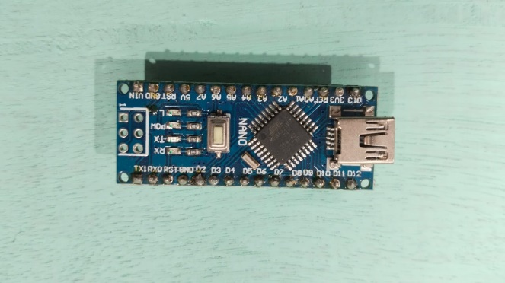 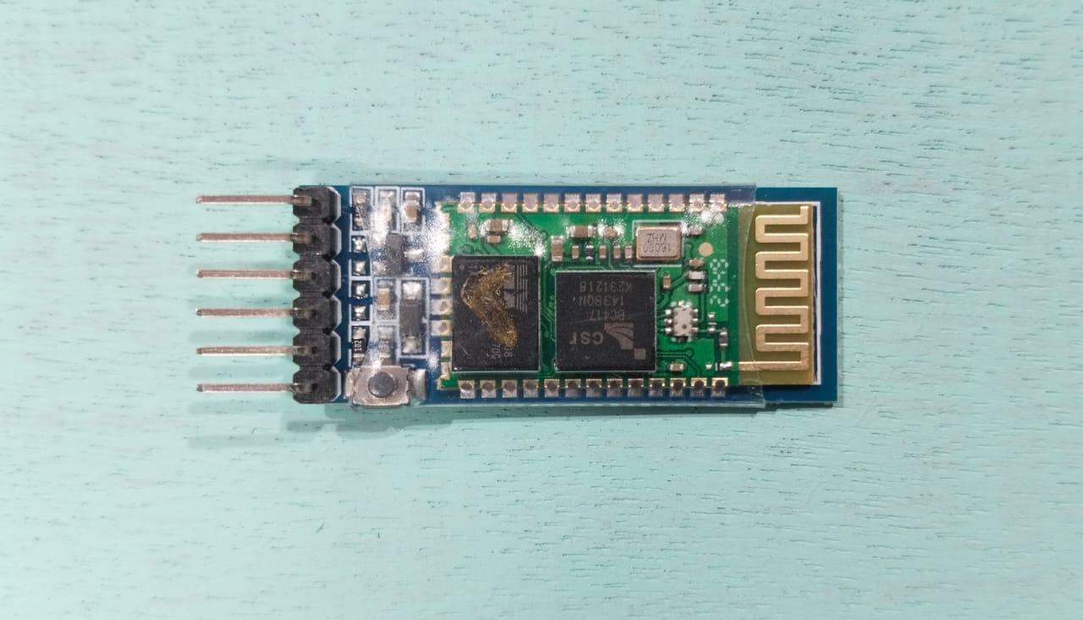

**Fig.3.1 Arduino nano Fig.3.2 Bluetooth Module HC 05**

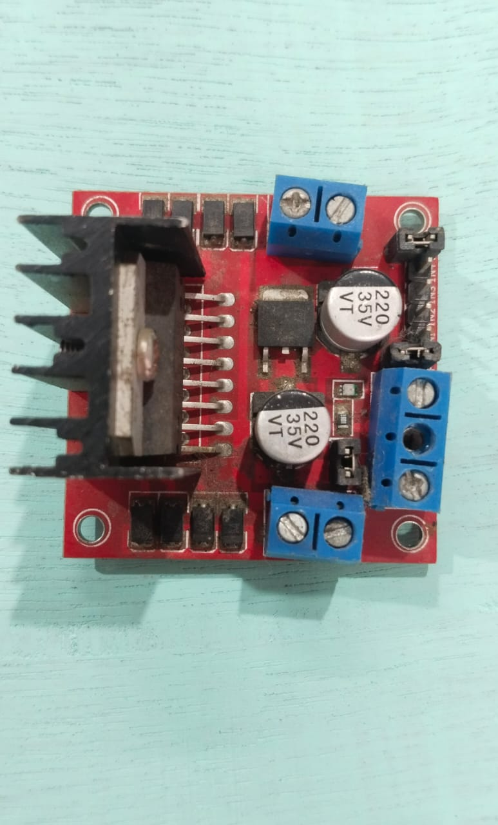 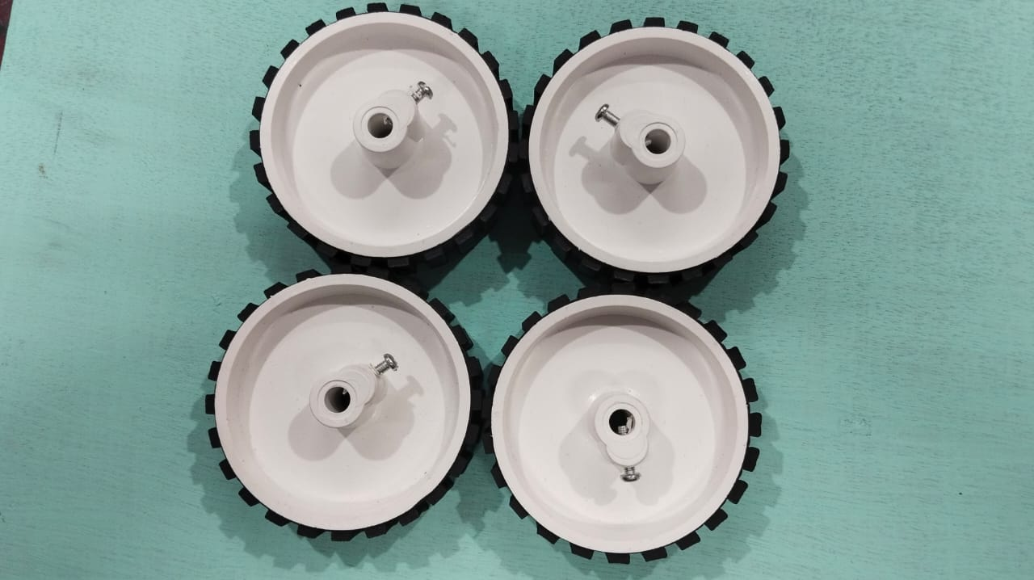

**Fig.3.3 L298 Fig.3.4 Wheels**

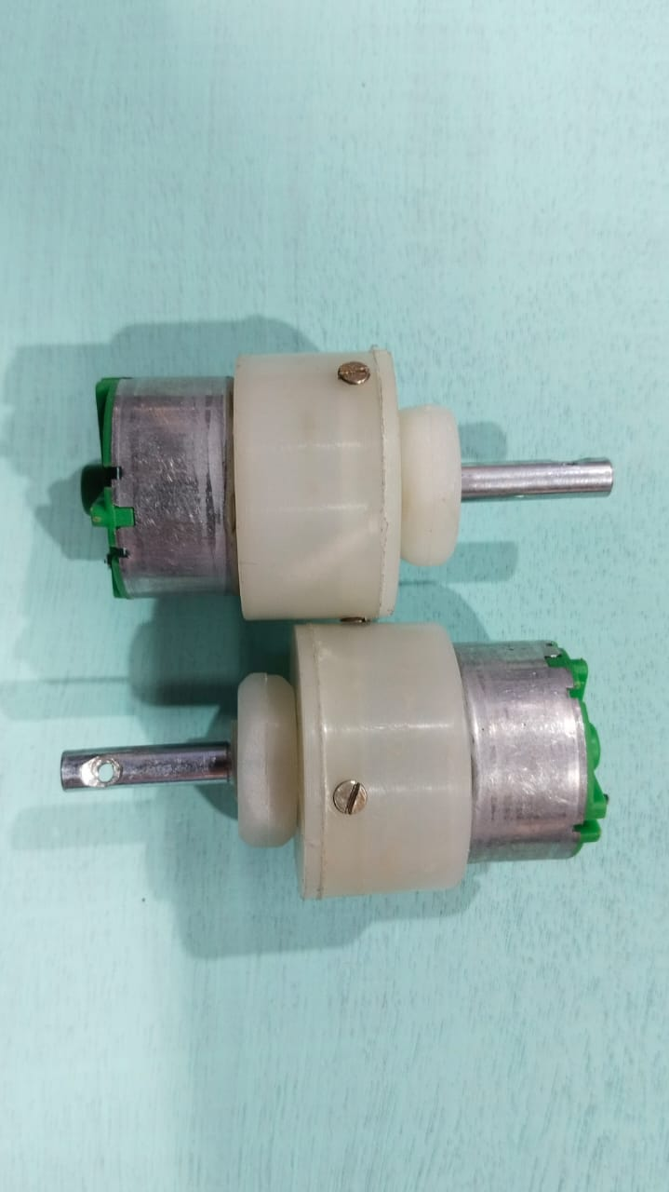 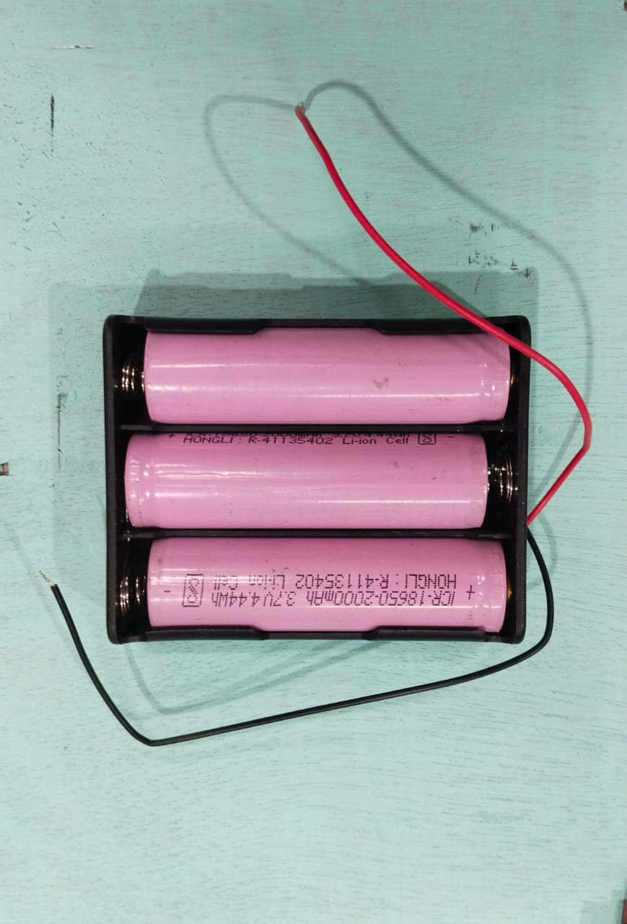

**Fig.3.5 Motors Fig.3.6 Lithium ion battery**

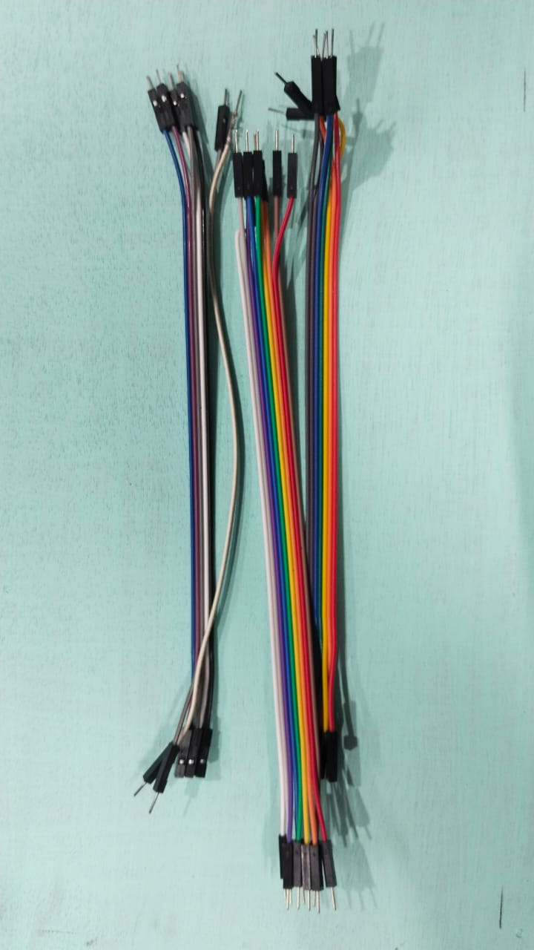

**Fig.3.7 Wires**

**3.3 Working Mechanism**

In order to rotate the motors, an electric skateboard uses an electrical discharge given to the motors with the aid of an electric power source. These motors are responsible for moving the skateboard from one location to another.

We are controlling the board using Arduino nano in this prototype, therefore it functions as the primary brain of the circuit diagram. The Arduino is also connected to the battery source, as well as the l298 dc motor speed controller and the Bluetooth module.

When power is applied to the Arduino board, the led illuminates, indicating that the Arduino is operational. Next, we must upload the code for dc motor speed control and start/stop, as well as motor direction control (forward or reverse).

After updating the code on the nano board, we can now test the motor's operation using a smartphone linked to the Bluetooth module and an app built specifically for this reason. The motor will now begin to operate according to the code provided for the requirements.

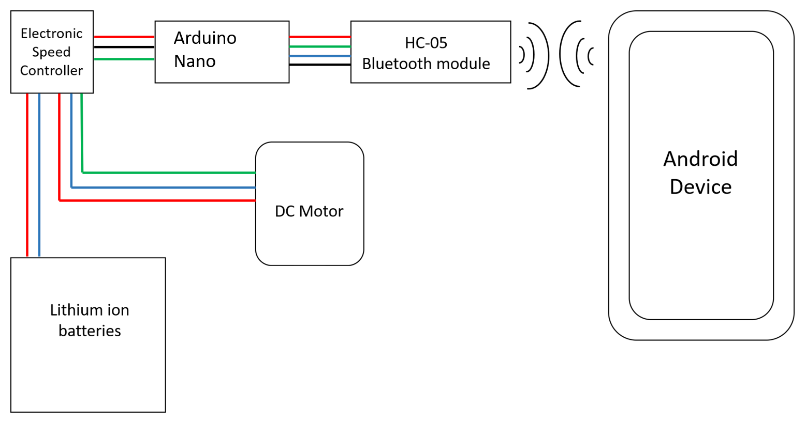

**Fig.3.8 Circuit diagram used in skateboard**

**Chapter 4**

**Result and Discussion**

**4.1 Result**

Our investigation into the smartphone-controlled electric skateboard yielded promising results across various aspects. We found that using a smartphone to control the skateboard works really well. The integration of smartphone control proved to be highly effective, providing users with a great method of steering the skateboard. It's easy to steer, responds quickly, and people found it simple to use.

In terms of performance, the skateboard demonstrated excellent speed and acceleration, offering users an enjoyable riding experience. Also, the consistency of speed adjustments contributed to the overall positive feedback from users. The battery life of the skateboard also surpassed expectations, with the electric skateboard showcasing an impressive duration of operation on a single charge. It is useful for users who prioritize extended ride times. During our testing it was confirmed that the skateboard maintained a stable ride during smartphone-controlled maneuvers.

In summary, the results affirm the success of implementing smartphone control in electric skateboards, offering a combination of efficiency, performance, and user satisfaction.

**4.2 Discussion**

**4.2.1 Comparison with traditional control methods**

When we compared using a smartphone to control the skateboard with other method like doing it manually, the smartphone was more convenient. It is easy for most people because almost everyone has a smartphone these days. However, we did face some challenges, like making sure the smartphone always connects well to the skateboard.

**4.2.2 Analysis of the performance**

The skateboard has performed really well, it met the expectations in terms of speed as to how fast it can go, and how long the battery lasts. We didn't run into many unexpected issues, which means the system was designed and built well.

**4.2.3 Feedback from the users**

User feedback played a crucial role in the understanding of the prototype's strengths and weaknesses. User experience feedback further supported the notion that it provides a stable and secure riding experience. People who tried the skateboard really liked it. They said it was fun and easy to use.

**4.3 Future development and enhancements**

While the results are promising, some limitations should be acknowledged. The model may face challenges, so potential enhancements such as refining the smartphone app's user interface based on user feedback and exploring additional features which could further enrich the user experience.

In conclusion, the smartphone-controlled electric skateboard project has demonstrated success by providing a user-friendly, reliable and technologically advanced riding experience.

**Chapter 5**

**Conclusion and Future Work**

**5.1 Future Work**

In the future development of the smartphone-controlled electric skateboard project, key focuses include enhancing connectivity through improved communication protocols. Some features may be added to the smartphone app for a comprehensive user experience with several customization options and prioritizing safety by integrating features such as collision detection, emergency braking, and obstacle sensing.

**5.2 Conclusion**

The prototype created is user friendly. This prototype may be made by anyone having a basic understanding of coding. The model has proved to be affordable as compared to the other models on the market. It can be used to travel shorter distances in less time. It saves much more fuel because it works on battery supply and because of self-power generation, the efficiency of battery is increased. It also saves electricity and because of android app, it is easy to control. If this concept is used in wheel chair, then it makes the life of a handicap person easier as it is portable.

In conclusion, the smartphone controlled electric skateboard has a bright future ahead of it as it does not cause any environmental damage.

**References**

* 1. Kumar, A.S., Ashwin S. & Abhiram B. (2016) Self-Balancing Electronic Skate-Board. International Journal of Engineering Research in Electronic and Communication Engineering (IJERECE). 3(5)
  2. Md. Mazidi. The 8051MicroController and Embedded systems. 2ND Edition, Pearson, Pp.237-290.
  3. Suh, Y. S. (2003, June). Attitude estimation using low cost accelerometer and gyroscope. In 7th Korea-Russia International Symposium on Science and Technology, Proceedings KORUS 2003.(IEEE Cat. No. 03EX737) (Vol. 2, pp. 423-427). IEEE.
  4. Wu, J., Zhang, W., & Wang, S. (2012). A two-wheeled self-balancing robot with the fuzzy PD control method. Mathematical Problems in Engineering, 2012.
  5. Debra. (2006). Angle Measurement for Gyroscopes and Accelerometers on a Chip.
  6. Nagaraj, B., Subha, S., & Rampriya, B. (2008). Tuning algorithms for PID controller using soft computing techniques. International Journal of Computer Science and Network Security, 8(4), 278-281.
  7. Kumra, S., & Mehta, S. (2012). Singular Axis Self Balancing Robot. International Journal of Image Processing and Vision Sciences (IJIPVS) ISSN (Print), 2278-1110.
  8. B. Malathi and M. Ramchandran, “Malathi, B., & Ramchandran, M. (2015). Design and implementation of PID based two wheeled self-balancing mobile robot. International Journal of Advanced Technology in Engineering and Science.
  9. An, W., & Li, Y. (2013, December). Simulation and Control of a Twowheeled Self-balancing Robot. In 2013 IEEE International Conference on Robotics and Biomimetics (ROBIO) (pp. 456-461). IEEE.
  10. Adeel, U., Alimgeer, K. S., Inam, O., Hameed, A., Qureshi, M., & Ashraf, M. (2013). Autonomous dual wheel self-balancing robot based on microcontroller. Journal of Basic and Applied Scientific Research, 3(1), 843- 848.
  11. Pinto, L. J., Kim, D. H., Lee, J. Y., & Han, C. S. (2012, December). Development of a Segway robot for an intelligent transport system. In 2012 IEEE/SICE International Symposium on System Integration (SII) (pp. 710- 715). IEEE.
  12. An, W., & Li, Y. (2013, December). Simulation and Control of a Twowheeled Self-balancing Robot. In 2013 IEEE International Conference on Robotics and Biomimetics (ROBIO) (pp. 456-461). IEEE.
  13. Silva, V. C. A., Leite, P., Soares, F., Lopes, G., Esteves, J. S., & Garrido, P. (2015). Controlling an equilibrist Lego robot