Good Morning MedinetTeam,

I have used these technologies:

1. Visual Studio 2019
2. .NET Core 3.1 API
3. Swagger for API testing
4. SOLID patterns, Repository pattern.
5. xUnit the unit testing.
6. Front end is developed using Angular 8, Bootstrap, Angular features – controller, services etc. are used.

I have completed the below tasks.

1. Medinet- API. For running the solution the solution properties should be:

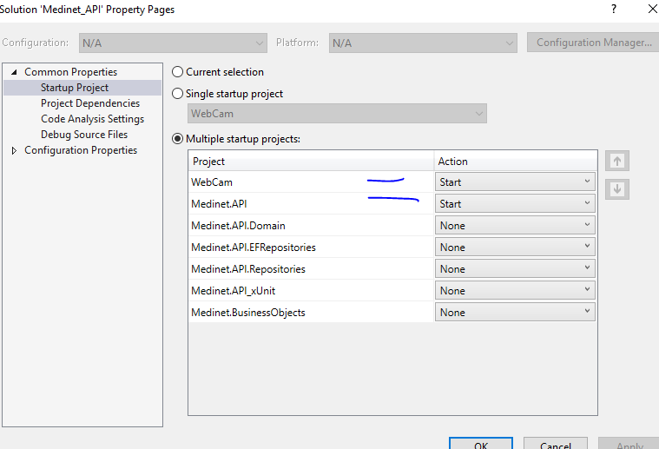

* 1. Run API project. This opens the API project using the Swagger. It may take little time in first load as the local DB migration scripts with two seed data runs.
  2. Webcam utility runs at <http://localhost:50861/>
  3. Run Angular ClientApp from the folder—ClientApp
     1. Open Node.js command prompt and CD to ClientApp folder.
     2. Run
        1. npm install
        2. ng build

(for production we will use [ng build --prod] and update environment.prod.ts file.)

* + - 1. The angular project should build without any errors.
      2. ng serve
      3. open the ClientApp on <http://localhost:4200>
      4. Test the below features:
         1. Two added record during the API project setup should display on the browser.
         2. Take New picture by clicking Take Photo
         3. UI integration for the Add/Edit/View is pending
         4. Delete and List All is working.

All Unit Test Case are working



First time lauch the UI looks like:

API

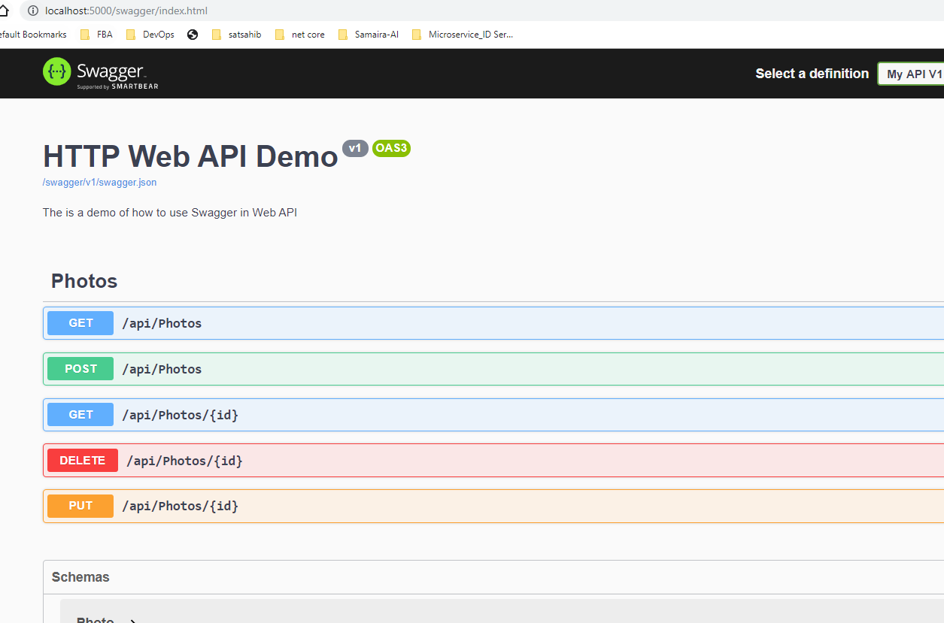

Front end:

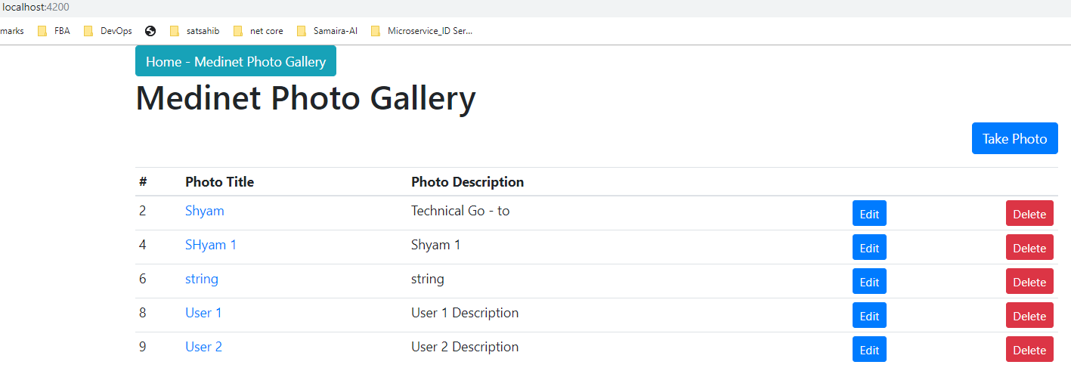

Delete Works

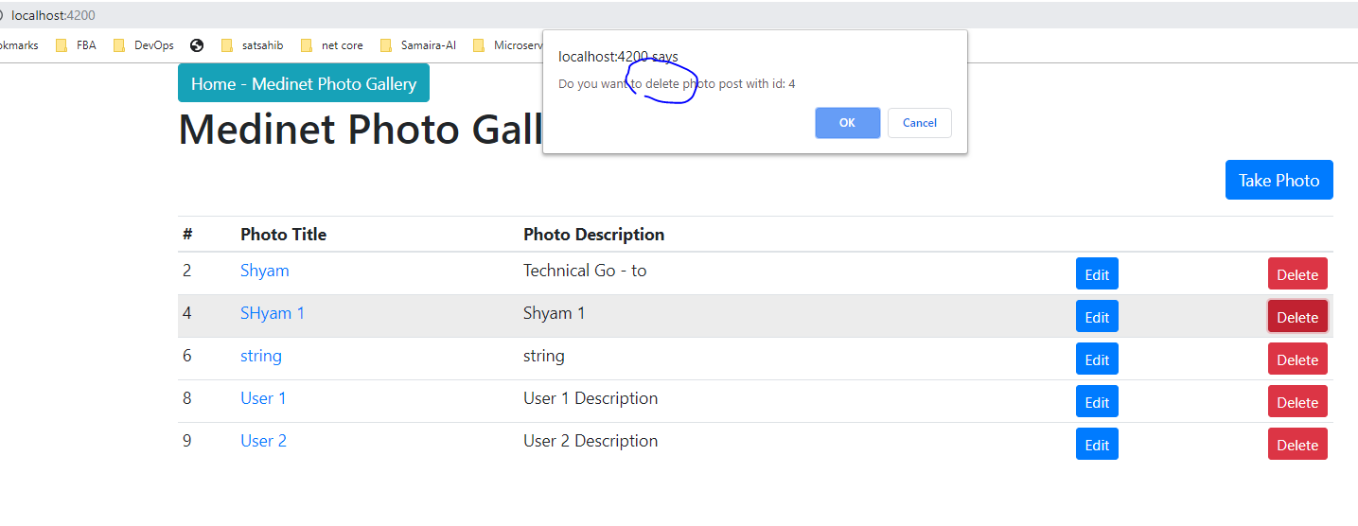

UI refreshed.

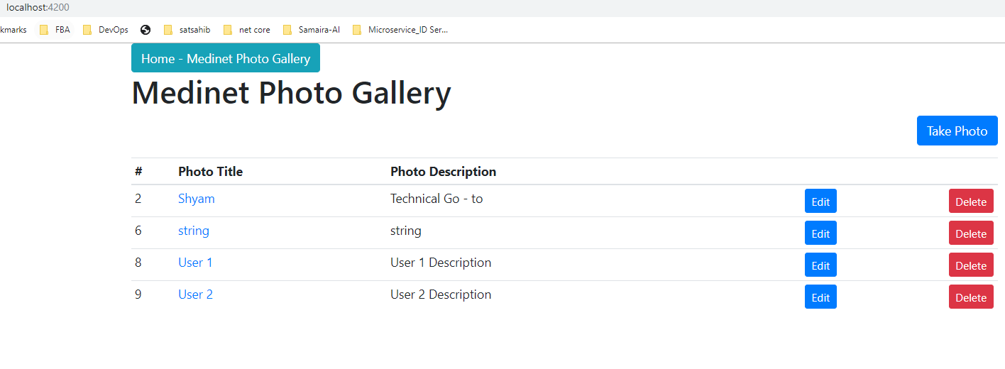

Add New item – from API in SWAGGER

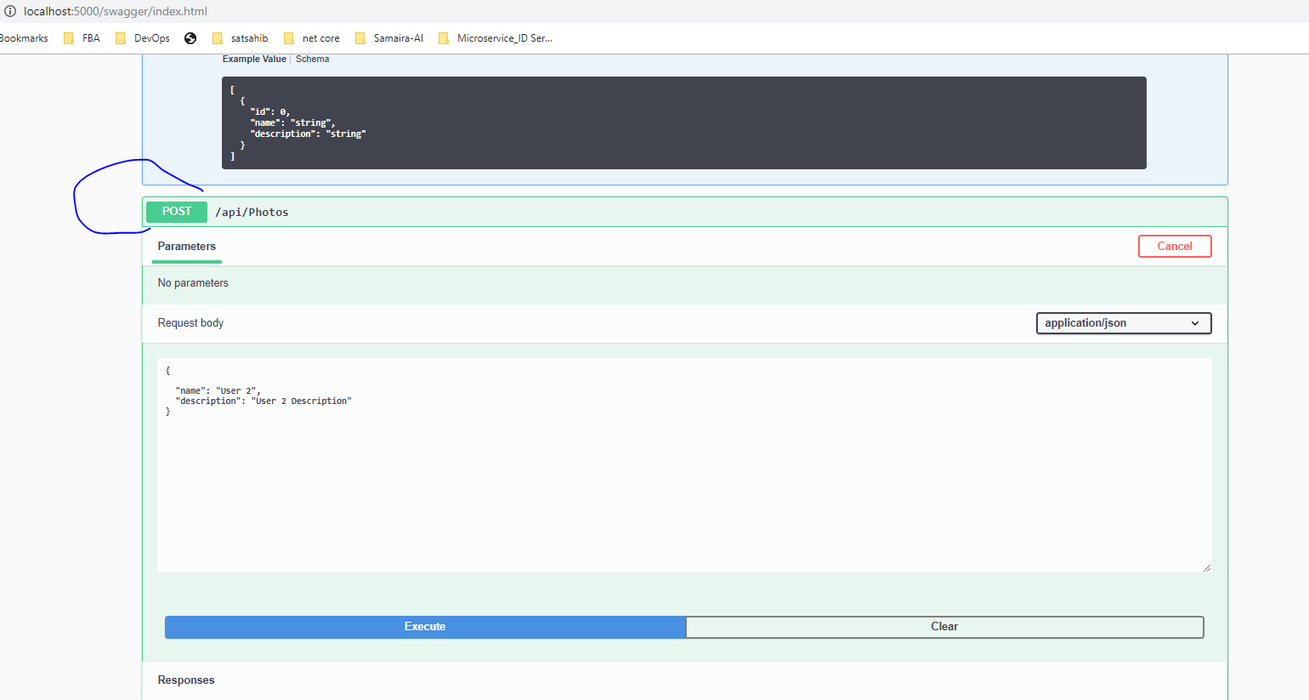

Add/Edit/Delete or view item details.

View item details:

\*\* Can be added:

NLog for logging the exception in the text file