I got many issue when create the micro service by using Sprint Tool Suite Application.

**Issue 1: Cannot create Sprint Starter Project via STS.**

I have to use starts.spring.io website instead.

**Issue #2: Cannot add dependencies during code micro service.**

Right click on pom.xml, sprint >> add starter

This is the same as issue 1.

** This is major issue because I cannot continue to code and need to create the new project every time when required to add new dependencies.

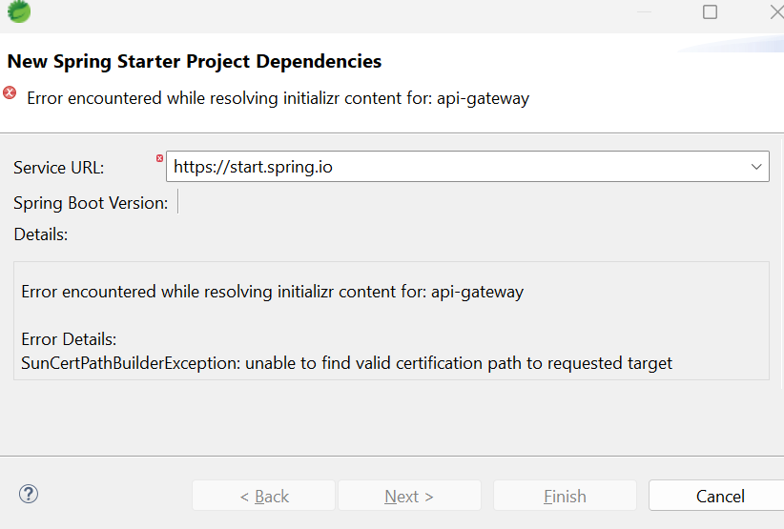

**Issue 3: Cannot continue to test API Gateway**

It does not show as IP address

