Active power distribution in integrated microgrid using a distributed control approach

**Objectives**

Design 12kw wind turbine.

Archive mppt in wind energy harvesting using P&O.

Design 5kW PV array.

Archive mppt using fuzzy logic.

Design a 3-phase inverter to meet AC loads.

Design and utilization of dual active bridge in battery charge control.

Design pi control DC bus voltage.

Block

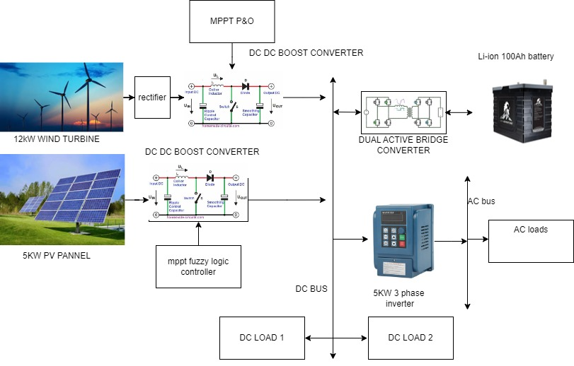

Figure THE PROPOSED SYSTEM

FLC BASED SOLAR PV MPPT POWER

P&O BASEED WECS MPPT POWER

POWER OF WIND ENERGY

POWER OF SOLAR PV

VARIABLE IRRADIANCE OF SOLAR PV

CURRENT OF BATTERY ENERGY STORAGE SYSTEM

VOLTAGE OF BATTERY ENERGY STORAGE SYSTEM

SOC

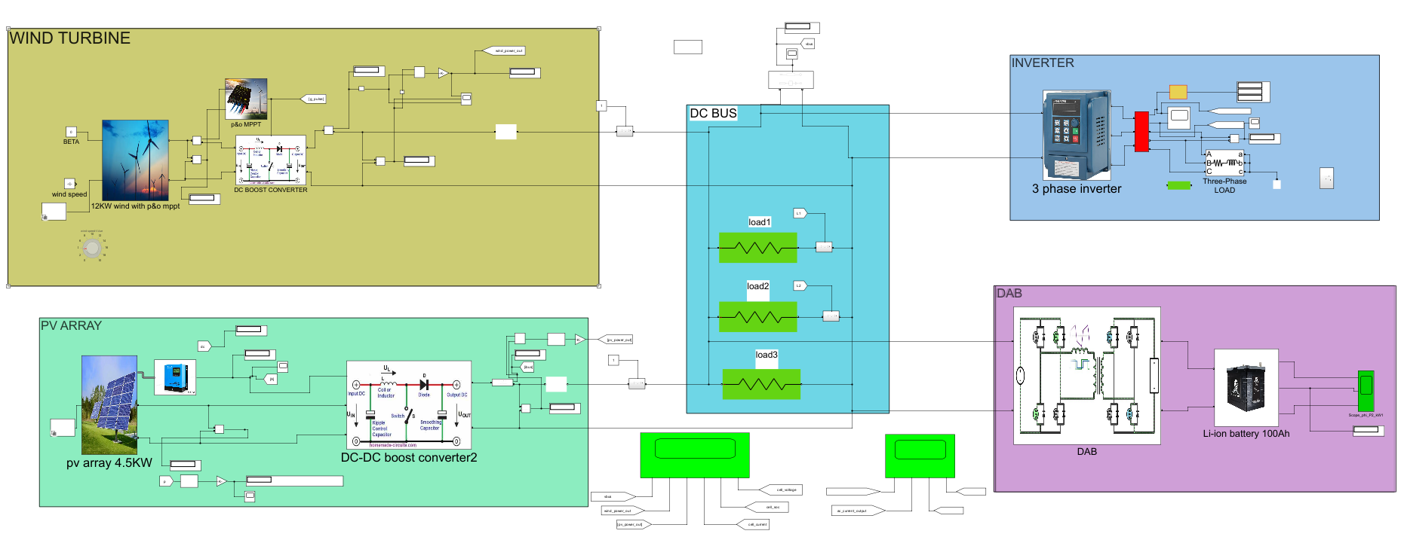

Figure Matlab file

Pv array

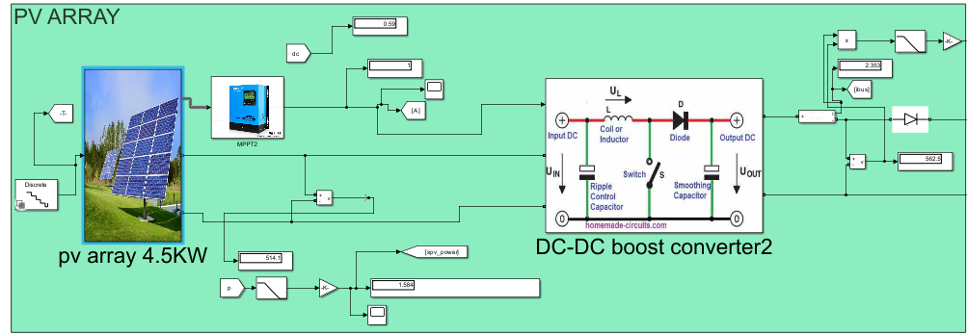

Mppt controller

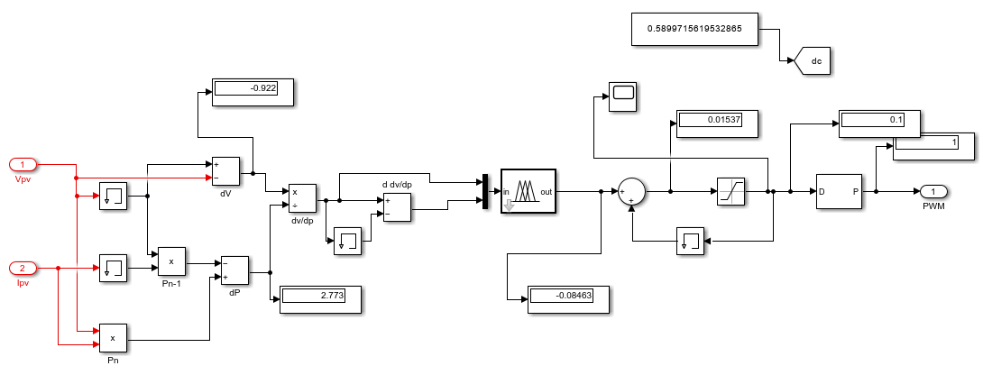

Figure flc based mppt controller

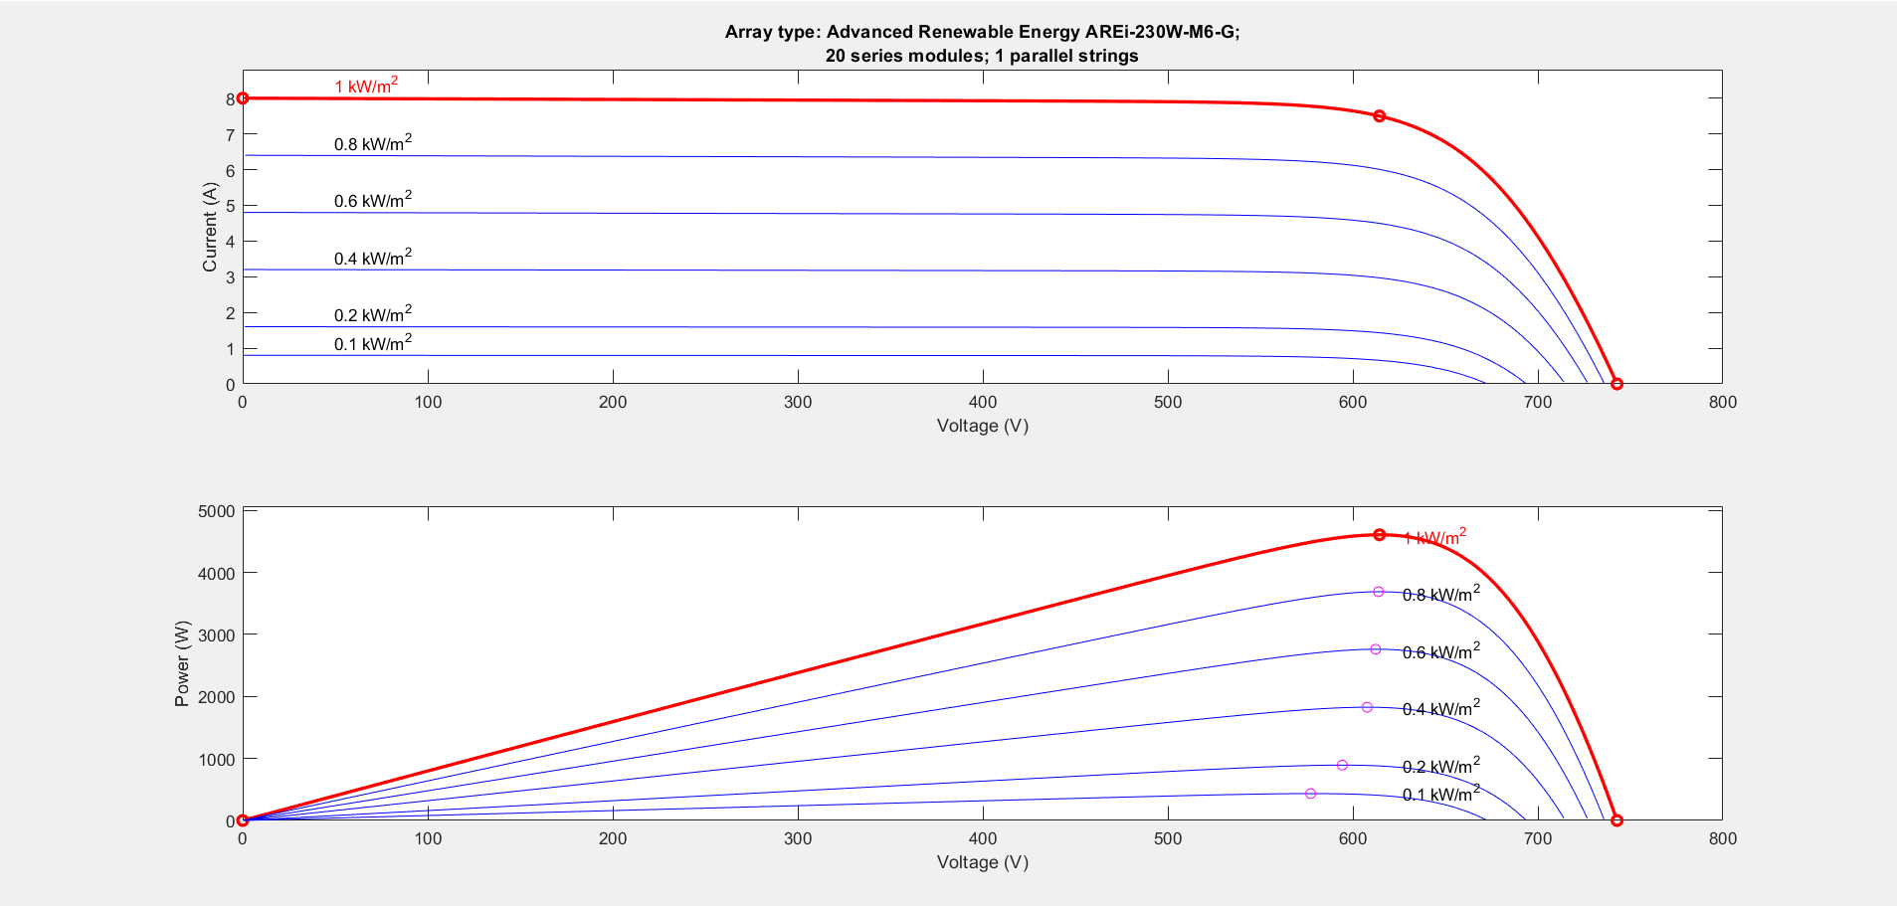

Figure MPPT PLOT OF SOLAR PV MODEL

AT 1000 irradiance mppt power is 4.6 kW

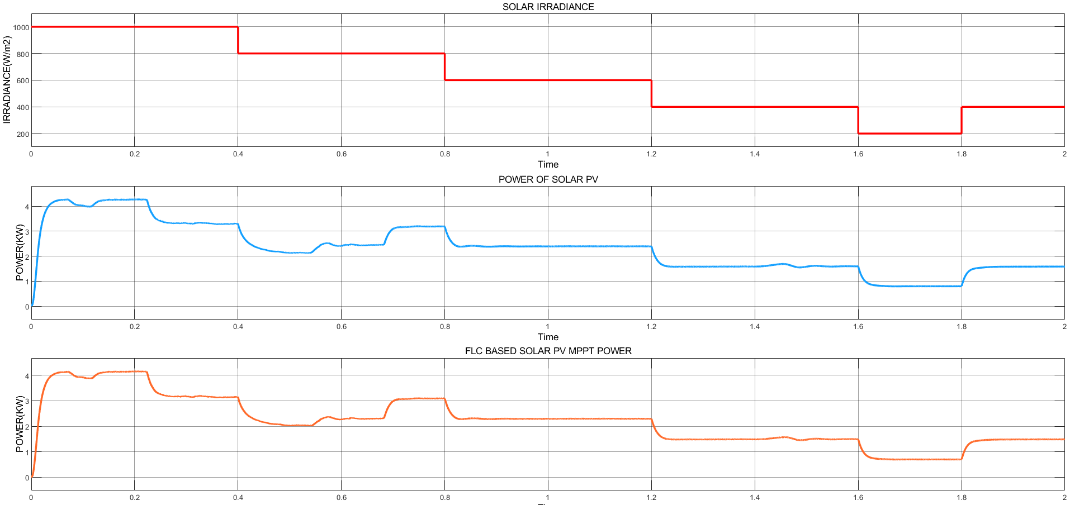

Figure PLOT 1 : VARYING SOLAR IRRADIENCE PLOT2: PV OUTPUT POWER PLOT 3: FLC BASED SOLAR PV MPPT POWER

At 1000 irradiance maximum power output is 4.28 kW, which is almost equal to actual value of mppt.

WIND ENERGY HARVESTING SYSTEM

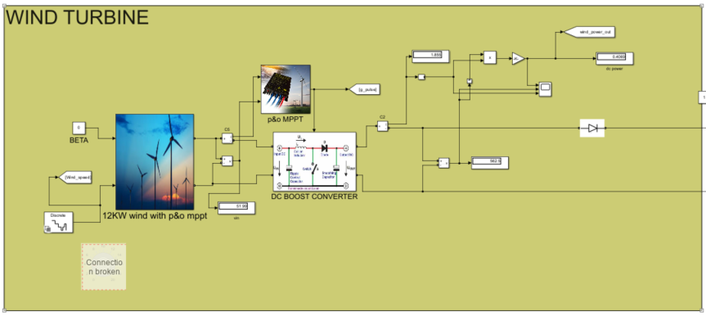

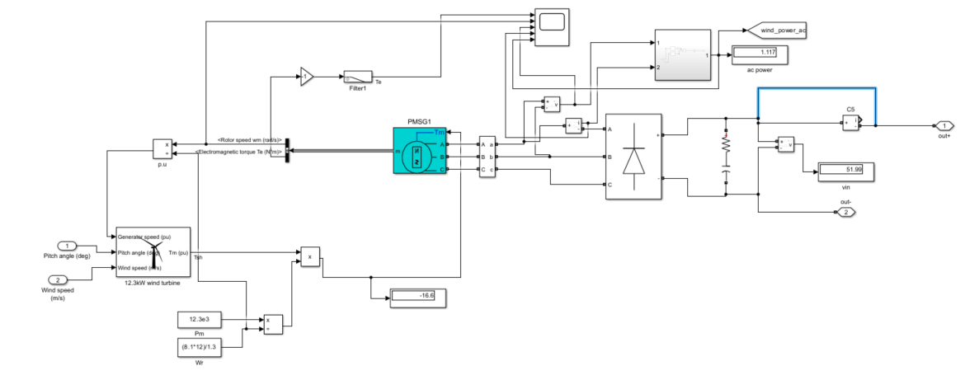

Figure DESIGN OF 12.3kW WIND TURBINE

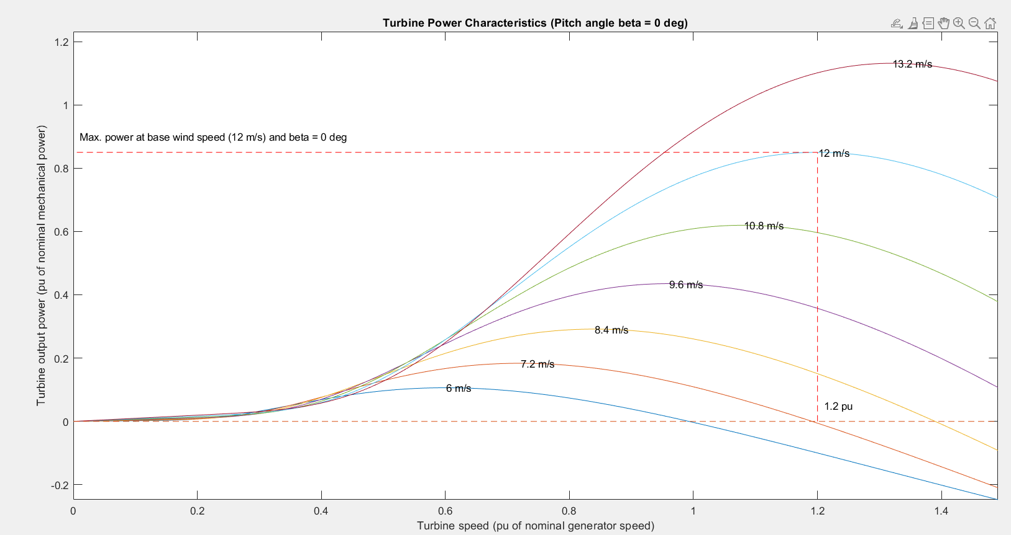

Figure turbine power characteristics

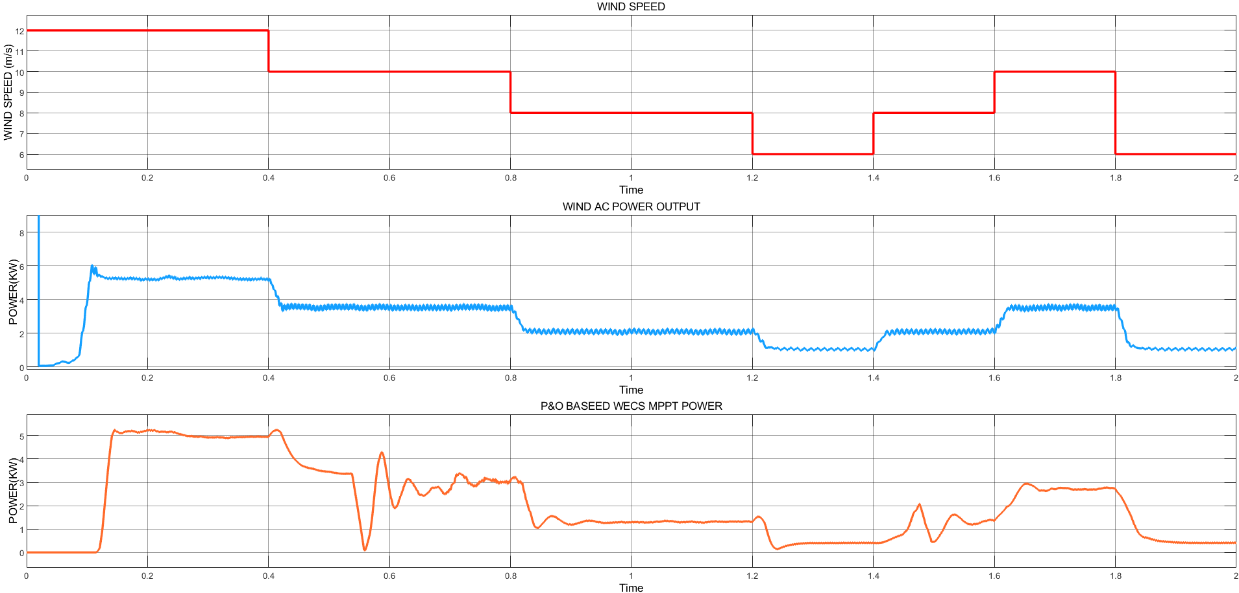

Figure WIND OUTPUT POWER AT AC SIDE AND AFTER MPPT

At 12m/s wind speed we are harvesting a power of about 5KW

**Battery storage system**

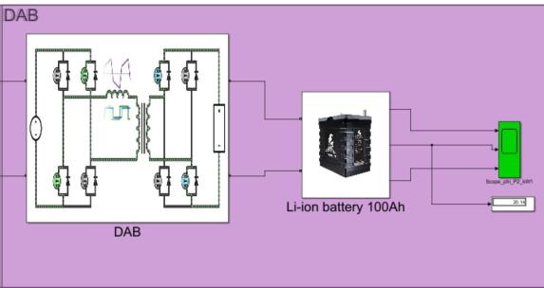

**Dual pi based Dual active bridge is used for battery charge and discharge control**

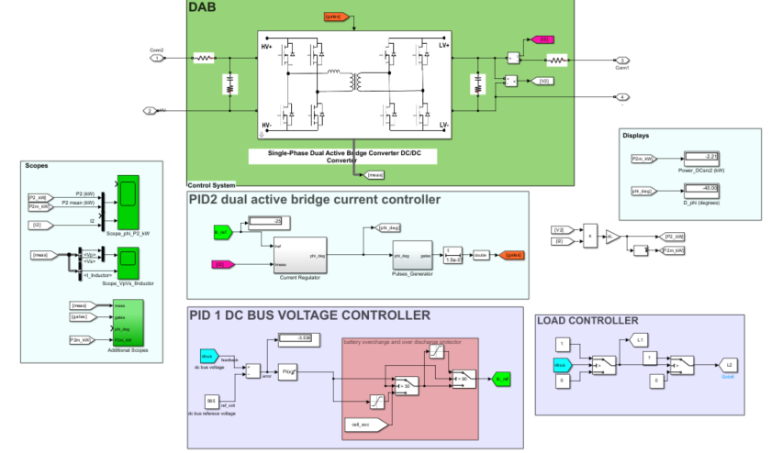

Figure DUAL ACTIVE BRIDGE MODEL

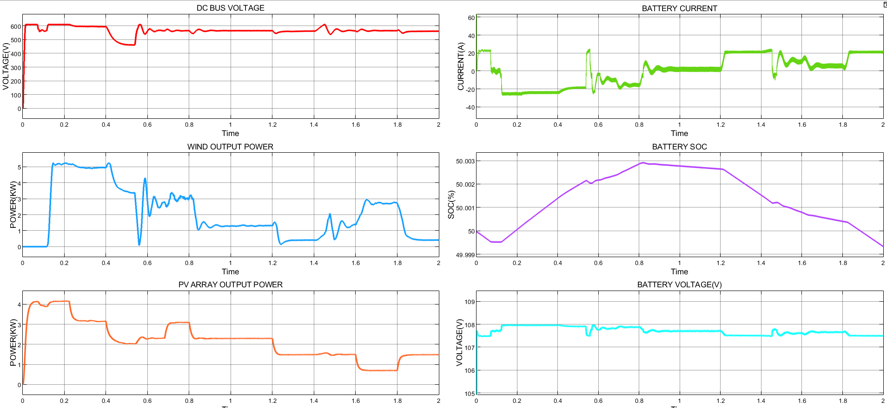

The controller will take dc bus voltage as input and feed it pi controller 1.the pi controller will generate a value which will be the reference current for pi controller 2 . pi controller 2 will produce a phase-shifted PWM pulse which will control the battery charging/discharging current.

If the bus voltage drops below the reference voltage as a result of low energy production from solar PV and wind, the battery will discharge to make up for the deficient power.

If the bus voltage rise above the reference voltage as a result of high energy production from solar pv and wind, the battery will charge to reduce the bus voltage.

**Reference bus voltage is 565v**

**Also if battery soc drops blow 30% ,the controller won’t let the battery to discharge anymore.And v bus voltage is adjusted by removing non priority load from the dc bus.**

**Also if the battery soc rises above 90% , the controller won’t let the battery charge anymore. The DC bus voltage is adjusted by removing the generator from the DC bus.**

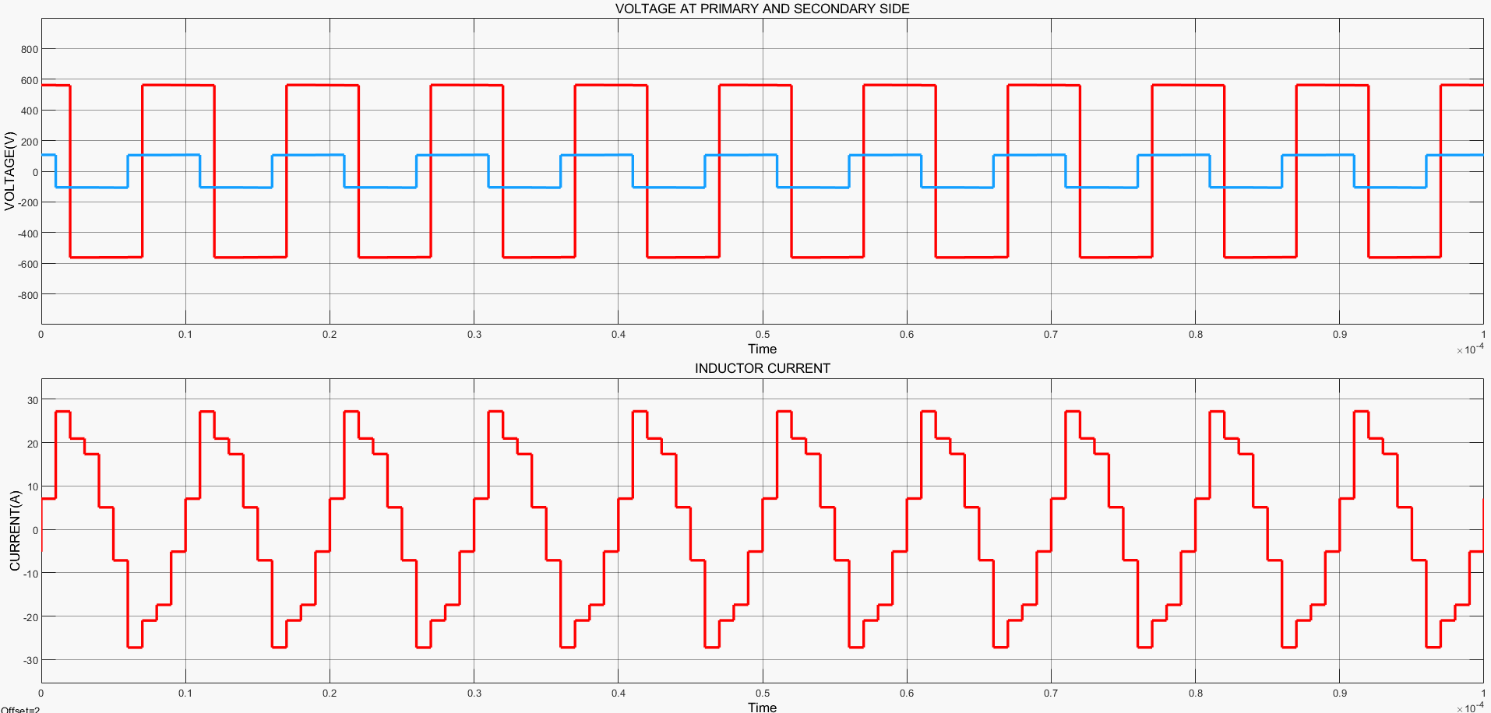

Figure DAB PRIMARY AND SECONDARY VOLTAGE

PLOT2: INDUCTOR CURRENT

**INVERTER TO MEET AC LOADS**

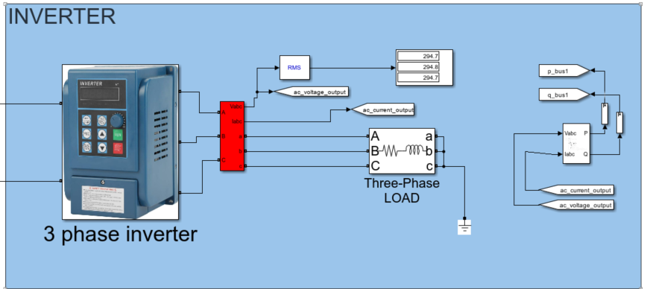

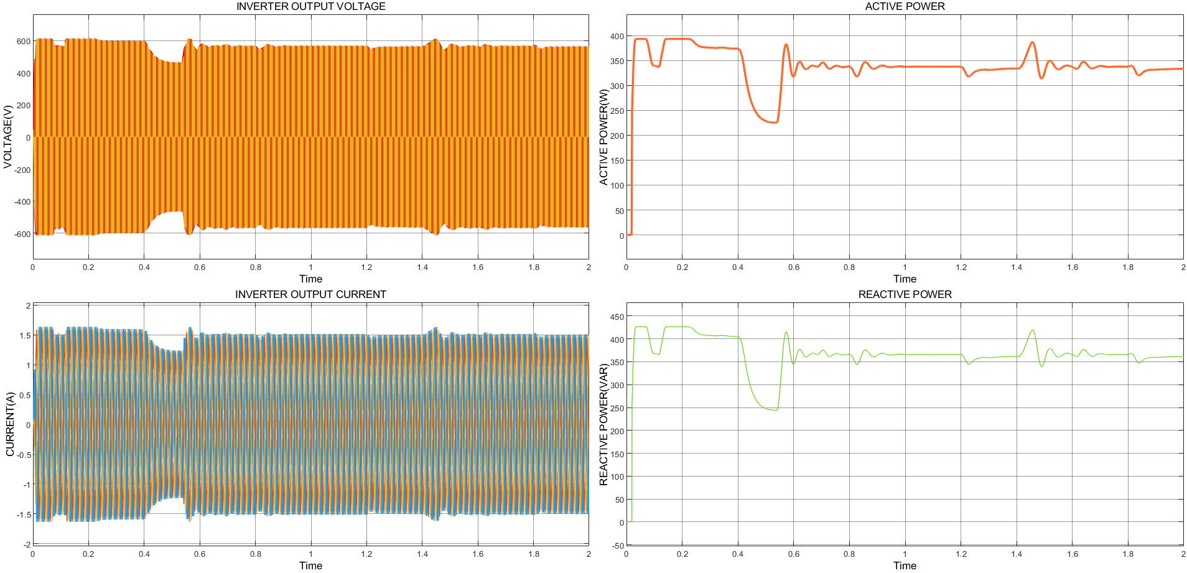

Figure INVERTER OUTPUT

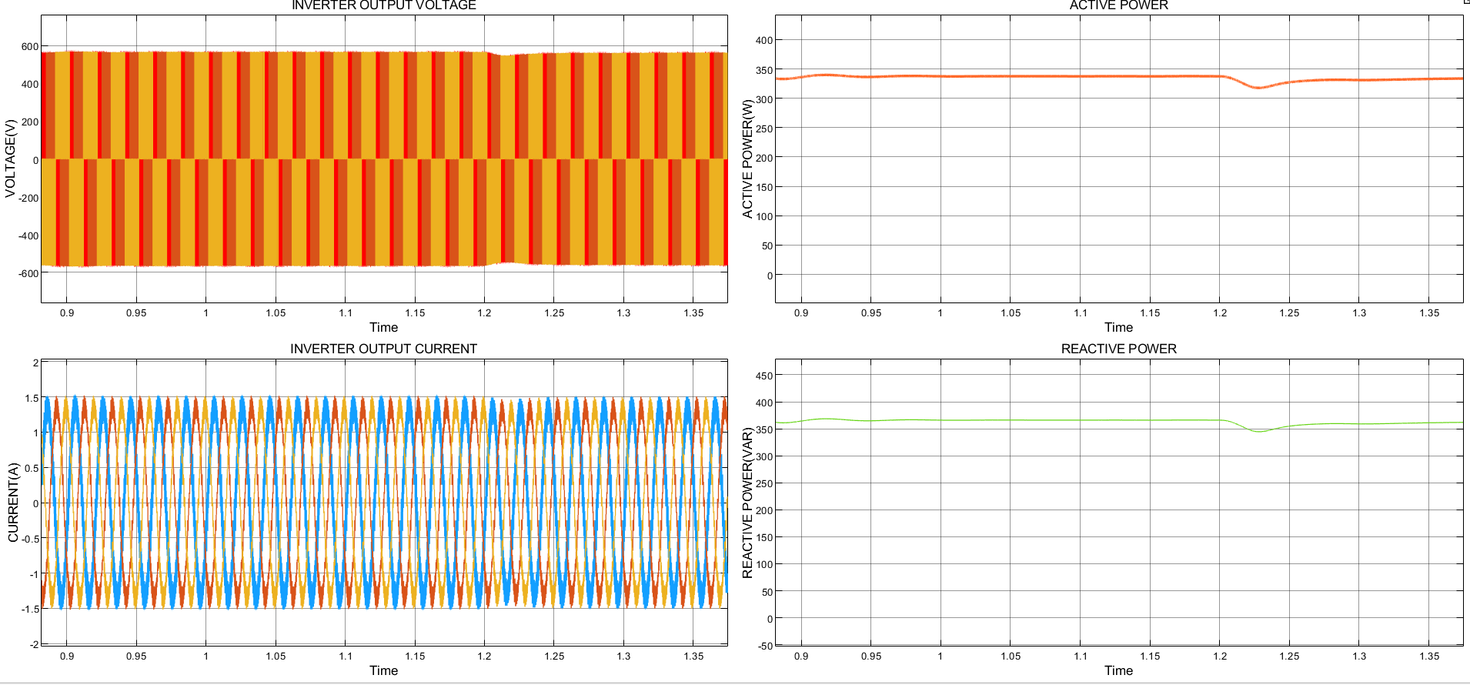

Even though the generated power changes the AC voltage and power remain the same ,because the dc bus voltage is controlled .

References

DAB - <https://in.mathworks.com/help/sps/ug/power-converters-dab-1ph.html>

<https://in.mathworks.com/videos/modeling-and-control-of-a-dual-active-bridge-dab-for-electric-vehicle-and-battery-charging-applications-1680202288419.html>

<https://in.mathworks.com/discovery/dual-active-bridge.html>

**solar pv -** [**https://www.youtube.com/watch?v=rR--Bj7hfRg**](https://www.youtube.com/watch?v=rR--Bj7hfRg)

**WIND -** [**https://www.youtube.com/watch?v=vE55TcCJ2OI**](https://www.youtube.com/watch?v=vE55TcCJ2OI)

[**https://www.youtube.com/watch?v=-fpDhsvBIeY&t=1s**](https://www.youtube.com/watch?v=-fpDhsvBIeY&t=1s)