NETFLIX CONTENT ANALYSIS:
AN EXPLORATORY DATA ANALYSIS
Comprehensive Internship Project Report
Student Name: | Suchismita Das
University: | Ravenshaw University (BCA Program)
Company / Organization: | ShadowFox
Internship Role: | Data Scientist Intern
Internship Duration: | September 1st, 2026 – September 30th, 2026
Project Mentor: | Hariharan MB

1. Introduction
Exploratory Data Analysis (EDA) is a foundational methodology in modern data science that enables analysts to investigate datasets, summarize main statistical characteristics, discover structural patterns, detect anomalies, and test hypotheses before applying complex predictive modeling algorithms. In digital media, subscription video-on-demand (SVOD) platforms like Netflix rely heavily on empirical data analysis to guide content acquisition strategies, regional catalog expansion, target demographic segmentations, and original production investments.
This project report provides an end-to-end exploratory study of the official Netflix Movies and TV Shows dataset. By applying systematic data wrangling, cleaning, feature engineering, statistical cross-tabulations, and data visualization techniques in Python, the study dissects 8,807 title records across 12 metadata dimensions. The report evaluates catalog proportions, multi-year content addition trajectories, multi-label genre and country representations, content rating distributions, runtime bell curves, and TV show lifespan dynamics.
2. Internship Overview
This report synthesizes the professional work completed during the Data Science Internship program at ShadowFox. The details of the internship engagement are summarized below:
Student Name: Suchismita Das
Academic Institution: Ravenshaw University (Bachelor of Computer Applications)
Host Organization: ShadowFox
Internship Role: Data Scientist Intern
Internship Duration: September 1st, 2026 – September 30th, 2026
Industry Mentor: Hariharan MB
ShadowFox provided an industry-aligned internship environment designed to develop practical analytics capabilities through hands-on project execution. Under the structured guidance of mentor Hariharan MB, the internship focused on constructing an end-to-end data pipeline in Python, performing rigorous data auditing and cleaning, producing reproducible Jupyter Notebooks, and communicating technical findings through professional documentation and high-resolution data visualizations.
3. Objectives
The overarching objective of the internship was to execute a thorough exploratory data analysis of Netflix's content library. The specific technical and analytical goals were:
1. Catalog Format Composition: Quantify the exact distribution between standalone Movies and episodic TV Shows across the global library.
2. Temporal Expansion Tracking: Map annual title additions from 2008 to 2021 to identify peak catalog growth phases and strategic licensing shifts.
3. Multi-Label Genre Decomposition: Unnest multi-category listings to identify leading programming classifications and audience preferences.
4. Geographic Production Analysis: Explode multi-country production credits to measure regional output and identify international market strongholds.
5. Target Demographic Profiling: Analyze maturity rating classifications across media formats to understand audience targeting strategies.
6. Runtime & Longevity Distribution: Evaluate film duration bell curves and TV show season longevity structures.
7. Content Lag Time Evaluation: Measure the temporal gap between original theatrical/broadcast release dates and platform addition dates.
8. Reproducible Pipeline Engineering: Deliver modular Python scripts, clean CSV outputs, and publication-grade visual artifacts.
4. Tasks and Responsibilities
During the internship period, Suchismita Das assumed full technical responsibility for the execution of the project lifecycle, including:
• Repository Setup & Environment Configuration: Establishing a modular folder hierarchy (data/, notebooks/, outputs/, src/, docs/) and configuring virtual environments with specified dependency versions.
• Data Ingestion & Auditing: Loading raw dataset files (netflix_titles.csv / netflix_titles.txt containing 8,807 rows × 12 columns), inspecting missingness distributions, and verifying unique identifier integrity.
• Non-Destructive Data Cleaning: Developing Pandas transformation logic to impute missing metadata (director, cast, country, rating) with 'Unknown' values without discarding rows.
• Regex-Based Feature Engineering: Constructing regular expressions to extract integer runtimes (duration_value) and unit identifiers (duration_unit), and deriving content lag metrics (content_age_at_addition).
• String Unnesting & Exploding: Implementing string splitting and exploding algorithms to disaggregate multi-value genre and country columns without losing parent row relationships.
• Statistical Aggregation & Crosstabulation: Generating frequency tables, contingency matrices, and summary statistic DataFrames.
• Visual Artifact Production: Coding Matplotlib and Seaborn visualization scripts to export 9 distinct figures at 300 DPI resolution.
• Documentation & Refactoring: Extracting modular cleaning logic into src/clean_data.py and documenting reproducibility workflows in README.md.
5. Project Overview
The project, titled 'Netflix Content Analysis: An Exploratory Data Analysis', investigates the content ecosystem of Netflix using metadata spanning 8,807 titles. By transforming unstandardized strings, combined dates, and multi-value text fields into structured analytical features, the project exposes historical curation patterns, regional investment focuses, content lifecycle lengths, and demographic positioning.
6. Problem Statement
Digital entertainment providers face complex strategic decisions regarding licensing budgets, regional content acquisition, target demographic focus, and original programming development. The central research problem addressed by this project is:
'What macro-level patterns, growth trajectories, geographic concentrations, and content duration characteristics define the Netflix streaming catalog based on metadata from 2008 to 2021?'
Supporting sub-questions include:
1. What is the structural proportion of Movies versus TV Shows in the catalog?
2. How did annual additions evolve across the 2008–2021 timeline?
3. Which genres and producing nations drive the highest volume of title associations?
4. What maturity ratings dominate the service?
5. What are the distributional standards for movie runtimes and TV show season counts?
7. Dataset Description
The analysis is grounded in the official netflix_titles.csv dataset, comprising 8,807 records and 12 columns. The schema and baseline data quality characteristics are detailed below:
Column Name | Data Type | Non-Null | Missing % | Description / Example
show_id | object | 8,807 | 0.00% | Unique title ID (e.g., s1, s2)
type | object | 8,807 | 0.00% | Media format: 'Movie' or 'TV Show'
title | object | 8,807 | 0.00% | Official content title name
director | object | 6,173 | 29.91% | Director name(s); comma-separated
cast | object | 7,982 | 9.37% | Lead cast members; comma-separated
country | object | 7,976 | 9.43% | Production country/countries
date_added | object | 8,797 | 0.11% | Date added to Netflix catalog
release_year | int64 | 8,807 | 0.00% | Original release year
rating | object | 8,803 | 0.05% | Maturity rating (e.g., TV-MA, TV-14)
duration | object | 8,804 | 0.03% | Runtime string ('90 min', '3 Seasons')
listed_in | object | 8,807 | 0.00% | Categories/genres; comma-separated
description | object | 8,807 | 0.00% | Textual synopsis of the content

8. Tools and Technologies
The project stack utilizes open-source Python analytics libraries:
• Programming Language: Python 3.12
• Data Wrangling & Manipulation: Pandas (DataFrames, datetime parsing, regex string processing, cross-tabulations) and NumPy (numeric arrays, conditional filtering).
• Data Visualization: Matplotlib (base figure plotting, axes formatting) and Seaborn (statistical themes, bar charts, line plots, heatmaps).
• Path Management & Utilities: Pathlib (Path cross-platform filesystem routing) and Warnings (suppression of non-critical execution warnings).
• Environment & Execution: Jupyter Notebook (.ipynb interactive development) and Python Virtual Environment (.venv dependency isolation).
9. Methodology
The exploratory data analysis followed an 8-phase scientific methodology:
1. Ingestion: Reading raw CSV data into a Pandas DataFrame using Path objects.
2. Quality Assessment: Auditing missing values, row duplication, unique constraints, and memory utilization.
3. Data Preprocessing: Imputing missing text values with 'Unknown' and parsing string dates into datetime64 format.
4. Feature Engineering: Extracting year, month, month name, numeric duration, unit identifiers, and content age at addition.
5. Category Unnesting: Splitting comma-separated genre and country fields into exploded sub-DataFrames.
6. Cross-Tabulation & Aggregation: Computing contingency tables and summary statistics.
7. Visual Output Generation: Plotting and exporting 9 high-resolution chart images.
8. Findings Synthesis: Interpreting visual data patterns and formulating data-grounded conclusions.
10. Data Collection
The dataset utilized in this project was supplied directly for the ShadowFox internship program. The primary source file netflix_titles.csv (with a backup raw text format netflix_titles.txt) was stored under data/. All processing operations were executed on a non-destructive copy of the dataset to preserve raw source data integrity.
11. Data Preprocessing
Data preprocessing transformed raw metadata into clean, structured analytical features:
• Categorical Imputation: Filled missing values in director (2,634 cells), cast (825 cells), country (831 cells), and rating (4 cells) with 'Unknown', preserving all 8,807 original rows.
• Datetime Conversion: Converted date_added strings to datetime objects via pd.to_datetime(..., errors='coerce').
• Temporal Feature Extraction: Extracted year_added (float/int), month_added (float/int), and month_name (string).
• Regex Runtime Extraction: Extracted numeric values from duration using regex pattern r'(\d+)' into duration_value and unit strings using r'([A-Za-z]+)$' into duration_unit.
• Content Lag Metric: Calculated content_age_at_addition = year_added - release_year, masking negative lag values.
• Multi-Value Exploding: Created genre_df and country_df by executing .str.split(', ').explode().
12. Exploratory Data Analysis
EDA examined the dataset across six key analytical dimensions:
1. Format Composition: Movies represent 6,131 titles (69.6%), whereas TV Shows account for 2,676 titles (30.4%), demonstrating a 2.29:1 film dominance.
2. Expansion Acceleration: Catalog additions were negligible prior to 2015, accelerating rapidly to peak additions in 2019 for Movies (1,424 titles) and 2020 for TV Shows (595 titles).
3. Category Hierarchy: Top exploded categories are International Movies (2,752 title associations), Dramas (2,427), Comedies (1,674), International TV Shows (1,351), and Documentaries (869).
4. Geographic Concentration: The United States leads global output with 3,689 title associations, followed by India (1,046), the United Kingdom (801), Canada (445), and France (393).
5. Rating Demographics: TV-MA is the single largest rating category (2,062 Movies, 1,146 TV Shows, total 3,208), followed by TV-14 (1,427 Movies, 733 TV Shows).
6. Runtime Bell Curve & Season Longevity: Movie durations form a normal distribution centered at 90–110 minutes (mean 99.6 min). TV Shows exhibit a sharp power-law drop-off, where 1,793 shows (67%) completed only 1 season.
13. Implementation
The project implementation is organized into a modular project directory containing executable Jupyter Notebooks and reusable Python modules:
• Jupyter Notebook: notebooks/Netflix_Content_Analysis.ipynb executes sequential data loading, cleaning, crosstabulation, and inline visualization.
• Preprocessing Script: src/clean_data.py encapsulates cleaning transformations into reusable pipeline functions.
• File Management: Uses pathlib.Path for cross-platform file routing, exporting cleaned CSV files and PNG figures to outputs/.
14. Important Code Explanation
Key Python code snippets from the implementation notebook demonstrate core analytical workflows:
1. Data Ingestion & Quality Profiling
import pandas as pd
import numpy as np
from pathlib import Path
DATA_PATH = Path('../data/netflix_titles.csv')
df = pd.read_csv(DATA_PATH)
print(f'Shape: {df.shape}')
Explanation: Imports Pandas and NumPy, constructs a relative path object, ingests the CSV dataset into a DataFrame, and verifies dataset shape (8,807 rows × 12 columns).
2. Datetime Parsing & Imputation
clean = df.copy()
clean['date_added'] = pd.to_datetime(clean['date_added'], errors='coerce')
for col in ['director', 'cast', 'country', 'rating']:
clean[col] = clean[col].fillna('Unknown')
Explanation: Performs non-destructive copy, safely parses string dates into datetime objects, and fills missing categorical text cells with 'Unknown'.
3. Regex Runtime Extraction & Feature Engineering
clean['year_added'] = clean['date_added'].dt.year
clean['month_added'] = clean['date_added'].dt.month
clean['duration_value'] = pd.to_numeric(clean['duration'].str.extract(r'(\d+)')[0], errors='coerce')
clean['duration_unit'] = clean['duration'].str.extract(r'([A-Za-z]+)$')[0]
clean['content_age_at_addition'] = clean['year_added'] - clean['release_year']
Explanation: Extracts numeric years and months, applies regular expressions to isolate numeric runtimes and unit text, and computes catalog lag time.
4. Multi-Value Category Exploding
genre_df = clean.assign(genre=clean['listed_in'].str.split(', ')).explode('genre')
country_df = clean.assign(country_clean=clean['country'].str.split(', ')).explode('country_clean')
Explanation: Splits comma-separated strings into lists and explodes them into individual rows, enabling multi-label category and country analyses.
15. Data Visualization
All 9 visual outputs generated during the exploratory data study are presented below with complete figure numbers, filenames, cell mappings, and detailed analytical explanations:

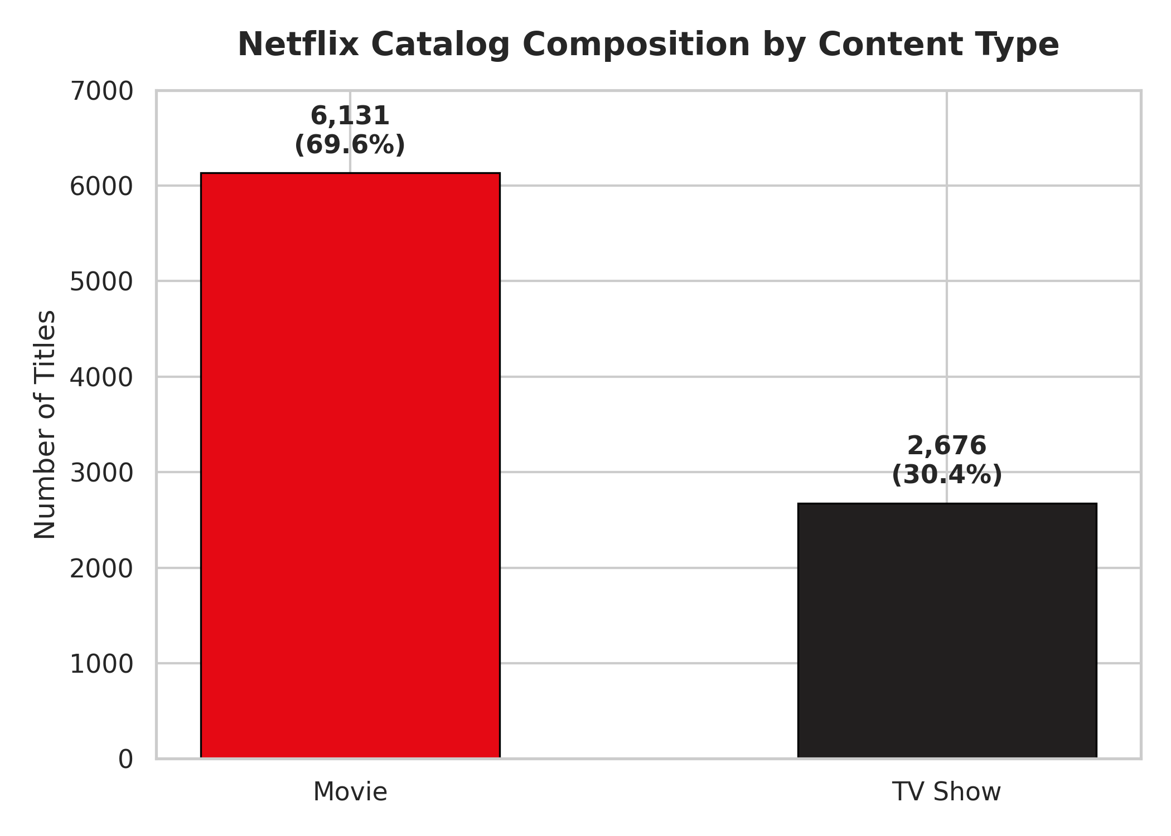
Caption: Figure 1: Netflix Catalog Composition by Content Type (01_content_type_distribution.png)
Notebook Cell Source: Section 6 (Overall Catalog Composition - In [15])
Observation: The vertical bar chart compares Movies (6,131 titles) against TV Shows (2,676 titles). Feature films constitute 69.6% of the catalog, demonstrating that standalone cinematic titles form the core foundation of Netflix's overall content library.
📌 KEY OBSERVATION
Movies outnumber TV Shows by a ratio of 2.29 to 1, demonstrating historical platform acquisition emphasis on single-viewing feature films over episodic TV series.

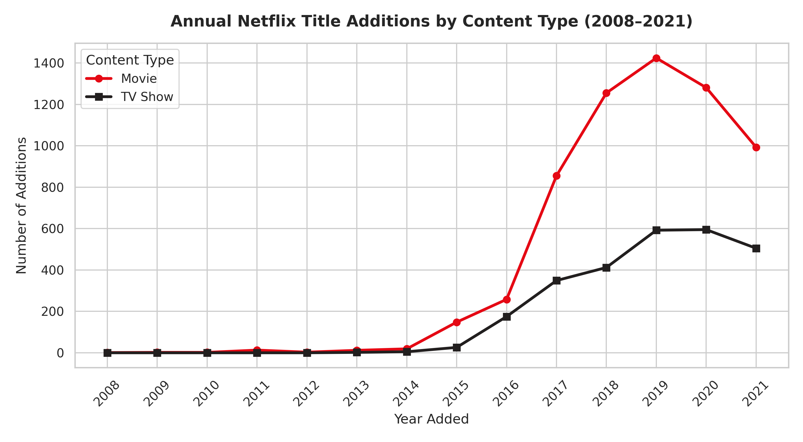
Caption: Figure 2: Annual Netflix Title Additions by Content Type from 2008 to 2021 (02_content_additions_by_year.png)
Notebook Cell Source: Section 7 (Content Addition Trends Over Time - In [18])
Observation: The dual line graph tracks annual catalog additions. Additions were minimal prior to 2015 before experiencing exponential acceleration. Movie additions peaked in 2019 (~1,424 additions) before declining, while TV Show additions peaked in 2020 (~595 additions).
📌 KEY OBSERVATION
The post-2019 contraction in movie additions reflects licensing shifts, market saturation, and a strategic turn toward commissioned TV series.

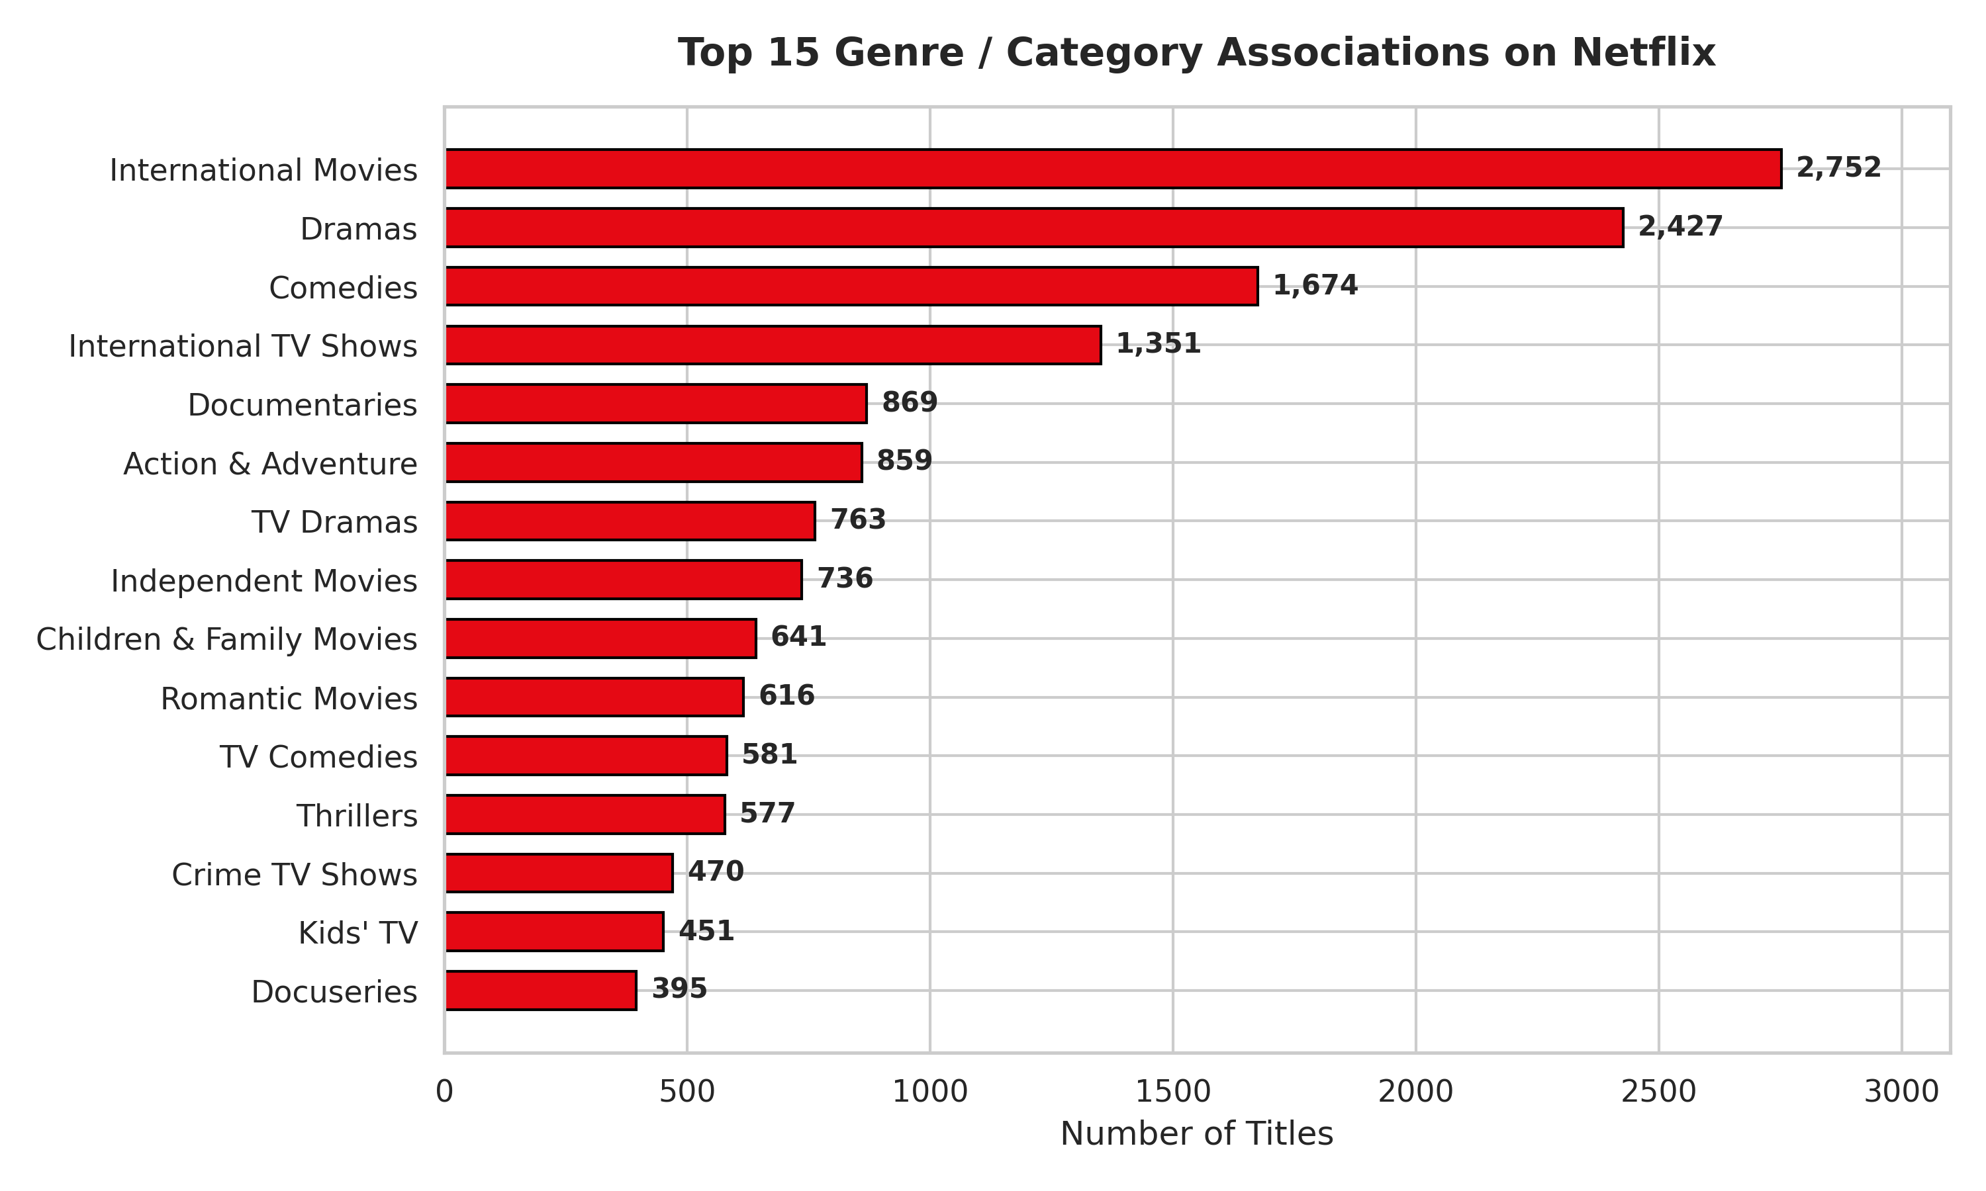
Caption: Figure 3: Top 15 Genre Associations on Netflix (03_top_genres.png)
Notebook Cell Source: Section 8 (Multi-Label Genre Analysis - In [20])
Observation: Horizontal bar chart ranking exploded genre counts. International Movies leads with 2,752 title associations, followed by Dramas (2,427), Comedies (1,674), and International TV Shows (1,351).
📌 KEY OBSERVATION
Non-English international titles and serialized drama/comedy content drive Netflix's primary global content categorization strategy.

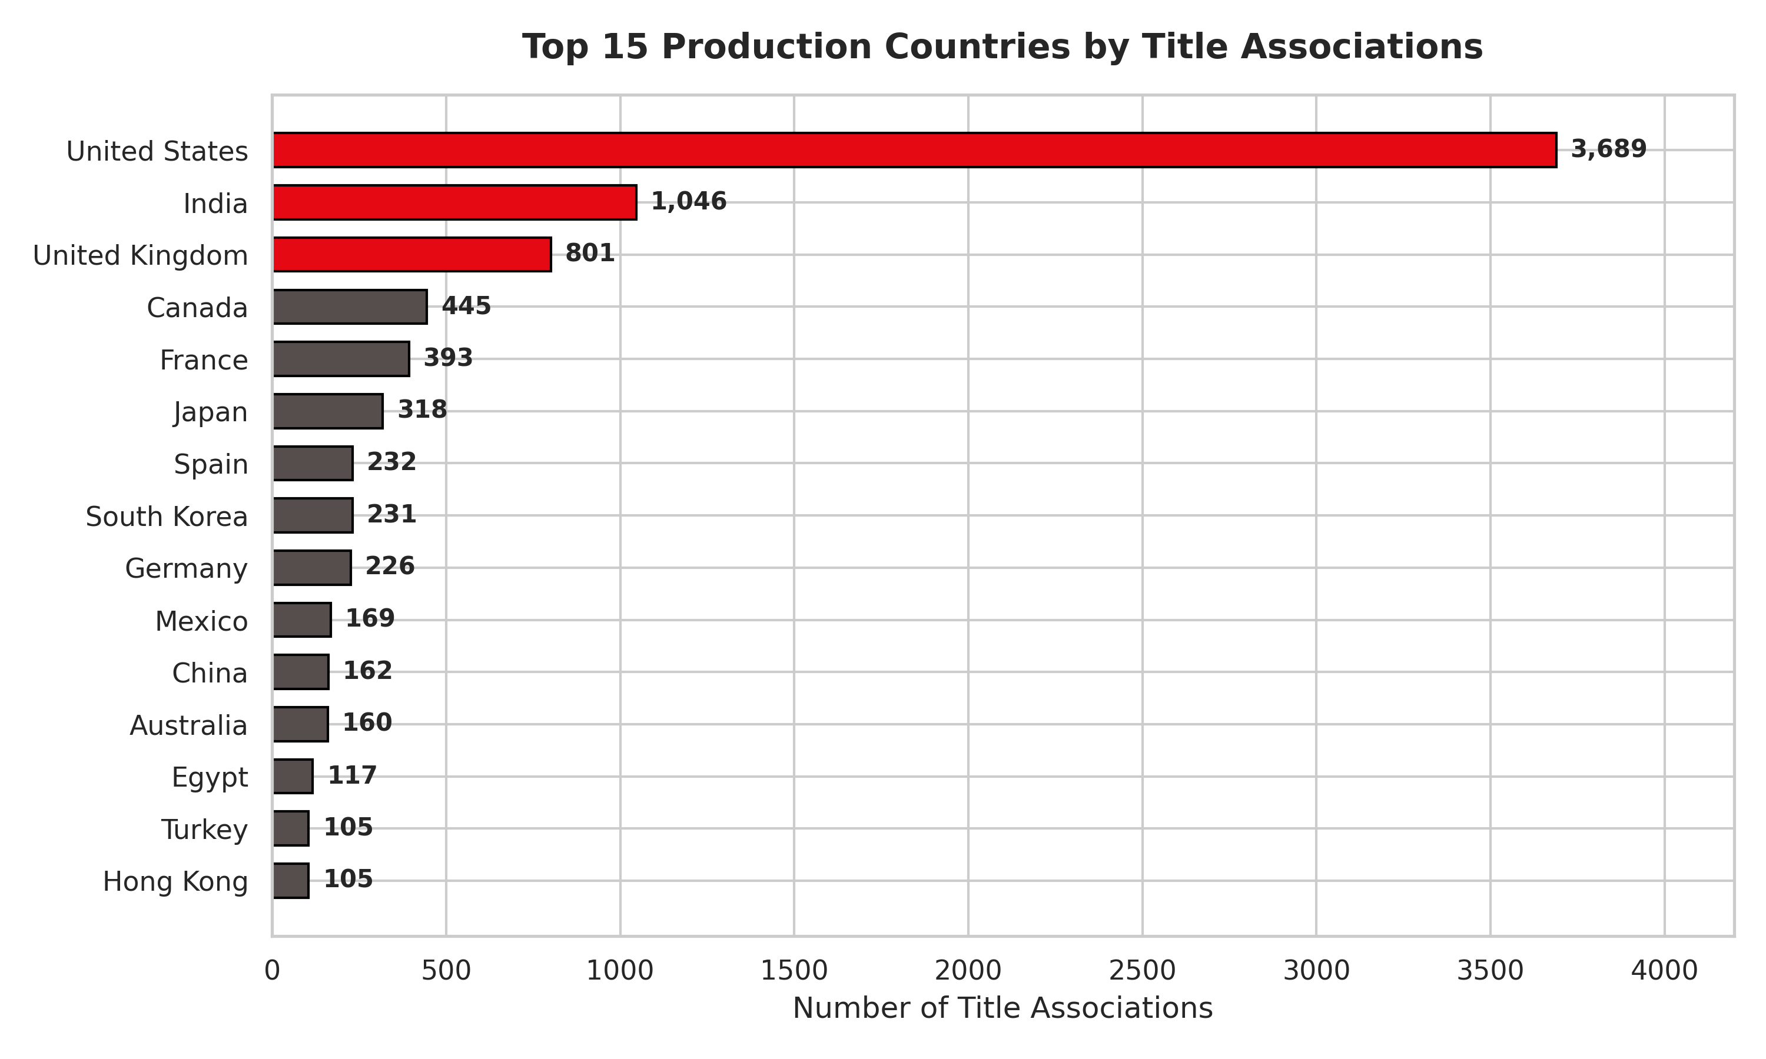
Caption: Figure 4: Top 15 Production Countries by Title Associations (04_top_countries.png)
Notebook Cell Source: Section 9 (Geographic Production Analysis - In [23])
Observation: Horizontal bar chart illustrating global geographic output. The United States holds a dominant lead (>3,600 associations), followed by India (>1,000) and the United Kingdom (>800).
📌 KEY OBSERVATION
The US produces more titles than the next four countries combined; India's strong second position reflects massive Bollywood movie catalog licensing.

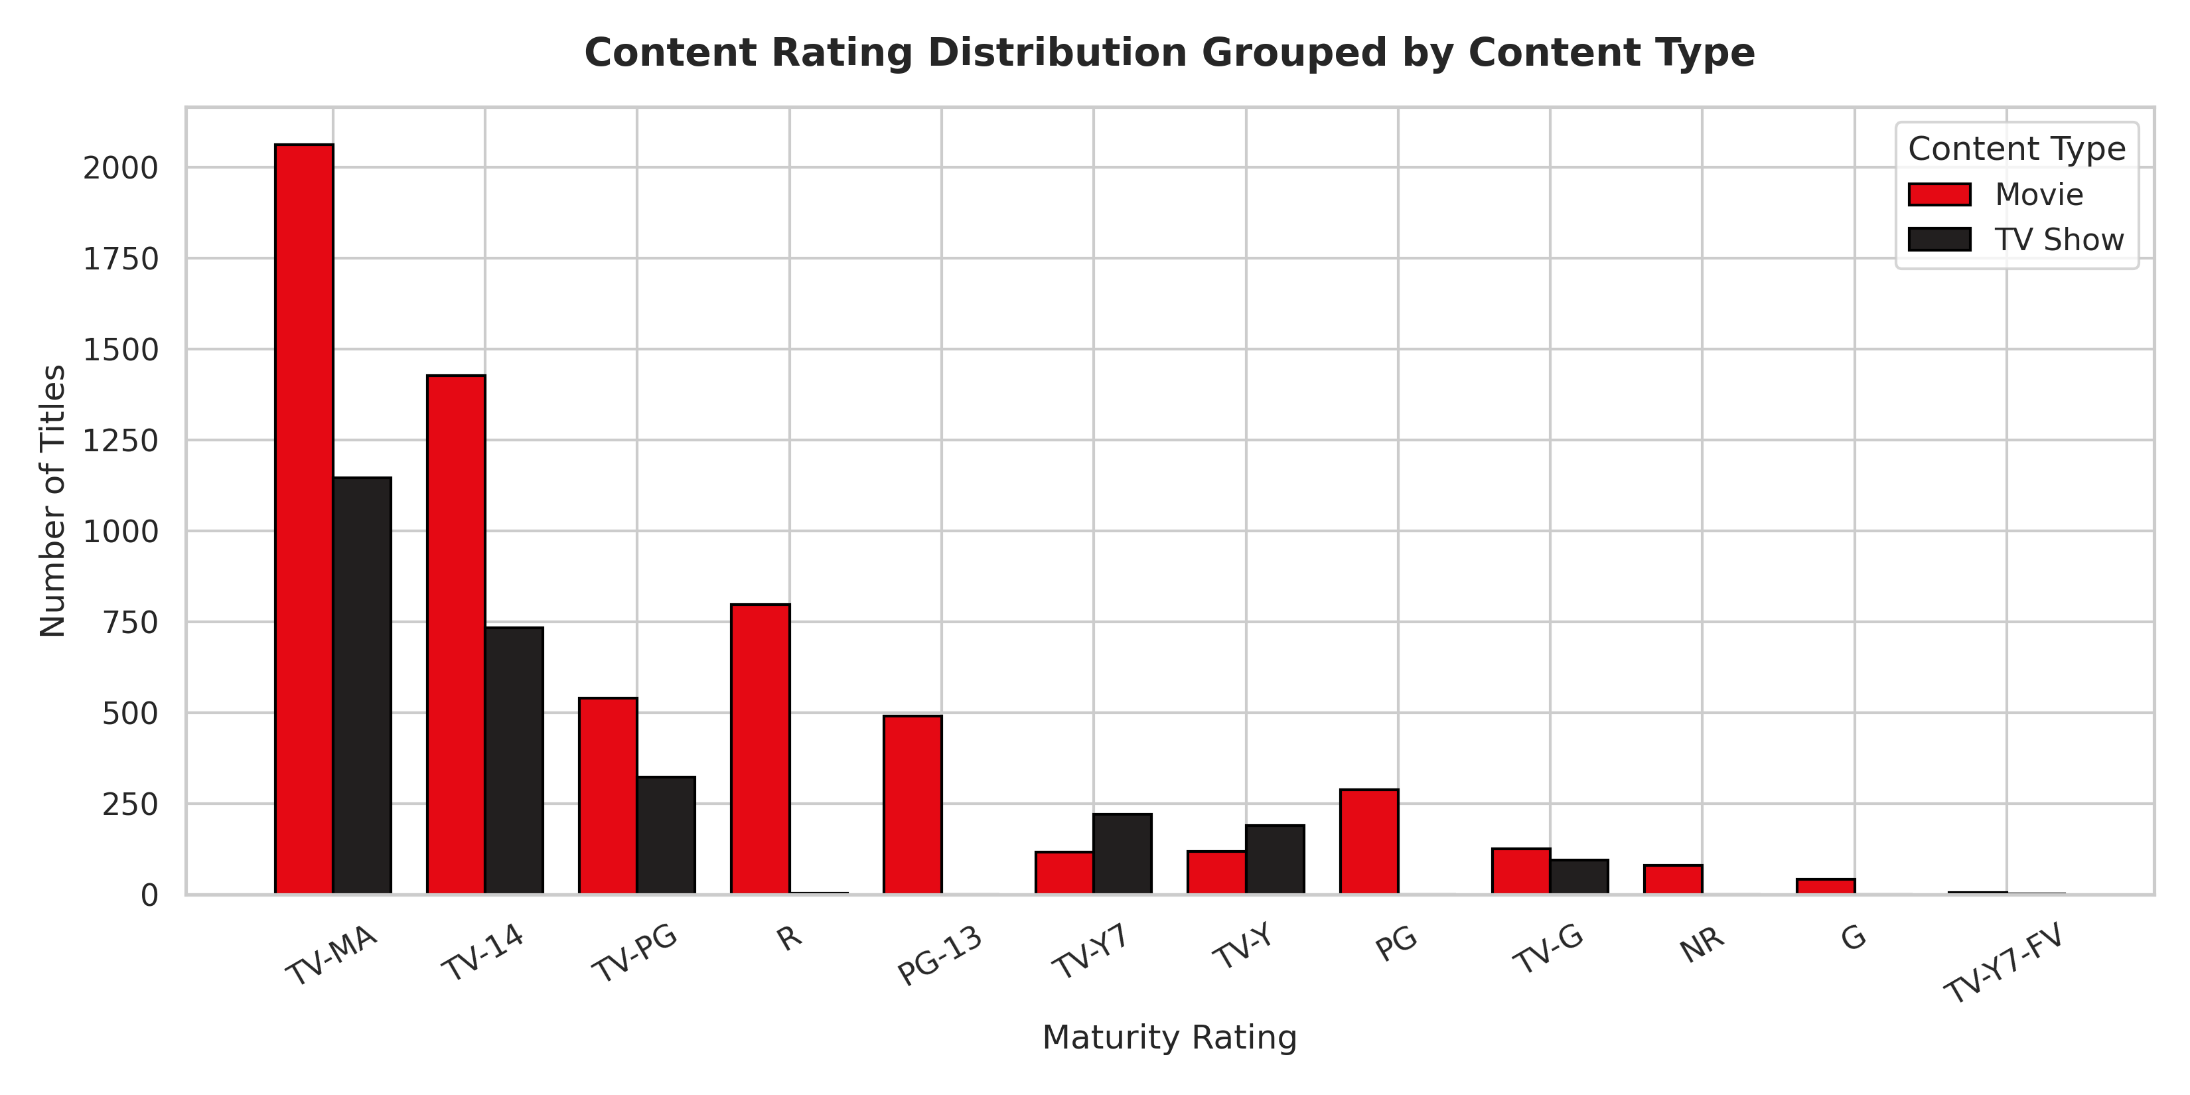
Caption: Figure 5: Content Rating Distribution Grouped by Format (05_ratings_by_type.png)
Notebook Cell Source: Section 10 (Maturity Rating Analysis - In [26])
Observation: Grouped bar chart displaying catalog volume across maturity ratings. TV-MA is the largest rating category (2,062 Movies, 1,146 TV Shows), followed by TV-14 (1,427 Movies, 733 TV Shows).
📌 KEY OBSERVATION
Over 50% of the Netflix catalog is classified under mature audience ratings (TV-MA, TV-14, R), demonstrating focus on young adult and adult demographics.

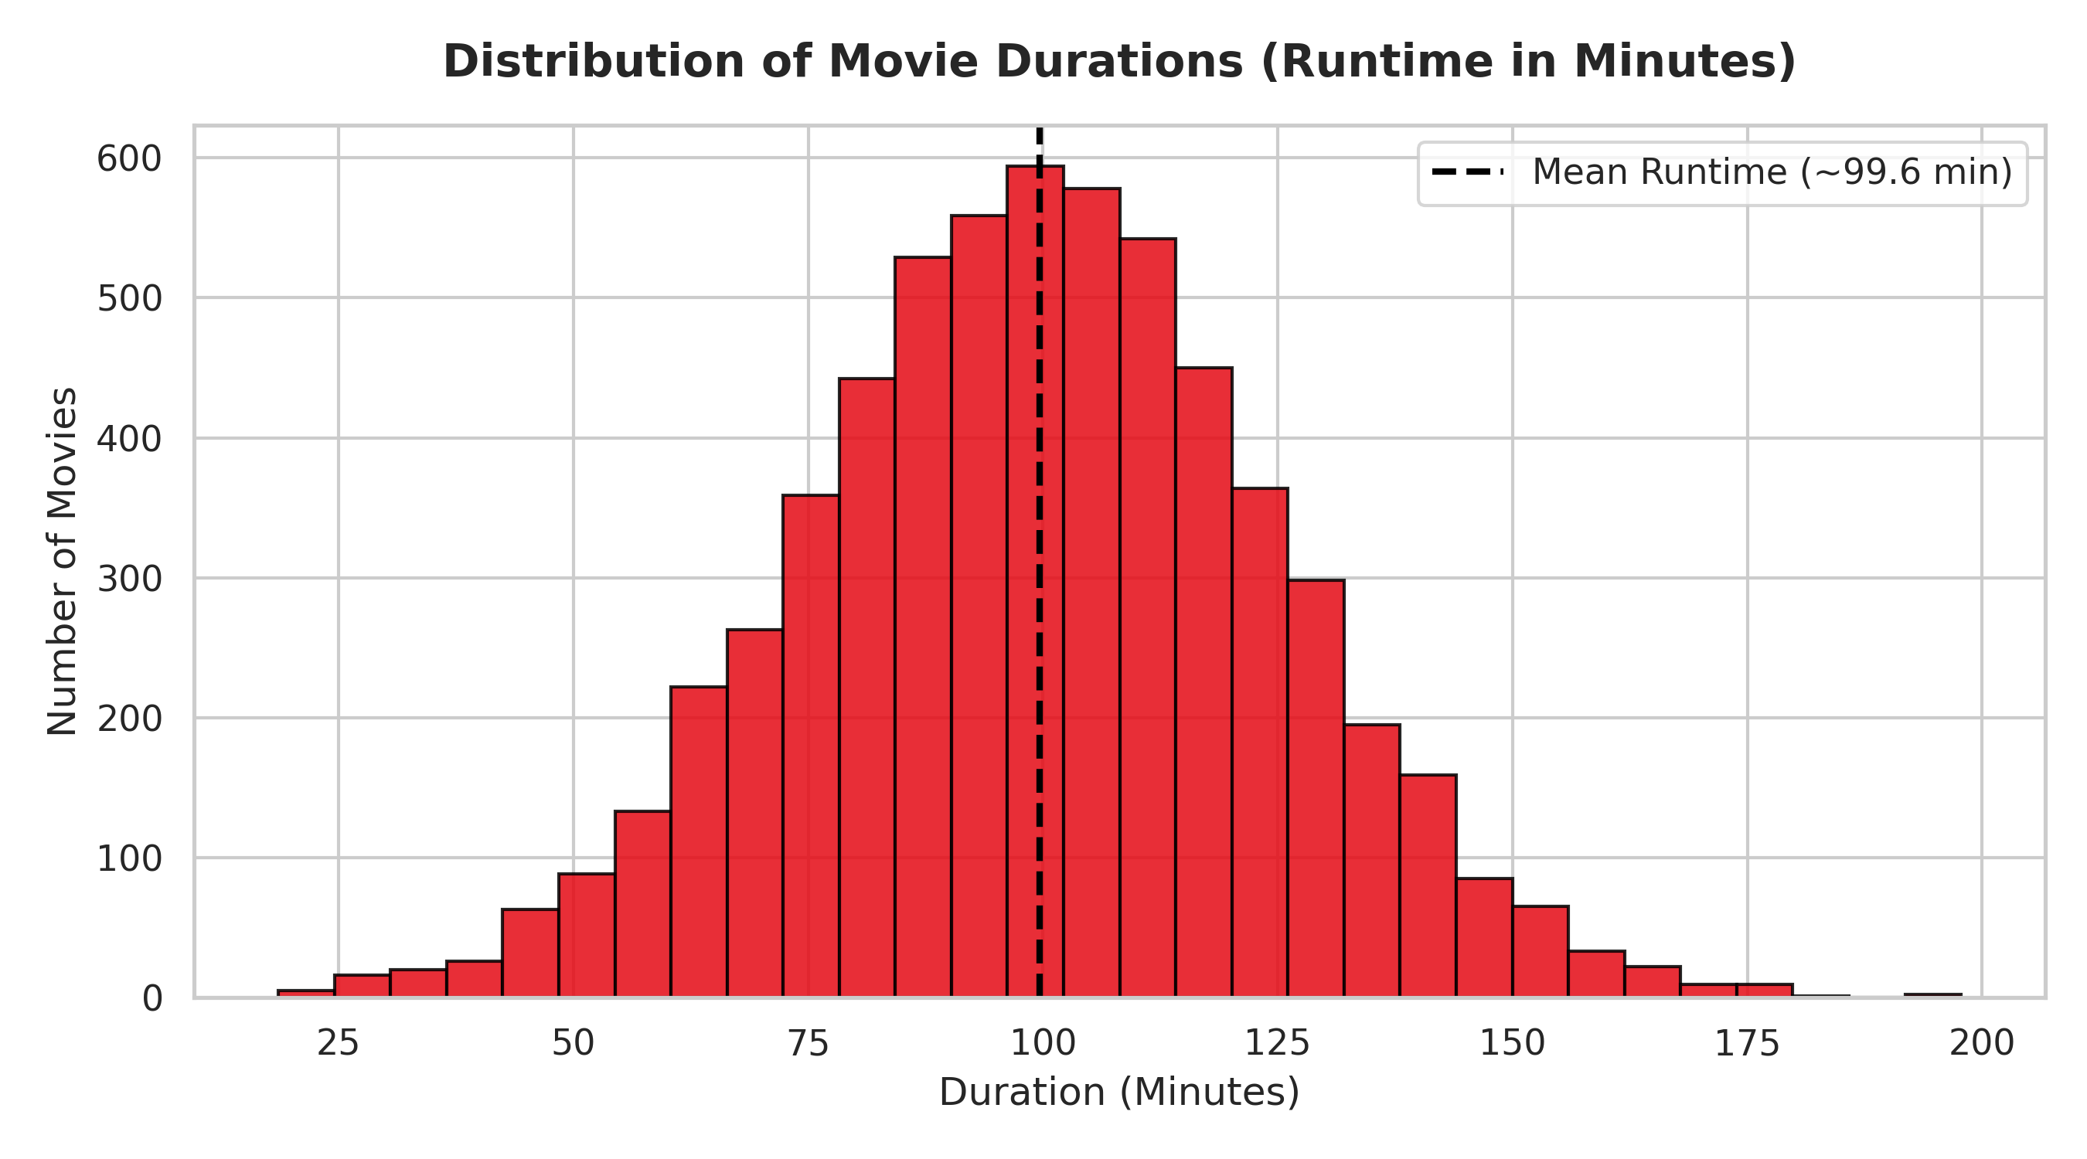
Caption: Figure 6: Histogram of Movie Durations in Minutes (06_movie_duration_distribution.png)
Notebook Cell Source: Section 11 (Movie Runtime Analysis - In [29])
Observation: Histogram with 30 bins displaying movie runtimes. The distribution follows a normal bell curve centered between 90 and 110 minutes, with a calculated mean runtime of 99.6 minutes.
📌 KEY OBSERVATION
Netflix movie runtimes strictly adhere to commercial theatrical standards of 1.5 to 2 hours; short films under 50 min or epics over 180 min are rare outliers.

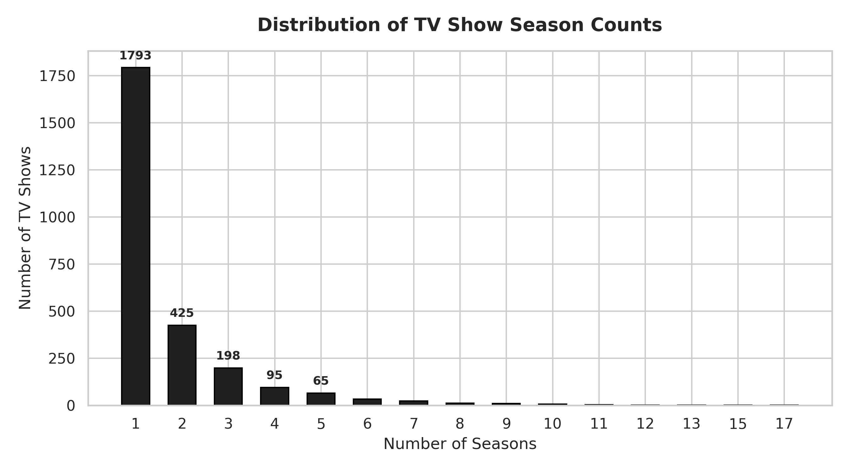
Caption: Figure 7: Distribution of TV Show Season Counts (07_tv_season_distribution.png)
Notebook Cell Source: Section 11 (TV Show Season Longevity - In [29])
Observation: Histogram plotting TV series against total completed seasons. Over 1,790 TV shows (67%) consist of only 1 season, with a sharp drop for 2 seasons (425 shows) and 3 seasons (198 shows).
📌 KEY OBSERVATION
Highlights a steep 'single-season attrition rate,' where the vast majority of series do not achieve multi-season renewal.

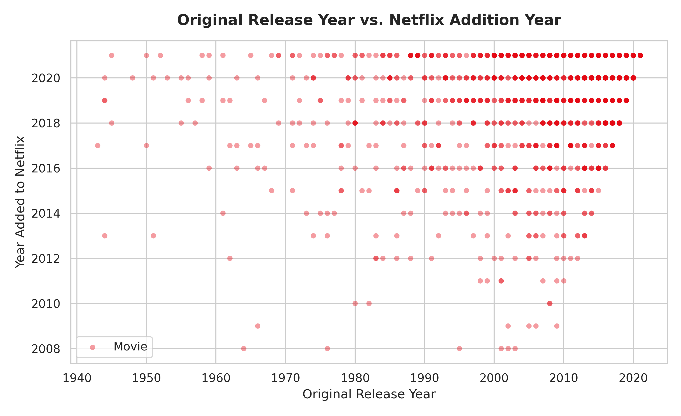
Caption: Figure 8: Original Release Year vs. Netflix Addition Year (08_release_year_vs_added_year.png)
Notebook Cell Source: Section 12 (Release vs. Addition Timing - In [31])
Observation: Scatter plot mapping original release year against Netflix addition year. Displays a dense cluster in the upper-right quadrant (post-2010 releases added post-2015), alongside sparse historical titles back to the 1940s.
📌 KEY OBSERVATION
Proves platform evolution from acquiring historical back-catalogs to hosting contemporary titles shortly after initial premiere.

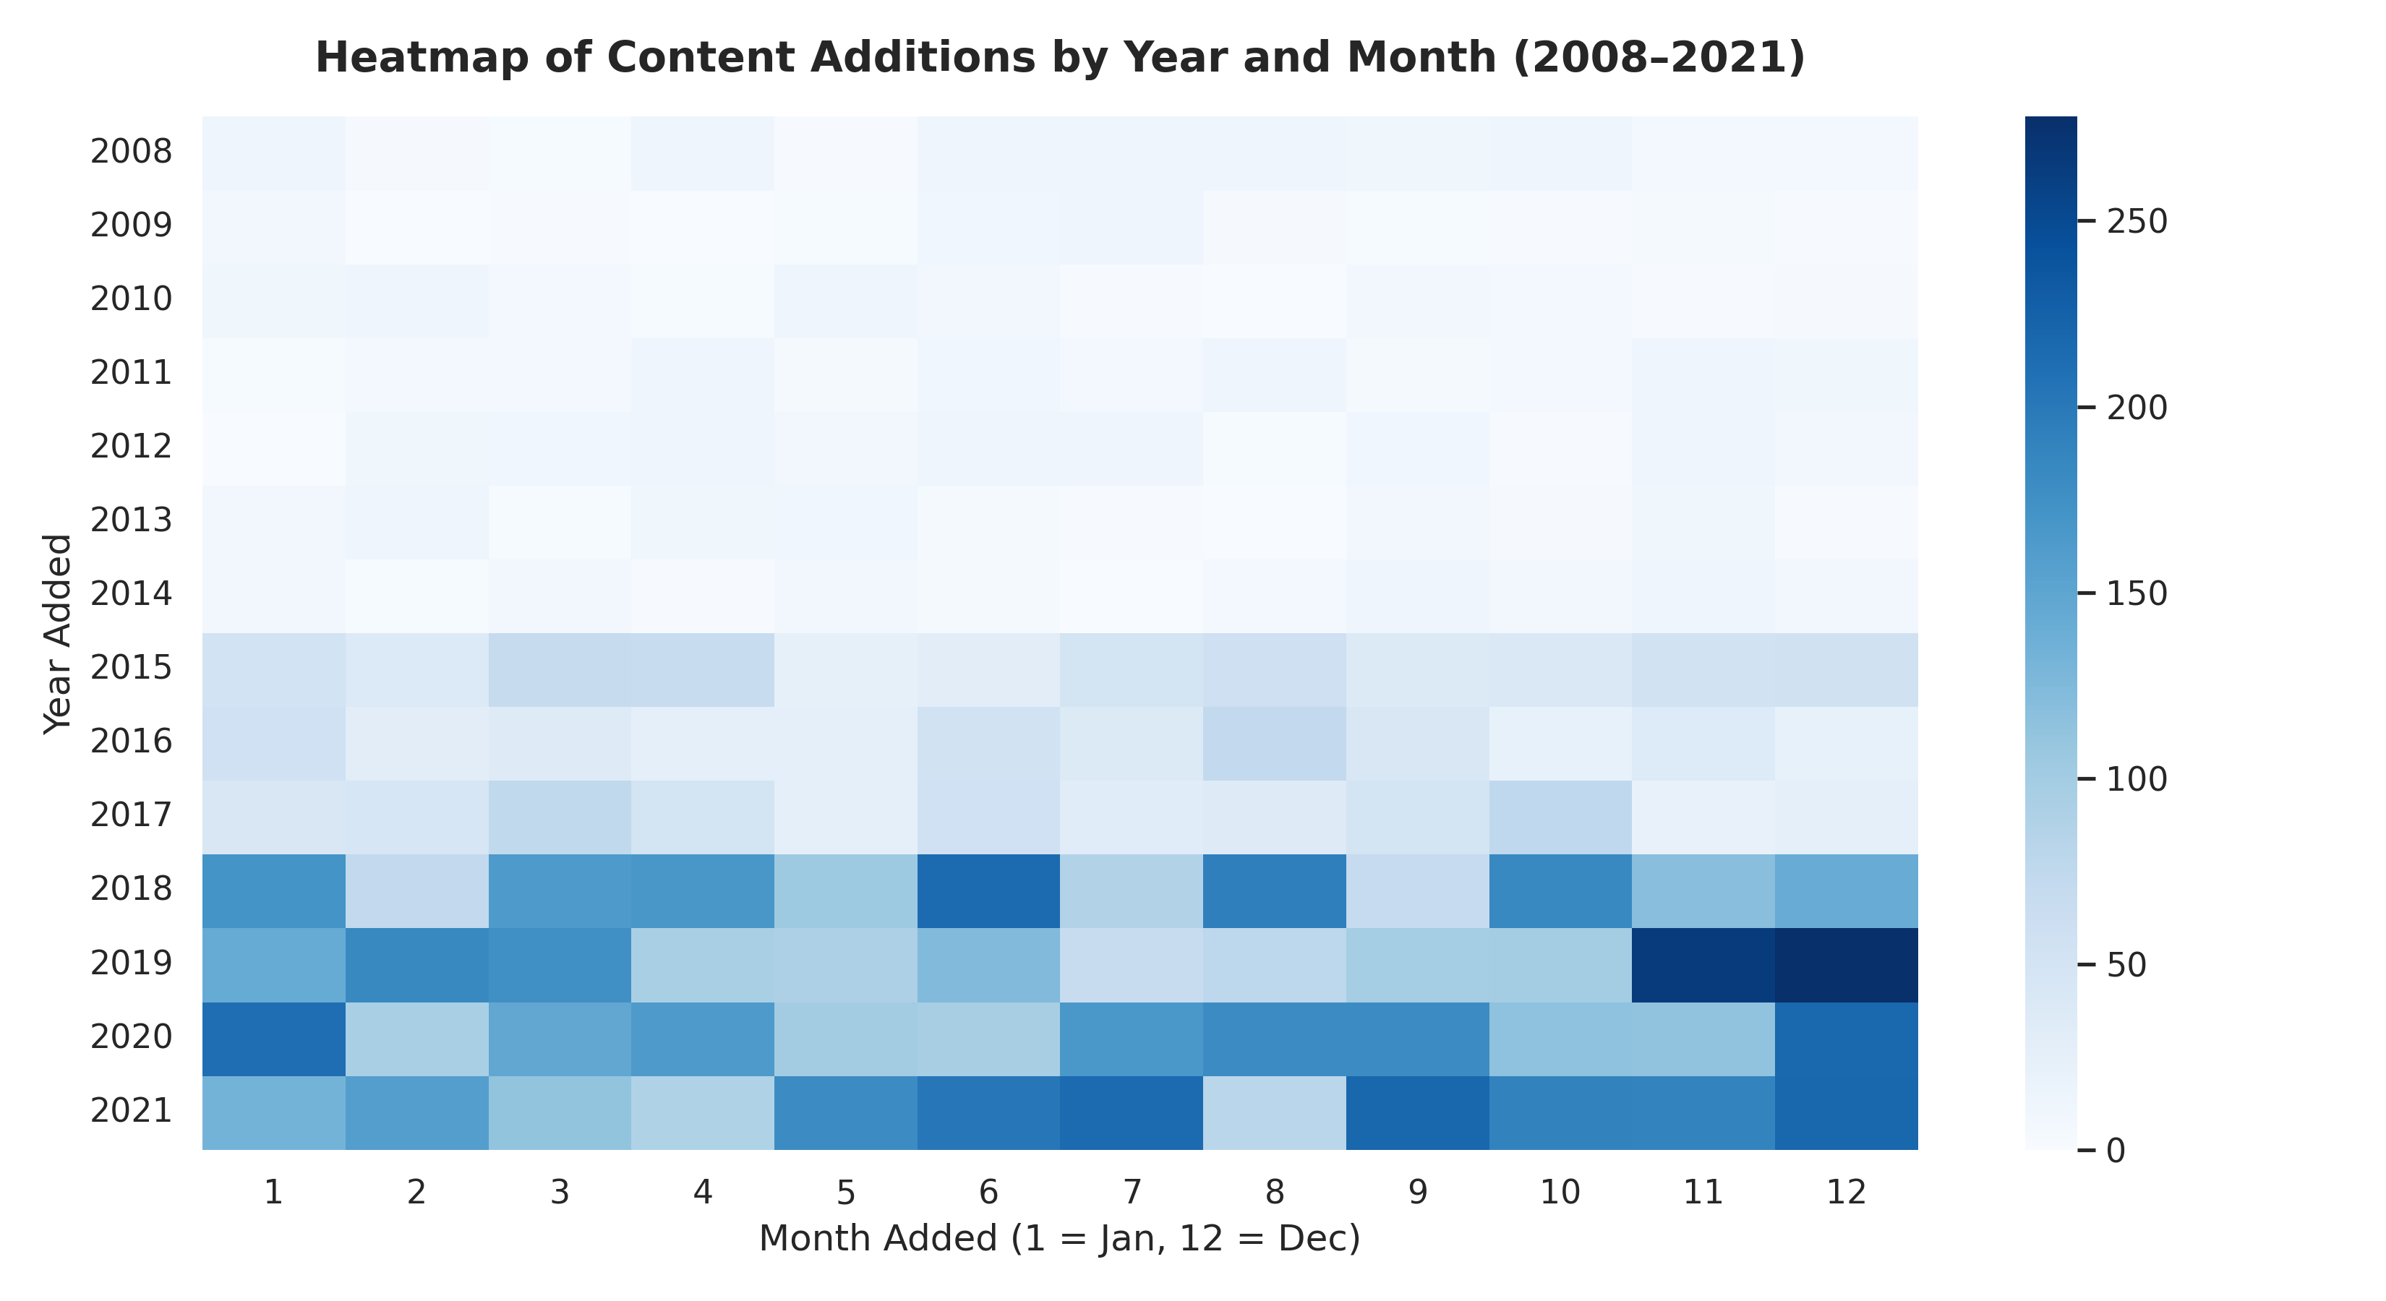
Caption: Figure 9: Heatmap of Content Additions by Year and Month (09_addition_heatmap.png)
Notebook Cell Source: Section 13 (Advanced Temporal Heatmap - In [35])
Observation: 2D color-mapped matrix plotting addition years (2008–2021) against months (1–12). Displays dark high-density blocks in November/December 2019 (>250 additions) and July 2021 (>200 additions).
📌 KEY OBSERVATION
Demonstrates strategic Q4 holiday content drop patterns and heavy sustained platform expansion during peak subscription periods.

16. Results and Findings
The core empirical findings of the exploratory data analysis are summarized as follows:
1. Catalog Split: Movies comprise 6,131 titles (69.6%), outnumbering TV Shows (2,676 titles, 30.4%) by 2.29:1.
2. Expansion Trajectory: Catalog additions surged post-2015, reaching peak additions in 2019 for Movies (1,424) and 2020 for TV Shows (595).
3. Category Dominance: International Movies (2,752), Dramas (2,427), and Comedies (1,674) represent the top category associations.
4. Geographic Output: The United States (3,689) and India (1,046) lead global content production credits.
5. Demographic Focus: TV-MA is the most common rating (3,208 total titles), confirming focus on adult audiences.
6. Format Standards: Movie runtimes average 99.6 minutes in a bell-curve distribution. TV shows experience high single-season mortality (67% single-season).
17. Learning Outcomes
Through this internship at ShadowFox, Suchismita Das mastered several practical data science competencies:
• Advanced Data Wrangling: Efficient use of Pandas for dataset reshaping, datetime parsing, and regular expression extraction.
• Multi-Label Categorical Processing: Utilizing string splitting and exploding algorithms to disaggregate complex string columns.
• Statistical Data Visualization: Designing publication-grade visual charts using Matplotlib and Seaborn.
• Reproducible Engineering: Building modular Python scripts (src/clean_data.py) and structured project documentation.
18. Challenges and Solutions
The project implementation resolved several key technical challenges:
Technical Challenge | Root Cause | Implemented Solution
High Missing Metadata | Missing cells in director (29.9%), country (9.4%), cast (9.4%). | Imputed missing values with string 'Unknown', preserving all 8,807 title records.
Combined Runtime Units | Mixed numeric values and text in duration ('90 min', '2 Seasons'). | Applied regex patterns r'(\d+)' and r'([A-Za-z]+)$' to separate numbers and unit labels.
Multi-Valued Text Strings | Multiple genres or countries stored as single comma-separated strings. | Executed .str.split(', ').explode() to disaggregate strings into individual rows.
Unparsed String Dates | Inconsistent textual date strings in date_added column. | Applied pd.to_datetime(..., errors='coerce') to convert text into valid datetime objects.

19. Limitations
The analysis acknowledges six specific dataset limitations:
1. Static Dataset Snapshot: Reflects historical dataset metadata up to 2021, excluding recent 2022–2026 catalog updates.
2. Absence of Engagement Metrics: Contains no viewership numbers, completion rates, subscriber counts, or financial performance data.
3. Licensing vs Production Date: date_added represents Netflix licensing timing rather than original production creation.
4. Association Count Basis: Exploded country and genre counts represent total title-category associations rather than mutually exclusive title totals.
5. Categorical Imputation: Filling missing cells with 'Unknown' preserves rows but leaves metadata unassigned.
6. Observational Scope: Analysis is purely descriptive; no causal inference regarding content success can be drawn.
20. Future Scope
Potential future extensions for this data science project include:
• Natural Language Processing (NLP): Applying TF-IDF, sentiment analysis, or topic modeling to description text synopses.
• Machine Learning Recommendation System: Building content-based filtering models using exploded genre, cast, and country features.
• Unsupervised Clustering: Segmenting titles into semantic clusters using K-Means or Hierarchical Clustering.
• Interactive Web Dashboard: Packaging analytics into an interactive web application using Streamlit, Plotly Dash, or Power BI.
21. Conclusion
The Data Science Internship completed by Suchismita Das at ShadowFox successfully executed a comprehensive exploratory data analysis of the Netflix content catalog. By constructing a reproducible Python processing pipeline, the study cleaned 8,807 title records, engineered temporal and runtime features, and unnested multi-valued metadata. Empirical findings established that standalone movies represent 69.6% of catalog volume, additions peaked during 2019–2020, TV-MA mature programming commands demographic ratings, and the US and India dominate production credits. Movie runtimes strictly follow a 90–110 minute bell curve, while TV series face high single-season cancellation rates. This project reinforced vital capabilities in data wrangling, statistical visualization, and reproducible data engineering.
22. Acknowledgments
I express my sincere gratitude to ShadowFox for offering this internship opportunity and providing a professional learning platform. I am deeply grateful to my mentor, Hariharan MB, for his valuable guidance, technical feedback, and support throughout the project lifecycle. I also extend my heartfelt appreciation to the faculty members and leadership of Ravenshaw University for their academic support and encouragement during my BCA studies.
23. References
1. Python Software Foundation. Python Language Reference, Version 3.12. Available at: https://www.python.org/
2. The Pandas Development Team. Pandas: Powerful Python Data Analysis Toolkit. Available at: https://pandas.pydata.org/
3. Hunter, J. D. (2007). Matplotlib: A 2D graphics environment. Computing in Science & Engineering, 9(3), 90-95.
4. Waskom, M. L. (2021). Seaborn: statistical data visualization. Journal of Open Source Software, 6(60), 3021.
5. ShadowFox Internship Project Specification & Netflix Catalog Dataset (netflix_titles.csv), 2026.
24. Appendix
Sub-section: Appendix A: Repository Directory Layout
netflix-content-analysis/
├── data/
│ ├── netflix_titles.csv # Raw primary catalog dataset (8,807 rows)
│ └── cleaned_netflix_titles.csv # Processed dataset output
├── notebooks/
│ └── Netflix_Content_Analysis.ipynb # Primary Jupyter Notebook
├── outputs/ # Exported PNG charts and CSV files
│ ├── 01_content_type_distribution.png ... 09_addition_heatmap.png
├── src/
│ └── clean_data.py # Preprocessing Python script
├── requirements.txt # Dependency requirements
└── README.md # Documentation & setup guide
Sub-section: Appendix B: Instructions for Reproducibility
1. Clone the repository and install requirements via pip install -r requirements.txt.
2. Execute src/clean_data.py to generate processed dataset outputs in data/.
3. Open notebooks/Netflix_Content_Analysis.ipynb in Jupyter Notebook and execute all cells sequentially.

