SENTIMENT ANALYSIS OF X (TWITTER) DATA USING NLP
Project Report
Dataset: X data.csv

1. Introduction
Social-media platforms contain large volumes of short, informal text that can reflect users' reactions, attitudes and opinions.
This project applies Natural Language Processing (NLP), exploratory data analysis and supervised machine learning to a supplied dataset of X posts.
The objective is to classify posts into positive, neutral and negative sentiment categories and identify measurable patterns in the sample.

2. Research Questions
- What is the distribution of positive, neutral and negative posts in the supplied dataset?
- Which words and terms are most frequently associated with the posts?
- How does text length vary among sentiment categories?
- How accurately can an NLP classifier predict the supplied sentiment labels?
- What limitations affect interpretation of these results?

3. Objectives
- Clean and prepare the supplied X-post dataset.
- Analyze the distribution of sentiment classes.
- Identify frequently occurring terms.
- Compare text-length characteristics across sentiment classes.
- Convert text into numerical TF-IDF features.
- Train and evaluate a supervised sentiment classifier.
- Visualize and interpret the findings.
- Document limitations and appropriate conclusions.

4. Dataset Description
The original CSV contains 162,980 rows and two columns: clean_text and category. There are 4 missing text values and 7 missing category values. After removing rows with missing text/labels, unexpected labels, and duplicate text entries, 162,968 unique usable posts remain.
Sentiment | Count | Percentage
Positive | 72,249 | 44.33%
Neutral | 55,210 | 33.88%
Negative | 35,509 | 21.79%
The category values are interpreted as -1 = Negative, 0 = Neutral and 1 = Positive. This mapping should be cross-checked against the original dataset documentation before final academic submission.

5. Methodology

Data cleaning
Rows with missing text or labels were removed, sentiment labels were normalized, and duplicate posts were removed.

Exploratory analysis
Class counts, percentages, word frequencies and text-length statistics were calculated.

NLP feature extraction
TF-IDF was used with unigrams and bigrams, up to 20,000 features.

Classification
Logistic Regression with balanced class weights was trained on 80% of the data.

Evaluation
The remaining 20% was held out for accuracy, precision, recall, F1-score and confusion-matrix evaluation.

Statistical analysis
A chi-square goodness-of-fit test was used to test whether the three sentiment classes occur in equal proportions.

6. Results and Visualizations
The following figures are generated directly from the supplied dataset.
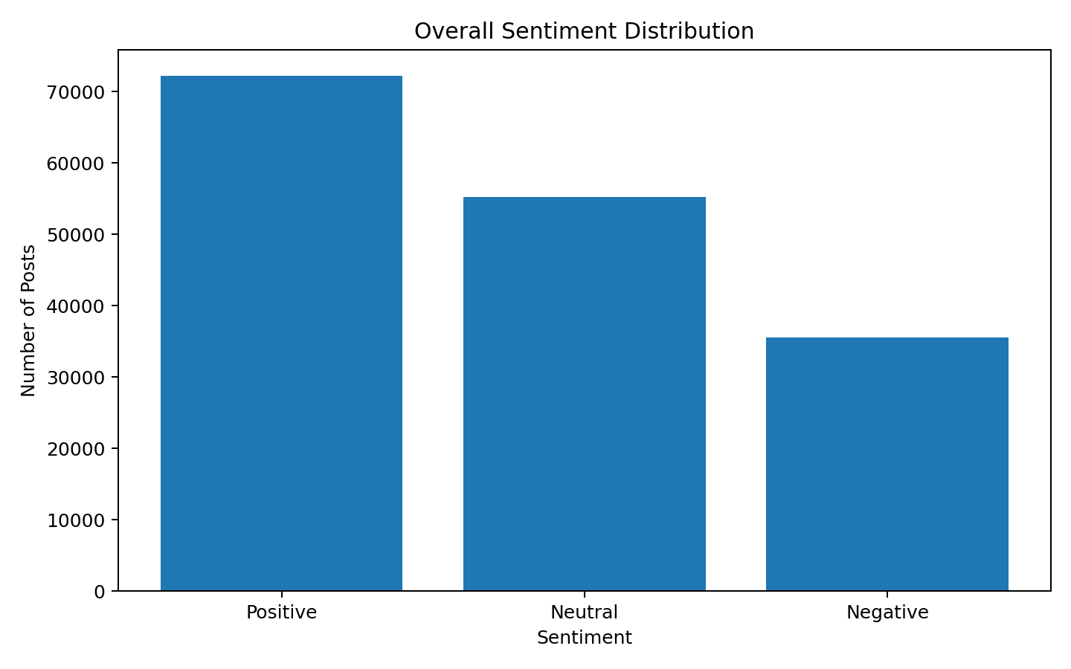
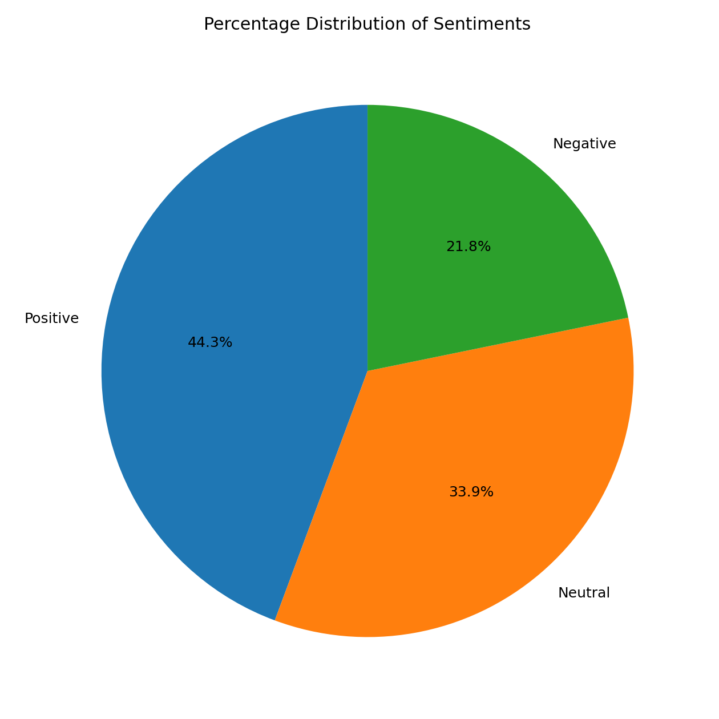
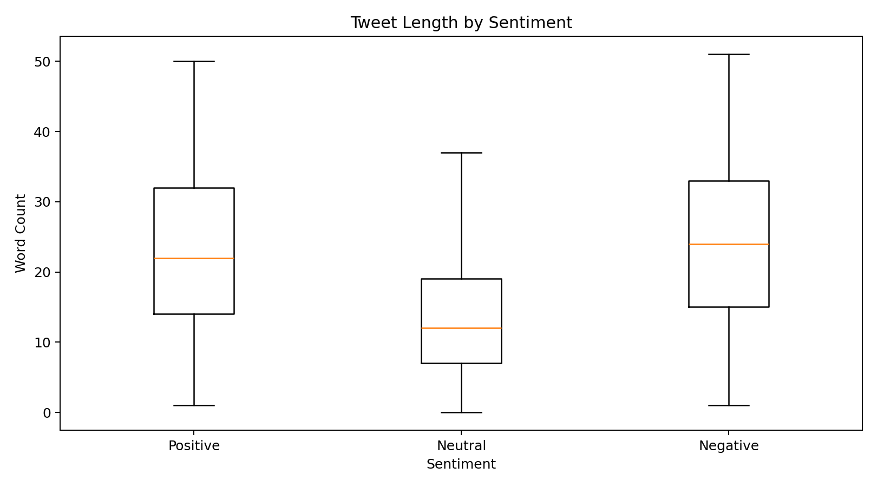

7. NLP Model Performance
The TF-IDF + Logistic Regression classifier achieved an accuracy of 91.86% on the 20% held-out test set.
Class | Precision | Recall | F1-score
Negative | 0.8578 | 0.8861 | 0.8717
Neutral | 0.9080 | 0.9732 | 0.9395
Positive | 0.9611 | 0.8928 | 0.9257
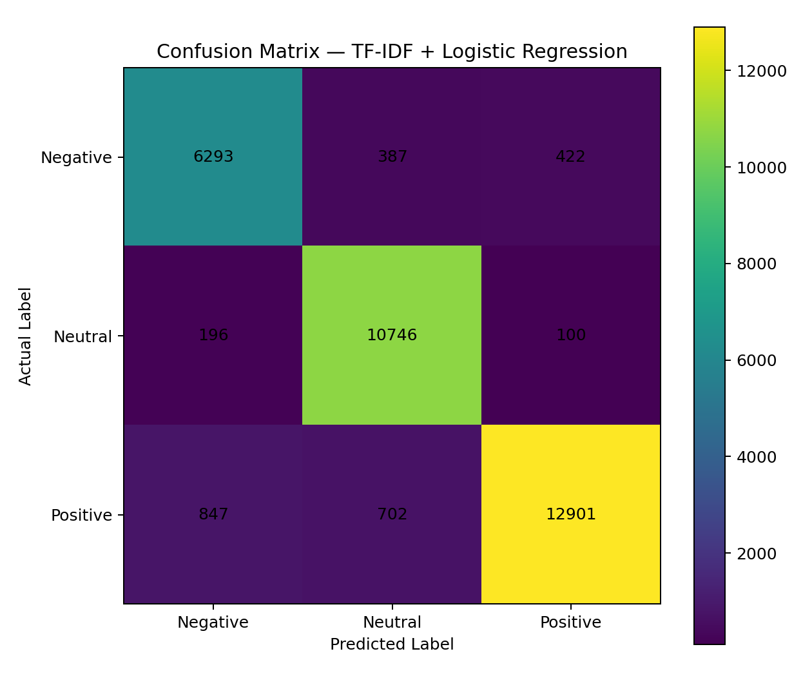

8. Most Frequent Words
Word | Frequency
modi | 155546
india | 29153
his | 16321
bjp | 14646
people | 13896
congress | 12829
like | 12578
your | 12566
only | 11842
now | 11538
narendra | 11466
govt | 10025
its | 9879
vote | 9304
one | 9298

9. Text-Length Analysis
Positive: mean 22.65 words; median 22.00 words.
Neutral: mean 14.27 words; median 12.00 words.
Negative: mean 23.88 words; median 24.00 words.
Across all usable posts, the mean length is 20.08 words and the median is 18 words.

10. Statistical Analysis
A chi-square goodness-of-fit test comparing the observed class counts with an equal one-third distribution produced χ² = 12445.91. The p-value is below conventional reporting precision (p < 0.001), indicating that the three observed class counts are not equally distributed in this sample.

11. Key Findings
Positive posts constitute 44.33% of the usable sample, neutral posts 33.88%, and negative posts 21.79%. The NLP classifier achieved 91.86% overall accuracy, with class-wise F1-scores of 0.872 for Negative, 0.939 for Neutral, and 0.926 for Positive.
The most influential terms learned by the classifier include sentiment-bearing language such as negative terms associated with criticism and positive terms associated with approval. These terms describe patterns in the dataset and should not be interpreted as evidence about the opinions of all X users.

12. Limitations
- The dataset does not contain a timestamp/date column; therefore, sentiment trends over time cannot be validly calculated from this CSV.
- The dataset is a supplied sample and should not automatically be treated as representative of all X users.
- Sentiment classification can be affected by sarcasm, irony, slang, abbreviations, context and multilingual expressions.
- The sentiment label mapping should be verified against the original dataset documentation.
- Political content appears in the dataset; therefore, findings should be reported descriptively rather than as claims about the broader electorate or public opinion.

13. Conclusion
This project demonstrates an end-to-end NLP workflow for analyzing sentiment in X posts. The process combines data cleaning, exploratory analysis, TF-IDF feature extraction, Logistic Regression classification, statistical testing and visualization. In the supplied sample, 44.33% of usable posts are labeled positive, 33.88% neutral and 21.79% negative. The supervised classifier achieved 91.86% accuracy on the held-out test set. These results describe the supplied dataset rather than all X users. A timestamped dataset would be required to extend the project to genuine sentiment-over-time analysis.

14. References
1. NLTK documentation: https://www.nltk.org/
2. scikit-learn documentation: https://scikit-learn.org/
3. X API documentation: https://docs.x.com/
4. Original dataset documentation/source: add the exact source supplied by your instructor or dataset provider.

