DATA VISUALIZATION USING PYTHON
Technical Project & Internship Task Report
Student Name: | Suchismita Das
Mentor Name: | Hariharan MB
University: | Ravenshaw University
Internship Duration: | September 1, 2026 – September 30, 2026
Organization: | ShadowFox
Role & Level: | Data Scientist (Beginner Level)

1. INTRODUCTION
Graphical presentation plays a paramount role in modern data science by converting abstract, multi-dimensional quantitative tables into intuitive visual representations. Raw numeric datasets—regardless of their structural completeness—often obscure underlying patterns, localized anomalies, and non-linear trends when evaluated solely through tabular inspection. Graphical abstraction bridges this cognitive gap, enabling rapid pattern recognition, distribution analysis, and evidence-based decision-making.
In the Python open-source data science ecosystem, visual exploration relies on two complementary foundational libraries: Matplotlib and Seaborn. Matplotlib serves as the low-level graphics engine offering explicit granular control over canvas rendering and individual chart primitives. Seaborn operates as a high-level statistical interface built directly on top of Matplotlib and integrated with Pandas DataFrames, automating complex statistical aggregation, color mapping, and aesthetic formatting.

2. MATPLOTLIB
Matplotlib was originally developed by John D. Hunter to replicate MATLAB-style desktop plotting functionality within Python on top of NumPy array architecture. It provides an Object-Oriented interface alongside the pyplot state-machine API, granting engineers absolute deterministic authority over every visual component—including axis tick locators, spine visibility, marker styling, and canvas figure dimensions.

2.1 Line Chart
Line charts are fundamental two-dimensional visual frameworks utilized to track data progression, trends, and sequential trajectory over time or ordered categories. Points are mapped across a Cartesian coordinate grid and connected via linear line segments.
import matplotlib.pyplot as plt

# Define sequential coordinate pairs
x = [1, 2, 3, 4, 5]
y = [10, 15, 13, 18, 20]

# Plot line with circular markers
plt.plot(x, y, marker='o', color='#1f77b4', linewidth=2, label='Growth Trend')
plt.xlabel('X Axis Interval')
plt.ylabel('Y Axis Value')
plt.title('Matplotlib Line Chart: Temporal Trend Analysis')
plt.grid(True, linestyle='--', alpha=0.6)
plt.savefig('/workspace/scratch/matplotlib_line_chart.png', dpi=300)
plt.close()

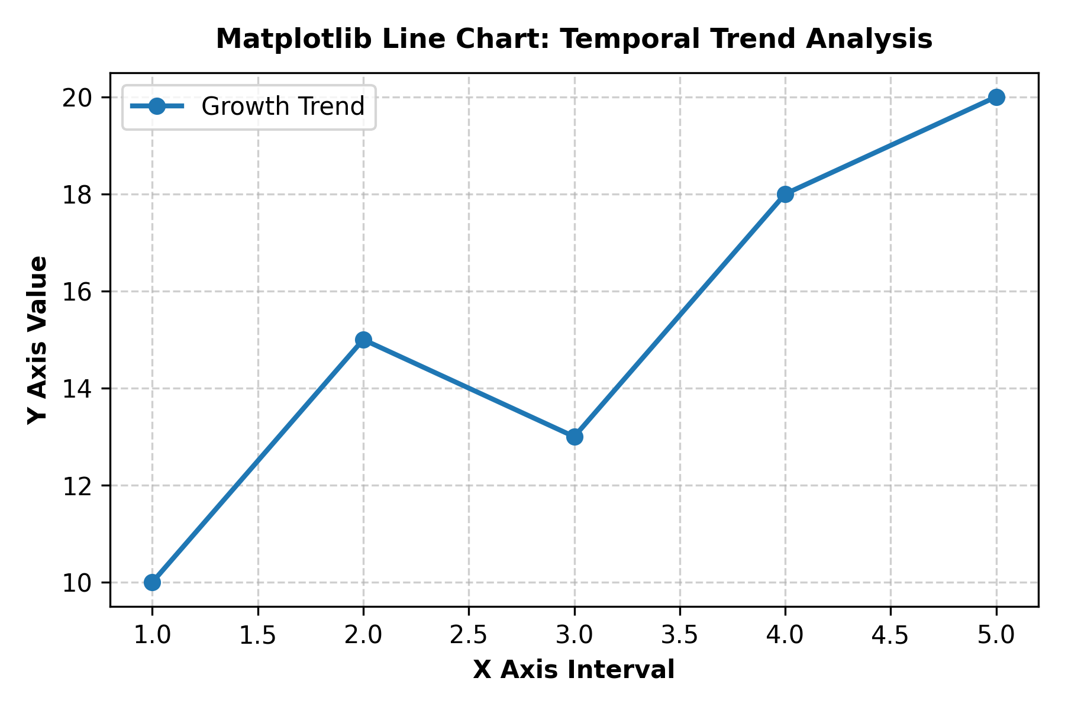
Figure 2.1: Matplotlib Line Chart showing sequential metric trajectory across five intervals.
Observation & Interpretation: The generated line plot illustrates a generally upward trajectory across the five intervals. Starting at y = 10 at x = 1, the variable ascends to 15 at x = 2, experiences a brief minor contraction to 13 at x = 3, and subsequently resumes strong positive growth to reach a peak value of 20 at x = 5. The inclusion of discrete circular markers ('o') highlights exact coordinate measurements while maintaining linear continuity.

2.2 Bar Chart
Bar charts provide categorical comparative evaluation, utilizing rectangular columns proportional in height to their represented values along a discrete axis.
import matplotlib.pyplot as plt

students = ['Student A', 'Student B', 'Student C', 'Student D']
marks = [85, 92, 78, 88]

plt.bar(students, marks, color=['#3498db', '#2ecc71', '#e74c3c', '#f39c12'], edgecolor='black')
plt.xlabel('Students')
plt.ylabel('Marks Obtained')
plt.title('Matplotlib Bar Chart: Academic Performance Comparison')
plt.ylim(0, 100)
plt.savefig('/workspace/scratch/matplotlib_bar_chart.png', dpi=300)
plt.close()

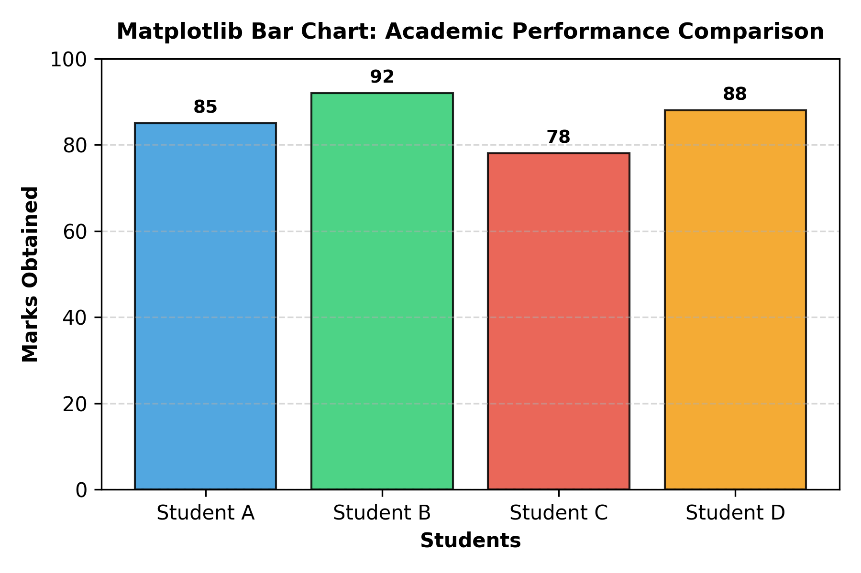
Figure 2.2: Matplotlib Bar Chart comparing academic assessment scores across four students.
Observation & Interpretation: The bar chart delivers an immediate comparative summary of academic achievement. Student B achieved the highest score at 92 marks, followed by Student D at 88 marks and Student A at 85 marks. Student C recorded the lowest score in the group at 78 marks. All four subjects maintained performance above 70 marks.

2.3 Histogram
Histograms model the probability distribution of continuous numerical data by grouping raw measurements into adjacent non-overlapping ranges (bins) and tracking occurrence frequencies.
import matplotlib.pyplot as plt
import numpy as np

np.random.seed(42)
data = np.random.normal(loc=0, scale=1, size=100)

plt.hist(data, bins=10, color='#2c3e50', edgecolor='white')
plt.xlabel('Value Ranges (Bins)')
plt.ylabel('Frequency Count')
plt.title('Matplotlib Histogram: Gaussian Distribution Analysis')
plt.savefig('/workspace/scratch/matplotlib_histogram.png', dpi=300)
plt.close()

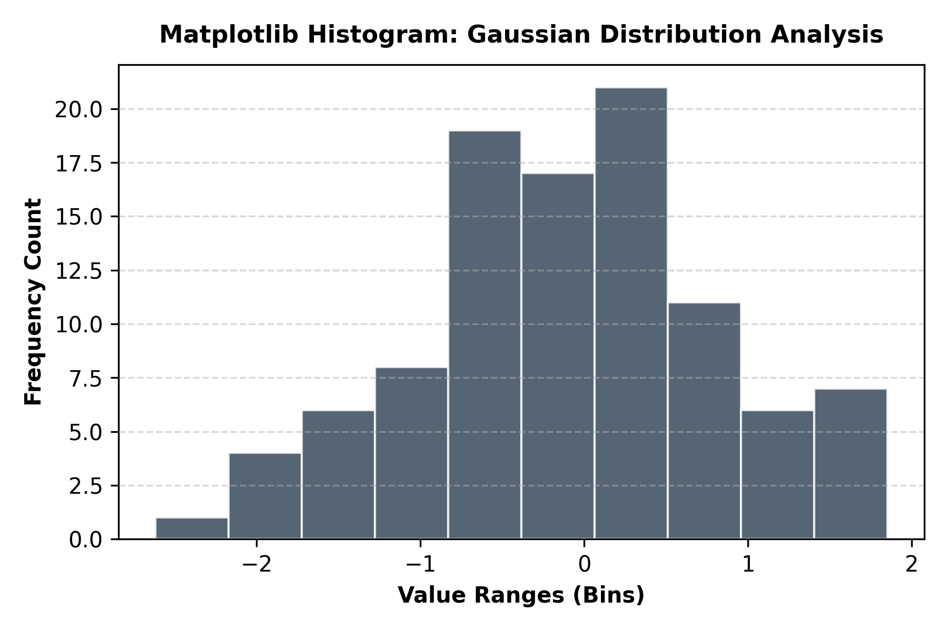
Figure 2.3: Matplotlib Frequency Histogram depicting Gaussian bell-curve distribution.
Observation & Interpretation: The generated 10-bin histogram reflects a classical Gaussian normal distribution centered near zero. The highest concentration of observations clusters around the central bin interval [-0.5, 0.5], while frequency counts taper symmetrically toward the upper and lower extreme bin tails.

2.4 Scatter Plot
Scatter plots evaluate spatial bivariate relationships by rendering paired numerical measurements as points on a Cartesian coordinate plane, exposing correlation direction, clustering density, and outliers.
import matplotlib.pyplot as plt

x = [5, 7, 8, 7, 2, 17, 2, 9, 4, 11, 12, 9, 6]
y = [99, 86, 87, 88, 111, 86, 103, 87, 94, 78, 77, 85, 86]

plt.scatter(x, y, color='#2980b9', s=60, edgecolors='black')
plt.xlabel('Independent Variable X')
plt.ylabel('Dependent Variable Y')
plt.title('Matplotlib Scatter Plot: Bivariate Negative Correlation')
plt.grid(True, linestyle='--', alpha=0.6)
plt.savefig('/workspace/scratch/matplotlib_scatter_plot.png', dpi=300)
plt.close()

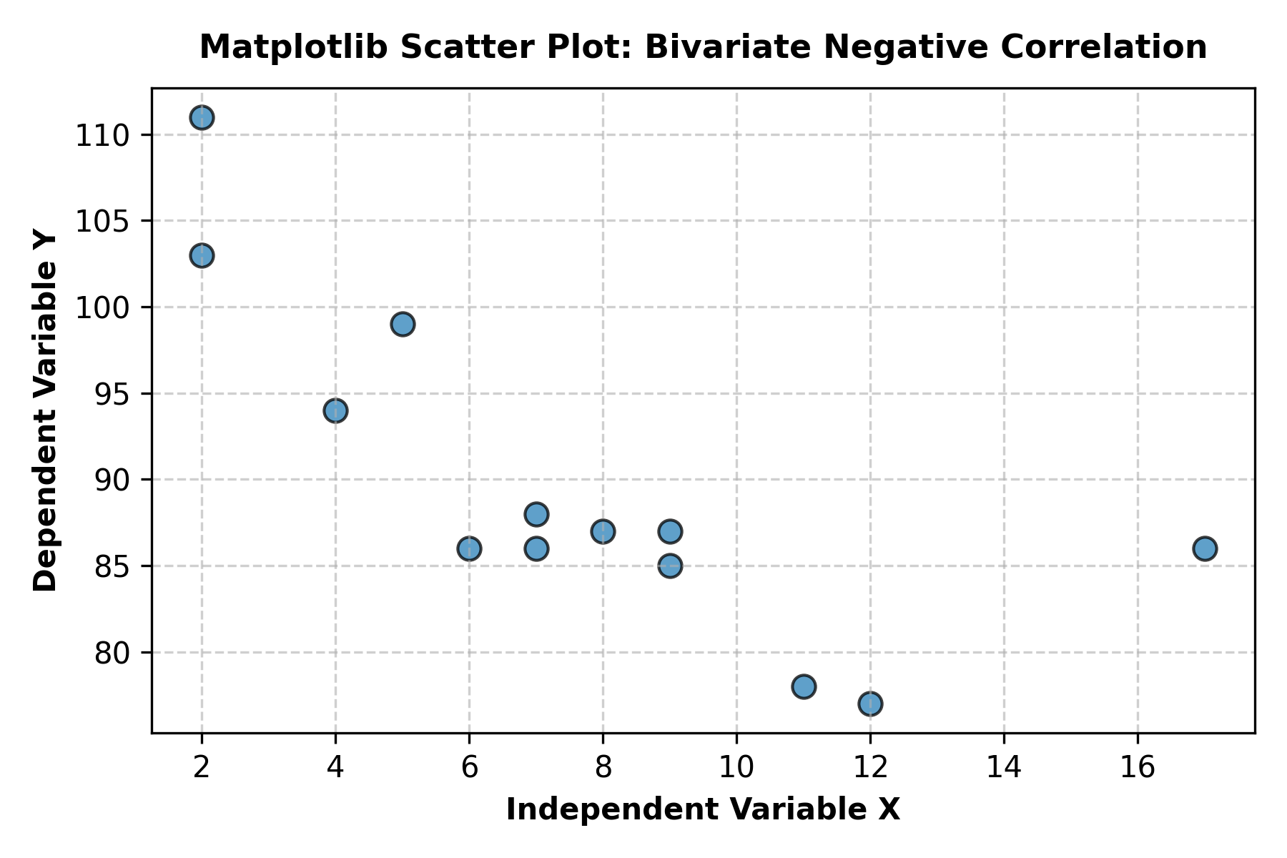
Figure 2.4: Matplotlib Scatter Plot depicting spatial negative correlation between X and Y variables.
Observation & Interpretation: The scatter plot reveals an inverse (negative) bivariate correlation between Variable X and Variable Y. Higher values of X correspond to systematically lower values of Y (e.g., x = 2, y = 111 vs. x = 12, y = 77). The data point at x = 17, y = 86 acts as a spatial outlier along the horizontal axis.

2.5 Pie Chart
Pie charts visualize proportional composition and whole-to-part geometric distributions, dividing a circular graph into proportional angular wedges based on categorical percentages.
import matplotlib.pyplot as plt

labels = ['Category A', 'Category B', 'Category C', 'Category D']
sizes = [25.0, 35.0, 20.0, 20.0]
colors = ['#ff9999', '#66b3ff', '#99ff99', '#ffcc99']

plt.pie(sizes, labels=labels, autopct='%1.1f%%', startangle=140, colors=colors)
plt.title('Matplotlib Pie Chart: Proportional Category Distribution')
plt.savefig('/workspace/scratch/matplotlib_pie_chart.png', dpi=300)
plt.close()

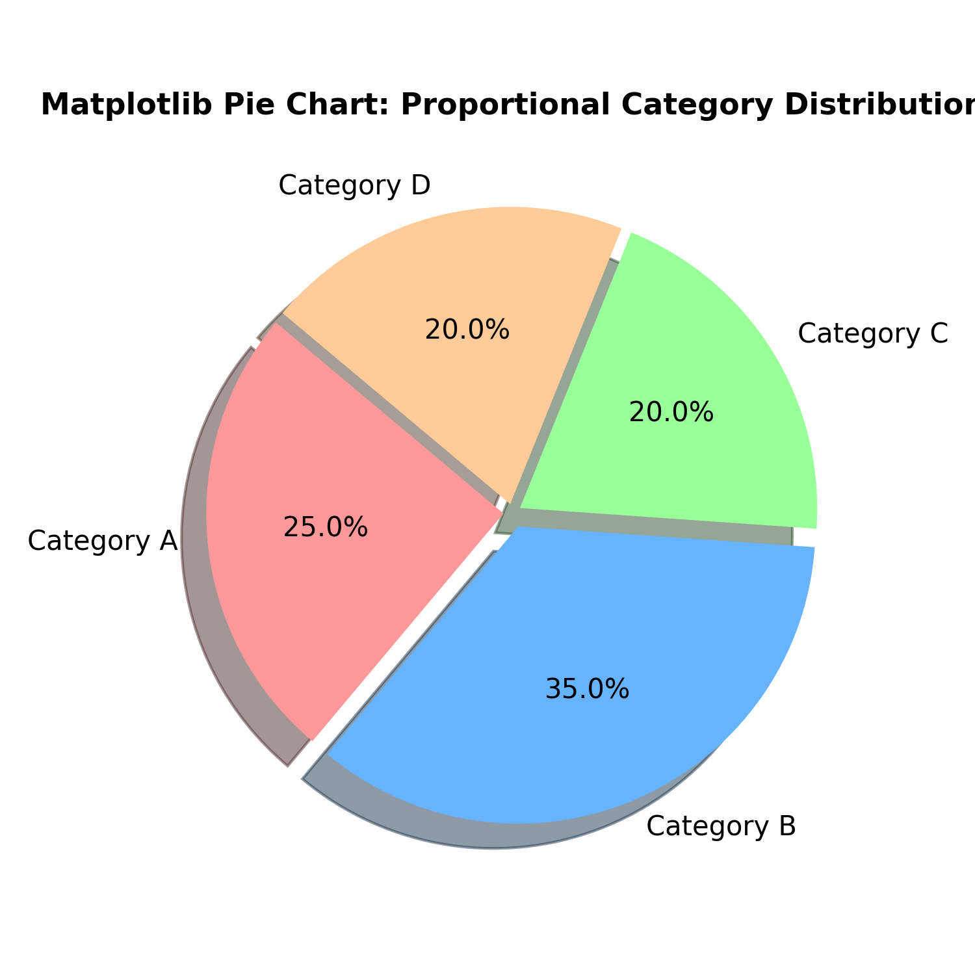
Figure 2.5: Matplotlib Pie Chart illustrating categorical share proportions summing to 100%.
Observation & Interpretation: The pie chart breaks down the categorical dataset into four distinct proportional segments. Category B forms the largest share at 35.0%, Category A represents 25.0%, and Categories C and D contribute equal proportions of 20.0% each, combining to form a complete 100% distribution.

3. SEABORN
Seaborn is a high-level statistical visualization library built on top of Matplotlib, designed for seamless integration with Pandas DataFrames. It automates advanced statistical estimates (such as bootstrapped confidence intervals and kernel density curves) and provides sophisticated color palettes and thematic styles out of the box.

Categorical Taxonomy of Seaborn Visualizations
The table below details Seaborn's main functional module categories and primary interface functions:
Category | Primary Plotting Methods | Key Analytical Purpose
Relational Plots | sns.lineplot()  sns.scatterplot() | Mapping continuous statistical relationships across multi-variable data dimensions.
Categorical Plots | sns.barplot()  sns.countplot()  sns.boxplot() | Summarizing distributions and frequencies across discrete categorical group boundaries.
Distribution Plots | sns.histplot()  sns.kdeplot()  sns.ecdfplot() | Modeling univariate and bivariate probability density distributions and cumulative frequencies.
Regression Plots | sns.regplot()  sns.lmplot() | Estimating statistical linear regression models with automatic confidence intervals.
Matrix Plots | sns.heatmap()  sns.clustermap() | Visualizing high-dimensional numerical covariance matrices and hierarchical clusters.

3.1 Line Plot
Seaborn's lineplot function applies statistical aggregation across continuous data series, automatically displaying trend curves alongside optional confidence interval shading.
import matplotlib.pyplot as plt
import seaborn as sns

sns.set_theme(style='whitegrid')
x = [1, 2, 3, 4, 5]
y = [2, 4, 7, 11, 16]

sns.lineplot(x=x, y=y, marker='o', color='#8e44ad', linewidth=2.5)
plt.xlabel('Step Interval')
plt.ylabel('Cumulative Growth Metric')
plt.title('Seaborn Line Plot: Non-Linear Trajectory Mapping')
plt.savefig('/workspace/scratch/seaborn_line_plot.png', dpi=300)
plt.close()

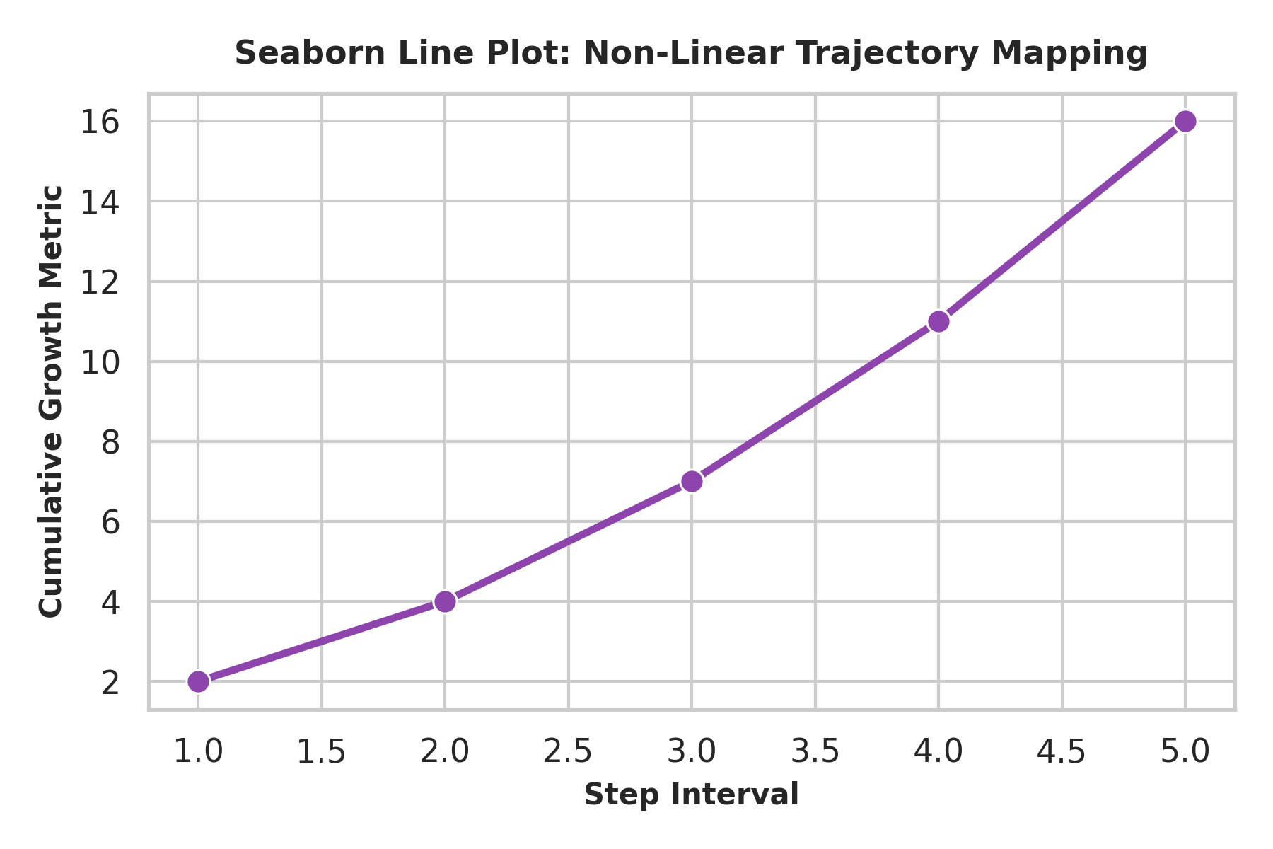
Figure 3.1: Seaborn Line Plot depicting accelerating non-linear growth across intervals.
Observation & Interpretation: The Seaborn line plot reveals an accelerating quadratic growth trajectory. As step intervals increase from 1 to 5, y values grow non-linearly from 2 to 4, 7, 11, and 16. Seaborn's whitegrid theme enhances grid readability without visual clutter.

3.2 Bar Plot
Seaborn's barplot automatically aggregates categorical data, calculating central tendency metrics (e.g., mean) while incorporating error bars to indicate statistical uncertainty.
import matplotlib.pyplot as plt
import seaborn as sns

students = ['Student A', 'Student B', 'Student C', 'Student D']
marks = [85, 92, 78, 88]

sns.barplot(x=students, y=marks, palette='mako')
plt.xlabel('Student Identifier')
plt.ylabel('Assessment Score')
plt.title('Seaborn Bar Plot: Categorical Performance Evaluation')
plt.ylim(0, 100)
plt.savefig('/workspace/scratch/seaborn_bar_plot.png', dpi=300)
plt.close()

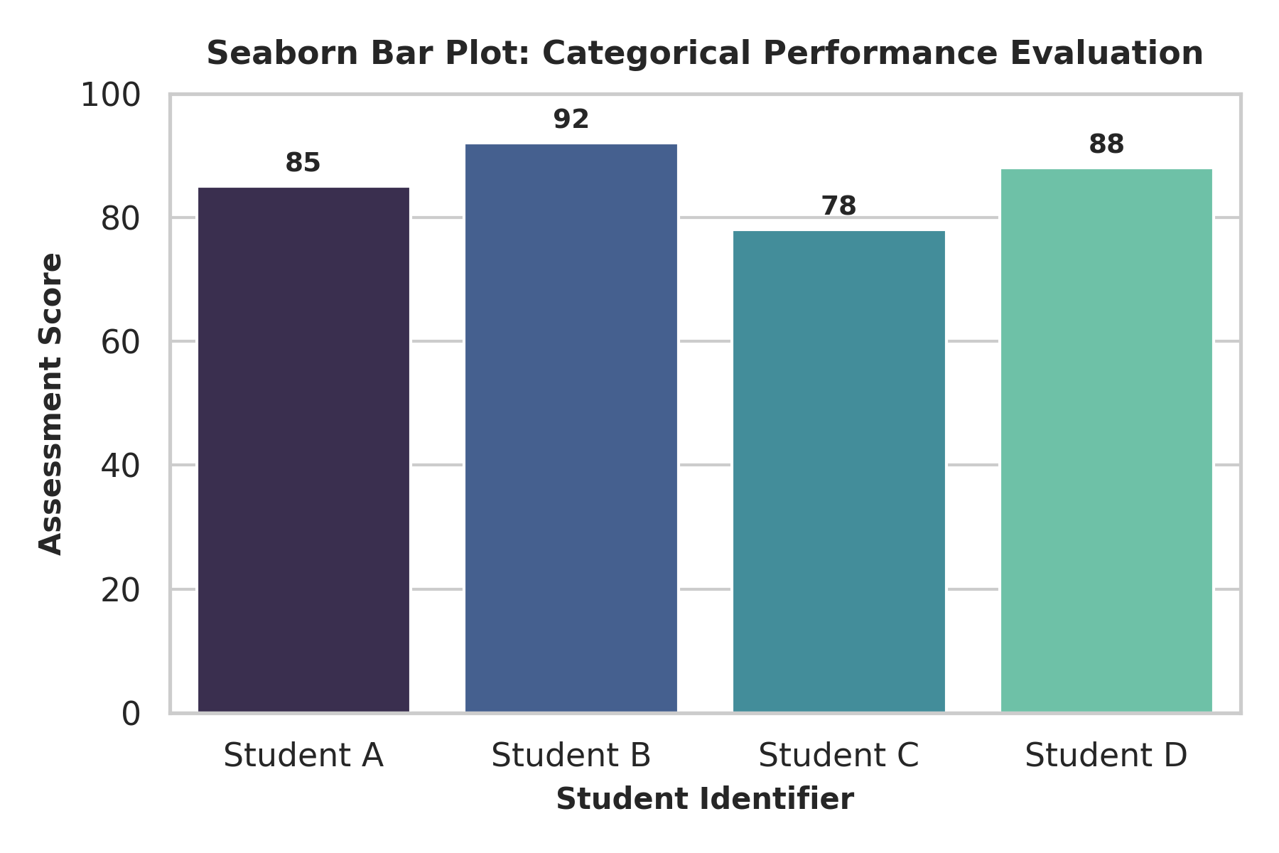
Figure 3.2: Seaborn Bar Plot applying the 'mako' color palette across student categories.
Observation & Interpretation: Applying Seaborn's barplot with the 'mako' color palette provides an aesthetically refined categorical chart. Student B leads with 92 marks, Student D follows with 88, Student A scores 85, and Student C records 78 marks.

3.3 Histogram with KDE
Seaborn's histplot combines discrete frequency histogram bars with a smooth Kernel Density Estimate (KDE) curve, yielding both binned counts and continuous probability density functions.
import matplotlib.pyplot as plt
import numpy as np
import seaborn as sns

np.random.seed(42)
data = np.random.normal(loc=0, scale=1, size=100)

sns.histplot(data, kde=True, color='#008080', bins=10)
plt.xlabel('Normalized Measurement Value')
plt.ylabel('Frequency Density')
plt.title('Seaborn Histogram: Density Distribution with KDE Overlay')
plt.savefig('/workspace/scratch/seaborn_histogram.png', dpi=300)
plt.close()

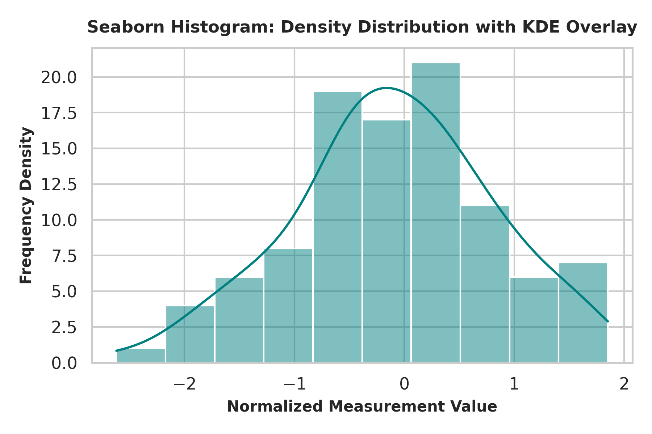
Figure 3.3: Seaborn Histogram with continuous Kernel Density Estimate (KDE) curve overlay.
Observation & Interpretation: The KDE overlay provides a smooth statistical estimate of the underlying probability distribution, highlighting the unimodal bell curve centered near zero and confirming data symmetry without relying strictly on bin edge boundaries.

3.4 Scatter Plot
Seaborn's scatterplot function enhances standard scatter plots by supporting additional visual encodings—such as hue gradients, point sizes (size), and marker shapes (style)—mapped directly to dataset attributes.
import matplotlib.pyplot as plt
import seaborn as sns

x = [5, 7, 8, 7, 2, 17, 2, 9, 4, 11, 12, 9, 6]
y = [99, 86, 87, 88, 111, 86, 103, 87, 94, 78, 77, 85, 86]

sns.scatterplot(x=x, y=y, hue=y, palette='crest', s=90)
plt.xlabel('Variable X')
plt.ylabel('Variable Y')
plt.title('Seaborn Scatter Plot: Hue-Graded Spatial Trend Analysis')
plt.savefig('/workspace/scratch/seaborn_scatter_plot.png', dpi=300)
plt.close()

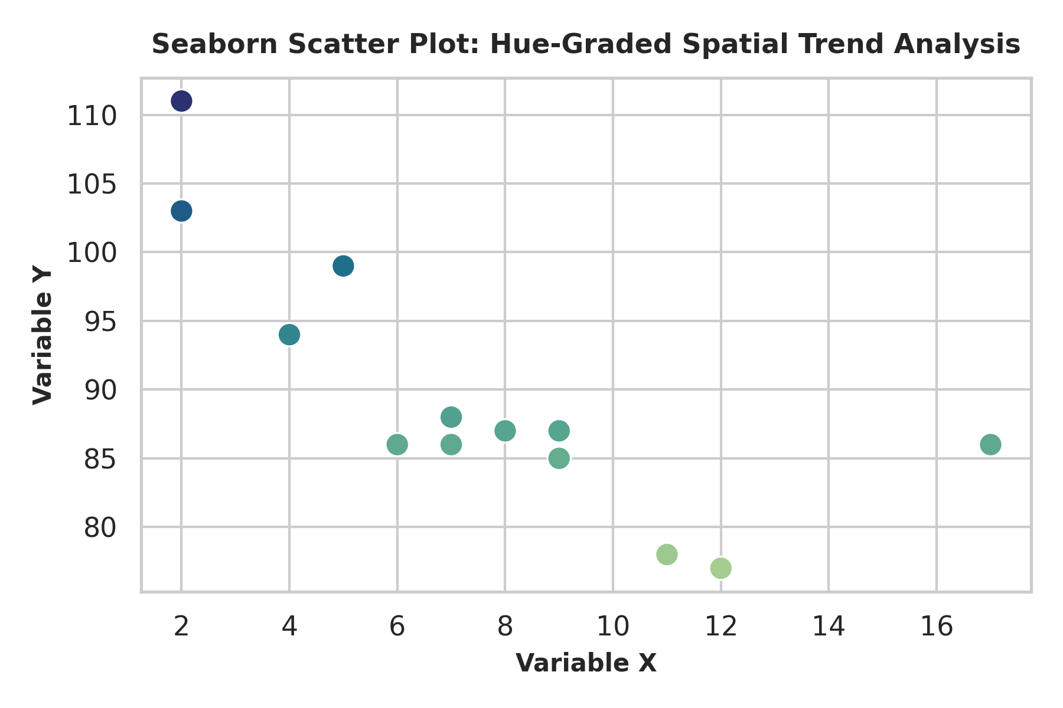
Figure 3.4: Seaborn Scatter Plot with hue mapped to value intensity using the 'crest' palette.
Observation & Interpretation: By mapping point hue to numerical value via the 'crest' color palette, the scatter plot visually emphasizes magnitude variations alongside spatial coordinates, illustrating how higher Y-values transition smoothly across color shades.

3.5 Box Plot
Box plots (box-and-whisker plots) depict five-number statistical summaries across distributions: minimum, lower quartile (Q1), median (Q2), upper quartile (Q3), and maximum, while explicitly isolating statistical outliers beyond whisker boundaries.
import matplotlib.pyplot as plt
import pandas as pd
import numpy as np
import seaborn as sns

np.random.seed(42)
df_box = pd.DataFrame({
'Dataset 0': np.random.normal(loc=50, scale=10, size=50),
'Dataset 1': np.random.normal(loc=60, scale=15, size=50)
})

sns.boxplot(data=df_box, palette='Set2')
plt.ylabel('Distribution Scale')
plt.title('Seaborn Box Plot: 5-Number Statistical Summary Comparison')
plt.savefig('/workspace/scratch/seaborn_box_plot.png', dpi=300)
plt.close()

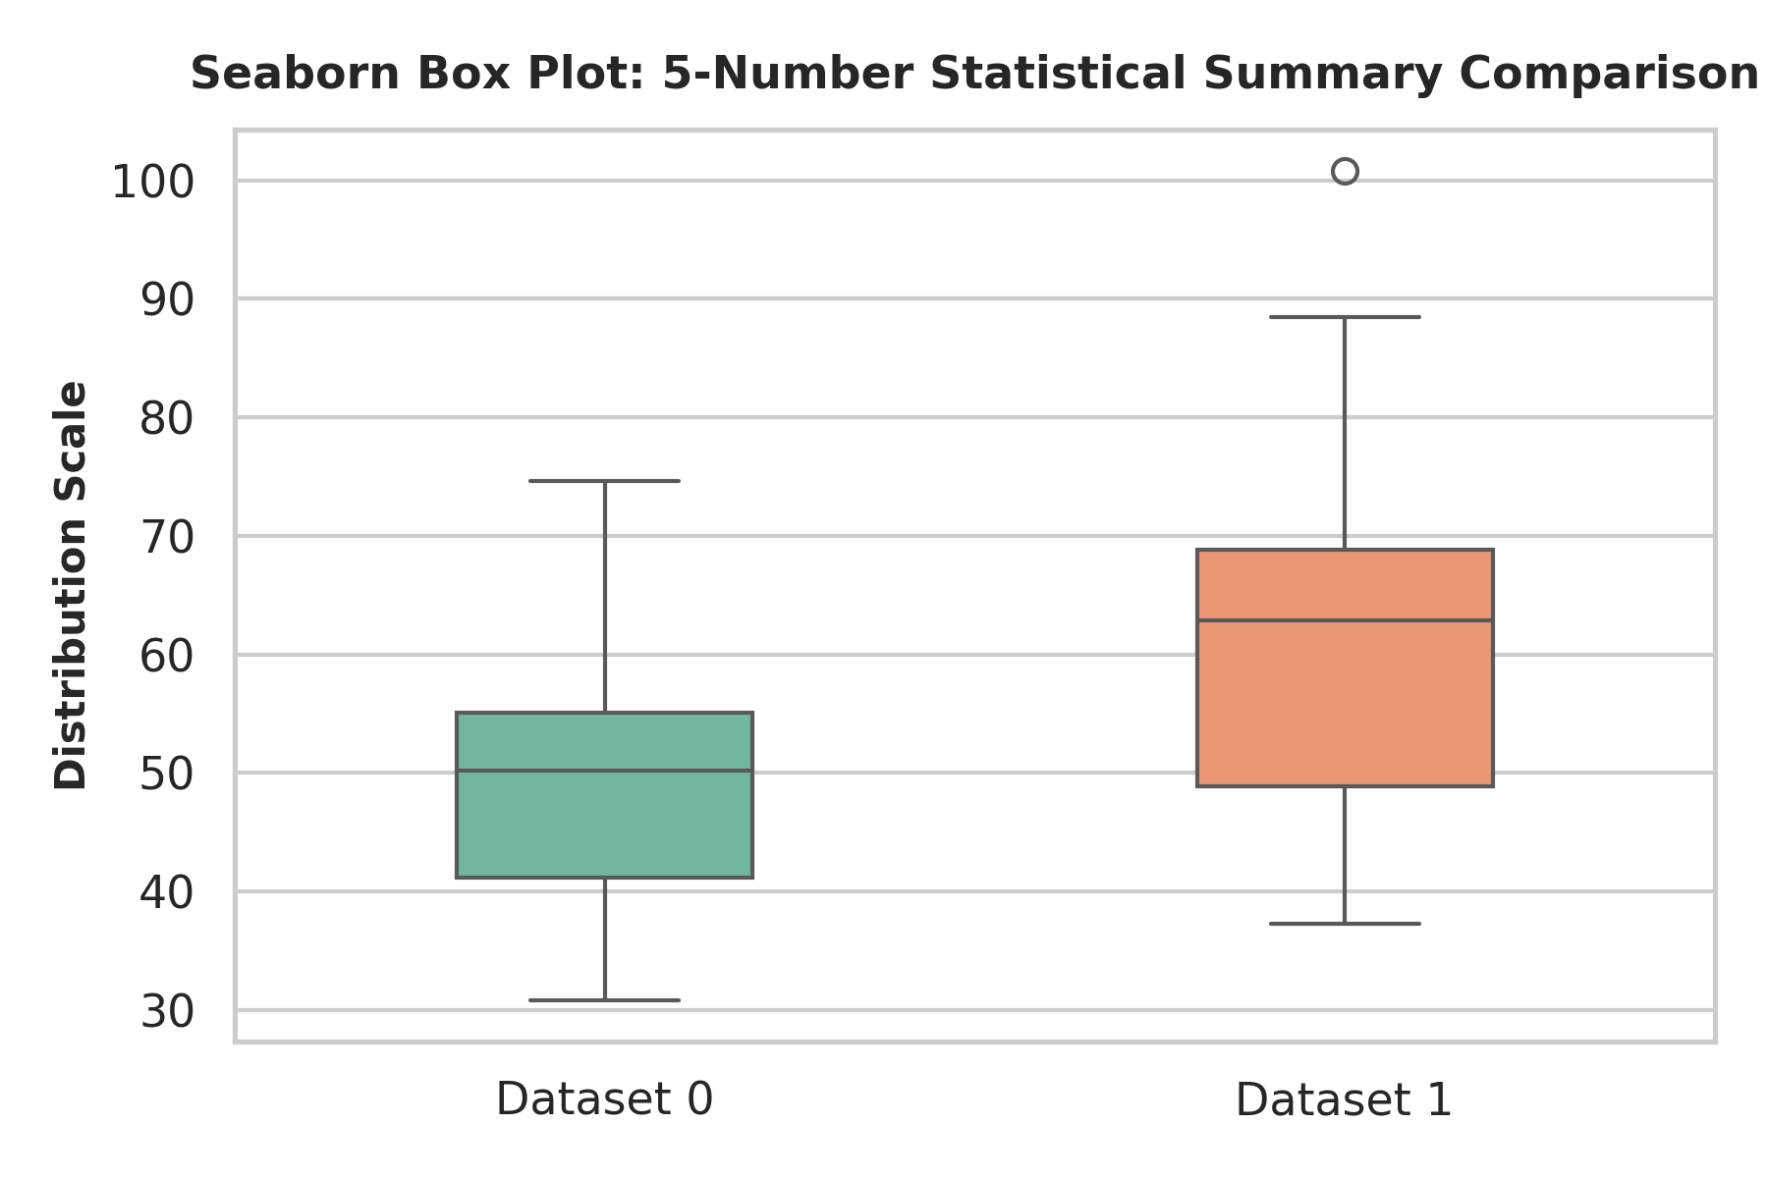
Figure 3.5: Seaborn Box Plot comparing interquartile ranges and medians across Dataset 0 and Dataset 1.
Observation & Interpretation: The side-by-side box plot facilitates comparative distribution analysis. Dataset 0 exhibits a lower median (~50) and tighter interquartile range (IQR), whereas Dataset 1 demonstrates a higher median (~60) and broader total spread (variance).

3.6 Count Plot
Seaborn's countplot functions as a categorical histogram, automatically tabulating discrete group occurrence frequencies without requiring manual data aggregation.
import matplotlib.pyplot as plt
import seaborn as sns

category_data = ['A', 'A', 'A', 'A', 'A', 'B', 'B', 'B', 'C', 'C']
sns.countplot(x=category_data, palette='Blues_r')
plt.xlabel('Categorical Groups')
plt.ylabel('Observed Frequency')
plt.title('Seaborn Count Plot: Categorical Frequency Distribution')
plt.savefig('/workspace/scratch/seaborn_count_plot.png', dpi=300)
plt.close()

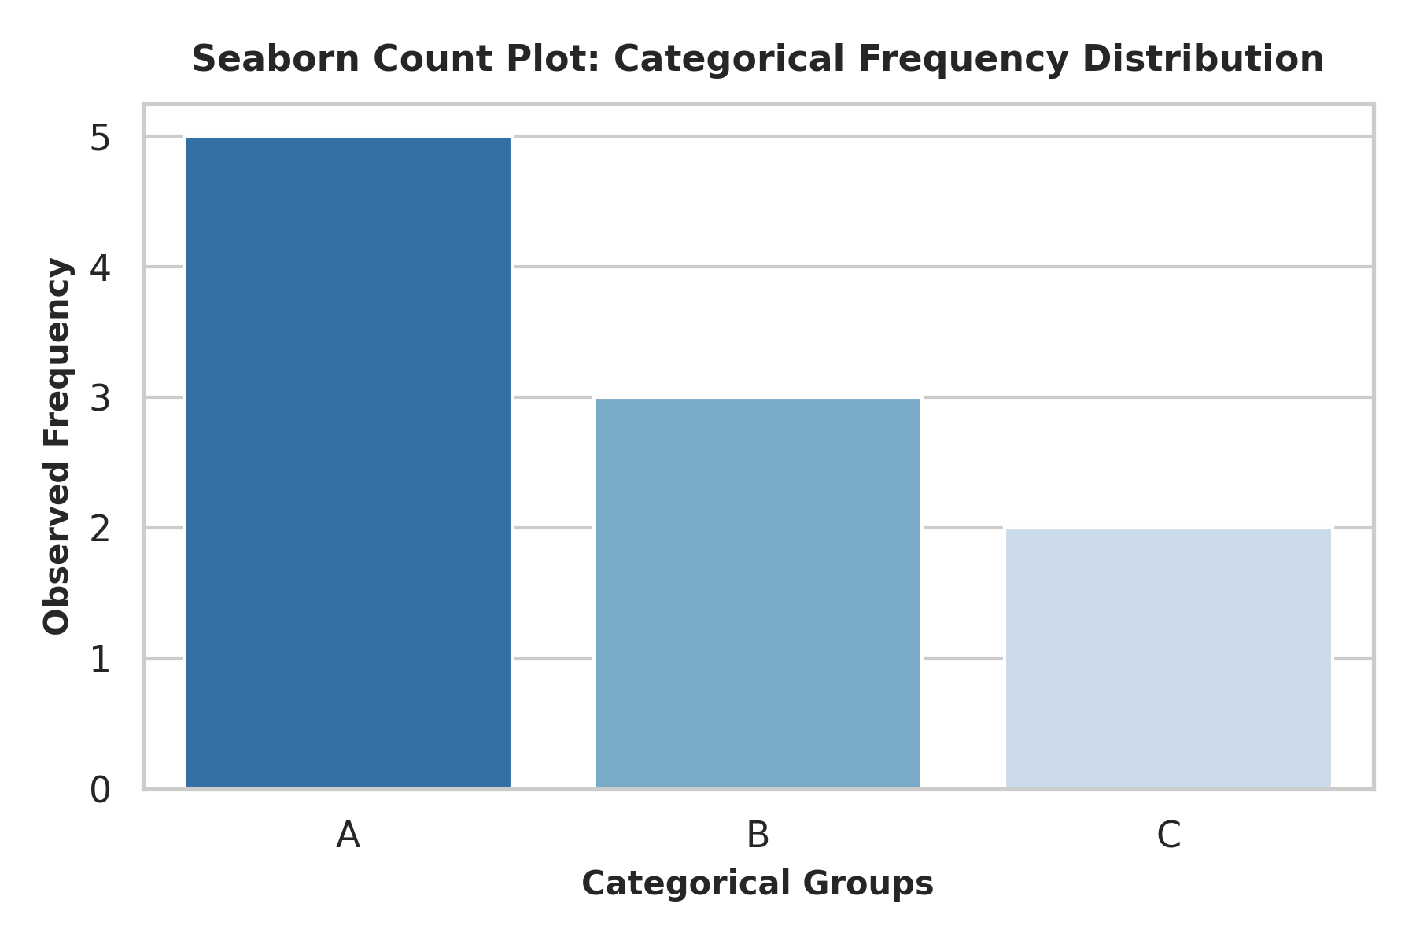
Figure 3.6: Seaborn Count Plot tabulating categorical frequency counts for Groups A, B, and C.
Observation & Interpretation: The count plot confirms a clear descending frequency distribution across groups: Category A registers 5 occurrences, Category B records 3 occurrences, and Category C records 2 occurrences.

4. COMPARISON: MATPLOTLIB VS. SEABORN
Choosing between Matplotlib and Seaborn depends on the technical objective, data structure, and required level of visual customization. Matplotlib excels when precise layout control, multi-panel canvas assembly, or bespoke graphic primitives are required. Seaborn streamlines exploratory statistical workflows by handling aggregation, color palette mapping, and complex statistical estimations in concise API calls.

Comparative Evaluation Framework
The evaluation matrix below synthesizes core architectural trade-offs across key dimensions:
Feature / Dimension | Matplotlib | Seaborn
Abstraction Level | Low-level imperative graphic engine | High-level declarative statistical interface
Syntax & Boilerplate | Verbose; requires explicit element definition | Concise, expressive single-line function calls
Default Aesthetics | Utilitarian default styles; requires manual styling | Modern, publication-ready themes out of the box
Data Structure Linkage | Operates primarily on NumPy arrays and basic lists | Native Pandas DataFrame integration with column mapping
Customization Control | Absolute, deterministic authority over all elements | High-level parameter abstraction (customizable via Matplotlib)
Statistical Estimation | Manual calculation required for stats/intervals | Automated statistical aggregation, KDE, and confidence intervals
Primary Strengths | Bespoke chart types, multi-axis layouts, annotations | Rapid EDA, statistical visualization, aesthetic color palettes

5. CONCLUSION
Through the execution of this internship project, core competencies were established in transforming unstructured tabular records into informative visual stories. Mastering both Matplotlib and Seaborn provides a versatile data science toolkit: Seaborn enables rapid statistical exploration during initial data investigation, while Matplotlib offers fine-grained customization when refining final figures for technical publications.
Combining high-level statistical abstraction with detailed graphic customization bridges the gap between raw quantitative outputs and clear, actionable insights, providing a strong foundation for advanced analytics workflows.

