**Diagrams and Table Design**

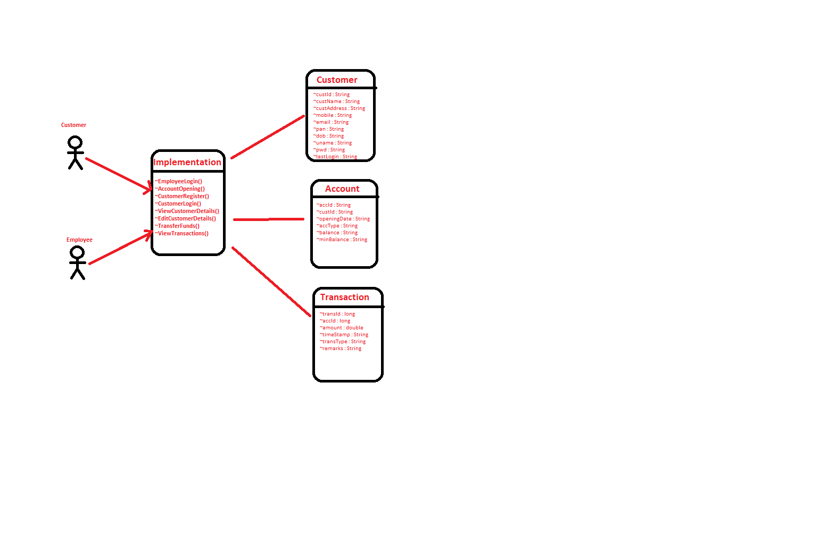

**Data Flow diagram**

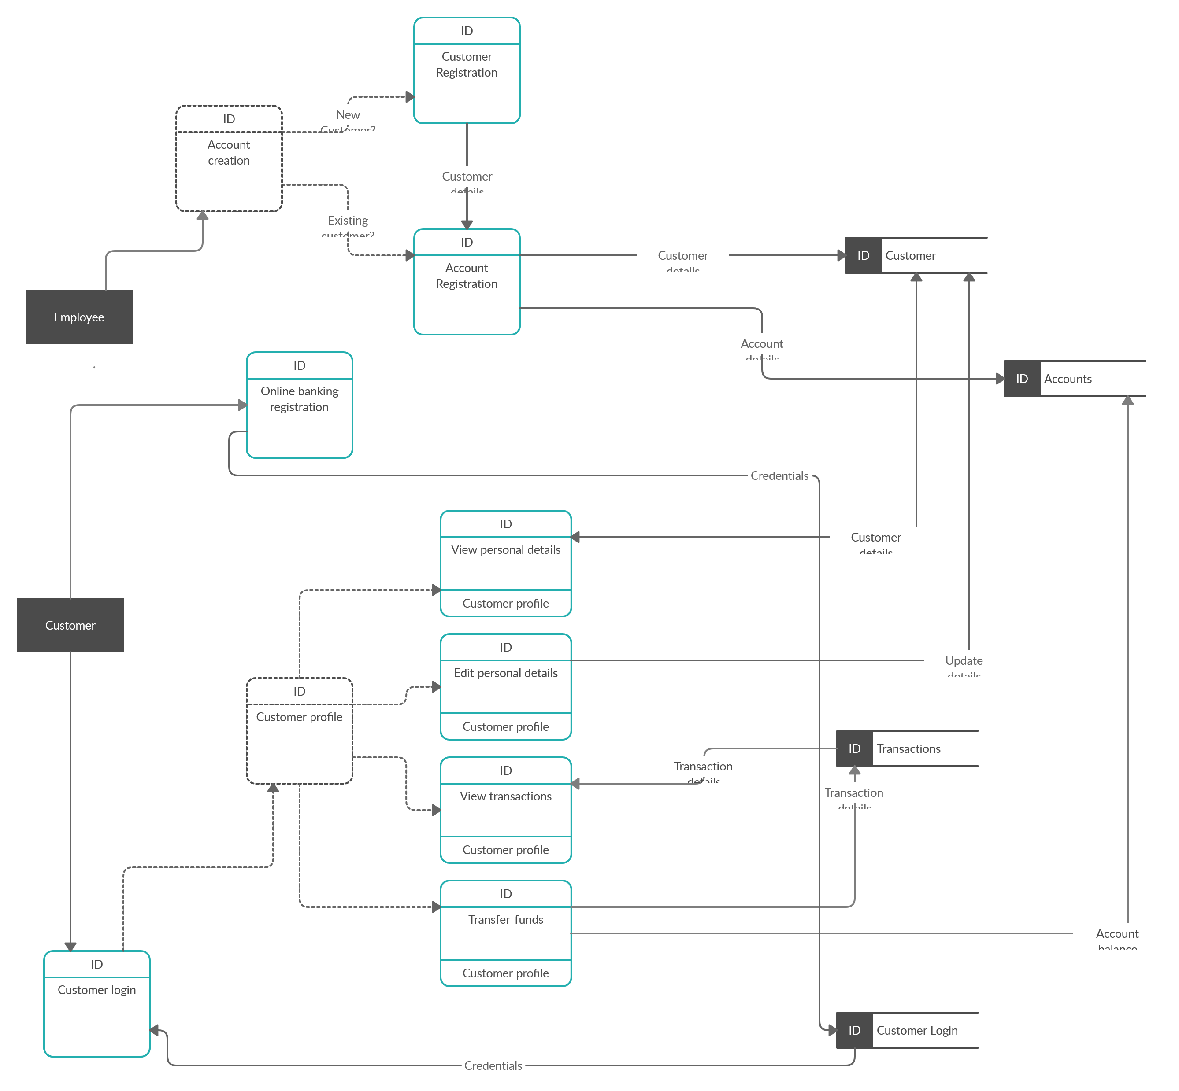

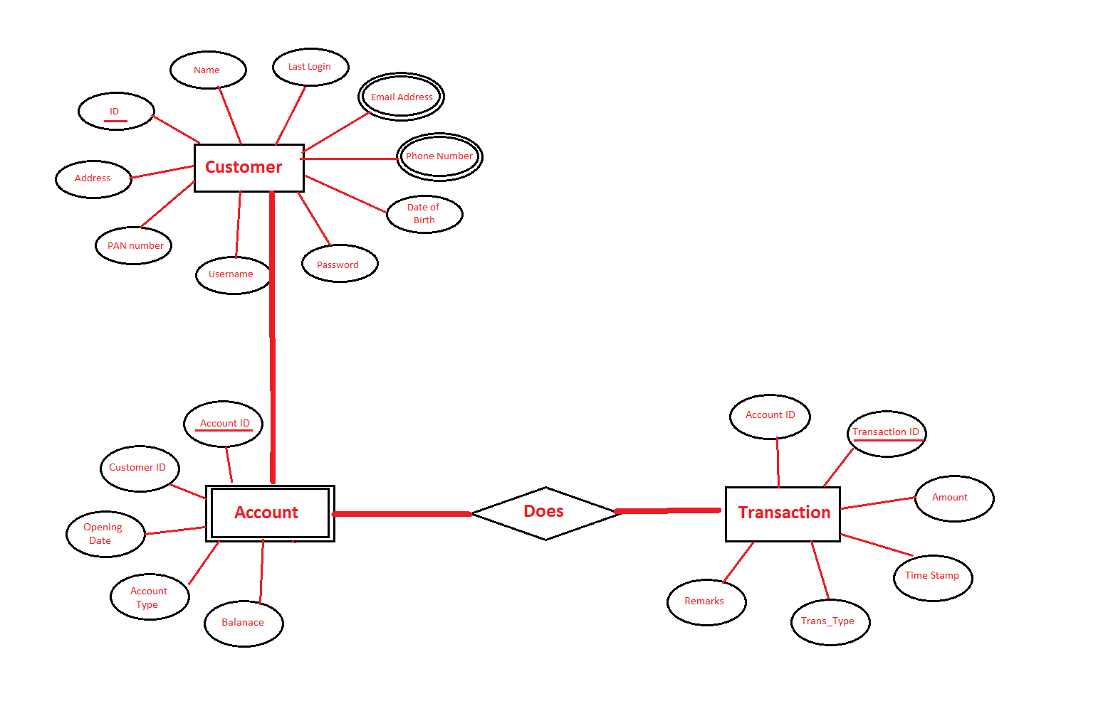**ER-diagram**

**Table Design**

Figure 5: ER Diagram

|  |
| --- |
|  |
|  | CREATE TABLE CUSTOMER  (CUST_ID INTEGER PRIMARY KEY GENERATED ALWAYS AS IDENTITY (START WITH 40000000, INCREMENT BY 1), |
|  | CUST_NAME varchar(15) NOT NULL, |
|  | ADDRESS varchar(10), |
|  | PAN varchar(10), |
|  | DOB varchar(10), |
|  | PHONE varchar(10), |
|  | EMAIL varchar(20), |
|  | ALT_PHONE varchar(10), |
|  | ALT_EMAIL varchar(20)); |
|  |  |
|  | CREATE TABLE CUSTLOGIN( |
|  | CUST_ID INTEGER, |
|  | USERNAME varchar(15) NOT NULL, |
|  | PASSWORD varchar(15) NOT NULL, |
|  | LAST_LOGIN varchar(25), |
|  | LOCKED_STATUS INTEGER, |
|  | FOREIGN KEY(CUST_ID) REFERENCES Customer(CUST_ID), |
|  | PRIMARY KEY(USERNAME)); |
|  |  |
|  | CREATE TABLE ACCOUNTS( |
|  | CUST_ID BIGINT NOT NULL, |
|  | ACCOUNT_ID INTEGER GENERATED ALWAYS AS IDENTITY (START WITH 201, INCREMENT BY 1), |
|  | OPENING_DATE TIMESTAMP NOT NULL, |
|  | ACCOUNT_TYPE VARCHAR(15) NOT NULL, |
|  | INIT_DEPOSIT DOUBLE NOT NULL, |
|  | BALANCE DOUBLE NOT NULL, |
|  | OVERDRAFT DOUBLE, |
|  | PRIMARY KEY(ACCOUNT_ID)); |
|  |  |
|  |  |
|  | CREATE TABLE TRANSACTIONS( |
|  | TRANS_ID BIGINT PRIMARY KEY GENERATED ALWAYS AS IDENTITY (START WITH 501, INCREMENT BY 1), |
|  | ACCOUNT_ID INTEGER, |
|  | AMOUNT DOUBLE NOT NULL, |
|  | TRANS_TYPE VARCHAR(6), |
|  | TRANS_TIME TIMESTAMP NOT NULL, |
|  | REMARKS VARCHAR(20)); |