**Complete the installation following software**  
  
1)Java : Jdk 1.8  
  
2)IntelliIDEA

3)opencsv

Automated test folder Structure

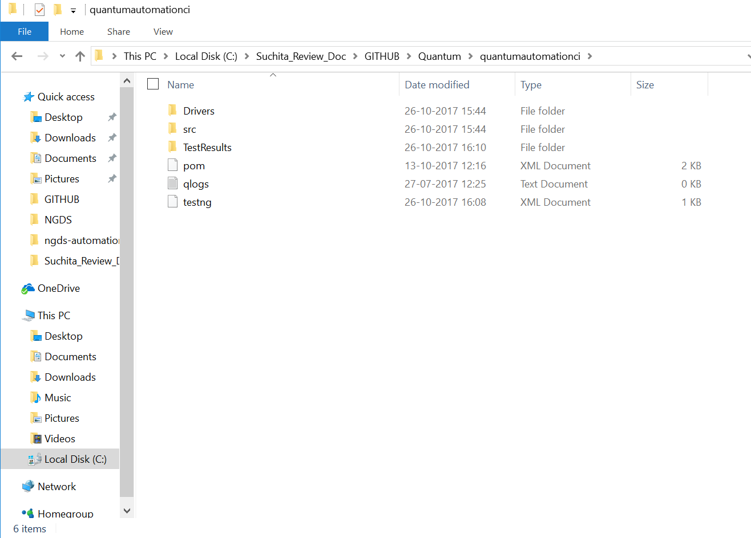

Source folder Structure

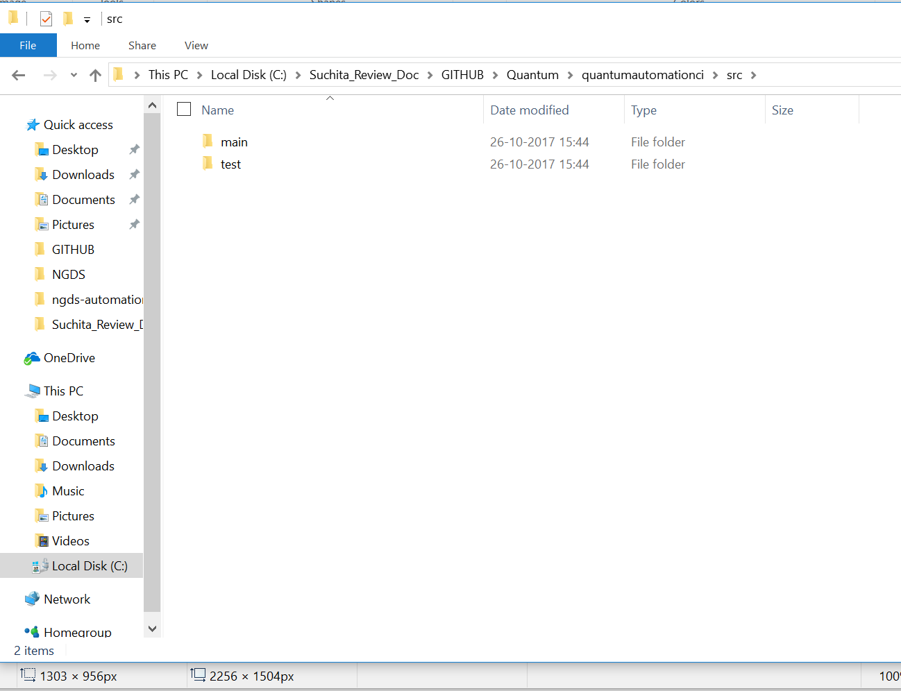

File Description

Pom.xml

It is a file that contains information about the project and configuration details used by Maven to build the project.

Drivers : Store driver executable for all supported browser

GenericKeywords.java

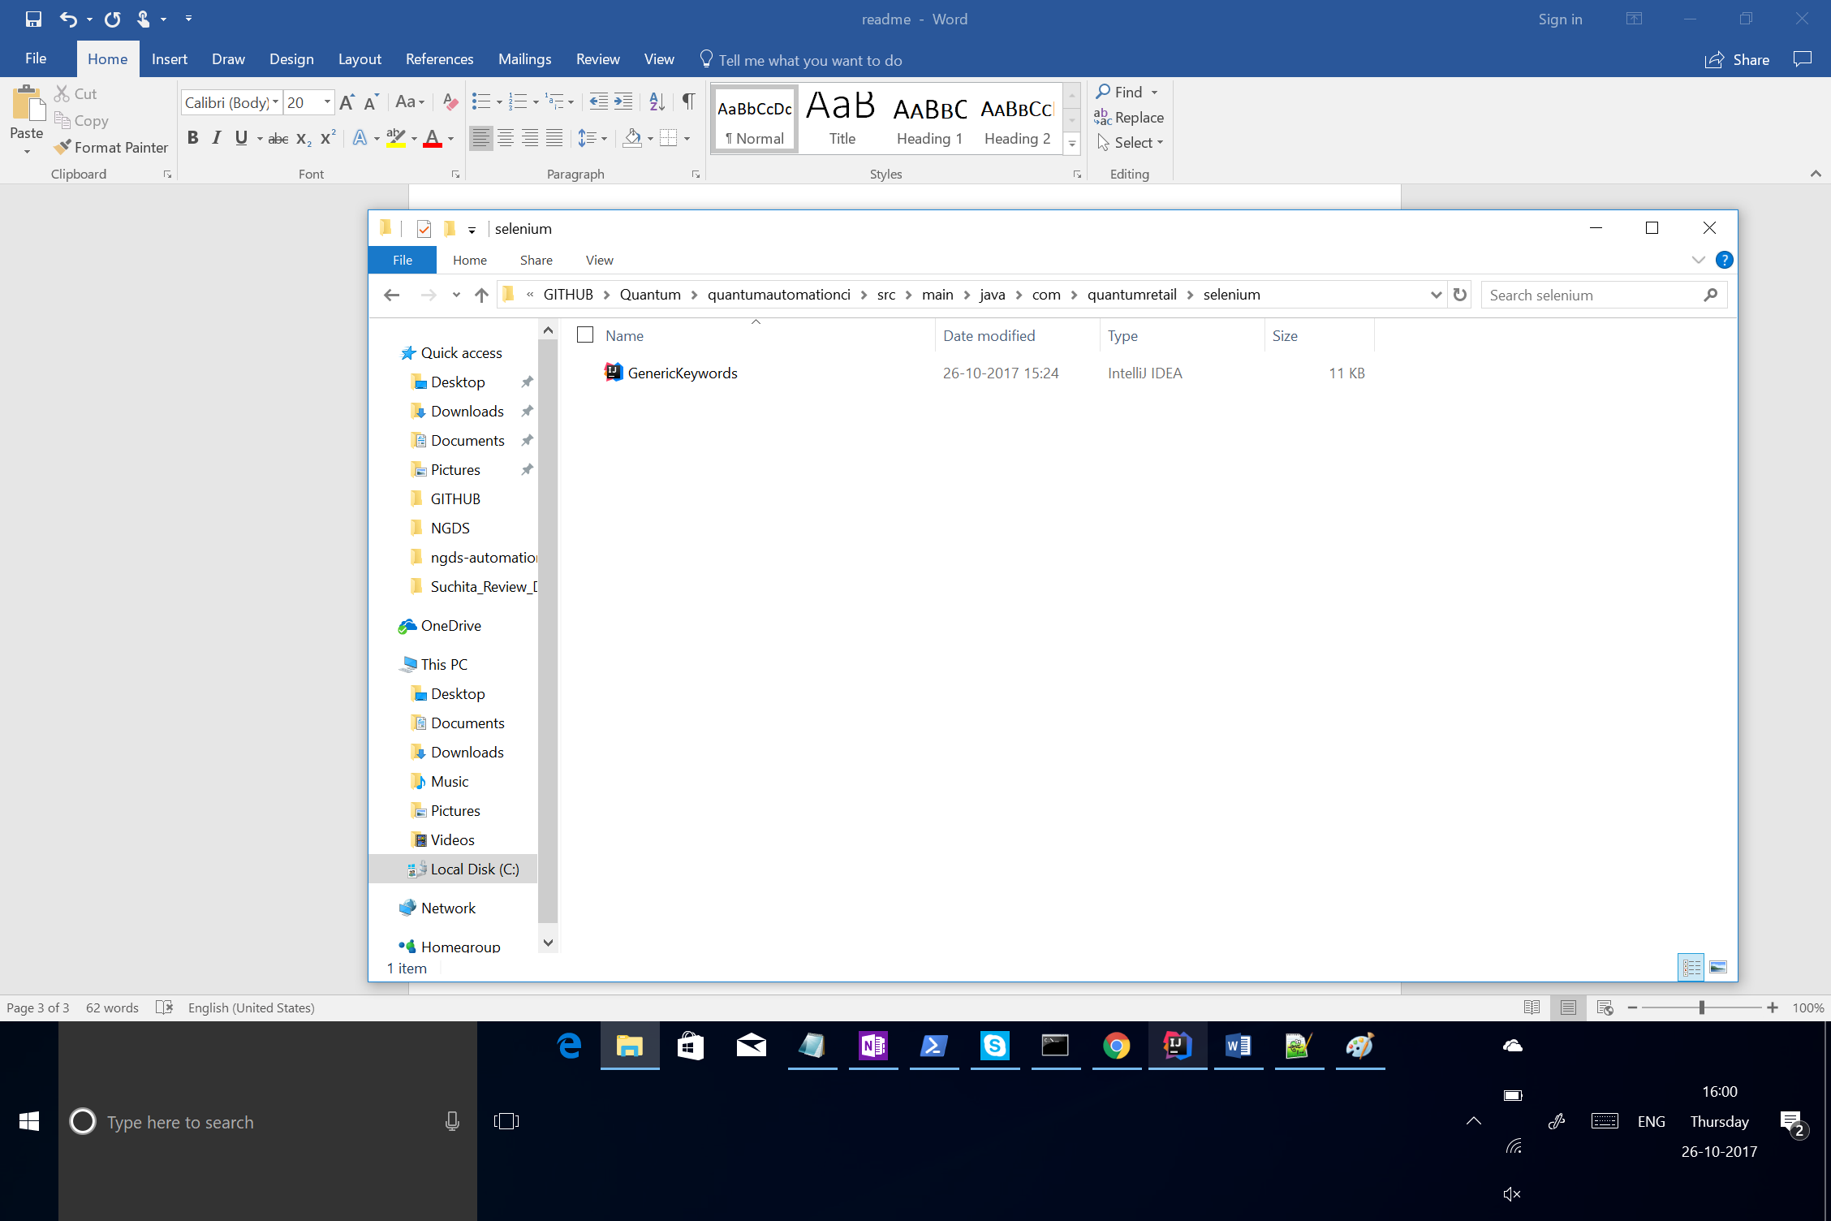

Store Global keywords and method can used across the

Automation projects

Utilities Folder : Store all Utilities classes used across the project

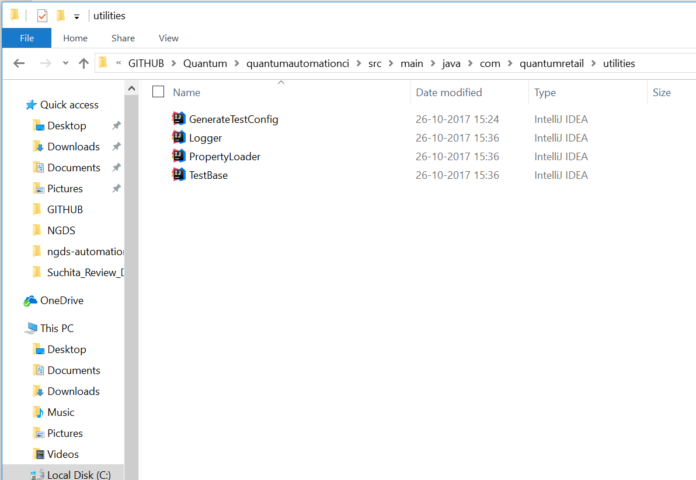

Test Results : Store Customized Html Test Report

All test classes and Pagepactory are store in

Src / test folder