Game Design Document

Fill up the following document

1. Write the title of your project.

Gun shooter

1. What is the goal of the game?

To kill the theif

1. Write a brief story of your game.

The theif has stolen a diamond and run away but now the theif and the police man are came face to face and try to kill each other . who ever kills first wins the game.

1. Which are the playing characters of this game?

* Playing characters are the ones who respond to the user based on the input from the user.
* Cars, monkeys, dinos, wizards, etc., are the playing characters in the game.

|  |  |  |
| --- | --- | --- |
| Number | Character Name | What can this character do? |
| 1 | Police man | He can shoot bullets |
| 2 |  |  |
| 3 |  |  |
| 4 |  |  |
| 5 |  |  |
| 6 |  |  |
| 7 |  |  |
| 8 |  |  |

1. Which are the Non-Playing Characters of this game?

* Non-Playing characters are the ones that don't have an action or behavior when the user interacts with the game.
* Hurdles, stones, bananas, coins, etc., are non-playing characters in the game.

|  |  |  |
| --- | --- | --- |
| Number | Character Name | What can this character do? |
| 1 | theif | The theif apperas at ramdom places along the y axis |
| 2 |  |  |
| 3 |  |  |
| 4 |  |  |
| 5 |  |  |
| 6 |  |  |
| 7 |  |  |
| 8 |  |  |

Draw your imagination of this game. What does this game look like?

* Draw the game either on your computer or on paper.
* Add images of the game scenes to show each of the playing and non-playing characters at least once.



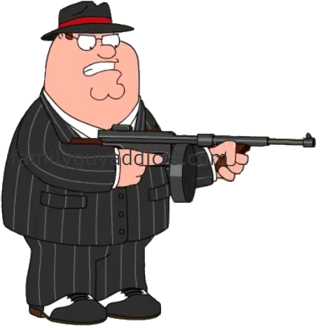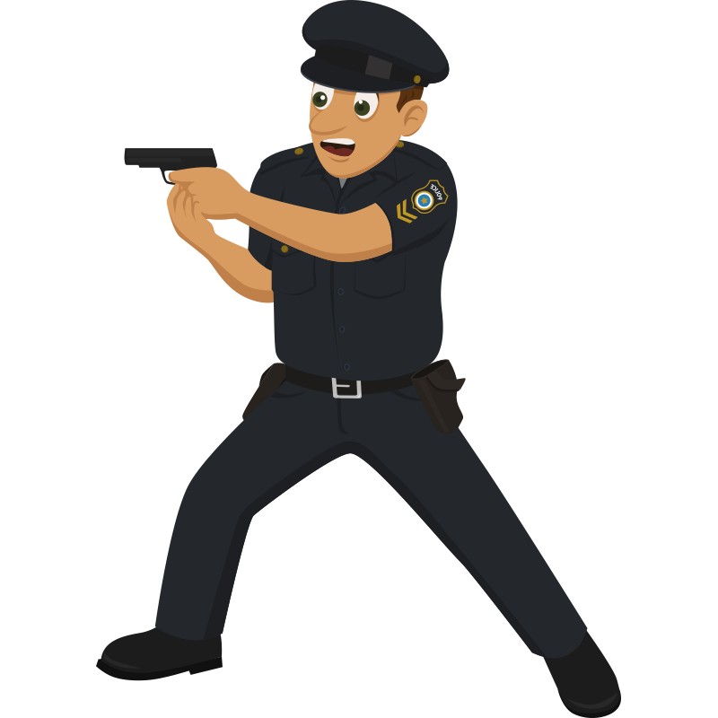

How do you plan to make your game engaging?

The police man can move along with mouse,when space bar it can shoot bullets