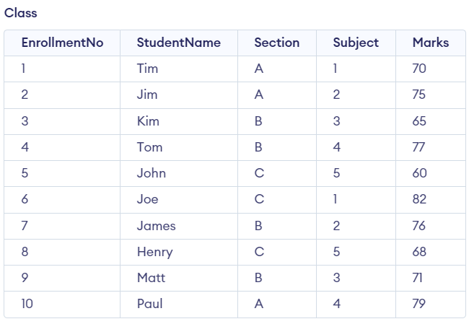

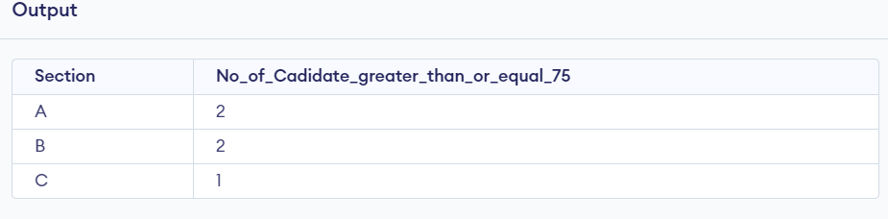

CREATE TABLE Class

(EnrollmentNo int NOT NULL,

StudentName char(20) NOT NULL,

Section char(1),

Subject int(1),

Marks int(3),

PRIMARY KEY (EnrollmentNo));

INSERT INTO Class values(1,'Tim','A',1,70);

INSERT INTO Class values(2,'Jim','A',2,75);

INSERT INTO Class values(3,'Kim','B',3,65);

INSERT INTO Class values(4,'Tom','B',4,77);

INSERT INTO Class values(5,'John','C',5,60);

INSERT INTO Class values(6,'Joe','C',1,82);

INSERT INTO Class values(7,'James','B',2,76);

INSERT INTO Class values(8,'Henry','C',5,68);

INSERT INTO Class values(9,'Matt','B',3,71);

INSERT INTO Class values(10,'Paul','A',4,79);

SELECT Section,Count(Section) as No_of_Cadidate_greater_than_or_equal_75 from Class WHERE Marks >=75 Group by Section;