SUMMARY FOR COUPON ACCEPTANCE RATE VS CUSTOMERS

Difference between customer who did and did not accept the coupon offers

We are provided with coupon data, available in data folder of GIT repo -

Based on the data analysis and visualization of the data we have created the following report for customer characteristics and behavior. This report provides a comparison of customer who accepted the coupon vs the ones who did not. Its highlights the key difference in characteristic and behavior of the customers and its acceptance rate. Our findings show some significant differences that could help to tailor future marketing plans, recommendation (personalization) for coupons to customers.

**Key Findings for Bar Coupon using single and multivariable analysis**

**Customer age:** The customers who accepted the coupons were older, more than a 50% were age 25 or above. On the opposite end of the acceptance spectrum, young consumers ages 18 to 24 evinced low acceptance rate

**Action :** Our coupon offering system should target driver who goes to bar/coffeehouse more than once a month than the one who never goes. Also target drivers who are older 21 than years old

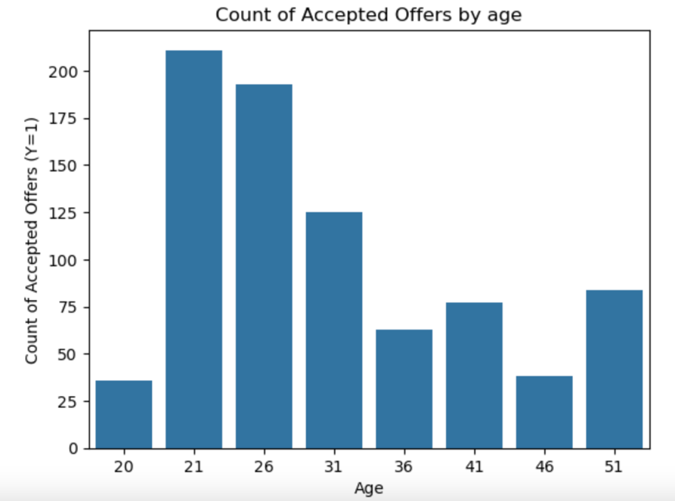

**Frequency of Bar Visits:** Interestingly, there was a major difference in how often customers went to bars. Coupon acceptance was significantly higher for customers who had visited a bar more than once in the previous month (76%) than among those who rarely or never went to one (37%)

**Action:** Our coupon offering system should target driver who goes to bar/coffeehouse more than once a month than the one who never goes. Also target drivers who are older 21 than years old

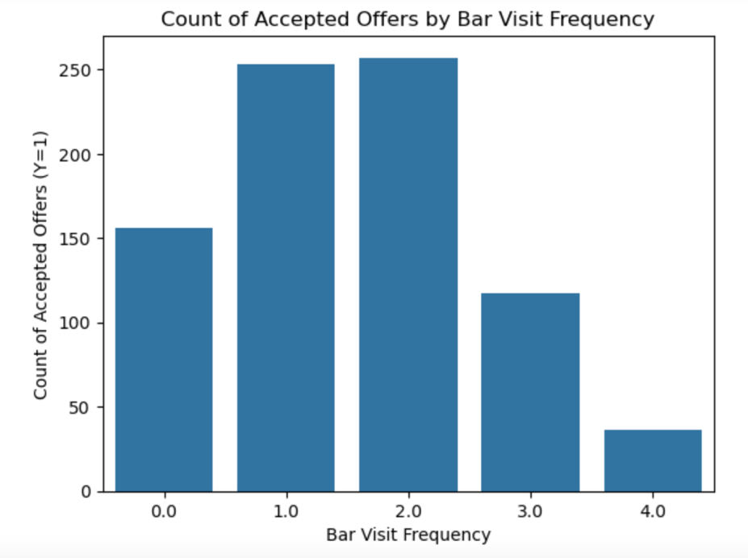

**Passenger Profile:** Adult passengers (i.e. non-kids) coupon had higher acceptance rate for bar coupon, while child passengers had an acceptance rate of only 29%. This indicates that the passenger mix could impact coupon acceptance.

**Action:** Target coupon offers to driver with adult passengers

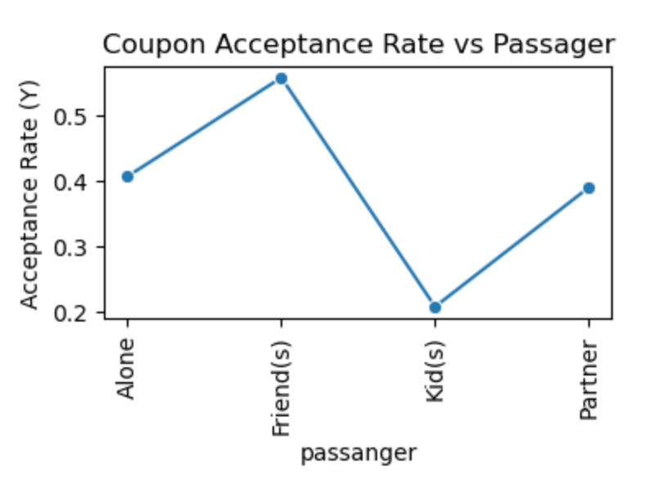

**Occupation:** Driver with occupations that were non-farming, fishing or forestry were more likely to use the bar coupons. Below graphs shows, occupation like architecture & engineering, healthcare support and production occupation has highest acceptance rate. Whereas occupation as retired has no acceptance rate. Hence targeting specific occupation demographic can increase chances of coupon acceptance.

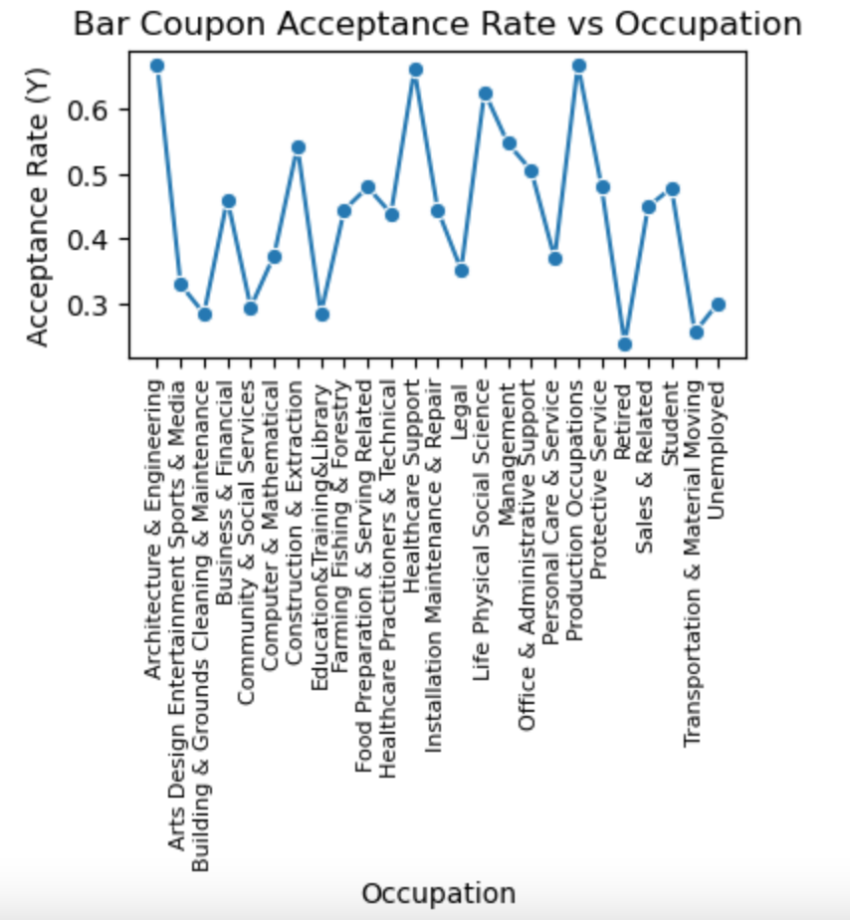

**Income Levels:** Driver with low income below $50K as well as very high income above 100K are more likely to use a bar coupon than others. This shows that income level has crucial role in coupon acceptance behavior. We can do further analysis on this to

**Action :** Markets offers for low-income driver who frequently goes to cheaper restaurants.

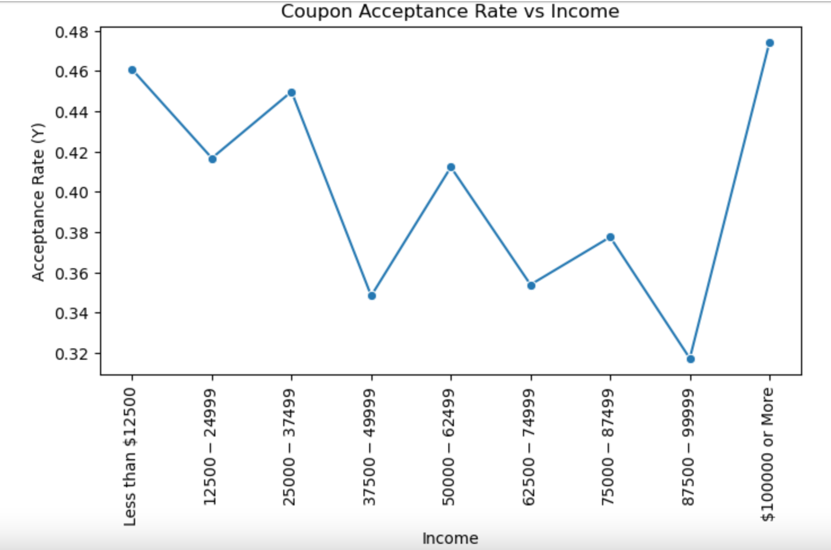

**Weather and Timing:** Consequently, coupon acceptance rates peaked during sunny weather and after 6 PM — which showcases that external factor plays a role in coupon acceptance rate.

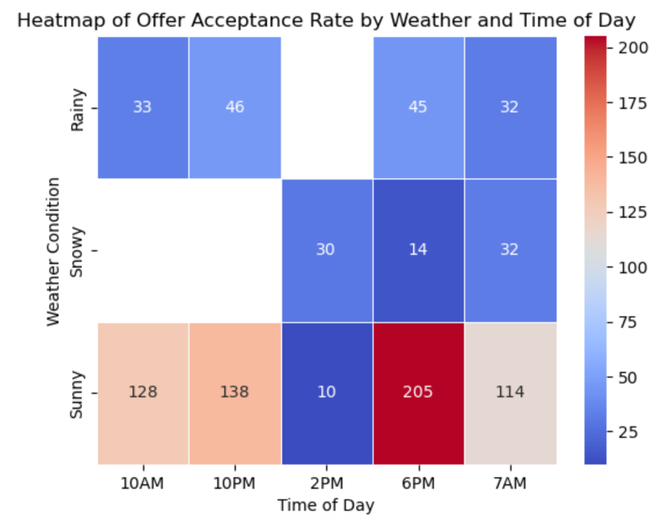

**Action :** Scheduling promotion activities more frequently during summers.

**Destination Urgency:** When the destination of customers was non-urgent place, the probability to accepted the bar coupon is comparative higher

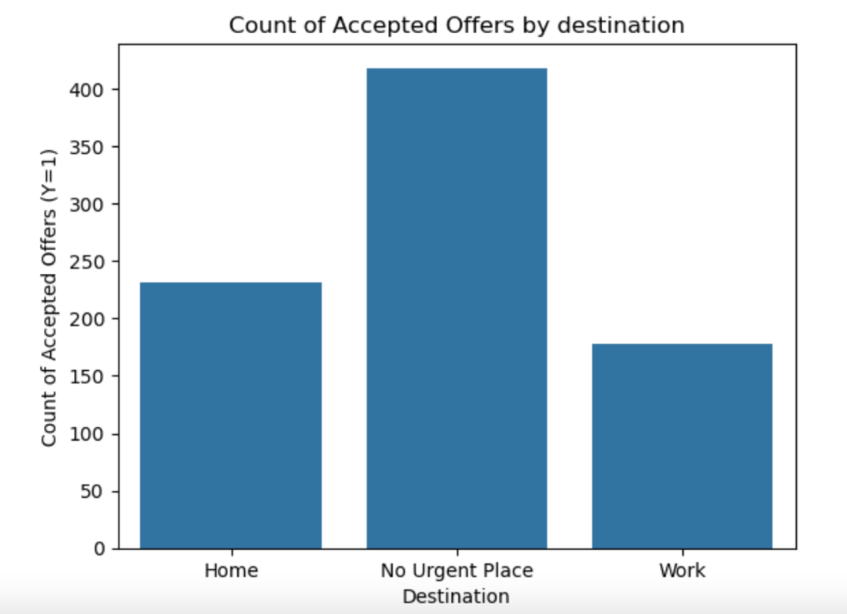

**Action :** Have additional discounts or incentives for the drivers who has no urgent destination to encourage coupon acceptance.

**Other Observations:**

Based on the below graph, It shows that coffeehouse, cheap restaurant, carry out and take away coupon have higher acceptance rating as compared to bar and expensive restaurants

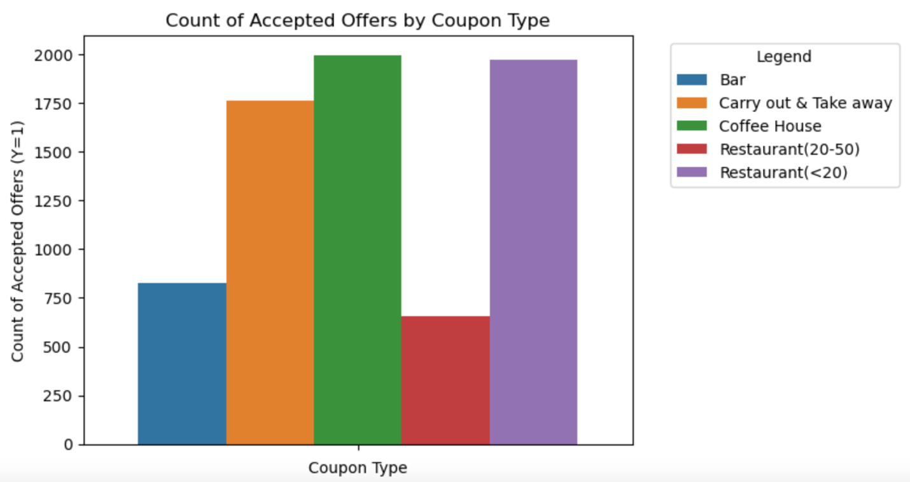

Customer accepts coupons that had validity for **1 day more than coupon that expires in 2hours**

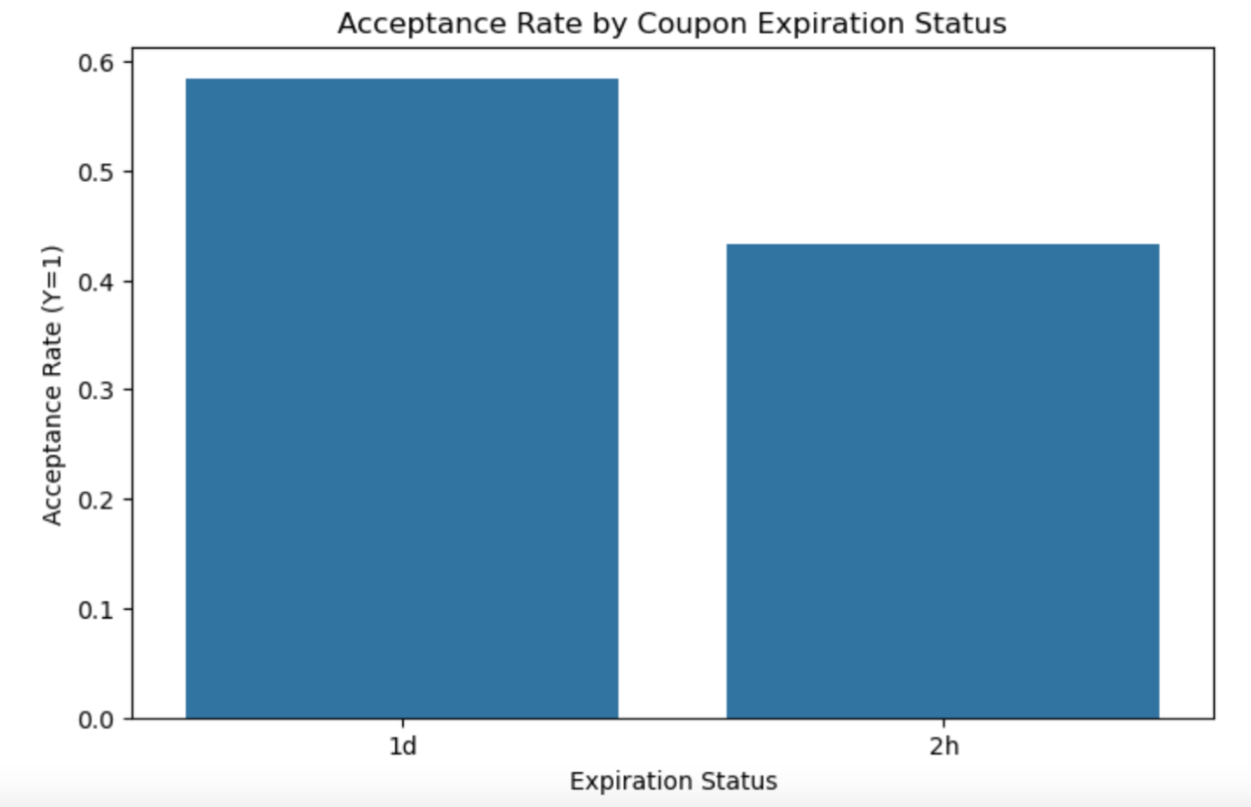

**Based on the acceptance rate that we have calculated and visualization, there is clear difference in acceptance rate based on customer characteristics and behaviors**

**Below analysis is for CoffeeHouse coupon group :**

1. **Driver age** The Driver who accepted the coupons were older, more than a 60% were age 25 or above. On the opposite end of the acceptance spectrum, young consumers ages 18 to 24 evinced low acceptance rate

**Action :** Our coupon offering system should target driver who goes to coffeehouse more than once a month than the one who never goes. Also target drivers who are older 21 than years old

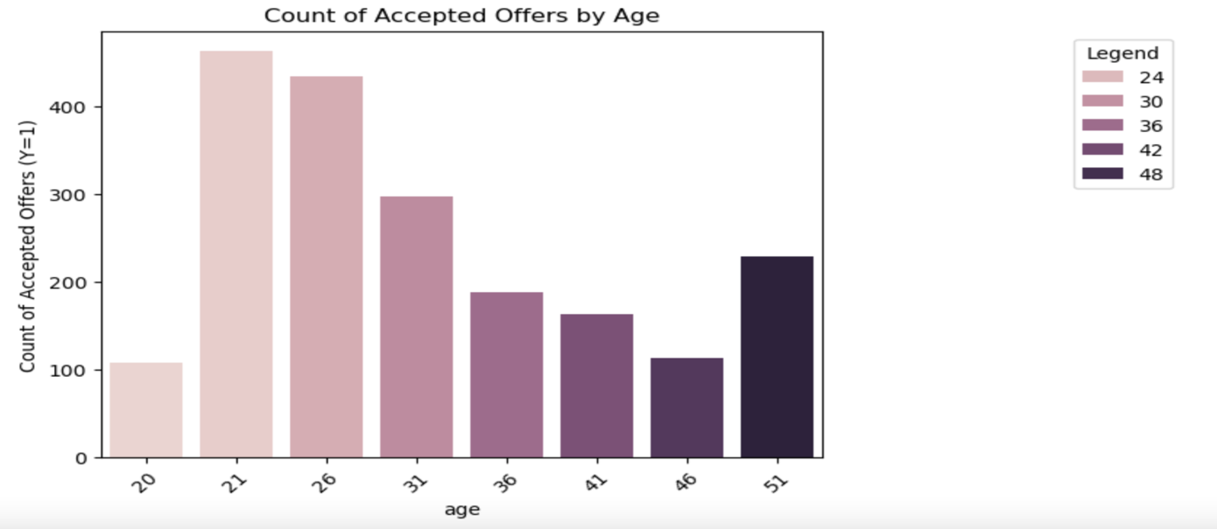

1. **Marital Status** Driver who are single and married with partners have more chances to accept the coffeehouse coupon then other especially widowed are very less likely to accept the coupon

**Action:** Target offering coupons to driver who are single and/or married with partners.

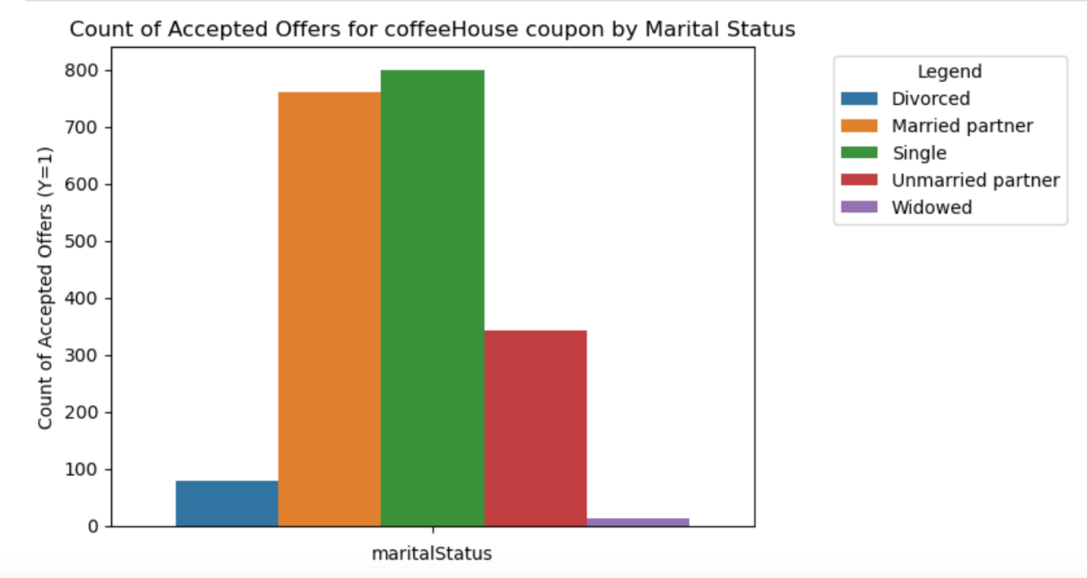

1. **Frequency visit** Driver who visits coffeehouse more than 1 times are more likely to accept the coupons than who never visits

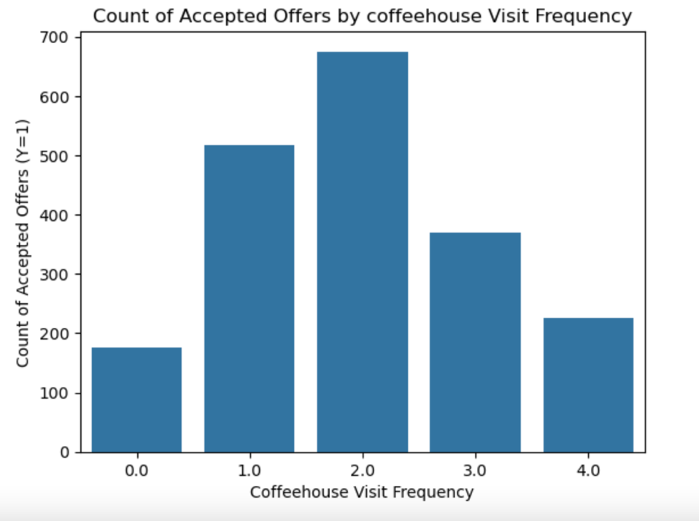

1. **Coupon Expiration** Acceptance of coupon with 1 day expiration is higher then 2hour expiration Driver with age greater than 25 are likely to accept coupons which are with expiration of 1 day then others

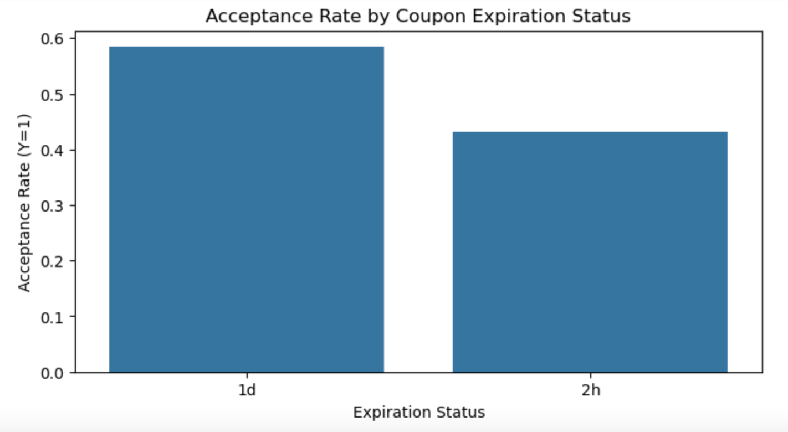

**Over all Actions:**

1. Create marketing campaigns for businesses using this data to target relevant customers to increase the success rate of coupon usage for increasing business revenue.

**Recommendation:**

1. Having feedback loop from driver’s apps will help continuous improvement to identify accurate segments for drivers who will accepts the coupons.
2. Continue analyzing the data to improve model performance and accuracy