D:\Selenium \ TestNG-P011-TestNg3-All-Concepts-Covered
TestNG Field Guide
Poora project ek jagah - bilkul simple language mein
Kya | Kitna
Total tests | 147
Pass hue | 146
Fail hue | 0
Skip hue (jaan bujh ke) | 1
Time laga | 83 second

Ye document TestNG ke saare concepts explain karta hai - lekin theory se nahi, chalte hue code se. Har concept ki apni suite XML hai, to aap ek ek karke sab try kar sakte ho.

Is Document Mein Kya Hai
# | Topic | Kya milega
1 | Ye project kya hai | Basic idea, aur do hisse
2 | Konsi website pe test | Swag Labs aur uske 4 accounts
3 | Poora system kaise chalta hai | Architecture diagram
4 | Ek test chalne pe kya hota hai | Sabse important diagram
5 | Konsa folder kis kaam ka | Ek line mein har folder
6 | Gyarah concepts | Aapki puri list, ek ek karke
7 | Kya kya try kar sakte ho | 10 experiment, command ke saath
8 | Result kaise padhein | 5 report jo har run banati hai
9 | Chaar problem jo aayi thi | Asli bugs aur unka fix
10 | Command cheat sheet | Sab commands ek jagah

1. Ye Project Kya Hai
Ise samjho ek aisi textbook jo chal bhi sakti hai.
Zyadatar TestNG tutorials mein ek chhota sa code snippet dikhta hai, aap sar hila dete ho, aur ek hafte baad yaad hi nahi rehta ki @BeforeTest ek class pe chalta hai ya kisi aur cheez pe. Ye project un sawaalon ka jawab chala ke deta hai.
Jaise lifecycle test - wo sirf batata nahi ki TestNG kis order mein annotations call karta hai. Wo order ko record karta hai jaise jaise wo hota hai, aur phir uspe assert karta hai. Kal ko agar TestNG apna order badal de, to test red ho jayega aur aapko bata dega.
Padhai ke neeche ye ek asli automation framework hai: page objects, thread-safe driver factory, environment config, retry, Excel se data, failure pe screenshot, aur apni khud ki reports. Yahan koi bhi cheez khilona nahi hai jo real project pe fail ho jaye.

Project ke do hisse
Aadhe test classes browser kholte hi nahi. Wo sirf TestNG ki mechanics ke baare mein hain - invocation count, thread pool, dependency, assertion style. Unke liye Chrome kholna 30 second waste karna hai aur prove kuch bhi nahi hota. Isliye wo BaseTest extend karte hain.
Baaki aadhe asli application chalate hain aur BaseWebTest extend karte hain, jo unke liye browser sambhalta hai. Isi wajah se concept suites second mein khatam ho jaati hain aur full regression ek minute leta hai.

2. Konsi Website Pe Test Kar Rahe Hain
Swag Labs - https://www.saucedemo.com. Ek chhoti si online shop jo branded saaman bechti hai. Login karo, 6 product dekho, sort karo, cart mein daalo, address bharo, total dekho, order place karo. Poora e-commerce journey lagbhag 6 click mein - padhane ke liye bilkul sahi size.
Ye website automation practice ke liye hi banayi gayi hai, isliye stable hai, hamesha up rehti hai, aur koi rok tok nahi hai. Sabse achhi baat - ismein 4 alag alag account hain jo jaan bujh ke alag behave karte hain. Yahi cheez is project ko banawati example ki jagah asli material deti hai.

Account | Kya karta hai | Hum kis liye use karte hain
standard_user | Sab kuch theek chalta hai | Zyadatar tests ka happy path
locked_out_user | Login pe hamesha reject | Negative test aur error message check
problem_user | Login ho jata hai, phir data toota dikhata hai | Soft assertion kis liye hoti hai, wo dikhane ke liye
performance_glitch_user | Login to hota hai, par bahut slow | Retry aur timeout ka asli demo

Sabka password secret_sauce hai. Website khud apne login page pe ye credentials likhti hai, to ismein koi secret nahi hai - phir bhi humne inhe config.properties mein rakha hai, code mein hardcode nahi kiya. Yahi aadat asli environment pe kaam aati hai.

3. Poora System Kaise Kaam Karta Hai
Chhe cheezein ek line mein hoti hain, aur listeners side se sab dekhte rehte hain. Bas yahi poora architecture hai.
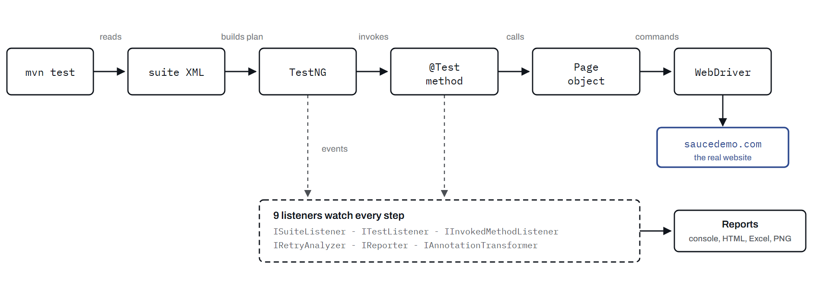
Run ek seedhi line hai; reporting side channel hai. Aapka test kabhi report se baat nahi karta, aur listener kabhi browser ko haath nahi lagata.
Isi wajah se aap reporting badal sakte ho bina ek bhi test class kholе.

Sabse bada decision: ThreadLocal
DriverFactory browser ko ek ThreadLocal mein rakhta hai - matlab har thread ko apna alag private copy milta hai. Jab suite bolti hai "4 test ek saath chalao", to 4 threads ko apna apna browser mil jata hai, aur page object ko pata bhi nahi chalta ki parallel chal raha hai.
Yahi ek decision hai jiski wajah se is project ki koi bhi suite parallel mode badal sakti hai bina ek line test code chhue.

4. Ek Test Chalne Pe Kya Hota Hai
Ye diagram yaad rakhne layak hai. TestNG jo kuch bhi karta hai, usi order mein, ek single test method ke liye.
Indentation hi asli baat hai: har @Before ka ek matching @After hai, aur andar wale bahar walon se zyada baar chalte hain.
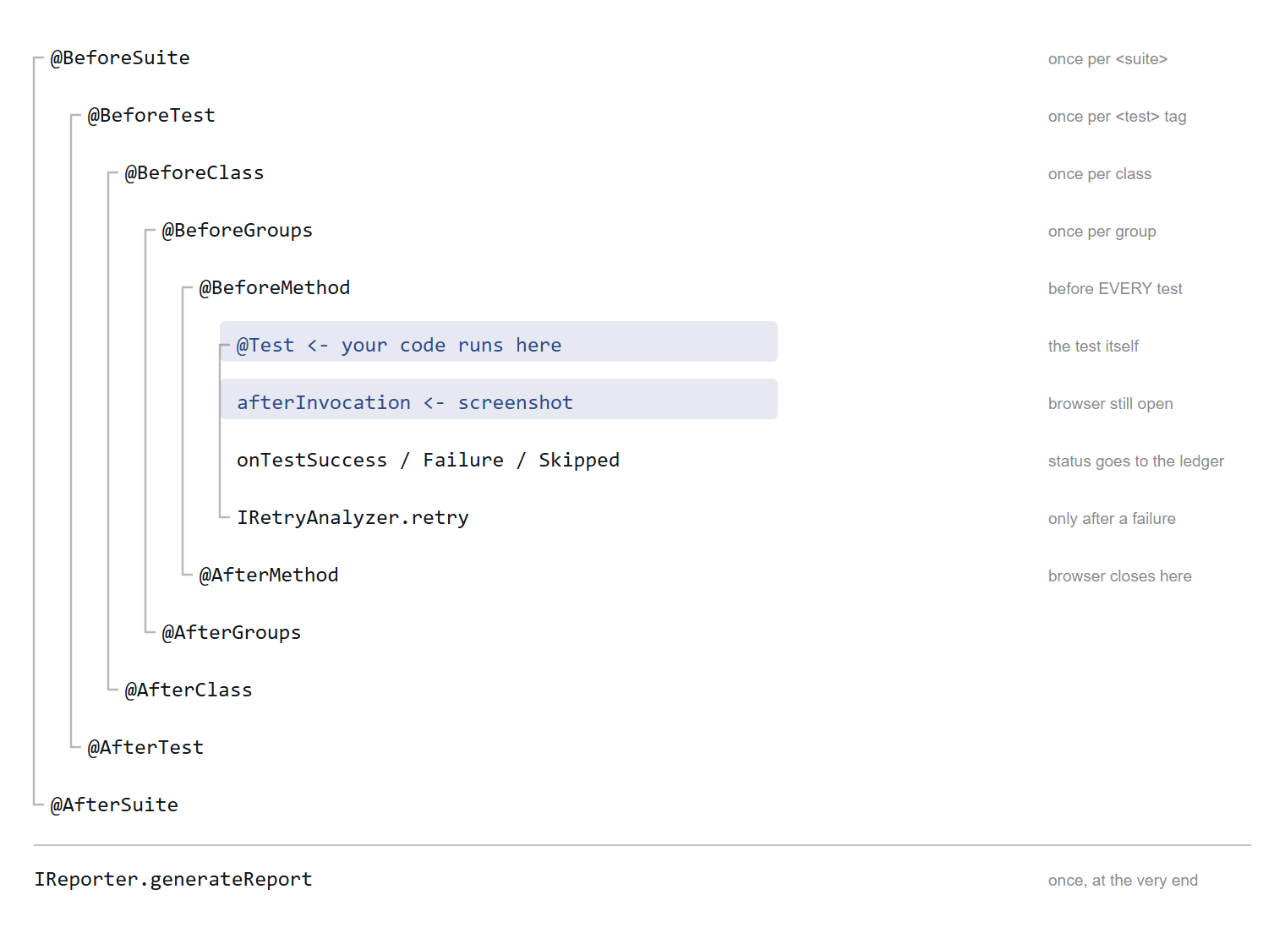
Do row highlight ki hui hain kyunki wahin ye framework apna kaam karta hai.
Failure ka screenshot afterInvocation mein liya jata hai, onTestFailure mein nahi. TestNG guarantee deta hai ki wo test method khatam hote hi chalega, jab browser abhi khula hai. Baad mein lene ki koshish karoge to screenshots folder khaali milega - ye classic galti hai.
JO LOG AKSAR GALAT SAMAJHTE HAIN
@BeforeTest ka test method se koi lena dena nahi hai. Wo suite XML ke <test> TAG ke baare mein hai. Agar aapki XML mein 3 <test> block hain, to wo 3 baar chalega. Har test method se pehle chalne wala @BeforeMethod hai.

5. Konsa Folder Kis Kaam Ka Hai
Ek ek line mein. Sab kuch src/test/java/com/sk/ ke andar hai.

Folder | Ismein kya hai | Pehle ye kholo
core/ | Config, driver factory, do base class, group ke naam | DriverFactory
pages/ | Saat page object. Project ke saare locator aur wait yahin hain | BasePage
model/ | Chhoti typed cheezein: account, sort option, sheet ki row | TestUser
listeners/ | Nau listener, retry analyzer, aur ledger jisse saari report banti hai | TestExecutionListener
dataproviders/ | Code mein likhi rows, aur Excel se aayi rows | ExcelDataProvider
utils/ | Excel padhna-likhna, screenshot, thread audit | ExcelReader
annotations/ | Humara apna @Flaky annotation | Flaky
tests/ | Har concept ka apna package. Padhna yahin se shuru karo | tests/e2e/
suites/ | Har concept ki apni XML, poori tarah comment ki hui | 04-groups-and-filters.xml
resources/config/ | config.properties aur qa / staging overlay | config.properties
resources/testdata/ | SwagLabsTestData.xlsx - teen sheet | ReadMe sheet

Do base class
- BaseTest - sirf logger aur class-level logging deta hai. Jab test ko browser nahi chahiye, tab ise extend karo.
- BaseWebTest extends BaseTest - browser add karta hai: har test method se pehle naya driver kholta hai, baad mein band karta hai, aur loginPage() deta hai journey shuru karne ke liye.

6. Gyarah Concepts
Number suite files se match karte hain - matlab concept 3 ka matlab suites/03-*.xml. Har concept mein: kya hai, kyun kaam ka hai, aur chalane ki exact command.

1. Annotations, aur unka order
Kya hai. Wo das @Before aur @After hooks jo aapke test ko cover karte hain, plus @Test pe lagne wale attributes - priority, enabled, timeOut, expectedExceptions, description.
Kyun kaam ka hai. Setup galat level pe rakh diya to ya to har test pe mehanga kaam dobara hoga, ya phir do tests aapas mein state share kar lenge jo nahi karni chahiye. Konsa hook kitni baar chalta hai - bas yahi farak hai.
Ek attribute alag se yaad rakho: enabled = false skip report nahi karta - test report se poori tarah gayab ho jata hai, aur 6 mahine baad kisi ko yaad hi nahi rehta ki wo tha. Uski jagah reason ke saath SkipException behtar hai.
Code: tests/annotations/AnnotationLifecycleTest, TestAttributesTest
Chalao: mvn test -DsuiteXmlFile=suites/01-annotations-and-attributes.xml

2. Suite properties, XML se class tak
Kya hai. Suite XML mein <parameter> likho aur @Parameters se code mein le lo. Ye suite level pe, <test> level pe, aur <class> level pe likha ja sakta hai - aur sabse specific wala jeetta hai.
Kyun kaam ka hai. Isi se ek test class teen browser ya chaar environment pe chalti hai, bina uske andar ek bhi if likhe.
Is suite mein humne ek hi parameter teeno level pe likha hai, taaki override chain ek file mein dikh jaye. Ek aur cheez jo log galat samajhte hain: @Parameters injection class-level parameter dekh leta hai, lekin ITestContext.getCurrentXmlTest().getParameter() nahi dekh sakta - kyunki test context poore <test> block ka hota hai, aur class-level value us scope pe defined hi nahi hai.
Code: tests/suiteconfig/SuiteParameterTest
Chalao: mvn test -DsuiteXmlFile=suites/02-suite-parameters.xml

3. Parallel execution - paanch alag level pe
Kya hai. TestNG thread baant sakta hai: method ke hisaab se, class ke hisaab se, <test> block ke hisaab se, factory instance ke hisaab se, ya poori suite ke hisaab se. Ye ek dusre ki jagah nahi le sakte - har ek decide karta hai ki thread kis cheez ko milega.
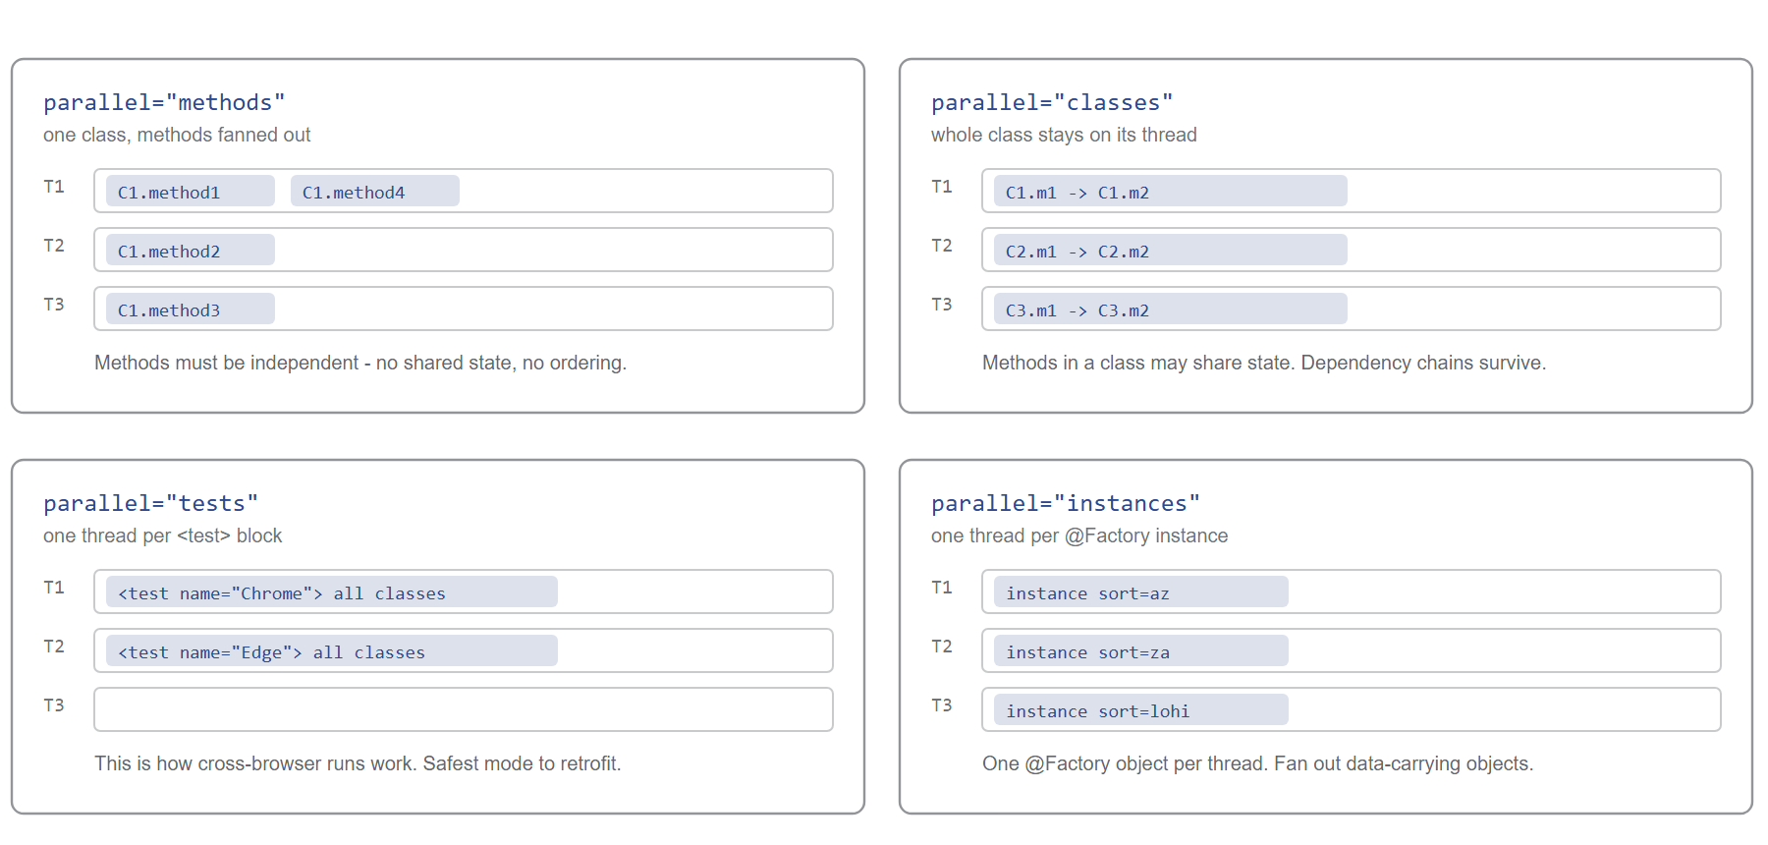
Farak sirf itna hai ki lane mein baithta kaun hai.
Ek paanchva level in sab ke upar hai: suiteThreadPoolSize poori suite files ko saath saath chalata hai. Aur ek chhathi pool, jo thread-count se bilkul alag hai, parallel data providers ki hoti hai.
Kyun kaam ka hai. Ek ghante ka regression 10 minute ka ho jata hai. Keemat ye hai ki aapke tests ko sach mein independent hona padega - jo waise bhi ek achhi aadat hai.
Code: tests/parallel/ - paanch class
Chalao: suites/03-parallel-methods.xml, -classes, -tests, -instances, 13-suite-of-suites.xml

4. Groups aur filtering
Kya hai. Test pe tag lagao - groups = {"smoke", "cart"} - aur suite XML mein un tags ko include ya exclude karo.
Kyun kaam ka hai. Ek hi codebase, alag alag pipeline. Har commit pe smoke chalao. Raat ko regression minus flaky. Release se pehle ek <define> kiya hua group jo dusre groups se bana ho.
Do rule jo jhagda khatam kar dete hain: exclude hamesha include ko harata hai, aur ek method ek se zyada group mein ho sakta hai. Speed ke hisaab se tag karo (smoke, regression) aur area ke hisaab se bhi (cart, checkout) - phir aap kisi bhi tarah se slice kar sakte ho.
Code: tests/groups/GroupedCatalogTest
Chalao: mvn test -DsuiteXmlFile=suites/04-groups-and-filters.xml -Dheadless=true

5. Dependency, invocation count aur thread pool
Kya hai. dependsOnMethods aur dependsOnGroups kehte hain "agar wo fail ho gaya to mujhe chalane ka fayda nahi". invocationCount ek hi method ko N baar chalata hai, threadPoolSize un runs ko threads pe baant deta hai, aur successPercentage kuch runs ko fail hone ki chhoot deta hai.
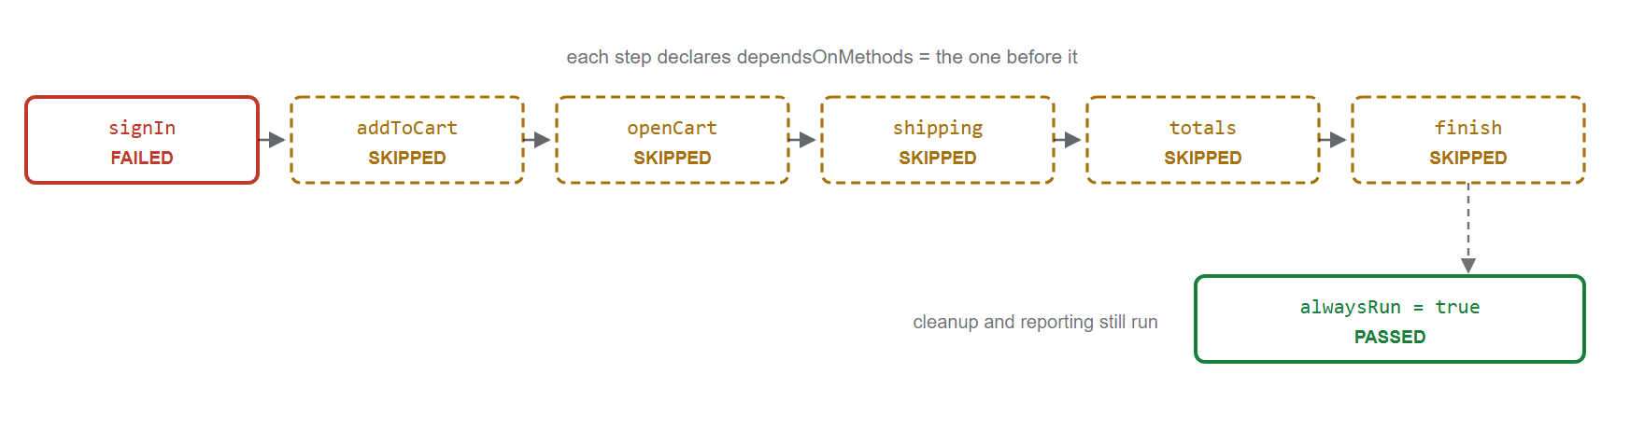
Ek red line, aur paanch imaandaar skip. Dependency ke bina aapko chhe ek jaise failure milte aur pata nahi chalta ki asli wajah kaun thi.
alwaysRun = true un cheezon ke liye escape hatch hai jo har haal mein chalni chahiye - teardown, alert, ya report upload.

Aur wo sawaal jo har koi poochta hai: kya thread-count negative ho sakta hai?
Nahi. XML model khushi khushi -4 store kar lega, kyunki XmlSuite ek simple bean hai jo validate nahi karta. Lekin TestNG us number se ek fixed thread pool banata hai, aur fixed pool 1 se kam kuch bhi accept nahi karta. Matlab negative thread-count ek configuration bug hai jo run time pe pakda jayega - ye "unlimited" kehne ka smart tarika nahi hai. ThreadCountBoundaryTest dono baatein assert karta hai.
Code: tests/dependency/, tests/execution/
Chalao: mvn test -DsuiteXmlFile=suites/05-dependency-invocation-threads.xml -Dheadless=true

6. Hard aur Soft assertions
Kya hai. Hard assertion (Assert.assertEquals) fail hote hi exception phenk deta hai, uske baad kuch nahi chalta. Soft assertion (SoftAssert) failure yaad rakhta hai aur aage badh jata hai, phir assertAll() pe sab ek saath report karta hai.
Kyun kaam ka hai. Hard tab use karo jab aage ka sab kuch us check pe depend karta ho - login hi nahi hua to cart ka total check karne ka koi matlab nahi. Soft tab use karo jab ek hi screen pe alag alag cheezein dekhni hon, taaki ek run mein hi chaaron problem pata chal jayein - na ki pehli problem, chaar baar, chaar din mein.
Do trap, dono code mein handle kiye hue hain. assertAll() bhoolna - test chup chaap pass ho jata hai. Ye sabse common tareeka hai suite ko green aur bekaar banane ka. Aur ek hi SoftAssert ko threads mein share karna - sab parallel tests ke failure mix ho jaate hain, isliye humara ThreadLocal mein rehta hai.
Code: tests/assertions/HardAssertionTest, SoftAssertionTest
Chalao: mvn test -DsuiteXmlFile=suites/06-assertions.xml -Dheadless=true

7. Listeners - poore nau
Kya hai. Aise hooks jinse aap run ko dekh sakte ho ya badal sakte ho, bina kisi test ko chhue. Is project mein TestNG ka har listener interface implement kiya gaya hai.

Interface | Kab chalta hai | Humara kya karta hai
IExecutionListener | Poore JVM run pe ek baar | Output folder banata hai, counters reset
IAnnotationTransformer | Har @Test pe, load time pe | @Flaky methods pe retry lagata hai
ISuiteListener | Har suite ke aage peeche | Parallel mode aur thread count ka banner
ITestListener | Har test result pe | Pass / fail / skip decide karta hai
IInvokedMethodListener | Har method pe (config bhi) | Failure ka screenshot leta hai
IConfigurationListener | @Before / @After ke result pe | Batata hai konsa setup toota
IMethodInterceptor | Ek baar, sab chalne se pehle | Smoke tests ko aage kar deta hai
IRetryAnalyzer | Failure ke baad | Decide karta hai dobara chalana hai ya nahi
IReporter | Sabse end mein ek baar | Console block, HTML, Excel

Register karne ke teen tareeke hain, aur project teeno use karta hai taaki aap compare kar sako: service loader file (META-INF/services/org.testng.ITestNGListener) har suite pe lagti hai; <listeners> suite XML mein sirf usi suite pe; aur @Listeners class pe.
YE HUMNE NAAPA HAI, MAANA NAHI
@Listeners sirf us class pe nahi lagta jispe likha hai - jo ki sab log expect karte hain. testng.xml chala ke dekha: ek class pe likha listener us <test> block ki saari paanch classes ko dekh raha tha, aur dusre block ki ek bhi nahi. Agar sach mein sirf ek class chahiye, to listener ko khud filter karna padega.
Code: listeners/ - aur tests/listeners/ListenerShowcaseTest
Chalao: mvn test -DsuiteXmlFile=suites/07-listeners.xml (browser nahi, ~2 second)

8. Data providers aur retry
Kya hai. @DataProvider ek hi test method ko bahut saari rows deta hai; har row apna alag result banti hai. Retry analyzer fail hue test ko gine chune baar dobara chalata hai.
Project chaar tarah ke provider dikhata hai: simple Object[][]; lazy Iterator; ek jo dekh leta hai ki wo konse Method ko data de raha hai aur uske hisaab se data badal deta hai; aur ek jo ITestContext padhta hai taaki smoke run mein kam rows aur regression run mein zyada rows jayein.
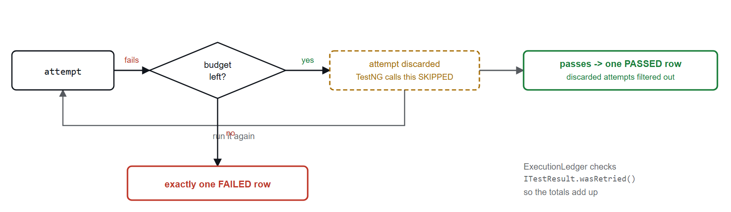
Retry chup chaap aapke numbers kharab kar deta hai, agar handle na karo.
TestNG retry mein phenke gaye attempt ko SKIPPED mark karta hai. Matlab jo test do baar fail hoke teesri baar pass hua, wo report mein "1 passed, 2 skipped" dikhega. Humara listener wasRetried() check karke un rows ko hata deta hai - isliye kabhi kabhi humara summary aur surefire ka number alag hota hai, aur humara sahi hota hai.
Retry ka rule. Ye asli environment ki problem ke liye hai, toote hue test ko green banane ke liye nahi. Isiliye humara retry sirf @Flaky marked methods pe lagta hai, aur wo annotation reason aur ticket number maangta hai.
Code: dataproviders/, tests/retry/, listeners/RetryAnalyzer
Chalao: mvn test -DsuiteXmlFile=suites/08-dataproviders-and-retry.xml -Dheadless=true

9. Excel se test data
Kya hai. Test data src/test/resources/testdata/SwagLabsTestData.xlsx mein hai. Ek row add karo, Execute ko Y kar do, aur agle build mein wo chal jayega. Java mein kuch badalne ki zaroorat nahi.
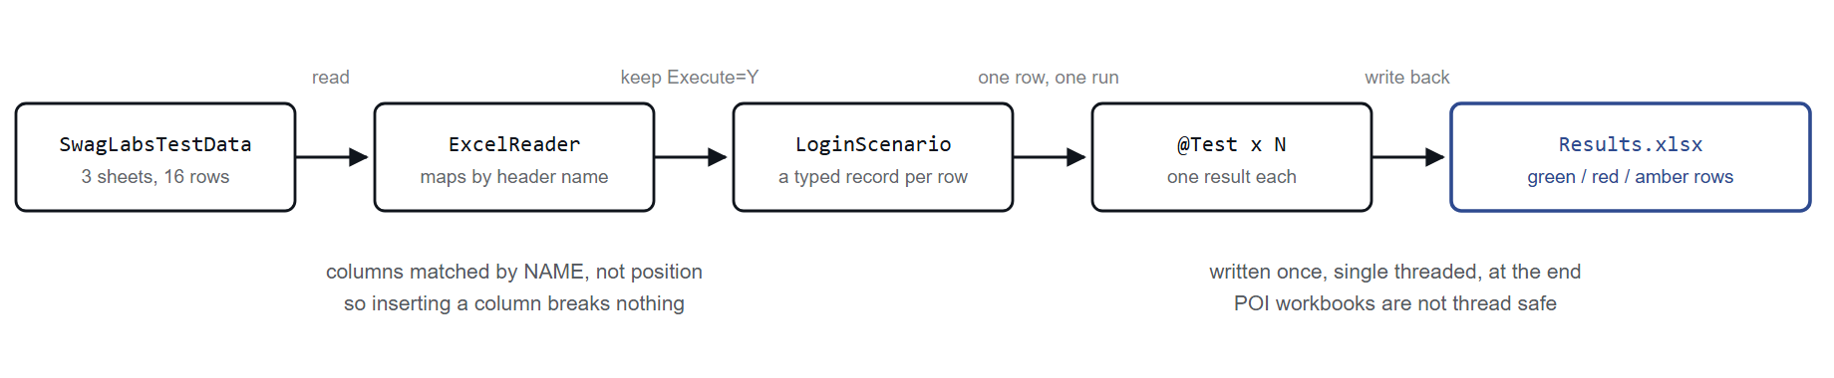
Column ko naam se match karna hi wo detail hai jiski wajah se ye tikta hai.
Agar index se match karte, to jis din kisi ne beech mein ek column daal diya, us din tees test chup chaap postcode ko surname se compare karne lagte.
Code: utils/ExcelReader, utils/ExcelWriter, tests/dataprovider/ExcelDriven*
Chalao: mvn test -DsuiteXmlFile=suites/09-excel-driven.xml -Dheadless=true

10. Skipped - aur iska asli matlab
Kya hai. Skip ka matlab hai humne ye check kiya hi nahi. Pass ka matlab hai humne check kiya aur sab theek tha. Dono ko mila dena hi wo tareeka hai jisse suite chalane layak nahi rehti.

Kaise skip hota hai | Report mein dikhta hai? | Kab use karo
throw new SkipException(...) | Haan, aapke message ke saath | Precondition puri nahi - feature flag off, data missing
dependsOn wala fail ho gaya | Haan | Apne aap. Dependency ka yahi to point hai
@BeforeMethod | Haan | Apne aap. Poori class ke tests skip ho jate hain
@Test(enabled = false) | Nahi - gayab ho jata hai | Lagbhag kabhi nahi

Yahi wo suite hai jo teeno status ek saath dikhati hai. Ye akeli suite hai jo demo-status group chalati hai, aur ye jaan bujh ke red khatam hoti hai - us group ka har test fail ya skip hone ke liye hi banaya gaya hai, taaki reporting ke paas dikhane ko kuch ho.
Code: tests/skip/SkipScenarioTest, SkipBySetupTest
Chalao: mvn test -DsuiteXmlFile=suites/10-skip-and-status-showcase.xml -Dheadless=true

11. Page Object Model
Kya hai. Har locator, wait aur click ek page class ke andar rehta hai. Test sirf ye batata hai ki karna kya hai.
// Poori purchase journey. Na koi locator, na wait, na findElement.
CheckoutOverviewPage overview = loginPage().loginAs(TestUser.STANDARD)
.sortBy(SortOption.PRICE_LOW_TO_HIGH)
.addToCart(BACKPACK)
.addToCart(BOLT_TSHIRT)
.openCart()
.checkout()
.enterShippingDetails("Ayush", "Dhiman", "560037")
.continueToOverview();
Ye kaam kyun karta hai. Chaar rule, jo com.sk.pages mein har jagah follow kiye gaye hain:
- Page ka action agli page return karta hai. cart.checkout() aapko CheckoutInformationPage deta hai, to compiler hi rok dega agar aap cart pe hote hue checkout ka method call karoge.
- Page object kuch assert nahi karta. Wo sirf state deta hai; sahi kya hai ye test decide karta hai. Jo page khud assert karta hai use dusra test reuse nahi kar sakta.
- Page object asli type return karta hai. Price ke liye double, na ki string "Total: $32.39". Parsing page object ka kaam hai.
- Kahin bhi Thread.sleep nahi hai. Har wait BasePage mein ek explicit condition hai.
Code: pages/ - saat class. tests/e2e/EndToEndPurchaseTest
Chalao: mvn test -DsuiteXmlFile=suites/11-pom-end-to-end.xml -Dheadless=true

7. Kya Kya Try Kar Sakte Ho
Lagbhag isi order mein, ki konsa kitna sikhata hai. Project root se chalao. Eclipse mein kisi bhi suite XML pe right-click karke Run As > TestNG Suite chun lo.
01. Teeno status ek hi run mein dekho
Reporting samajhne ka sabse tez tareeka. Ye suite red khatam hone ke liye hi bani hai.
mvn test -DsuiteXmlFile=suites/10-skip-and-status-showcase.xml -Dheadless=true
Kya dekhna hai: Output ke end mein summary block. Phir test-output/custom-report/execution-summary.html aur test-output/screenshots/ kholo. Sirf do screenshot milenge, kyunki sirf do failure mein browser tha.
02. Chaar browser ek saath chalte dekho
-Dheadless hata do aur browser dikhne lagenge. Chaar window, chaar test, ek class.
mvn test -DsuiteXmlFile=suites/03-parallel-methods.xml
Kya dekhna hai: Log mein [TestNG-methods-1] wala column. Method ke naam aapas mein mix ho rahe honge - yahi parallel hai, baari baari chalna nahi.
03. Dekho ki parallel sach mein time bacha raha hai
Wahi suite do baar chalao. suites/03-parallel-methods.xml mein thread-count ko 4 se 1 kar do aur Time elapsed compare karo.
mvn test -DsuiteXmlFile=suites/03-parallel-methods.xml -Dheadless=true
Kya dekhna hai: thread-count="1" pe lagbhag chaar guna time lagega, jabki summary mein Total runtime ... of test-method time lagbhag wahi rahega. Yahi gap poora point hai.
04. Jaan bujh ke ek test todo
tests/parallel/ParallelMethodsTest mein product count 6 se 5 kar do aur chalao.
mvn test -DsuiteXmlFile=suites/03-parallel-methods.xml -Dheadless=true
Kya dekhna hai: test-output/screenshots/ mein method ke naam se ek PNG aa jayega, HTML report mein row red ho jayegi, aur console summary mein Not-passed detail ke neeche dikhega. Yahi listener chain ka kaam hai. Baad mein wapas 6 kar dena.
05. Bina Java likhe ek naya test case add karo
src/test/resources/testdata/SwagLabsTestData.xlsx kholo, LoginData sheet pe jao, aur ek row add karo: TC-E10, username problem_user, password wrong, ShouldLogin N, ExpectedMessage Epic sadface: Username and password do not match any user in this service, Execute Y. Save karo.
mvn test -DsuiteXmlFile=suites/09-excel-driven.xml -Dheadless=true
Kya dekhna hai: Result mein ek extra row, TC-E10 naam se. Phir Execute ko N kar do aur wo gayab ho jayega. Ek column ka header rename karke bhi dekho - failure bahut clear message ke saath aayega.
06. Wahi tests, chaar alag tareeke se slice karo
Ek class, chaar <test> block, chaar alag group filter. Java mein kuch nahi badalta.
mvn test -DsuiteXmlFile=suites/04-groups-and-filters.xml -Dheadless=true
Kya dekhna hai: Har block alag count dikhayega. Phir XML kholo aur smoke block mein <exclude name="cart"/> add karke dekho - ek test kam ho jayega.
07. Retry hote hue dekho
FlakyRetryTest pehli baar jaan bujh ke fail hota hai aur baad mein pass ho jata hai.
mvn test -DsuiteXmlFile=suites/08-dataproviders-and-retry.xml -Dheadless=true
Kya dekhna hai: Log mein RETRY 1/2 aur RETRY 2/3 lines, phir ATTEMPT DISCARDED. Ab surefire ka Skipped: 3 aur humare summary ka SKIPPED: 0 compare karo - dono ek hi run ki baat kar rahe hain, aur humara wo gin raha hai jaise insaan ginta.
08. Chrome aur Edge saath saath chalao
Do <test> block, do browser parameter, ek ek thread.
mvn test -DsuiteXmlFile=suites/12-cross-browser.xml -Dheadless=true
Kya dekhna hai: Log mein Started CHROME aur Started EDGE. Ab isi command mein -Dbrowser=chrome add karke dubara chalao aur dekho ki dono block Chrome start karenge - system property XML parameter ko harata hai. Ye neeche wali problem 1 hai.
09. Environment badal ke dekho
config/staging.properties config.properties ke upar chadh jati hai - lamba wait, ek extra retry, headless by default.
mvn test -DsuiteXmlFile=suites/07-listeners.xml -Denv=staging
Kya dekhna hai: Log ke top pe suite banner ab Environment : staging bolega, aur wait 15s se 25s ho jayega.
10. Sab kuch chalao
Chhe block, chaar parallel mode, poore 147 test.
mvn test -DsuiteXmlFile=suites/master-regression.xml -Dheadless=true
Kya dekhna hai: Lagbhag 83 second ka asli time, jabki test-method time lagbhag 215 second hai. Ek jaan bujh ke kiya gaya skip. Zero failure.

8. Result Kaise Padhein
Har run paanch cheezein banata hai. Aap zyadatar pehli hi dekhoge.
+--------------------------------------------------------------------------+
| EXECUTION SUMMARY |
+--------------------------------------------------------------------------+
| Environment : qa (https://www.saucedemo.com) |
| Total tests : 12 |
| PASSED : 3 (25.0%) |
| FAILED : 5 (41.7%) |
| SKIPPED : 4 (33.3%) |
+--------------------------------------------------------------------------+

Not-passed detail:
[FAILED] ThreadCountBoundaryTest.demoExceedsItsTimeoutOnPurpose
-> ThreadTimeoutException: didn't finish within the time-out 500
[SKIPPED] SkipScenarioTest.demoDependentIsSkipped
-> depends on not successfully finished methods
Cheez | Kahan milegi | Kis kaam ki
Console summary | Maven output ke end mein | Wahi number jo aap dekhna chahte ho
Custom HTML report | test-output/custom-report/execution-summary.html | Share karne ke liye, build mein lagane ke liye
Excel results | test-output/excel/SwagLabsTestData-Results.xlsx | Jo non-technical log kholenge
Screenshots | test-output/screenshots/ | Toota tab page kaisa dikh raha tha
Log (thread name ke saath) | logs/testng-execution.log | Parallel run ko suljhane ke liye

DO NUMBER ALAG KYUN AATE HAIN
Surefire aur humara custom summary kabhi kabhi alag total dikhate hain, aur humara sahi hota hai. TestNG retry mein phenke gaye attempt ko skipped mark karta hai, to jo test do baar fail hoke teesri baar pass hua wo surefire mein "1 passed, 2 skipped" dikhta hai. Humara listener unhe filter kar deta hai.

9. Chaar Problem Jo Aayi Thi
Ye documentation padh ke nahi mili thi. Ye suites chala ke mili, jab wo ajeeb tareeke se fail ho rahi thi. Har ek fix ho chuki hai aur code mein wahin comment ki hui hai - aur har ek aisi hai jo real project pe aadha din kha jaati hai.

1. Ek command-line flag chup chaap cross-browser suite ko hara raha tha
Dikh kya raha tha: build green, aur <test name="Edge"> block Chrome chala raha tha.
Wajah: @Parameters injection ke liye TestNG matching system property ko XML se upar rakhta hai. Pom surefire ke <systemPropertyVariables> mein browser bhej raha tha, to har block ko Chrome mil raha tha, chahe XML kuch bhi kahe. Kuch fail nahi hua. Bas coverage thi hi nahi.
Fix: use bhejna band kar diya. -Dbrowser=edge ab bhi jaan bujh ke override karne ke liye kaam karta hai.

2. Field mein rakha page object threads ke beech share ho jata hai
Dikh kya raha tha: NoSuchSessionException: Session ID is null, RejectedExecutionException ... [Shutting down], random StaleElementReferenceException. Inmein se koi bhi asli wajah nahi batata.
Wajah: TestNG ek test class ka sirf ek object banata hai aur saare method usi pe chalata hai. parallel="methods" mein - aur parallel data provider mein to aur bhi zyada - kai threads wahi ek object share karte hain. @BeforeMethod mein set kiya gaya loginPage field ek thread overwrite kar deta tha jab dusra use kar raha hota tha, aur phir uska browser band kar deta tha.
Fix: loginPage() ab method hai, field nahi. Har baar ThreadLocal driver se naya page object banata hai. Isse jo rule nikalta hai: parallel suite mein test class ke andar koi mutable instance state nahi honi chahiye.

3. React parallel load mein keystrokes gira deta hai
Dikh kya raha tha: kabhi kabhi "username and password do not match" - wo bhi standard_user pe, sahi credentials ke saath. Har run mein alag test. Haath se reproduce hi nahi hota tha.
Wajah: Swag Labs React ke controlled inputs use karta hai. Jab teen headless Chrome CPU ke liye lad rahe hote hain, to onChange handler peeche reh jata hai aur characters gir jate hain - sendKeys("standard_user") ke baad field mein standard_use reh jata hai. Bilkul product bug jaisa dikhta hai.
Fix: BasePage.type() ab getDomProperty("value") se value wapas padhta hai aur match na hone pe dobara type karta hai. Ek jagah fix karne se kisi test ya page object ko ye jaanna hi nahi padta.

4. Do library logging pe aapas mein ladh rahi thi
Dikh kya raha tha: NoSuchFieldError: DefaultFlowMessageFactory ... INSTANCE - ek bhi test chalne se pehle.
Wajah: Apache POI purana log4j-api aur slf4j-api transitively le aata hai, jo Selenium aur log4j-core ki zaroorat se puraane hain. Maven conflict ko "nearest definition wins" se solve karta hai, to purane jeet gaye.
Fix: ek <dependencyManagement> block, jo kisi bhi depth pe transitive resolution ko harata hai. Jab bhi build NoSuchMethodError ya NoSuchFieldError se mare kisi aisi library mein jise aapne kabhi directly call hi nahi kiya - mvn dependency:tree chalao aur bilkul yahi dhoondo.

10. Command Cheat Sheet

Switches
Switch | Kya karta hai
-Dheadless=true | Browser window nahi dikhega. CI aur parallel suites ke liye
-Denv=staging | config/staging.properties upar chadha deta hai
-Dbrowser=edge | Sab kuch Edge pe. Suite XML ko override karta hai
-DsuiteXmlFile=... | Konsi suite chalani hai. Default testng.xml

Suites
# default - concepts plus ek smoke slice
mvn test

# ek ek concept
mvn test -DsuiteXmlFile=suites/01-annotations-and-attributes.xml
mvn test -DsuiteXmlFile=suites/02-suite-parameters.xml
mvn test -DsuiteXmlFile=suites/03-parallel-methods.xml -Dheadless=true
mvn test -DsuiteXmlFile=suites/03-parallel-classes.xml -Dheadless=true
mvn test -DsuiteXmlFile=suites/03-parallel-tests.xml -Dheadless=true
mvn test -DsuiteXmlFile=suites/03-parallel-instances.xml -Dheadless=true
mvn test -DsuiteXmlFile=suites/04-groups-and-filters.xml -Dheadless=true
mvn test -DsuiteXmlFile=suites/05-dependency-invocation-threads.xml -Dheadless=true
mvn test -DsuiteXmlFile=suites/06-assertions.xml -Dheadless=true
mvn test -DsuiteXmlFile=suites/07-listeners.xml # browser nahi, ~2s
mvn test -DsuiteXmlFile=suites/08-dataproviders-and-retry.xml -Dheadless=true
mvn test -DsuiteXmlFile=suites/09-excel-driven.xml -Dheadless=true
mvn test -DsuiteXmlFile=suites/10-skip-and-status-showcase.xml -Dheadless=true
mvn test -DsuiteXmlFile=suites/11-pom-end-to-end.xml -Dheadless=true
mvn test -DsuiteXmlFile=suites/12-cross-browser.xml -Dheadless=true
mvn test -DsuiteXmlFile=suites/13-suite-of-suites.xml

# sab kuch
mvn test -DsuiteXmlFile=suites/master-regression.xml -Dheadless=true

Eclipse mein
Kisi bhi suite XML pe right-click karo aur Run As > TestNG Suite chuno. Koi switch dena ho to Run Configurations > Arguments > VM arguments mein -Dheadless=true likh do.

Install kuch nahi karna
Selenium 4.6 aur uske baad Selenium Manager aata hai, jo apne aap sahi driver download kar leta hai. Na WebDriverManager dependency chahiye, na chromedriver.exe ko browser version ke saath match karke rakhna padta hai.

TestNG-P011-TestNg3-All-Concepts-Covered | Java 17 - TestNG 7.10.2 - Selenium 4.47.0 - Apache POI 5.3.0 | 59 Java files, 18 suite XMLs, 147 tests
Iska chhota version project root mein README.md hai, aur English wala full version docs/testng-field-guide.html mein. Har class ke upar uski apni Javadoc explanation hai - code padhne ke liye likha gaya hai, sirf chalane ke liye nahi.

