JAVA + TESTNG CONCEPTS
Thread, ThreadLocal,
Sync, Async aur Listeners
Pehle bilkul aasan bhasha mein, phir interview ke liye technical
Part | Kya hai ismein
Part 1 | Layman samajh - roz ki zindagi ke example se, bina code ke
Part 2 | Technical - Java code, rules, aur kya galti hoti hai
Part 3 | Aapke apne project mein ye sab kahan use hua hai
Part 4 | 25 interview questions, seedhe jawab ke saath
Part 5 | Cheat sheet - ek page pe sab yaad karne ke liye

9 diagram hain is document mein. Har concept pehle picture se samjhaya gaya hai, phir code se.

PART 1 - Bilkul Aasan Bhasha Mein
Is part mein ek line bhi code nahi hai. Sirf samajh. Code Part 2 mein hai.

1.1 Thread kya hai?
Ek line mein: Thread ek kaam karne wala banda hai jo aapke program ke andar kaam karta hai.
Restaurant wala example. Socho aapka ek restaurant hai. Ek waiter hai. Wo ek table ka order lega, kitchen jayega, khana layega, phir doosre table pe jayega. Ek waiter = ek thread. Sab kuch ek ke baad ek.
Ab aapne 4 waiter rakh liye. Chaaron ek saath alag alag table sambhal rahe hain. Kaam 4 guna tez. Chaar waiter = chaar thread.
Jab aap Java program chalate ho, ek thread apne aap ban jata hai - use main thread kehte hain. Baaki threads aapko khud banane padte hain, ya TestNG jaisa framework aapke liye bana deta hai.

Process aur Thread mein kya farak hai?
Process = alag ghar. Thread = ek hi ghar ke log. Do alag ghar ka saaman alag hota hai - ek ghar wale doosre ke fridge mein haath nahi daal sakte. Par ek hi ghar ke log kitchen aur fridge share karte hain, sirf apni almari alag hoti hai.
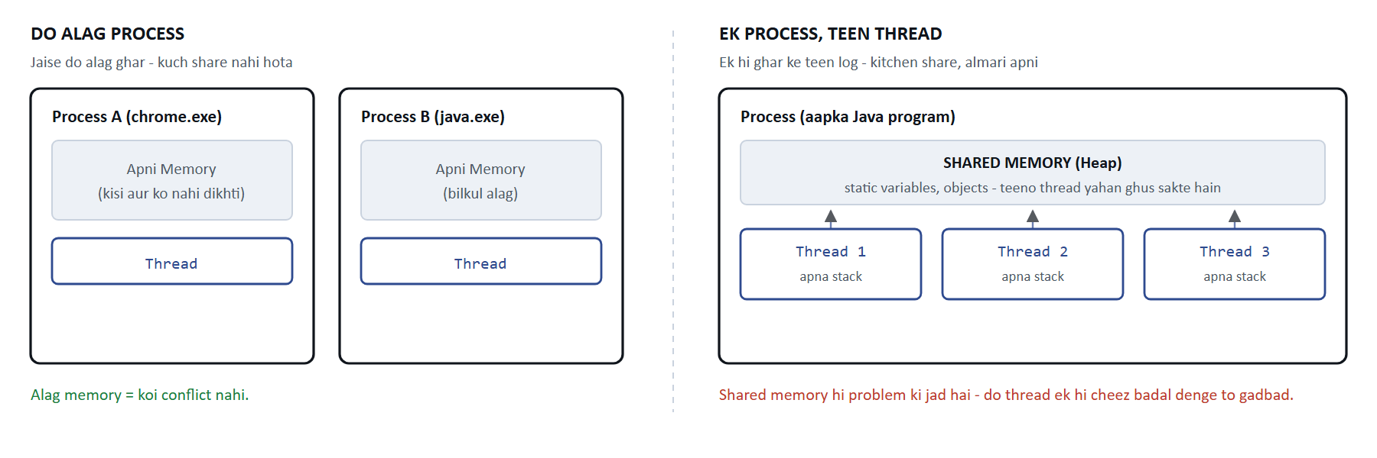
Process ki memory alag hoti hai. Thread ki memory share hoti hai - aur yahi se saari problem shuru hoti hai.
Isi share hone ki wajah se do thread ek hi cheez ko ek saath badal sakte hain, aur tab gadbad hoti hai. Aage race condition mein yahi dekhenge.

1.2 Multi-threading se fayda kya hai?
Seedha jawab: time bachta hai.
Aapke paas 4 test hain, har ek 3 second leta hai. Ek thread se 12 second lagenge. Chaar thread se sirf 3 second.
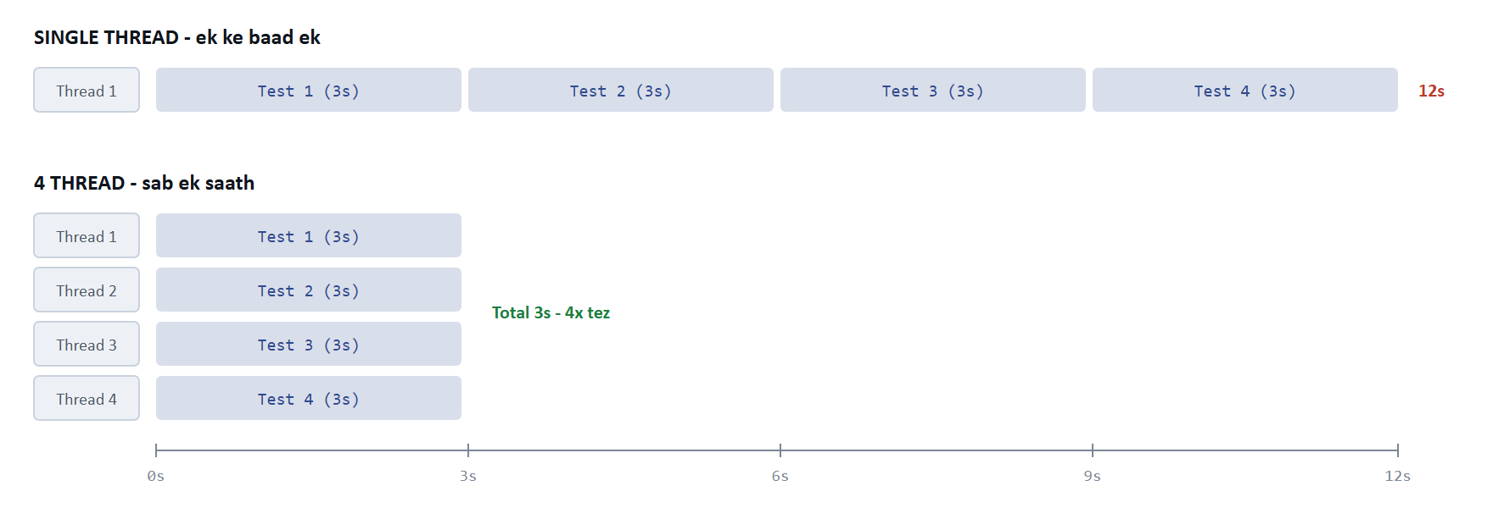
Wahi kaam, wahi 12 second ki mehnat - par aapko 3 second mein result mil gaya.
Dhyan dene wali baat: kaam kam nahi hua. CPU ne utni hi mehnat ki. Bas aapko intezaar kam karna pada. Isiliye report mein do number alag alag hote hain - wall clock time (aapne kitna wait kiya) aur total test-method time (kul kitna kaam hua).
Par muft mein kuch nahi milta. Multi-threading do naye problem laati hai: (1) shared cheezein kharab ho sakti hain, aur (2) bug kabhi kabhi aayega, har baar nahi - jo debug karne mein sabse mushkil cheez hai.

1.3 ThreadLocal kya hai?
Ek line mein: ThreadLocal ek locker hai - har thread ka apna alag.
Office ka example. Office mein sabke liye locker hain. Sab log kehte hain "main apna bag locker se le raha hoon". Sentence sabka same hai, par jab Ramesh apna bag nikalta hai to Ramesh ka bag aata hai, Suresh ka nahi.
ThreadLocal bilkul yahi hai. Code mein aap likhte ho DriverFactory.getDriver() - ye line har thread mein same hai. Par Thread 1 ko Chrome #1 milta hai, Thread 2 ko Chrome #2.
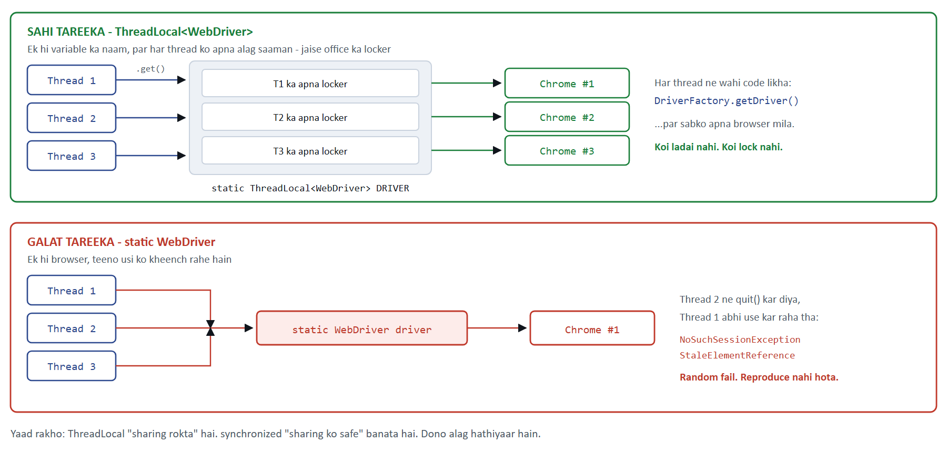
Upar wala tareeka sahi hai. Neeche wala aapke project mein sach mein bug ban chuka tha.
Agar ThreadLocal na ho to kya hoga? Sochiye 4 waiter hain par order likhne ki copy ek hi hai. Waiter 1 table 5 ka order likh raha hai, waiter 2 usi page pe table 9 ka likh deta hai, waiter 3 page phaad deta hai. Kitchen mein galat khana banega.
Selenium mein bilkul yahi hota hai: ek hi browser 4 thread share karenge, aur ek thread browser band kar dega jab doosra abhi use kar raha hoga. Error milega NoSuchSessionException - jo bilkul nahi batata ki asli galti kya thi.
YAAD RAKHNE WALI BAAT
ThreadLocal sharing ko ROKTA hai. synchronized sharing ko SAFE banata hai. Dono alag hathiyaar hain. Agar cheez share karne ki zaroorat hi nahi (jaise browser), to ThreadLocal behtar hai - kyunki usmein koi wait nahi karna padta.

1.4 Race Condition - gadbad kaise hoti hai?
Ek line mein: Do log ek hi cheez ko ek saath badal rahe hain, aur result galat aa jata hai.
Bank ka example. Account mein 1000 rupaye hain. Aap ATM pe 800 nikal rahe ho, aur usi second aapki biwi phone app se 800 nikal rahi hain.
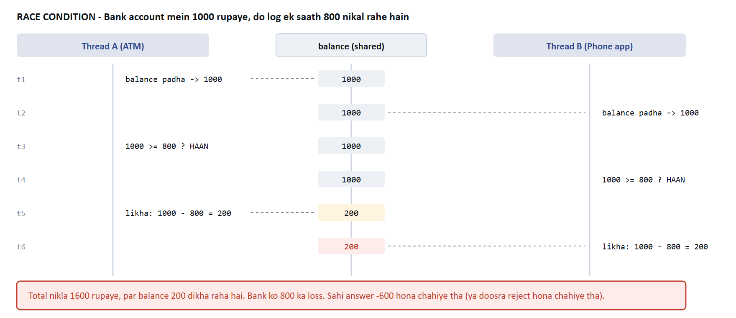
Dono ne balance 1000 padha, dono ne socha paisa hai, dono ne nikal liya. Bank ko 800 ka nuksaan.
Problem kahan hui? "Balance padho, check karo, phir ghatao" - ye teen alag kaam hain. Beech mein doosra banda ghus gaya. Agar ye teeno ek saath, bina ruke hote, to problem nahi hoti.
Jo kaam beech mein toda na ja sake use atomic kehte hain. Race condition ka ilaaj hai in teeno step ko atomic bana dena.
Sabse khatarnak baat: ye bug har baar nahi aata. 100 mein se 3 baar aata hai. Aap test dobara chalate ho, pass ho jata hai, aap sochte ho "chalo theek hai" - aur wo bug production mein chala jata hai.

1.5 synchronized - ilaaj kya hai?
Ek line mein: Ek kamra jiski ek hi chaabi hai. Ek time pe ek hi banda andar.
ATM booth ka example. ATM booth mein ek time pe ek hi banda jaata hai. Darwaza band. Baaki log bahar line mein khade rehte hain. Jab pehla nikalta hai, tabhi doosra ghusta hai.
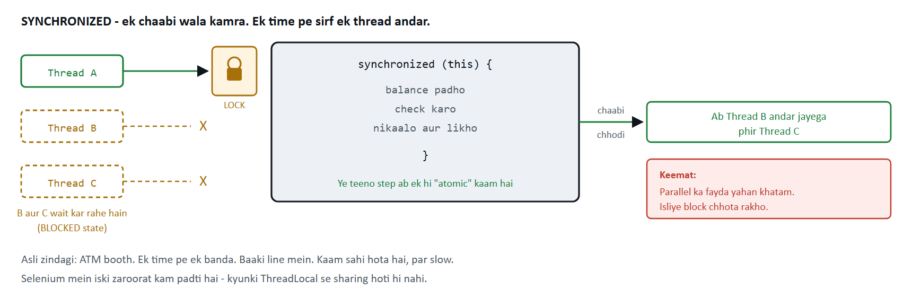
Thread A ke paas lock hai. B aur C ko rukna padega. Kaam sahi hoga, par slow.
Keemat kya hai? Speed. Aapne 4 thread isliye banaye the ki kaam tez ho, aur ab teen thread line mein khade hain. Isiliye rule hai: synchronized block jitna chhota ho sake, utna chhota rakho.
SELENIUM WALON KE LIYE
Aapke automation framework mein synchronized ki zaroorat bahut kam padti hai. Kyunki hum cheezein share karte hi nahi - har thread ka apna browser (ThreadLocal), apna page object. Sharing hi nahi to lock kis baat ka? Ye ek achha design decision hai jo interview mein bolne layak hai.

1.6 Synchronous aur Asynchronous
Sawaal sirf ek hai: kaam khatam hone tak main ruka hoon ya nahi?
Synchronous = bank counter ki line. Aap counter pe khade ho. Clerk aapka kaam kar raha hai. Aap kuch aur nahi kar sakte. Kaam khatam, tab aage badhe.
Asynchronous = restaurant mein order. Aapne order diya. Waiter chala gaya. Aap phone chalate ho, baat karte ho. Khana taiyaar hone pe wo khud aa jayega. Aap block nahi hue.
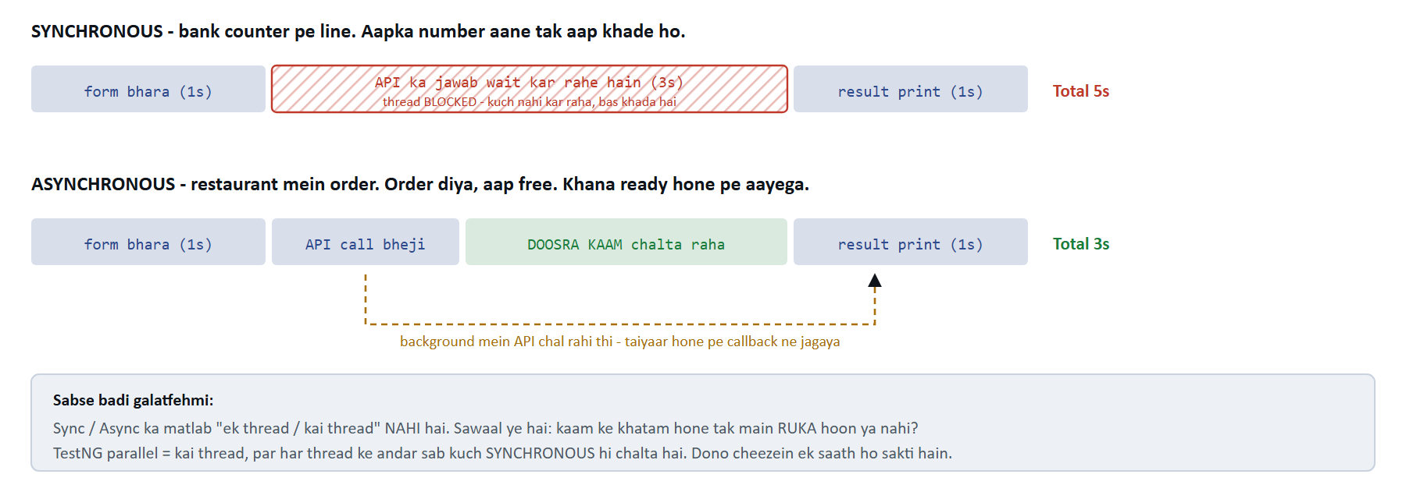
Dono mein API ne 3 second liye. Farak sirf itna ki us beech mein aap kuch aur kar paye ya nahi.
SABSE BADI GALATFEHMI
Bahut log samajhte hain ki Synchronous ka matlab "ek thread" aur Asynchronous ka matlab "kai thread" hai. Ye galat hai. Ye do alag alag cheezein hain. Aapke TestNG parallel run mein kai thread hain, par har thread ke andar ka har kaam synchronous hi hai - driver.get() page load hone tak rukta hai, phir agli line chalti hai.

1.7 Listener kya hai?
Ek line mein: Ek chowkidar jo dekhta rehta hai, aur kuch hone pe apne aap kaam karta hai.
Doorbell ka example. Aap din bhar darwaze pe khade nahi rehte ki koi aayega to pata chalega. Aapne bell laga di. Koi aayega, bell bajegi, aap chale jaoge. Aap apna kaam karte raho - bell aapko bula legi.
Test framework mein bilkul yahi: aapka test sirf apna kaam karta hai. Use pata bhi nahi hota ki koi screenshot le raha hai, koi report bana raha hai, koi count kar raha hai.
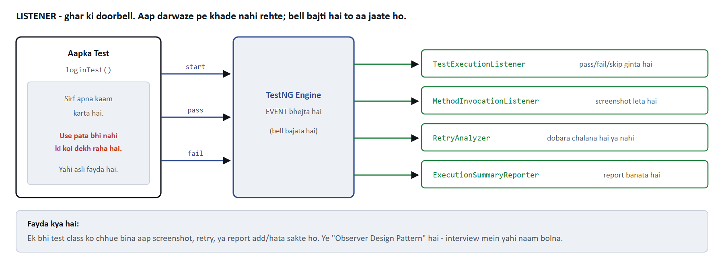
Test kisi listener ko nahi jaanta. TestNG event bhejta hai, listeners apna apna kaam karte hain.
Fayda kya hai? Maan lo kal aapko har fail hone wale test ka screenshot chahiye. Bina listener ke aapko har ek test class mein try-catch likhna padta - 50 class, 50 jagah. Listener ke saath: ek class likho, ek jagah register karo, poore project mein chalu ho jayega.
Iska proper naam hai Observer Design Pattern - interview mein yahi shabd bolna.

PART 2 - Technical (Interview Ke Liye)
Ab wahi cheezein, code ke saath aur theek theek shabdon mein.

2.1 Thread - Java mein
Thread banane ke teen tareeke hain. Interview mein teeno pooche jaate hain.
// 1) Thread class ko extend karo - sabse kam use hota hai
// kyunki Java mein multiple inheritance nahi hai, ek hi class extend kar sakte ho
class MyTask extends Thread {
public void run() { System.out.println("chal raha hoon"); }
}
new MyTask().start(); // start() naya thread banata hai

// 2) Runnable implement karo - PREFER karo
// class free rehti hai kisi aur ko extend karne ke liye
Runnable task = () -> System.out.println(Thread.currentThread().getName());
new Thread(task).start();

// 3) ExecutorService - real project mein YAHI use hota hai
ExecutorService pool = Executors.newFixedThreadPool(3);
pool.submit(task);
pool.shutdown();
INTERVIEW KA FAVOURITE SAWAAL
start() aur run() mein kya farak hai? start() naya thread banata hai aur usmein run() chalata hai. Agar aap seedhe run() call karoge to wo normal method call hai - koi naya thread nahi banega, sab kuch usi thread mein chalega. Ye galti bahut log karte hain.

Thread ki lifecycle
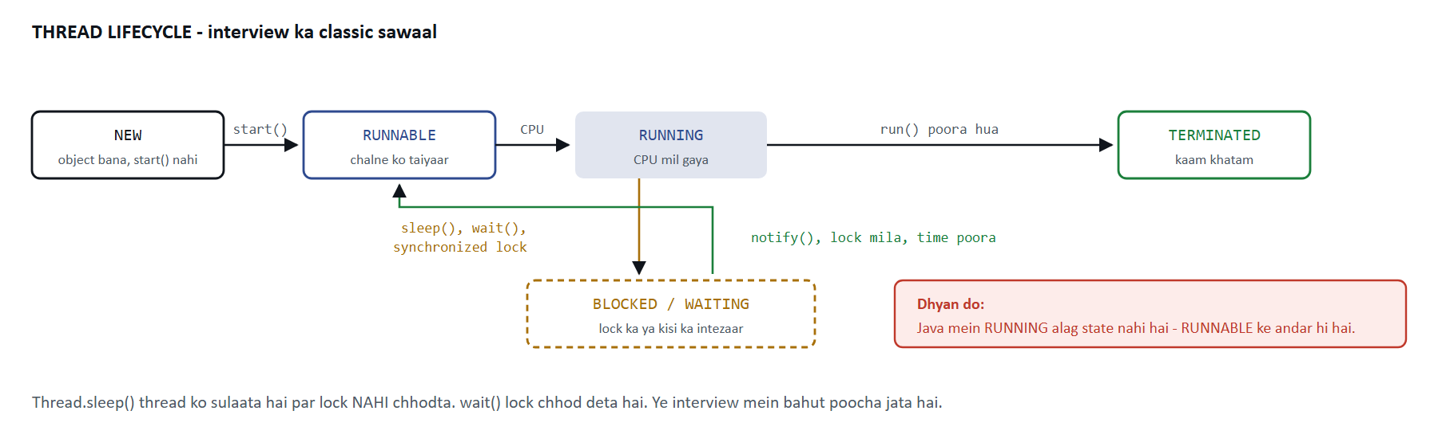
NEW se TERMINATED tak. BLOCKED / WAITING wo jagah hai jahan thread ruka hua hai.
State | Kab hoti hai
NEW | Thread object ban gaya, par start() nahi hua
RUNNABLE | start() ho gaya. Chalne ko taiyaar hai ya chal raha hai
BLOCKED | synchronized lock ka intezaar kar raha hai
WAITING | wait() ya join() ke baad - koi jagayega tabhi uthega
TIMED_WAITING | sleep(1000) jaisa - time poora hone pe khud uth jayega
TERMINATED | run() poora ho gaya, ya exception aaya

sleep() aur wait() ka farak - ye sabse zyada poocha jata hai. Thread.sleep() thread ko sulaata hai par lock nahi chhodta (haath mein chaabi lekar so gaya). wait() lock chhod deta hai taaki doosra thread kaam kar sake. sleep() Thread class ka hai, wait() Object class ka.

2.2 ThreadLocal - technical
Definition: ThreadLocal ek aisa container hai jismein har thread ka apna alag copy hota hai. Ek thread doosre thread ka value dekh hi nahi sakta.
public final class DriverFactory {

private static final ThreadLocal<WebDriver> DRIVER = new ThreadLocal<>();

public static void set(WebDriver driver) {
DRIVER.set(driver); // sirf IS thread ke liye
}

public static WebDriver getDriver() {
WebDriver d = DRIVER.get(); // sirf IS thread ka milega
if (d == null) {
throw new IllegalStateException("Is thread pe driver hai hi nahi");
}
return d;
}

public static void quit() {
WebDriver d = DRIVER.get();
if (d != null) {
try { d.quit(); }
finally { DRIVER.remove(); } // <-- SABSE ZAROORI LINE
}
}
}
INTERVIEW MEIN YE BOLO TO NUMBER BADHENGE
remove() kyun zaroori hai? Thread pool threads ko reuse karta hai. Agar aapne remove nahi kiya, to purana WebDriver us thread ke saath chipka reh jayega aur agle test ko mil jayega - ye memory leak hai. Application servers (Tomcat) mein to ye classic bug hai, kyunki wahan thread hamesha zinda rehte hain.

ThreadLocal andar se kaam kaise karta hai?
Har Thread object ke andar ek ThreadLocalMap hota hai. Jab aap DRIVER.get() likhte ho, to Java aapke current thread ke us map mein dekhta hai, jismein key = ThreadLocal object aur value = aapka driver. Isiliye value thread ke saath judi hoti hai, variable ke saath nahi.

2.3 Race Condition aur Thread Safety
Yahi wo code hai jo bank wala bug banata hai:
class Account {
private int balance = 1000;

// GALAT - thread safe nahi hai
public void withdraw(int amount) {
if (balance >= amount) { // step 1: padha
// <-- yahan doosra thread ghus sakta hai
balance = balance - amount; // step 2: likha
}
}
}
Problem: balance = balance - amount dikhne mein ek line hai, par CPU ke liye ye teen kaam hain: padho, ghatao, wapas likho. Beech mein doosra thread ghus sakta hai.
Teen tarah se theek kar sakte ho:
// Tareeka 1: synchronized - poora method lock
public synchronized void withdraw(int amount) { ... }

// Tareeka 2: synchronized block - sirf zaroori hissa lock (BEHTAR)
public void withdraw(int amount) {
prepareReceipt(); // ye lock ke bahar rahega
synchronized (this) {
if (balance >= amount) { balance -= amount; }
}
}

// Tareeka 3: Atomic classes - lock lagta hi nahi, sabse tez
private final AtomicInteger balance = new AtomicInteger(1000);
balance.addAndGet(-amount);

Hathiyaar | Kab use karo | Speed
ThreadLocal | Cheez share karni hi nahi hai (browser, SoftAssert) | Sabse tez
AtomicInteger | Bas ek number badhana / ghatana hai (counter) | Bahut tez
ConcurrentHashMap | Map ko kai thread padhenge aur likhenge | Tez
synchronized | Kai step ek saath atomic banane hain | Slow - wait hota hai
volatile | Sirf visibility chahiye (ek thread likhe, baaki turant dekhein) | Tez, par counter ke liye kaafi NAHI

VOLATILE KA TRAP
volatile sirf visibility deta hai - matlab ek thread ne badla to doosre ko turant dikh jayega. Par wo atomicity NAHI deta. volatile int count; count++; ab bhi race condition hai, kyunki count++ teen kaam hain. Counter ke liye AtomicInteger use karo. Ye interview ka trick question hai.

2.4 Thread Pool - TestNG isi se chalta hai
Har test ke liye naya thread banana mehnga hai. Isliye pool banate hain: gine chune thread, aur kaam queue mein lagta jata hai.
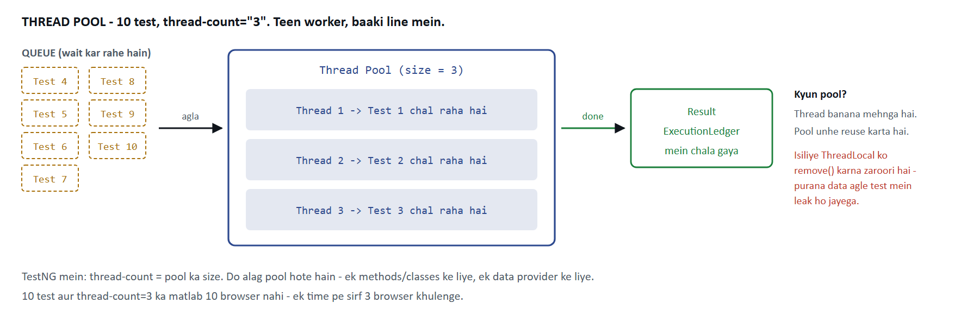
thread-count=3 ka matlab ek time pe sirf 3 browser. Baaki 7 test line mein khade hain.
TestNG mein do alag pool hote hain - aur ye interview mein poocha jata hai. thread-count wala pool methods / classes / tests chalata hai. data-provider-thread-count wala pool @DataProvider(parallel = true) ki rows chalata hai. Ek ko badhane se doosre pe koi asar nahi padta.
Yahi se ThreadLocal wala remove() ka rule aata hai. Pool thread ko reuse karta hai, to agar aapne remove nahi kiya to purana driver agle test ko mil jayega.

2.5 Synchronous aur Asynchronous - code mein
// SYNCHRONOUS - line by line, har line agli ka intezaar karti hai
String data = callApi(); // 3 second yahin ruke
process(data); // tab jaake ye chalega
System.out.println("done");

// ASYNCHRONOUS - kaam bheja aur aage badh gaye
CompletableFuture<String> future = CompletableFuture.supplyAsync(() -> callApi());
doSomethingElse(); // ye TURANT chal jayega
String data = future.get(); // ab jab zaroorat padi, tab wait kiya
Selenium kahan fit hota hai? Selenium ka har command synchronous hai. driver.findElement() browser ko HTTP request bhejta hai aur jawab aane tak rukta hai. Isiliye Selenium test padhne mein aasan lagta hai - upar se neeche, ek ke baad ek.
WebDriverWait async hai kya? Nahi. Wo polling karta hai - har 500 millisecond mein check karta hai "element aaya kya?". Poore samay aapka thread ruka hua hai. Ye synchronous hi hai, bas smart tareeke se.

 | Synchronous | Asynchronous
Thread ka kya hota hai | Ruka rehta hai (blocked) | Free rehta hai, aage badh jata hai
Result kab milta hai | Usi line pe, turant | Baad mein - callback / Future se
Code padhna | Aasan - upar se neeche | Mushkil - flow tut jata hai
Selenium | Sab kuch synchronous | Nahi hota
Example | driver.get(url) | CompletableFuture

2.6 Listeners - poora technical
Definition: Listener ek interface hai jise aap implement karte ho. Framework tay samay pe aapke method ko khud call karta hai. Isse kehte hain callback - aap framework ko call nahi karte, framework aapko call karta hai.

TestNG ke saare listener - ek table mein
Interface | Kab chalta hai | Kya kaam aata hai
IExecutionListener | Poore JVM run mein ek baar - sabse bahar | Folder banana, DB connect, Appium server start
IAnnotationTransformer | Har @Test padhte samay, run se pehle | Retry lagana, test disable karna, group badalna
ISuiteListener | Har <suite> ke aage aur peeche | Suite banner, environment setup
ITestListener | Har test ke result pe | Sabse zyada use hota hai
IInvokedMethodListener | HAR method pe - @Before/@After bhi | Screenshot (browser abhi khula hota hai)
IConfigurationListener | @Before / @After ke result pe | Batana ki konsa setup toota
IMethodInterceptor | Ek baar, sab chalne se pehle | Test ka order badalna ya hataana
IRetryAnalyzer | Fail hone ke baad | Dobara chalana hai ya nahi
IReporter | Sab khatam hone ke baad ek baar | Final report banana

ITestListener ke methods
public class MyListener implements ITestListener {

@Override public void onStart(ITestContext ctx) { } // <test> shuru
@Override public void onTestStart(ITestResult r) { } // test shuru
@Override public void onTestSuccess(ITestResult r) { } // PASS
@Override public void onTestFailure(ITestResult r) { } // FAIL
@Override public void onTestSkipped(ITestResult r) { } // SKIP
@Override public void onTestFailedButWithinSuccessPercentage(ITestResult r) { }
@Override public void onTestFailedWithTimeout(ITestResult r) { }
@Override public void onFinish(ITestContext ctx) { } // <test> khatam
}

Register karne ke teen tareeke
// 1) Class pe - us <test> block bhar ke liye
@Listeners(MyListener.class)
public class LoginTest { }

// 2) Suite XML mein - us suite bhar ke liye
<listeners>
<listener class-name="com.sk.listeners.MyListener"/>
</listeners>

// 3) Service loader - POORE project ke liye, sabse saaf tareeka
// file: src/test/resources/META-INF/services/org.testng.ITestNGListener
// andar bas class ka naam likho:
com.sk.listeners.TestExecutionListener
DO BAATEIN JO LOG GALAT SAMAJHTE HAIN
1. @Listeners sirf us class pe nahi lagta - wo poore <test> block pe lagta hai. Humne aapke project mein ye chala ke check kiya tha. 2. @Listeners se IAnnotationTransformer register NAHI hota, kyunki wo tab chalta hai jab TestNG abhi classes padh raha hota hai - usse pehle.

Selenium ka apna listener
// Har click aur har findElement ko log karna ho to:
WebDriver driver = new EventFiringDecorator<>(new WebDriverListener() {
@Override public void beforeClick(WebElement el) {
System.out.println("click karne ja raha hoon: " + el);
}
}).decorate(new ChromeDriver());

PART 3 - Aapke Project Mein Ye Sab Kahan Hai
Interview mein sabse achha jawab wo hota hai jo apne project se diya jaye. Ye rahi list - file kholo aur dekh lo.
Concept | File | Kya kiya gaya hai
Thread + ThreadLocal | core/DriverFactory.java | Har thread ko apna browser. Poore parallel setup ki jad.
ThreadLocal - remove() | DriverFactory.quit() | finally block mein remove(), warna agle test mein leak.
Thread pool | suites/*.xml | thread-count aur data-provider-thread-count - do alag pool.
Shared state ka bug | core/BaseWebTest.java | loginPage() method hai, field nahi - kyunki field share ho jata tha.
ThreadLocal (dobara) | tests/assertions/SoftAssertionTest | SoftAssert bhi ThreadLocal mein, warna failures mix ho jate.
Thread-safe counter | listeners/ExecutionLedger | ConcurrentLinkedQueue - kai thread ek saath likhte hain.
Thread-safe map | listeners/RetryAnalyzer | ConcurrentHashMap + AtomicInteger se retry ginti.
Listener - result | listeners/TestExecutionListener | pass / fail / skip decide karta hai.
Listener - screenshot | listeners/MethodInvocationListener | afterInvocation mein, jab browser abhi khula hai.
Listener - retry | listeners/RetryAnalyzer | IRetryAnalyzer - fail hone pe dobara chalata hai.
Listener - report | listeners/ExecutionSummaryReporter | IReporter - sab khatam hone pe report banata hai.
Thread audit | utils/ThreadAuditor.java | Kaunsa test kis thread pe chala - parallel prove karne ke liye.

INTERVIEW MEIN SUNANE LAYAK KAHANI
"Mere framework mein parallel data provider ke saath random NoSuchSessionException aa raha tha. Root cause ye tha ki TestNG ek test class ka ek hi object banata hai, aur maine page object ko instance field mein rakha tha - to ek thread doosre ka driver overwrite kar deta tha. Maine use method bana diya jo har baar ThreadLocal driver se naya page object banata hai. Uske baad suite stable ho gayi." Ye sunke interviewer samajh jayega ki aapne sach mein parallel kaam kiya hai.

PART 4 - 25 Interview Questions
Jawab chhote rakhe hain - jitna bolna chahiye utna hi.

Thread ke baare mein
Q1. Process aur Thread mein farak?
Process ki apni memory hoti hai, dusre process se bilkul alag. Thread ek process ke andar chalta hai aur uski memory share karta hai, sirf apna stack alag hota hai. Thread banana process banane se sasta hai.
Q2. start() aur run() mein farak?
start() naya thread banata hai aur usmein run() chalata hai. Seedha run() call karoge to naya thread banega hi nahi - wo bas ek normal method call ban jayega, usi thread mein.
Q3. Thread ki states kitni hain?
Chhe: NEW, RUNNABLE, BLOCKED, WAITING, TIMED_WAITING, TERMINATED. Java mein RUNNING alag state nahi hai - wo RUNNABLE ke andar hi hai.
Q4. sleep() aur wait() mein farak?
sleep() lock nahi chhodta, wait() chhod deta hai. sleep() Thread class ka static method hai, wait() Object class ka. wait() sirf synchronized block ke andar chal sakta hai.
Q5. Runnable ya Thread - kaunsa behtar?
Runnable, kyunki Java mein ek hi class extend kar sakte ho. Thread extend kar liya to aur kuch extend nahi kar paoge. Runnable se class free rehti hai. Real project mein waise bhi ExecutorService use hota hai.
Q6. Thread pool kyun use karte hain?
Thread banana mehnga kaam hai. Pool ek baar thread bana ke unhe reuse karta hai. Saath hi ye limit bhi lagata hai - 1000 task aayein to 1000 thread nahi banenge, sirf pool ke size jitne.

ThreadLocal ke baare mein
Q7. ThreadLocal kya hai?
Ek variable jiska har thread ke paas apna alag copy hota hai. Ek thread doosre ka value dekh hi nahi sakta. Sharing rokne ka tareeka hai.
Q8. Selenium mein ThreadLocal kyun chahiye?
Parallel run mein har thread ko apna browser chahiye. Agar driver static rakh do to saare thread ek hi browser pe ladenge - ek thread quit kar dega jab doosra use kar raha hoga, aur NoSuchSessionException aayega.
Q9. ThreadLocal mein remove() kyun karna chahiye?
Thread pool threads ko reuse karta hai. Remove nahi kiya to purana value us thread ke saath chipka rehta hai aur agle test ko mil jata hai. Ye memory leak hai - Tomcat jaise server mein to bahut bada problem ban jata hai.
Q10. ThreadLocal andar se kaise kaam karta hai?
Har Thread object ke andar ek ThreadLocalMap hota hai. Key hoti hai ThreadLocal object, value aapka data. get() current thread ke map mein dekhta hai. Isliye value thread se judi hoti hai.
Q11. ThreadLocal aur synchronized mein kya farak?
ThreadLocal sharing rokta hai - har thread ka apna data, koi wait nahi. synchronized sharing ko safe banata hai - data ek hi hai, par ek time pe ek thread. Agar share karne ki zaroorat nahi to ThreadLocal behtar aur tez hai.

Thread safety ke baare mein
Q12. Race condition kya hai?
Jab do ya zyada thread ek hi shared data ko ek saath badalte hain aur result is baat pe depend karta hai ki kaun pehle chala. Result har baar alag aa sakta hai.
Q13. count++ thread safe hai?
Nahi. Dikhne mein ek line hai par asal mein teen kaam hain - padho, badhao, likho. Beech mein doosra thread ghus sakta hai. AtomicInteger.incrementAndGet() use karo.
Q14. volatile kya karta hai?
Sirf visibility deta hai - ek thread ne badla to doosron ko turant dikhega, cache se purana value nahi milega. Par atomicity nahi deta, isliye counter ke liye kaafi nahi hai.
Q15. synchronized method aur block mein kya behtar?
Block, kyunki usmein aap sirf zaroori hissa lock karte ho. Poora method lock karne se wo saare log bhi wait karenge jinhe shared data se matlab hi nahi tha.
Q16. Deadlock kya hai?
Do thread ek dusre ka lock pakde baithe hain aur dono wait kar rahe hain - kabhi khatam nahi hoga. Bachne ka tareeka: lock hamesha ek hi order mein lo, ya timeout wala lock use karo.
Q17. HashMap ya ConcurrentHashMap?
Multi-thread mein ConcurrentHashMap. Normal HashMap ko kai thread ek saath likhenge to wo corrupt ho sakta hai - purane Java mein to infinite loop tak ho jata tha.

Sync aur Async ke baare mein
Q18. Synchronous aur Asynchronous mein farak?
Synchronous mein caller kaam khatam hone tak rukta hai. Asynchronous mein kaam bhej ke aage badh jata hai, result baad mein callback ya Future se milta hai.
Q19. Kya Asynchronous ka matlab multi-threading hai?
Nahi. Ye do alag cheezein hain. Async ka sawaal hai "main ruka hoon ya nahi", multi-threading ka sawaal hai "kitne worker hain". JavaScript single thread pe bhi async karta hai. TestNG parallel multi-thread hai par andar sab synchronous hai.
Q20. Selenium synchronous hai ya asynchronous?
Synchronous. Har command browser ko HTTP request bhejta hai aur jawab ka intezaar karta hai. WebDriverWait bhi async nahi hai - wo polling karta hai, thread poore samay ruka rehta hai.

Listeners ke baare mein
Q21. TestNG listener kya hai aur kyun use karte hain?
Ek interface jise TestNG khud call karta hai jab kuch hota hai - test shuru, pass, fail. Isse cross-cutting kaam (screenshot, logging, report, retry) ek jagah likh sakte ho, har test class mein nahi. Ye Observer design pattern hai.
Q22. Aapne kaunse listener use kiye hain?
ITestListener result ke liye, IInvokedMethodListener screenshot ke liye, IRetryAnalyzer retry ke liye, IReporter final report ke liye, aur IAnnotationTransformer se @Flaky methods pe apne aap retry lagta hai.
Q23. Screenshot onTestFailure mein loge ya kahin aur?
IInvokedMethodListener.afterInvocation mein. TestNG guarantee deta hai ki wo test method khatam hote hi chalega, jab browser abhi khula hai. onTestFailure mein karoge to @AfterMethod pehle browser band kar sakta hai aur screenshot folder khaali reh jayega.
Q24. Listener register karne ke kitne tareeke hain?
Teen: @Listeners class pe, <listeners> suite XML mein, aur META-INF/services/org.testng.ITestNGListener file (service loader) - jo poore project pe lagta hai. Note: IAnnotationTransformer @Listeners se register nahi hota.
Q25. Retry ke saath report ka count galat kyun aata hai?
TestNG retry mein phenke gaye attempt ko SKIPPED mark karta hai. To jo test do baar fail hoke teesri baar pass hua, wo "1 passed, 2 skipped" dikhta hai. Iska hal: listener mein ITestResult.wasRetried() check karke un rows ko report se hata do.

PART 5 - Cheat Sheet
Interview se pehle sirf ye page dekh lo.

Ek line mein har concept
Concept | Ek line mein | Roz ki misaal
Thread | Program ke andar kaam karne wala banda | Restaurant ka waiter
Process | Apni alag memory wala program | Alag ghar
ThreadLocal | Har thread ka apna alag copy | Office ka personal locker
Race condition | Do thread ek saath badal rahe hain, result galat | Do log ek saath paise nikal rahe hain
synchronized | Ek time pe ek hi thread andar | ATM booth
volatile | Badla hua value turant sabko dikhega | Notice board
Atomic | Bina lock ke safe badalna | Turnstile gate
Deadlock | Dono ek dusre ka intezaar kar rahe hain | Do gaadi tangi galli mein aamne saamne
Synchronous | Kaam khatam hone tak ruko | Bank counter ki line
Asynchronous | Bhej ke aage badh jao | Restaurant mein order
Thread pool | Gine chune worker, kaam queue mein | 3 counter, lambi line
Listener | Kuch hone pe apne aap chalne wala code | Ghar ki doorbell

Kaunsa hathiyaar kab
- Share karne ki zaroorat nahi? ThreadLocal - sabse tez, sabse simple.
- Sirf ek counter hai? AtomicInteger / AtomicLong.
- Map ya List share karni hai? ConcurrentHashMap, ConcurrentLinkedQueue.
- Kai step ek saath atomic chahiye? synchronized block - jitna chhota utna achha.
- Sirf visibility chahiye? volatile - par counter ke liye kaafi nahi.

Galtiyan jo sabse zyada hoti hain
- parallel run mein - browser aapas mein mix ho jayenge.
- ThreadLocal se remove() na karna - memory leak aur agle test mein purana data.
- Test class ke instance field mein state rakhna - TestNG ek hi object banata hai, sab thread use share karenge.
- Ek hi SoftAssert sab threads mein - failures aapas mein mix ho jayenge.
- ko seedha call karna - naya thread banta hi nahi.
- ko thread safe samajhna - wo teen kaam hain, ek nahi.
- Screenshot onTestFailure mein lena - browser tab tak band ho chuka ho sakta hai.

Thread, ThreadLocal, Sync/Async aur Listeners | Java + TestNG + Selenium | 9 diagrams, 25 interview questions
Saara code jo yahan diya gaya hai wo aapke apne project TestNG-P011-TestNg3-All-Concepts-Covered mein chal raha hai. Part 3 mein file ke naam diye hain - kholo aur milaao.

