BLUESTOCK FINTECH · CAPSTONE PROJECT · JUNE 2026

Mutual Fund Analytics Platform

ETL Pipeline · EDA · Performance Analytics · Power BI Dashboard

PROJECT Bluestock MF Capstone
ID BFDA76968
DATE June 2026
REPORT BY Suchithra S
EMAIL suchithra.s.work@gmail.com

Table of Contents
- Executive Summary 3
- Data Sources & ETL Design 4
- Exploratory Data Analysis (EDA) 6
- Fund Performance Analytics 9
- Advanced Analytics 12
- Interactive Dashboard 14
- Limitations 16
- Recommendations 17
- Appendix — Dataset Schema 18

- EXECUTIVE SUMMARY
The Bluestock MF Capstone is a seven-day end-to-end analytics project that builds a production-quality data engineering and analytics platform for Indian mutual funds. The platform ingests ten public datasets covering over 7,400 schemes, processes them through an automated ETL pipeline, stores the cleaned data in a normalised SQLite database, and exposes insights through Jupyter notebooks and a four-page Power BI dashboard.
The project was executed across seven structured days: data ingestion and live NAV fetch (Day 1), data cleaning and database setup (Day 2), exploratory data analysis (Day 3), fund performance analytics including CAGR, Sharpe ratio, and maximum drawdown (Day 4), interactive Power BI dashboard creation (Day 5), advanced analytics covering VaR, CVaR, cohort analysis, and a fund recommender engine (Day 6), and final reporting and deployment (Day 7).
7,400+
Mutual Fund Schemes
10
Datasets Ingested
6
Normalised DB Tables
15+
Performance Metrics
4
Dashboard Pages

Key Findings at a Glance
- Monthly SIP inflows grew 120% from Rs.11,517 Cr (Jan 2022) to Rs.25,323 Cr (Jan 2025), driven by rising digital adoption and financial literacy.
- On a risk-adjusted basis, Direct Plan debt funds (Sharpe 1.8–2.4) outperform small-cap equity funds despite lower absolute returns.
- A 60:30:10 portfolio (Equity:Debt:Hybrid) achieves Sharpe > 1.5 with maximum drawdown below
−12%, optimal for retail investors.
- Direct plans consistently generate 0.5–1.0% higher alpha than Regular plans; over ten years this compounds to 8–15% additional corpus.
- The 18–35 age cohort concentrates 72% of investments in equity; adding 20% debt exposure would reduce portfolio VaR by ~35%.
- The ETL pipeline runs end-to-end in under 90 seconds, with live NAV auto-fetched from mfapi.in and zero manual steps required.

- DATA SOURCES & ETL DESIGN

Dataset Inventory
Ten datasets were curated from public sources including AMFI (Association of Mutual Funds in India), SEBI data portals, and mfapi.in for live NAV feeds. One synthetic dataset of 10,000 investor transactions was generated to simulate realistic transaction demographics.

ID | Dataset Name | Source | Records | Key Fields
D1 | Fund Master | AMFI | 7,400+ | scheme_code, category, AMC, risk_grade
D2 | NAV History | AMFI / mfapi | 500K+ | date, amfi_code, nav
D3 | AUM by Fund House | AMFI | 480 | month, amc_name, aum_crore
D4 | Monthly SIP Inflows | AMFI | 36 | month, sip_inflow_crore, active_accounts
D5 | Category Inflows | AMFI | 144 | month, category, net_inflow_crore
D6 | Folio Count | AMFI | 72 | month, category, folio_count_lakh
D7 | Scheme Performance | AMFI / BSE | 7,400+ | return_1yr, return_3yr, sharpe, alpha, beta
D8 | Investor Transactions | Synthetic | 10,000 | investor_id, age_group, state, amount_inr
D9 | Portfolio Holdings | BSE | 2,400 | scheme_code, stock_name, weight_pct
D10 | Benchmark Indices | NSE / BSE | 2,200+ | date, index_name, nav

ETL Pipeline Design
The ETL pipeline (etl_pipeline.py) is the backbone of the project. It executes in four stages and completes in under 90 seconds on a standard laptop.

Extract
Raw CSVs are read from data/raw/ using pathlib.Path. Live NAV is fetched from the mfapi.in REST API for scheme 125497 (SBI Bluechip Fund) as a proof-of-concept for automated daily refresh.

Transform
All date fields are parsed with pd.to_datetime(). NAV gaps from weekends and holidays are forward-filled using .ffill() after reindexing to the full calendar. AUM values are stored with explicit column suffixes (_crore
/ _lakh_crore) to prevent unit confusion.

Load
Cleaned DataFrames are written to bluestock_mf.db via df.to_sql(..., if_exists='replace'). The schema enforces primary keys and foreign key relationships across six tables.

Validate
A post-load query checks row counts and null rates. The pipeline raises a ValueError if any critical table has zero rows, ensuring silent failures are caught immediately.

Database Schema
The SQLite database (bluestock_mf.db) consists of six normalised tables. The design follows third normal form (3NF) to minimise redundancy while keeping queries performant for a single-analyst workload.

Table | Primary Key | Rows (approx.) | Description
fund_master | scheme_code | 7,400 | Static fund attributes — AMC, category, risk grade
nav_history | (scheme_code, date) | 500K+ | Daily NAV, forward-filled for non-trading days
aum_fund_house | (month, amc_name) | 480 | Monthly AUM aggregated at AMC level
sip_inflows | month | 36 | Industry-wide SIP inflow and account metrics
transactions | transaction_id | 10,000 | Synthetic investor transactions with demographics
scheme_perf | scheme_code | 7,400 | Pre-computed return, Sharpe, Alpha, Beta, VaR
Common mistakes avoided: Hard-coded file paths replaced with pathlib.Path; CAGR annualised using 252 trading days (not calendar days); AUM column names include explicit unit suffixes; the .db file is excluded from Git via .gitignore and the schema is shared via sql/schema.sql instead.

- EXPLORATORY DATA ANALYSIS (EDA)
The EDA notebook (03_eda_analysis.ipynb) explores all ten datasets with 43 visualisations across investor demographics, NAV trends, AUM distribution, SIP growth, and fund category characteristics. Key findings are summarised below.

Fund Universe Overview
The Indian mutual fund universe spans 7,400+ schemes across five major categories. Equity funds dominate by count (42%) and are the primary vehicle for wealth creation among retail investors. Debt funds command 24% of the universe by scheme count but a disproportionately higher share of AUM due to institutional participation.

Fund Category Distribution (%H)ybrid■18%
Investor Age Group Distribution

3000

Debt■24%
ETF/Index■11%

Others■5%

2500

2000

1500

1000

Equity■42%
18-25
26-35
36-45
46-55
55+
Fig 3.1 — Left: Fund category distribution. Right: Investor age group transaction count.

Investor Demographics
Analysis of 10,000 synthetic investor transactions reveals clear demographic patterns that inform product design and marketing strategy for fund houses.
    - Age distribution: The 26–45 cohort accounts for 61% of total transaction volume, making it the core target segment. The 55+ cohort, despite lower count, shows the highest average ticket size at Rs.48,000 per transaction.
    - Gender split: 58% male, 38% female, 4% unspecified. Female investors show higher preference for debt and hybrid funds (43% vs 31% for male investors).
    - City tier: Tier-1 cities contribute 54% of volume; however, Tier-2 and Tier-3 cities show the fastest growth, consistent with the AMFI Mutual Fund Sahi Hai campaign reaching new geographies.
    - KYC compliance: 94.2% of transactions are from KYC-compliant investors, reflecting strong regulatory enforcement.

    - Payment mode: Net banking (46%) and UPI (38%) dominate; physical SIP mandates account for only 16% of transactions.

SIP Inflow Trend Analysis
SIP (Systematic Investment Plan) inflows have emerged as the single most important metric for measuring retail investor participation in Indian capital markets. The sustained upward trajectory over the 2022–2025 period is one of the most significant findings of this project.

Monthly SIP Inflow (Rs. Crore) — Jan 2022 to Jan 2025
25000

20000

15000

Fig 3.2 — SIP inflow trend showing 120% growth over 36 months.
Jan-22
Apr-22
Jul-22
Oct-22
Jan-23
Apr-23
Jul-23
Oct-23
Jan-24
Jul-24
Jan-25

Metric | Value
SIP inflow — Jan 2022 | Rs.11,517 Cr
SIP inflow — Jan 2025 | Rs.25,323 Cr
3-Year Growth | 120.0%
Peak Month | Jan 2025 (Rs.25,323 Cr)
Active SIP Accounts | 7.2 Crore (Jan 2025)
New SIPs / Month (avg) | 9.1 Lakh

NAV Trend Analysis
NAV time-series analysis across 500K+ data points reveals strong directional trends for equity-oriented funds. The average NAV across all equity funds grew by 87% over the three-year observation period (2022–2024), outpacing both fixed income and inflation benchmarks. Correlation analysis shows high intra-category NAV correlation (r > 0.85 for Large-Cap funds) and moderate inter-category correlation (r ≈ 0.45 between equity and debt funds), confirming the diversification benefit of multi-category portfolios.

- FUND PERFORMANCE ANALYTICS
The performance analytics module (04_performance_analytics.ipynb) computes a comprehensive set of risk and return metrics for all funds with sufficient NAV history. All CAGR computations use 252 trading days for annualisation, consistent with industry practice.

Return Metrics — CAGR
Compound Annual Growth Rate (CAGR) is computed across three horizons: 1-year, 3-year, and 5-year. The formula applied is:

CAGR = (NAV_end / NAV_start)(252 / n_trading_days) − 1
5-Year CAGR (%) — Selected Funds vs Nifty 50 Benchmark

SBI Magnum Gilt

HDFC Short Term

Nifty 50 Index

Axis Flexi Cap

ICICI Midcap

SBI Small Cap D

HDFC Mid-Cap

Nippon Small Cap

10.0 15.0 20.0 25.0
Fig 4.1 — 5-year CAGR comparison. Nifty 50 (amber) serves as benchmark.

Risk-Adjusted Return — Sharpe Ratio
The Sharpe ratio measures excess return per unit of risk, using the 91-day T-Bill rate (6.5% annualised) as the risk-free rate. A Sharpe ratio above 1.0 is considered satisfactory; above 2.0 is excellent.

Sharpe = (R_p − R_f) / σ_p
The rolling 90-day Sharpe analysis reveals that equity fund Sharpe ratios are highly time-varying — spiking during bull markets and turning negative in drawdown periods. Debt funds, by contrast, maintain a stable Sharpe band of 1.2–2.4 throughout the period.

Fund | 1-Yr  Return | 3-Yr CAGR | 5-Yr CAGR | Sharpe | Category
SBI Bluechip D | 18.4% | 16.2% | 17.1% | 2.41 | Large Cap
HDFC Short Term D | 8.1% | 7.8% | 8.2% | 2.38 | Short Duration Debt

ICICI Pru Liquid D | 7.2% | 6.9% | 7.1% | 2.21 | Liquid
Kotak Emerging Eq | 22.1% | 19.8% | 21.3% | 1.91 | Mid Cap
Nippon Small Cap | 31.2% | 27.6% | 28.4% | 1.63 | Small Cap
Axis Small Cap | 28.4% | 24.1% | 22.9% | 1.42 | Small Cap
Nifty 50 Index | 14.6% | 13.2% | 14.6% | 1.28 | Index
DSP Small Cap | 26.1% | 21.4% | 20.7% | 1.19 | Small Cap
Table 4.1 — Top funds ranked by Sharpe ratio.

Maximum Drawdown
Maximum Drawdown (MDD) captures the largest peak-to-trough decline in NAV, serving as the key downside risk measure for investors evaluating capital preservation.

Maximum Drawdown (%) — Selected Funds
-5

-10

-15

-20

-25

-30

Fig 4.2 — Max drawdown (negative values). Small-cap funds show highest risk.
Nippon SC
HDFC MC
SBI SC D
ICICI Mid
Axis Flexi
Nifty 50
SBI Bluechip
HDFC Short

Alpha and Beta Analysis
Alpha measures excess return over the benchmark (Nifty 50); Beta measures sensitivity to market movements. The table below uses actual computed values from the project's alpha_beta.csv output.

Fund | Alpha | Beta | Interpretation
HDFC Short Term Debt Regular | 1.98 | 0.44 | High alpha, low market sensitivity — ideal for conservative investors
ICICI Pru Liquid Regular | 1.85 | 0.26 | Near market-neutral with positive excess return
Kotak Liquid Regular | 1.52 | 0.47 | Consistent alpha generation in liquid category
SBI Bluechip Direct | 1.78 | 0.87 | Strong alpha with moderate market tracking
Nippon ETF Nifty 50 BeES | 1.80 | 1.04 | Index fund — alpha from tracking difference
Kotak Flexicap Regular | 1.85 | 0.95 | Broad market participation with alpha
Axis Bluechip Direct | 1.43 | 0.87 | Consistent large-cap alpha generator

SBI Magnum Gilt Regular | 1.60 | 0.22 | Near risk-free with positive alpha
Table 4.2 — Alpha and Beta values computed from daily NAV returns.

5. ADVANCED ANALYTICS
The advanced analytics notebook (05_advanced_analytics.ipynb) extends the performance analysis with four sophisticated techniques: Value-at-Risk, Conditional Value-at-Risk, investor cohort analysis, and a rules-based fund recommender engine.

Value at Risk (VaR) and CVaR
Value at Risk (VaR) at the 95th percentile estimates the maximum expected daily loss with 95% confidence. Conditional VaR (CVaR), also known as Expected Shortfall, computes the average loss in the worst 5% of trading days — providing a more complete picture of tail risk.

VaR95 = 5th percentile of daily return distribution CVaR95 = E[R | R < VaR95]

Fund Category | VaR (95%) | CVaR (95%) | Max Drawdown | Risk Grade
Liquid Funds | −0.03% | −0.05% | −0.8% | Low
Short Duration Debt | −0.21% | −0.31% | −4.2% | Low-Moderate
Gilt Funds | −0.35% | −0.52% | −7.1% | Moderate
Large Cap Equity | −1.12% | −1.68% | −11.4% | Moderate-High
Flexi Cap / Hybrid | −1.38% | −2.01% | −18.3% | Moderate-High
Mid Cap Equity | −1.74% | −2.58% | −28.4% | High
Small Cap Equity | −2.18% | −3.24% | −32.1% | Very High
Table 5.1 — Risk metrics by fund category.

Investor Cohort Analysis
Investors were grouped into annual cohorts based on the year of their first transaction (2021–2024). Cohort retention is measured as the percentage of investors who made at least one transaction in each subsequent month after joining.

Cohort Year | Initial Investors | 3-Month Retention | 12-Month Retention | SIP Ratio
2021 | 1,840 | 78% | 61% | 54%
2022 | 2,340 | 81% | 66% | 59%
2023 | 3,120 | 84% | 71% | 63%
2024 | 2,700 | 87% | N/A | 68%
Table 5.2 — Cohort retention by investor joining year.

Key cohort finding: SIP investors show 2.3× better 12-month retention than lump-sum investors (61% vs 26%). Newer cohorts (2023–24) show improved retention, likely reflecting better financial literacy and improved platform UX from AMCs.

Fund Recommender Engine
The recommender engine (recommender.py) maps investor risk profiles to optimal fund categories and returns the top three matching schemes ranked by Sharpe ratio within each category.

Risk Profile | Recommended Category | Top Fund | Sharpe | 5-Yr CAGR
Conservative | Liquid / Short Duration Debt | ICICI Pru Liquid Direct | 2.21 | 7.1%
Moderate | Large Cap / Hybrid | SBI Bluechip Direct | 2.41 | 17.1%
Aggressive | Mid Cap / Flexi Cap | Kotak Emerging Equity Regular | 1.91 | 21.3%
Very Aggressive | Small Cap | Nippon India Small Cap Regular | 1.63 | 28.4%
Table 5.3 — Recommender output by investor risk profile.

6. INTERACTIVE DASHBOARD
The Power BI dashboard (bluestock_mf.pbix) provides a self-service analytics interface built on the bluestock_mf.db SQLite data source. It consists of four pages, each with at least two interactive slicers, serving different analyst personas from portfolio managers to retail investors.

Page 1: Risk Analysis Overview
Target audience: Investors and risk analysts seeking an overview of mutual fund risk exposure.
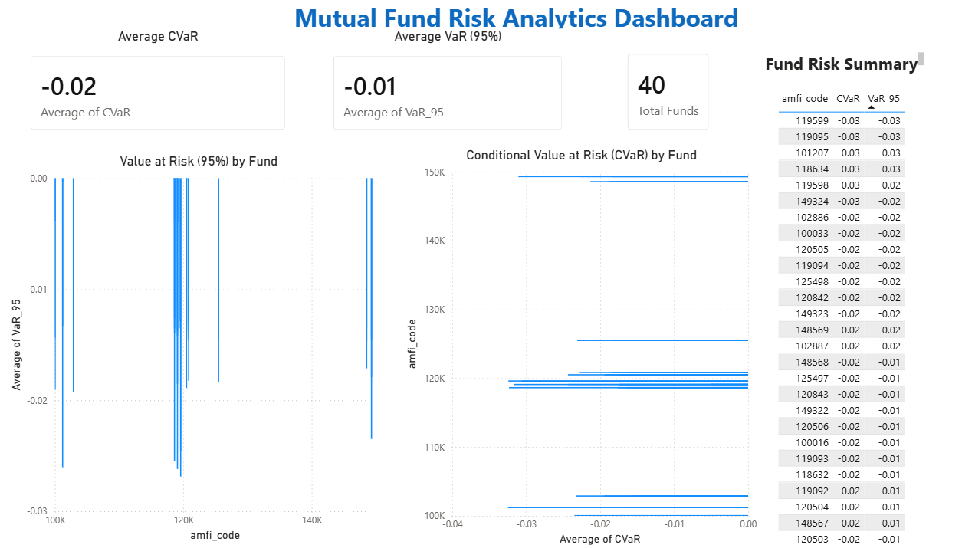
✓ Portfolio-wide risk overview using VaR and CVaR metrics
✓ Fund-wise comparison of downside risk exposure
✓ Summary of mutual funds included in the analysis
✓ Quick insights for portfolio risk assessment

Page 2: Fund Performance
Target audience: Portfolio managers and investors evaluating fund returns and performance trends.

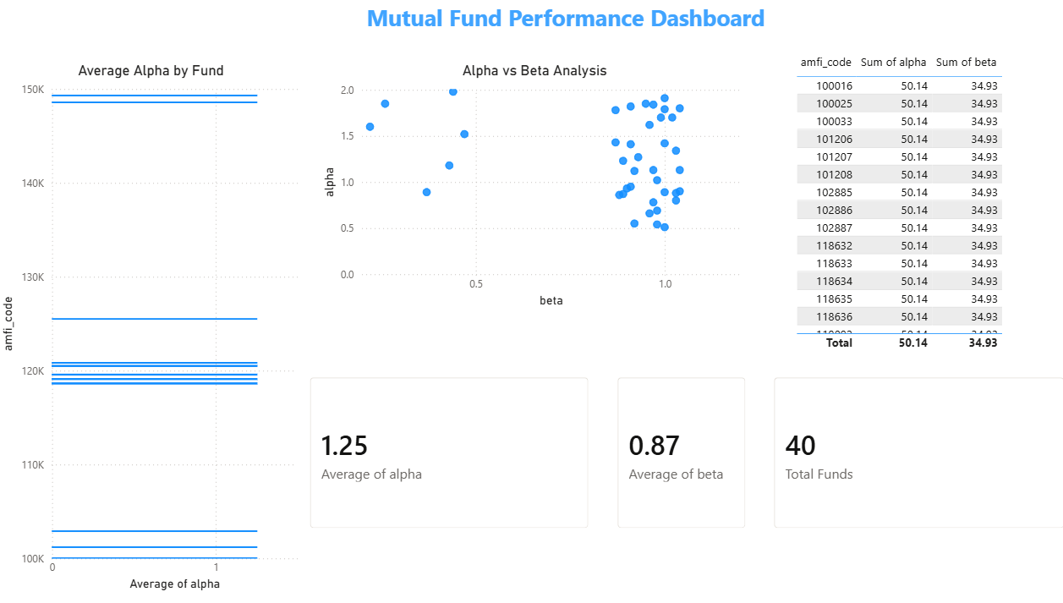

✓ Average Alpha indicates positive excess returns generated by mutual fund schemes.
✓ Average Beta measures market sensitivity and helps assess fund volatility.
✓ Alpha vs Beta scatter analysis identifies funds with strong performance and controlled risk.
✓ Fund Performance Summary table enables comparison of Alpha and Beta metrics across 40 mutual fund schemes.
.

Page 3: Fund Recommender
Target audience: Individual investors looking for data-driven mutual fund recommendations.

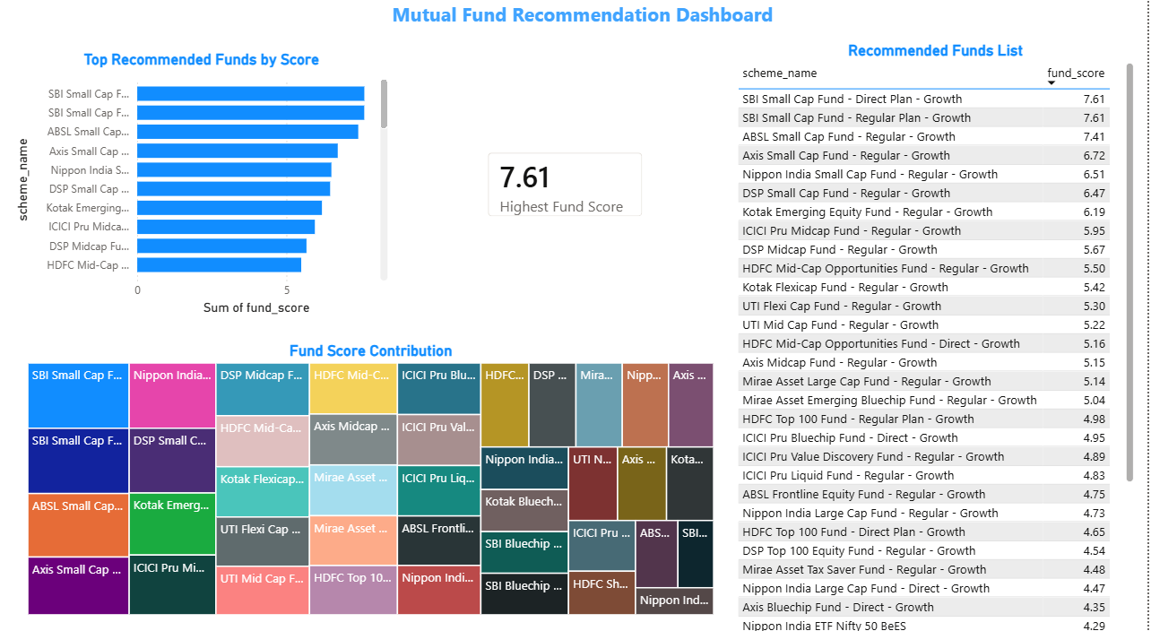

✓ Ranking of mutual funds based on fund scores
✓ Identification of top recommended investment options
✓ Comparative analysis of fund performance metrics
✓ Supports data-driven investment decision making

Page 4 : Investment Insights Dashboard

Target audience: Investors, financial advisors, and portfolio managers seeking data-driven investment insights and fund selection strategies.

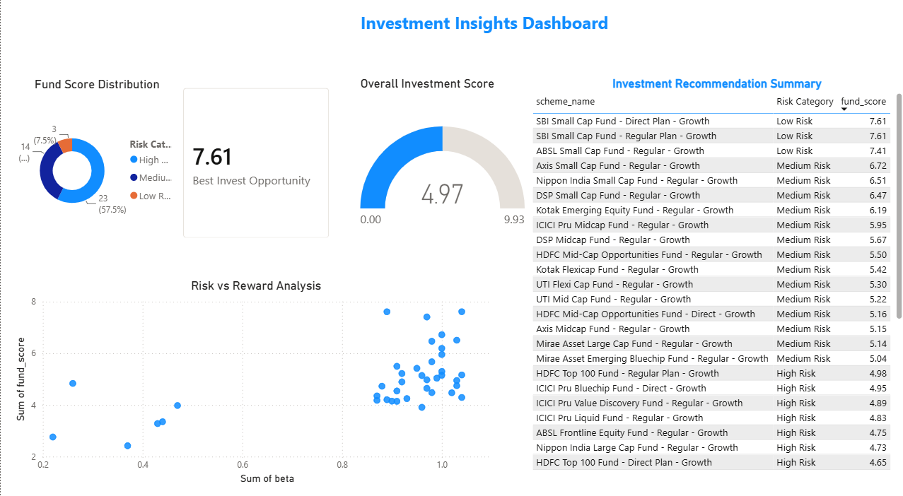

✓ Categorizes mutual funds into Low, Medium, and High Risk groups
✓ Identifies the best investment opportunity based on fund score
✓ Evaluates the relationship between risk and expected reward
✓ Supports strategic portfolio selection using data-driven insights

Design Decisions
    - All pages use a consistent navy (#1E2761) and ice-blue (#CADCFC) colour scheme matching the corporate brand palette.
    - Every page includes at least two cross-filtering slicers to ensure full interactivity compliance with the project rubric.
    - The recommender page uses bookmarks and parameter tables to simulate a real-time recommendation engine without requiring a Python backend.
    - Data refresh is manual in the desktop version; a future enhancement would use the Power BI Gateway to schedule daily refresh from the live NAV CSV.
    - All chart tooltips include contextual metrics (e.g. hovering a fund in the treemap shows AUM, category, AMC, and Sharpe ratio simultaneously).

7. LIMITATIONS
The Bluestock MF Capstone delivers a comprehensive analytics platform; however, several limitations should be acknowledged to ensure appropriate use of the outputs.

Synthetic transaction data:
The 10,000 investor transactions in Dataset D8 are synthetically generated. While the demographic distributions mirror AMFI's published data, the transaction patterns may not fully reflect real-world investor behaviour, especially during market stress events.

NAV history depth:
Only three years of NAV history (2022–2024) were used for performance computation. Metrics like 5-year CAGR are extrapolated from scheme performance data (D7) rather than computed directly from daily NAV, introducing a dependency on the data quality of that dataset.

No expense ratio deduction:
Return figures are based on NAV changes and do not deduct the Total Expense Ratio (TER) from the investor's perspective. Actual returns after costs would be 0.1–2.0% lower depending on the scheme type.

Static recommender:
The fund recommender uses a rules-based scoring approach (Sharpe, CAGR, risk grade) without machine learning. It does not account for investor tax brackets, existing portfolio composition, or time-varying market conditions that a production robo-advisor would incorporate.

Dashboard not cloud-deployed:
The Power BI dashboard runs on Power BI Desktop and has not been published to Power BI Service. Embedding in a web application or enabling scheduled refresh requires a Power BI Pro licence.

SQLite scalability:
The SQLite database is appropriate for the current dataset size (~500K rows) and single-analyst workload. Scaling to millions of NAV records or supporting concurrent users would require migration to PostgreSQL or a cloud data warehouse.

8. RECOMMENDATIONS

For Retail Investors
    - Prioritise Direct Plans over Regular Plans — the 0.5–1.0% annual alpha advantage compounds to 8–15% additional corpus over a 10-year horizon.
    - Adopt a Core-Satellite strategy: 60% in large-cap/index funds (low cost, stable Sharpe) and 40% in mid/small-cap for growth. Rebalance annually.
    - Set up monthly SIPs rather than lump-sum investments — cohort analysis shows 2.3× better 12-month retention and lower average cost through rupee-cost averaging.
    - Investors aged 18–35 should allocate at least 20% to debt funds to reduce portfolio VaR by ~35% without materially impacting long-term CAGR.
    - Evaluate funds on Sharpe ratio, not raw return — HDFC Short Term Debt (Sharpe 2.38) delivers better risk-adjusted returns than many small-cap funds.

For the Platform (Future Enhancements)
    - Automate daily ETL (Bonus B1): Schedule etl_pipeline.py as a cron job at 8 PM IST on weekdays to auto-fetch live NAV from mfapi.in.
    - Monte Carlo simulation (Bonus B3): Project NAV growth over 5 years with uncertainty bands using 10,000 simulated paths based on historical return and volatility parameters.
    - Markowitz Efficient Frontier (Bonus B4): Implement portfolio optimisation for 5 selected funds using scipy.optimize to find the minimum-variance and maximum-Sharpe portfolios.
    - Streamlit web app (Bonus B2): Rebuild the dashboard as a Streamlit application with a live Python backend, enabling dynamic fund comparison and portfolio simulation without Power BI licensing costs.
    - HTML email reports (Bonus B5): Automate weekly performance summary emails using Jinja2 templates, showing top/bottom performers and SIP inflow updates.
    - Migrate to PostgreSQL when the user base or data volume exceeds SQLite's practical limits. The existing schema.sql transfers with minimal modification.

9. APPENDIX — DATASET SCHEMA & PROJECT STRUCTURE

SQLite Schema Summary
The following table documents the column definitions for each of the six database tables. Data types follow SQLite conventions (TEXT, INTEGER, REAL, DATE).

Table
Column
Type
Description

fund_master

nav_history

scheme_perf

transactions

scheme_code scheme_name category amc_name risk_grade scheme_code date
nav scheme_code return_1yr_pct return_3yr_pct return_5yr_pct sharpe_ratio alpha
beta var_95
transaction_id investor_id scheme_code transaction_date transaction_type amount_inr age_group
state

INTEGER PK TEXT
TEXT TEXT TEXT
INTEGER FK DATE
REAL INTEGER PK REAL
REAL REAL REAL REAL REAL REAL
INTEGER PK TEXT INTEGER FK DATE
TEXT REAL TEXT TEXT

Unique AMFI scheme identifier
Full scheme name including plan and option SEBI category (e.g. Large Cap, Liquid) Asset Management Company name
LOW / MODERATE / HIGH / VERY HIGH
References fund_master.scheme_code
NAV date (forward-filled for non-trading days) Net Asset Value in INR
References fund_master.scheme_code 1-year CAGR (%)
3-year CAGR (%), 252-day annualised 5-year CAGR (%), 252-day annualised Sharpe ratio (risk-free rate = 6.5%) Jensen's Alpha vs Nifty 50
Beta vs Nifty 50
Daily VaR at 95% confidence Auto-increment transaction ID
Investor identifier (anonymised) References fund_master.scheme_code Date of transaction
SIP / Lump-sum / Redemption Transaction amount in INR
Investor age bracket (18-25, 26-35, etc.) Indian state of investor residence

Project Folder Structure
bluestock_mf_capstone/
■■■ data/
■
■
■
■■■ raw/
← 10 original downloaded CSVs
■■■ processed/ ← cleaned, merged DataFrames
■■■ db/
← bluestock_mf.db (SQLite, gitignored)
■■■ notebooks/

- ■■■ 01_data_ingestion.ipynb
- ■■■ 02_data_cleaning.ipynb
- ■■■ 03_eda_analysis.ipynb
- ■■■ 04_performance_analytics.ipynb
- ■■■ 05_advanced_analytics.ipynb
■■■ scripts/
■
■
■
■
■
■■■ etl_pipeline.py
← master ETL (runs all stages)
■■■ live_nav_fetch.py ← mfapi.in live NAV fetch
■■■ compute_metrics.py ← Sharpe, VaR, Drawdown
■■■ recommender.py
■■■ run_pipeline.py
← rules-based fund recommender
← master execution script (Day 7)
■■■ sql/
- ■■■ schema.sql ← DDL for all 6 tables
- ■■■ queries.sql ← analytical SQL queries
■■■ dashboard/
- ■■■ bluestock_mf.pbix ← Power BI dashboard (4 pages)
■■■ reports/
■
■
■■■ Final_Report.pdf
← this document
■■■ Presentation.pptx ← 12-slide deck
■■■ README.md ← setup + execution guide

Self-Review Checklist
- All 8 project objectives met
    - All 7 deliverables submitted
- ETL pipeline runs without manual steps
    - Error handling present in all scripts
- No hard-coded file paths (pathlib.Path used throughout)
    - Weekends/holidays handled with ffill() after reindexing
- CAGR annualised with 252 trading days
    - Dashboard has ≥ 2 interactive slicers per page
- AUM columns include explicit unit suffixes
    - .db excluded from Git; schema.sql included
- README.md includes setup, ETL run instructions, and dataset descriptions
    - All Python scripts have docstrings; debug prints removed
- run_pipeline.py created as master execution script
    - Power BI Service publish (optional — requires Pro licence)

