**SO2 Prediction**

> bandrapro<-read.csv('bandrapro.csv')

> attach(bandrapro)

> qplot(Date,so2,data=bandrapro)

A picture containing outdoor, sky, wall

Description generated with high confidence

> summary(so2)

Min. 1st Qu. Median Mean 3rd Qu. Max.

12.00 16.00 18.00 19.91 23.00 33.00

> dsso2<-bandrapro$Date

> y<-log(bandrapro$so2)

> dfso2<-data.frame(dsso2,y)

> qplot(dsso2,y,data=dfso2)

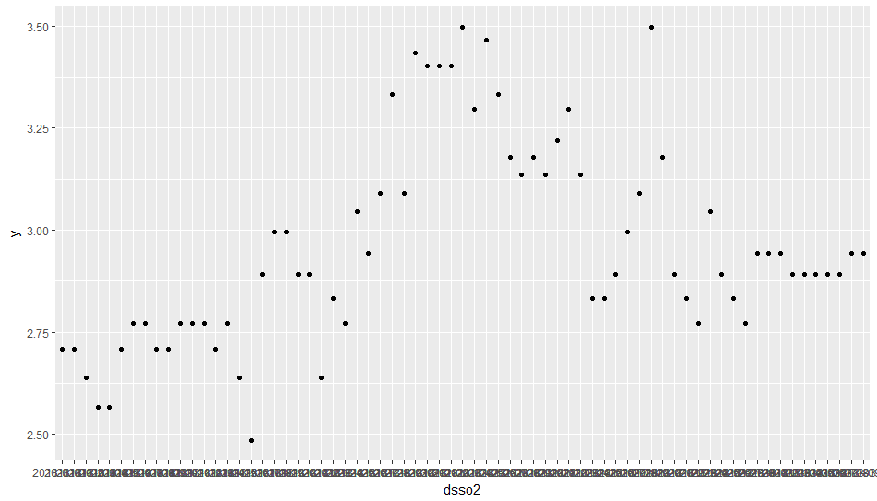

> mso2<-prophet(dfso2)

Initial log joint probability = -2.21451

Optimization terminated normally:

Convergence detected: absolute parameter change was below tolerance

> future<-make_future_dataframe(mso2,periods = 5)

> futureso2<-make_future_dataframe(mso2,periods = 5)

> head(futureso2)

ds

1 2018-01-01

2 2018-01-02

3 2018-01-03

4 2018-01-04

5 2018-01-05

6 2018-01-06

> forecastso2<-predict(mso2,futureso2)

> head(forecastso2)

ds trend seasonal seasonal_lower seasonal_upper seasonalities seasonalities_lower

1 2018-01-01 2.568375 0.04085310 0.04085310 0.04085310 0.04085310 0.04085310

2 2018-01-02 2.587132 0.02636674 0.02636674 0.02636674 0.02636674 0.02636674

3 2018-01-03 2.605889 -0.01449138 -0.01449138 -0.01449138 -0.01449138 -0.01449138

4 2018-01-04 2.624646 -0.04541206 -0.04541206 -0.04541206 -0.04541206 -0.04541206

5 2018-01-05 2.643403 -0.01616556 -0.01616556 -0.01616556 -0.01616556 -0.01616556

6 2018-01-06 2.662159 -0.01080191 -0.01080191 -0.01080191 -0.01080191 -0.01080191

seasonalities_upper weekly weekly_lower weekly_upper yhat_lower yhat_upper trend_lower trend_upper

1 0.04085310 0.04085310 0.04085310 0.04085310 2.405339 2.810306 2.568375 2.568375

2 0.02636674 0.02636674 0.02636674 0.02636674 2.423126 2.801784 2.587132 2.587132

3 -0.01449138 -0.01449138 -0.01449138 -0.01449138 2.393028 2.784143 2.605889 2.605889

4 -0.04541206 -0.04541206 -0.04541206 -0.04541206 2.384037 2.773260 2.624646 2.624646

5 -0.01616556 -0.01616556 -0.01616556 -0.01616556 2.440043 2.829372 2.643403 2.643403

6 -0.01080191 -0.01080191 -0.01080191 -0.01080191 2.456346 2.849431 2.662159 2.662159

yhat

1 2.609228

2 2.613499

3 2.591397

4 2.579234

5 2.627237

6 2.651357

> tail(forecastso2[c('ds','yhat','yhat_lower','yhat_upper')])

ds yhat yhat_lower yhat_upper

69 2018-03-10 2.839263 2.633786 3.022336

70 2018-03-11 2.858357 2.664285 3.043745

71 2018-03-12 2.868201 2.665404 3.081123

72 2018-03-13 2.842356 2.656841 3.045444

73 2018-03-14 2.790139 2.606681 2.985963

74 2018-03-15 2.747860 2.559921 2.940311

> exp(2.83)

[1] 16.94546

> exp(2.85)

[1] 17.28778

>plot(mso2,forecastso2)

A close up of a map

Description generated with very high confidence

>prophet_plot_components(mso2,forecastso2)

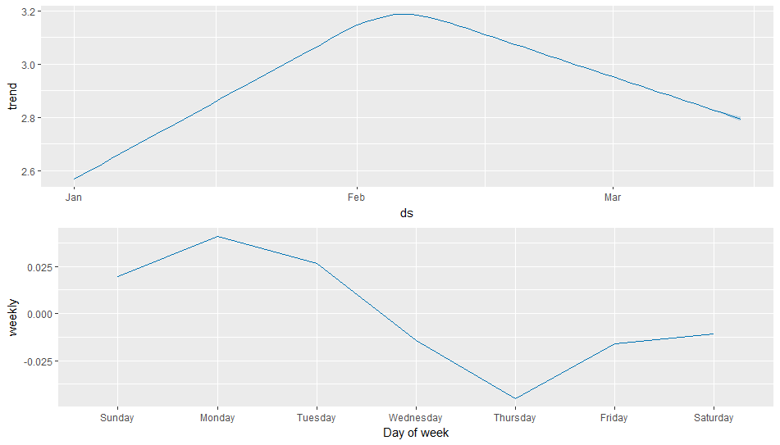

**No2  Prediction**

>qplot(Date,no2,data=bandrapro)

**A picture containing outdoor, wall, sky, bird

Description generated with very high confidence**

> summary(no2)

Min. 1st Qu. Median Mean 3rd Qu. Max.

21.00 70.00 87.00 91.51 109.00 214.00

> dsno2<-bandrapro$Date

> y<-log(bandrapro$no2)

> dfno2<-data.frame(dsno2,y)

> qplot(dsno2,y,data=dfno2)

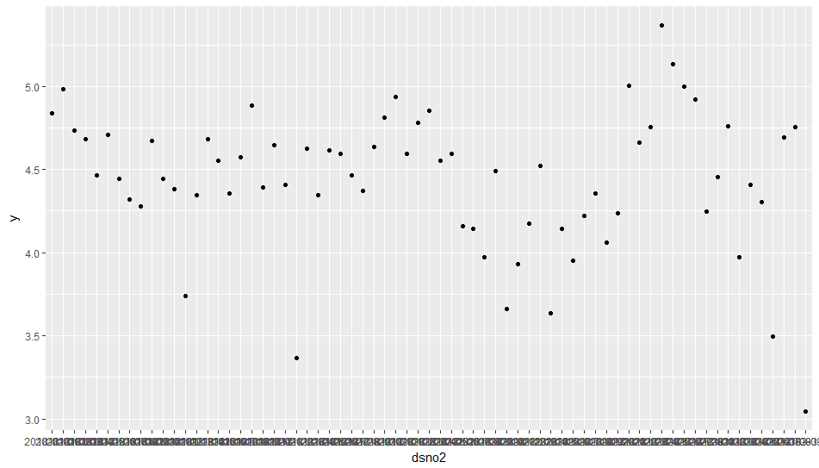

> mno2<-prophet(dfno2)

Initial log joint probability = -2.77209

Optimization terminated normally:

Convergence detected: absolute parameter change was below tolerance

> futureno2<-make_future_dataframe(mno2,periods = 5)

> head(futureno2)

ds

1 2018-01-01

2 2018-01-02

3 2018-01-03

4 2018-01-04

5 2018-01-05

6 2018-01-06

> forecastno2<-predict(mno2,futureno2)

> head(forecastno2)

ds trend seasonal seasonal_lower seasonal_upper seasonalities seasonalities_lower

1 2018-01-01 4.561190 0.05192183 0.05192183 0.05192183 0.05192183 0.05192183

2 2018-01-02 4.557558 -0.04941725 -0.04941725 -0.04941725 -0.04941725 -0.04941725

3 2018-01-03 4.553925 0.01260751 0.01260751 0.01260751 0.01260751 0.01260751

4 2018-01-04 4.550293 0.03282689 0.03282689 0.03282689 0.03282689 0.03282689

5 2018-01-05 4.546660 0.05855911 0.05855911 0.05855911 0.05855911 0.05855911

6 2018-01-06 4.543028 -0.10872167 -0.10872167 -0.10872167 -0.10872167 -0.10872167

seasonalities_upper weekly weekly_lower weekly_upper yhat_lower yhat_upper trend_lower trend_upper

1 0.05192183 0.05192183 0.05192183 0.05192183 4.066993 5.107536 4.561190 4.561190

2 -0.04941725 -0.04941725 -0.04941725 -0.04941725 4.005698 5.027264 4.557558 4.557558

3 0.01260751 0.01260751 0.01260751 0.01260751 4.026793 5.090783 4.553925 4.553925

4 0.03282689 0.03282689 0.03282689 0.03282689 4.069073 5.072711 4.550293 4.550293

5 0.05855911 0.05855911 0.05855911 0.05855911 4.036568 5.132652 4.546660 4.546660

6 -0.10872167 -0.10872167 -0.10872167 -0.10872167 3.941829 4.937608 4.543028 4.543028

yhat

1 4.613112

2 4.508141

3 4.566533

4 4.583120

5 4.605219

6 4.434306

> tail(forecastno2)

ds trend seasonal seasonal_lower seasonal_upper seasonalities seasonalities_lower

69 2018-03-10 4.319357 -0.108721672 -0.108721672 -0.108721672 -0.108721672 -0.108721672

70 2018-03-11 4.315812 0.002223572 0.002223572 0.002223572 0.002223572 0.002223572

71 2018-03-12 4.312267 0.051921834 0.051921834 0.051921834 0.051921834 0.051921834

72 2018-03-13 4.308722 -0.049417247 -0.049417247 -0.049417247 -0.049417247 -0.049417247

73 2018-03-14 4.305178 0.012607506 0.012607506 0.012607506 0.012607506 0.012607506

74 2018-03-15 4.301633 0.032826894 0.032826894 0.032826894 0.032826894 0.032826894

seasonalities_upper weekly weekly_lower weekly_upper yhat_lower yhat_upper trend_lower trend_upper

69 -0.108721672 -0.108721672 -0.108721672 -0.108721672 3.699094 4.727220 4.319357 4.319357

70 0.002223572 0.002223572 0.002223572 0.002223572 3.798914 4.846963 4.315811 4.315813

71 0.051921834 0.051921834 0.051921834 0.051921834 3.870548 4.875105 4.312264 4.312271

72 -0.049417247 -0.049417247 -0.049417247 -0.049417247 3.743572 4.774393 4.308714 4.308730

73 0.012607506 0.012607506 0.012607506 0.012607506 3.789093 4.855644 4.305162 4.305191

74 0.032826894 0.032826894 0.032826894 0.032826894 3.808814 4.852220 4.301611 4.301653

yhat

69 4.210635

70 4.318036

71 4.364189

72 4.259305

73 4.317785

74 4.334460

> tail(forecastno2[c('ds','yhat','yhat_lower','yhat_upper')])

ds yhat yhat_lower yhat_upper

69 2018-03-10 4.210635 3.699094 4.727220

70 2018-03-11 4.318036 3.798914 4.846963

71 2018-03-12 4.364189 3.870548 4.875105

72 2018-03-13 4.259305 3.743572 4.774393

73 2018-03-14 4.317785 3.789093 4.855644

74 2018-03-15 4.334460 3.808814 4.852220

> exp(4.31)

[1] 74.44049

> exp(4.36)

[1] 78.25713

>plot(mno2,forecastno2)

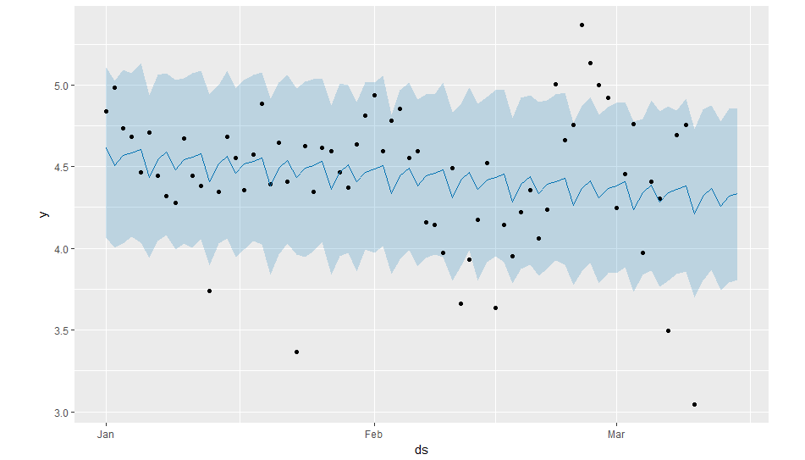>prophet_plot_components(mno2,forecastno2)

**A close up of a map

Description generated with high confidence**

**RSPM Prediction**

> qplot(Date,rspm,data=bandrapro)

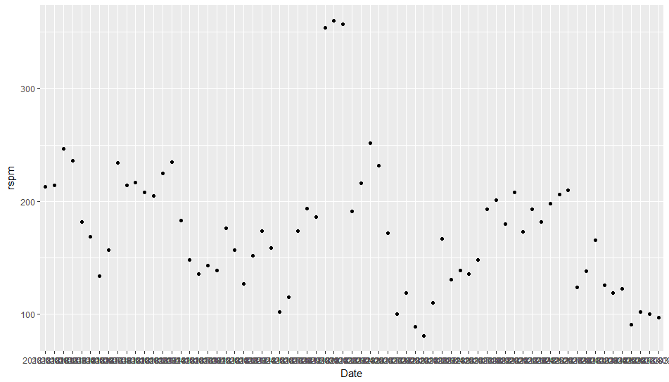

> summary(rspm)

Min. 1st Qu. Median Mean 3rd Qu. Max.

81.0 134.0 173.0 174.5 208.0 360.0

> dsrspm<-bandrapro$Date

> y<-log(bandrapro$rspm)

> dfrspm<-data.frame(dsrspm,y)

> qplot(dsrspm,y,data=dfrspm)

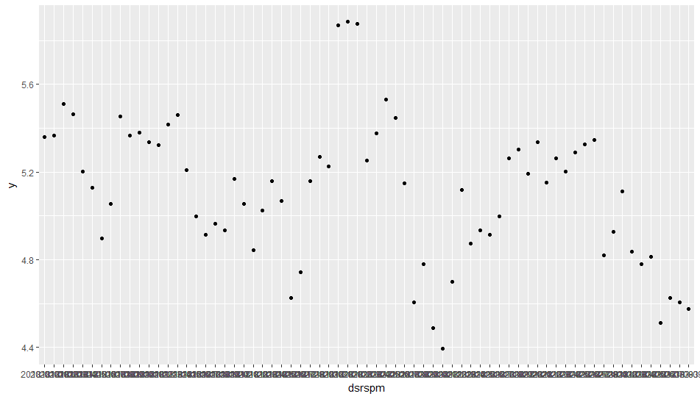

> mrspm<-prophet(dfrspm)

Initial log joint probability = -2.13677

Optimization terminated normally:

Convergence detected: absolute parameter change was below tolerance

> futurerspm<-make_future_dataframe(mrspm,periods = 5)

> head(futurerspm)

ds

1 2018-01-01

2 2018-01-02

3 2018-01-03

4 2018-01-04

5 2018-01-05

6 2018-01-06

> forecastrspm<-predict(mrspm,futurerspm)

> head(forecastrspm)

ds trend seasonal seasonal_lower seasonal_upper seasonalities seasonalities_lower

1 2018-01-01 5.318143 -0.004131951 -0.004131951 -0.004131951 -0.004131951 -0.004131951

2 2018-01-02 5.311990 0.064348202 0.064348202 0.064348202 0.064348202 0.064348202

3 2018-01-03 5.305837 0.062675606 0.062675606 0.062675606 0.062675606 0.062675606

4 2018-01-04 5.299684 0.054075125 0.054075125 0.054075125 0.054075125 0.054075125

5 2018-01-05 5.293531 -0.030250167 -0.030250167 -0.030250167 -0.030250167 -0.030250167

6 2018-01-06 5.287378 -0.039439541 -0.039439541 -0.039439541 -0.039439541 -0.039439541

seasonalities_upper weekly weekly_lower weekly_upper yhat_lower yhat_upper trend_lower trend_upper

1 -0.004131951 -0.004131951 -0.004131951 -0.004131951 4.931148 5.652223 5.318143 5.318143

2 0.064348202 0.064348202 0.064348202 0.064348202 4.981623 5.718429 5.311990 5.311990

3 0.062675606 0.062675606 0.062675606 0.062675606 4.962259 5.762299 5.305837 5.305837

4 0.054075125 0.054075125 0.054075125 0.054075125 4.992524 5.731251 5.299684 5.299684

5 -0.030250167 -0.030250167 -0.030250167 -0.030250167 4.893541 5.629664 5.293531 5.293531

6 -0.039439541 -0.039439541 -0.039439541 -0.039439541 4.857950 5.597358 5.287378 5.287378

yhat

1 5.314011

2 5.376338

3 5.368512

4 5.353759

5 5.263280

6 5.247938

> tail(forecastrspm)

ds trend seasonal seasonal_lower seasonal_upper seasonalities seasonalities_lower

69 2018-03-10 4.898292 -0.039439541 -0.039439541 -0.039439541 -0.039439541 -0.039439541

70 2018-03-11 4.892061 -0.107277273 -0.107277273 -0.107277273 -0.107277273 -0.107277273

71 2018-03-12 4.885829 -0.004131951 -0.004131951 -0.004131951 -0.004131951 -0.004131951

72 2018-03-13 4.879598 0.064348202 0.064348202 0.064348202 0.064348202 0.064348202

73 2018-03-14 4.873366 0.062675606 0.062675606 0.062675606 0.062675606 0.062675606

74 2018-03-15 4.867135 0.054075125 0.054075125 0.054075125 0.054075125 0.054075125

seasonalities_upper weekly weekly_lower weekly_upper yhat_lower yhat_upper trend_lower trend_upper

69 -0.039439541 -0.039439541 -0.039439541 -0.039439541 4.471703 5.226102 4.898292 4.898292

70 -0.107277273 -0.107277273 -0.107277273 -0.107277273 4.423189 5.164915 4.892060 4.892061

71 -0.004131951 -0.004131951 -0.004131951 -0.004131951 4.488374 5.283365 4.885825 4.885833

72 0.064348202 0.064348202 0.064348202 0.064348202 4.544028 5.310001 4.879590 4.879605

73 0.062675606 0.062675606 0.062675606 0.062675606 4.544424 5.324450 4.873354 4.873379

74 0.054075125 0.054075125 0.054075125 0.054075125 4.535451 5.302674 4.867116 4.867154

yhat

69 4.858852

70 4.784783

71 4.881697

72 4.943946

73 4.936042

74 4.921210

> tail(forecastrspm[c('ds','yhat','yhat_lower','yhat_upper')])

ds yhat yhat_lower yhat_upper

69 2018-03-10 4.858852 4.471703 5.226102

70 2018-03-11 4.784783 4.423189 5.164915

71 2018-03-12 4.881697 4.488374 5.283365

72 2018-03-13 4.943946 4.544028 5.310001

73 2018-03-14 4.936042 4.544424 5.324450

74 2018-03-15 4.921210 4.535451 5.302674

> exp(4.85)

[1] 127.7404

> exp(4.78)

[1] 119.1044

> plot(mrspm,forecastrspm)

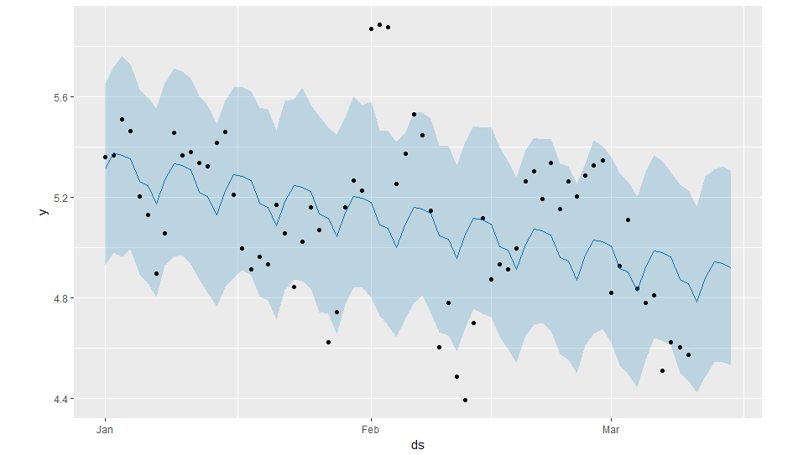

> prophet_plot_components(mrspm,forecastrspm)

