DEEPFAKE DETECTION OF AUDIO MANIPULATIONS

Suchit Meshram Raghav Singhania
Department of computer engineering Department of computer engineering
Vishwakarma institute of technology Vishwakarma institute of technology
suchit.meshram16@vit.edu raghav.singhania16@vit.edu

Sachin Chaudhari Rushikesh Khardekar
Department of computer engineering Department of computer engineering
Vishwakarma institute of technology Vishwakarma institute of technology
sachin.chaudhari16@vit.edu rushikesh.khardekar16@vit.edu

- ABSTRACT
Audio Deepakes, technically known as logical-access voice spoofing techniques, have become an increased threat on voice interfaces due to the recent breakthroughs in speech synthesis and voice conversion technologies. Effectively detecting these attacks is critical to many speech applications including automatic speaker verification systems. As new types of speech synthesis and voice conversion techniques are emerging rapidly, the generalization ability of spoofing countermeasures is becoming an increasingly critical challenge. This paper focuses on overcoming this issue by using large margin cosine loss function (LMCL) and online frequency masking augmentation to force the neural network to learn more robust feature embeddings. We evaluate the performance of the proposed system on the ASVspoof 2019 logical access (LA) dataset. Additionally, we evaluate it on a noisy version of the ASVspoof 2019 dataset using publicly available noises to simulate more realistic scenarios. Finally, we evaluate the proposed system on a copy of the dataset that is logically replayed through the telephony channel to simulate spoofing attacks in the call center scenario.
- INTRODUCTION

The word Deepfake is a combination of "Deep Learning" and "Fake." Deep Fakes are used to replace a person in an existing image or video with someone else's likeness by using artificial neural networks. Even sounds such as voices can be trained to sound like a particular person. It for example, your phone rings, you pick up. It’s your spouse asking you for details about your savings account — they don’t have the account information on hand, but want to deposit money there this afternoon. Later, you realize a bunch of money has gone missing! After investigating, you find out that the person masquerading as them on the other line was a voice 100% generated with AI. You’ve just been scammed, and on top of that, can’t believe the voice you thought belonged to your spouse was actually a fake.

2. RELATED WORKS

2.1 Voice Synthesis Voice synthesis can be divided into two categories: 1) non-DNN based, such as using hidden Markov models (HMMs) and Gaussian mixture models (GMMs) to learn speech features and replicate them, and 2) DNN based for synthesizing naturalness speech and even on unseen words. The first technique is speech concatenation that concatenates some pre-recorded speech segments to synthesize a new clip voice [62]. The other technique on format analysis uses acoustic models without a human voice as input to generate robotic-sounding speech

[52]. Modeling the human vocal tract and vocal biomechanics is another technique for synthesizing speech, which is known as articulatory speech synthesis [26]. Some studies explore leveraging HMM to modulate speech proprietaries like fundamental frequency and duration [64]. These techniques are widely employed in the early years for speech synthesis, but suffer from naturalness issues, which could be easily sounded by human ears. DNN based. DNN-based speech synthesis techniques directly map linguistic features to acoustic features by leveraging the power of DNNs in representation. Various models (e.g., Boltzmann machines [24], deep belief network [18], mixed density networks [2],
Bidirectional LSTM [22]) are proposed based on DNNs for synthesizing high quality and natural speech. Some synthesized samples are available online [39]. WaveNet [44] developed by DeepMind in 2016 and Tacotron [58] created by Google in 2017 are two milestones in speech synthesis. The two models significantly promote the progress of speech synthesis, which enables large scale commercial applications for building TTS and VC systems. WaveNet originates from PixelCNN [56] or PixelRNN [45] and shown its powerful capabilities in modeling waveforms with a generative model that is trained on a real audio dataset. Tacotron [58] is an end-to-end speech synthesis model that can be trained on pairs to avoid large human annotation efforts. Due to the powerful capabilities of WaveNet and Tacotron, some commercial products are developed based on them, such as Baidu TTS [33], Amazon AWS Polly [7], and Google Cloud TTS [9]. Unfortunately, some attackers can maliciously use speech synthesis techniques and develop fake voices for fraud intentions.bringing potential security concerns.

2.2 Fake Voice Detection In the past decades, some digital audio forensic studies are working on detecting various forms of audio spoofing [63]. These approaches examine metadata of audio files and investigate their actual bytes. Douglas et al. [21] examine the eleven audio recordings from three Olympus recorders in the digital header data for audio authentication. Malik et al. [65] propose using acoustic environment signature as an important feature for detecting audio forgery by verifying the integrity of digital audio. These studies failed in addressing audio content that is synthesized. The most similar work to ours is [1] that is the first study dedicated to AI-synthesized fake voices. In their work, they propose a bispectral analysis method for detecting AI-synthesized fake voices. They observe that specific and unusual spectral correlation exhibited in the fake voices synthesized with DNNs, which are called bispectral artifacts. Thus, they explore to use higher-order polyspectral features for discriminating fake voices. This work is also motivated by investigating artifacts introduced in fake voices like some recent studies on detecting fake images [23, 61]. Artifact-based detectors will be invalid when the artifacts are fixed with some optimization methods or new synthetic techniques are proposed. In this paper, instead of investigating the artifacts in raw voices introduced in synthesis, we explore a new way by monitoring neuron behaviors of DNN-based SR systems with a simple binaryclassifier to distinguish real and fake voices. The layer-wise neuron behaviors can capture more subtle features in differentiating real and fake voices. Experimental results show that our approach outperforms previous work (by investigating bispectral artifacts [1]) in terms of both effectiveness and robustness.

3. The Proposed System
3.1 Data Preprocessing
We have huge amount of mixed data where real audios and fake audios are mixed. For the training purpose we need to separate and make two classes of them and same for the test dataset also.
Dataset has given metadata file in which all data is labelled as real and fake. So using the python libraries such as pandas we separated the data into two classes.
3.2 Converting train and test audio files to mel spectrogram
We cannot directly differentiate audios on the basis of their sounds. Two sounds may be similar to human naked ears but can be different for machines. We need parameters in audio files to classify them. Sound parameters can be amplitude and frequency. But amplitude only defines the loudness of sound but frequency defines the type of sound. Sya more about characteristics of sound. We can draw frequency vs time graph using python libraries. It is called logarithmic fourior transformation of frequency. Here wee use mel scale to transform the frequencies. We use mel scale over logarithmic scale because study shows mel scale gives precise features of sound.
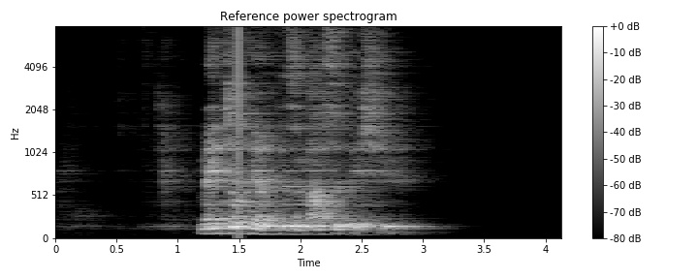
Fig. Frequency vs time Mel spectrogram
Now we have two classes of spectogram images, Real and Fake.
In case, we have video and we want to check that audio in the video is deepfake or not then wwe can extract audio from video using moviepy library and can perform similar operations performed on normal audio.
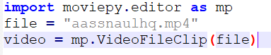
Fig. Code snippet for extracting audio from video file

3.3 Classification of Classes
For the classification of images, CNN (Convolutional neural networks) model works best than other classification models. So we applied CNN on those classes. Output will be binary ‘Real’ or ‘Fake’ that’s why activation function chosen is ‘relu’.

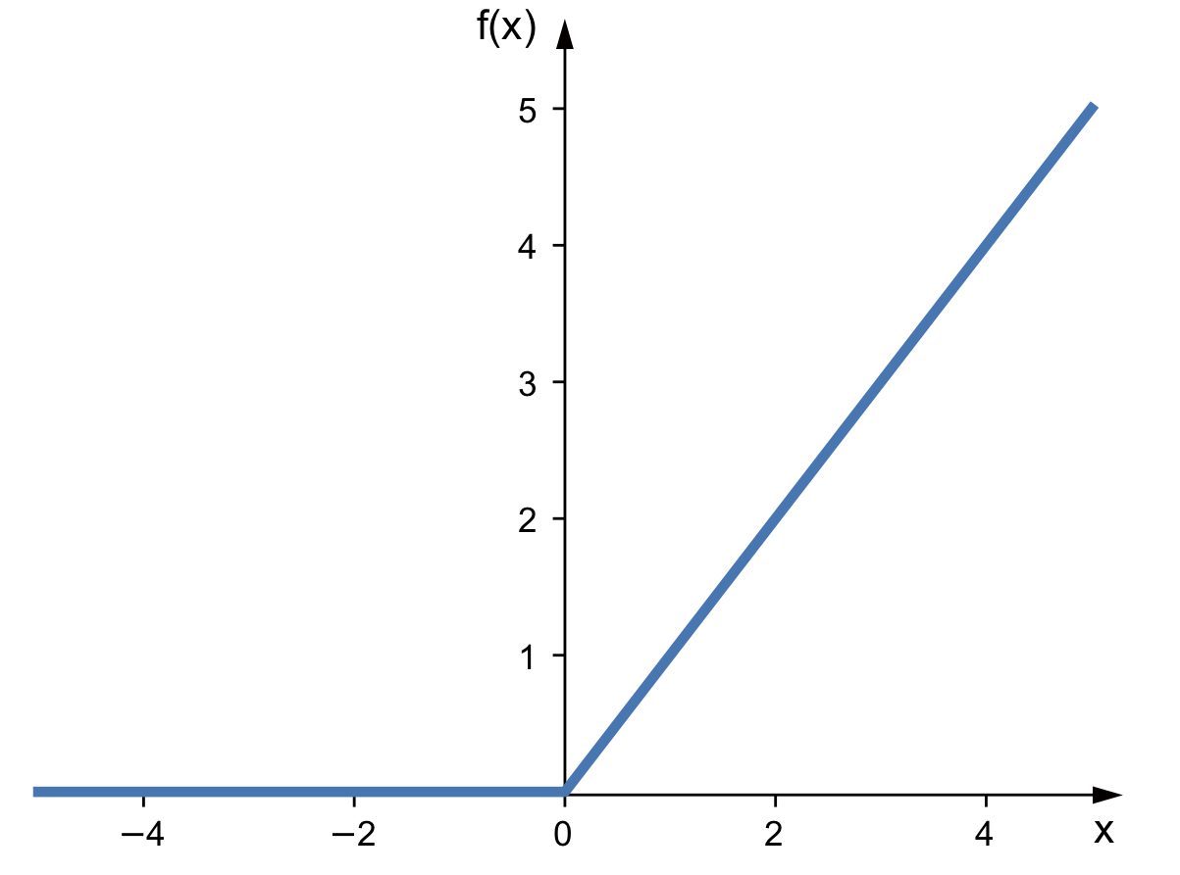
Fig.Relu function graph

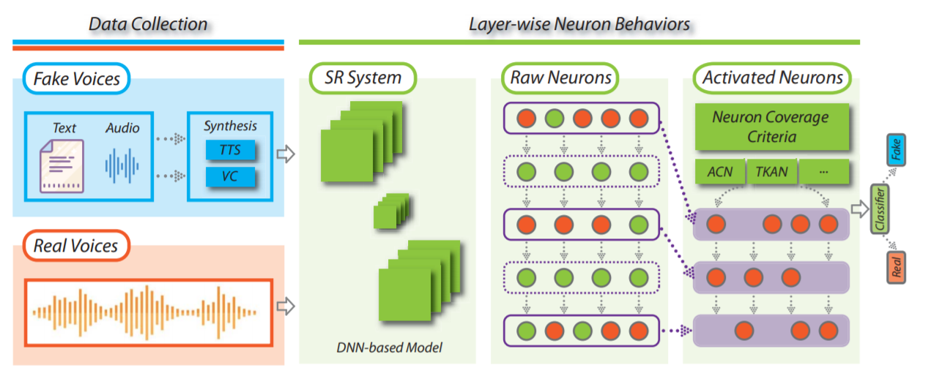
Fig. Visulisation of processing of CNN
3.4 Training and Saving the CNN model
When we are training our CNN model, we need to get best accuracy possible. It can be increased by changing no. of epochs, adding more layers to CNN, etc called parameter tuning. Once we get the desired result we can save the CNN model weights and then we not need to train the model every time. Just load weights and use the model.
3.5 Prediction of Single Data
CNN model is trained with best accuracy possible, now time to classify the given unknown audio file real or fake. We can use simple keras functions to do that.
If the model is predicting precisely then model can be finalize for deployment otherwise needs to improve the accuracy.

4. Experimental Results

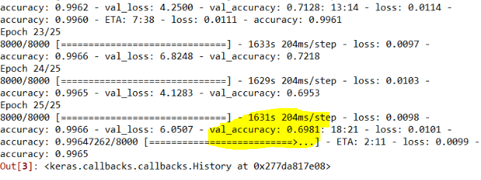
Fig. For our model final validation accuracy is 69.81%

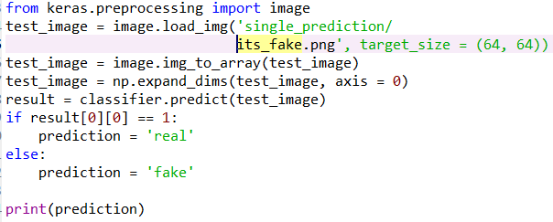
Fig. In this code snippet we checking of fake sample and result was correct and similar happened when tried real sample.

5. Conclusion and Perspectives
It is not the first time the world encounters forgery, it has been there for eras. Every technology has its own pros and cons. Though in this concern, the negativity outweighs the positive aspects, if people are enlightened and if proper solutions are attained such that, if another AI could possibly differentiate a legitimate audio and fake one, then that should be called a true development. From the study conducted it is found out that the majority of the audio files were differentiated between original and duplicate copies. The wave differences could be identified between the original and duplicate copies. The alterations were identified using spectrograph of the original files. WAV files are used in all the areas of audio, from portable players, and handheld recorders, to audio interfaces and more. The WAV files are a more accurate and lossless format. They are of simple format, so we feed this wav files to CNN and got a Model which gives a great accuracy to find the Fake audios

6. References
1] Zhizheng Wu, Tomi Kinnunen, Nicholas Evans, Junichi Yamagishi, Cemal Hanilc¸i, Md Sahidullah, and Aleksandr Sizov, “Asvspoof 2015: the first automatic speaker verification spoofing and countermeasures challenge,” in Sixteenth Annual Conference of the International Speech Communication Association, 2015.
[2] A¨aron Van Den Oord, Sander Dieleman, Heiga Zen, Karen Simonyan, Oriol Vinyals, Alex Graves, Nal Kalchbrenner, Andrew W Senior, and Koray Kavukcuoglu, “Wavenet: A generative model for raw audio.,” SSW, vol. 125, 2016.
[3] Sercan ¨O Arik, Mike Chrzanowski, Adam Coates, Gregory Diamos, Andrew Gibiansky, Yongguo Kang, Xian Li, John Miller, Andrew Ng, Jonathan Raiman, et al., “Deep voice: Real-time neural text-to-speech,” in Proceedings of the 34th International Conference on Machine Learning-Volume 70. JMLR. org, 2017, pp. 195–204.
[4] Yuxuan Wang, RJ Skerry-Ryan, Daisy Stanton, Yonghui Wu, Ron J Weiss, Zongheng Yang Jaitly, Ying Xiao, Zhifeng Chen, Samy Bengio, Quoc Le, et al., “Tacotron: Towards end-to-end speech synthesis,” in Interspeech, 2017.
[5] Jaime Lorenzo-Trueba, Junichi Yamagishi, Tomoki Toda, Daisuke Saito, Fernando Villavicencio, Tomi Kinnunen, and Zhenhua Ling, “The voice conversion challenge 2018: Promoting development of parallel and nonparallel methods,” in roc. Odyssey 2018 The Speaker and Language Recognition Workshop, 2018, pp. 195–202.
[6] Tomi Kinnunen, Jaime Lorenzo-Trueba, Junichi Yamagishi, Tomoki Toda, Daisuke Saito, Fernando Villavicencio, and Zhenhua Ling, “A spoofing benchmark for the 2018 voice conversion challenge: Leveraging from spoofing countermeasures for speech artifact assessment,” in Proc. Odyssey 2018 The Speaker and Language Recognition Workshop, 2018, pp. 187–194.
[7] Massimiliano Todisco, Xin Wang, Ville Vestman, Md Sahidullah, Hector Delgado, Andreas Nautsch, JunichiYamagishi, Nicholas Evans, Tomi Kinnunen, and Kong Aik Lee, “Asvspoof 2019: Future horizons in spoofed and fake audio detection,” arXiv preprint arXiv:1904.05441, 2019.
[8] Massimiliano Todisco, H´ector Delgado, and Nicholas Evans, “A new feature for automatic speaker verification anti-spoofing: Constant q cepstral coefficients,” in Odyssey 2016, The Speaker and Language Recognition Workshop, 2016.

[9] ZhizhengWu, Eng Siong Chng, and Haizhou Li, “Detecting converted speech and natural speech for anti-spoofing attack in speaker recognition,” 2012.
[10] ZhizhengWu, Tomi Kinnunen, Eng Siong Chng, Haizhou Li, and Eliathamby Ambikairajah, “A study on spoofingattack in state-of-the-art speaker verification: the telephone speech case,” 2012.
[11] Rohan Kumar Das, Jichen Yang, and Haizhou Li, “Long range acoustic and deep features perspective on asvspoof 2019,” in IEEE Autom. Speech Recognit. Understanding Workshop, 2019.
[12] Yanmin Qian, Nanxin Chen, Heinrich Dinkel, and Zhizheng Wu, “Deep feature engineering for noise robust spoofing detection,” IEEE/ACM Transactions on Audio, Speech, and Language Processing, vol. 25, no. 10, pp. 1942–1955, 2017.
[13] Hossein Zeinali, Themos Stafylakis, Georgia Athanasopoulou, Johan Rohdin, Ioannis Gkinis, Luk´aˇs Burget, Jan Cˇ ernocky`, et al., “Detecting spoofing attacks using vgg and sincnet: But-omilia submission to asvspoof 2019 challenge,” arXiv preprint arXiv:1907.12908, 2019.
[14] Yexin Yang, Hongji Wang, Heinrich Dinkel, Zhengyang Chen, Shuai Wang, Yanmin Qian, and Kai Yu, “The sjtu robust anti-spoofing system for the asvspoof 2019 challenge,” Proc. Interspeech 2019, pp. 1038–1042, 2019.
[15] Balamurali BT, Kin Wah Edward Lin, Simon Lui, Jer-Ming Chen, and Dorien Herremans, “Towards robust audio spoofing detection: a detailed comparison of traditional and learned features,” arXiv preprint arXiv:1905.12439, 2019.
[16] Hao Wang, Yitong Wang, Zheng Zhou, Xing Ji, Dihong Gong, Jingchao Zhou, Zhifeng Li, andWei Liu, “Cosface: Large margin cosine loss for deep face recognition,” in Proceedings of the IEEE Conference on Computer Vision and Pattern Recognition, 2018, pp. 5265–5274.

