ECG MONITORING SYSTEM
CIRCUIT DESIGN
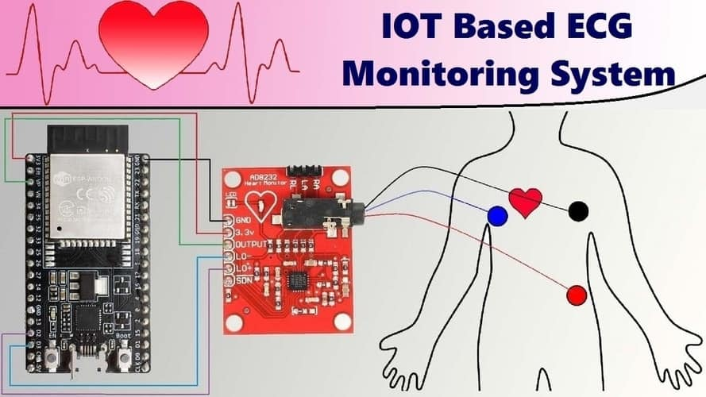

HARDWARE IMPLEMENTATION
