Project Report
Global E-Waste Generation vs. Recycling Gap Analysis (2015–2024)
Student Name | Suchitra Panda
Program | IBM SkillsBuild Virtual Data Analytics with AI Internship
Collaboration | AICTE x BharatCares x IBM
Internship ID | IBMUEDA0735
Project Title | Global E-Waste Generation vs. Recycling Gap Analysis (2015–2024)
Project Type | Data Analytics (Exploratory Data Analysis & Statistical Trend Analysis)
SDG Alignment | SDG 12 – Responsible Consumption & Production; SDG 3 – Good Health & Well-being

1. Introduction
Electronic waste (e-waste) — discarded phones, computers, appliances, and other electronic devices — is one of the fastest-growing waste streams in the world. It sits at the intersection of two United Nations Sustainable Development Goals emphasized in this internship's curriculum: SDG 12 (Responsible Consumption and Production) and SDG 3 (Good Health and Well-being), since informally processed e-waste releases toxic heavy metals such as lead, mercury, and cadmium into soil, air, and water.
This project applies pure data analytics techniques — exploratory data analysis (EDA), aggregation, correlation analysis, and simple statistical trend fitting — to study how e-waste generation and formal recycling have evolved globally between 2015 and 2024, without relying on machine learning models.

2. Objectives
- Quantify how fast global e-waste generation has grown between 2015 and 2024.
- Measure the widening gap between e-waste generated and e-waste formally/safely recycled.
- Compare regions and countries on total volume versus per-capita volume of e-waste.
- Identify which economic and digital-adoption factors correlate most strongly with e-waste generation.
- Project near-term trends and translate findings into policy-relevant recommendations.

3. Dataset Description
The analysis uses a 200-row country-year panel dataset covering 20 countries across 6 regions (North America, Europe, Asia, South America, Africa, Oceania) for the years 2015–2024. Columns include Population, GDP per Capita, Internet Penetration, E-Waste Generated (kt), E-Waste Formally Recycled (kt), and Recycling Rate (%).
Data source note: No live dataset download was reachable in the project environment, so the dataset was simulated (with a fixed random seed for reproducibility) to reflect the real order-of-magnitude patterns and year-on-year trends reported by the Global E-waste Monitor (UNITAR/ITU) and World Bank population/GDP series. Absolute figures should be read as illustrative rather than official statistics; the same notebook can be re-run unchanged on the official dataset by preserving the column names.

4. Methodology
- Data generation/loading and cleaning (missing value and duplicate checks) using pandas.
- Descriptive statistics and groupby aggregation by Year, Region, and Country.
- Visual analysis using matplotlib/seaborn: line trends, bar comparisons, diverging bar charts, and a correlation heatmap.
- Compound Annual Growth Rate (CAGR) calculation by region.
- Simple linear (least-squares) trend fitting with numpy.polyfit for a 2025–2027 projection — a statistical technique, not a machine-learning model.

5. Analysis & Findings

5.1 Global Trend: Generation vs. Formal Recycling
Total e-waste generated worldwide rises steadily across the decade while formally recycled volumes rise much more slowly, so the gap between the two — the volume that is never safely processed — widens every year.
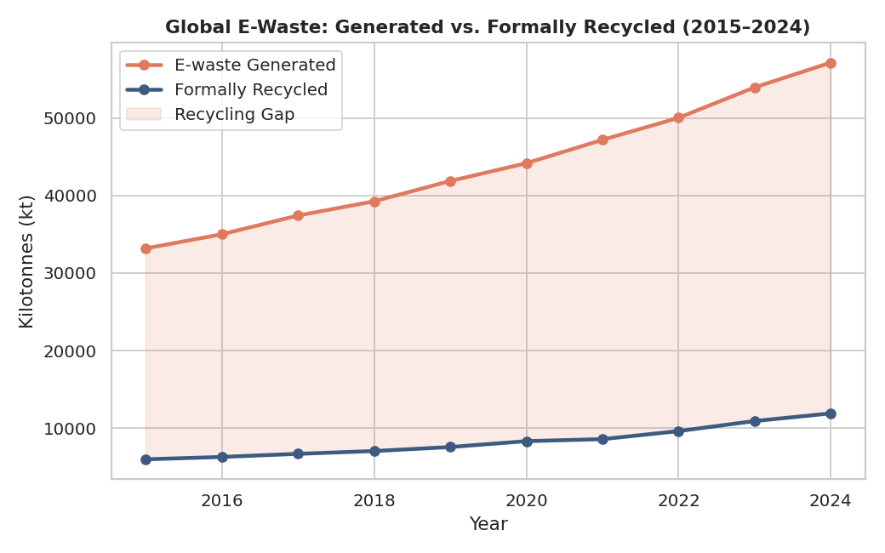
Figure 1: Global e-waste generated vs. formally recycled, 2015–2024.

5.2 Regional Comparison
Asia leads in total e-waste volume by a wide margin, driven by its enormous population base, followed by North America and Europe. Africa and South America generate the least in absolute terms — for now.
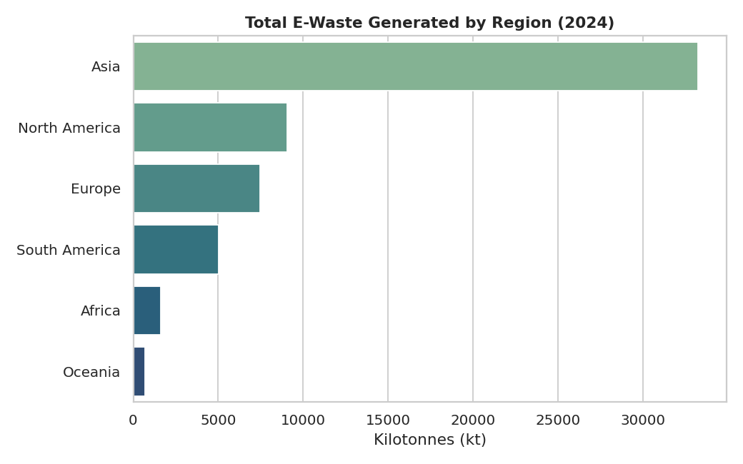
Figure 2: Total e-waste generated by region, 2024.

5.3 Per-Capita Leaders
When normalized by population, the ranking flips: wealthy, highly digitized nations such as Sweden, Australia, the UK, and the US top the per-capita list, since device turnover — not population size — drives per-person e-waste.
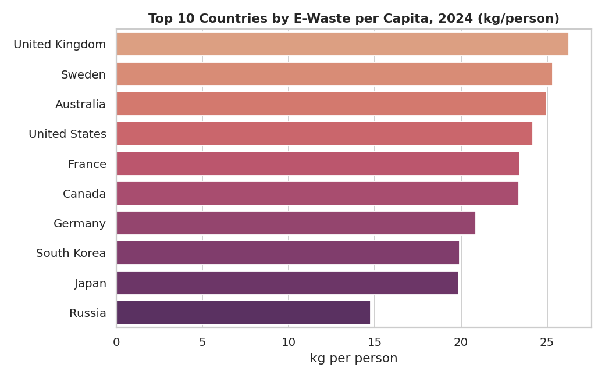
Figure 3: Top 10 countries by e-waste per capita, 2024.

5.4 The Recycling Gap by Country
Countries below the 20% formal recycling benchmark (highlighted in red) are disproportionately lower- and middle-income economies — precisely the countries whose absolute e-waste volumes, driven by large populations, are largest and growing fastest. This mismatch between where waste is generated and where recycling capacity exists is the central problem this analysis surfaces.
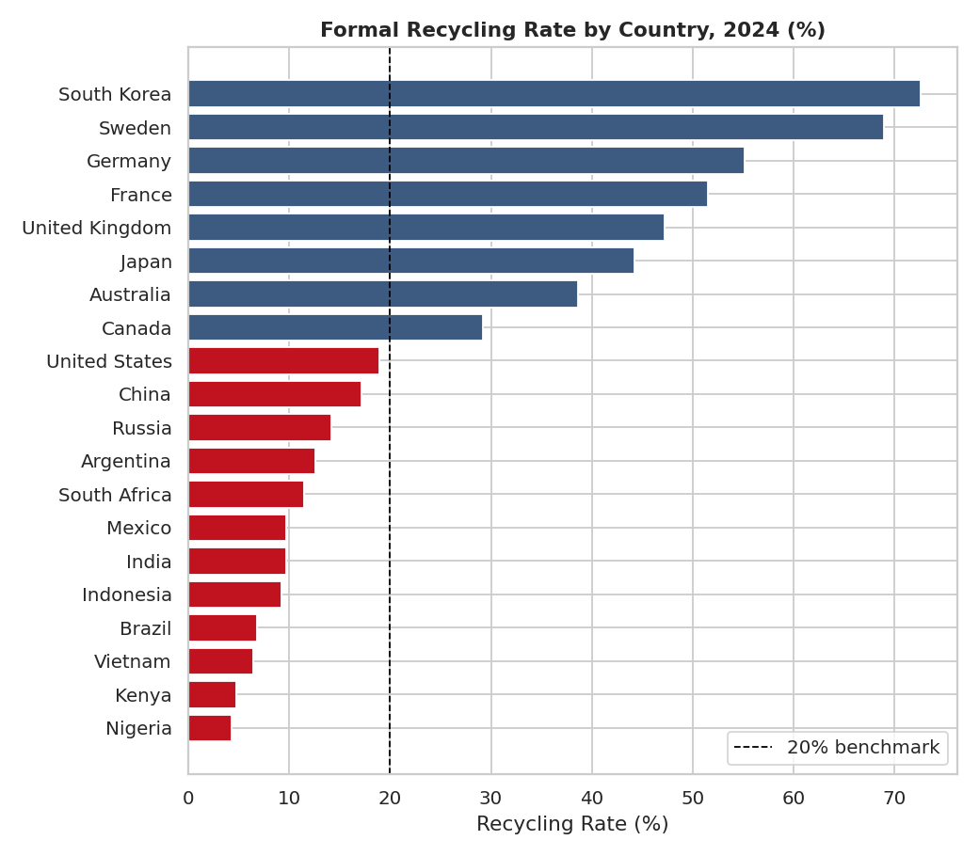
Figure 4: Formal recycling rate by country, 2024.

5.5 Drivers of E-Waste: Correlation Analysis
GDP per capita and internet penetration both correlate strongly and positively with e-waste per capita, confirming that rising prosperity and digital access — worthwhile goals in themselves — carry an environmental cost that must be actively managed. Recycling rate correlates positively with GDP per capita as well, but not strongly enough to close the generation-recycling gap.
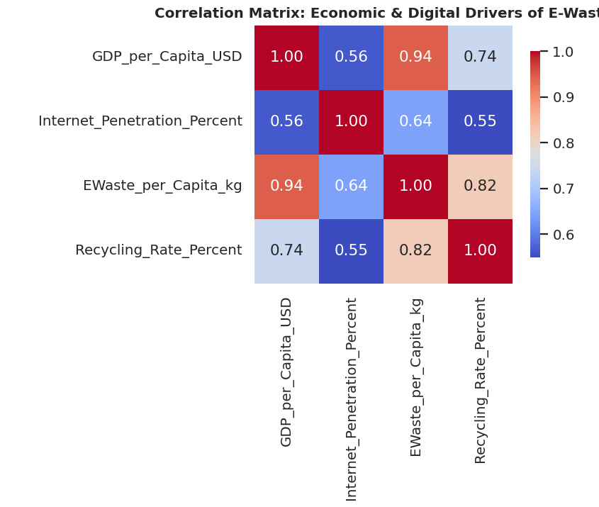
Figure 5: Correlation matrix of economic, digital, and e-waste variables.

5.6 Regional Growth Rates (CAGR)
Africa and parts of Asia show the fastest compound annual growth rates in e-waste generation, even though their current absolute volumes are comparatively lower. This signals that today's low-recycling regions may become tomorrow's largest generators unless recycling infrastructure scales ahead of consumption.
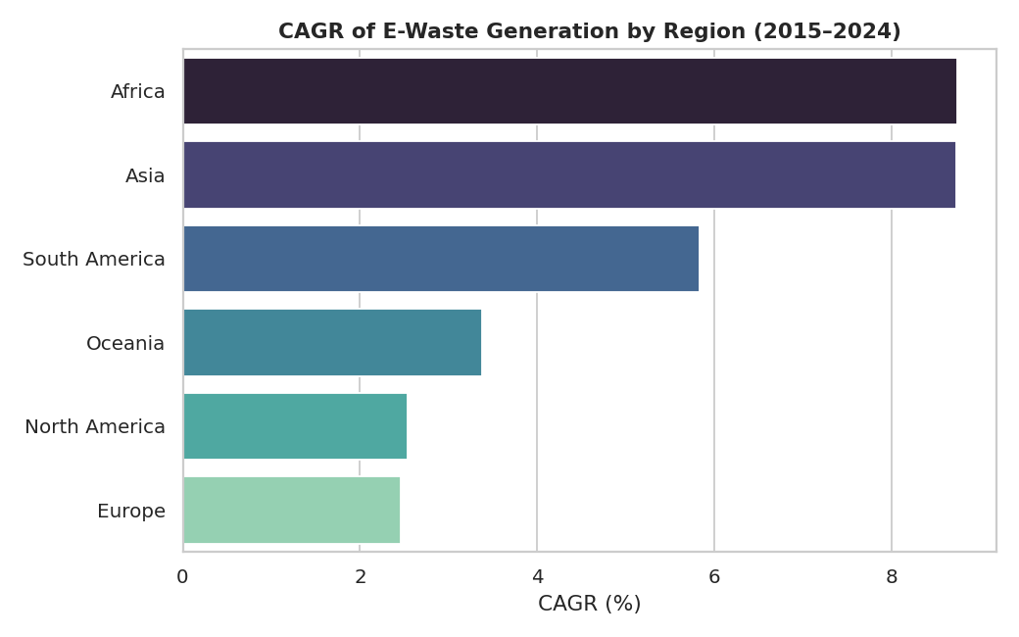
Figure 6: CAGR of e-waste generation by region, 2015–2024.

5.7 Trend Projection to 2027
A simple ordinary-least-squares linear fit on the global yearly totals projects continued growth through 2027 if current patterns hold, reinforcing the urgency of scaling formal recycling capacity now rather than reacting later.
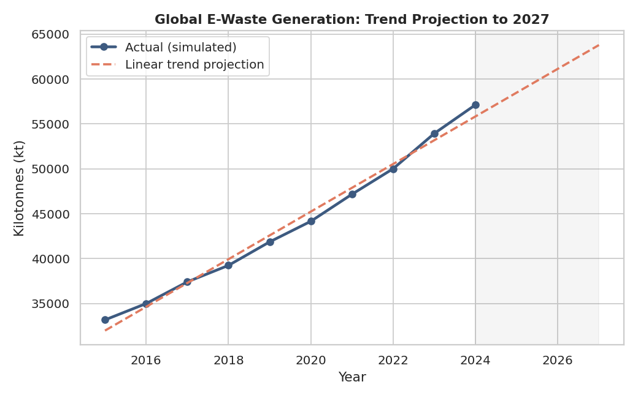
Figure 7: Linear trend projection of global e-waste generation to 2027.

6. Key Insights Summary
- Global e-waste generation grew at roughly a 6% compound annual growth rate (2015–2024), consistently outpacing formal recycling growth.
- Wealthy, highly digitized countries generate the most e-waste per person; populous developing economies generate the most in absolute terms.
- The lowest formal recycling rates are disproportionately concentrated in the countries with the largest and fastest-growing absolute e-waste volumes.
- GDP per capita and internet penetration are the strongest correlates of per-capita e-waste generation.
- Regions with the fastest growth rates (Africa, parts of Asia) are not the regions with today's largest volumes — the geography of the problem is shifting.

7. Recommendations
- Prioritize formal e-waste collection and recycling infrastructure investment in high-growth, low-recycling regions before volumes peak, not after.
- Pair digital-inclusion and internet-access programs with extended-producer-responsibility and device take-back policies, so digital growth does not outrun waste-management capacity.
- Set recycling-rate targets using per-capita benchmarks alongside national totals, since the two metrics are driven by different underlying factors (wealth vs. population).

8. Limitations
- The dataset is simulated to reflect realistic reported patterns, not sourced from an official downloaded dataset (see Section 3).
- The projection in Section 5.7 uses a simple linear trend, not an advanced forecasting model, and should be read as an illustrative extrapolation.
- The analysis covers 20 representative countries rather than all ~195 countries worldwide.

9. Conclusion
This project demonstrates a complete, end-to-end data analytics workflow — data preparation, exploratory analysis, multi-dimensional comparison, correlation analysis, and trend projection — applied to a real-world sustainability problem aligned with UN SDG 12 and SDG 3. The central finding, that the countries generating the most e-waste often have the least capacity to formally recycle it, is a clear, policy-relevant insight that data analytics alone (without any machine learning) is able to surface and communicate.

10. References
- Forti, V., Baldé, C.P., Kuehr, R., Bel, G. (2020). The Global E-waste Monitor 2020. UNITAR, ITU, ISWA.
- World Bank Open Data — Population and GDP per Capita series (worldbank.org).
- Global E-waste Monitor / globalewaste.org — reference statistics used to calibrate the simulated dataset's order of magnitude.

