Excel Tasks:
- Data Exploration
Save the marketing campaign csv file as excel file
  - Create a statistical summary for numeric features
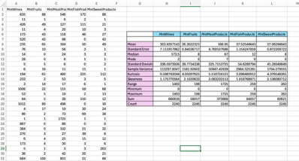
  - Create a line chart for number of enrollemnts by year
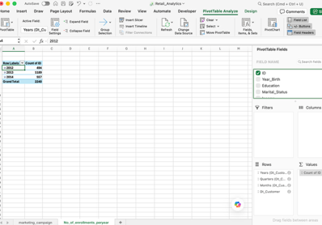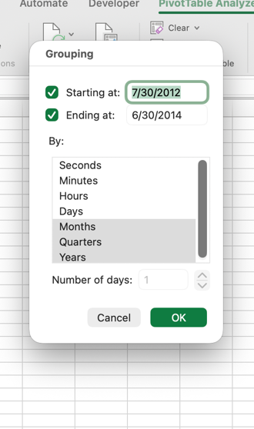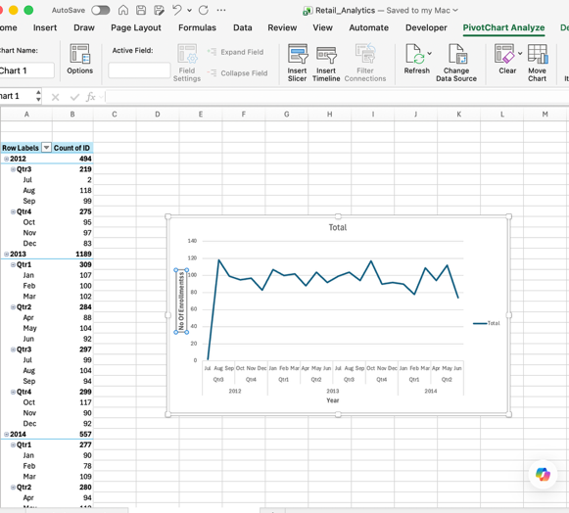
  - Give a cross tabulated count for response values against education
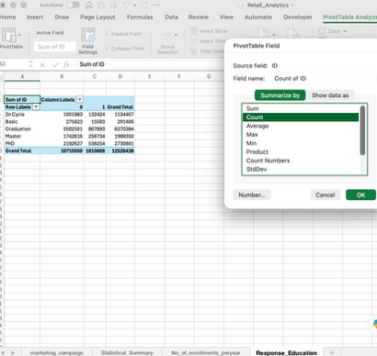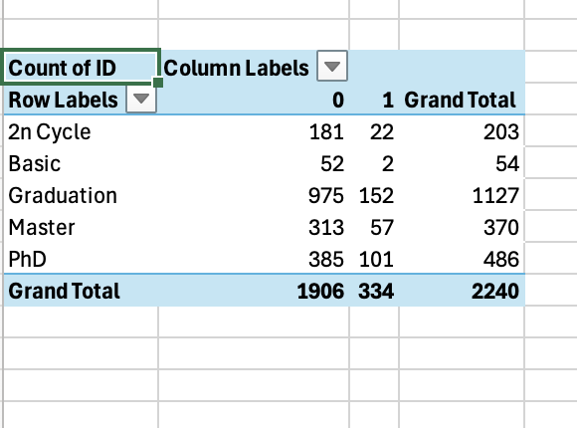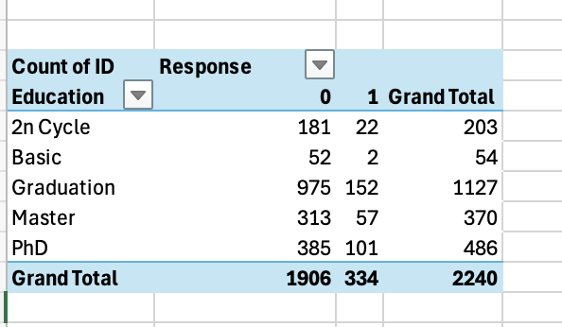
  - Make a box plot on income and write your observations
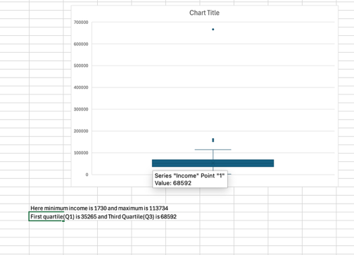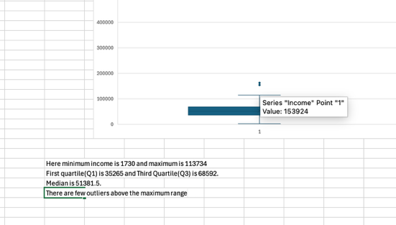
Here minimum income is 1730 and maximum is 113734. First quartile(Q1) is 35265 and Third Quartile(Q3) is 68592. Median is 51381.5. There are few outliers above the maximum range.
  - Calculate the age of customers and make a histogram of that
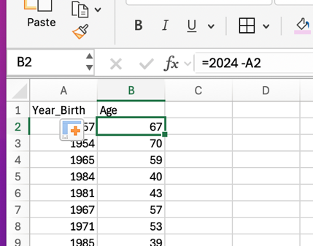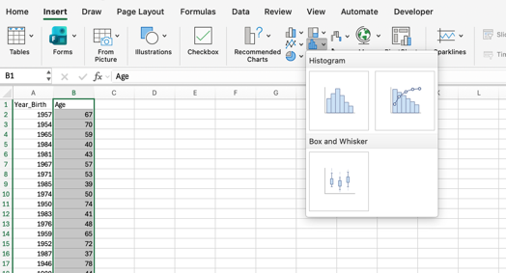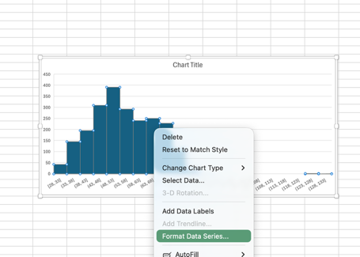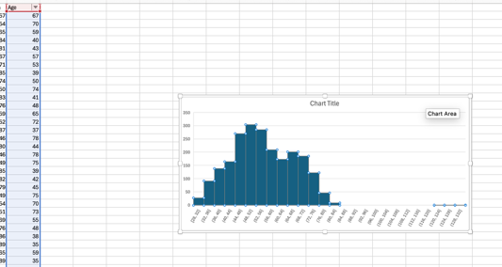
  - Visualise the response against Marital status
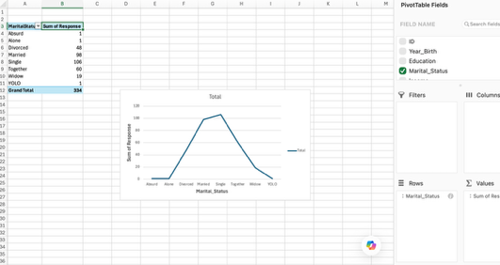
***********------**************
SQL Tasks:
- Data Loading
2.1) Create a schema named retail_data
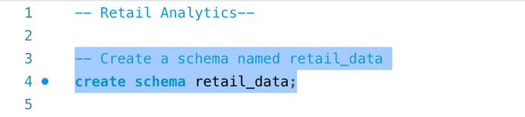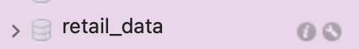

2.2) Set retail_data as the default schema


2.3) Create tables to store the retail transaction data
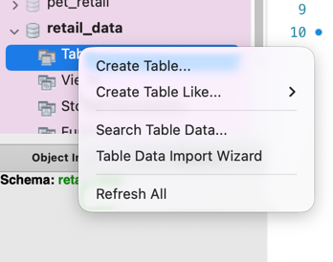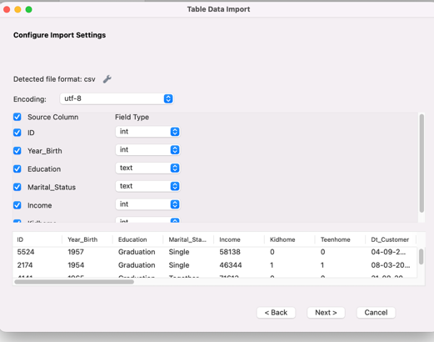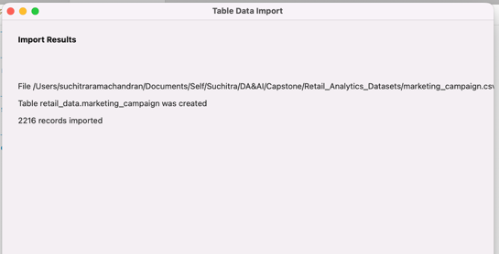
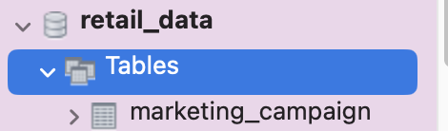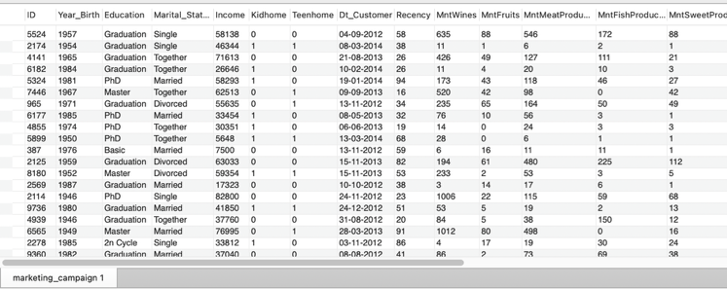

- Data Preprocessing
3.1) Calculate total no of customer encounters
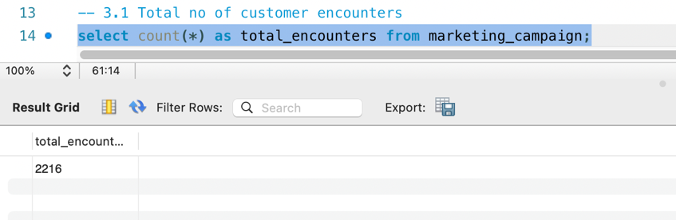
3.2) Identify the top 10 most purchased products such as wines, meat products, etc.
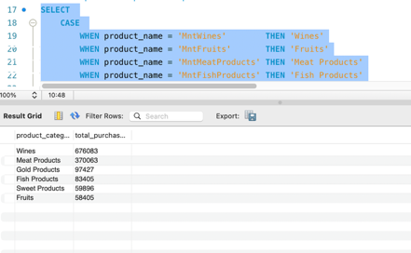
3.3) Count of response values
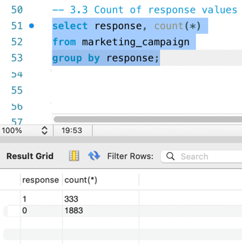
3.4) Distribution of customers based on their education level and marital status.
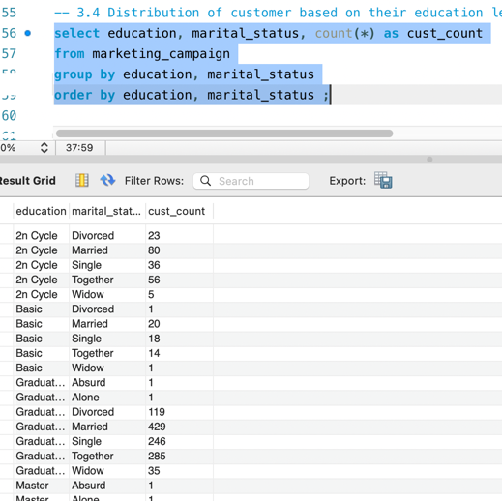
3.5) Average income of customers who participated in the campaign
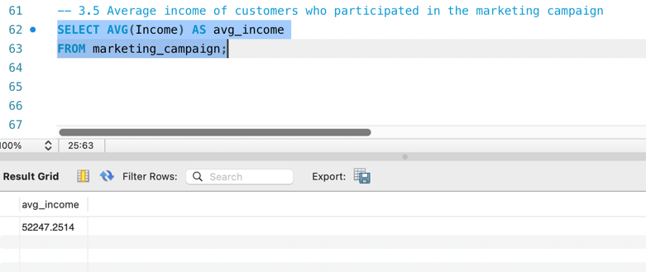
3.6) Total no of promotions accepted by customers
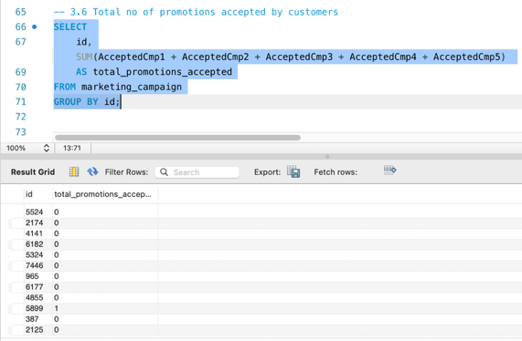

3.7) Distribution of customer response
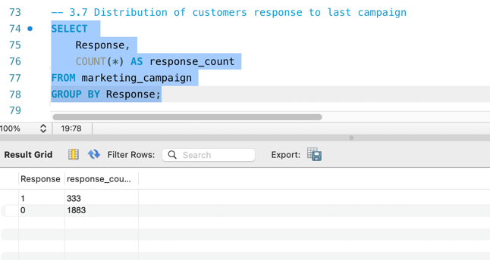
3.8) Average no of children and teenagers in customer households
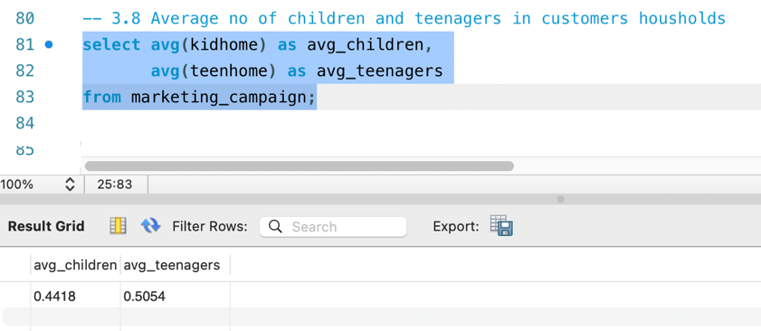
3.9) Create an age column by subtracting year_birth from current year
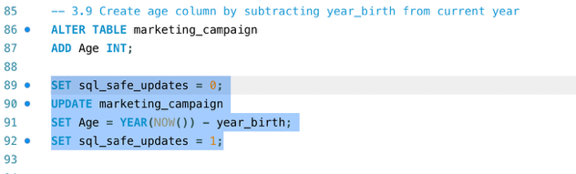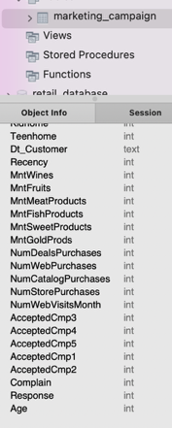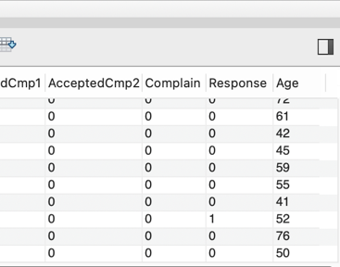
3.10) Create age group column based on conditions provided:
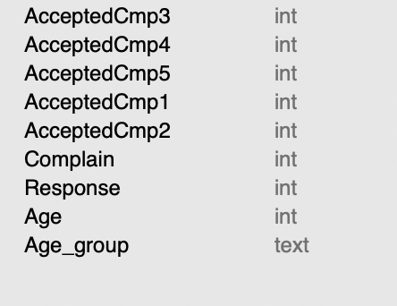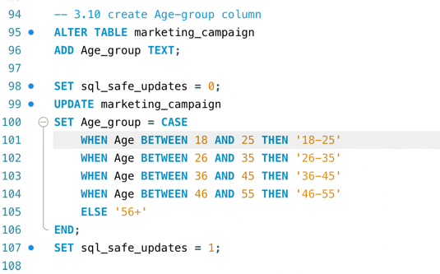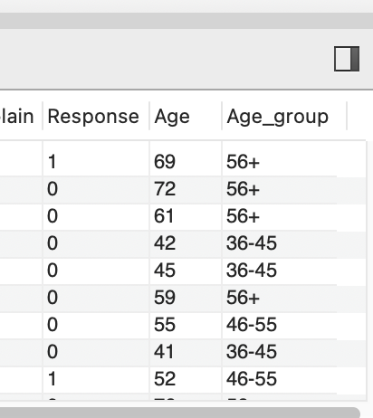

3.11) Determine average no of visits per month for customers in each age group
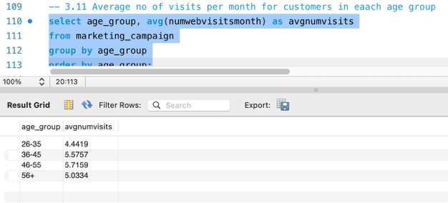

***********------**************
Python Tasks:
Import the libraries and upload the data
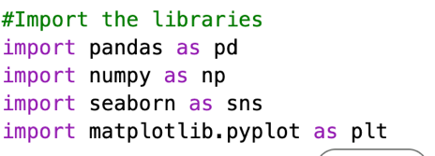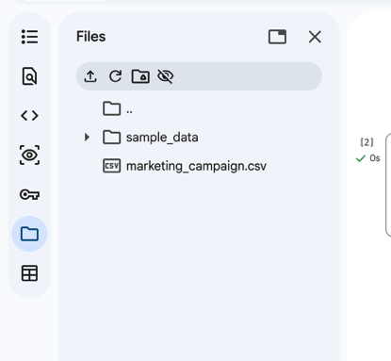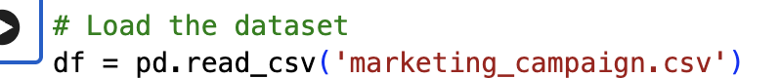
4) Exploratory Data Analysis
4.1) General Data Overview
a) Check the first few rows of the dataset to understand its structure
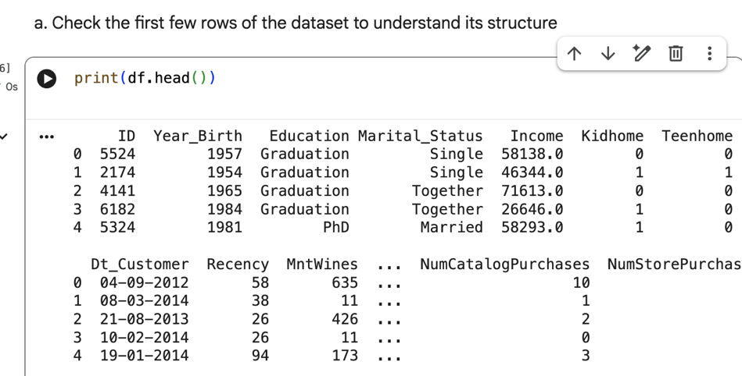
b) Check the data type of each column
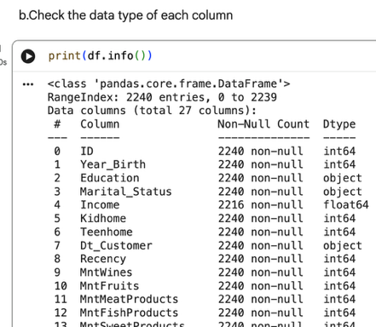

c) Check for any missing values in the dataset
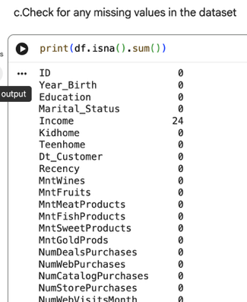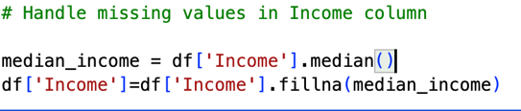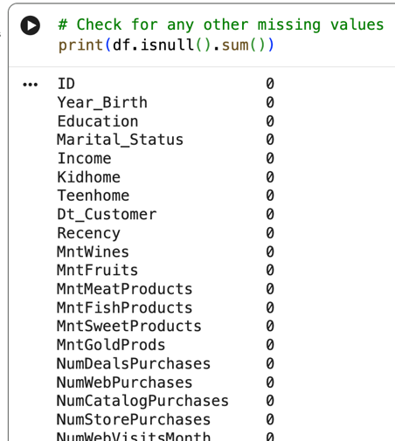

4.2) Descriptive Statistics
a) Compute summary statistics for numeric columns(mean, medium,min, max and standard deviation)
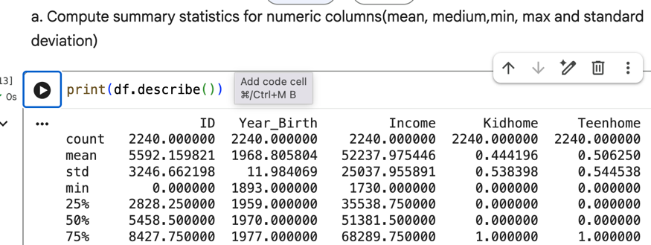
b) Explore the distribution of numerical variables using histograms or box plots
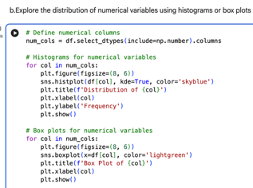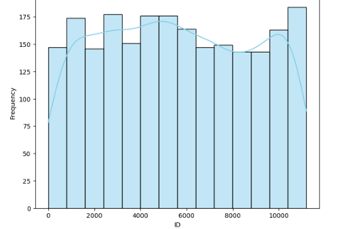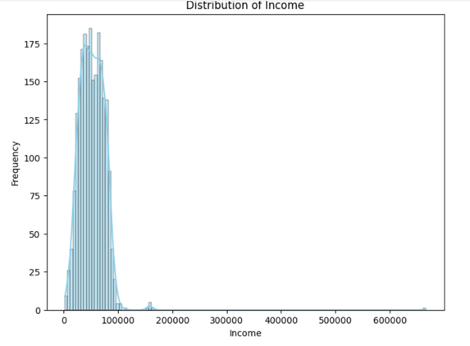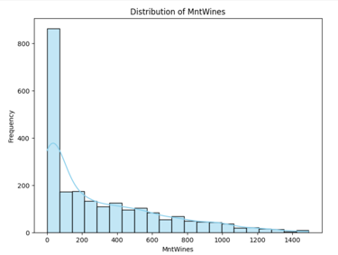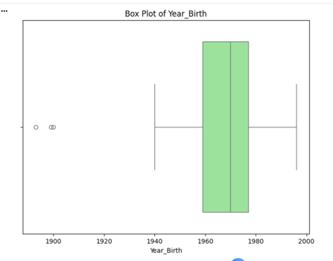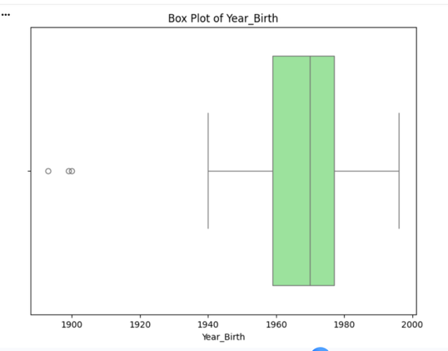

4.3) Univariate Analysis
a) Explore the distribution of each numerical variable using histograms or kernel density plots
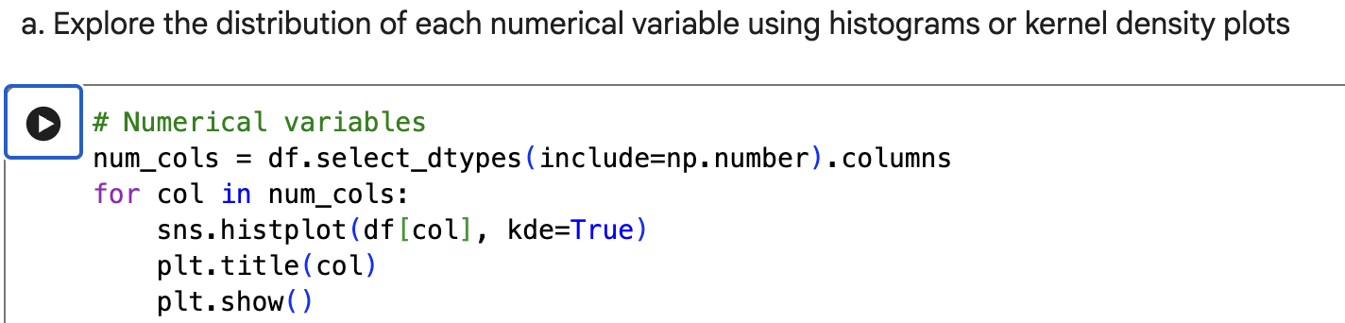
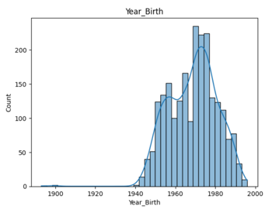
b) Explore the distribution of each categorical variable using bar plots or pie charts
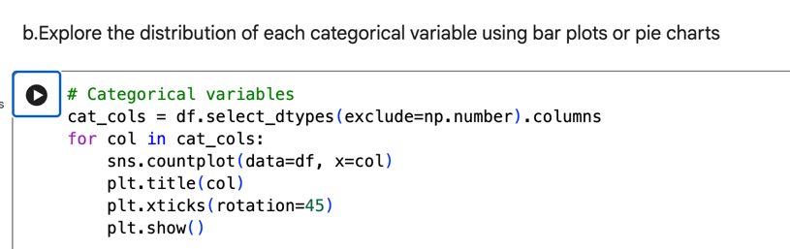
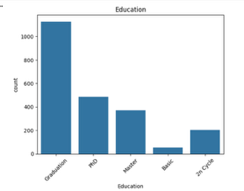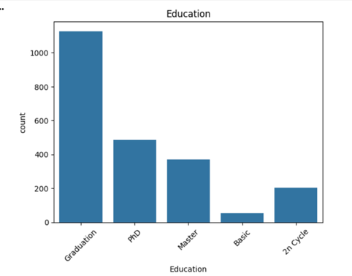
c) Identify outliers in numerical variables using box plots or scatter plots
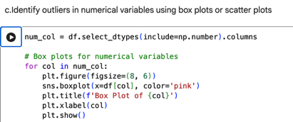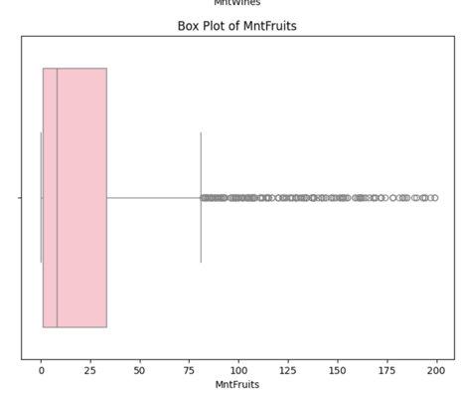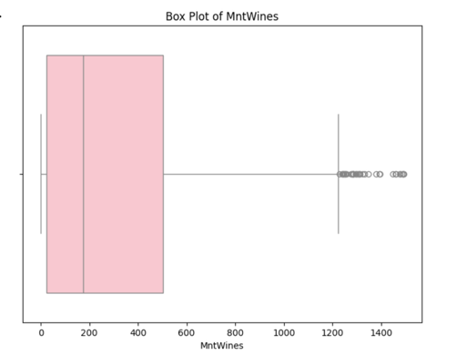

4.4) Bivariate Analysis
a) Explore the relationship between numerical variables and the target variable(Response) using scatter plots or correlation matrices
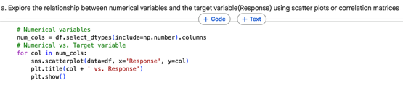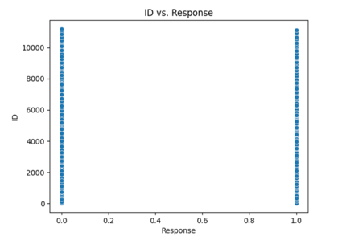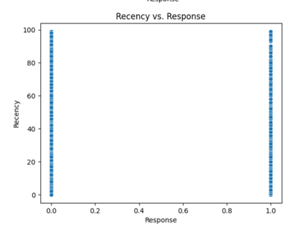
b) Explore the relationship between categorical variables and the target variable(Response) using box plots or chi-squared tests
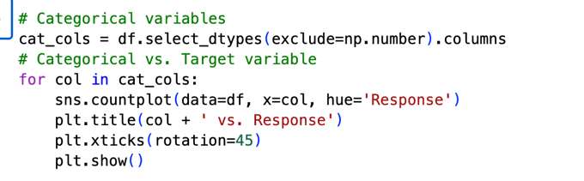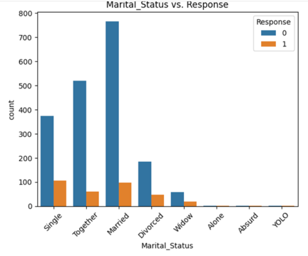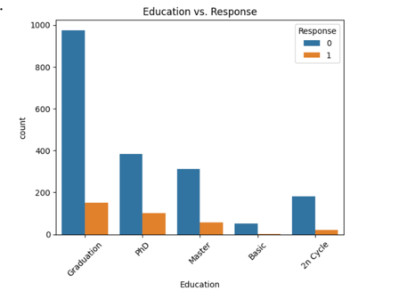
c) Explore the relationship between numerical and categorical variables
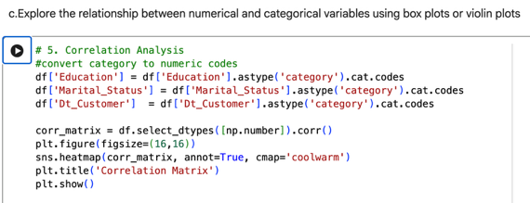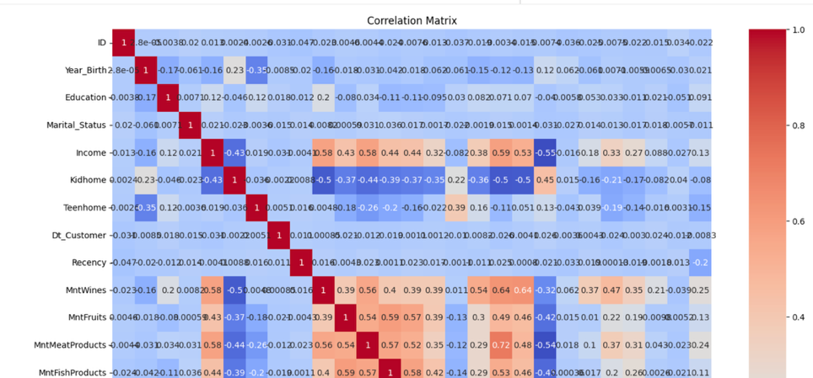

***********------**************
Tableau Tasks:
First upload marketing_campaign dataset by selecting text file from connet pane
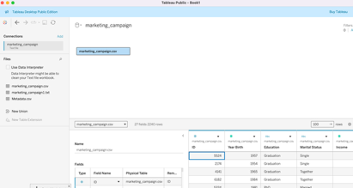
- Visualise Customer income distribution grouped by Year of Registration
In New worksheet
Create calculated field YearRegistered
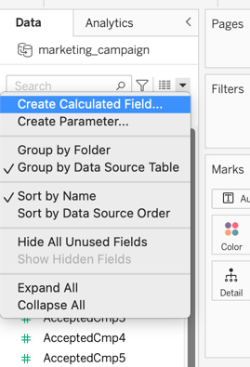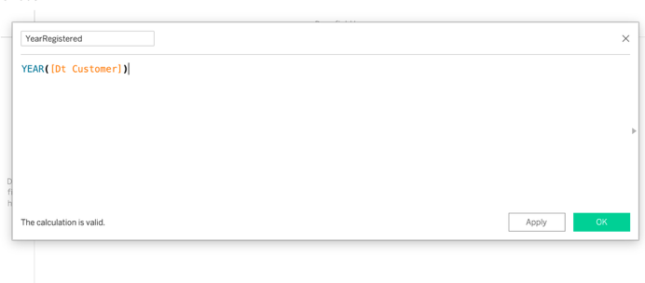
Create Income bins
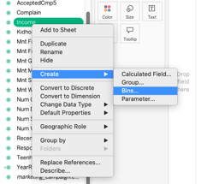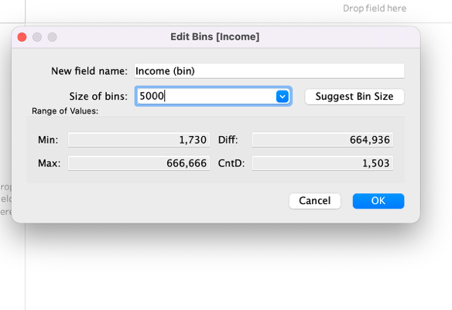
Drag YearRegistered to columns & Income(bins) to rows
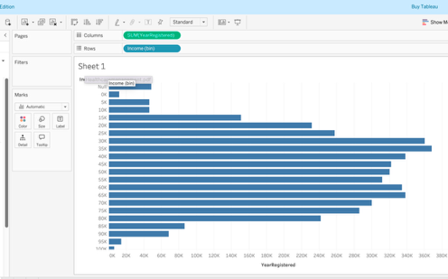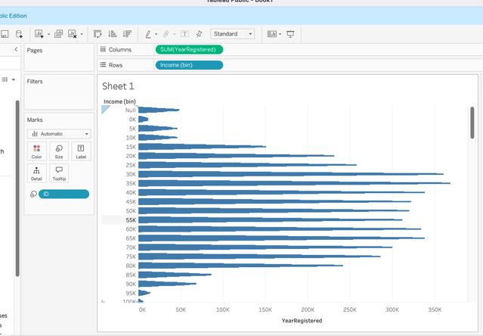
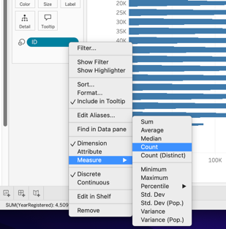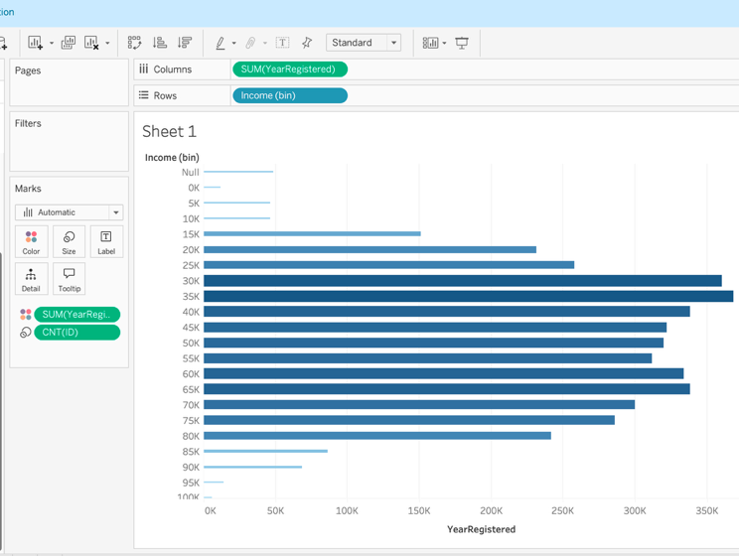
Swap Rows and columns for better visualization
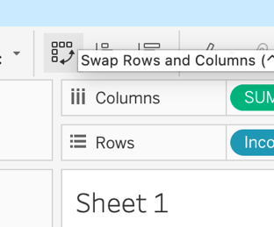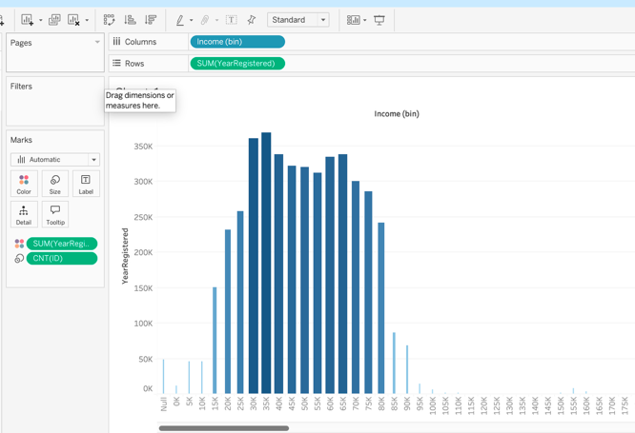

- Examine the breakdown of education levels and marital staus using side-by-side circles to represent count
In new sheet drag education to columns, income to rows and select measure as count
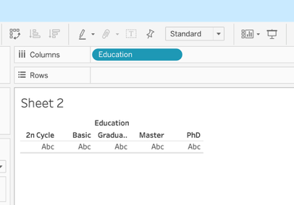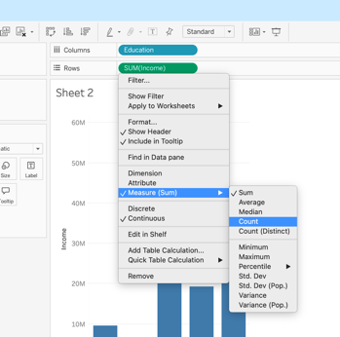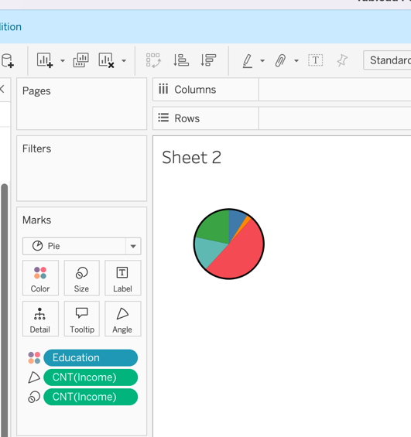
Drag education to labels
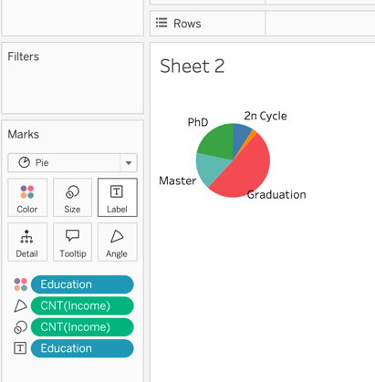
Drag marital status to column, income to rows and measure as count
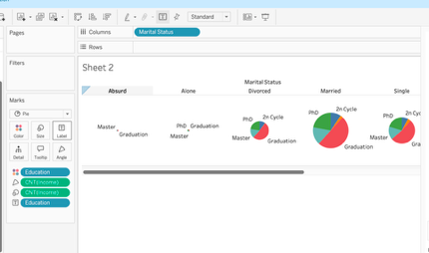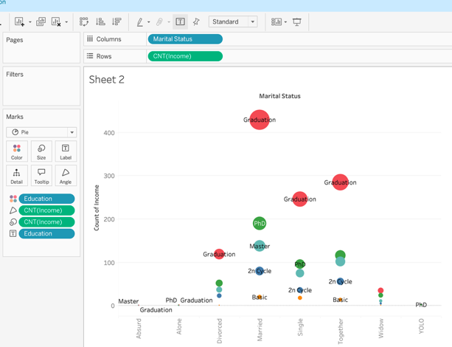
Select side-by-side circle from show me options, Drag income to label and measure as count

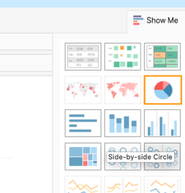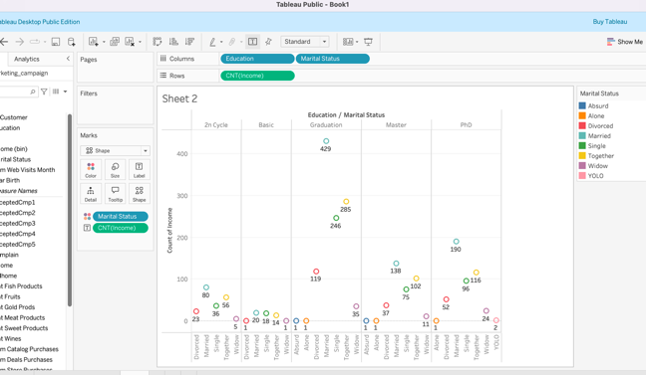
- Explore the relationship between income and wine spending
Create calculated field Wine spending = [MntWine]/[Income]
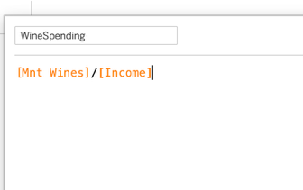
Drag income to column and winespending to rows and change graph type to circle in marks.Drag winespending and income to labels as well.
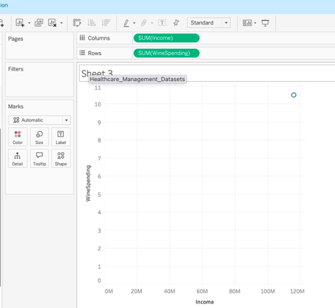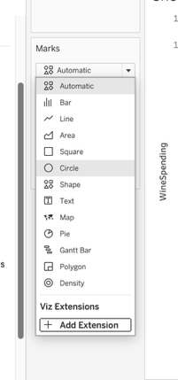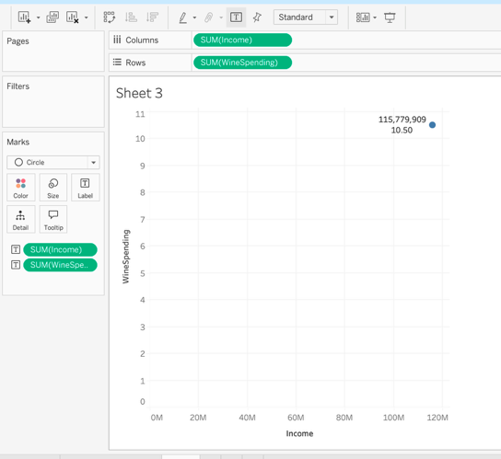

- Analyse the frequency of purchases across various product categories
Drag Mnt Wines, Mnt Fruits and Mnt Meat Products to rows. Drag ID to Columns
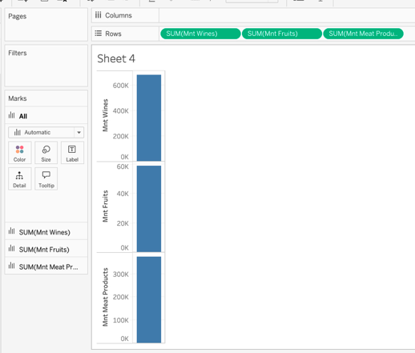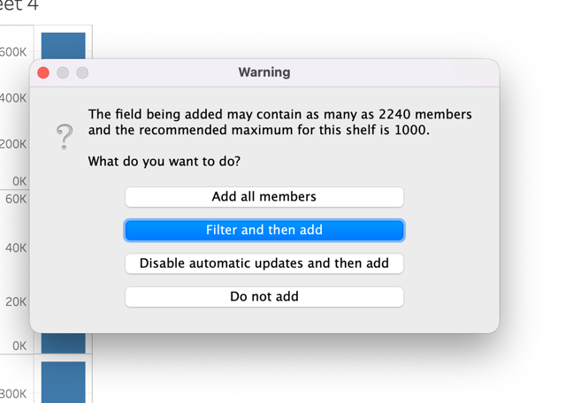
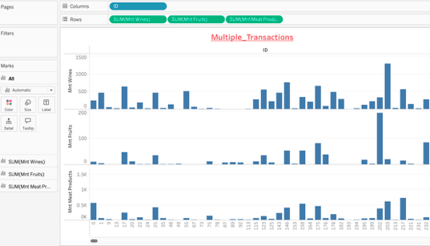
- Create a dashboard using all the visualisations
