

A Project Report

ON

**RAILWAY RESERVATION SYSTEM**

BY

**SUCHITRA.P-1PI11IS111**

**SWATHI SANTHOSH-1PI11IS116**

**Guide**

**Dr.Ganga Holi**

**Associate Professor**

**Department of IS & E,**

**PESIT**

**Bangalore**

**Jan 2014 – May 2014**

## DEPARTMENT OF INFORMATION SCIENCE & ENGINEERING

**PES INSTITUTE OF TECHNOLOGY**

**100 FEET RING ROAD, BANASHANKARI III STAGE**

# **BANGALORE-560085**

1. **INTRODUCTION**

In India, Railway service is the mostly widely used transportation for long distance travelling. Passengers from different locations will try to book tickets. In this process data managing will be a tough task.

Railway Reservation System is a web application. It is designed by considering improvements in train ticket booking system which can help passengers to book tickets online.

1. **PROPOSEED APPROACH**

Using Railway reservation system software the following functionalities can be managed easily-

* Availability of seats.
* Fares for various trains.
* Information of trains between stations are managed.

Users can even plan journey and book tickets using online methods.

The functionalities that can be performed by the users are-

* Train Enquiry
* Book Ticket
* Check PNR Status
* Login and Logout

The functionalities that can be performed by the admin of the web application are-

* Remove Trains
* Update train timings
* Get Passenger List

1. **COMPONENTS USED**

* The J2EE components used in our project are-

JSP(Java Server Pages)

JDBC(Java DataBase Connectivity)

Sessions in JSP.

* HTML5 is used for GUI.
* MYSQL is used for store the data.
* Apache Tomcat web server is used to implement JSP.
* MYSQL Connector/ODBC is used to connect to the database.

1. **SOURCE CODE**

Booking tickets

ticket2.jsp

<!DOCTYPE html>

<%@ page import ="java.sql.*" %>

<%@ page import ="java.util.*" %>

<%@ page import ="java.io.*" %>

<%@ page import ="javax.sql.*" %>

<html>

<head>

<style>

body

{

background:url(logo.jpg);

background-size:200px 180px;

background-repeat:no-repeat;

padding-top:40px;

margin:30px;

}

.right

{

border-style:solid;

border-color:#eee;

margin-top:50px;

margin-left:300px;

padding-top:50px;

padding-bottom:50px;

padding-right:100px;

padding-left:100px;

position:absolute;

width:600px;

background-color:deepskyblue;

align:center;

}

#d1

{

font-family:"Times New Roman";

font-size:20px;

color:black;

text-align:center;

}

body

{

background-color:white;

}

#p1{

font-family:"Times New Roman";

font-size:20px;

color:black;

}

.button {

color: white;

background-color: #3333cc;

}

#div1 {

width:550px;

height:500px;

border: 3px solid red;

background-color:white;

}

</style>

<title>TRAIN TICKET</title>

</head>

<body>

<div id="d1">YOUR TRAIN TICKET</div>

<div class="right">

<div id="div1">

<%!int pnrno=12311;%>

<%

String name=(String)session.getAttribute( "name" );

String trainname=(String)session.getAttribute( "trainname" );

String trainno=(String)session.getAttribute("trainno");

String src=(String)session.getAttribute( "src" );

String dest=(String)session.getAttribute( "dest" );

String type1=(String)session.getAttribute( "type" );

String num=(String)session.getAttribute( "noofseats");

String adults=(String)session.getAttribute( "adults");

String childs=(String)session.getAttribute( "childs");

%>

<p> USER NAME: <%out.print(name); %></p>

<p> TRAIN NAME: <%out.print(trainname);%></p>

<p> TRAIN NO:<% out.print(trainno); %></p>

<p> SOURCE : <%out.print(src); %></p>

<p> DESTINATION :<%out.print(dest);%></p>

<p> CLASS TYPE:<%out.println(type1); %></p>

<p> TOTAL NO OF SEATS: <% out.println(num);%></p>

<p> ADULTS:<%out.println(adults); %></p>

<p> CHILDREN:<%out.println(childs); %></p>

<%

Class.forName("com.mysql.jdbc.Driver");

java.sql.Connection con = DriverManager.getConnection("jdbc:mysql://localhost/train","root","admin");

Statement st= con.createStatement();

String classtype="sleeper";

ResultSet rs=st.executeQuery("select arrvtime,depttime,totalseats,seatsava,price from train where trinno='"+trainno+"' and classtype='"+classtype+"' and src='"+src+"' and des='"+dest+"' ");

int avail=0,total=0;

String no1=(String)session.getAttribute( "noofseats");

int no=Integer.parseInt(no1);

if(rs.next())

{ %>

<p>DEPARTURE TIME:<%=rs.getString("depttime") %></p>

<p>ARRIVAL TIME:<%=rs.getString("arrvtime") %></p>

<p> FARE: <% int price1=rs.getInt("price"); int fare=price1*no ; out.print(fare); %></p>

<p>SEAT NUMBERS:<%

total=rs.getInt("totalseats");

avail=rs.getInt("seatsava"); }

if(avail>=no)

{

int p=total-avail;

for (int count=1; count<=no;count++)

{

out.println(p=p+1);

}

st.executeUpdate("update train set seatsava=seatsava-'"+no+"' where trinno='"+trainno+"' and classtype='"+classtype+"' and src='"+src+"' and des='"+dest+"' ");

}

else

{

out.print("waiting ");

}

%></p>

<p> PNR NUMBER:<%

out.print(pnrno=pnrno+1);

String status;

if(avail>=no)

{

status="booked";

for(int count1=1;count1<=no;count1++)

{

st.executeUpdate(" insert into pnr values( '"+pnrno+"','"+count1+"','"+status+"','"+status+"' )");

}

}

else

{

status="waiting";

for(int count2=1;count2<=no;count2++)

{

st.executeUpdate(" insert into pnr values( '"+pnrno+"','"+count2+"','"+status+"','"+status+"' )");

}

}

%></p>

</div>

</div>

</body>

</html>

1. SCREENSHOTS OF THE OUTPUT

Creating an account-

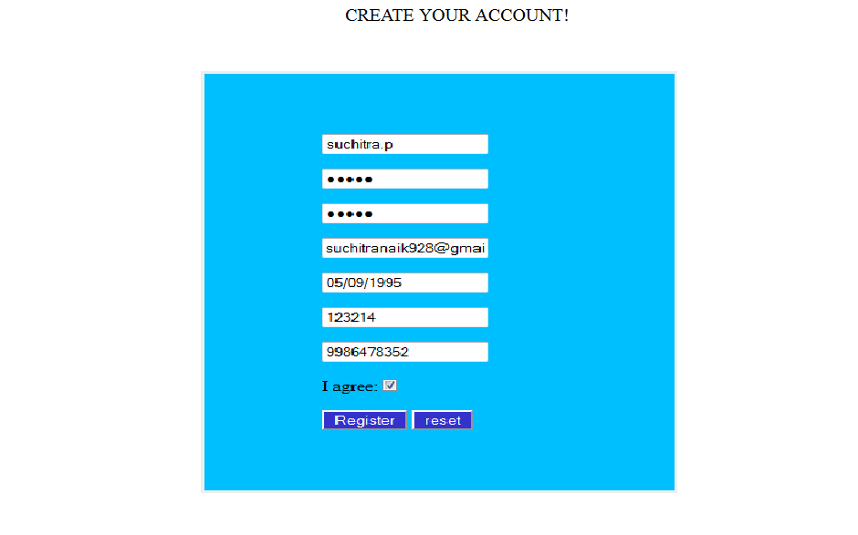

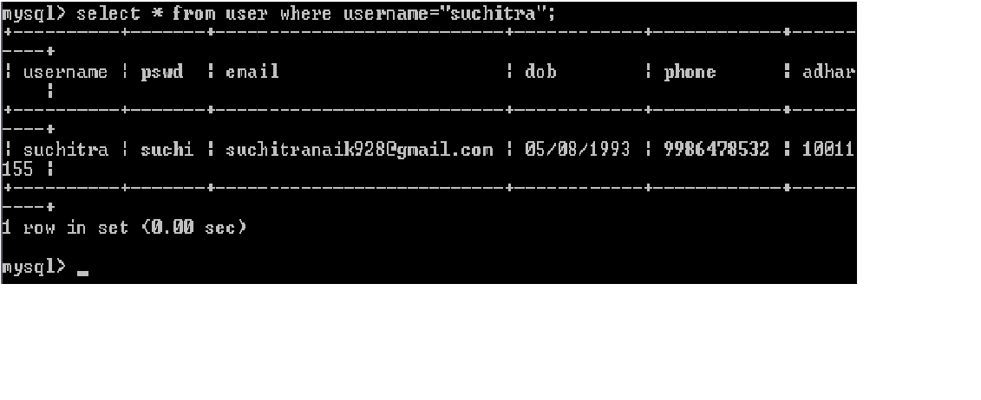

Booking ticket-

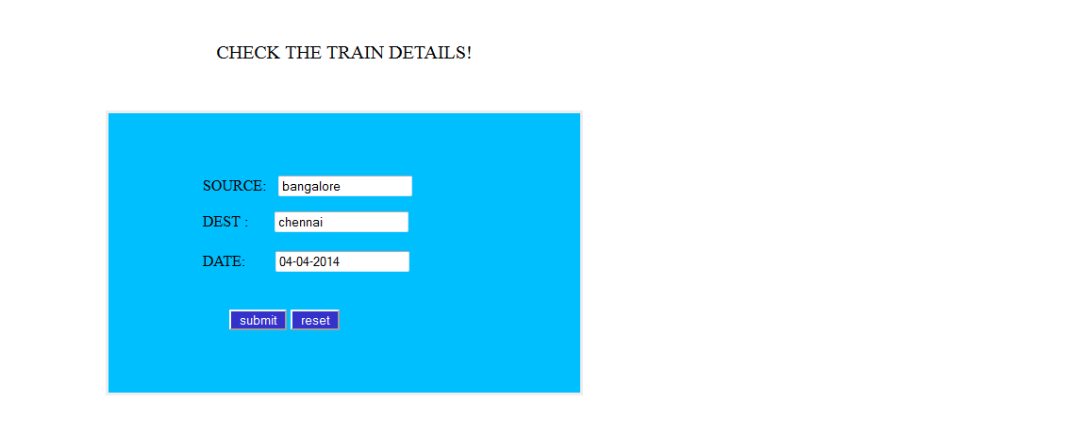

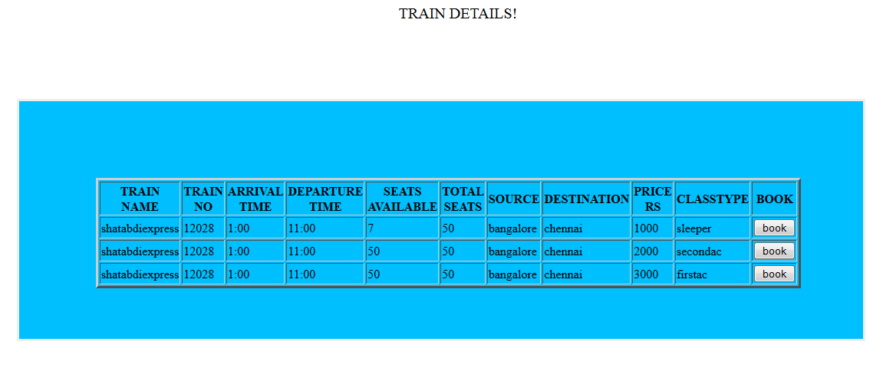

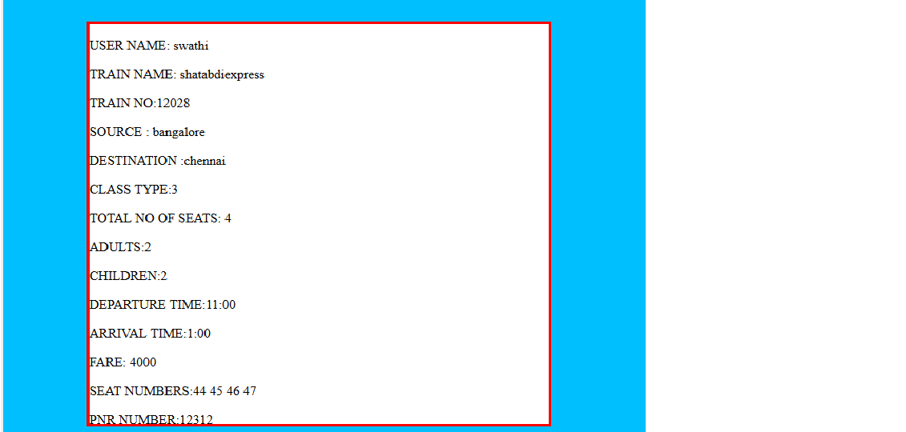

Update train timings-

